Project Title: Leveraging Earth Observation Data for Informed Agricultural Decision-Making

High-Level Project Summary:

In this challenge we explored and analysed ground water storage data from NASA – GRACE and GRACE-FO to address the ground water level exhaustion concerns and to take precautions on time. Early warning would also help improve their farming practices. There is heavy dependence on ground water by Indian population both for drinking and farming. 70 to 80% of the Indian farmers depend on ground water. Therefore, to solve this problem, we extracted data specific to India and added Indian states based on longitude and latitude information in the dataset and tried to find trends across states and seasons. Further, we also found that the features surface level soil moisture (sfsm) and root zone soil moisture (rtzsm) are highly correlated with each other and with the target ground water storage. We explored 2 models LSTM and ST-CNN and finally chose ST-CNN because of higher accuracy. The results can be seen in our website.

Project Demo: PPT

<https://docs.google.com/presentation/d/1h8yXnEaw545x803bobIzvHOJtCi2XUWP/edit?usp=sharing&ouid=100003043874139109221&rtpof=true&sd=true>

Final Project:

<https://github.com/adithi21/NASA_Hackathon_2024_Meteoric_Minds/tree/main>

Project Details:

Our main goal in the project was to forecast ground water storage based on GRACE (Gravity Recovery And Climate Experiment) data from January 2023 to May 2024. The data is at the week level and consisted of following features:

Latitude (lat)

Longitude (lon)

Groundwater Storage (gws_inst)

Root Zone Soil Moisture (rtzsm_inst): Water at upper 200 cm of soil

Surface Soil Moisture (sfsm_inst): Water at upper 10 cm of soil

Week / Time

We filtered out data only for India based on shape files and mapped Indian states to respective longitude and latitude. What we find is that the gws_inst is highly correlated to rtzsm_inst and sfsm_inst. Also, rtzsm_inst and sfsm_inst are highly correlated to each other.

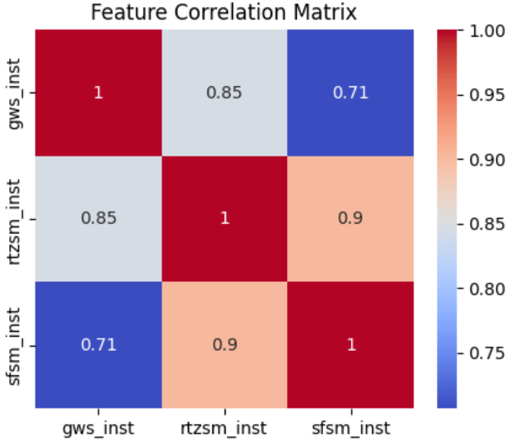

We further analysed the features trend over the weeks for different states of India.

1. We observe southern states like Karnataka, Tamil Nadu and Kerela’s GWS falls significantly as weeks proceeds:

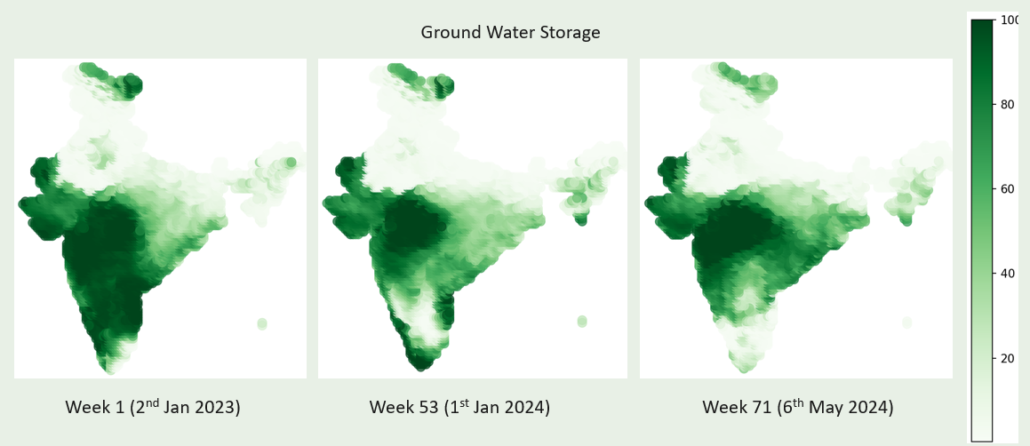

1. Similar trend is observed for soil moisture data:

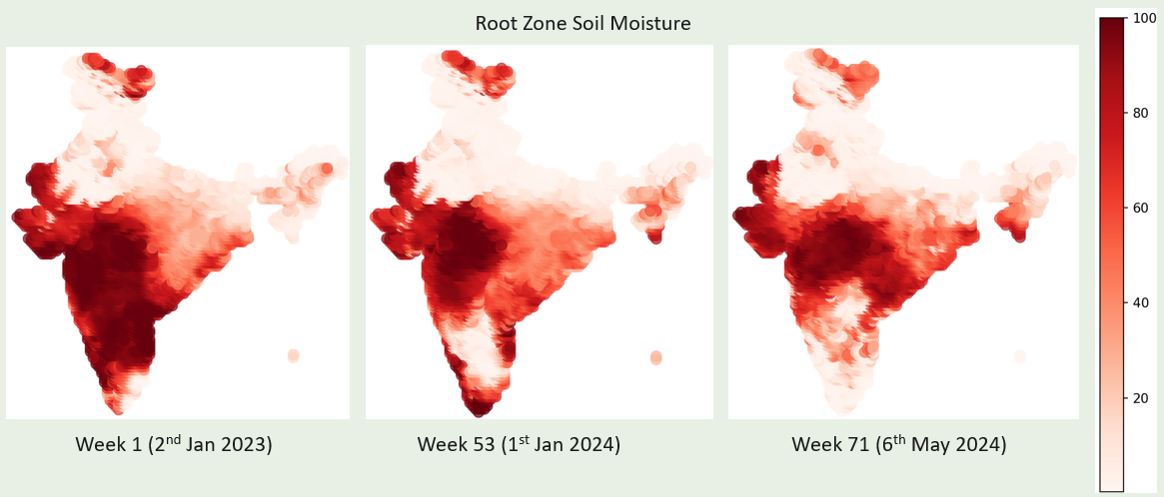

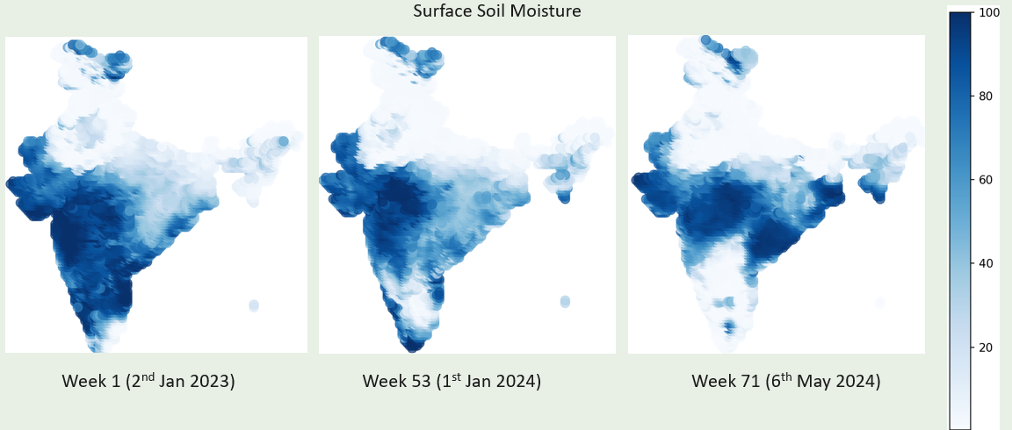

1. Ground Water Storage falls in the summer, replenishes during monsoons starts depleting again towards the end of winter for southern states. The GWS increases for Mizoram.

After data cleaning and explorations, we used Machine Learning models to forecast weekly ground water storage based on its historical data, latitude, longitude, and week. We experimented with two models LSTM and ST-CNN.

We finalized with ST-CNN which has higher accuracy on 20 epochs and early stopping.

The model is then saved to a pickle file and a website was developed so that the end user (farmers and other members agriculture community) can enter the week number for which forecast is required.

Use Of Artificial Intelligence:

We used models LSTM and ST-CNN to forecast ground water storage. ST-CNN was able to explain the variance by 87.82 %, 3% higher than LSTM. We created data sequences from the weekly GWS data with longitude, latitude, week as features and GWS as the independent variable. Following are the evaluation metrics:

|  |  |  |
| --- | --- | --- |
| **Metric** | **LSTM** | **ST-CNN** |
| Mean Absolute Error (MAE) | 9.46 | 8.63 |
| Mean Squared Error (MSE) | 207.04 | 163.9 |
| Root Mean Squared Error (RMSE) | 14.38 | 12.8 |
| R-squared | 84.59 | **87.82** |

Loss for ST-CNN model:

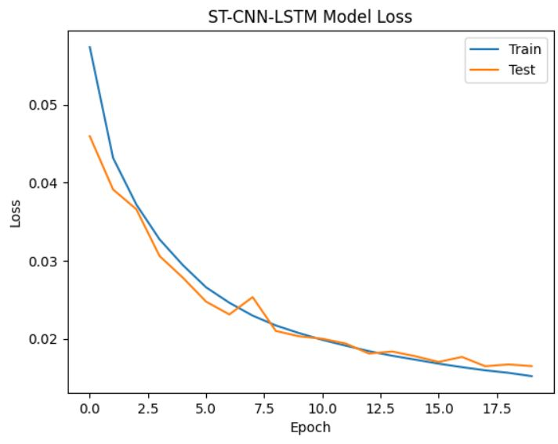

In addition to above we also tried CatBoost regressor model, to solve the problem as a regression but it does not meet our end goal and the accuracy was very low due to highly correlated soil moisture features.

Space Agency Data:

https://www.earthdata.nasa.gov/learn/pathfinders/agricultural-and-water-resources-data-pathfinder/find-data#water

https://search.earthdata.nasa.gov/search?q=GRACEDADM_CLSM025GL_7D

References:

<https://journalofbigdata.springeropen.com/articles/10.1186/s40537-022-00599-y>

https://towardsdatascience.com/exploring-the-lstm-neural-network-model-for-time-series-8b7685aa8cf

https://cgwa-noc.gov.in/LandingPage/LatestUpdate/NCDGWR2023.pdf

<https://www.indianremotesensing.com/2017/01/Download-India-shapefile-with-kashmir.html>

<https://vajiramandravi.com/upsc-daily-current-affairs/mains-articles/status-of-groundwater-in-india/>

<https://wotr.org/2023/03/29/groundwater-resources-in-india/#:~:text=The%20annual%20ground%20water%20recharge%2C%20also%20known%20as%20dynamic%20groundwater,entire%20country%20are%20398.08%20bcm>.

<https://welllabs.org/indian-farmers-dependent-on-groundwater-solar-irrigation-inadequate-to-change-crop-choices-report/>

<https://docs.streamlit.io/get-started/tutorials/create-an-app>

https://towardsdatascience.com/geopandas-101-plot-any-data-with-a-latitude-and-longitude-on-a-map-98e01944b972

AI Tools:

ChatGPT: For any code issues.