Indian Tax Law RAG Chatbot
A retrieval-augmented assistant for the Income-tax Act, 1961, built with NVIDIA Nemotron
Submitted By: Adithi Jahnavi

What I built
I built a chatbot that answers questions about Indian income-tax law using Retrieval-Augmented Generation (RAG). Instead of relying on what a language model has memorised (which is risky and unverifiable for tax), it retrieves the relevant passages from the actual Act and answers from them, citing the document, section, and page. The reasoning engine is NVIDIA Nemotron, and the interface is a simple chat UI.
The corpus is the Income-tax Act, 1961 and the Income-tax Rules, 1962 (official PDFs from incometaxindia.gov.in). I deliberately scoped it to the 1961 Act because that is the numbering taxpayers and professionals actually use — more on that decision below.

How it works
The system has an ingestion stage (run once) and a query stage (every question):
- Ingest: read the PDFs, split them into chunks, label each chunk with the legal section it falls under, embed them, and store them in a vector database (Chroma).
- Retrieve: for a question, run hybrid retrieval — semantic search (embeddings) and keyword search (BM25) together, fused with Reciprocal Rank Fusion — then re-rank with a cross-encoder. If the question names a section, a section-aware step forces in the chunk where that provision actually begins.
- Answer: Nemotron is given only the retrieved chunks and must answer from them, citing each fact, or say it could not find the answer.
- Verify: an answer-audit step then checks that every section the answer cites actually appears in the retrieved sources, and shows a 'verified' or 'caution' badge. This catches the occasional wrong citation before the user trusts it.
This reason-from-sources design is what makes the answers trustworthy: the bot cannot invent a section because it only sees the real text, and every claim points back to a page.

How I measured it
Rather than just demoing a few questions, I built an evaluation harness: 20 real tax questions whose correct section I know in advance, and a script that measures, for each, whether retrieval found the right section, whether the answer cited it, and whether key facts appeared. This turns 'it seems to work' into actual numbers, and it is how I drove every improvement.
Final results on the 20-question set:
Metric | Result
Retrieval hit-rate (right section retrieved) | ~70%
Citation accuracy (right section cited) | ~70-80%
Answer rate (answered vs refused) | ~80%
Corpus | Income-tax Act 1961 + Rules 1962 (3,320 chunks)
Reasoning model | NVIDIA Nemotron (Super 49B)

Citation accuracy improved from a 45% baseline to ~80% over the course of the project. (The numbers vary by a few percent between runs because the language model is non-deterministic — about ±2 questions on a 20-question set.)

Problems I hit and how I fixed them
Most of the real work was diagnosing why retrieval failed and fixing it. Each fix came from inspecting the actual retrieved text:
- Provisions drowned by cross-references. Asking about 'section 80C' returned other 80-series sections, because 80C is mentioned in dozens of places. Fix: section-aware retrieval that finds where the provision actually begins.
- The table of contents hijacked results. The 'Arrangement of Sections' list looked relevant to every query. Fix: detect list-style chunks (a header immediately followed by the next header) and exclude them.
- Two laws fighting each other. I first indexed both the 1961 and 2025 Acts, but the 2025 Act renumbered every section, so correct answers cited numbers nobody uses and citations got noisy. Fix: I measured this was hurting accuracy and scoped the corpus to the 1961 Act.
- Vocabulary mismatch. Users say 'home loan' but the Act says 'interest on borrowed capital for house property'. Fix: a query-expansion step that rewrites the question into formal statutory wording before searching.
- The model leaked its reasoning ('Okay, let's...') into answers. Fix: ask it to wrap the answer in tags and strip anything outside them.
- A prompt change that backfired. I tightened the prompt to stop the reasoning leak, but the eval showed it made the bot refuse more and scores dropped — so I reverted it. This is exactly why having measurements mattered.
- An environment bug: the embedding library hung on a network call to Hugging Face every run; fixed by forcing offline mode since the models are cached locally.

Screenshots

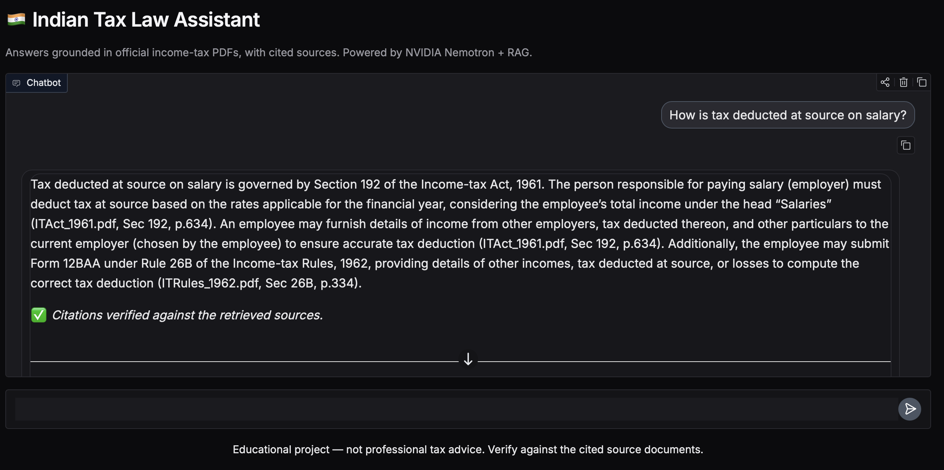

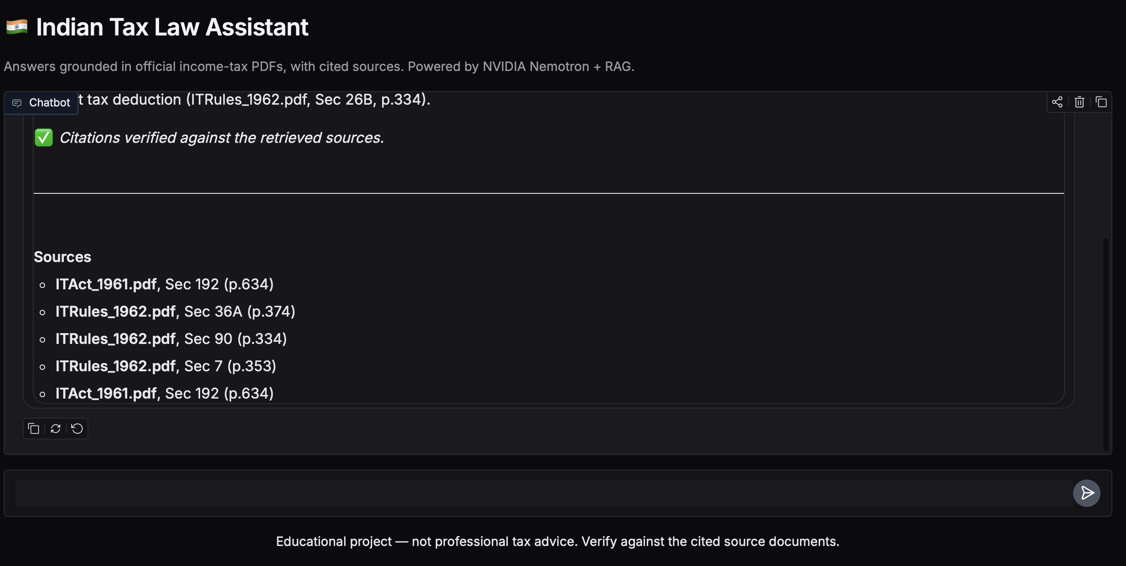

Tech stack
Component | Tool
Reasoning model (answers) | NVIDIA Nemotron via NVIDIA API
PDF parsing | pypdf
Embeddings | sentence-transformers (BAAI/bge-small-en-v1.5)
Keyword search | BM25 (rank-bm25)
Re-ranking | cross-encoder (ms-marco-MiniLM)
Vector database | Chroma
Interface | Gradio

Limitations and future work
- Streaming + caching: stream answers token-by-token and cache results to reduce the ~15-second response time on the free API tier.
- Better section labelling: the PDF headers carry amendment markers and footnotes that make labels imperfect; a structure-aware parser would improve citations.
- Procedural-section retrieval: add synonym mappings or a stronger embedder to close the gap on filing/PAN/penalty questions.
- Add the 2025 Act back with explicit current-vs-previous handling once the numbering can be presented clearly.

What I learned
The hardest and most useful part was not wiring the pieces together — it was measuring the system, finding where it actually broke, and fixing those specific failures. Building the evaluation harness changed how I worked: every change was checked against numbers, which caught a 'fix' that actually made things worse. I also learned to make deliberate scope decisions (dropping the 2025 Act) based on evidence rather than trying to include everything.

