Assignment 3-JavaScript function
Submitted by Adithi M Shrouthy
Matriculation Number:11037633

const people = ["Adithi", "Namrata", "Praveen", "Yamini"];
const isKayoComing = true;//if isKayoComing=false, error will be handled

// Creation of promise
const Kayo = new Promise((resolve, reject) => {
setTimeout(() => {
if (isKayoComing) {
resolve("Kayo Arrived with Cake");
} else {
reject("Kayo can't come");
}
}, 4000);
});

//creation of party function
const party = () => {
Kayo.then((response) => {
console.log(response);
console.log("Party started");
people.forEach((p) => console.log(p + " Arrived"));
}).catch((error) => {
console.error(error); //Here, the error is handled if isKayoComing = false;
});
};

party();

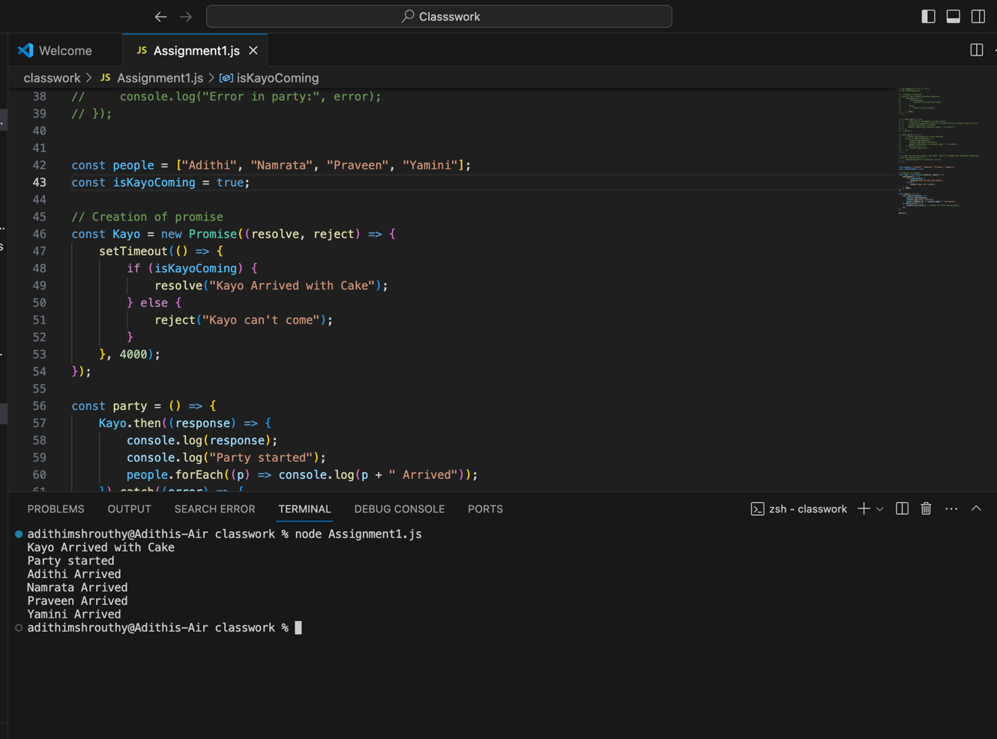
Output 1

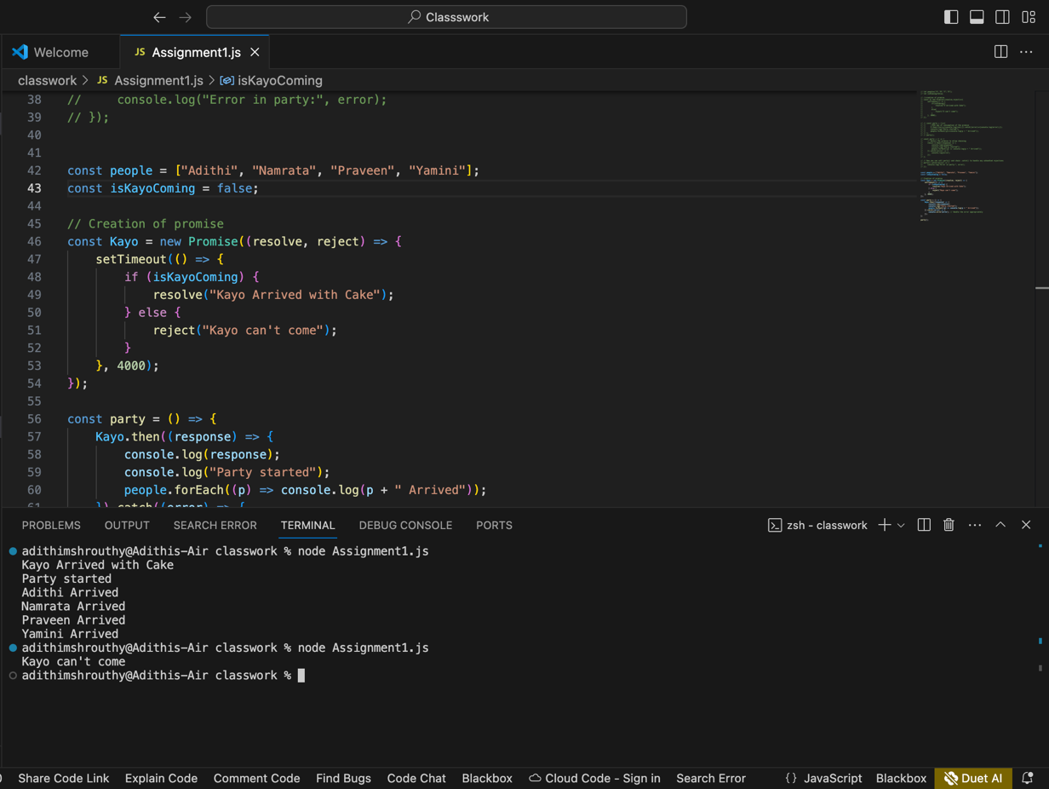
Output 2

