Assignment 4- Write unit test for the Button component from the React-clothing project(2 unit test cases)
Submitted by Adithi M Shrouthy
Matriculation Number:11037633

import React from 'react';
import { shallow } from 'enzyme';
import Button from './Button';
import Loader from '../Loader/Loader';

describe('Button component renders', () => {
it('button with loader when isLoading is true', () => {
const wrapper = shallow(<Button isLoading={true} />);
expect(wrapper.find('button').exists()).toBe(true);
expect(wrapper.find(Loader).prop('component')).toEqual('Login');
});

it('button with value as displayTrue when isLoading is false', () => {
const handleLoginMock = jest.fn();
const wrapper = shallow(
<Button
isLoading={false}
value={true}
handleLogin={handleLoginMock}
displayTrue="True Text"
displayFalse="False Text"
/>
);
const button = wrapper.find('button');
expect(button.exists()).toBe(true);
expect(button.text()).toEqual('True Text');
});
});

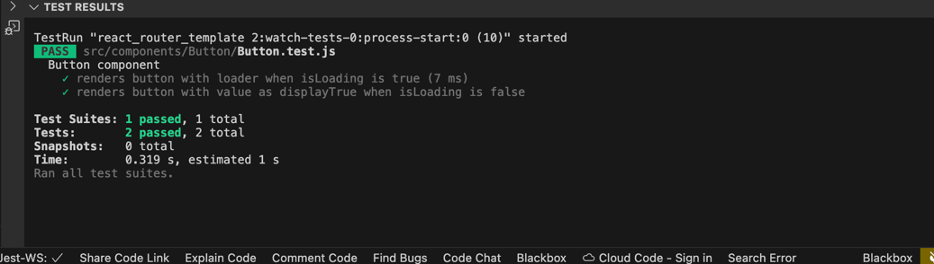
Output

