**A Dynamic Web Application to Track Assets using Geospatial Technology: Asset Connect**

Adithi R. Upadhya 1,* and Parag Khatavkar 2

1 Institute of Environment Education and Research, Bharati Vidyapeeth Deemed University, Pune- 411403, Maharashtra, India, email– [adithiru095@protonmail.com](mailto:adithiru095@protonmail.com)

2 Chief Operating Officer, HubMatrix Technologies Private Limited, Pune, Maharashtra, India, email-- [khatavkarparag@gmail.com](mailto:khatavkarparag@gmail.com)

**Key Words:** Web-GIS, API, Asset Management System, Web Services

**Abstract:**

Geographic Information Systems (GIS) have the capability for consolidating large-scale spatial information to an easily accessible, physically less tedious platform and allows the data to be visualized on maps. The best way to visualize ground-based assets is by regular monitoring at real time. Spatial information is one of the crucial requirements in decision making for ground-based assets. An effective asset management system can improve the performance of the asset; strengthen the infrastructure and tackle current and future challenges. Most of the existing asset management systems focus on reducing the maintenance while extending the lifetime of the asset. Although current management systems provide the aforementioned services, there is a need to integrate the system with GIS and implement real time auditing. Such a system is very essential and crucial in the infrastructure industry where ground based assets need a continuous spatial monitoring. The methodology consisted of a three-phase approach which included data modelling of masters and transactions, spatial analysis of assets using a comprehensive system, tracking asset to provide an advanced spatial decision support system. The web services play the most crucial role by providing a gateway for any device to interact with the system for e.g. a mobile or a Garmin device. We have designed a user-friendly, interactive GIS. It provides cost of travel and asset history along with the asset data and provides an assessment of the current condition of the asset. It demarcates buffers around an asset for nearest possible replacement if any damage occurs to that particular asset. The details of the asset along with any other specific damage alert or a regular assessment of the asset is emailed to the concerned authority along with a report. The unique characteristics of the system are as follows: a) the system can interact with any device e.g.: mobile or a Garmin; b) real time auditing of the assets can be done while the assets are visible on the map; c) a complete track of asset’s history is maintained for security monitoring; d) it can schedule the maintenance; e) it can perform analysis and reporting to identify faults and replacements if needed. As a whole it improves the decision making of the organisation by tracking the assets along with its parameters in real time. Ease of access to this system can be attributed to the integration among stored data such as the location, status, condition, history, and description. We have developed an organized management system to reduce time invested in physical management thus reducing overall cost of maintenance. The results in this paper will improve the spatial dimension of asset management systems; we do maintain that not all kinds of assets can be benefitted by this application. The future scope of this study is to integrate the system with Artificial Intelligence to predict damages even before it occurs.

*Corresponding author

1. **Introduction**

Asset management is a systematic approach to maintain, upgrade and operate assets. The asset management can be grouped into five elements: basic information, performance measures, needs, analysis, program analysis, and program delivery. Asset tagging is a simple way of tagging or keeping track of an asset. Geographic information systems (GIS) are becoming more powerful, affordable and simpler to use for small scale organizations seeking utility asset management solutions. A GIS serves as a repository of location information and asset details, based on a map with layers corresponding to various systems that can be updated and shared in real-time with workers in the field. The features of an effective asset management system are: an asset inventory, inventory of programs, defined roles, and responsibilities, identification and calculation of risk.

The design and implementation of a Geographical Information System (GIS) based Utility Management System at a Housing Colony in India for the purpose of efficient network monitoring and providing instant information access to all concerned engineers. It is essential to minimize time for maintenance of water, power failures, and for efficient planning and Preventive Maintenance(Ajwaliya & Patel, 2014).

The Web-GIS based Utility Management System (WGUMS) developed by the SAC team is used to visualize and maintain utility. It can manage the scattered data into a single platform. Developed WGUMS is helpful in effective management of utility assets at a residential area as well as the SAC office at Ahmedabad(Ajwaliya, Patel, & Sharma, 2017).

Designing of GeoJSON Web Service road asset management system using Mobile GPS is another application. The road assets get deteriorated very easily and hence it becomes necessary to maintain their database. This application records the data and then transforms it into digital format and displays it on the map. GPS was used as a tracker in this application. This application will also create a boundary for the road to be exchanged in GeoJSON format. The logic used here was Point in Polygon Algorithm to find missing assets (Gunawan, Ferdinandus, & Setiawan, 2016).

A conceptual design model of a Geographic Information System (GIS) for a Web-based utility management system using open source technologies (Web-GIS based application for utility management system). Dynamic Digital Data Asset Management System has also come up which provides interactive access to varied data. It seems to be necessary to deliver data at the real-time to an individual’s request. So there will be a central distribution system which will be able to send the data (Krugler et al., n.d.).

The trends of data collection in asset management are changing drastically from physical means to airborne like LiDAR technology. In the recent years, LiDAR technology has proven to be a very good means to collect Highway inventory data. It has proven to be quite fast and simple, also reduces cost. Since the highway inventory data is very complicated and needs many physical resources this technology has been a game changer by providing accurate data for 5he above(He, Song, & Liu, 2017).

Traditionally infrastructure industries were constrained by the lack of visibility of their data. They lost track of the assets. The traditional systems also needed separate systems to perform various operations. The ways of tagging also varied from QR codes to GPS monitoring. There is a need for an integrated system which provides a holistic approach to manage assets by overcoming the traditional shortcomings. There is a huge demand for real-time visualization of asset data which is why the application was built using GIS technology. Spatial data provides a higher understanding of reality. Spatial Decision Support Systems are powerful tool to activate more intuitive and efficient data queries, explorations and visualizations in their spatial context. No special devices are required to collect the spatial data. It can be easily done using a mobile phone with GPS. Spatial data has changed the complete appearance of the system by providing the information in a format which can be comprehended by any layman. There are many asset management systems already existing in the market which are used widely. The recent one launched is SQL Asset Management System by Syntax Studio. It is cloud based and allows real time monitoring; it also has the features of an alert system. Even the mining industry has an advanced asset management system called [Isaac Plains Coal Management by Ausenco](https://www.google.co.in/url?sa=t&rct=j&q=&esrc=s&source=web&cd=2&cad=rja&uact=8&ved=0ahUKEwi-8ais68rYAhWLwI8KHe66B2IQFgguMAE&url=https%3A%2F%2Fwww.ausenco.com%2Fen%2Fvalidate-and-optimise-existing-asset-management-functions&usg=AOvVaw30wSgKZefOlt5s7PeN11KF). Another system by Creatix Campus has features of optimizing resource allocation, maximize asset value, etc. Itemit is software which is quite flexible for any kind of physical asset which is, - tagged by using any tag. Even DELL is not far behind in this game; even they have a customised own Software Asset management System. IBM and SNFC have been able to use Watson IOT to make a powerful System which is now used for French Railway Operations which is able to predict a breakdown or delay before it actually happens using their system. Lowering operating costs by moving it into cloud is the main aim of EAM. BOSS Solutions and SapphireIMS, SAP and RAM are some other asset management systems. ASAP systems have a wide range of asset management systems. Komtrax is used by Komatsu which monitors the health of the vehicle.

The main uses of this software are: to compile a central asset register which will contain a central geo-database with no redundancy and data inconsistency. The asset's history will be traced, storing detailed asset information and its location. The asset tracking system will tag the asset and track its location at real-time by using geospatial technology. The main challenge in the industry is real-time auditing for which this software is a solution. The use of spatial analysis will help in modifying or updating the location information of assets and maximize their utilization.



**Fig. 1:** *Asset Connect*

1. **Objectives**

The main objective of this paper focuses on the efficient management of assets using the geospatial technology. Another objective is to study the use of IOT and mobile technology for monitoring infrastructure or ground based assets.

1. **Study Area and Data**

The study area chosen for testing this application is Pune. The Pune Municipal Corporation had initiated a road construction program to widen the existing road from Katraj to Swargate. The total distance between these two regions is 7 km. The total number of ground-based assets recorded was 50. The initial locations of each asset were recorded using a mobile. The number of assets which were movable was reported to be 18 while the rest were immovable assets. The primary data is collected using the assets data on ground.

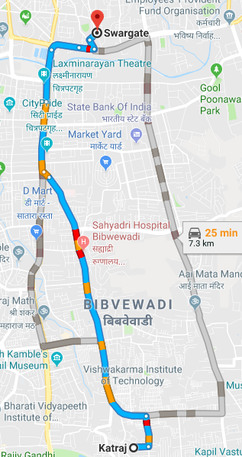

**Fig. 2:** *Geographical location of the study area.*

1. **Methodology**

A GIS stores, manages, analyses, manipulates and displays spatial data. In this system GIS relates database records to their associated attribute values. They can also define spatial relationships between features. The integration of spatial data has enabled the system to improve maintenance, rehabilitation and replacement of assets. The threats of theft are greatly reduced. This eventually leads to reduced cost in management of the assets. The generation of revenue from the assets is met without compromising competitiveness of the industry. Overall this improves the spatial decision making system. The system stores data efficiently to simplify the search and retrieve by location or by other parameters relevant to the application at hand. This system provides a map which is a flexible canvas and a powerful tool to provide information about ground-based infrastructure assets. The system implements geo-visualization which helps in finding spatial patterns of the distributed assets and a wide perspective for spatial manipulations.

**4.1 Architecture:**

The system is built using Environment as Visual Studio Community Version with .NET framework and using object oriented programming language, C#, while the client end is developed using Bootstrap. LINQ is used to communicate with the database and the application tier. Ajax and JavaScript is extensively used to do spatial analysis on the assets. The methodology consists of a four-phase approach which includes data modelling of masters and transactions, spatial analysis of assets using a comprehensive system, tracking history of asset, costing and reporting to provide an advanced spatial decision support system. The spatial database communicates with the application tier using LINQ. The logic tier provides a layer created using C# application for data exchange.

**LOCATION DATA COLLECTION**

**GEODATABASE: MSSQL SERVER**

**SQL**

**LOGIC BLOCK**

**APPLICATION SERVER**

**C#**

**WEB SERVICES**

**XML**

**CLIENT BLOCK**

**DATA BLOCK**

**Fig. 3:** *Architecture*

**4.2 Application Development:**

Database is created using Microsoft SQL Server. A total of 12 look up tables are defined for masters and one table for manipulating the asset details. The relationships are defined on the tables to maintain integrity and also to reduce redundancy. The relationships which are defined on the database are:

One-to-One: Asset and Asset Service Provider have a one-to-one relationship e.g.: Asset has zero or one Asset Service Provider.

One-to-Many: Asset and Asset Groups have a one-to-many relationship e.g.: Many Assets can be associated with one Asset Group.

Many-to-Many: Asset and Tag Type have a many-to-many relationship using Master table which includes Asset ID and Tag Type ID. So one asset can join many tags and one tag also can have many assets.

The Entity Framework's ORM implementation provides services like change tracking, identity resolution, lazy loading, and query translation so that developers can focus on their application-specific business logic rather than the data access fundamentals.

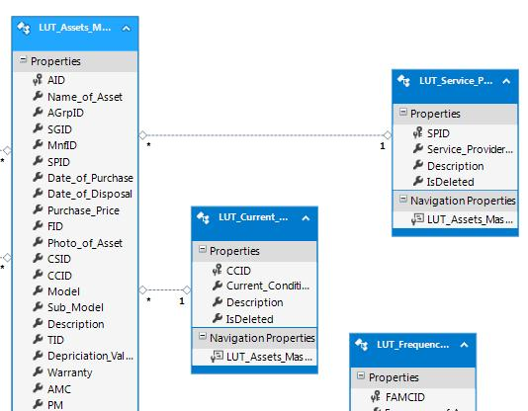

**Fig. 4:** *ER Model*

The location data of each asset is updated using web services. The web services are a gateway to interact with various devices and to support interoperability over a network. SOAP and REST are different architectures supported by web services. The output formats to return data are usually JSON and XML. The mobile or Garmin device is running on Android, IOS etc. The web application is built using .NET, so the data transfer happens using the web services. Any operation which is possible using the web application can be performed using a mobile application too. The location data of the assets are acquired by a mobile which is transferred to the database using the web services. A unique URI defines the web services: the client has to obtain the URI to discover the web service. The client device sends request or an XML message to consume web service's URI by using HTTP. The web service validates this request which has the description of its communication format and service functionality and calls the right function. It returns the output for the request in the format of either JSON or XML sometimes along with a response message. The architecture used here is SOAP which returns data in the format of XML. The XML format can be converted to JSON when required using functions; to make the consumption easier by the mobile device. If the mentioned service is unavailable, no data is exchanged and there is no response to the client. So web services can make the web application platform independent. Since the cost of having a proprietary server is high the web services allow any user to communicate with the application.

The web services are written in C# to make sure that the location is updated each hour. The advantages of these web services are: they help in making the application reach out to workers and any layman with a smart phone. It also helps in maintaining an updated database. All the operations which can be utilized using the web application have been made consumable by any device using these web services. Data addition and deletion can be performed using any device. The barriers of interaction are removed using this technology. Web services use standardized protocol for communication. The cost of internet is low for implementing web services.

The framework which has been used to create the logic tier is ASP.NET, a framework which is widely used for windows based applications and e-biz applications. The real time locations of the assets were inserted using the web forms which are connected to the application server using the web services. The other parameters are imported into the database. The application tier has the logic of the whole system where the CRUD operations can be performed along with manipulations on the asset data. The application tier was integrated with Google API to do spatial manipulations on the data. The Google map API was used in the system for having base map. The spatial manipulations were done using JavaScript which is a dynamic, weakly typed, prototype-based and multi-paradigm language.

Master Transaction Selection

**Database Management System**

**DATA: SQL**

Relationship and Database Model Design

1. Masters Data
2. Asset Data
3. User Input Validations
4. Filtering
5. Real Time Auditing
6. Nearest Replacement
7. Scheduling
8. History of Asset
9. Reporting
10. Decision System

**C#**

**JavaScript, Ajax**

**CRUD Operations and Spatial Analysis**

**All Devices interact with the database using Web Services in XML format**

**Web Forms to exchange Data: Bootstrap, HTML 5.0**

**Fig. 5:** *Methodology flowchart*

Google Maps JavaScript API was used for spatial operations. The API key was procured. Real time auditing was achieved through Ajax call-back. The programs were written in the IDE under the script tag. The language used here was JavaScript and a lot of libraries were used. Distance API was another important API which was used in the Borrow tool. The web forms were designed using bootstrap, and HTML 5.0.

1. **Results**

The implementation of Google maps API gives us the visualization platform for displaying the assets. GIS plays an important role here. Traditionally the tagging of assets was done using QR codes, RFID etc. But now the technology has moved on to location tracking of assets. This shows asset location at real time. This system has great potential in visualizing ground assets and hence infrastructure assets. The visualization helps in decision making. The distribution of the assets can be verified due to the visualization and it also helps in replacements. The visualization then helps in carrying out conditional analysis on the assets. Spatial manipulations help in decision making.

A user-friendly, interactive GIS interface is designed for dealing with the assets information. There are levels of security for advanced safety parameters.

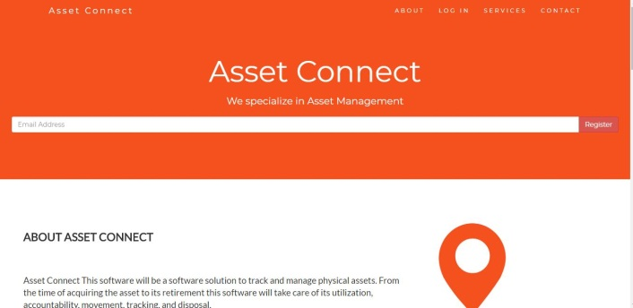

**Fig. 6:** *Application*

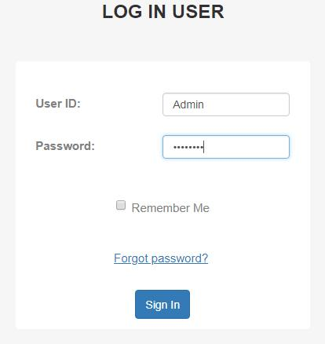

**Fig. 7:** *Log In page*

Special privileges are given to only Admin to register a new user and decide which security level is accessible to that user. Only the administrator can add the assets and edit the assets while the rights of deleting are for none. The assets can be filtered according to their ID. New assets can be added or edited.

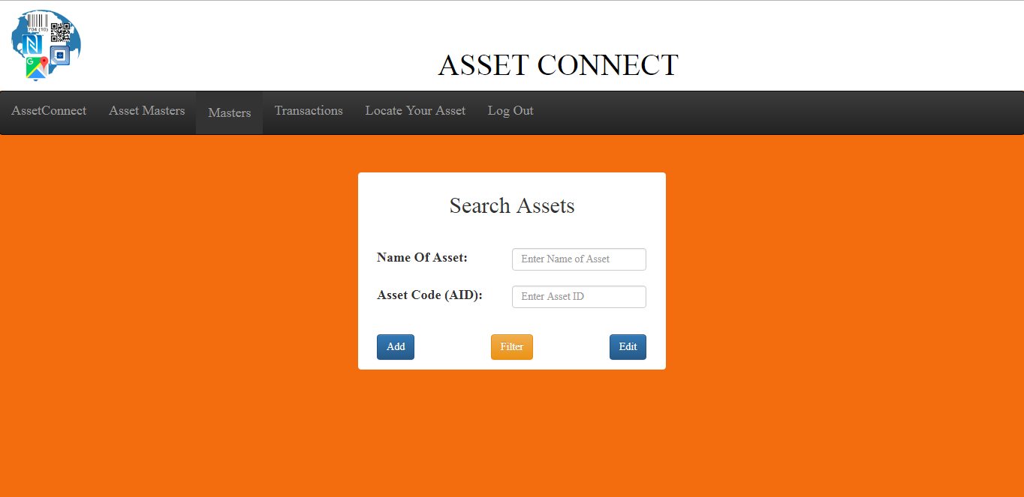

**Fig. 8:** *Search Asset page.*

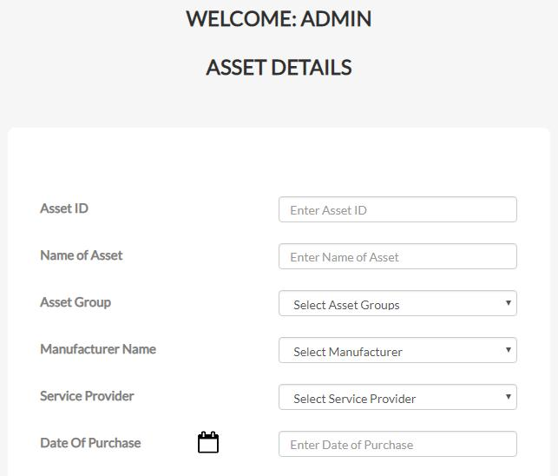

**Fig. 9:** *Add New Asset Page*

The Admin can alter the data in the master table's form as shown below. The master data is the one which is constant for all the assets and appears in dropdown boxes while the transactions are the ones which keep changing for each asset. The data in the master table which is activated will be shown on the map. Once the master data is deactivated it is no longer seen as information of the asset on the map though it is still stored in the database. This gives a freedom to choose the right number of parameters to define an asset. There are 12 master tables required to exactly define an infrastructure asset. It helps in maintaining the health of the asset and schedule maintenance.

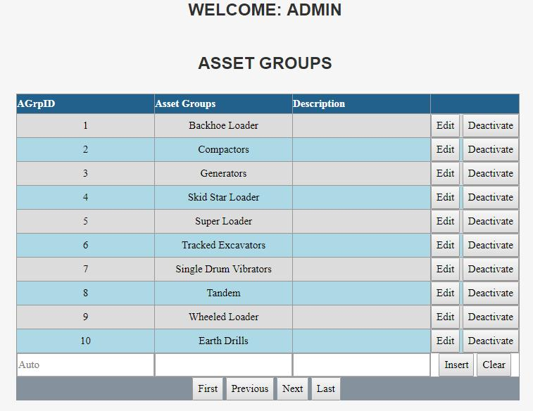

**Fig. 10:** *Master table Page of Asset Groups*

It tracks remote assets on map. The spatial manipulations can be done using filtering based on the condition, status or asset group or all three together. This allows anyone to have a visualization of all the assets. It can lead to a better view of the condition and status of assets spread over a region. It also increases the ability to report on the status and condition of assets and to determine strategies for improving their performance. The map shows the real time visibility of assets which lack in traditional asset management systems.

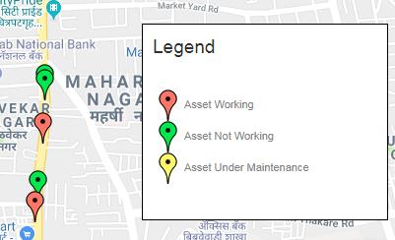

**Fig. 11:** *Asset location*

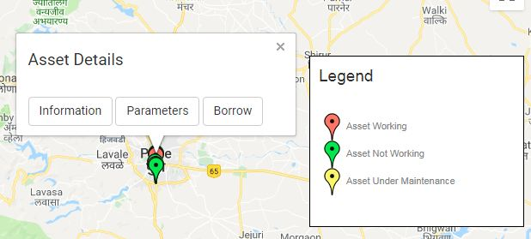

**Fig. 12:** *Info Window*

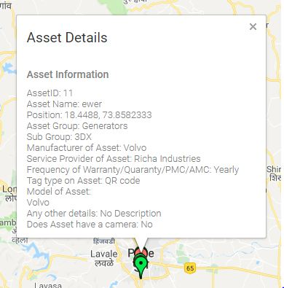

**Fig. 13:** *Asset Details when clicked on Details button in the Info window.*

It draws buffers in a region for nearest replacement possible if any damage occurs to a particular asset. A click on the map will create a buffer; the assets lying inside the buffer are mentioned in the console. Searching of nearest assets seems a fairly tedious operation when it comes to digging huge data, while this system solves this issue. Looking up location information in the database and then identifying the assets inside the buffer is very time consuming and sometimes inaccurate. This is very advantageous during accidental damages; working assets can be identified and quickly replaced, greatly reducing the time consumption and little hindrance to the on-going work.

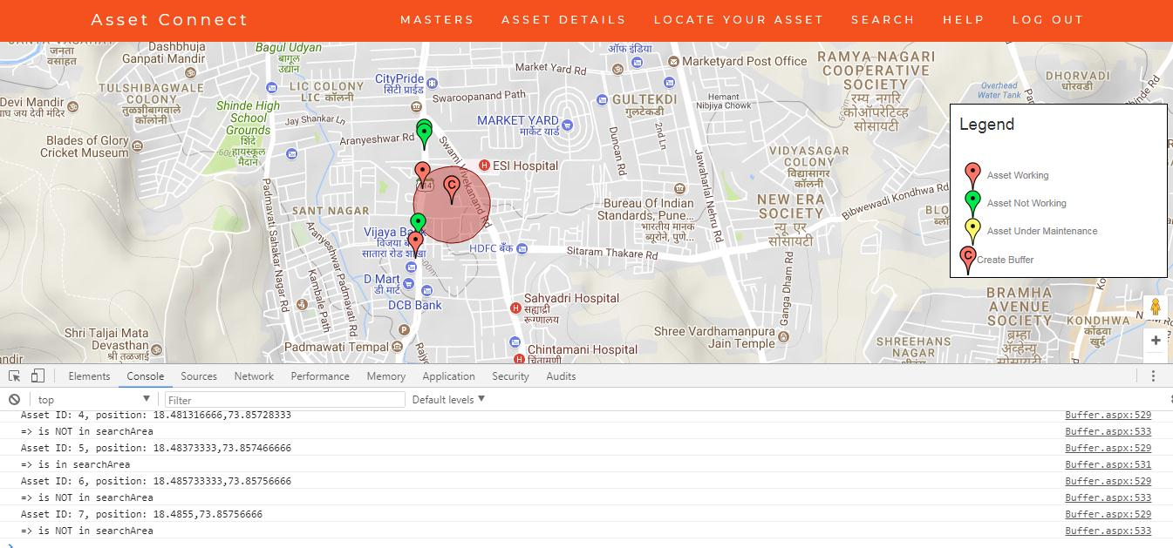

**Fig. 14:** *Buffer Area for Nearest Replacement.*

Real-time auditing of the assets which are visible on the map can be performed using the system. The workers can update the database while on the field. There is a need for this technology since most of the assets are vulnerable to damages while they are on the field. Once the record of its status and condition is updated, it appears on the map immediately for further analysis using the updated data. Hence it helps in condition assessment and renewal planning. This helps in monitoring the health of the asset. This is extremely useful for predictive maintenance of the assets, and assessment strategies for infrastructure improvement. In case of criticality of an asset, it can be determined using subjective criteria and its impact can be studied. The info window is the door to the asset information. It sums up the entire data of masters and transactions of the asset. Hence the life cycle of asset is shown in this window.

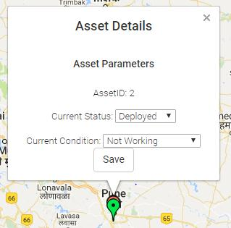

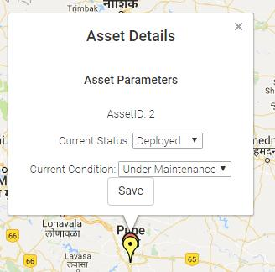

**Fig. 15 & 16:** *Real time auditing: Before and after*

Cost of travel from one place to another for each asset can be determined by this software. The API needs the Source, Destination and travel cost for each kilometre. The outcome of this is as shown in Fig below. The details appearing on screen can be very useful in understanding the cost and time taken to shift the assets. Another interesting feature is “Borrow” which is used when someone orders for an asset. The expected or approximated travel cost and time is given by the system which can be very useful for scheduling the assets. This feature helps in having the assets route and schedule planned for the next assignment. (The details of the asset along with any other specific damage alert or regular assessment of the asset can be mailed to authority using this application); a report is also generated and attached with it. Or else only a report can be generated as a pdf and stored for future reference. Sharing data, like status and condition, can have a positive impact on the work force.

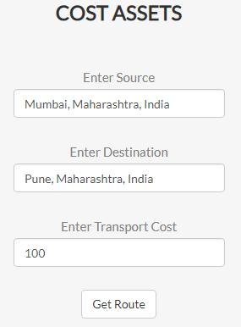

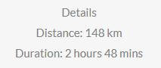

**Fig. 17 & 18:** *Details which appear when the source and destination are added using Autocomplete.*

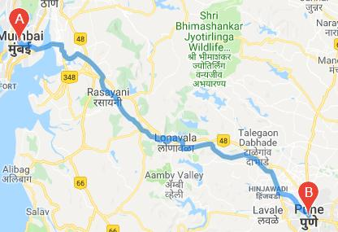

**Fig. 19:** *Route which appears on the map from Source to Destination*

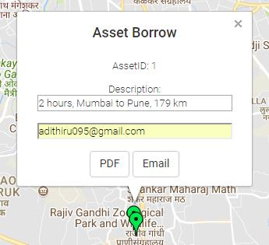

**Fig. 20:** *Message can be emailed.*

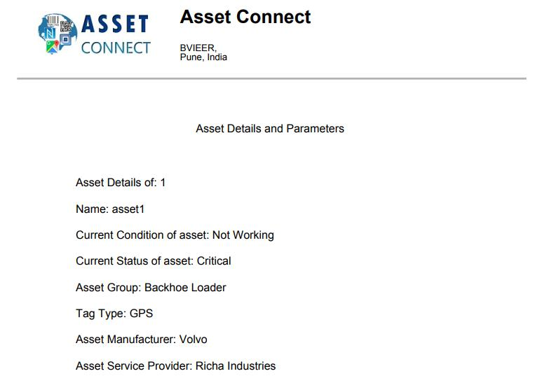

**Fig. 21:** *Report*

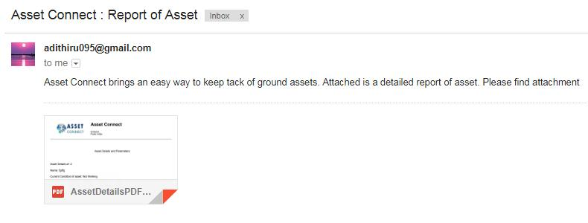

**Fig. 22:** *Email*

The history of the asset will be of utmost importance to find or locate where the asset has been scheduled. The history of the asset is shown on the map, along with its future scheduling. This will improve the planning of the assets and will benefit the organization. Any damage can be located back in the map improving the security of the asset. A special button is present for past and future scheduled locations of a particular asset which will show up accordingly. The ID of the asset should be filled to get the history of the asset. The database of past locations is updated each time the location of asset changes while the future schedules can be saved using the master table of History of Asset.

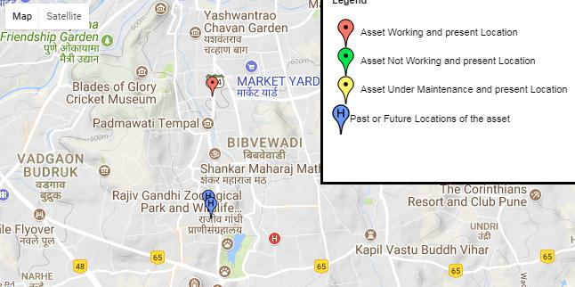

**Fig. 23:** *Asset ID: 2 is shown along with its**past locations*

1. **Discussions**

The system has a mature maintenance database that supports the life-cycle management functions for any kind of asset specifically designed to help infrastructure organizations efficiently and cost-effectively.

Data Validation & User Management: There are built-in data validation and data consistency mechanisms which help to maintain clean data. User-based permissions keep data secure and safe by not allowing any random intrusion into the database. Interoperable: Simple system integration between any kinds of assets, groups, scheduling, accounting or financial system.

The assets can be filtered based on condition. This will provide an understanding of the different assets distributed in a region. The whole asset auditing can be done without surfing to different pages. An asset located spatially can be audited by just its location data. The Borrow tool estimates the approximate road distance and time to make the asset to travel from one place to another. The Cost of the whole travel can also be calculated using an API. The options of Email and PDF help the user to record the details and enhance the reporting. The history is used for the trail of the asset. If any damage was done during the tenure of its location it can be traced back to its history.

If the asset seems to move out of the buffer area then an alert in the form of an Email can be sent. This technology should be used in all organizations which deal with ground assets to keep their assets up to date and safeguard them.

Another huge advantage of using this software is that it has web services written which can be used for communicating with any device. It is highly compatible with any device.

It should also have better security levels. Another important factor could be that- it could be a challenge in the Software asset management systems to visualize it spatially.

The future scopes of this system are that there can be a camera on the asset which can be switched on to monitor the movements of the asset and evaluate its performance without actually going on the field. Use of Artificial Intelligence will be the trend in this century because of low cost sensors, easy connectivity, and cloud platform, processing and storage capabilities of huge data on big data platforms. IOT adds intelligence to automated workflows, control of assets, predictive maintenance, real time alerts and automation. It will reduce labour cost, reduce the time involved and improve efficiency by reducing human intervention, physical checks and periodic checks. Human intervention will be needed only in decision making. Machine learning and other advanced intelligence help in real time decision making. This will help the organization to overcome common challenges using innovative ideas. It will also help to reduce unnecessary visits to spatially dispersed assets due to predictive maintenance.

1. **Conclusion**

We have developed an organized management system to reduce time invested in physical management thus reducing overall cost of maintenance. The unique characteristics of the system are as follows: a) the system can interact with any device e.g.: mobile or a Garmin; b) real time auditing of the assets can be done while the assets are visible on the map; c) a complete track of asset’s history is maintained for security monitoring; d) it can schedule the maintenance; e) it can manage a geo-database with inconsistent input, without producing redundant data; f) it can perform analysis and reporting to identify faults and replacements if needed.

Integration amongst stored data like the location, status, condition, history, and description has enabled easy access to the system. Utilizing asset management software that supports data flows from both the authority and on the field workers greatly decreases the chance for data inconsistency.

Since assets have a location data, maps have always been a better visualization method to catalogue an organization’s assets. Assets are interconnected and in proximity to other assets and features, even if their location is not fixed. It can render asset data on maps; analyse interconnectivity, proximity between them, and define other complex spatial relationships. The concept of predictive maintenance is achieved partially using this system. An organized management is achieved leading to less cost and less time consumption. Further scope for this work is by integrating advanced artificial intelligence in the system.

1. **Acknowledgement**

We would like to thank the Director of Bharati Vidyapeeth Institute of Environment Education and Research Dr. Erach Bharucha for his encouragement.

The authors declare no conflict of interest.

1. **References**

Ajwaliya, R. J., & Patel, S. (2014). Design and development of GIS based utility management system at DOS housing colony, Vikramnagar, Ahmedabad. *International Journal of Engineering Research and Applications, ISSN*, 2248–9622.

ASAP Systems: https://www.asapsystems.com/.

Bootstrap: https://getbootstrap.com/docs/4.0/getting-started/download/.

Creatix Campus: http:// https://www.creatrixcampus.com/.

DELL Asset management System: http://www.deployandmanage.com/Software-Asset-Mgmt.asp.

Easty, A. D., Wagner, B. D., Wendt, T. C., McConaughy, J., Baskin, A. R., Taplin, J. T., & Chechik, J. (2001). Dynamic digital asset management.

Ferdinandus, F. X., & Setiawan, E. I. (2016). GeoJSON Web Service based road assets management system for Surabaya city using mobile GPS. In *Computer Science and Engineering Conference (ICSEC), 2016 International* (pp. 1–5). IEEE.

Google API: https://cloud.google.com/maps-platform/.

He, Y., Song, Z., & Liu, Z. (2017). Updating highway asset inventory using airborne LiDAR. *Measurement*, *104*, 132–141. https://doi.org/10.1016/j.measurement.2017.03.026

IBM: https://www.ibm.com/blogs/internet-of-things/sncf-iot-french-railways/.

Itemit: <https://itemit.com/>.

Isaac Plains Coal Management: https://www.ausenco.com/en/validate-and-optimise-existing-asset-management-functions.

J. Ajwaliya, R., Patel, S., & A. Sharma, S. (2017). Web-GIS based application for utility management system. *Journal of Geomatics*, *11*.

jQuery: https://getbootstrap.com/docs/4.0/getting-started/download/https://jquery.com/download/.

Komtrax: https://www.komatsuamerica.com/service-and-support/komtrax.

## Microsoft .NET Framework 4 Full Language Pack (x86 x64): https://www.microsoft.com/en-us/download/details.aspx?id=3324.

MSSQL server 2012: https://www.microsoft.com/en-in/download/details.aspx?id=29062.