Streaming Media with IBM Cloud

Video Streaming

# TEAM MEMBERS:

### 1.SHARIKA PARVEEN.S- 310121243042

### 2.VARSHA.G-310121243049

### 3.PRIYADHARSHINI.S-310121243033

### 4.ADITHI.J-310121243003

### 5.SUMITHRA.M-310121243044

# Introduction to IBM Cloud Video Streaming

IBM Cloud Video Streaming is a powerful platform designed to help you deliver high-quality, engaging video content to your audience. Whether you're a business owner looking to promote your brand, an educator seeking to enhance your students' learning experience, or a content creator looking to share your work with the world, IBM Cloud Video Streaming has the tools and features you need to succeed. With IBM Cloud Video Streaming, you can easily upload, manage, and share your video content with viewers around the globe. Our platform is designed to be user-friendly and accessible, so you don't need to be a tech expert to get started. And with our powerful analytics and reporting tools, you can track your viewership, engagement, and other key metrics to help you make informed decisions about your content strategy. So, whether you're just getting started with video streaming or you're looking to take your content to the next level, IBM Cloud Video Streaming has everything you need to succeed. Let's get started!

# Getting Started with IBM Cloud Video Streaming

IBM Cloud Video Streaming is a powerful tool for streaming live and on- demand video content. Whether you're a small business owner or a large enterprise, IBM Cloud Video Streaming can help you reach your audience and engage them with high-quality video content. In this guide, we'll walk you through the basics of using IBM Cloud Video Streaming to get started with your own video streaming projects.

# Creating an Account

To get started with IBM Cloud Video Streaming, you'll need to create an account. Visit the IBM Cloud Video Streaming website and click the "Sign Up" button to create your account. You'll need to provide some basic information about yourself and your organization, as well as choose a plan that fits your needs. Once you've created your account, you'll be ready to start streaming video content.

# Uploading Your Content

Once you've created your account, you can start uploading your video content to IBM Cloud Video Streaming. You can upload both live and on-demand content, and IBM Cloud Video Streaming supports a wide range of file formats. To upload your content, simply log in to your IBM Cloud Video Streaming account and follow the prompts to upload your files. You can also use the IBM Cloud Video Streaming API to automate the upload process if you have a large number of files to upload.

# Creating Your Channels

After you've uploaded your content, you'll need to create channels to organize your videos. Channels are like playlists, and they make it easy for your viewers to find the content they're looking for. To create a channel, simply log in to your IBM Cloud Video Streaming account and follow the prompts to create a new channel. You can add your uploaded videos to your channels, and you can also customize your channels with your own branding and logos.

Some Images Streaming Video with IBM Cloud

Video Streaming

# Live Streaming

IBM Cloud Video Streaming allows you to live stream events such as concerts, sports games, and conferences with ease. With our platform, you can easily customize your streaming experience and manage your content all in one place.



# On Demand Video Streaming

IBM Cloud Video Streaming also allows you to offer on demand video streaming of movies, TV shows, and other content. Our platform provides cinematic quality and high detail, ensuring that your viewers have the best experience possible.





# Customization

IBM Cloud Video Streaming allows you to fully customize your streaming experience. You can add your own branding, create custom playlists, and even monetize your content with advertising.

# Content Management

With IBM Cloud Video Streaming, you can easily manage your content all in one place. Our platform provides tools for organizing, searching,

and sharing your videos, making it easy to keep your content organized and accessible.

# Customizable Player

IBM Cloud Video Streaming offers a customizable player that allows you to match your brand and style. You can add custom logos, colors, and even change the layout of the player to fit your needs.



# APIs and SDKs

IBM Cloud Video Streaming also provides APIs and SDKs that allow you to integrate your streaming experience with your existing workflow.

You can use these tools to automate processes, customize player behavior, and more.

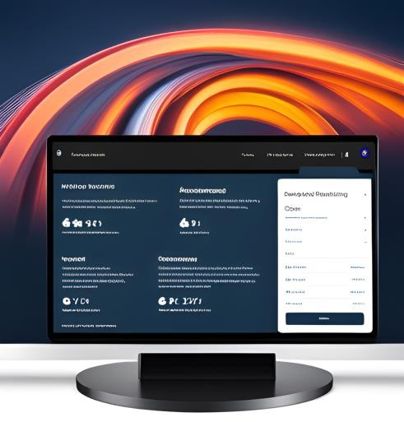 

# Content Management

IBM Cloud Video Streaming offers a variety of tools for managing your video content. From the dashboard, you can easily upload and organize Your videos, create playlists, and set access controls

# Metadata and search

IBM Cloud Video Streaming allows you to add metadata to your videos, making them easily searchable. You can also use the search function to quickly find specific videos or groups of videos.

# Analytics

IBM Cloud Video Streaming provides detailed analytics on your video content, including views, engagement, and audience demographics. These insights can help you optimize your content and improve your overall streaming strategy.

# Conclusion and Next Steps

IBM Cloud Video Streaming is a powerful platform that enables you to stream video content to your audience with ease. Whether you're a

small business owner or a large enterprise, IBM Cloud Video Streaming has the tools you need to create a customized streaming experience that meets your unique needs.