DB terminal: where mongo db running
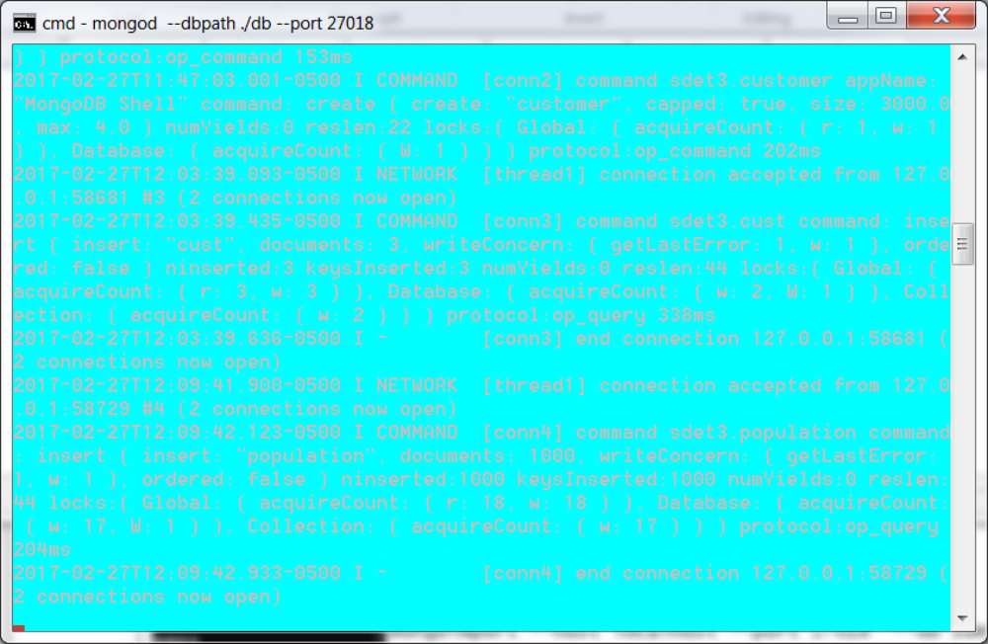

Terminal: 2nd terminal to run queries
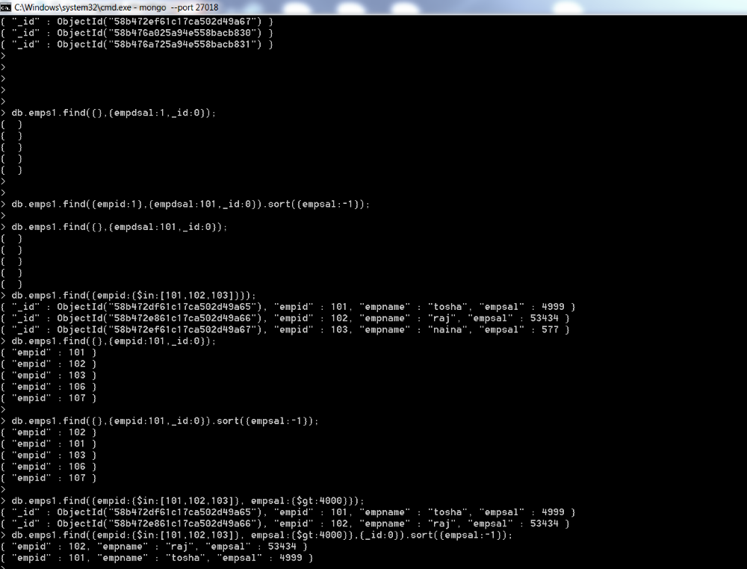

terminal 3: to run import and export
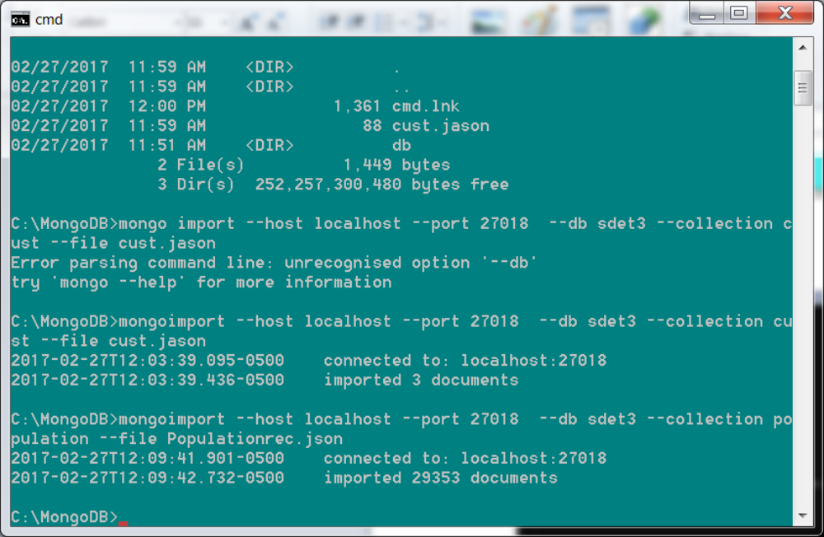

Create a jason file:
create file cust.jason:
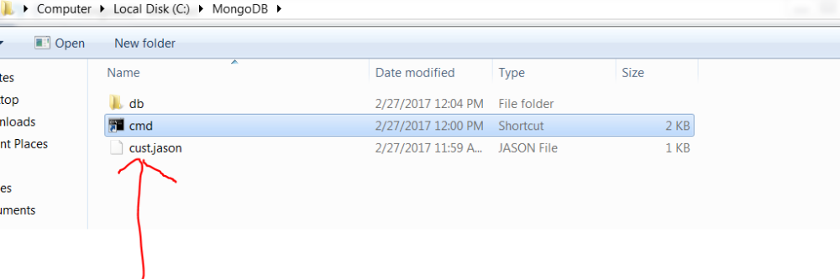

Now open another terminal
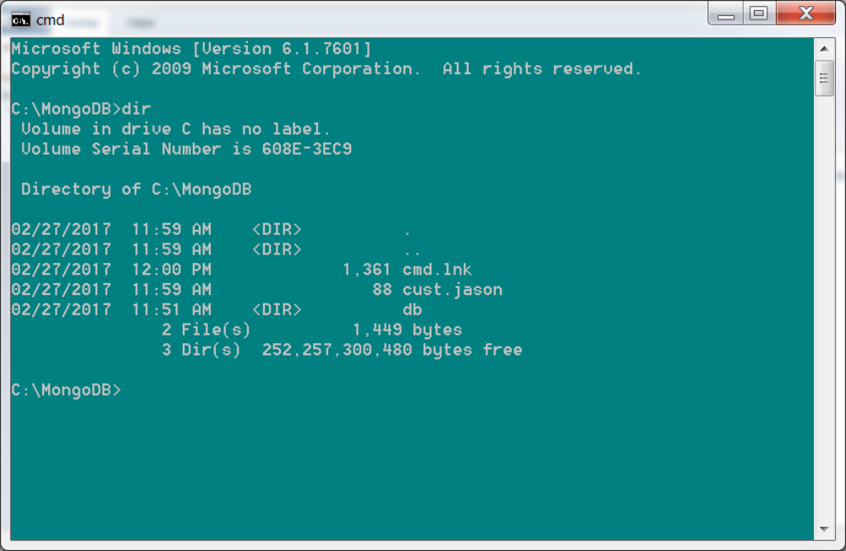
cmd:
C:\MongoDB>mongoimport --host localhost --port 27018 --db sdet3 --collection cust --file cust.jason
TYPE: goimport --host localhost --port 27018 --db sdet3 --collection population --file Populationrec.json
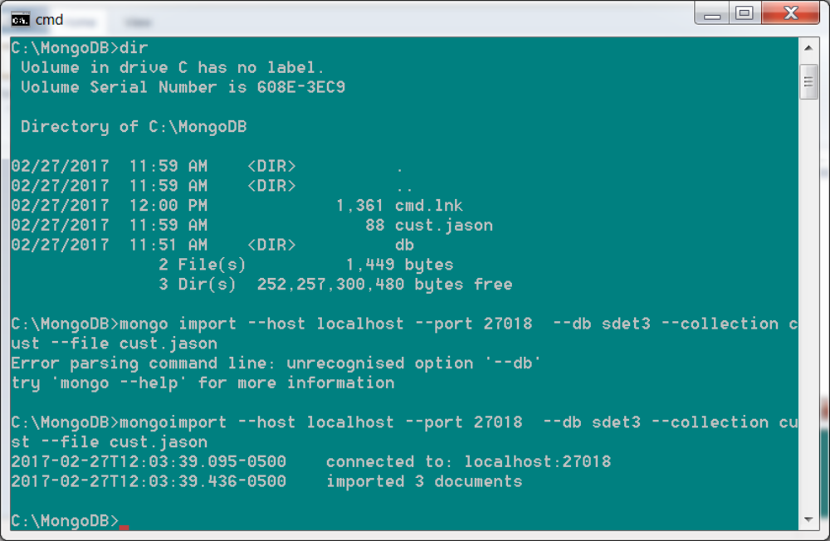

ANother IMPORT
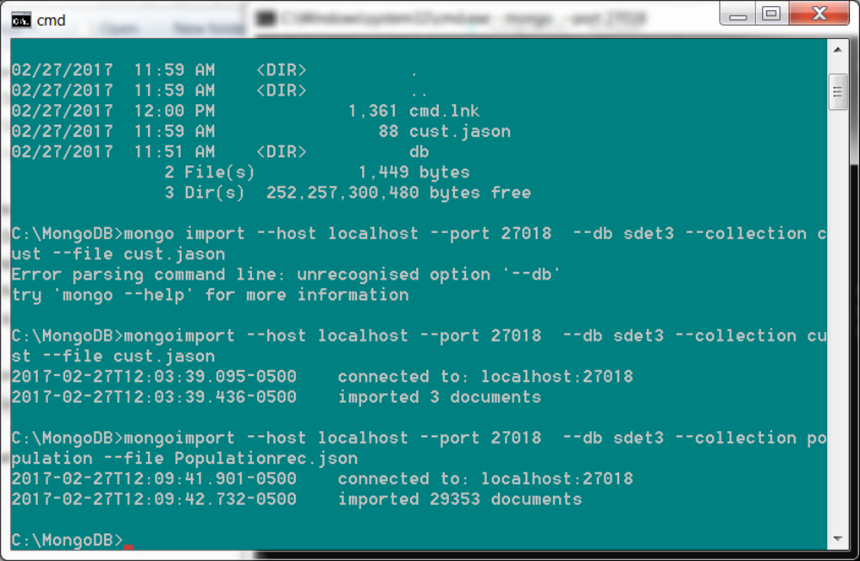

GO to terminal where you are quering:
> show collections;
account
cust
customer
emos
emps
population

SELECT cmd:
> db.population.find();
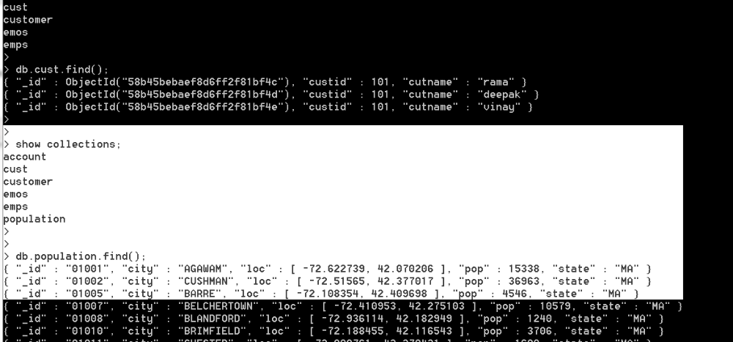

IF you want to import data in array fashion
is you want to importdata in array fashion
[{custid:101,cutname:'rama'}
{custid:101,cutname:'deepak'}
{custid:101,cutname:'vinay'}]
( in qry terminal)
CMD: > mongoimport --host localhost --port 27018 --db sdet3 --collection population --file Populationrec.json --jasonArray

> db.cust.find({custid:101},{custid:1});
{ "_id" : ObjectId("58b45bebaef8d6ff2f81bf4c"), "custid" : 101 }
{ "_id" : ObjectId("58b45bebaef8d6ff2f81bf4d"), "custid" : 101 }
{ "_id" : ObjectId("58b45bebaef8d6ff2f81bf4e"), "custid" : 101 }

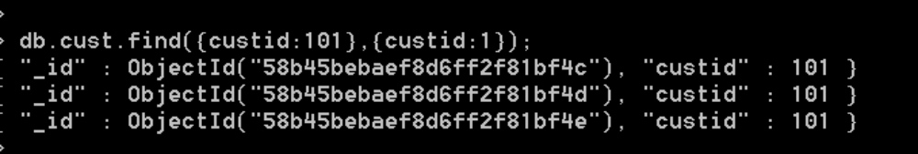
if you don't wnat to see objetc id: ( specify: _id:0)
db.cust.find({custid:101},{custid:1, _id:0});
> db.cust.find({custid:101},{custid:1, _id:0});
{ "custid" : 101 }
{ "custid" : 101 }
{ "custid" : 101 }
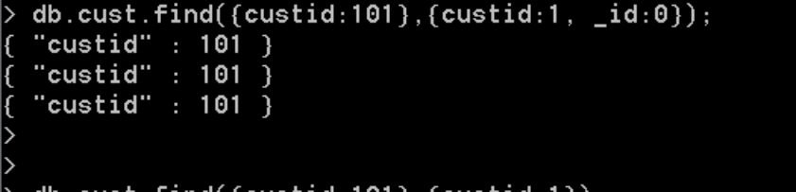

LOOPS:
For loop:
note: //this returns iterator : var itr=db.emps1.find();
while(itr.hasNext()){
var temp= itr.next();
print(temp.empid +', '+ temp.empsal);
}
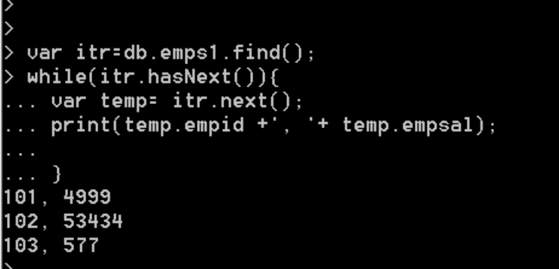

-- on collection emps1

db.emps1.find().sort({empid:1});
//desc order
db.emps1.find().sort({empid:-1});
//top 3 sal emp
db.emps1.find().sort({empdsal:-1}).limit(3);
//skips 1st 3 then give you rest recs
db.emps1.find().sort({empdsal:-1}).skip(3).limit(3);
//sorted dec order on sal then skip 3 recs then limit number of recs you want
//1 is show 0 is no show, -1 is ascending sort
db.emps1.find({},{empid:1,_id:0}).sort({empsal:-1});
//find on empid =1
db.emps1.find({empid:1},{empid:101,_id:0}).sort({empsal:-1});
db.emps1.find({});
db.emps1.find({},{empid:101});
db.emps1.find({},{empid:101,_id:0}).sort({empsal:-1});

in clause:
//to find emp in 101,102,103
db.emps1.find({empid:{$in:[101,102,103]}});

AND condition:
--to show employees who are in 101,102 ,103 and sal > 4000
db.emps1.find({empid:{$in:[101,102,103]}, empsal:{$gt:4000}});
db.emps1.find({empid:{$in:[101,102,103]}, empsal:{$gt:4000}},{_id:0}).sort({empsal:-1});

OR clasue:
db.emps1.find({$or:[{empid:{$in:[101,102,103]},empsal:{$gt:4000}}]});
---EMBEDDED DOCUMENT ( FK relationship)
db.account.insert({
accid:101,
balance:1000,
customer:{
custd:'c101',
custname:'rajol',
},
location:'Reston'
});

db.account.insert({
accid:102,
balance:400,
customer:{
custd:'c102',
custname:'britt',
},
location:'Reston'
})
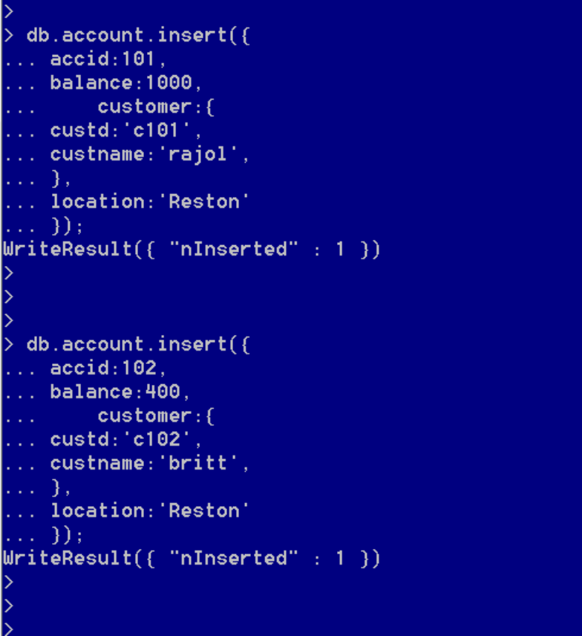
> db.account.find({'customer.custname':'britt'}).pretty();
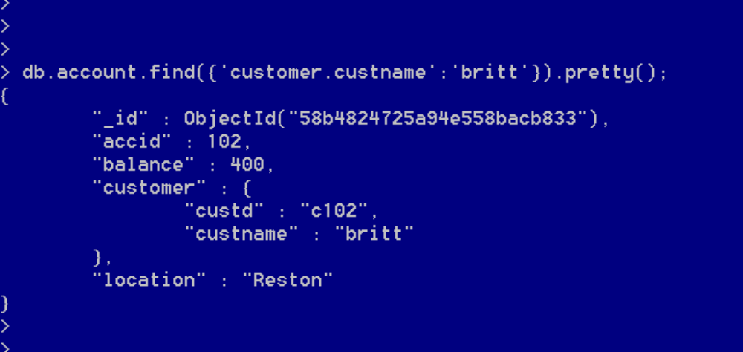

ARRAY:
db.food.insert({_id:1,type:'food', item:'aaa',ratings:[5,8]});

db.food.insert({_id:2,type:'food', item:'bbb',ratings:[5,5,8]});

//Look for ratings 5 and 8
db.food.find({ratings:[5,8]});
//element whose first val is 5
db.food.find({'ratings.0':5});
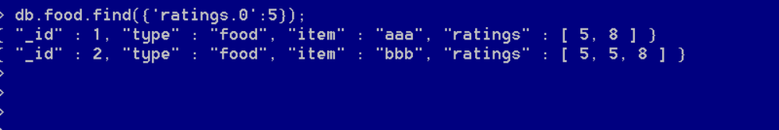
//find any item whose rating is more than 5
db.food.find({ratings:{$elemMatch:{$gt:5}}});
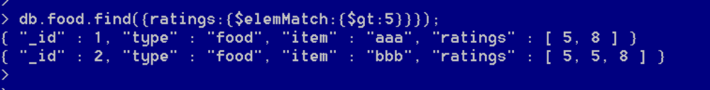
//less than
db.food.find({ratings:{$elemMatch:{$lt:5}}});
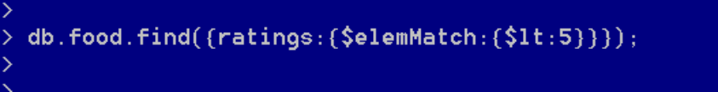

UPDATE:
//to update only one place where sal is gt than 3000
db.emps.find({empsal:{$gt:3000}});
db.emps.update({empsal:{$gt:3000}},{set:{city:'Reston'}})
//to update everywhere where sal is gt tham 3000
db.emps.update(
{empsal:{$gt:3000}},
{set:{city:'Reston'}},
{multi:true});
DELETE: NO concept of truncate
//all recs will be deleted
db.emps.remove({});
//to delete specific
db.emps.remove({empid:101});

To COPY certain field to another collections:
Ex: cpoy fields empid and empname to emps2 and (create table emps2) from emps1
var itr=db.emps1.find();
while(itr.hasNext()){
var temp = itr.next();
db.emps2.insert({'empid':temp.empid, 'empname':temp.empname});
}
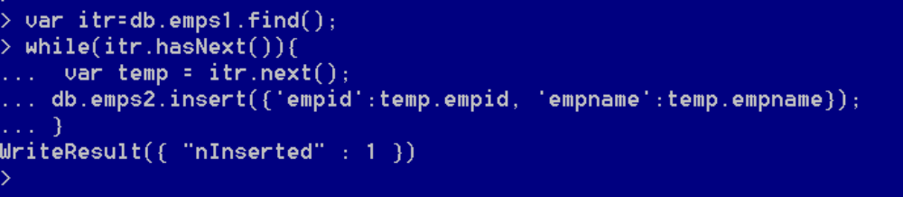

UPDATE / INSERT:
// update if found and insert if not presenrpresent
db.emps1.update(
{empid:101},
{$set:{city:'Rewa'}},
{upsert:true});
Result:
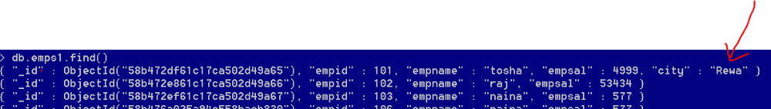

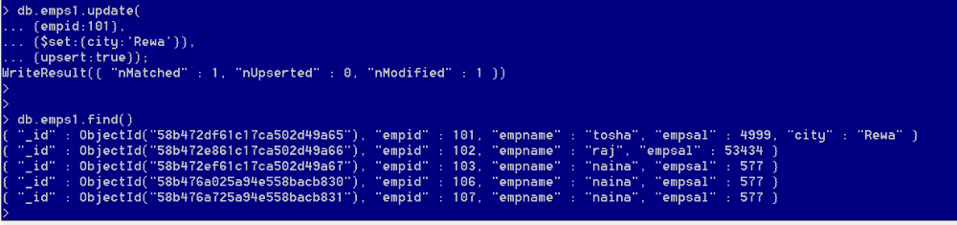

db.devices.save({name:'laptop'})
//to update particular iD
db.devices.save({ "_id" : ObjectId("58b4908025a94e558bacb839"), "name" : " lenova laptop" })
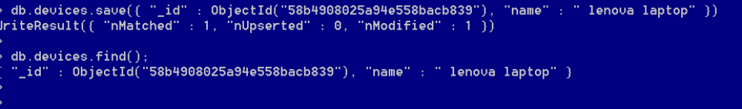

INDEXES:
//create an index on asc order of sal
db.emps1.createIndex({empsal :1});
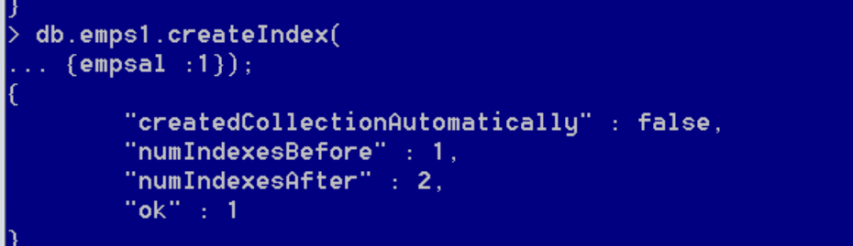

db.emps1.find({empsal:1});
db.emps1.find({empsal:53434}).explain('executionStats');
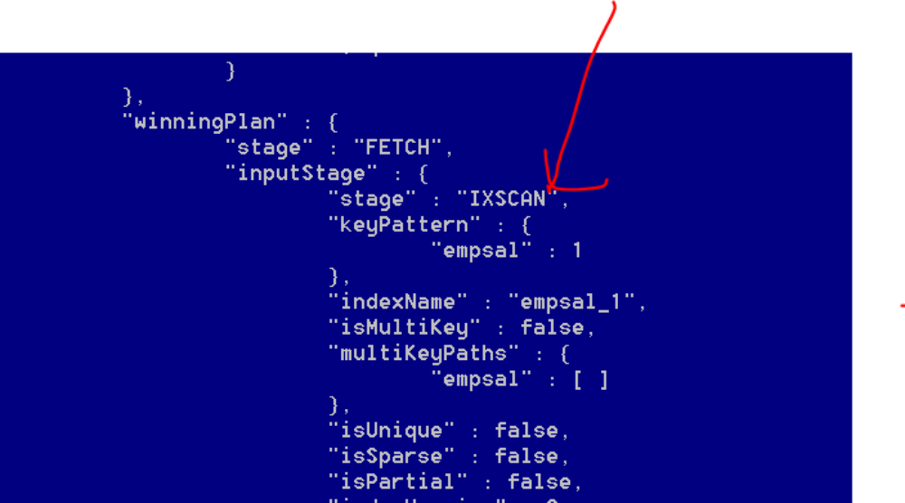

db.population.findOne();
db.population.getIndexes();
db.population.find(
{pop:{$gt:30000}}).explain('executionStats');
db.population.createIndex({pop :1});
db.population.getIndexes();
1st index is created by default ( like PK) and pop_1 is the one we created
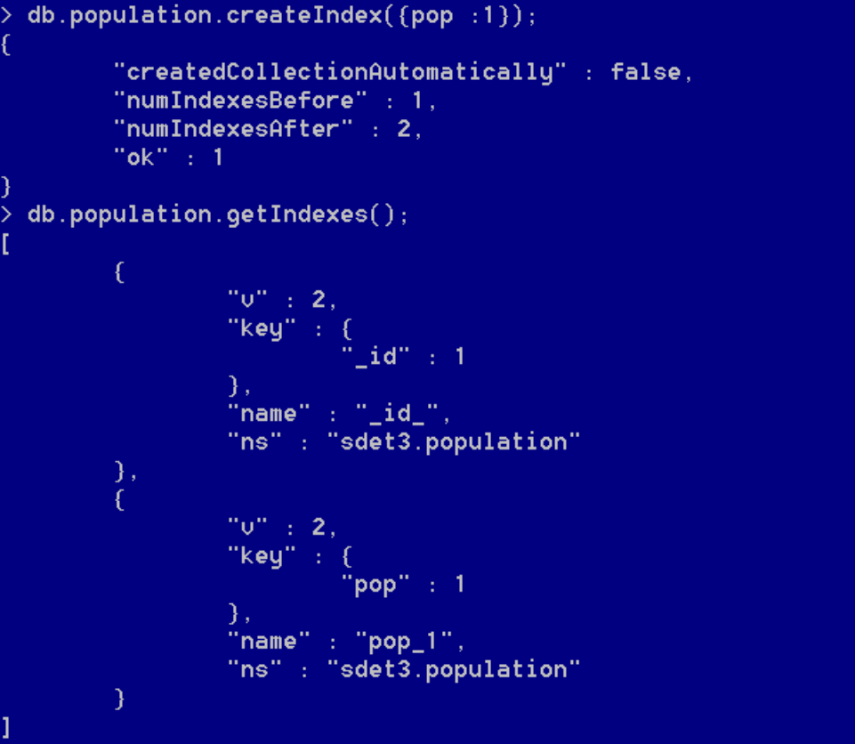

DUPS check
//to avoid dups, on enull is allowed
db.emps1.createIndex({empid:1},{unique:true})
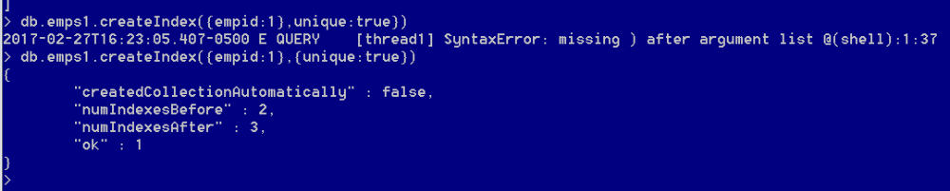
db.emps1.insert({empid:101})
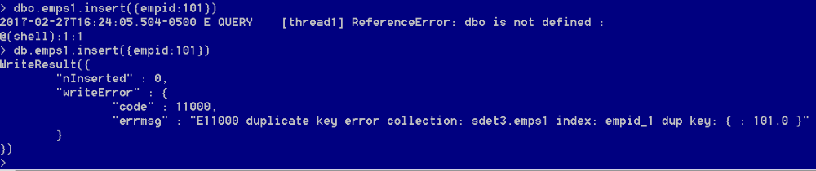

to remove index:
remove index
to rebuild: ( also it can't be modified so it needs to be rebuild)
db.tablename.reIndex()
this is very expensive slows system so make it as backprocess
db.emps1.stats()

go to the other terminal where we did import and export
C:\MongoDB>mongotop --port 27018
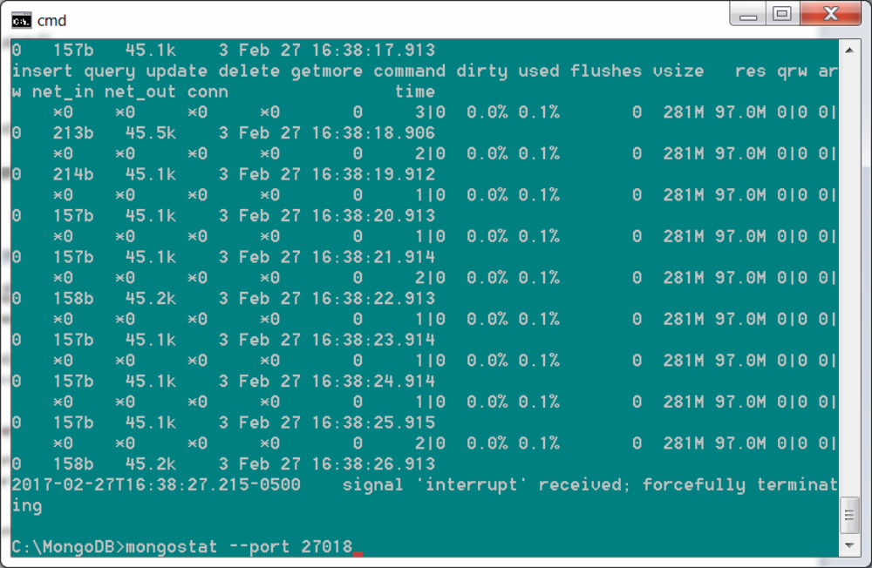

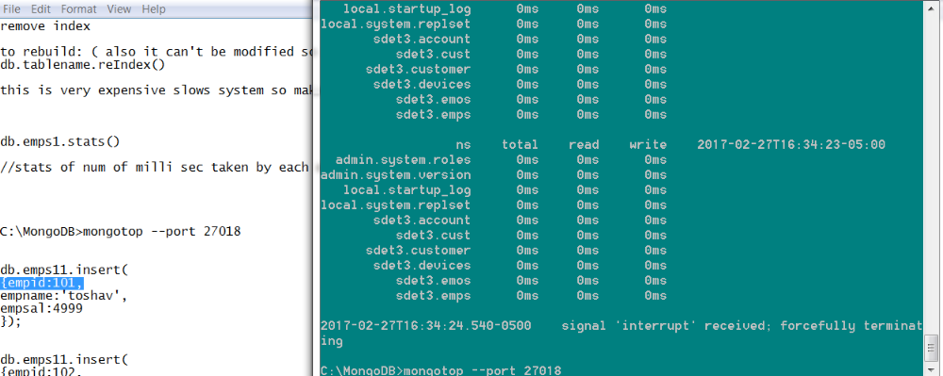

This is how 3 terminals look:
