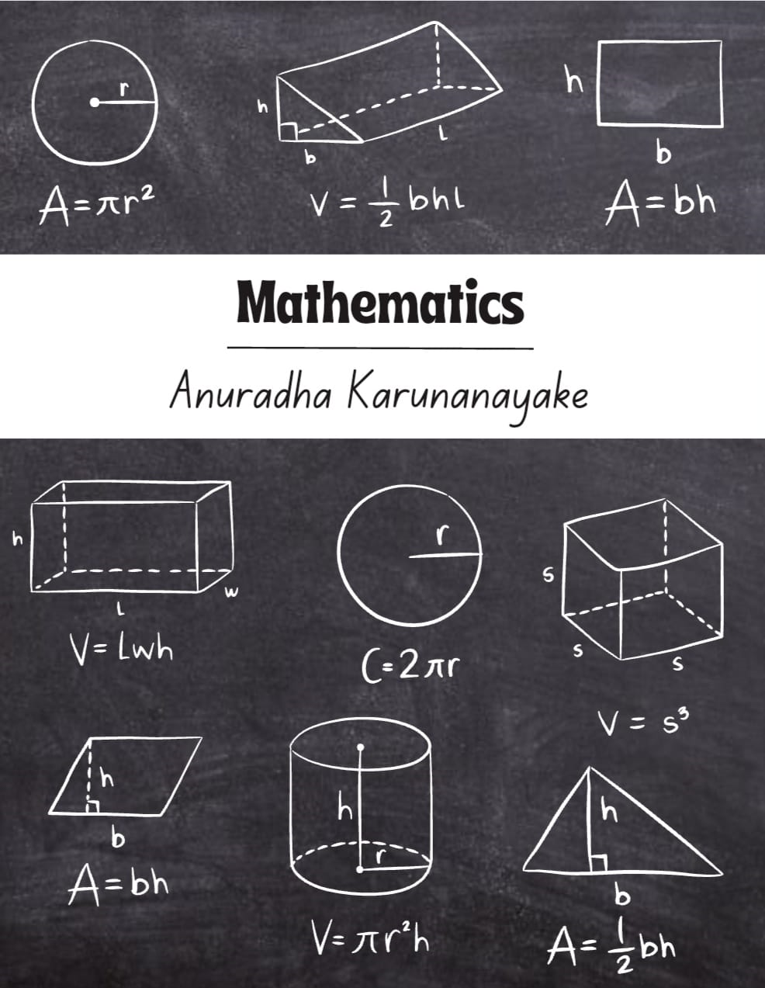

**Simultaneous equations**

**Introduction**

On occasions you will come across two or more unknown quantities, and two or more equations relating them. These are called simultaneous equations and when asked to solve them you must find values of the unknowns which satisfy all the given equations at the same time. On this leaflet we illustrate one way in which this can be done

**1. The solution of a pair of simultaneous equations**

The solution of the pair of simultaneous equations

3x + 2y = 36, and 5x + 4y = 64

is x = 8 and y = 6. This is easily verified by substituting these values into the left-hand sides to obtain the values on the right. So x = 8, y = 6 satisfy the simultaneous equations.

**2. Solving a pair of simultaneous equations**

There are many ways of solving simultaneous equations. Perhaps the simplest way is **elimination.** This is a process which involves removing or eliminating one of the unknowns to leave a single equation which involves the other unknown. The method is best illustrated by example.

**Example**

Solve the simultaneous equations 3x + 2y = 36 (1)

5x + 4y = 64 (2)

**Solution**

Notice that if we multiply both sides of the first equation by 2 we obtain an equivalent equation

6x + 4y = 72 (3)

Now, if equation (2) is subtracted from equation (3) the terms involving y will be eliminated:

6x + 4y = 72 − (3)

5x + 4y = 64 (2)

x + 0y = 8

EQUATIONS AND INEQUALITIES Grade-10

So, x = 8 is part of the solution. Taking equation (1) (or if you wish, equation (2)) we substitute this value for x, which will enable us to find y:

3(8) + 2y = 36

24 + 2y = 36

2y = 36 − 24

2y = 12

y = 6

Hence the full solution is x = 8, y = 6.

You will notice that the idea behind this method is to multiply one (or both) equations by a suitable number so that either the number of y’s or the number of x’s are the same, so that subtraction eliminates that unknown. It may also be possible to eliminate an unknown by addition, as shown in the next example.

**Example**

Solve the simultaneous equations

5x − 3y = 26 (1)

4x + 2y = 34 (2)

**Solution**

There are many ways that the elimination can be carried out. Suppose we choose to eliminate y. The number of y’s in both equations can be made the same by multiplying equation (1) by 2 and equation (2) by 3. This gives

10x − 6y = 52 (3)

12x + 6y = 102 (4)

If these equations are now added we find

10x − 6y = 52 + (3)

12x + 6y = 102 (4)

22x + 0y = 154

so that x = 154 /22 = 7. Substituting this value for x in equation (1) gives

5(7) − 3y = 26

35 − 3y = 26

−3y = 26 – 35

−3y = −9

y = 3

Hence the full solution is x = 7, y = 3

**Inequalities**

In Mathematics, the relationship between two values that are not equal is defined by **inequalities**. Inequality means not equal. Generally, if two values are not equal, we use the “not equal symbol (≠)”. But to compare the values, whether it is less than or greater than, different inequalities are used. In this article, we will discuss the inequalities used in algebra, different inequality symbols, properties, and the procedure for solving the [linear inequalities](https://byjus.com/maths/linear-inequalities/) in one variable and two variables, with examples.

## **Inequalities Definition**

In Algebra, inequality is a mathematical statement that shows the relation between two expressions using the inequality symbol. The expressions on both sides of an inequality sign are not equal. It means that the expression on the left-hand side should be greater than or less than the expression on the right-hand side or vice versa. If the relationship between two algebraic expressions is defined using the inequality symbols, then it is called literal inequalities.

**Definition:** “**If two real numbers or the algebraic expressions are related by the symbols “>”, “<”, “≥”, “≤”, then the relation is called an inequality**.”

For example, x>3 (x should be greater than 3)

**Open Sentence:**The inequality is said to be an open sentence if it has only one variable.

For example, x < 6 (x is less than 6)

**Double Inequalities**: The inequality is said to be a double inequality if the statement shows the double relation of the expressions or the numbers.

Example:

3≤x<8 ( x is greater than or equal to 3 and less than 8)

**Find the solutions to the following word problems:**

1. 7/8 of a certain number is 5 more than 1/3 of the number. Find the number

b) Three rulers and two pens have a total cost of R 21,00. One ruler and one pen have a total cost of R 8,00. How much does a ruler cost and how much does a pen cost?

c) A group of friends is buying lunch. Here are some facts about their lunch:

• a hotdog costs R 6 more than a milkshake

• the group buys 3 hotdogs and 2 milkshakes

• the total cost for the lunch is R 143

Determine the individual prices for the lunch items.

**INEQUALITIES**

**Solve and represent your answer on a number line**

a) 2x − 3 < 3x − 2 2 , x ∈ N

b) 3(1 − b) − 4 + b > 7 + b, b ∈ Z

c) 1 − 5x > 4(x + 1) − 3, x ∈ R

**Solve for x and show your answer in interval notation**

a) −4x + 1 > −2(x − 15)

b) x + 2 4 ≤ −1(x + 1) 6

c) 1 4 x + 2 3 (x + 1) ≥ 2 5 x + 2

d) 3x − 3 > 14 or 3x − 3 < −2

