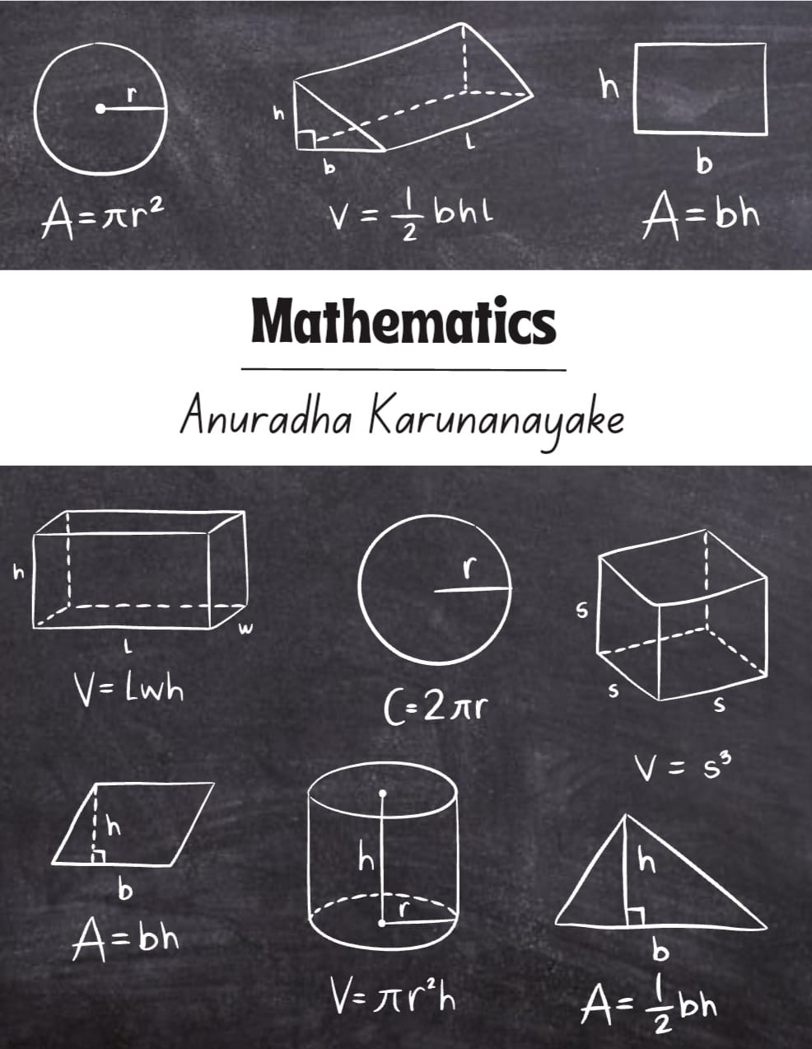

**Binomial Theorem**

As the power increases, the expansion becomes lengthy and tedious to calculate. A binomial expression that has been raised to a very large power can be easily calculated with the help of the Binomial Theorem. On this page, you will learn the definition and statement of binomial theorem, binomial expansion formulas, properties of binomial theorem, how to find the binomial coefficients, terms in the binomial expansion, applications, etc.

**Binomial Theorem Statement**

The binomial theorem is the method of expanding an expression that has been raised to any finite power. A binomial theorem is a powerful tool of expansion which has applications in [Algebra](https://byjus.com/maths/algebra/), probability, etc.

**Binomial Expression:**A binomial expression is an algebraic expression that contains two dissimilar terms. Eg: a + b, a3 + b3, etc.

**Binomial Expansion**

Important points to remember

* The total number of terms in the expansion of (x+y)n  is (n+1)
* The sum of exponents of x and y is always n.
* nC0, nC1, nC2, … .., nCn are called binomial coefficients and also represented by C0, C1, C2, ….., Cn
* The binomial coefficients, which are equidistant from the beginning and from the ending, are equal, i.e., nC0= nCn, nC1= nCn-1, nC2= nCn-2 ,….. etc.

**Binomial Expansion Formula:** Let n ∈ N,x,y,∈ R then

(x + y)n = nΣr=0 nCr xn – r· yr where,

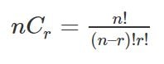

BINOMIAL EXPANSIONS Grade-11

**Illustration 1:** **Expand (x/3 + 2/y)4**

**Sol:**

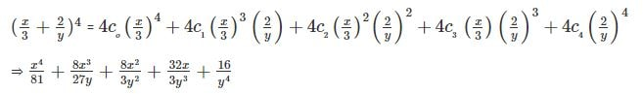

**Illustration 2: (√2 + 1)5 + (√2 − 1)5**

**Sol:**

We have

(x + y)5 + (x – y)5 = 2[5C0  x5 + 5C2  x3 y2  +  5C4 xy4]

= 2(x5+ 10 x3 y2+ 5xy4)

Now (√2 + 1)5+ (√2 − 1)5= 2[(√2)5+ 10(√2)3(1)2+ 5(√2)(1)4]

=58√2

## Binomial Expansion Formulas

To find binomial coefficients, we can also use **Pascal’s Triangle**.

**Some other useful expansions:**

* (x + y)n+ (x−y)n= 2[C0 xn+ C2 xn-1 y2+ C4 xn-4 y4+ …]
* (x + y)n– (x−y)n= 2[C1 xn-1y + C3 xn-3 y3+ C5 xn-5 y5+ …]
* (1 + x)n= nΣr-0 nCr. xr= [C0+ C1 x + C2 x2+ … Cn xn]
* (1+x)n+ (1 − x)n= 2[C0 + C2 x2+C4 x4+ …]
* (1+x)n− (1−x)n= 2[C1 x + C3 x3 + C5 x5 + …]
* The number of terms in the expansion of (x + a)n + (x−a)nis (n+2)/2 if “n” is even or (n+1)/2 if “n” is odd.
* The number of terms in the expansion of (x + a)n − (x−a)nis (n/2) if “n” is even or (n+1)/2 if “n” is odd.

### **General Term in Binomial Expansion:**

We have (x + y)n= nC0 xn+ nC1 xn-1. y + nC2 xn-2 . y2+ … + nCn yn

General Term = Tr+1 = nCr xn-r . yr

* General Term in (1 + x)n is nCrxr
* In the binomial expansion of (x + y)n, the rth term from the end is (n – r + 2)th.

**Illustration:** Find the number of terms in (1 + 2x +x2)50

**Sol:**

(1 + 2x + x2)50= [(1 + x)2]50= (1 + x)100

The number of terms = (100 + 1) = 101

**Illustration:**Find the fourth term from the end in the expansion of (2x – 1/x2)10

**Sol:**

Required term =T10 – 4 + 2 = T8 = 10C7(2x)3(−1/x2)7= −960x-11

### **Middle Term(s) in the Expansion of (x+y)n.n**

* If n is even, then (n/2 + 1) Term is the middle term.
* If n is odd then, [(n+1)/2]thand [(n+3)/2)th terms are the middle terms.

**Illustration:**Find the middle term of (1 −3x + 3x2– x3)2n

**Sol:**

(1 − 3x + 3x2– x3)2n = [(1 − x)3]2n= (1 − x)6n

Middle Term = [(6n/2) + 1] term = 6nC3n (−x)3n

Determining a Particular Term:

* In the expansion of (axp + b/xq)nthe coefficient of xm is the coefficient of Tr+1 where r = [(np−m)/(p+q)]
* In the expansion of (x + a)n, Tr+1/Tr = (n – r + 1)/r . a/x

## Applications of Binomial Theorem

The binomial theorem has a wide range of applications in Mathematics, like finding the remainder, finding the digits of a number, etc. The most common binomial theorem applications are as follows:

### **Finding Remainder Using Binomial Theorem**

**Illustration:**Find the remainder when 7103 is divided by 25.

**Sol:**

(7103/ 25) = [7(49)51 / 25)] = [7(50 − 1)51/ 25]

= [7(25K − 1) / 25] = [(175K – 25 + 25−7) / 25]

= [(25(7K − 1) + 18) / 25]

∴ The remainder = 18

**Illustration:** If the fractional part of the number (2403 / 15) is (K/15), then find K.

**Sol:**

(2403 / 15) = [23(24)100 / 15]

= 8/15 (15 + 1)100 = 8/ 15 (15λ + 1) = 8λ + 8/15

∵ 8λ is an integer, fractional part = 8/15

So, K = 8.

### **Relation between Two Numbers**

**Illustration:**Find the larger of 9950 + 10050 and 10150

**Sol:**

10150= (100 + 1)50= 10050+ 50 . 10049+ 25 . 49 . 10048+ …

⇒ 9950= (100 − 1)50= 10050– 50 . 10049+ 25 . 49 . 10048− ….

⇒ 10150– 9950= 2[50 . 10049+ 25(49) (16) 10047+ …]

= 10050+ 50 . 49 . 16 . 10047+ … >10050

∴ 10150– 9950> 10050

⇒ 10150> 10050+ 9950

### Divisibility Test

**Illustration:**Show that 119+ 911 is divisible by 10.

**Sol:**

119+ 911= (10 + 1)9+ (10 − 1)11

= (9C0. 109+ 9C1. 108+ … 9C9) + (11C0. 1011− 11C1. 1010+ … −11C11)

= 9C0. 109+ 9C1. 108+ … + 9C8. 10 + 1 + 1011− 11C1. 1010+ … + 11C10. 10−1

= 10[9C0. 108+ 9C1. 107+ … + 9C8+ 11C0. 1010− 11C1. 109+ … + 11C10]

= 10K, which is divisible by 10.

