INTRODUCTION

CHAPTER 1

INTRODUCTION

“Strategic Crime Monitoring” is a comprehensive online platform for filing complaints and managing computerized crime reports. To report an incident or to file a case, users must first register and log in. When they logged in, and then they can submit complaints, which are then sent to the police. The law rulers (police) can reply with updates on the complaint status through the platform. It streamlines various police tasks traditionally done online, allowing police to manage records on offenders, incidents, complaint histories, and more from a secure, centralized database. This system enhances the efficiency of police work by minimizing manual tasks and providing access to historical criminal data, making it a valuable tool for both the public and law enforcement.

Project Description:

The “Strategic Crime Monitoring” is a website for filing online complaints and managing computerized crime reports. Anyone needs report an incident or to file a case on this website must register as a member before logging in, and can then logged in to the system to make a complaint. It will be reported to the police, and the police reaches them by the status of the same. Police can yield benefit after this to deal with various offenses also the tasks that are done manually in police stations. Police receive the login password directly from the administrator. Therefore, this website helps police find out offences happening in public by without having to visit the station. Strategic Crime Monitoring can help maintain data on to offenders, incidents, complaint records, incident history, etc. This allows individuals to enter records when required. All histories can placed in a distinct database. The way is more secure thus only the genuine users have access to it. This application can make you get information about criminals that go back years. This could also help minimize a significant portion of police work.

Company Profile:

Tequevia Technologies

Organization Overview:

Since 2019, we have more than a decade’s worth of experience in providing outstanding customer-oriented software solutions as well as steering computer science students in their projects and thesis development. In Kerala, we are the Number One software development and project organization offering Special Training Programs by Industry Experts. Moreover, these trainers are involved in live projects having hands-on experience of how it feels like developing such programs; hence graduates can be indirectly taught by software engineers equipped with modern techniques.
A real-time Training organization delivering all kinds of technical software development in Software domain such as Python, CRM/Software Product based Real-Time Project and many more.
Tequevia Technologies has a R&D lab is well equipped, Infrastructure wise – lab-setup with indicative examples like AC classrooms, WiFi setup by network department Smart Class Rooms apart from other facilities. The institution had even created a result in the subject project exam that having scored 800 out of 800 marks, she got an SSP.
Vision And Mission
- High quality based training will be given that with the modern technologies.
- Tequevia Technologies is highly dedicated in promoting innovation, agility and a deep understanding of technology He said this has driven the creation of projects using dataviz for customer insights. In Tech category services, Tequevia media provides.

Organization Structure:

A union, a charity, a company, or a neighbourhood association are examples of groups of individuals that work together. The term “organization” can be used to describe a company, a group, or the process of creating something. The methodical placement of human resources inside an organization with achieving shared business objectives well-known as per organizational structure (OS).

Our Clients:













Reach At:

- Company Name : Tequevia Technologies
- Guide : Mr. Praveen Prakash
- Phone : +91 8590807542

LITERATURE SURVEY
CHAPTER 2

LITERATURE SURVEY

Existing and Proposed System
    - Existing System
The motivation behind developing the Strategic Crime Monitoring stems from the need for a more efficient and streamlined approach to handling crime-related activities. Traditional methods of filing complaints and managing crime records often involve cumbersome paperwork and manual processes, leading to delays, errors, and inefficiencies. By leveraging web-based technology, the Strategic Crime Monitoring aims to modernize these processes, making it easier for both citizens and law enforcement agencies to report incidents, track cases, and manage records in a more organized and accessible manner. The current system of managing crime records and handling complaints is outdated and inefficient. Manual paperwork and physical visits to police stations can lead to delays and errors in processing complaints and managing records. Moreover, the lack of a centralized database makes it challenging to access and analyze crime-related information effectively. Here it requires a comprehensive solution that automates processing complaints, managing records, and communicating updates between citizens and law enforcement agencies.

    - Proposed Methodology

The Strategic Crime Monitoring is a web-based platform designed to facilitate the online reporting of incidents, the management of crime records, and communication between citizens and law enforcement agencies. Key features of the system include user registration and authentication, complaint filing, status tracking, news and safety tips dissemination and access to information on missing persons and wanted criminals. The system aims to streamline the process of reporting and managing crime-related activities while ensuring data security and confidentiality.
      - To develop a user-friendly web-based platform for citizens to file complaints and report incidents online.
      - To automate the process of managing crime records, including storing, updating, and accessing information on criminals, cases, and complaints.

      - To enable communication between citizens and law enforcement agencies regarding the status of complaints and updates on ongoing cases.

Feasibility Study:
This study provides a thorough and in-depth assessment of the expenses, demand, and certain development readiness. This study is crucial to the formulation and making of judgments regarding a certain stage of development.

- Technical Feasibility
Technology feasibility examining the particular requirements of our suggested project is necessary to determine its technical viability. It talks about the software needs and system configurations related to technology.

- Economic Feasibility
Another important component of development is figuring out potential low- cost methods; this should look into issues with profit and cost.

- Behavioral Feasibility
Based on ethical considerations, the project has been evaluated and found feasible. Ensure ethical viability, it was designed and built to be both mathematically efficient and user-friendly.
- Operational Feasibility
A stable and dependable internet connection is essential for system access and entry, guaranteeing a robust and uninterrupted connection.

Tools and Technology Used
    - Technologies used

- HTML:

The Definition HTML (Hypertext Markup Language) which is aimed at crafting content for Web. It works with a number of tags or elements that define different contents in web pages such as paragraphs, pictures, links etc. You use html to markup content on a webpage and tell browsers how to interpret the layout of web page elements.
It allows you to insert types of multimedia like image, audio, video and ability for structured ordering or categorizing material. And because HTML is a static language., it only describes the layout and contents of web pages; it cannot allow dynamic or interactive behavior.

- CSS:
Abbreviation for CSS (Cascading Style Sheets) is the language used to describe on exhibition and visualizational elements of HTML on a web page. This provides a fixed rules for stylistic elements, such as borders, color, typeface, spacing, and arrangement. Updating and maintaining a website's visual aspect is made easier when content and presentation are separated using CSS. With CSS, site designers can create visually appealing and consistent designs for several web pages. Layout and look can be adjusted based on being viewed which uses CSS.

- Bootstrap:

Bootstrap is a free, open-source CSS framework designed for responsive, mobile- first front-end web design. Before Bootstrap, various function libraries were used in interface development, leading to inconsistencies and high maintainability issues. Twitter developer Mark Otto remarked, “I joined a small group of developers to design and build new internal tools and saw the opportunity to do more. We found ourselves creating more through this process than any other internal tool. A few months later, we finally launched Bootstrap as a way to document and share designs and company assets.” This project originated from

Twitter Blueprint and was released as an open-source project on August 19, 2011, as part of Hack Week, a hackathon-style event for Twitter's development team.

- MySql:
MySql is one of the RDBMS that operates as a server, providing multi-user access to multiple databases. It’s a good option for databases which is in platforms like Web Applications and is a key module of widely used LAMP (Linux, Apache, MySQL, PHP/Perl/Python). MySQL is the most popular open-source database in the world due to its quick and speed performance, high in making reliability, and also easiness of use,etc. Well- known open-source database server currently available.

- Python:

It is a programming language which is high-level interpreted with flexible semantics. Its advanced built-in data management and structure make it highly attractive for scripting, as for developing large-scale applications quickly. Python’s simple and readable syntax emphasizes clarity, reducing cost. It contains modules, data packages for encouraging code reuse. Python’s interpreter and broad libraries being available for free in both source and binary forms across all major platforms. The edit-test-debug cycle in it is very fast because it doesn't require compiling steps. Fixing it’s program is straightforward: if an error occurs, it raises an exception instead of causing a segmentation fault. If the exception isn't caught, the interpreter provides a stack trace. Python’s source-level debugger allows you to inspect local and overall variables. The debugger, written in Python, showcases the language’s introspective capabilities.

- Python Flask:

Python Flask is classified as a micro framework why because, this framework not need any tool or libraries.[3] database layer is not there in this, also form validation is not there, or other components for which third-party libraries gives functionality. Also, It always supports external extensions which can add functionality to your application as if it is implemented in itself. There are extensions to upload processing, various open authentication technologies, and several common infrastructure-related tools. Extensions are efficient and more regularly than the default Flask program.[4] Applications that use the Flask framework include Interest and LinkedIn.

SOFTWARE REQUIREMENTS AND SPECIFICATION

CHAPTER 3

SOFTWARE REQUIREMENTS AND SPECIFICATION

Introduction
This makes software and the issue it is intended to tackle clear. Describe what is contained in and not contained in the system. Abstraction, definitions, and an acronym. Acknowledge the exact words and symbols that were needed on the paper.

Hardware and Software Requirements

    - Hardware Requirements:

- Microprocessor: Intel CORE i3 or more
- Clock Speed: 1.3 GHZ
- RAM: 4 GB or more
- Hard Disk: 500 GB or more
- Keyboard: Standard keyboard
- Mouse: Standard mouse
- Connectivity: LAN, WiFi, etc.

    - Software Requirements:

- Front End: HTML, CSS, Bootstrap 4, JavaScript
- Back End: Python 3.8 flask
- Database : MySQL Workbench
- Platform : Windows, mac or Ubuntu.
- Server Side Scripting: Python

Module Description

- Super Admin Module: The Super Admin can log in securely, manage police stations and employees, add and manage advocate admins, approve users, and view advocate ratings and complaints.
- Station Admin Module: The Station Admin can log in, manage station employees, approve user registrations, and handle cases and complaints.
- Advocate Admin Module: The Advocate Admin can log in, verify advocates, and view case history and advocate ratings.
- Advocate Module: Advocates can register, log in securely, manage profiles, view case requests and history, and see user ratings.
- User Module: Users can register, log in securely, manage profiles, file various types of complaints, manage case requests, and view advocate details for legal assistance.

Functional Requirements

    - Hardware Interfaces
- PC, Mobile phone etc.

    - Software Interfaces
- Operating system (OS)

- MySQL Workbench

- Visual Studio Code

  - Non-Functional Requirements

    - Safety Requirement
Data transferred from a database or Data Creek must be carried securely, ensuring that the content remains unchanged and its integrity is maintained.

    - Reliability Requirements
Since the given the sensitive nature of the data, the results generated must be highly accurate and reliable to ensure effective crime prevention and response strategies

    - Security Requirements
Data base holds no.of user records, making it a potential target for hackers. Therefore, ensuring data security must be a top priority, as it contains sensitive health information about users.

    - Usability Requirements
The application is user-friendly, allowing anyone to access and navigate it with ease.

    - Availability
With the database fully specified, the presented data is relocated and restructured continuously.

SYSTEM DESIGN

CHAPTER 4
SYSTEM DESIGN

Purpose
System design, or developing a strategy or technique for software system design, is the needy stage for the development process of software. This ensures alignment with the predetermined aim and requirements and covers the system's architectural framework, modules, components, and interface.

Context Flow Diagram
CFDs Known as bubble charts, CFDs offer a straightforward graphical depiction of the inputs into a system, the data processing that is done on it, and the results that are produced. Logical CFD typically employs four notations only:

- Signifies the starting (source) or endpoint(destination) of data.
- Signifies Data Flow.
- Signifies procedure that converts received data into sent data.
- Signifies Source Data

Here are the specific symbols used:

- Function Symbol (FS): Indicated by a circle, this symbol is known bubble or process.
- Exterior Unit Symbol (EUS): Indicated by a rectangle, this symbol denotes exterior unit or entity member. These exterior units are physically outside the software system, but engage with it through input data as well as data consumption.
- DFD: (Data Flow Diagram) This symbol represents the data flow across two processes, or among an entity and a process, and is represented by a directed arrow.
- DSS: (Data Store Symbol) Represented by two parallel lines, this symbol denotes a rational file or data store.

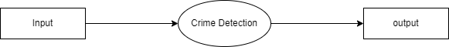

Strategic Crime Monitoring

Fig 4.2 : Flow Diagram

Data Flow Diagram:

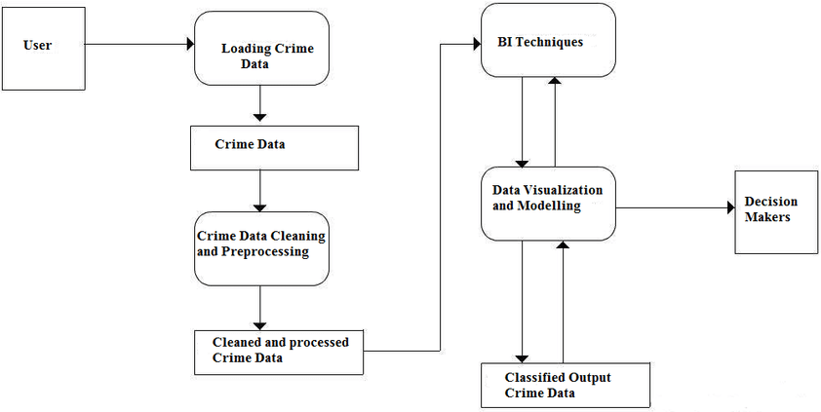







Register/ Login
Station Admin
Report Crime
Processing and Finalizing the Crime Report
Storing into Database
Transferring to Police
Updating to Database

Fig (a) 4.3 : Data Flow

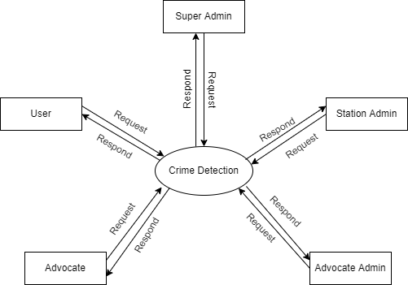
Strategic Crime Monitoring
Fig (b) 4.3 : Data Flow

    - Super Admin
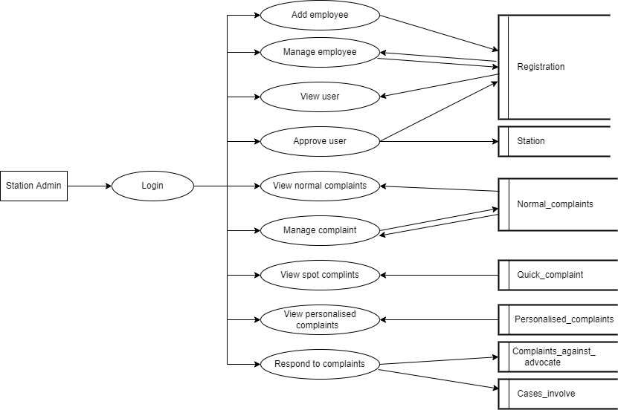
Super Admin
Fig 4.3.1 : Super Admin

    - Station Admin
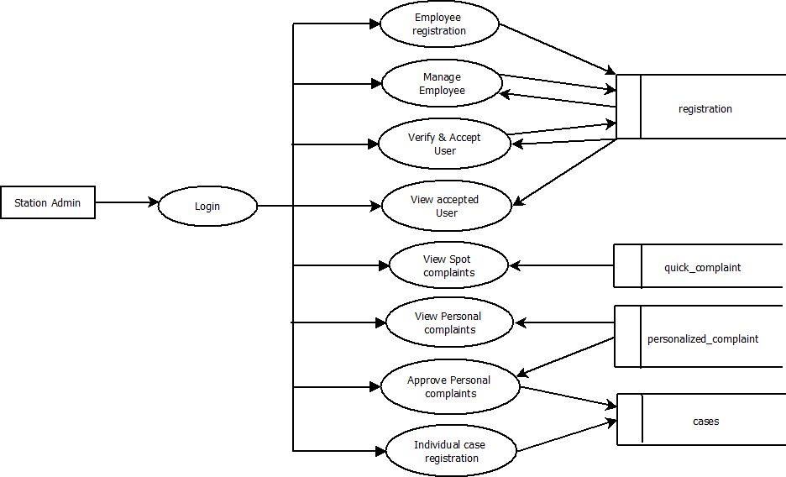
Fig 4.3.2 : Station Admin

    - Advocate Admin
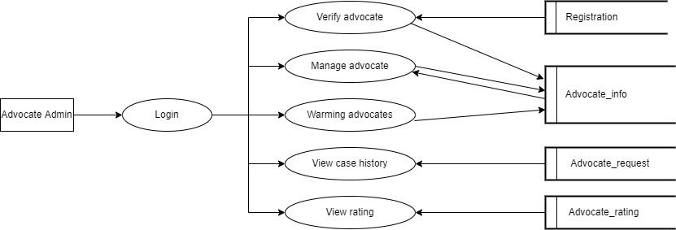

Fig 4.3.3 : Advocate Admin

    - Advocate
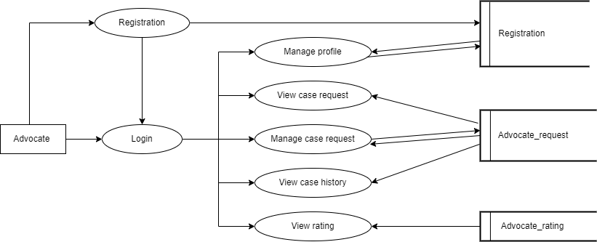

Fig 4.3.4 : Advocate

    - User
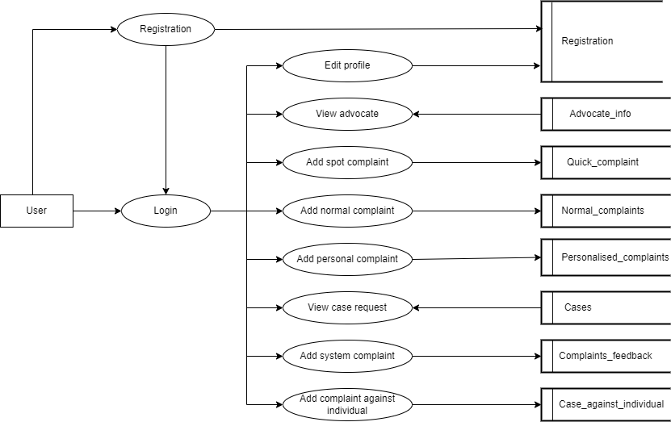

Fig 4.3.5 : User

Use Case Diagram











Update and Store Report in System
Make Enquiry and Send the Status
Report Incident/ Crime

Fig 4.4 : Use Case Diagram

SOFTWARE TESTING

CHAPTER 5

  - Introduction
SOFTWARE TESTING

One of the steady and important stages of the development process of software’s is testing. In this process, the system's constituent parts are evaluated to look if they satisfy the wants of the client. Testing entails confirming the emerging system's quality. To compare the final product, the software will undergo testing and analysis under specific settings.

Types of Testing

    - Unit Testing
It entails creating fields with different kinds of numbers to confirm acceptance and confirm that every single value is entered into the system accurately.

    - Integration Testing
It is a software testing procedure that integrates and evaluates every module collectively. Integration tests combine interactions between several system components, such as the OS and interfaces. This is done to identify problems which persist in between the different integrated system modules and components.

    - System Testing
To determine whether the integrated software or hardware system satisfies the criteria, the entire system is tested at this step of testing. Black-box testing, which exempts users from system knowledge requirements, includes this kind of testing. After passing integration testing, system testing compares the output to the anticipated outcomes for the embedded software components.

    - Acceptance Testing
In this testing phase it is carried out after the system testing done, and all necessary modifications have been made. This type of testing is made by the users, customers, and/or other stake holders to validate the system meet the specified requirements. The main goal of this type of test is to figure out a trust in the entire system.

    - White Box Testing
In this testing phase it involves generating test cases, modules, and functions to saw weather subroutine passes every loop, other branch statements are tense to be tested conditionally, and any errors identified during this process are subsequently fixed.

    - Black Box Testing
In this testing phase it involves creating every potential test scenario and examining every test scenario, and errors are identified by comparing the every test scenario with the real world results. Once identified, errors are corrected to ensure the system functions correctly.

IMPLEMENTATION

CHAPTER 6
IMPLEMENTATION

Screenshots
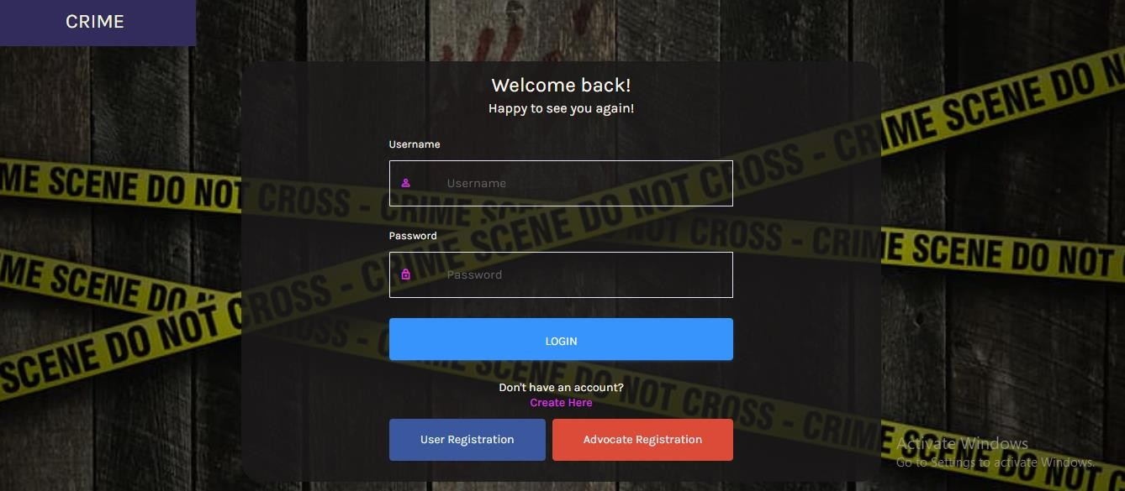

Fig 6.1.1 : Login Page

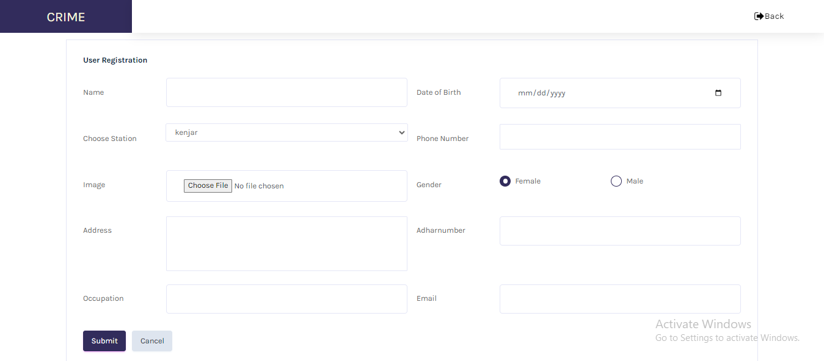

Fig 6.1.2 : User Registration Page

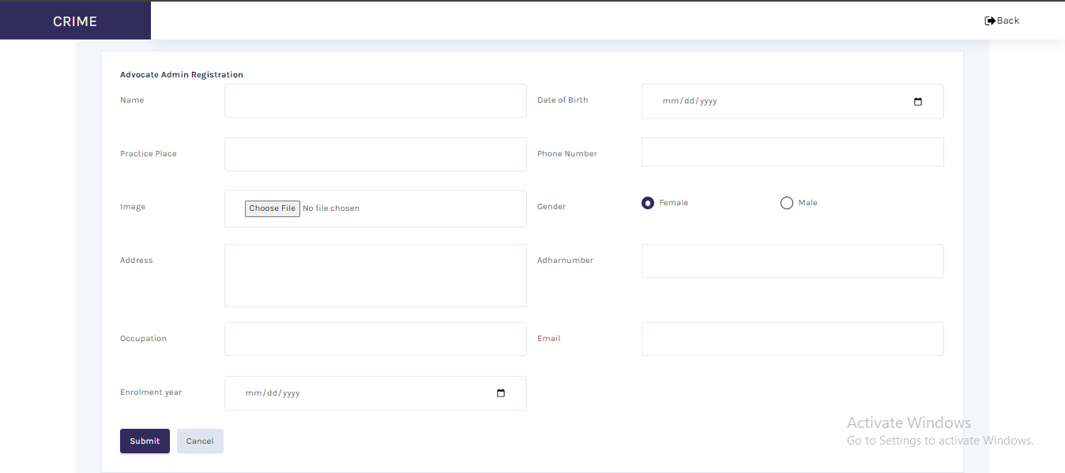

Fig 6.1.3 : Advocate Registration Page

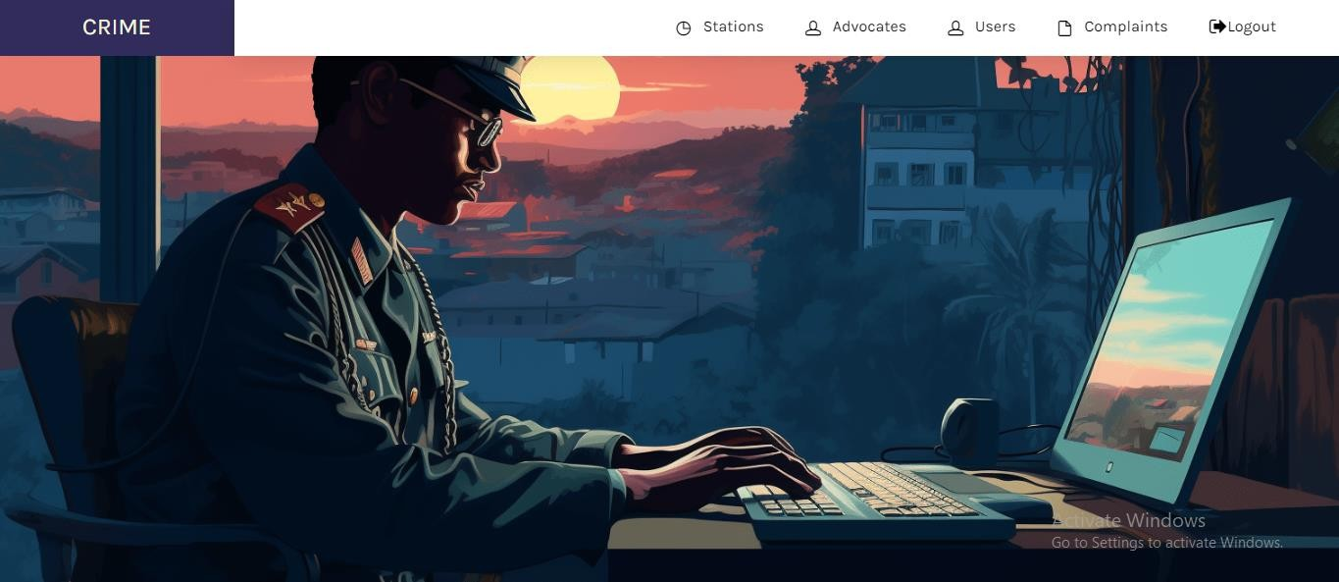
Fig 6.1.4 : Admin Home Page

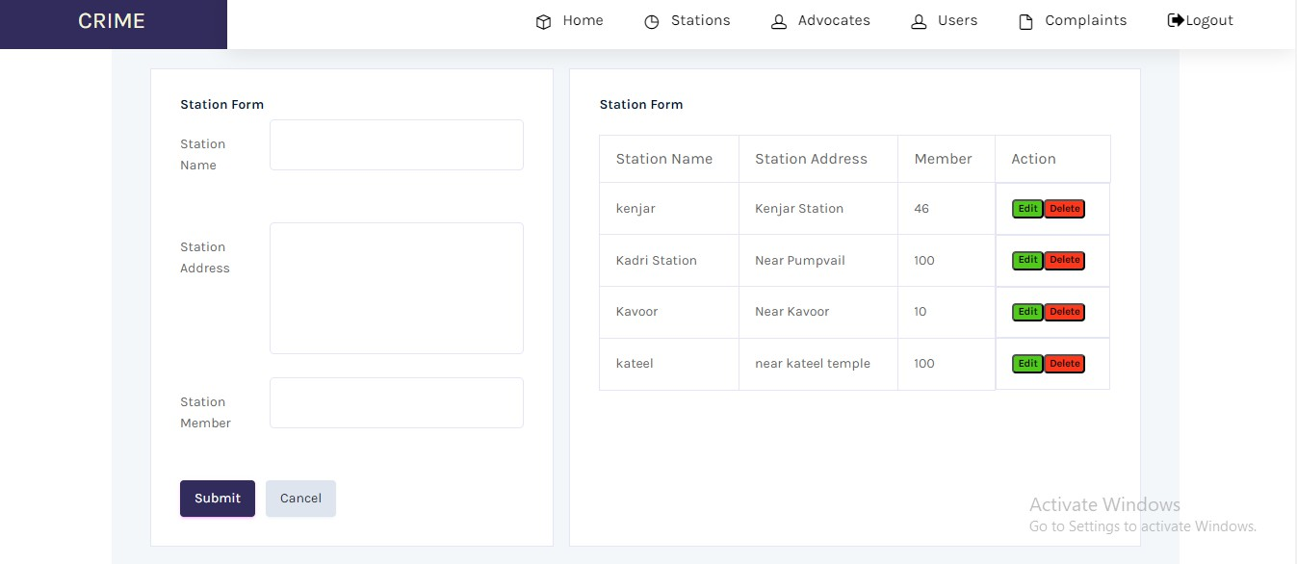
Fig 6.1.5 : Admin Adding Station


Fig 6.1.6 : User Home Page

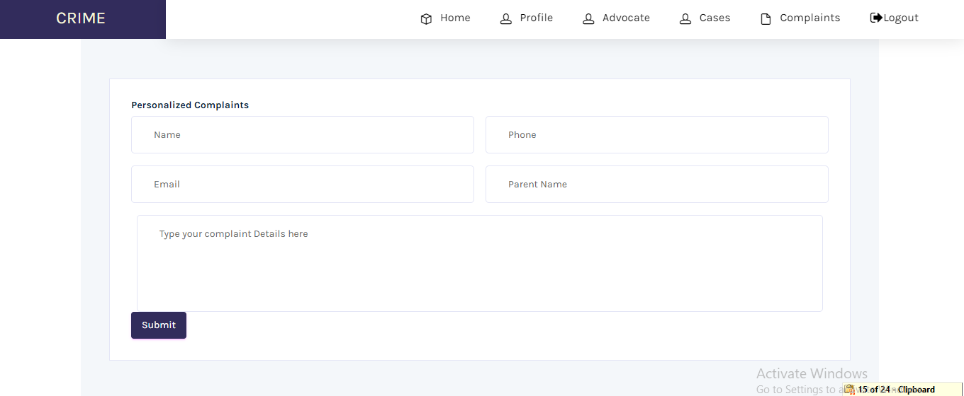
Fig 6.1.7 : User Complaint Registration

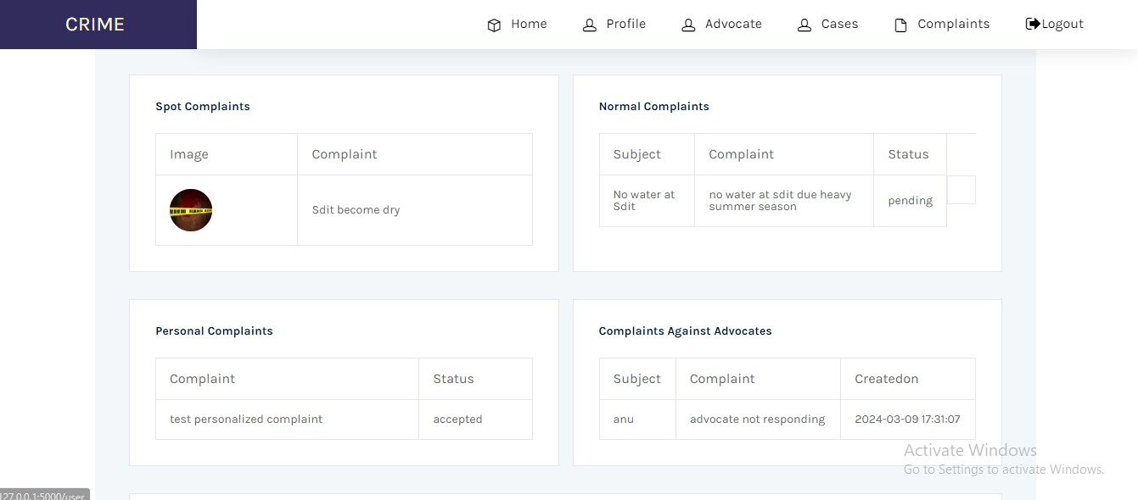

Fig 6.1.8 : User View Complaint Status

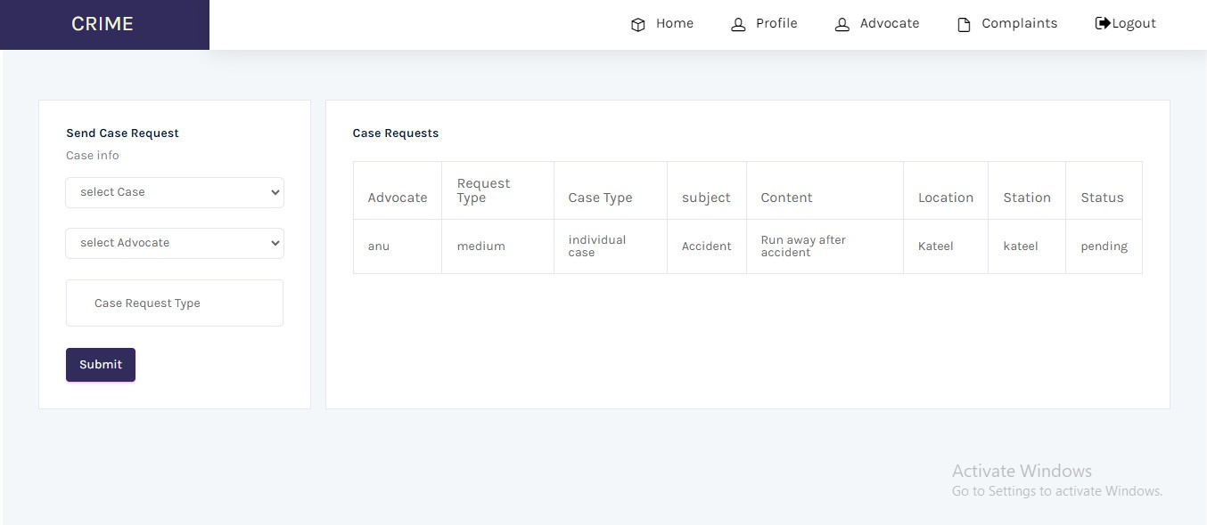

Fig 6.1.9 : User View Case Status

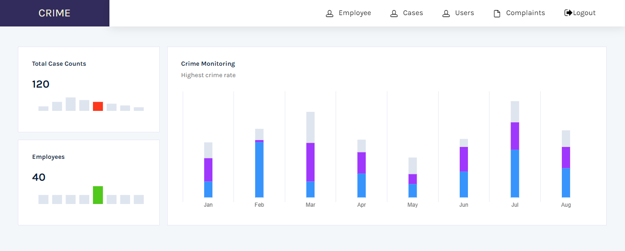
Fig 6.1.10 : Station Admin Home Page

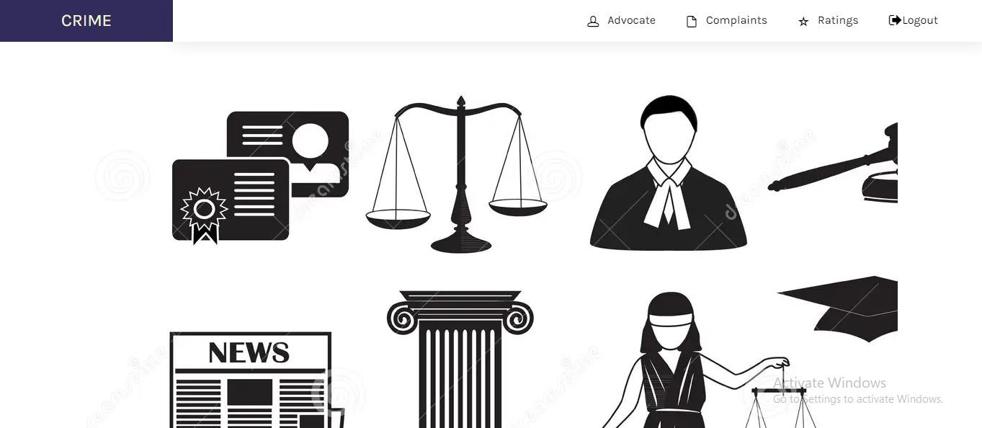
Fig 6.1.11 : Advocate Admin Home Page

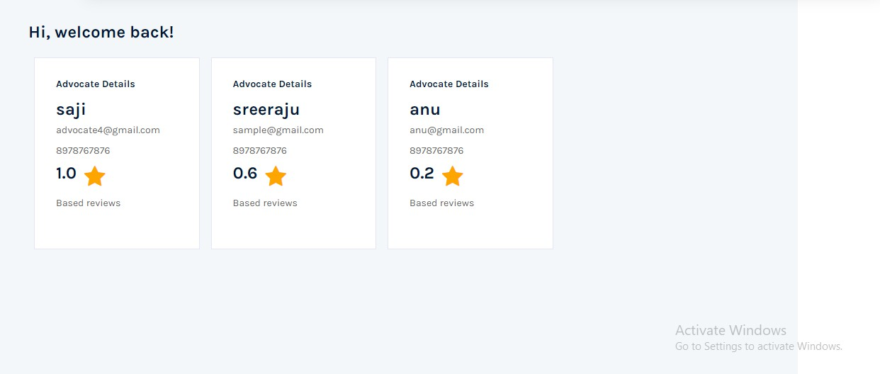
Fig 6.1.12 : Advocate View Ratings of Advocates

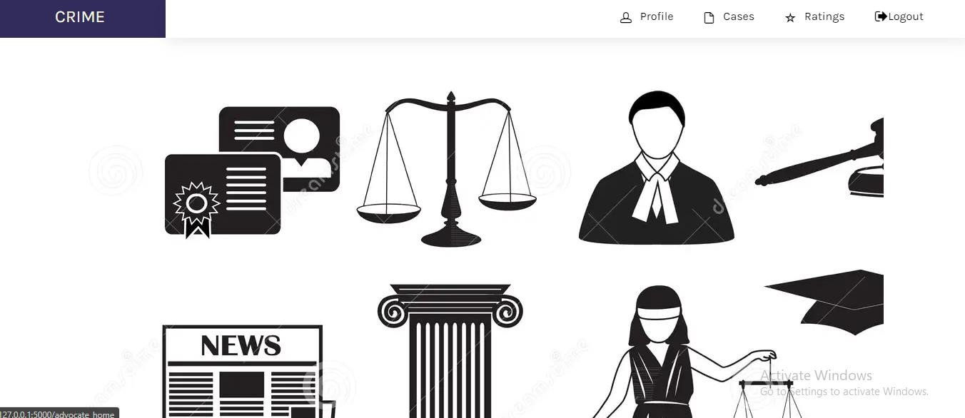

Fig 6.1.13 : Advocate Home Page

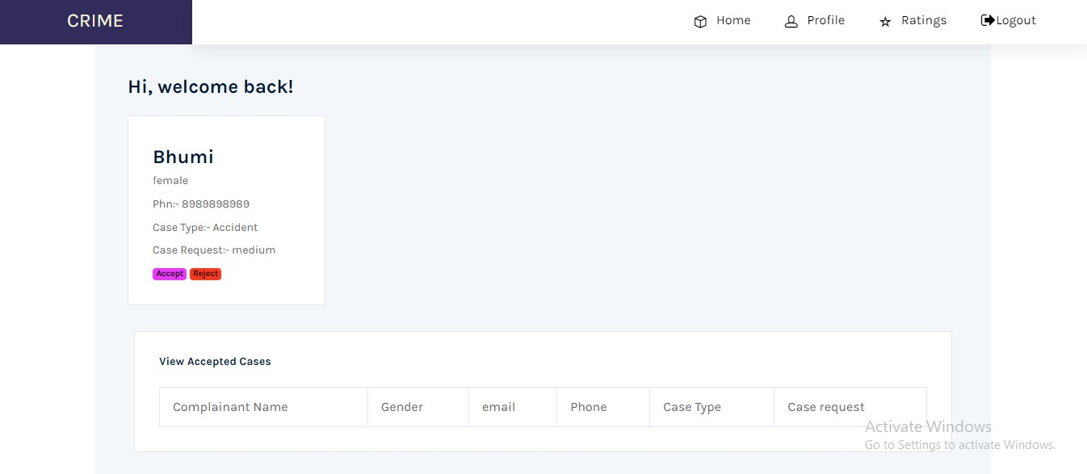
Fig 6.1.14 : Advocate View Case Request

Test Cases
    - User Test Cases

Table 6.2 User Login
Test Case No | Test Case Description | Input | Expected Output | Remark
1 | User Login | User Id and  Password | Login  Successful | Pass
2 | Wrong User Login | User Id And Password | Login Unsuccessful | Pass

CHAPTER 7

CONCLUSION

Strategic Crime Monitoring acts as a tool for police agencies by providing an accessible and user-friendly platform for reporting and managing crimes. Through its intuitive website interface, individuals can easily submit complaints or incidents, streamlining the process for both the public and police personnel. This enhances transparency and accountability within the community, as it fosters clear communication channels between citizens and law enforcement agencies.

The strength of the system is the centralized database, which consolidates crucial information related to criminals, cases, and complaints. By storing all this data in one location, the system enables police to efficiently access and manage information, facilitating quicker and more informed decision-making. It saves lot of time, as well as it also guarantees consistency and accuracy in keeping records safe.

Moreover, Strategic Crime Monitoring prioritizes security by implementing robust to protect sensitive information. Only legal users with suitable credentials were granted contact with confidential data, ensuring that privacy as well as data integrity are maintained at all times. This instills confidence in users that their personal id or information and complaints are handled securely and professionally.

Overall, Strategic Crime Monitoring represents a significant leap forward in law enforcement technology, empowering police to effectively address crime and maintain public safety. By leveraging modern digital tools and streamlined processes, the system helps law enforcement agencies fulfill their mandate of serving and protecting communities efficiently and responsibly.

CHAPTER 8

FUTURE ENHANCEMENT

The application can be further enhanced in a lot of aspects;

- Mobile Application Integration: Develop a mobile app to provide users and police with easier access to the platform and real-time notifications.

- AI and Machine Learning: Implement AI and machine learning algorithms to predict crime trends and assist in proactive policing.

- Real-time Analytics and Dashboards: Create real-time analytics and dashboards for police to monitor crime patterns and response times more effectively.

- Integration with Other Government Systems: Integrate with other government databases and systems for comprehensive data sharing and verification.

- Enhanced Security Features: Cutting-edge security like Bio-metric authentication and multi-factor authentication to is a feature to enhance user security.

- Incident Mapping and Visualization: Incorporate geographic information systems (GIS) for incident mapping and visualization to identify hotspots and patterns.

BIBLIOGRAPHY

Python.org YouTube Geeks4Geeks w3schools Stack Overflow

