PBCMT404 : DATABASE SYSTEMS
MINI PROJECT REPORT
“Online Blood Bank and Donor Management System”
Using Python, Flask and SQLite
(2025-2026 ACADEMIC YEAR)
B.Tech Semester IV
SREE BUDDHA COLLEGE OF ENGINEERING
(AUTONOMOUS)
PATTOOR P.O., NOORANAD , ALAPPUZHA , KERALA
DEPARTMENT OF
COMPUTER SCIENCE AND ENGINEERING (ARTIFICIAL
INTELLIGENCE AND MACHINE LEARNING)
PREPARED BY
[Student Name] | [Roll No.]
[Student Name] | [Roll No.]
[Student Name] | [Roll No.]
[Student Name] | [Roll No.]
[Student Name] | [Roll No.]
[Student Name] | [Roll No.]

CONTENTS
CHAPTERS | CONTENTS | PAGE No
Chapter 1 | Introduction | 1
Chapter 2 | Methodology | 2-4
Chapter 3 | Implementation | 5-10
Chapter 4 | Results | 11-18
Chapter 5 | Conclusion | 19

This report describes the submitted academic prototype. All names, hospitals, stock counts and requests are synthetic demonstration data.

CHAPTER - 1
INTRODUCTION
The Online Blood Bank and Donor Management System (OBBDMS) is a database-driven web application designed to manage donor records, hospital blood stock, requests, donations and donation appointments. In a traditional blood bank, these records are often maintained in registers, spreadsheets and separate hospital systems. Staff must reconcile donor details, available units, pending requests and donation history before they can answer a simple question: does a hospital currently have usable units of a given blood group?
That fragmentation creates duplicate records, inconsistent stock counts and requests whose status is known only to the person who received a phone call. A donor may also have no reliable way to check when they last donated or when they are next eligible. The project addresses these problems by bringing the core records into one relational database and giving each user a focused interface for the work they need to perform.
The system is implemented using Python 3.10, Flask 3.1 and SQLite. Flask provides the application layer and route-level access control; Jinja templates and a custom CSS interface provide the presentation layer; SQLite stores the relational data. Two roles are supported. Donors register, sign in, check eligibility, book a donation slot, search for blood and raise requests. Administrators manage hospitals, inventory, requests, donations and donor records from a dispatch-board interface.
From a database-systems perspective, the project demonstrates relational schema design, primary and foreign keys, uniqueness constraints, check constraints, indexes and multi-table joins. The schema contains six related tables: users, hospitals, inventory, requests, donations and appointments. Inventory is unique per hospital and blood group; requests and donations reference both a user and a hospital; appointments reference a donor and a hospital. These constraints keep the data consistent when records are inserted or updated through the application.
The primary objectives of the project are to centralise donor and stock data, provide public availability search, calculate donor eligibility from donation history, enforce a controlled request lifecycle, protect state-changing operations with authentication and CSRF tokens, and present the same relational data through a usable desktop and mobile interface. The system is deliberately scoped as an academic prototype. It does not verify clinical compatibility, screen blood, confirm donor identity or replace hospital procedures.
The remainder of this report follows the PBCMT404 mini-project structure. Chapter 2 explains the requirement analysis, system design, architecture and tools. Chapter 3 presents the database schema and implementation modules. Chapter 4 shows the working interface and the results of the implemented workflows. Chapter 5 concludes the report and identifies the limitations of the prototype.
CHAPTER - 2
METHODOLOGY
2.1 Requirement Analysis
The requirements were derived from the daily work of a small blood bank: registering donors, checking stock, responding to hospital requests, recording donations and helping donors understand their eligibility. The following functional requirements were identified:
- Public availability search by blood group and city, without requiring a login.
- Donor registration and secure login with email and password.
- Donor dashboard with last donation, 90-day eligibility, donation history, appointment booking and personal request history.
- Administrator dashboard with stock strips, critical groups, pending requests, recent donations and hospital totals.
- Hospital and inventory management, including one stock line per hospital and blood group.
- Request lifecycle: Pending, Approved, Completed and Cancelled, with stock deducted only on valid completion.
- Donation logging and donor record management.
- Role-based access control, CSRF protection and server-side validation for every state-changing operation.
2.2 System Design
The design follows an entity-relationship model. The main entities and relationships are:
- Users: donors and administrators. Each user has a unique email and a role constrained to donor or admin.
- Hospitals: blood-bank sites with a name, city, phone number and address.
- Inventory: one row per hospital and blood group, with a non-negative unit count. The pair (hospital_id, blood_group) is unique.
- Requests: a blood request raised by a user for a hospital, blood group, unit count, urgency and status.
- Donations: a completed donation by a donor at a hospital, used to calculate eligibility and history.
- Appointments: a booked donation slot for a donor at a hospital, with a date, time and status.
A user can raise many requests and make many donations. A hospital can hold many inventory lines, receive many requests and record many donations. A donor can book many appointments over time. These one-to-many relationships are enforced with foreign keys, and SQLite foreign-key enforcement is enabled for every connection.
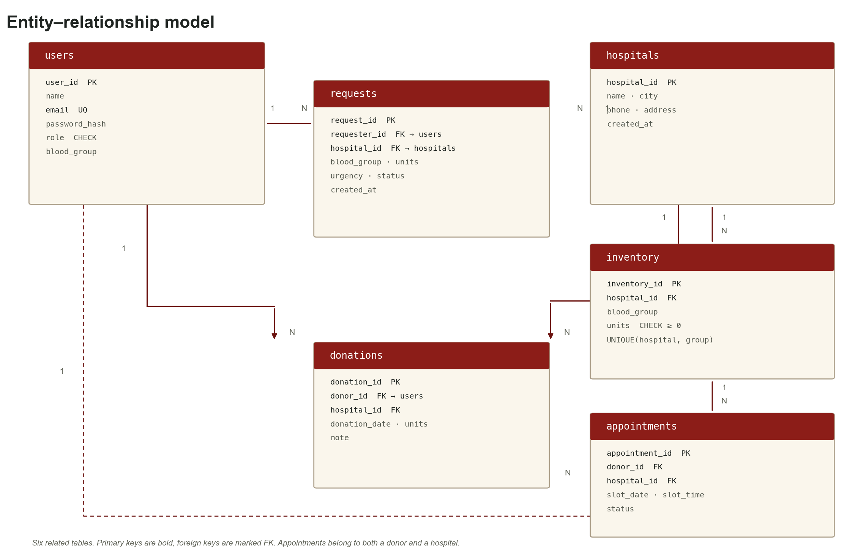
fig(2.1) Entity–Relationship Diagram
2.3 Architecture
The application uses a three-tier architecture:
- Presentation tier: server-rendered Jinja templates, a custom CSS design system and a small amount of JavaScript for status updates, counters and motion.
- Application tier: Flask routes, authentication decorators, CSRF validation, request validation and parameterized database queries.
- Database tier: SQLite with six related tables, foreign-key constraints, check constraints, unique constraints and search indexes.
The browser sends an HTTP request to Flask. The application checks the session, role and CSRF token where required, runs a parameterized query and renders a template with the result. The same route structure supports both desktop and mobile layouts; the responsive interface is implemented in CSS rather than a separate mobile application.
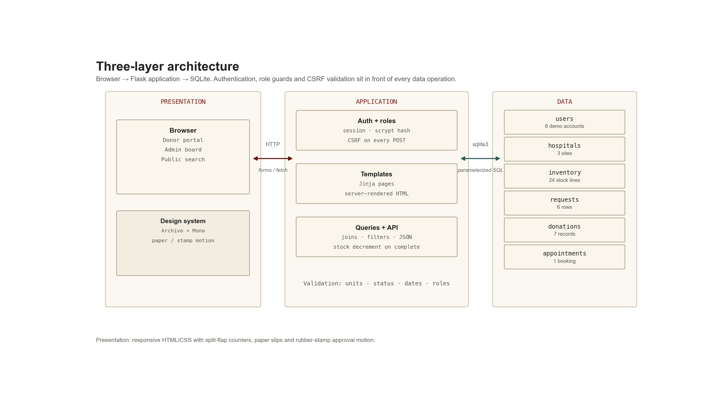
fig(2.2) Three-Tier Architecture
2.4 Tools and Technologies Used
- Programming language: Python 3.10.
- Web framework: Flask 3.1.3.
- Database: SQLite 3, with a MySQL-portable relational schema.
- Templates: Jinja2.
- Frontend: HTML5, custom CSS and vanilla JavaScript.
- Security: Werkzeug password hashing, signed sessions and CSRF tokens.
- Testing: Flask test client and Google Chrome through Playwright.
- Report diagrams: Matplotlib; screenshots: Playwright at 1440×900 and 390×844.
CHAPTER - 3
IMPLEMENTATION
3.1 Database Implementation
The database is created automatically on first run. The schema uses primary keys, foreign keys, check constraints and a unique constraint on inventory. The following statements define the six tables and their indexes.
CREATE TABLE users (
user_id INTEGER PRIMARY KEY AUTOINCREMENT,
name TEXT NOT NULL,
email TEXT NOT NULL UNIQUE,
password_hash TEXT NOT NULL,
role TEXT NOT NULL CHECK (role IN ('donor','admin')),
phone TEXT, city TEXT, blood_group TEXT,
created_at TEXT NOT NULL DEFAULT (datetime('now'))
);
CREATE TABLE hospitals (
hospital_id INTEGER PRIMARY KEY AUTOINCREMENT,
name TEXT NOT NULL,
city TEXT NOT NULL,
phone TEXT, address TEXT,
created_at TEXT NOT NULL DEFAULT (datetime('now'))
);
CREATE TABLE inventory (
inventory_id INTEGER PRIMARY KEY AUTOINCREMENT,
hospital_id INTEGER NOT NULL,
blood_group TEXT NOT NULL,
units INTEGER NOT NULL DEFAULT 0 CHECK (units >= 0),
updated_at TEXT NOT NULL DEFAULT (datetime('now')),
UNIQUE (hospital_id, blood_group),
FOREIGN KEY (hospital_id) REFERENCES hospitals(hospital_id) ON DELETE CASCADE
);
CREATE TABLE requests (
request_id INTEGER PRIMARY KEY AUTOINCREMENT,
requester_id INTEGER NOT NULL,
hospital_id INTEGER NOT NULL,
blood_group TEXT NOT NULL,
units INTEGER NOT NULL CHECK (units > 0),
urgency TEXT NOT NULL DEFAULT 'Routine',
note TEXT,
status TEXT NOT NULL DEFAULT 'Pending'
CHECK (status IN ('Pending','Approved','Completed','Cancelled')),
created_at TEXT NOT NULL DEFAULT (datetime('now')),
updated_at TEXT NOT NULL DEFAULT (datetime('now')),
FOREIGN KEY (requester_id) REFERENCES users(user_id),
FOREIGN KEY (hospital_id) REFERENCES hospitals(hospital_id)
);
CREATE TABLE donations (
donation_id INTEGER PRIMARY KEY AUTOINCREMENT,
donor_id INTEGER NOT NULL,
hospital_id INTEGER NOT NULL,
donation_date TEXT NOT NULL,
units INTEGER NOT NULL DEFAULT 1 CHECK (units > 0),
note TEXT,
created_at TEXT NOT NULL DEFAULT (datetime('now')),
FOREIGN KEY (donor_id) REFERENCES users(user_id),
FOREIGN KEY (hospital_id) REFERENCES hospitals(hospital_id)
);
CREATE TABLE appointments (
appointment_id INTEGER PRIMARY KEY AUTOINCREMENT,
donor_id INTEGER NOT NULL,
hospital_id INTEGER NOT NULL,
slot_date TEXT NOT NULL, slot_time TEXT NOT NULL,
status TEXT NOT NULL DEFAULT 'Booked'
CHECK (status IN ('Booked','Kept','Missed','Cancelled')),
created_at TEXT NOT NULL DEFAULT (datetime('now')),
FOREIGN KEY (donor_id) REFERENCES users(user_id),
FOREIGN KEY (hospital_id) REFERENCES hospitals(hospital_id)
);
CREATE INDEX idx_inventory_group ON inventory(blood_group);
CREATE INDEX idx_requests_status ON requests(status);
CREATE INDEX idx_donations_donor ON donations(donor_id);
The schema is normalised around one fact per table: a hospital holds stock, a user raises a request, a donor makes a donation and a donor books an appointment. This avoids repeating hospital names inside inventory or donor details inside requests.
3.2 Database Connection and Query Helpers
A new SQLite connection is opened for each Flask application context. Foreign-key enforcement is switched on explicitly because SQLite does not enable it by default. A teardown hook closes the connection at the end of the request.
def get_db():
if "db" not in g:
os.makedirs(os.path.dirname(DB_PATH), exist_ok=True)
g.db = sqlite3.connect(DB_PATH)
g.db.row_factory = sqlite3.Row
g.db.execute("PRAGMA foreign_keys = ON")
return g.db
@app.teardown_appcontext
def close_db(_exc):
db = g.pop("db", None)
if db is not None:
db.close()
def query(sql, args=(), one=False):
cur = get_db().execute(sql, args)
rows = cur.fetchall()
cur.close()
return (rows[0] if rows else None) if one else rows
def execute(sql, args=()):
db = get_db()
cur = db.execute(sql, args)
db.commit()
last_id = cur.lastrowid
cur.close()
return last_id
3.3 Authentication, Roles and CSRF
Registration validates the email, password length, blood group and required fields, hashes the password with Werkzeug and inserts the user with the donor role. Login verifies the hash and stores the user id and role in the signed session. The admin_required decorator returns HTTP 403 when a signed-in donor attempts to open an administrator route.
Every POST request is checked by a before_request hook. The token is generated per session, embedded in forms and in a meta tag for fetch calls, and compared using secrets.compare_digest. A missing or stale token is rejected before the route can change data.
@app.before_request
def csrf_protect():
if request.method == "POST":
sent = request.form.get("csrf_token") or request.headers.get("X-CSRF-Token")
if not sent or not secrets.compare_digest(sent, session.get("csrf", "")):
if request.path.startswith("/api/"):
return jsonify({"error": "Invalid CSRF token."}), 400
abort(400, description="Invalid CSRF token.")
3.4 Request Lifecycle and Stock Consistency
Status changes are not accepted as free text. The API defines the allowed next state for each current state and returns HTTP 409 for an invalid transition. Completion performs a stock read for the request's hospital and blood group; if the row is missing or holds fewer units than requested, the transition is refused. Only then is the inventory decremented and the request marked Completed.
allowed = {
"Pending": {"Approved", "Cancelled"},
"Approved": {"Completed", "Cancelled"},
"Completed": set(),
"Cancelled": set(),
}
if new_status not in allowed.get(row["status"], set()):
return jsonify({"error": "Invalid transition."}), 409
if new_status == "Completed":
inv = query("SELECT * FROM inventory WHERE hospital_id = ? AND blood_group = ?",
(row["hospital_id"], row["blood_group"]), one=True)
if not inv or inv["units"] < row["units"]:
return jsonify({"error": "Not enough units in stock."}), 409
execute("UPDATE inventory SET units = units - ? WHERE inventory_id = ?",
(row["units"], inv["inventory_id"]))
execute("UPDATE requests SET status = ? WHERE request_id = ?",
(new_status, request_id))
3.5 Search Implementation
Search is built from optional predicates instead of separate queries for every combination. A blood group uses exact equality, while a city uses a parameterized LIKE. The query joins inventory to hospitals so the result can show the site name, city and phone number without duplicating those fields in the inventory table.
SELECT i.blood_group, i.units, i.updated_at, h.name, h.city, h.phone
FROM inventory i
JOIN hospitals h ON h.hospital_id = i.hospital_id
WHERE 1=1
AND i.blood_group = ?
AND h.city LIKE ?
AND i.units > 0
ORDER BY i.units DESC, h.name;
Values are always bound as parameters. An injection-style city string is treated as literal data and returns no rows rather than changing the query structure.
3.6 Donor Module
The donor dashboard combines eligibility, history, appointments and requests on one page. Eligibility is calculated from the most recent donation plus a 90-day cooldown. The function returns the last donation date, the next eligible date, the days remaining and the donor's lifetime totals.
def donor_stats(user_id):
last = query(
"SELECT donation_date FROM donations WHERE donor_id = ? "
"ORDER BY donation_date DESC LIMIT 1",
(user_id,), one=True
)
total = query(
"SELECT COUNT(*) AS c, COALESCE(SUM(units),0) AS u "
"FROM donations WHERE donor_id = ?",
(user_id,), one=True
)
last_date = next_date = None
days_left = 0
if last:
last_date = datetime.strptime(last["donation_date"], "%Y-%m-%d").date()
next_date = last_date + timedelta(days=DONOR_COOLDOWN_DAYS)
days_left = max(0, (next_date - date.today()).days)
return {
"last_date": last_date, "next_date": next_date,
"days_left": days_left, "eligible": days_left == 0,
"count": total["c"], "units": total["u"],
}
Appointment booking validates the hospital, date and time before inserting the row. Cancellation checks ownership on the server, so a donor cannot cancel another donor's appointment by changing the URL. The donor's request form follows the same pattern: validate the selected hospital, blood group, unit count and urgency, then insert the request with Pending status.
@app.route("/book", methods=["POST"])
@login_required
def book_appointment():
hospital_id = request.form.get("hospital_id", type=int)
slot_date = request.form.get("slot_date", "")
slot_time = request.form.get("slot_time", "")
if not hospital_id or not slot_date or not slot_time:
flash("Choose a hospital, date and time.", "error")
return redirect(url_for("donor_dashboard"))
chosen = datetime.strptime(slot_date, "%Y-%m-%d").date()
if chosen < date.today():
flash("Pick today or a future date.", "error")
return redirect(url_for("donor_dashboard"))
execute(
"INSERT INTO appointments "
"(donor_id,hospital_id,slot_date,slot_time) VALUES (?,?,?,?)",
(session["user_id"], hospital_id, slot_date, slot_time),
)
@app.route("/appointment/<int:appointment_id>/cancel", methods=["POST"])
@login_required
def cancel_appointment(appointment_id):
row = query("SELECT * FROM appointments WHERE appointment_id = ?",
(appointment_id,), one=True)
if not row or row["donor_id"] != session["user_id"]:
abort(404)
execute("UPDATE appointments SET status = 'Cancelled' "
"WHERE appointment_id = ?", (appointment_id,))
3.7 Administrator Module
The administrator board summarises stock by blood group, marks critical groups, lists pending requests and shows recent donations and hospital totals. The pending-request query joins users and hospitals so each paper slip can show the requester, reference, blood group, unit count, urgency and hospital without storing duplicate names in the requests table.
slips = query("""
SELECT r.*, u.name AS requester, h.name AS hospital, h.city
FROM requests r
JOIN users u ON u.user_id = r.requester_id
JOIN hospitals h ON h.hospital_id = r.hospital_id
WHERE r.status = 'Pending'
ORDER BY CASE r.urgency WHEN 'Critical' THEN 0 ELSE 1 END,
r.created_at
LIMIT 4
""")
Donation logging is a separate administrator action. The route validates the donor, hospital, date and unit count, inserts the donation, reads the donor's blood group, and updates the matching inventory row. If the hospital does not yet hold that group, a new inventory line is created.
@app.route("/admin/donations", methods=["GET", "POST"])
@admin_required
def admin_donations():
if request.method == "POST":
donor_id = request.form.get("donor_id", type=int)
hospital_id = request.form.get("hospital_id", type=int)
donation_date = request.form.get("donation_date", "")
units = request.form.get("units", type=int) or 1
execute(
"INSERT INTO donations "
"(donor_id,hospital_id,donation_date,units,note) "
"VALUES (?,?,?,?,?)",
(donor_id, hospital_id, donation_date, units, note),
)
group = query(
"SELECT blood_group FROM users WHERE user_id = ?",
(donor_id,), one=True
)["blood_group"]
execute(
"UPDATE inventory SET units = units + ? "
"WHERE hospital_id = ? AND blood_group = ?",
(units, hospital_id, group),
)
return render_template("admin_donations.html", ...)
The same module provides hospital management, inventory management, donor search and the request queue. The request queue exposes only the actions permitted by the current state: Pending requests can be approved or declined; Approved requests can be completed or cancelled; terminal rows remain visible as filed records.
3.8 Interface Implementation
The interface uses a hospital dispatch-desk metaphor rather than a generic admin template. Cream paper, an oxidized-red rail, ink typography, amber signals and teal approvals create a clear operational surface. Stock is shown as paper strips with split-flap counters; pending requests are paper slips; approval presses a rubber stamp before the slip is filed.
The layout is responsive. At mobile width the fixed rail becomes a compact header with a horizontally scrollable navigation strip, the board collapses to one column, stock strips become two-up and action buttons grow to a 40-pixel minimum height. Wide tables scroll inside their own container. A reduced-motion media query collapses animation and transition durations and reveals all content immediately, so no state depends on motion.
3.9 Transaction Handling and Data Integrity
Insert, update and delete operations are followed by commit in the execute helper. SQLite transactions ensure that a request status update and its stock deduction are not partially applied. Foreign keys protect relationships, the inventory check prevents negative stock, and the unique constraint prevents duplicate stock lines for the same hospital and blood group. Validation is repeated on the server even when the browser also provides constraints.
CHAPTER - 4
RESULTS
The Online Blood Bank and Donor Management System was implemented using Python, Flask, SQLite and a responsive HTML interface. The following screens were captured from the running application with the synthetic demo database. Each screen is followed by the implemented features and the observed result.
4.1 Login Interface
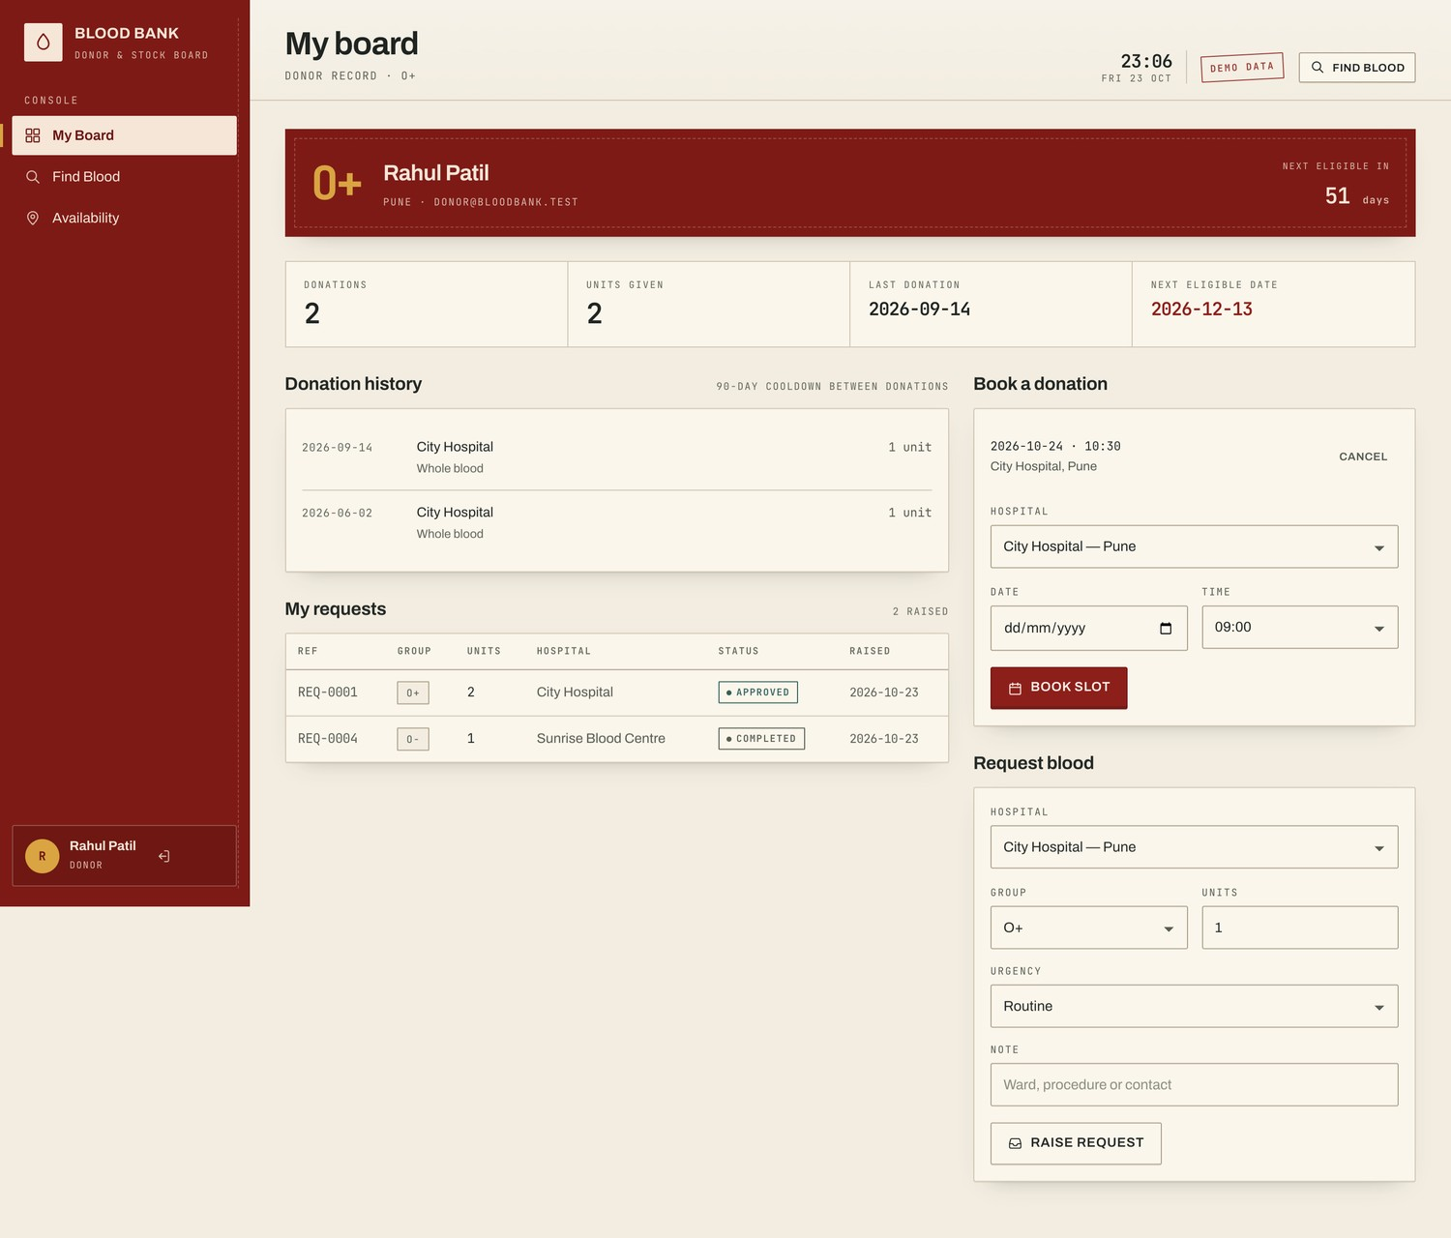
Fig. 4.1 Login Page
This is the entry screen for donors and administrators. Users enter their email and password; the server verifies the password hash, creates a signed session and redirects the user according to their role.
Features: email and password inputs, CSRF-protected form, password hashing, role-based redirect and clear error messages.
Result: A valid administrator reaches /admin, a valid donor reaches /dashboard, and an invalid or missing CSRF token is rejected with HTTP 400.
4.2 Public Landing Page
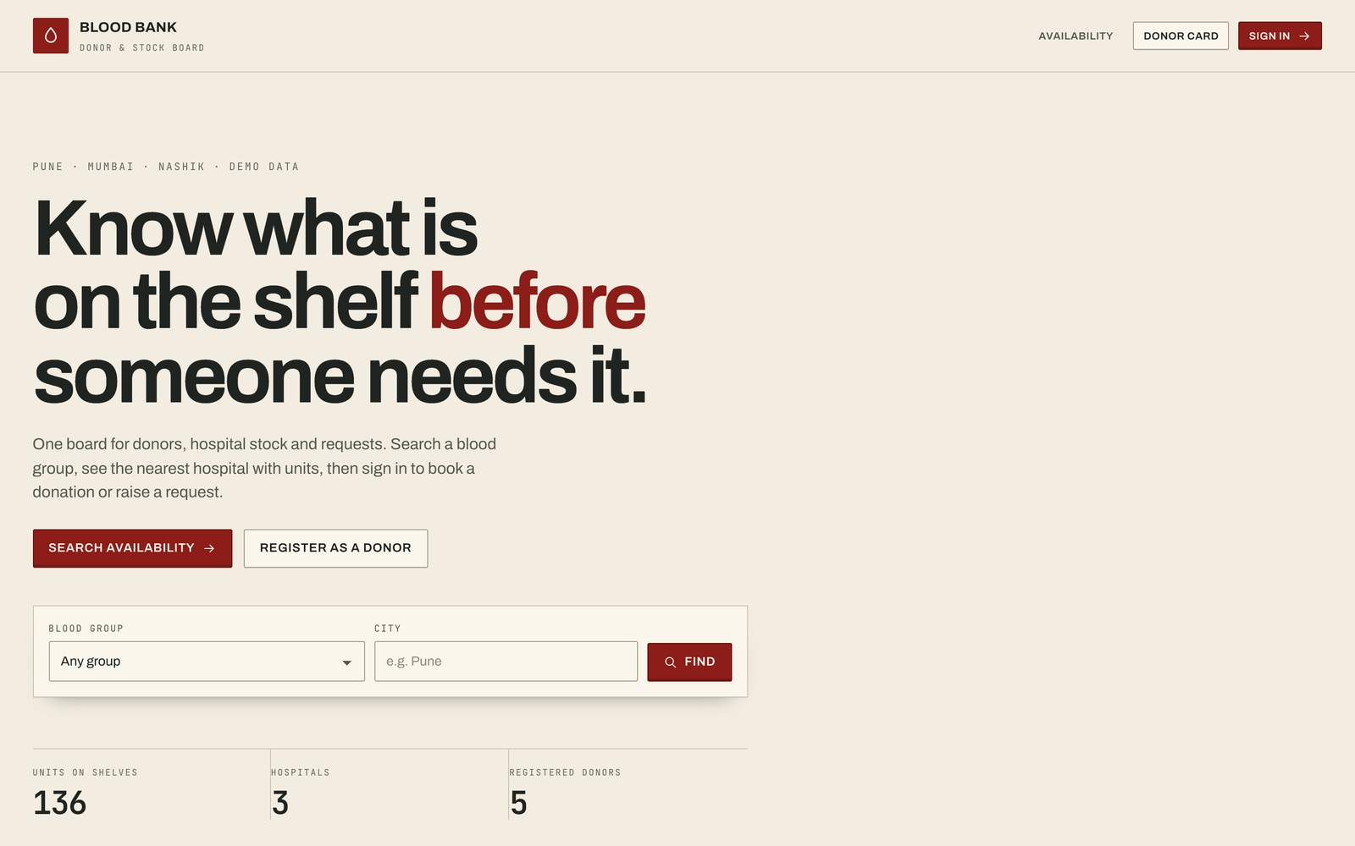
Fig. 4.2 Public Landing Page
The landing page states the problem and gives visitors two immediate actions: search for availability or register as a donor. The board metaphor is established before any data is shown, and group-level stock totals are visible without signing in.
Features: public availability search, donor registration, live stock summary, low-stock signalling and a clear route to sign in.
Result: A visitor can check whether blood is available in a city before travelling, while donor and administrator actions remain protected.
4.3 Availability Search
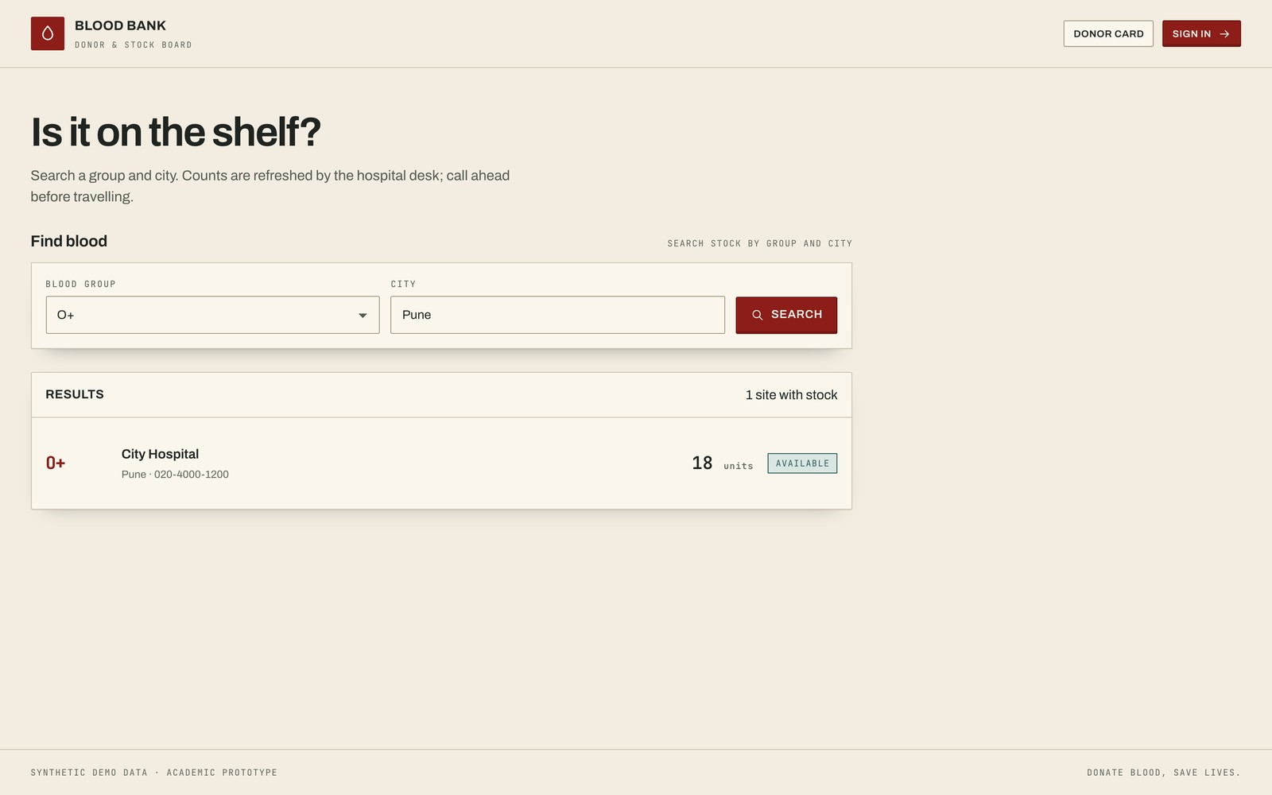
Fig. 4.3 Availability Search for O+ in Pune
The search page returns hospital rows for the selected blood group and city. Each row includes the hospital name, city, phone number and available units, so the visitor can act on the result immediately.
Features: blood-group filter, city filter, joined hospital data, positive-stock filter and parameterized SQL.
Result: The O+ search in Pune returned City Hospital with its contact number. An injection-style city string returned zero rows and did not expose or alter data.
4.4 Donor Dashboard
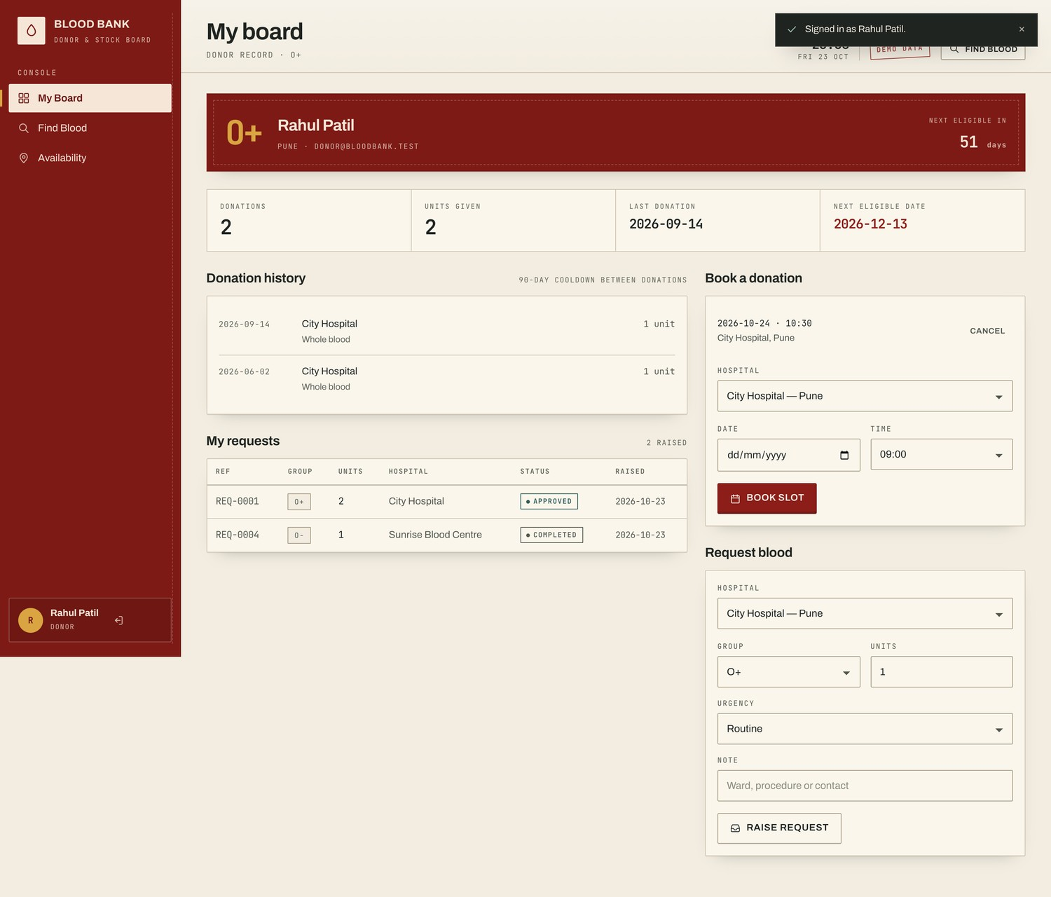
Fig. 4.4 Donor Dashboard
The donor dashboard answers the questions a donor actually asks: when did I last donate, when can I donate again, what have I given, and what is happening to my request?
Features: 90-day eligibility strip, donation history, appointment booking, personal request form, request history and appointment cancellation.
Result: A donor can see the next eligible date, book a future slot and review only their own records. Ownership checks prevent cancellation of another donor's appointment.
4.5 Administrator Dashboard
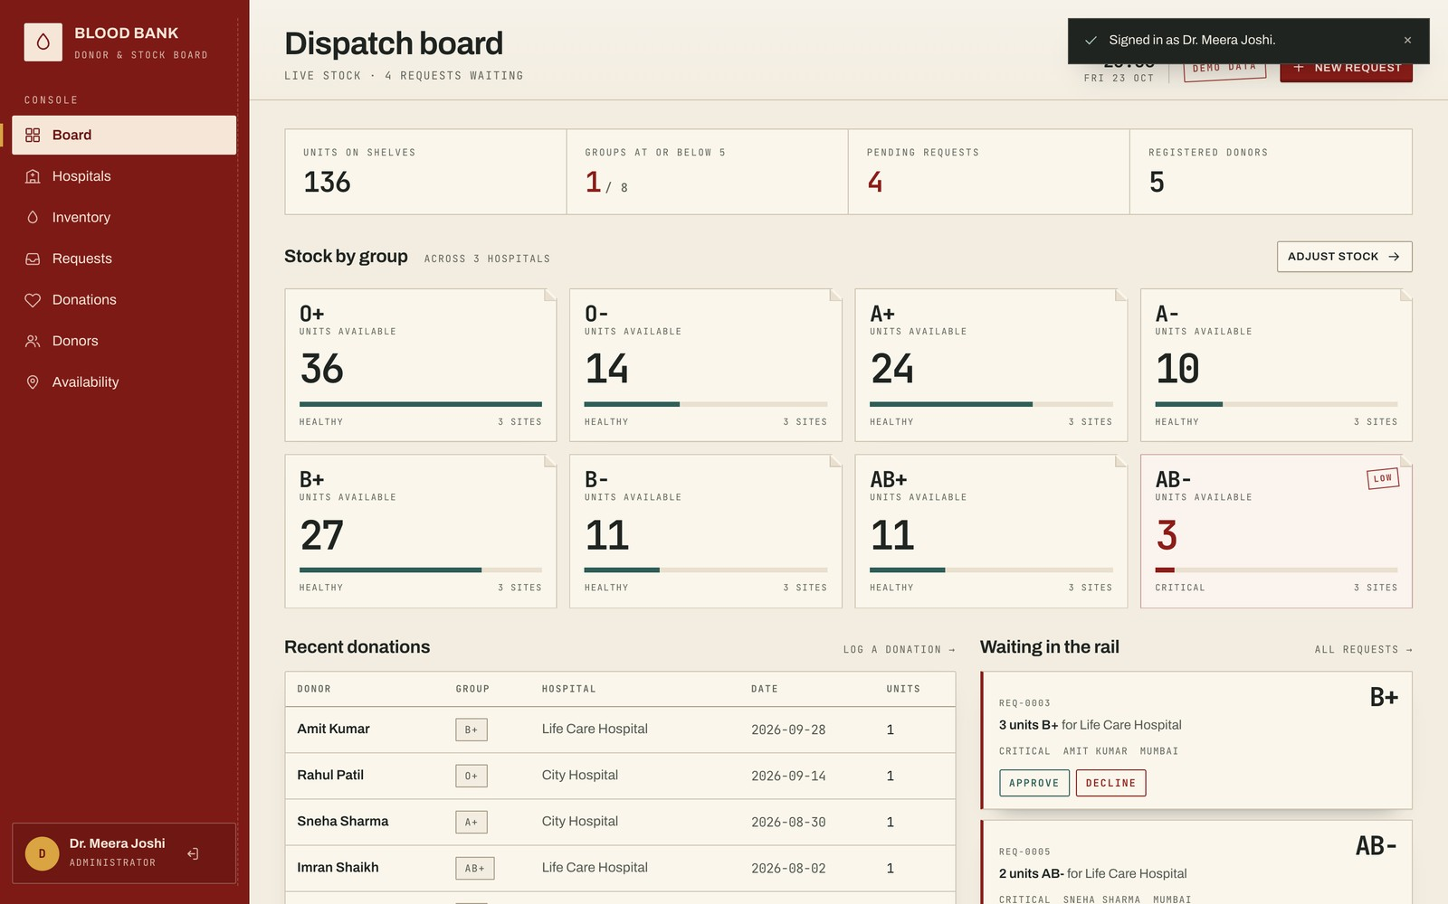
Fig. 4.5 Administrator Dispatch Board
The administrator board is the first viewport after login. Group stock is arranged as split-flap strips, critical groups are marked in red, and pending requests appear as paper slips. The right column shows recent donations and hospital totals.
Features: stock strips, critical-group signalling, pending request rail, recent donations, hospital stock totals and top-level statistics.
Result: An administrator can understand stock and pending work at a glance and move directly to the request queue or inventory page.
4.6 Request Management and Status Actions
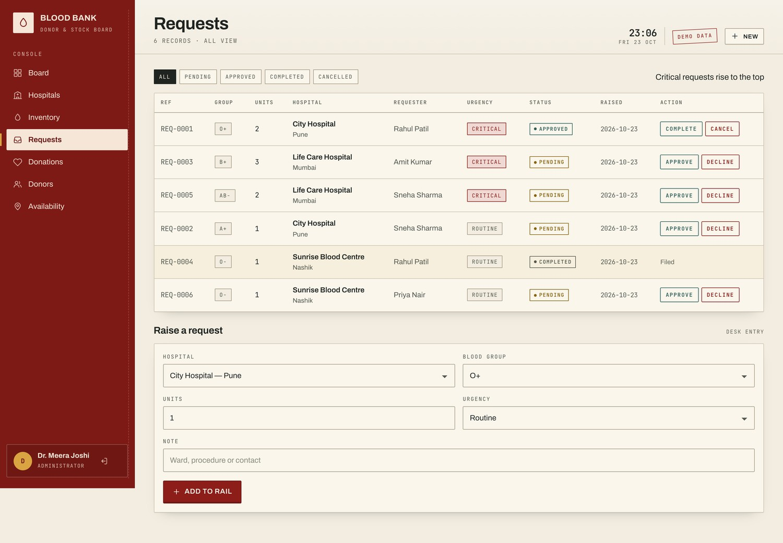
Fig. 4.6 Request Queue with Status Actions
The request page exposes the full queue with status filters. Pending requests offer Approve and Decline; approved requests offer Complete and Cancel. Completing a request is the only action that changes stock.
Features: status filters, permitted actions by state, server-side transition checks, stock validation, confirmation toast and retained terminal rows.
Result: Approval returned HTTP 200, repeat completion returned HTTP 409, and completing a valid request reduced A+ stock from 12 to 11 units.
4.7 Mobile Responsive Interface
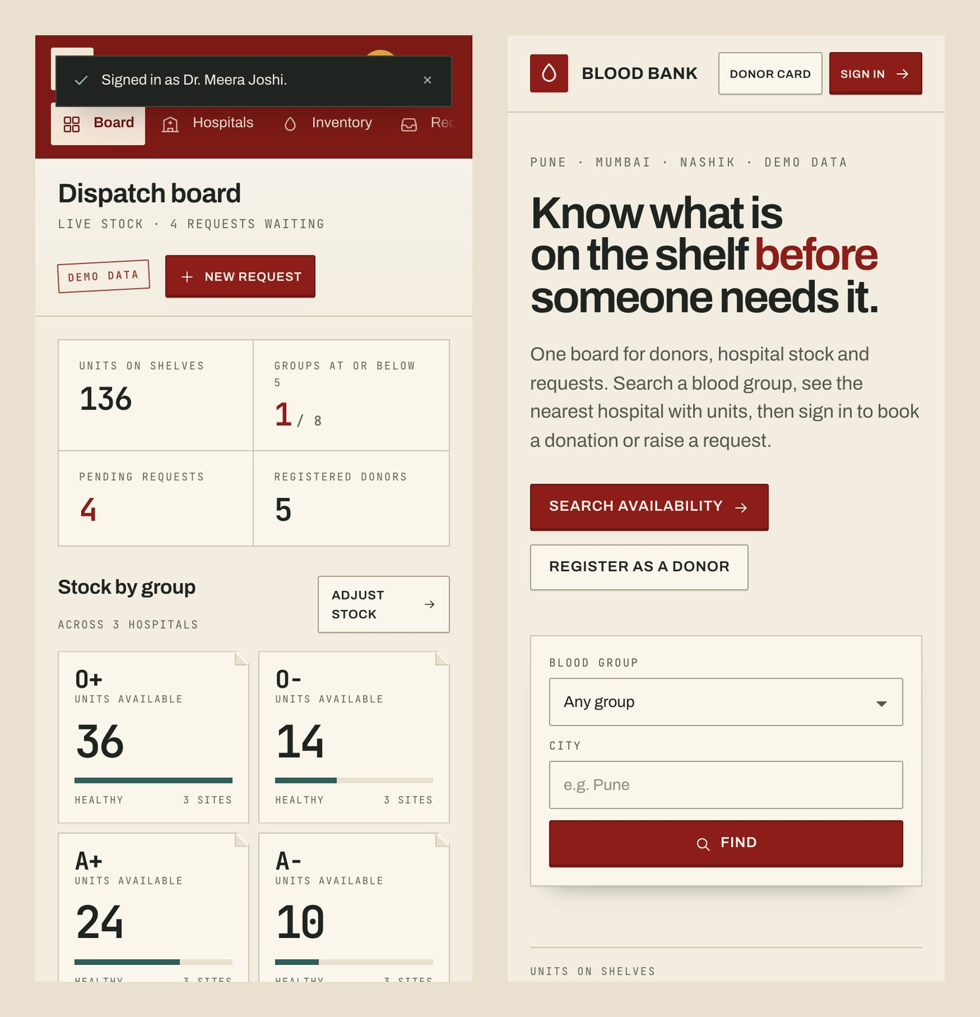
Fig. 4.7 Mobile Layout at 390×844
The mobile layout keeps the same information architecture rather than hiding core actions. The rail becomes a compact header with a scrollable tab strip, the board collapses to a single column and stock strips become two-up.
Features: responsive navigation, one-column board, internally scrolling tables, 40-pixel action targets and a reduced-motion path.
Result: Browser checks found no page-level horizontal overflow at 390 pixels, sampled text met WCAG AA contrast, and reduced motion revealed content immediately.
4.8 Overall System Result
All planned modules were implemented and exercised: registration, login, public search, donor dashboard, administrator board, hospital and inventory management, donation logging, request processing and appointments.
- The six-table relational schema is created automatically and enforces primary keys, foreign keys, uniqueness and check constraints.
- Fourteen functional and security checks were executed, including missing CSRF, role denial, invalid state transitions and injection-style search.
- Browser checks covered desktop and mobile overflow, sampled contrast, reduced motion and loaded assets.
- Stock changed only after a valid completion, and the database row count changed only after a successful request or appointment insert.
The prototype is not an exhaustive penetration test or a clinical validation. It is a working demonstration that database constraints, server-side validation and interface state can be kept consistent through one application.
CHAPTER - 5
CONCLUSION
The Online Blood Bank and Donor Management System demonstrates how a relational database can support a time-sensitive healthcare workflow. The six-table schema captures users, hospitals, inventory, requests, donations and appointments with explicit primary keys, foreign keys, uniqueness rules and check constraints. The application gives each role a focused surface: donors can find blood, check eligibility and manage their contribution history; administrators can see the shelf, clear the request rail and record donations.
From a DBMS perspective, the project applies relational schema design, normalisation, foreign-key integrity, unique and check constraints, indexes and multi-table joins. The application uses parameterized SQL throughout, commits each write, and performs stock validation before deducting units. Authentication, role guards and CSRF protection show that database quality must be paired with application-level security; a correct schema alone does not prevent an unauthorised action.
The interface contributes to the result. A conventional dashboard would display the same data, but the dispatch-board language gives the administrator a mental model that matches the work: stock is a strip, a request is a slip, approval is a stamp and completion is a deduction. The mobile layout keeps the same actions available on a phone, and the reduced-motion path keeps the content usable without animation.
The prototype has clear limits. It uses SQLite, which is suitable for a single-node demonstration but not for concurrent multi-branch operation. It does not verify clinical compatibility, screen donated blood, confirm donor identity or replace hospital procedures. It also lacks email notifications, audit logging, rate limiting and production backup. Future work can migrate the schema to MySQL or PostgreSQL, add versioned migrations, audit trails, notifications, pagination and a CI test pipeline.
Overall, the project meets its academic objective: it turns a database exercise into a coherent, working application and shows how schema constraints, server-side validation, role-based access and interface craft combine to produce trustworthy behaviour. With the migration and operational work described above, the same structure could serve as the foundation for a larger blood-bank information system.

