# Appendix

Appendix 1.1 - Screenshot of email for client requirements

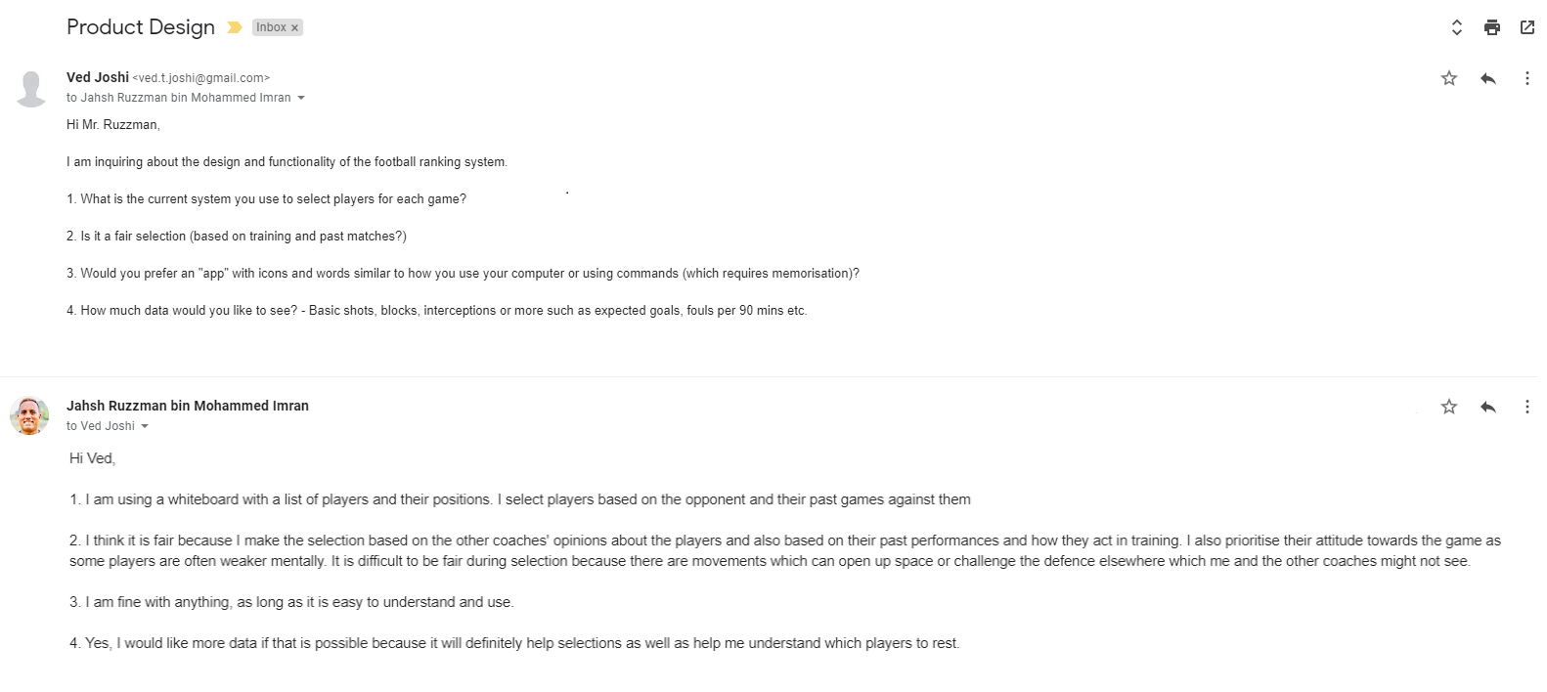

Appendix 1.2 - Image of current system (paper + names)

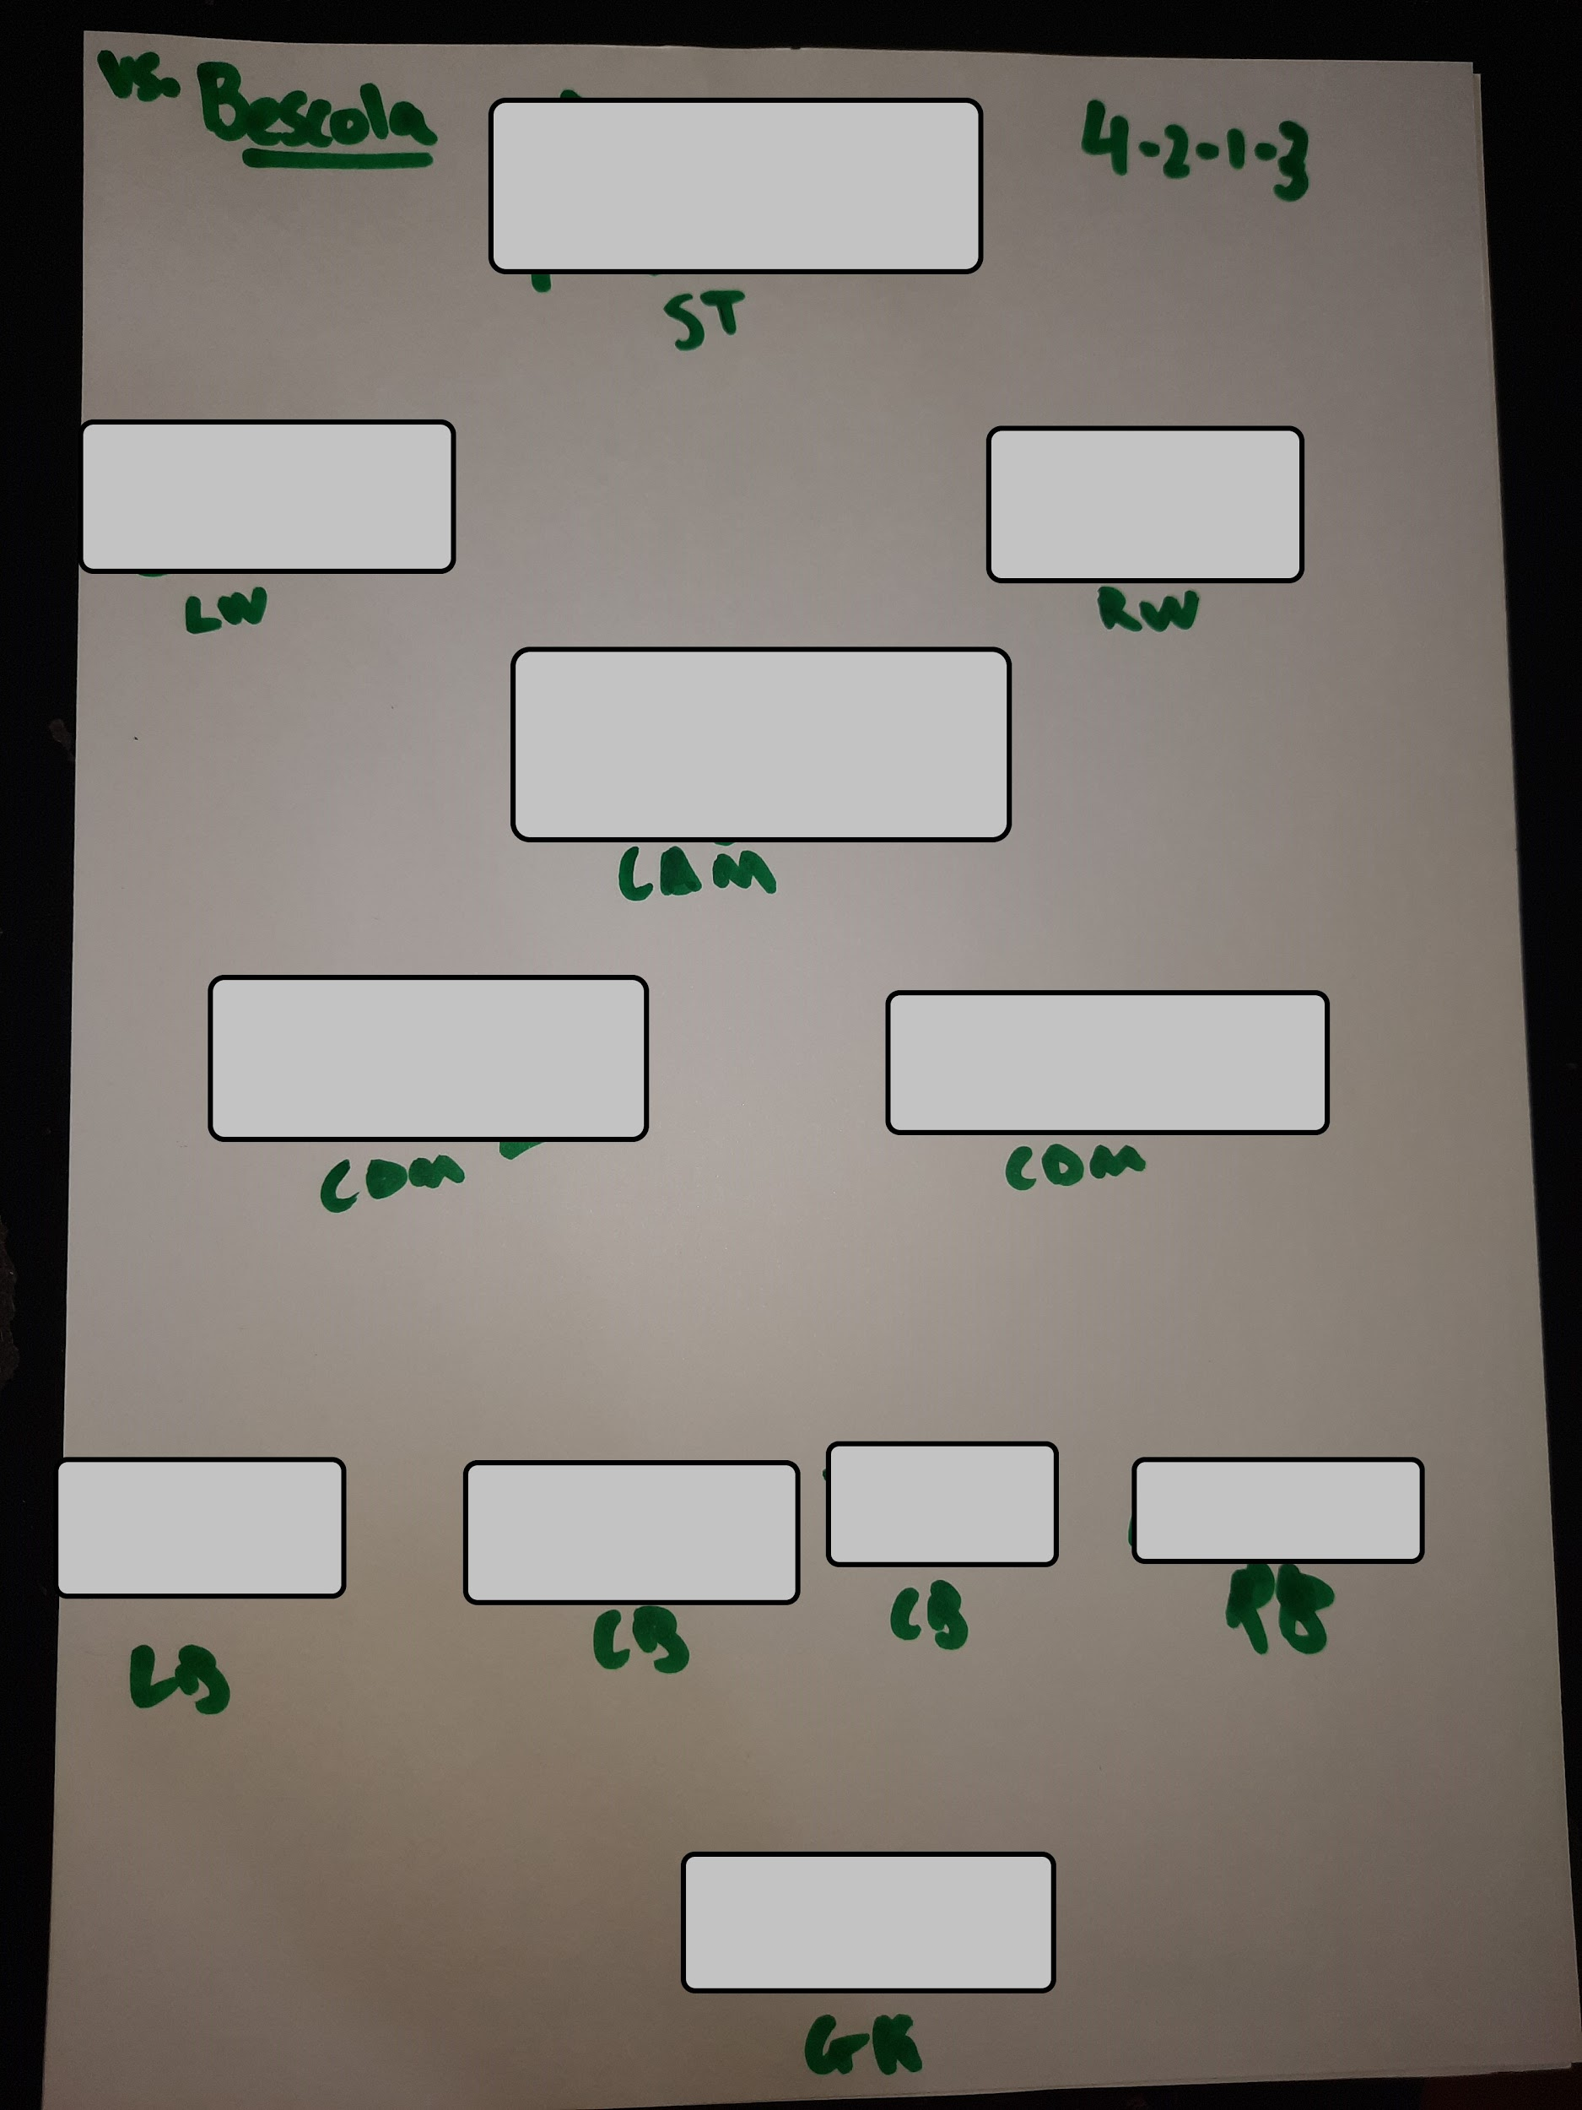

Appendix 1.3 - Response to questionnaire for feedback from the client

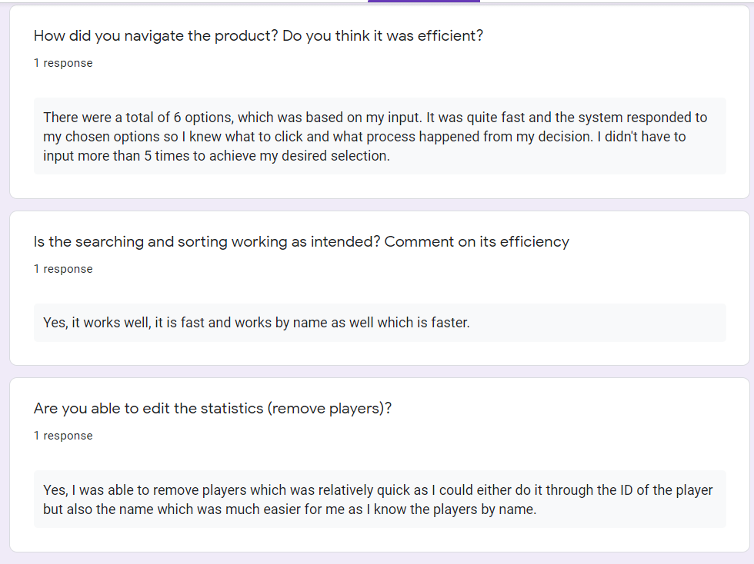

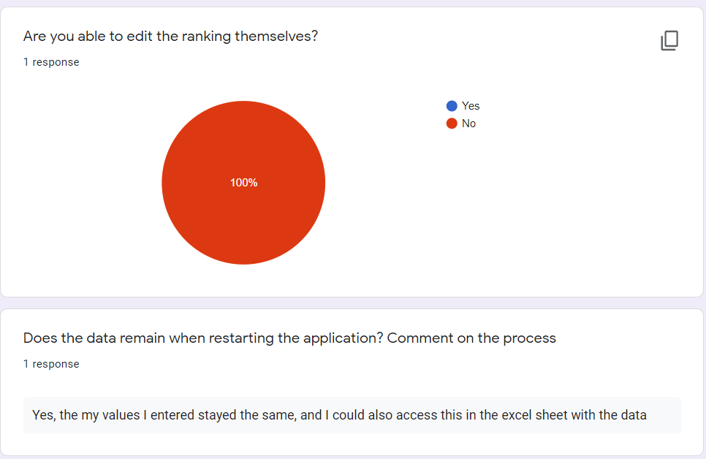

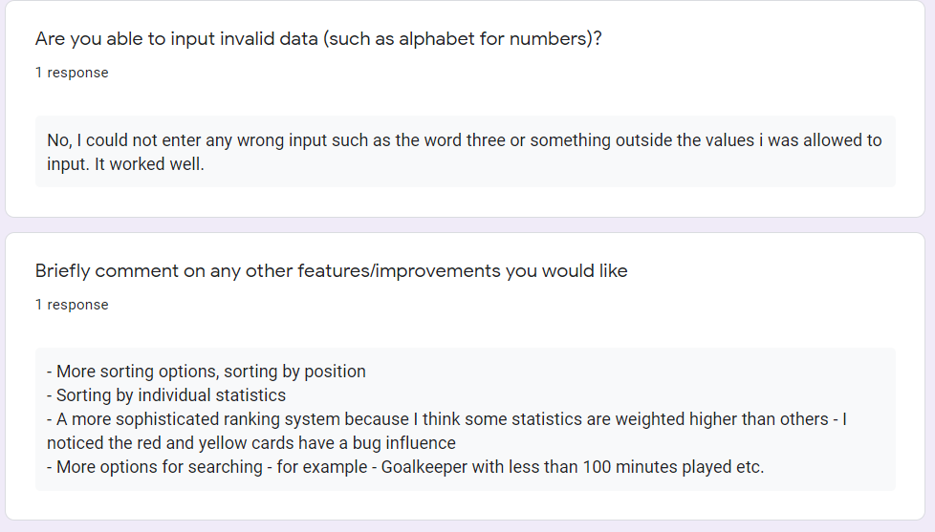

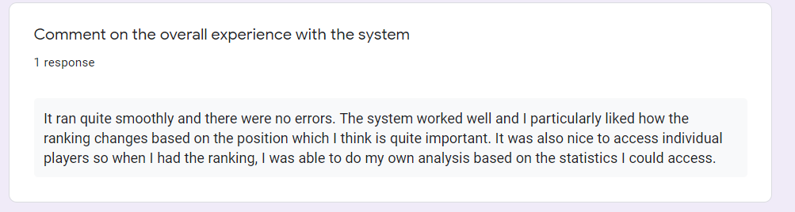

Works Cited:

Atkins, John. *JAVA Input Validation for Number Range and Numeric Values Only with Counter*. https://www.xspdf.com/resolution/52140855.html. Accessed 1 Feb. 2021.

*Binomial.Java*. https://introcs.cs.princeton.edu/java/36inheritance/Binomial.java.html. Accessed 1 Feb. 2021.

‘Collections.Sort() in Java with Examples’. *GeeksforGeeks*, 30 Oct. 2016, https://www.geeksforgeeks.org/collections-sort-java-examples/.

Dimitriou, Kostas, and Markos Hatzitaskos. *Core Computer Science: For the IB Diploma Program (International Baccalaureate)*. Express Publishing, 2018.

‘Java Try-Catch - Javatpoint’. *Www.Javatpoint.Com*, https://www.javatpoint.com/try-catch-block. Accessed 1 Feb. 2021.

‘Linear Search in Java - Javatpoint’. *Www.Javatpoint.Com*, https://www.javatpoint.com/linear-search-in-java. Accessed 1 Feb. 2021.

Ruzzman, Jahsh. *Client Interview for Development*. 20 Oct. 2020.

Shah, App. ‘In Java How to Save and Load Data from a File - Simple Production Ready Utility for File I/O Read-Write Operation • Crunchify’. *Crunchify*, 11 Oct. 2016, https://crunchify.com/java-saving-and-loading-data-from-a-file-simple-production-ready-utility-for-file-readwrite-operation/.

*The Switch Statement (The JavaTM Tutorials > Learning the Java Language > Language Basics)*. https://docs.oracle.com/javase/tutorial/java/nutsandbolts/switch.html. Accessed 1 Feb. 2021.