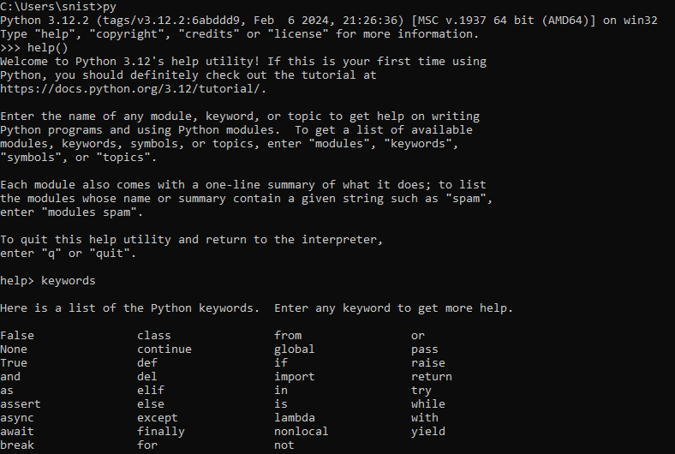0Week 1 help_ keywords: calculator:

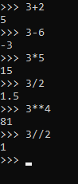  
Week 2

Books:

books.png

Miles:

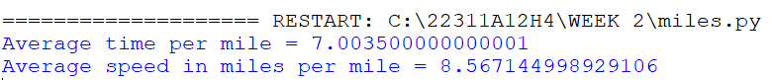

Volume:



Week 3

7a:



7b:

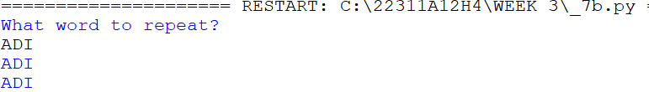

7c:

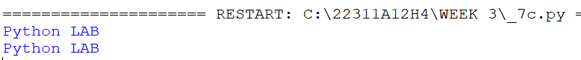

7d:

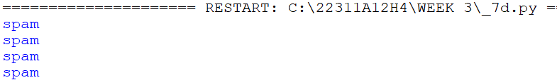

8:

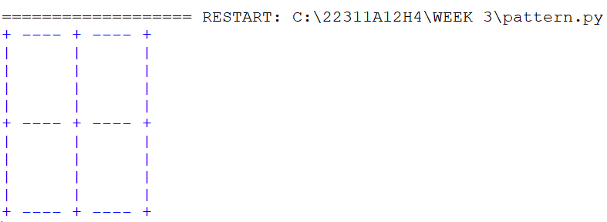

9:

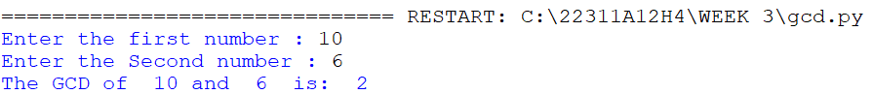

10:

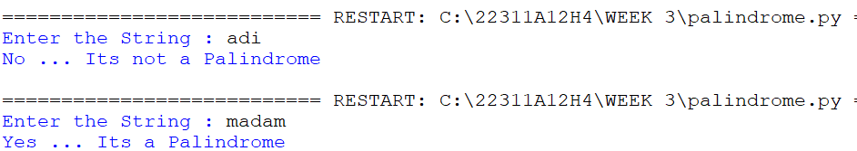

---------------------PRINT DONE---------------------

WEEK 4

11:

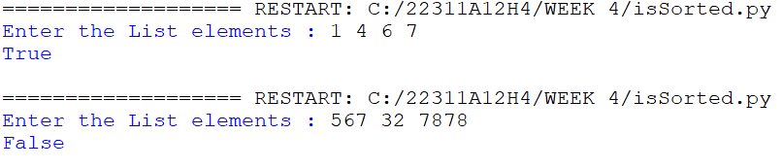

12:

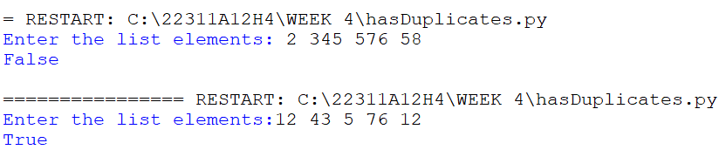

13: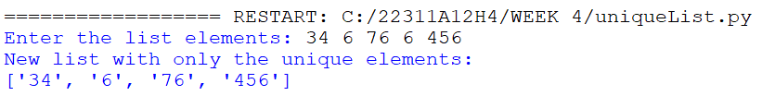

15:

