ZyvanaCart — Indian E-commerce Sales & Profitability Investigation.

Project Overview
Project: ZyvanaCart E-commerce Sales & Profitability Investigation.
Business Problem: Improve ZyvanaCart's current 8.44% profitability by identifying the key drivers of sales and profit and uncovering opportunities to improve profitability.
Core Objective: Identify data-driven opportunities to improve profitability while maintaining healthy sales performance.
End-to-End Approach: Excel → SQL → Python → Power BI → Business Recommendations.

Project Positioning
ZyvanaCart is a mid-sized Indian e-commerce retailer selling Clothing, Electronics, and Furniture across multiple Indian states and cities.
The business generates healthy sales, but management wants to improve its current profitability and lacks a consolidated view of what is driving sales, where profit is being generated, and where strong sales are not translating into proportionally strong profitability.
Management therefore needs to understand:
- Where are sales coming from?
- Which categories and sub-categories generate the most profit?
- Are the highest-sales categories also the most profitable?
- Which customers and markets contribute significantly to sales?
- Which payment methods dominate business activity?
- Which states and cities contribute significantly to revenue and orders?
- Does high sales volume translate into healthy profit margins?
- How are sales and profitability changing over time?
This creates a need for an end-to-end analysis of ZyvanaCart's transactional data to identify the key drivers of sales and profitability and uncover opportunities for improving overall business profitability.

1. The Business Problem
ZyvanaCart management has observed healthy sales but a profitability rate that needs improvement. The business currently generates approximately ₹4.38 lakh in sales and ₹36.96K in profit, resulting in an overall profit margin of 8.44%.
Management wants to understand what is driving this current profitability level and where opportunities exist to improve the profit margin without compromising healthy sales performance.
The central business question is:
“Why is ZyvanaCart generating healthy sales but only an 8.44% profit margin, and what can management do to improve profitability?”
To answer this, the analysis will investigate:
- Sales and profit performance
- Category and sub-category profitability
- Customer and order contribution
- Geographic performance
- Payment-method activity
- Historical sales and profitability trends
- Areas where high sales do not correspond to strong profitability
The analysis will use Excel, SQL, Python, and Power BI to examine the transactional data, identify profitability drivers and improvement opportunities, and translate the findings into actionable business recommendations.
Final objective
To identify data-driven opportunities that can help ZyvanaCart improve its current profitability rate and support more profitable, sustainable growth.

2. Business Objectives
The primary objective of this project is to identify the key drivers of ZyvanaCart's current 8.44% profit margin and uncover data-driven opportunities to improve overall profitability while maintaining healthy sales performance.
To achieve this, the analysis will:
- Analyze overall sales and profitability to establish the current financial performance and identify the gap between revenue generation and profit generation.
- Evaluate category and sub-category performance to identify high-revenue, high-profit, and low-profitability segments and determine where product focus should be optimized.
- Analyze customer and order contribution to identify high-value customers and understand customer concentration across sales and profitability.
- Evaluate geographic performance across states and cities to identify markets contributing significantly to sales, orders, and profitability.
- Analyze payment-method activity to understand customer payment behavior and identify dominant payment channels.
- Analyze sales and profitability trends over time to identify changes in business performance and areas requiring management attention.
- Compare sales contribution with profit contribution to identify areas where strong sales volume does not translate into proportionally strong profitability.
- Develop actionable, data-driven recommendations focused on product, customer, and market prioritization that could help improve ZyvanaCart's current profitability rate and support sustainable growth.

3. Dataset & Data Model
Dataset Overview
The ZyvanaCart analysis is based on transactional e-commerce data containing 1,500 line-item records across 500 unique orders and 336 distinct customers.
The dataset is divided into two related tables:
Orders Table
Column | Description
Order ID | Unique identifier for each order
Order Date | Date on which the order was placed
CustomerName | Customer associated with the order
State | Customer/order state
City | Customer/order city
Details Table
Column | Description
Order ID | Identifier linking the transaction to the Orders table
Amount | Sales/revenue generated
Profit | Profit generated
Quantity | Units sold
Category | Product category
Sub-Category | Product sub-category
PaymentMode | Payment method used
Data Relationship
The two tables are connected through Order ID.
- The Orders table contains order-level information.
- The Details table contains transaction/line-item-level information.
- A single Order ID can appear multiple times in the Details table because one order may contain multiple products or line items.
- This relationship allows sales and profitability data to be analyzed alongside customer, date, city, and state information.
Data Structure
Orders
Order ID → Order Date → Customer → State → City
Details
Order ID → Category → Sub-Category → Quantity → Amount → Profit → Payment Mode
Relationship:
Orders[Order ID] ↔ Details[Order ID]
Data Quality & Validation
Before analysis, the dataset will be validated for:
- Missing or invalid values
- Duplicate records
- Correct data types
- Consistency of Order ID across both tables
- Accuracy of sales and profit calculations
- Correct relationship between order-level and line-item-level data
The validated dataset will then serve as the foundation for the Excel, SQL, Python, and Power BI analyses.

4. Excel Analysis & Initial Business Findings
The Excel stage serves as the initial business analysis and data validation layer of the project. The objective is to establish a reliable baseline of ZyvanaCart's sales and profitability performance before moving into deeper SQL and Python analysis.
The analysis will focus on:
- Overall sales, profit, profit margin, orders, customers, and quantity sold
- Sales and profit performance by category and sub-category
- Top-performing states and cities
- Customer and order contribution
- Payment-method activity
- Initial comparison of sales contribution against profit contribution
- Identification of segments requiring deeper profitability investigation
Excel Analysis Deliverables
The Excel workbook will include:
- Data validation and cleaning
- Lookup-based analysis using XLOOKUP/VLOOKUP and INDEX-MATCH
- Conditional formatting
- PivotTables and PivotCharts
- Interactive filtering using slicers and data-validation drop-downs
- KPI summaries
- Interactive Excel dashboard
Initial Business Findings
The Excel analysis will establish the initial performance baseline and highlight areas requiring further investigation.
Key baseline metrics include:
- Total Sales: ₹4,37,771
- Total Profit: ₹36,963
- Profit Margin: 8.44%
- Unique Orders: 500
- Unique Customers: 336
- Total Line Items: 1,500
- Total Quantity Sold: 5,615
The initial analysis will specifically examine whether high sales contribution is consistently associated with high profit contribution, helping identify potential profitability gaps for deeper analysis in the subsequent SQL and Python stages.

5. SQL Analysis
The SQL stage will move beyond the initial Excel overview and investigate profitability patterns, concentration, and business opportunities that are not immediately visible from high-level summaries.
SQL Business Questions
1. Sales-to-profit mismatch
Which sub-categories generate substantial sales but contribute disproportionately less profit?
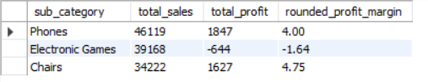
Key Finding
Phones, Electronic Games, and Chairs generate substantial sales but have relatively weak profit margins. Electronic Games is the most concerning, with ₹39,168 in sales but a -1.64% profit margin.
Business Interpretation
The findings indicate that high sales volume does not necessarily translate into strong profitability. These sub-categories should be prioritized for further profitability investigation.
2. Profitability opportunity segments
Which sub-categories have both meaningful sales contribution and below-average profit margins, making them potential areas for profitability improvement?
Key Finding
Phones, Electronic Games, and Chairs combine meaningful sales with below-average profit margins. Electronic Games stands out as the highest-priority segment due to its negative profit margin of -1.64%.
Business Interpretation
These sub-categories represent potential opportunities for margin improvement, with priority given to segments where stronger profitability could be achieved without compromising their meaningful sales contribution.
3. Customer profitability
Which customers generate high sales but relatively low profit?
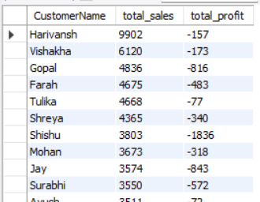
Key Finding
38 customers in the identified segment generate negative profit, despite contributing meaningful sales. Harivansh has the highest sales at ₹9,902 but generates -₹157 profit, while Shishu records the largest loss at -₹1,836.
Business Interpretation
The findings indicate that sales contribution alone does not reflect customer profitability. These customers should be investigated further to identify opportunities to improve the profitability of high-value customer relationships.
4. High-value customer contribution
What percentage of total sales and profit is generated by the top 10% of customers?
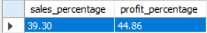
Key Finding
The top 10% of customers contribute 39.30% of total sales and 44.86% of total profit, indicating a strong concentration of business value among a relatively small customer segment.
Business Interpretation
ZyvanaCart's profitability is significantly influenced by its highest-value customers. Maintaining and strengthening relationships with these customers should therefore be a priority for sustainable profitability.
5. Customer order economics
Which customers place multiple orders but generate relatively low profit per order?
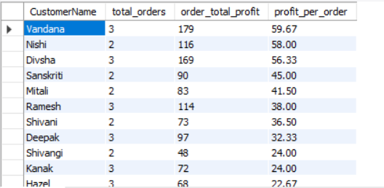
Key Finding: Several repeat customers generate low or negative profit per order, with Chirag recording the lowest at -₹365.50 per order.
Business Interpretation: Repeat orders do not always translate into profitable customers, highlighting opportunities to improve customer-level profitability.
6. Geographic profitability gap
Which states generate significant sales but have below-average profit margins?
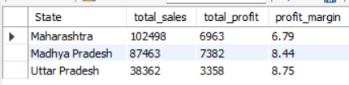
Key Finding: Maharashtra has the highest sales at ₹1,02,498 but only a 6.79% profit margin, below the overall average.
Business Interpretation: Maharashtra represents a key profitability improvement opportunity because of its strong sales contribution but relatively weak margin.
7. City-level opportunity analysis
Which cities combine meaningful order volume with weak profitability?
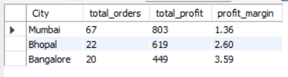
Key Finding
Mumbai, Bhopal, and Bangalore combine above-average order volume with below-average profit margins, making them priority cities for profitability improvement.
Business Interpretation
These cities contribute meaningful business activity but generate relatively weak profitability, indicating opportunities to improve margins without affecting order volume.
8. Profit concentration
What percentage of total profit is generated by the top-performing sub-categories and customers?
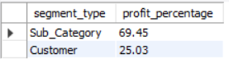
Key Finding
The top 5 sub-categories generate 69.45% of total profit, while the top 5 customers contribute 25.03%.
Business Interpretation
Profit is highly concentrated among a few sub-categories, making them critical to ZyvanaCart's overall profitability.
9. Category-level customer behavior
Which customers contribute the most profit within each product category?
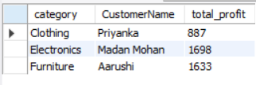
Key Finding
Priyanka, Madan Mohan, and Aarushi are the highest-profit customers in Clothing, Electronics, and Furniture respectively.
Business Interpretation
These customers are key contributors to category-level profitability and can be prioritized for customer retention and engagement.
10. Payment behavior vs profitability
Do different payment methods show meaningful differences in average order value or profit contribution?
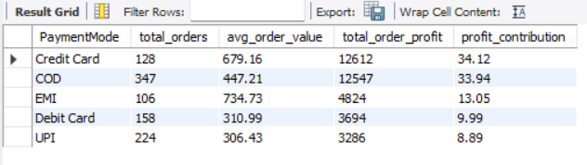
Key Finding
Credit Card generates the highest profit contribution at 34.12%, while EMI has the highest average order value at ₹734.73.
Business Interpretation
Payment methods show meaningful differences in order value and profit contribution, with Credit Card and EMI customers contributing relatively stronger value.
11. Low-profit high-volume segments
Which segments have high quantities sold but comparatively low profit, indicating potential opportunities to improve the profitability of high-volume sales?
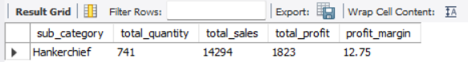
Key Finding
Hankerchief is the only sub-category identified as high-volume but relatively low in total profit, with 741 units sold generating ₹1,823 in profit.
Business Interpretation
Despite its strong sales volume, Hankerchief contributes relatively limited total profit. This makes it a potential area for profitability improvement, where management could review pricing, product mix, or other available profitability drivers.
12. Profitability ranking
Rank customers and sub-categories based on profit contribution to identify the strongest and weakest contributors.
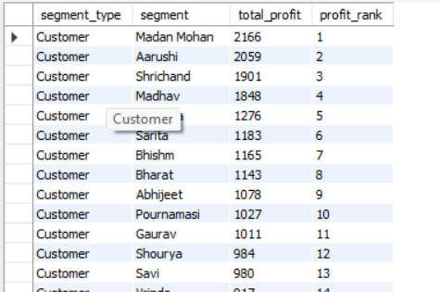
Key Finding
Madan Mohan is the top-profit customer (₹2,166), while Printers is the top-profit sub-category (₹8,606).
Business Interpretation
Prioritize high-profit customers and sub-categories while reviewing loss-making segments.

6. Python Analysis — EDA & Deeper Investigation
The Python stage will build on the findings from Excel and SQL by performing deeper exploratory data analysis (EDA) to uncover patterns, relationships, concentration, and unusual observations that may influence ZyvanaCart's profitability.
Python Business Questions
1. Profit distribution
How is profit distributed across transactions, and is profitability concentrated in a small number of transactions?
Top 10% profitable orders → 46.34% of total positive profit
2. Sales–profit relationship
How strongly are sales and profit related, and do higher-value transactions consistently generate higher profit?
Sales ↔ Profit correlation = 0.33
Plus scatter plot. This directly addresses whether higher-value orders consistently generate higher profit. ✅
3. Quantity–profit relationship
Does selling higher quantities translate into proportionally higher profit?
Quantity ↔ Profit correlation = 0.20
Plus scatter plot. Good evidence that quantity alone isn't a strong predictor of profit. ✅
4. Outlier detection
Are there unusually high- or low-value sales/profit transactions that could distort the overall profitability picture?
- 33 sales outliers
- 94 profit outliers
- Highest profit outliers
- Lowest profit outliers
5. Customer profitability patterns
What patterns distinguish high-value/high-profit customers from customers generating high sales but comparatively lower profit?
- High-sales + low-margin customers
- High-sales + high-profit customers
along with sales, profit, quantity and order activity.
6. Profit concentration
How concentrated is ZyvanaCart's total profit among customers, categories, and sub-categories?
- Customers → 42.61%
- Categories → 36.05%, 35.61%, 28.34%
- Sub-categories → 38.52%
7. Category profitability behavior
How does profitability vary within each category rather than only comparing category totals?
- Average profit
- Median profit
- Profit variation
- Average margin
- Lowest/highest profit
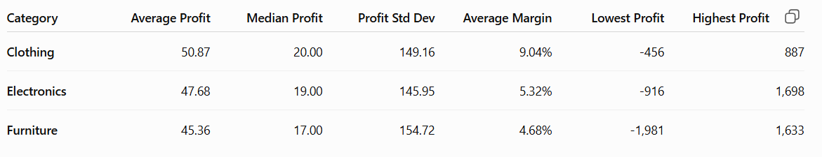
8. Low-margin high-sales investigation
What characteristics are common among segments generating substantial sales but relatively weak profit margins?
- Saree
- Phones
- Electronic Games
- Chairs
as high-sales/weak-margin segments.
Electronic Games: -1.64% margin is particularly actionable.
9. Customer segmentation
Can customers be grouped based on their sales, order activity, quantity, and profit contribution to identify high-value and improvement segments?
- 93 High Value
- 43 Profit Improvement
- 56 Profit Efficient
- 44 Low Value
10. Relationship and pattern analysis
What relationships between quantity, sales, profit, customer activity, and product segments can provide additional evidence for profitability improvement opportunities?
- Sales ↔ Quantity = 0.80
- Sales ↔ Profit = 0.43
- Quantity ↔ Profit = 0.32
- Orders ↔ Profit = 0.25

7. Power BI Dashboard & Management Insights
The Power BI stage will transform the key findings from the Excel, SQL, and Python analysis into an interactive management dashboard focused on ZyvanaCart's sales performance and profitability.
The dashboard will enable management to:
- Monitor total sales, profit, profit margin, orders, customers, and quantity sold.
- Compare sales and profitability across categories and sub-categories.
- Identify high-sales but low-profitability segments.
- Analyze customer contribution and profitability.
- Evaluate state and city-level business performance.
- Examine payment-method activity.
- Drill down from overall performance into specific business segments.
- Interactively filter the analysis using slicers and other dashboard controls.
The dashboard will emphasize the relationship between revenue generation and profitability, allowing management to quickly identify areas requiring attention and evaluate where profitability improvement opportunities exist.
Purpose of the Power BI Stage
Convert the analytical findings into an interactive management reporting solution that makes profitability drivers and improvement opportunities easy to monitor and act upon.

8. Business Recommendations & Profitability Improvement
The final stage will translate the analytical findings into data-driven business recommendations aimed at improving ZyvanaCart's current 8.44% profit margin.
Recommendations will be based on the specific profitability patterns identified across:
- Categories and sub-categories
- Customers
- States and cities
- Sales and profit contribution
- High-sales, low-margin segments
- Customer and profit concentration
- Payment-method activity
The recommendations may focus on:
- Prioritizing higher-margin products and sub-categories.
- Reviewing high-sales but low-profitability segments.
- Focusing resources on high-value and profitable customer segments.
- Identifying geographic markets with stronger profitability potential.
- Reviewing business segments where sales volume is high but profit contribution is relatively weak.
- Using the identified profitability drivers to support more profitable growth decisions.
Each recommendation will be connected to an analytical finding, rather than being based on assumptions.
Expected Business Impact
The objective is not to claim that the analysis itself increased profit, but to identify actionable opportunities that, if implemented effectively, could improve ZyvanaCart's current profit margin and support sustainable profitable growth.
Final Objective
Use the combined findings from Excel, SQL, Python, and Power BI to provide management with clear, evidence-based actions for improving profitability from the current 8.44% level.

