Article

HOSPITAL MANAGEMENT SYSTEM

Adithya S.T (18MIS1025) 1, Harishkumar M (18MIS1031) 2 ,Praveen G.K. (18MIS1034)2,* and Dhilipkumar M (18MIS1112)

|  |
| --- |
| **Citation:** Lastname, F.; Lastname, F.; Lastname, F. Title. *Sensors* **2022**, *22*, x. https://doi.org/10.3390/xxxxx  Academic Editor: Firstname Lastname  Received: date  Accepted: date  Published: date  **Publisher’s Note:** MDPI stays neutral with regard to jurisdictional claims in published maps and institutional affiliations.    **Copyright:** © 2022 by the authors. Submitted for possible open access publication under the terms and conditions of the Creative Commons Attribution (CC BY) license (https://creativecommons.org/licenses/by/4.0/). |

1 Affiliation 1; e-mail@e-mail.com

2 Affiliation 2; e-mail@e-mail.com

**\*** Correspondence: e-mail@e-mail.com; Tel.: (optional; include country code; if there are multiple corresponding authors, add author initials)

**Abstract:** The purpose of the project entitled as “Hospital Management System” is to computerize the Front Office Management of Hospital to develop software which is user friendly simple, fast, and price – effective. It deals with the gathering of patient’s information, diagnosis details, etc. Traditionally, it was done manually. The main function of the system is register and store patient details and doctor details and retrieve these details as and when required, and also to control these details meaningfully System input contains patient details, diagnosis details, while system output is to urge these details on to the screen. The Hospital Management System are often entered employing a username and password. It is accessible either by an administrator or receptionist. Only they will add data into the database. The data can be retrieved easily. The data are well protected for private use and makes the info processing in no time .

..

**Keywords:** keyword 1; keyword 2; keyword 3 (List three to ten pertinent keywords specific to the article yet reasonably common within the subject discipline.)

1. Introduction

The project Hospital Management system includes registration of patients, storing their details into the system, and also computerized billing in the pharmacy, and labs. The software has the facility to give a unique id for every patient and stores the details of every patient and the staff automatically. It includes a search facility to know the current status of each room. User can search availability of a doctor and the details of a patient using the id.

The Hospital Management System can be entered using a username and password. It is accessible either by an administrator or receptionist. Only they can add data into the database. The data can be retrieved easily. The interface is very user-friendly. The data are well protected for personal use and makes the data processing very fast.

Hospital Management System is powerful, flexible, and easy to use and is designed and developed to deliver real conceivable benefits to hospitals.

Hospital Management System is designed for multispecialty hospitals, to cover a wide range of hospital administration and management processes. It is an integrated end-to-end Hospital Management System that provides relevant information across the hospital to support effective decision making for patient care, hospital administration and critical financial accounting, in a seamless flow.

Hospital Management System is a software product suite designed to improve the quality and management of hospital management in the areas of clinical process analysis and activity-based costing. Hospital Management System enables you to develop your organization and improve its effectiveness and quality of work. Managing the key processes efficiently is critical to the success of the hospital helps you manage your processes

1.2 Problem Introduction:

Lack of immediate retrievals: -

The information is very difficult to retrieve and to find particular information like- E.g. - To find out about the patient’s history, the user has to go through various registers. This results in in convenience and wastage of time.

Lack of immediate information storage: -

The information generated by various transactions takes time and efforts to be stored at right place.

Lack of prompt updating: -

Various changes to information like patient details or immunization details of child are difficult to make as paper work is involved.

Error prone manual calculation: -

Manual calculations are error prone and take a lot of time this may result in incorrect information. For example, calculation of patient’s bill based on various treatments.

Preparation of accurate and prompt reports: -

This becomes a difficult task as information is difficult to collect from various register.

Objective: -

1. Define hospital
2. Recording information about the Patients that come.
3. Generating bills.
4. Recording information related to diagnosis given to Patients.
5. Keeping record of the Immunization provided to children/patients.
6. Keeping information about various diseases and medicines available to cure them.

These are the various jobs that need to be done in a Hospital by the operational staff andDoctors. All these works are done on papers.

Scope of the Project:-

1. Information about Patients is done by just writing the Patients name, age and gender. Whenever the Patient comes up his information is stored freshly.
2. Bills are generated by recording price for each facility provided to Patient on a separate sheet and at last they all are summed up.
3. Diagnosis information to patients is generally recorded on the document, which contains Patient information. It is destroyed after some time period to decrease the paper load in the office.
4. Immunization records of children are maintained in pre-formatted sheets, which are kept in a file.
5. Information about various diseases is not kept as any document. Doctors themselves do this job by remembering various medicines.

All this work is done manually by the receptionist and other operational staff and lot of papers are needed to be handled and taken care of. Doctors have to remember various medicines available for diagnosis and sometimes miss better alternatives as they can’t remember them at that time.

1.3 Modules:

The entire project mainly consists of 7 modules, which are

* Admin module
* User module (patient)
* Doctor module
* Nurse module
* Pharmacist module
* Laboratorist module
* Accountant module

1.3.1 Admin module:

* manage department of hospitals, user, doctor, nurse, pharmacist, laboratorist accounts.
* watch appointment of doctors
* watch transaction reports of patient payment
* Bed ,ward, cabin status
* watch blood bank report
* watch medicine status of hospital stock
* watch operation report
* watch birth report
* watch diagnosis report
* watch death report

1.3.2 user module(patient):

* View appointment list and status with doctors
* View prescription details
* View medication from doctor
* View doctor list
* View blood bank status
* View operation history
* View admit history. like bed, ward icu etc
* Manage own profile

1.3.3 Doctor module:

* Manage patient. account opening and updating
* Create, manage appointment with patient
* Create prescription for patient
* Provide medication for patients
* Issue for operation of patients and creates operation report
* Manage own profile

1.3.4 Nurse module:

* Manage patient. account opening and updating
* Allot bed, ward, cabin for patients
* Provide medication according to patient prescription
* Manage blood bank and update status
* Keep record of patient operation, baby born and death of patient
* Manage own profile

1.3.5 Pharmacist module:

* Maintain medicine
* Keep records of hospitals stock medicines and status
* Manage medicine categories
* Watch prescription of patient
* Provide medication to prescriptions

1.3.6 Laboratorist module:

* Watch prescription list
* Upload diagnostic report
* Preview of report files. like xray images, ct scan, mri reports
* Manage own profile

1.3.7 Accountant module:

* Create invoice for payment
* Order invoice to patient
* Take cash payment
* Watch payment history of patients
* Manage own profile

2. Requirement Specification:

2.1 Introduction:

To be used efficiently, all computer software needs certain hardware components or the other software resources to be present on a computer. These pre-requisites are known as(computer) system requirements and are often used as a guideline as opposed to an absolute rule. Most software defines two sets of system requirements: minimum and recommended. With increasing demand for higher processing power and resources in newer versions of software, system requirements tend to increase over time. Industry analysts suggest that this trend plays a biggerpart in driving upgrades to existing computer systems than technological advancements.

2.2 Hardware Requirements:

The most common set of requirements defined by any operating system or software application is the physical computer resources, also known as hardware. A hardware requirements list is often accompanied by a hardware compatibility list (HCL), especially in case of operating systems. An HCL lists tested, compatibility and sometimes incompatible hardware devices for a particular operating system or application. The following sub-sections discuss the various aspects of hardware requirements.

Hardware Requirements For Present Project:

Processor : Intel dual Core ,i3

Ram : 1 GB

Hard Disk : 80 GB

2.3 Software Requirements:

Software Requirements deal with defining software resource requirements and pre-requisites that need to be installed on a computer to provide optimal functioning of an application. These requirements or pre-requisites are generally not included in the software installation package and need to be installed separately before the software is installed.

Software Requirements For Present Project:

Operating System : Windows 7/ XP/8

Front End : Html,css,java script.

SERVER SIDE SCRIPT : Php

DATABASE : Mysql

3. Analysis

**3.1 Existing System:**

Hospitals currently use a manual system for the management and maintenance of critical information. The current system requires numerous paper forms, with data stores spread throughout the hospital management infrastructure. Often information is incomplete or does not follow management standards. Forms are often lost in transit between departments requiring a comprehensive auditing process to ensure that no vital information is lost. Multiple copies of the same information exist in the hospital and may lead to inconsistencies in data in various data stores.

**3.2 Proposed System:**

The Hospital Management System is designed for any hospital to replace their existing manual paper-based system. The new system is to control the information of patients. Room availability, staff and operating room schedules and patient invoices. These services are to be provided in an efficient, cost-effective manner, with the goal of reducing the time and resources currently required for such tasks.

4. System Design

4.1.1introduction To Uml:

**UML Design**

The Unified Modeling Language (UML) may be a standard language for specifying, visualizing, constructing, and documenting the software and its components. It is a graphical language , which provides a vocabulary and set of semantics and rules. The UML focuses on the conceptual and physical representation of the system. It captures the choices and understandings about systems that has got to be constructed. It is used to understand, design, configure, maintain, and control information about the systems.

The UML is a language for:

• Visualizing

• Specifying

• Constructing

• Documenting

Visualizing

Through UML we see or visualize an existing system and ultimately we visualize how the system goes to plan implementation. Unless we think, we cannot implement. UML helps to see , how the components of the system communicate and interact with one another .

Specifying

Specifying means building, models that are precise, unambiguous and complete UML addresses the specification of all the important analysis design, implementation decisions that has got to be made in developing and deploying a software system.

Constructing

UML models are often directly connected to a spread of programing language through mapping a model from UML to a programing language like JAVA or C++ or VB. Forward Engineering and Reverse Engineering is feasible through UML.

Documenting

The Deliverables of a project aside from coding are some Artifacts, which are critical in controlling, measuring and communicating a few system during its developing requirements, architecture, desire, ASCII text file , project plans, tests, prototypes releasers, etc...

**4.2 UML Approach**

UML Diagram

A diagram is that the graphical presentation of a gaggle of elements, most frequently rendered as a connected graph of vertices and arcs . you draw diagram to ascertain a system from different perspective, so a diagram could also be a projection into a system. For about most trivial systems, a diagram represents an elided view of the weather that structure a system. an equivalent element may appear altogether diagrams, only a couple of diagrams , or in no diagrams in the least . In theory, a diagram may contain any combination of things and relationships. In practice, however, alittle number of common combinations arise, which are consistent with the five most useful views that comprise the architecture of a software-intensive system. For this reason, the UML includes nine such diagrams:

1. Class diagram

2. Object diagram

3. Use case diagram

4. Sequence diagram

5. Collaboration diagram

6. State chart diagram

7. Activity diagram

8. Component diagram

9. Deployment diagram

**Use Case Diagram:**

**A usecase diagram within the Unified Modeling Language(UML) is atype of behavioral diagram defined by and created from a use-case analysis.its purpose is to present a graphical overview of the functionality provided by a system in terms of actors, their goals(represented as use cases),and any dependencies between those use cases.**

**Use case diagrams are formally included in two modeling languages defined by the OMG:theunfied modeling language(UML) and therefore the systems modeling language(sysML)**

**Use case diagram of our project:**



**Class Diagram:**

**A Class could also be a category or group of things that has similar attributes and customary behavior. A Rectangle is that the icon that represents the category it's divided into three areas. The upper most area contains the name, the middle; area contains the attributes and therefore the lowest areas show the operations. Class diagrams provides the representation that developers work from. Class diagrams assistance on the analysis side, too.**

**Sequence diagram:**

**Sequence diagram:**

**A Sequence Diagram is an interaction diagram that emphasis the time ordering of messages; a collaboration diagram is an interaction diagram that emphasizes the structural organization of the objects that send and receive messages. Sequence diagrams and collaboration diagrams are isomorphic, meaning that you simply simply can take one and transform it into the other .**

**Collaboration diagram:**

**A Collaboration Diagram also called a communication diagram or interaction diagram, is an illustration of the relationships and interactions among software objects. The concept is sort of a decade old although it has been refined as modeling paradigms have evolved.**

**Deployement diagram:**

**A Deployment Diagram shows the configuration of run-time processing nodes and thus the components that survive them. Deployment diagrams address the static deployment view of architecture. they're related to component diagrams therein a node typically encloses one or more components.**

**Statechart Diagrams:**

**The state diagram shows the states of an object and represents activities as arrows connecting the states. The Activ-ity Diagram highlights the activities. Each activity is represented by a rounded rectangle-narrower and more oval-shaped than the state icon. An arrow represents the transition from the one activity to subsequent . The activity diagram features a start line represented by filled-in circle, and an end point represented by bulls eye.**

5. System Implementation

**5.1 Introduction:**

Implementation is that the stage of the project when the theoretical design is clothed into a working system. Thus it are often considered to be the foremost critical stage in achieving a successful new system and in giving the user, confidence that the new system will work and be effective.

The implementation stage involves careful planning, investigation of the prevailing system and it’s constraints on implementation, designing of methods to know changeover and evaluation of changeover methods.

**5.2 Sample code:**

**Home.html:**

<!DOCTYPE html>

<html>

<body>

<table width="1350" height="640" border="1" >

<tr>

<td colspan="2" style="background-color:#FFF5EE;">

<h1>HOSPITAL MANAGEMENT SYSTEM</h1>

<h3 align="center">ADMIN PANEL</h3>

</td>

</tr>

<tr>

<td style="background-color:#00FFFF;width:50px;height:400px;">

<table align="center">

<tr><td><form action="doctor.php" align="center">

<input type="submit" align="center" value=" doctor ">

</form></td>

</tr>

<tr>

<td><form action="nurse.php" align="center">

<input type="submit" align="center" value=" nurse ">

</form></td>

</tr>

<tr>

<td><form action="patient.php" align="center">

<input type="submit" align="center" value=" patient ">

</form></td>

</tr>

<tr>

<td><form action="pharmacist.php" align="center">

<input type="submit" align="center" value=" pharamacist ">

</form></td>

</tr>

<tr>

<td><form action="laboratorist.php" align="center">

<input type="submit" align="center" value=" laboratorist ">

</form></td><tr>

<td><form action="accountant.php" align="center">

<input type="submit" align="center" value=" accountant ">

</form></td>

</tr>

</table>

</td>

<td style="background-color:#eeeeee;height:200px;width:400px;height:400px;"><h3 align="center">Advanced, powerfull, flexible complete management software for hospital, clinic and medical institutes. Integrates and facilitates all user area of a hospital: </h3><h4>align="center">Administrator</h4>

<h4 align="center">Doctor</h4>

<h4 align="center">Patient</h4>

<h4 align="center">Nurse</h4>

<h4 align="center">Pharmacist</h4>

<h4 align="center">Laboratorist</h4>

<h4 align="center">Accountant</h4>

</td>

</tr>

<tr>

<td colspan="2" style="background-color:#9ACD32;text-align:center;">

<table align="right">

<th>

<tr>

<form action="appointment.php" align="center">

<input type="submit" align="center" value=" appointment ">

</form>

</tr>

<tr>

<form action="payment.php" align="center">

<input type="submit" align="center" value=" payment ">

</form>

</tr>

<tr>

<form action="bloodbank.php" align="center">

<input type="submit" align="center" value=" bloodbank ">

</form>

</tr>

<tr>

<form action="medicine.php" align="center">

<input type="submit" align="center" value=" medicine ">

</form>

</tr>

<tr>

<form action="operations.php" align="center">

<input type="submit" align="center" value=" operations ">

</form>

</tr>

<tr>

<form action="birthreport.php" align="center">

<input type="submit" align="center" value=" birthreport ">

</form>

</tr>

<tr>

<form action="deathreport.php" align="center">

<input type="submit" align="center" value=" deathreport ">

</form>

</tr>

<tr>

<form action="bedallotment.php" align="center">

<input type="submit" align="center" value=" bedallotment ">

</form>

</tr>

</th>

</table>

</td>

</tr></table></body></html>

**Doctor.PHP**

<!DOCTYPE html>

<html>

<body>

<table width="1350" height="640" border="1" >

<tr>

<td colspan="2" style="background-color:#FFF5EE;">

<h1>HOSPITAL MANAGEMENT SYSTEM</h1>

<h3 align="center">ADMIN PANEL</h3>

</td>

</tr>

<tr>

<td style="background-color:#00FFFF;width:50px;height:400px;">

<table align="center">

<tr>

<td><form action="nurse.php" align="center">

<input type="submit" align="center" value=" nurse ">

</form></td>

</tr>

<tr>

<td><form action="patient.php" align="center">

<input type="submit" align="center" value=" patient ">

</form></td>

</tr>

<tr>

<td><form action="pharmacist.php" align="center">

<input type="submit" align="center" value=" pharamacist ">

</form></td>

</tr>

<tr>

<td><form action="laboratorist.php" align="center">

<input type="submit" align="center" value=" laboratorist ">

</form></td>

<tr>

<td><form action="accountant.php" align="center">

<input type="submit" align="center" value=" accountant ">

</form></td>

</tr>

</table>

</td>

<td style="background-color:#eeeeee;height:200px;width:400px;height:400px;">

<?php

$host='localhost';

$username='root';

$password='';

$dbname='hospital';

$con=mysql_connect($host,$username,$password);

mysql_select_db($dbname);

$result = mysql_query("SELECT * FROM doctor");

echo "<h4 align='center'> doctors list </h4>";

echo "<table border=1 align=center><tr><th>s.no</th><th>name</th><th>d_id</th><th>qualification</th><th>speciality</th><th>age</th></tr>";

while($row = mysql_fetch_array($result))

{

echo "<tr>";

echo "<td>" . $row['s_no'] . "</td>";

echo "<td>" . $row['name'] . "</td>";

echo "<td>" . $row['d_id'] . "</td>";

echo "<td>" . $row['qualification'] . "</td>";

echo "<td>" . $row['speciality'] . "</td>";

echo "<td>" . $row['age'] . "</td>";

echo "</tr>";

}

echo "</table>";

mysql_close($con);

?>

<br><br>

<table align="right">

<th>

<tr>

<form action="adddoctor.php" align="center">

<input type="submit" align="center" value=" add new doctor ">

</form>

</tr>

<tr>

<form action="deletedoctor.php" align="center">

<input type="submit" align="center" value=" delete doctor ">

</form></tr>

<tr>

<form action="viewcompletedoctor.php" align="center">

<input type="submit" align="center" value=" viewcomplete ">

</form>

</tr>

<tr>

<form action="admin.html" align="center">

<input type="submit" align="center" value=" home ">

</form>

</tr></table>

</td>

</tr><tr>

<td colspan="2" style="background-color:#9ACD32;text-align:center;">

<table align="right">

<th>

<tr><form action="appointment.php" align="center">

<input type="submit" align="center" value=" appointment ">

</form>

</tr><tr><form action="payment.php" align="center">

<input type="submit" align="center" value=" payment ">

</form>

</tr><tr><form action="bloodbank.php" align="center">

<input type="submit" align="center" value=" bloodbank ">

</form>

</tr><tr>

<form action="medicine.php" align="center">

<input type="submit" align="center" value=" medicine ">

</form>

</tr><tr><form action="operations.php" align="center">

<input type="submit" align="center" value=" operations ">

</form>

</tr><tr>

<form action="birthreport.php" align="center">

<input type="submit" align="center" value=" birthreport ">

</form>

</tr><tr><form action="deathreport.php" align="center">

<input type="submit" align="center" value=" deathreport ">

</form>

</tr><tr><form action="bedallotment.php" align="center">

<input type="submit" align="center" value=" bedallotment ">

</form>

</tr></th> </table>

</td></tr></table>

</body>

</html>

**Appointment.php**

<!DOCTYPE html>

<html>

<body>

<table width="1350" height="640" border="1" ><tr>

<td colspan="2" style="background-color:#FFF5EE;">

<h1>HOSPITAL MANAGEMENT SYSTEM</h1>

<h3 align="center">DOCTOR PANEL</h3>

</td>

</tr>

<tr>

<td style="background-color:#00FFFF;width:50px;height:400px;">

<table align="center">

<tr> <td><form action="docappointment.php" align="center">

<input type="submit" align="center" value=" Appointment ">

</form> </td></tr>

<tr> <td><form action="docperscription.php" align="center">

<input type="submit" align="center" value=" perscription ">

</form> </td> </tr>

<tr> <td> <form action="docoperation.php" align="center">

<input type="submit" align="center" value=" Operation ">

</form> </td></tr>

<tr> <td><form action="docmedicines.php.php" align="center">

<input type="submit" align="center" value=" Add Medicines ">

</form></td></tr>

<tr> <td> <form action="doctests.php" align="center">

<input type="submit" align="center" value=" Add Tests ">

</form></td>

</table>

</td>

<td style="background-color:#eeeeee;height:200px;width:400px;height:400px;">

<h2 align="center"> Appointments </h2>

<?php

$host='localhost';

$username='root';

$password='';

$dbname='hospital';

$con=mysql_connect($host,$username,$password);

mysql_select_db($dbname);

$result = mysql_query("SELECT * FROM appointment WHERE d_id='$a'");

echo "<table border=1 align=center> <tr> <th>s.no</th> <th>pid</th> <th>name</th> <th>problem</th> <th>date</th> <th>time</th> <th>status</th> <th> update</th> </tr>";

while($row = mysql_fetch_array($result))

{

echo "<tr>";

echo "<td>" . $row['s_no'] . "</td>";

echo "<td>" . $row['p_id'] . "</td>";

echo "<td>" . $row['name'] . "</td>";

echo "<td>" . $row['problem'] . "</td>";

echo "<td>" . $row['date_of_app'] . "</td>";

echo "<td>" . $row['time_of_app'] . "</td>";

echo "<td>" . $row['status'] . "</td>";

echo "<td>" ;?> <form action="updateappointment.php" align="center" method="POST">

<input type="hidden" name="sno" value=" <?php echo $row['s_no']; ?> ">

<input type="hidden" name="pid" value=' <?php echo $row['p_id']; ?> '>

<input type="submit" align="center" value=" update ">

</form> <?php echo "<td>";

echo "</tr>";

}

echo "</table>";

mysql_close($con);

?>

<br><br>

<table align="center">

<tr>

<td><form action="allappointment.php" align="center">

<input type="submit" align="center" value=" all Appointment ">

</form> </td>

<td><form action="pendingappointment.php" align="center">

<input type="submit" align="center" value=" pending Appointment ">

</form> </td>

<td> <form action="upcomingappointment.php" align="center">

<input type="submit" align="center" value=" upcoming appointment ">

</form> </td>

<td><form action="completedappointment.php" align="center">

<input type="submit" align="center" value=" completed Appointment ">

</form></td></table>

</td></tr>

<tr>

<td colspan="2" style="background-color:#9ACD32;text-align:center;">

<table align="center"> <tr> <td> Doctor name </td> <td> </td> <td> Doctor id </td> <td> </td> </tr> </table>

</td></tr>

</table></body></html>

6. Sample Screenshots:

Login Page:

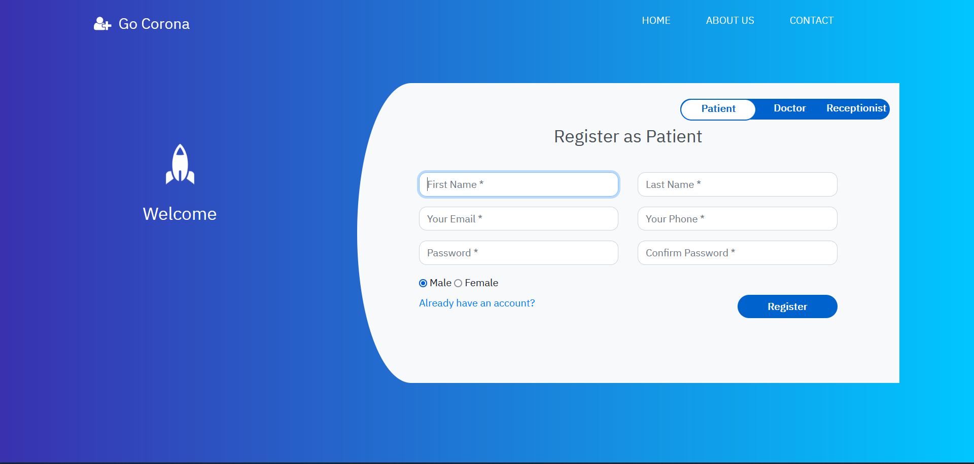

Admin Panel:

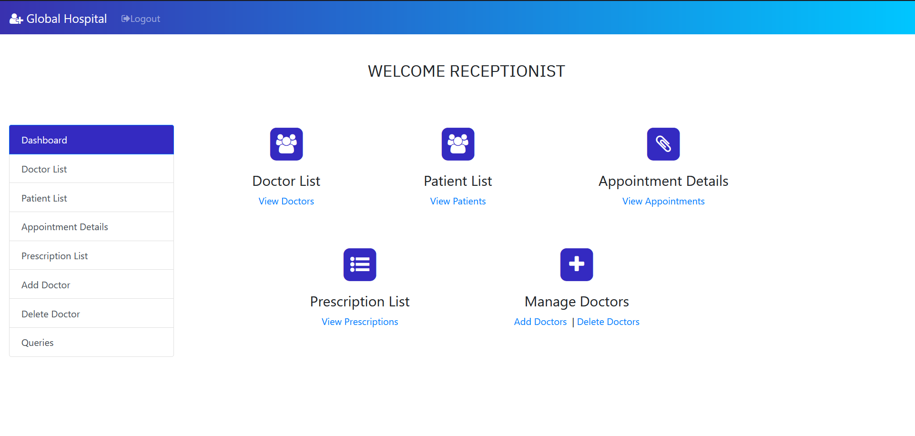

Adding New Employee Details:

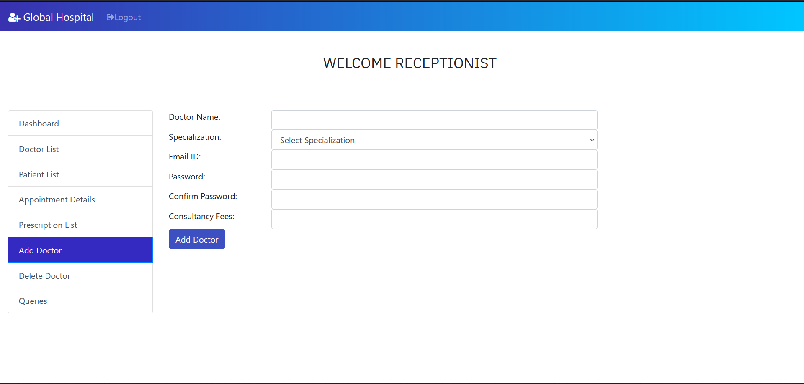

Doctor module:

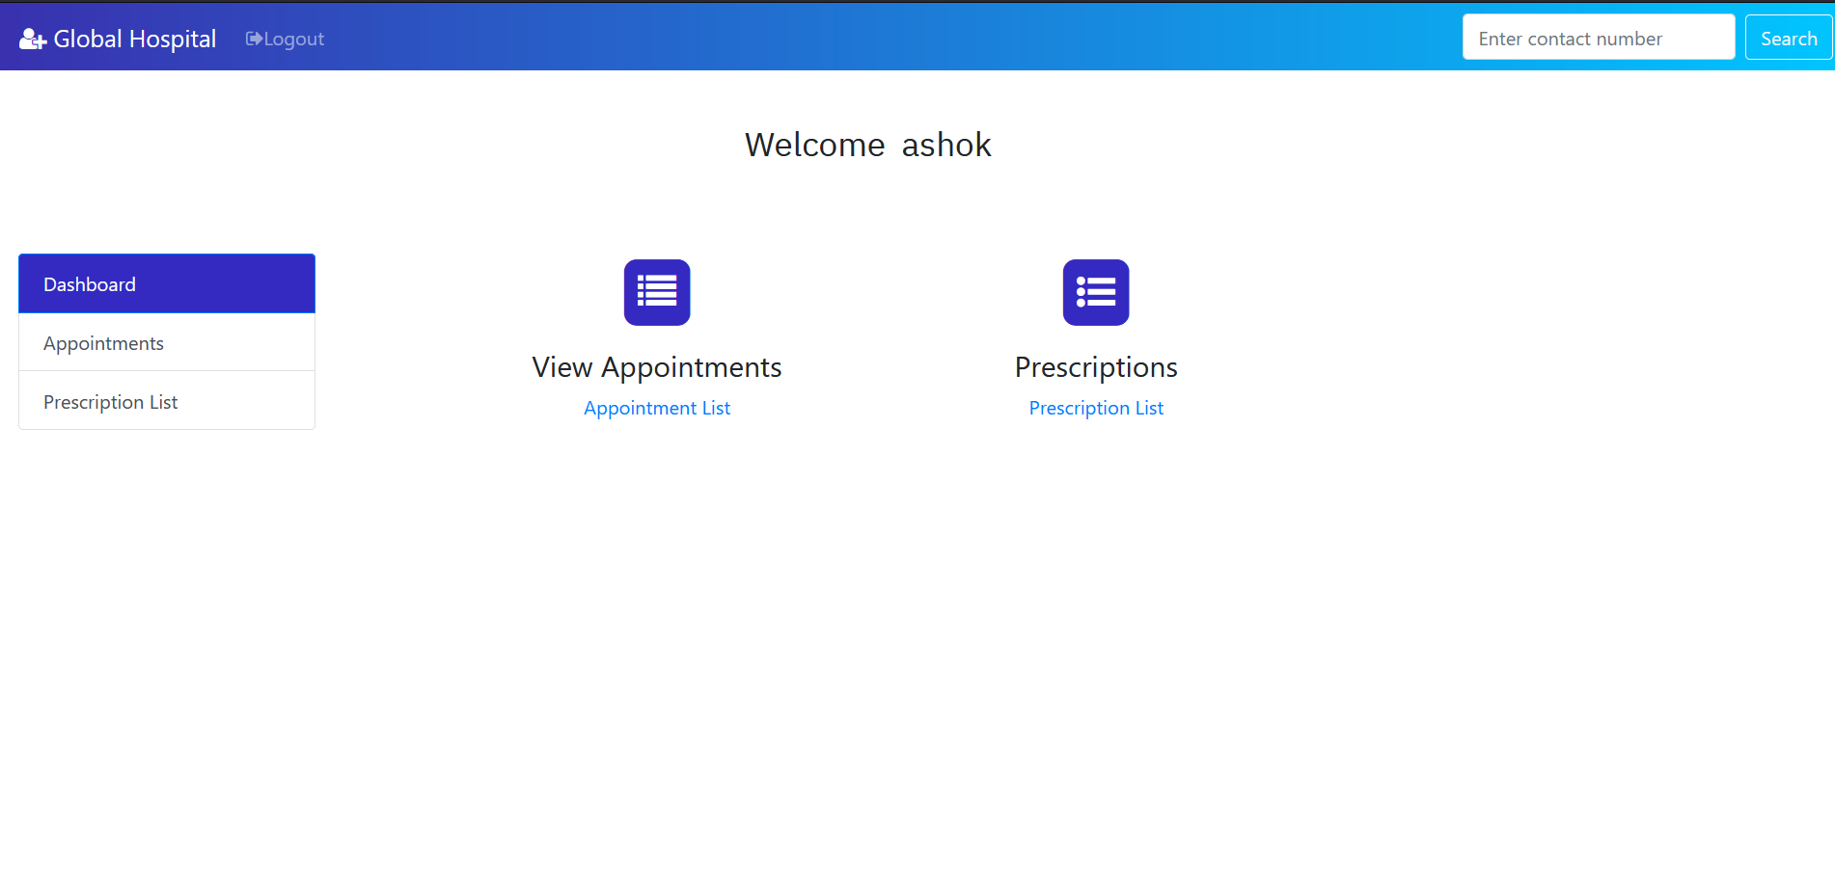

Appointment details:

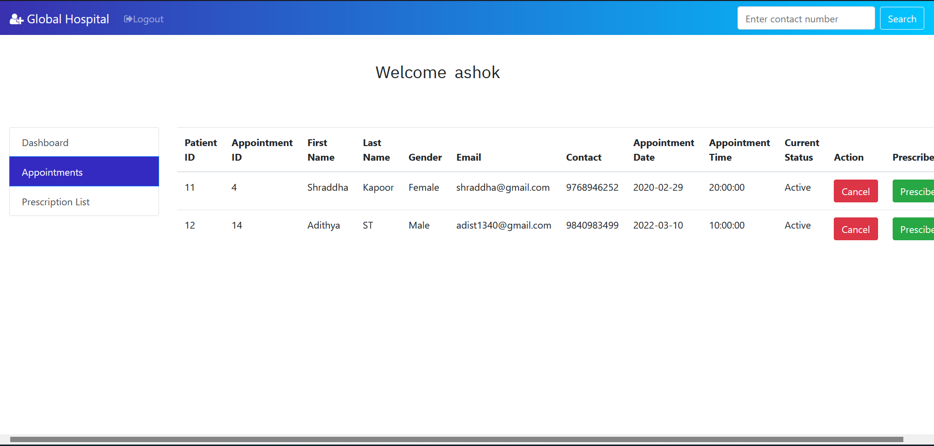

Prescribe medicine:

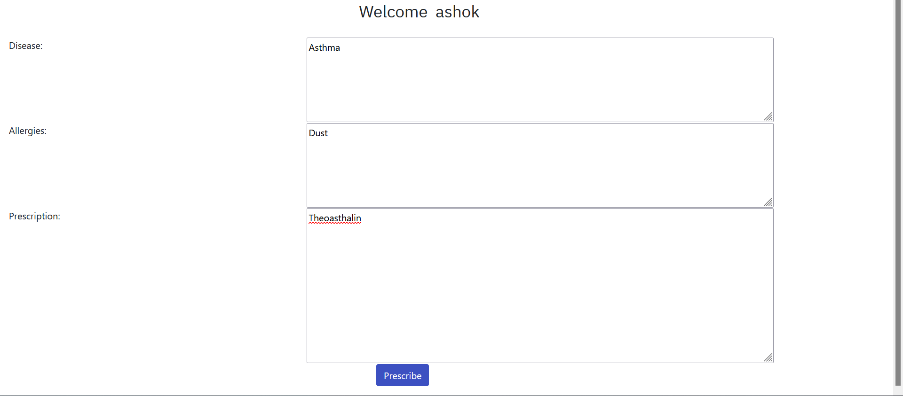

Prescription List:

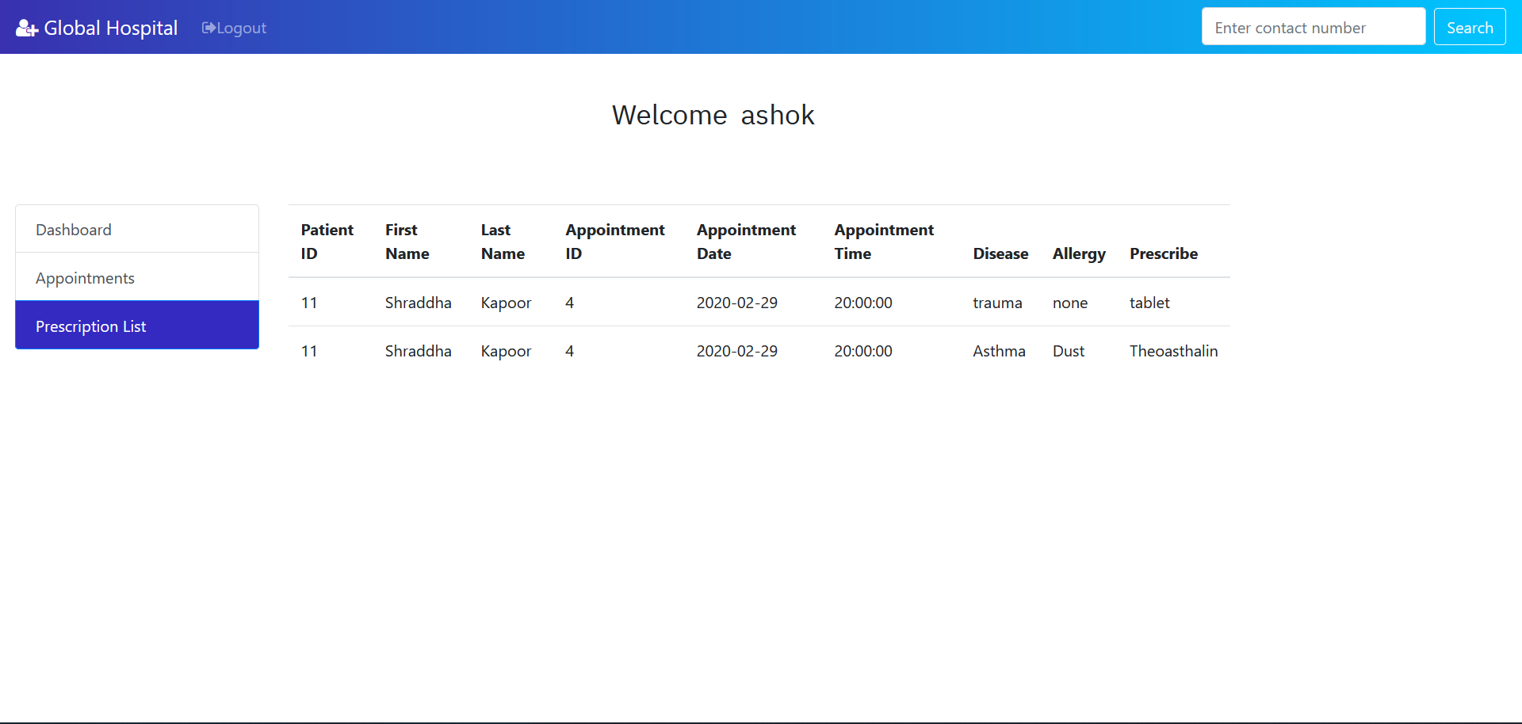

Patient Dashboard:

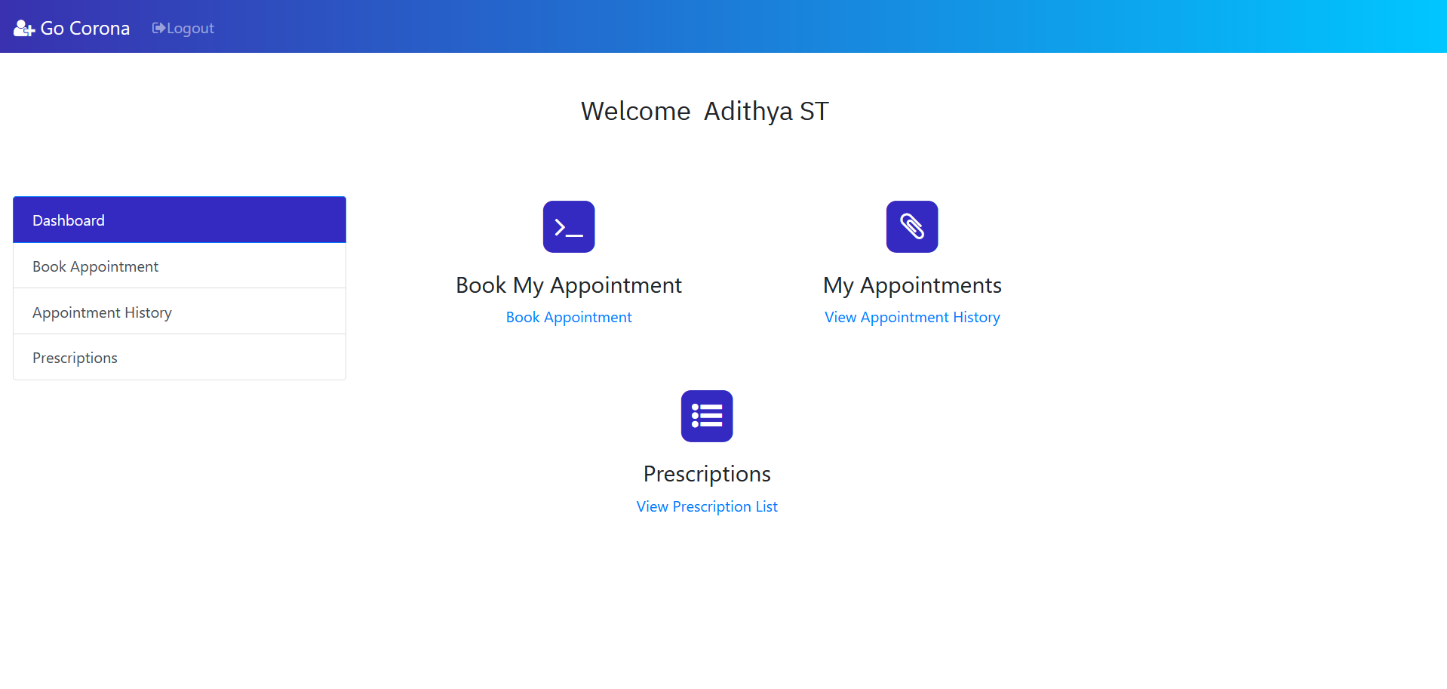

Book Appointment:

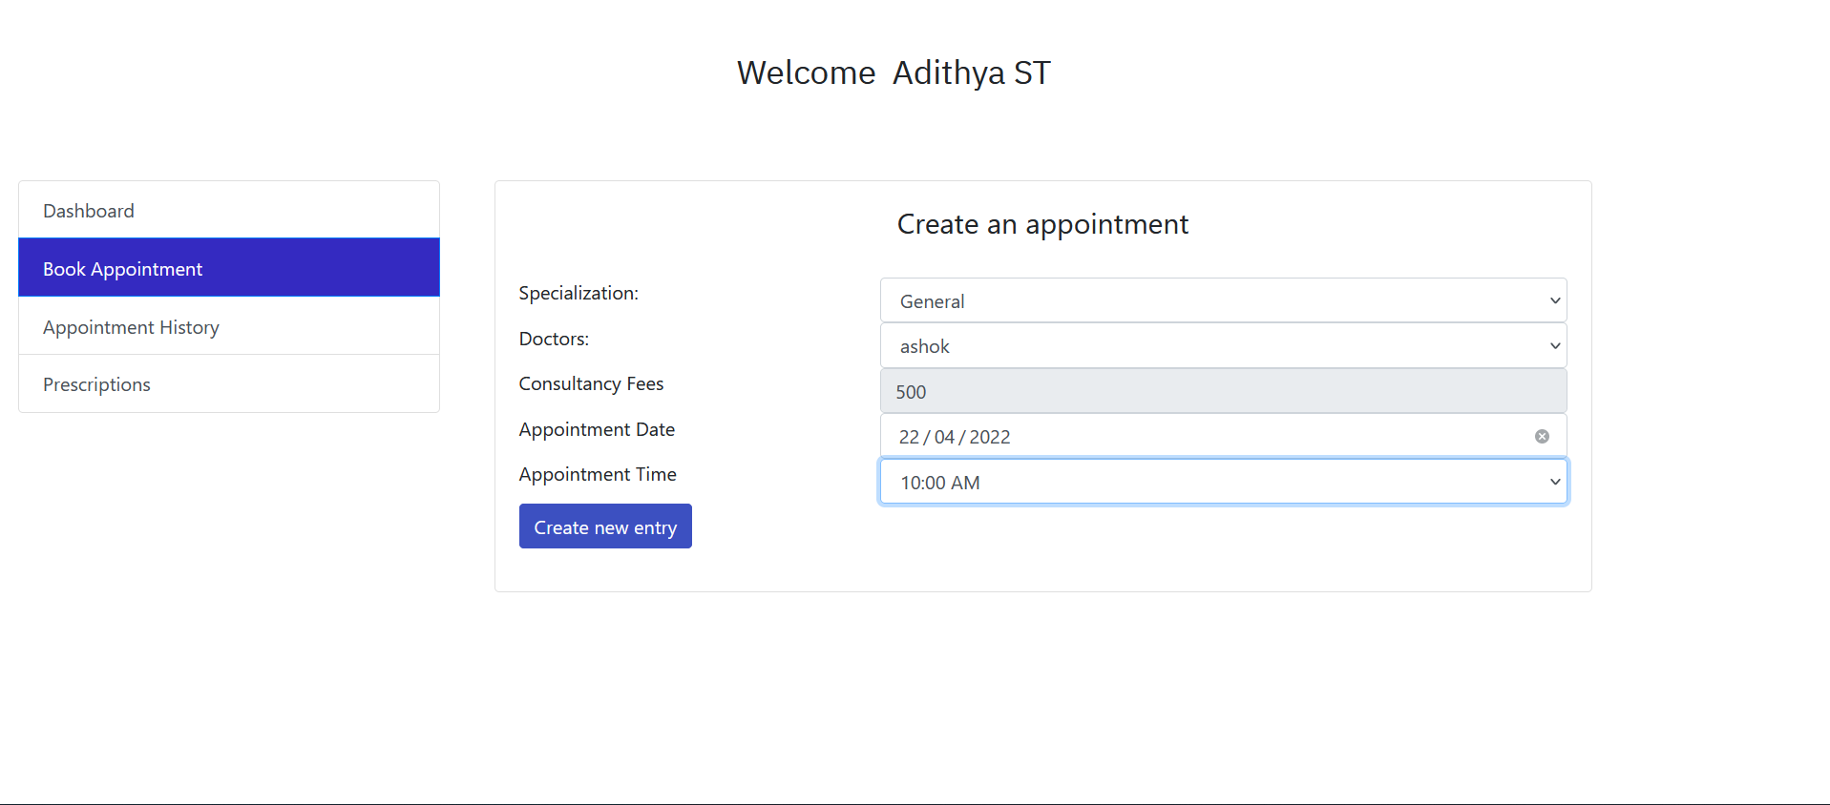

Appointment History:

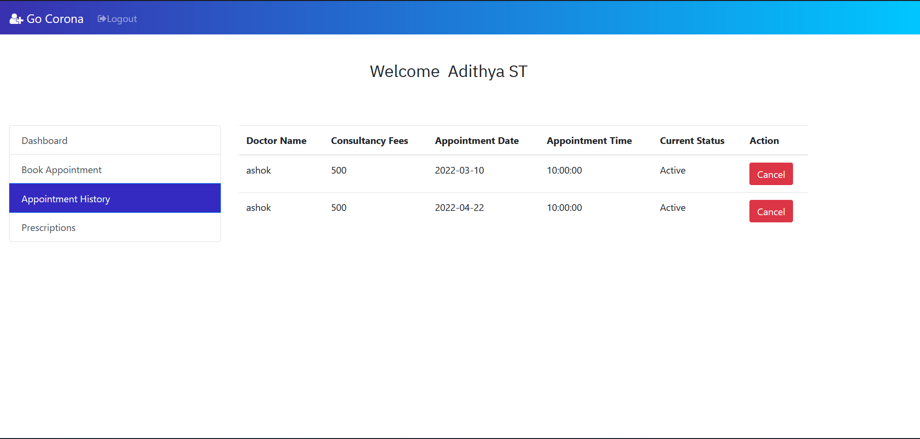

Prescription List:

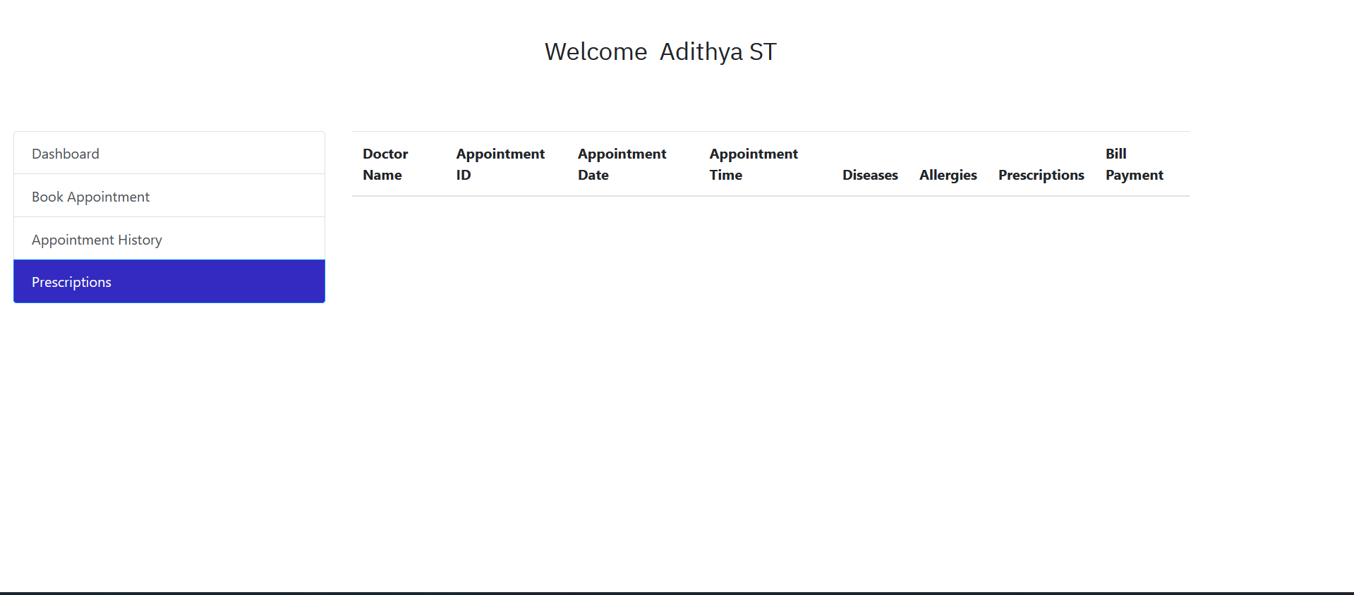

Feedback Page:

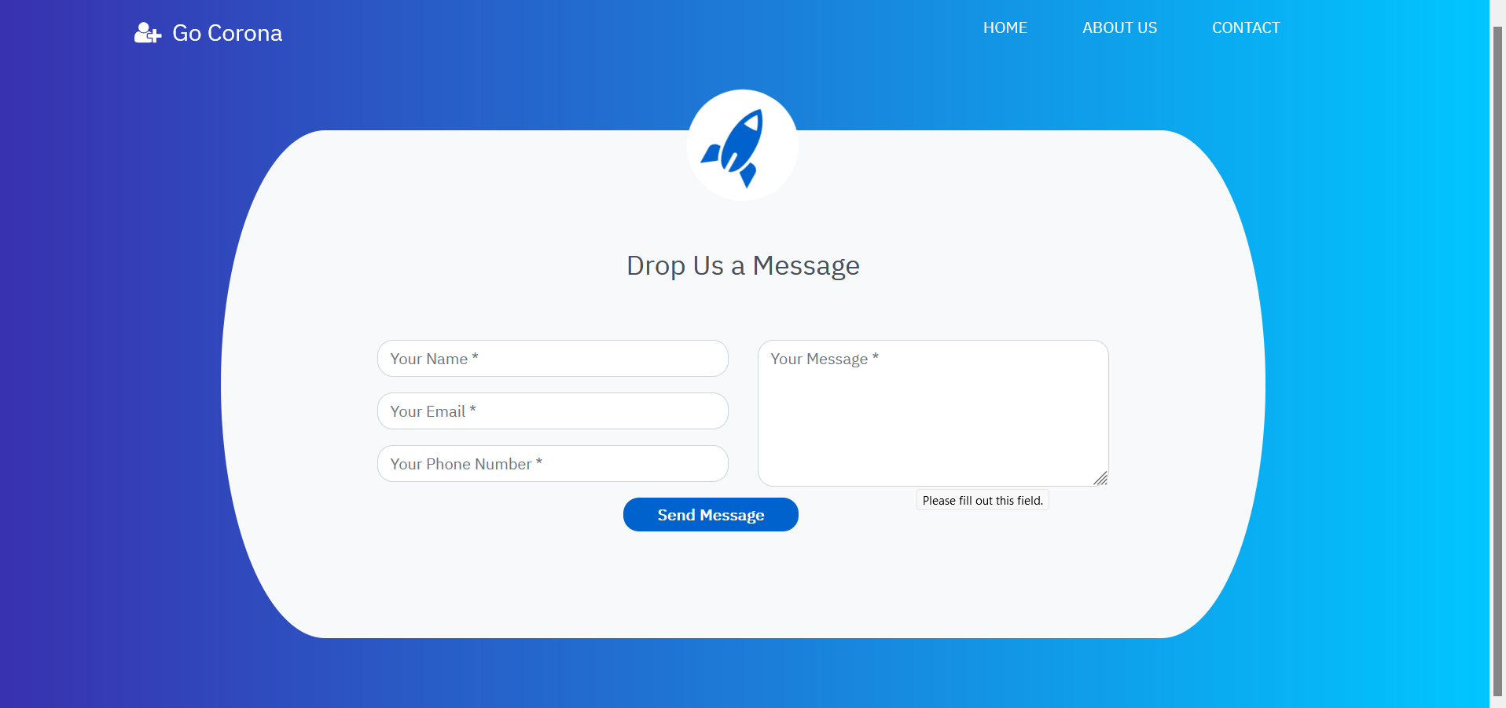

References

1. 1. PHP MySQL Website Programming: Problem - Design – Solution byChris
2. Lea, Mike Buzzard, Dilip Thomas , Jessey White-Cinis
3. 2. Beginning PHP5, Apache, and MySQL Web Development (Programmer to
4. Programmer) by Elizabeth Naramore
5. 3. MySQL/PHP Database Applications, 2nd Edition by Brad Bulger
6. 4. How to Do Everything with PHP and MySQL by Vikram Vaswani