**Ruby Programming**

**Lab -1**

**Name:** Adithya S.T.

**Reg No:**18MIS1025

**Question 1:**

1. A farmer is asking you to tell him how many legs can be counted among all his animals. The farmer breeds three species:

chickens = 2 legs

cows = 4 legs

pigs = 4 legs

The farmer has counted his animals and he gives you a subtotal for each species. Accept number of chickens, cows and pigs and return the total number of legs

**Code:**

puts("Enter no of chickens,cows and pigs")

chickens=gets.to_i

cows=gets.to_i

pigs=gets.to_i

total_no_of_chickens=chickens*2

total_no_of_cows=cows*4

total_no_of_pigs=pigs*4

total_of_all_legs=total_no_of_chickens+total_no_of_cows+total_no_of_pigs

puts("Total no of legs:"+total_of_all_legs.to_s)

**Output:**

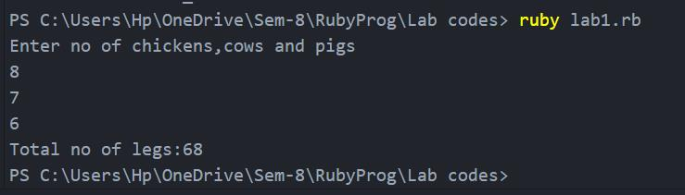

**2. Write a program that finds the maximum range of a triangle's third edge, where the side lengths are all integers.**

**Notes**

**(side1 + side2) - 1 = maximum range of third edge.**

**Code:**

puts("Input all the length of the slides")

side1=gets.to_i

side2=gets.to_i

side3=gets.to_i

max_range_of_third_edge=(side1+side2)-1

puts("Maximum range of third edge:"+max_range_of_third_edge.to_s)

**Output:**

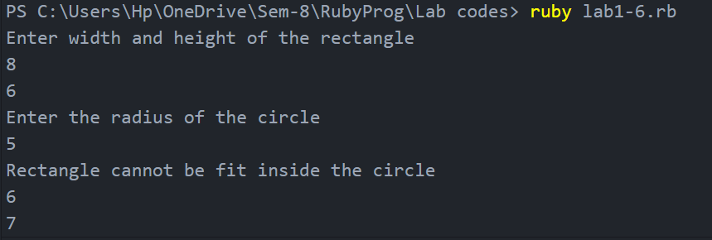

**3. Write a program to calculate the days for a given age. Age will be a whole numbers**

**Code:**

puts("Enter the age")

age=gets.to_i

days=age*365

puts("Total no of days:"+days.to_s)

**Output:**

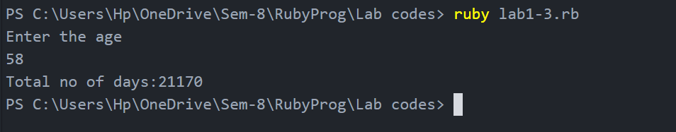

**4. Write a program to convert the second into minutes and days into months ( assume all the months are having 30 days)**

**Code:**

puts("Enter the no of seconds")

seconds=gets.to_i

minutes=seconds/60

puts("No of minutes is:"+minutes.to_s)

puts("Enter the no of days")

days=gets.to_f

months=days/30

puts("No of months is:"+months.to_s)

**Output:**

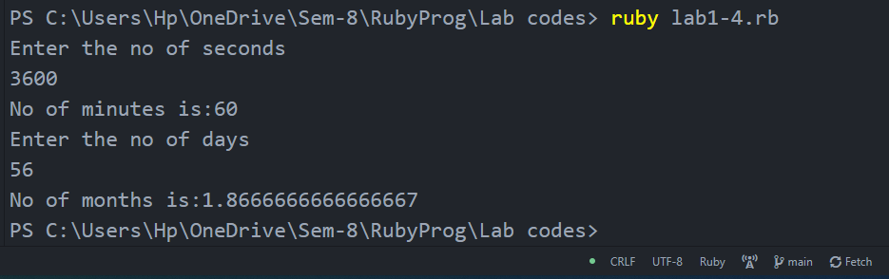

**5. An university is setting up a new lab at their premises. Design an algorithm and write Python code to determine the approximate cost to be spent for setting up the lab. Cost for setting the lab is sum of cost of computers, cost of furnitures and labour cost. Use the following formulae for solving the problem:**

**Cost of computer = cost of one computer * number of computers**

**Cost of furniture = Number of tables * cost of one table + number of chairs * cost of one chair**

**Labour cost = number of hours worked * wages per hour**

**Code:**

puts("Enter the cost of one computer")

cost_one_pc=gets.to_i

puts("Enter the no of computers")

cost_no_pc=gets.to_i

cost_of_all_pc=cost_one_pc*cost_no_pc

puts("Cost of all computers:"+cost_of_all_pc.to_s)

puts("Enter No of tables")

tables=gets.to_i

puts("Enter the cost of one table")

cost_of_one_table=gets.to_i

puts("Enter the no of chairs")

no_of_chairs=gets.to_i

puts("Enter the cost of one chair")

cost_of_one_chair=gets.to_i

cost_of_furniture=(tables*cost_of_one_table)+(no_of_chairs*cost_of_one_chair)

puts("Cost of all furnitures"+cost_of_furniture.to_s)

puts("Enter no of hours worked")

no_of_hours_worked=gets.to_i

puts("Enter wages per hour")

wages_per_hour=gets.to_i

labour_cost=no_of_hours_worked+wages_per_hour

puts("The Labour cost is:"+labour_cost.to_s)

**Output:**

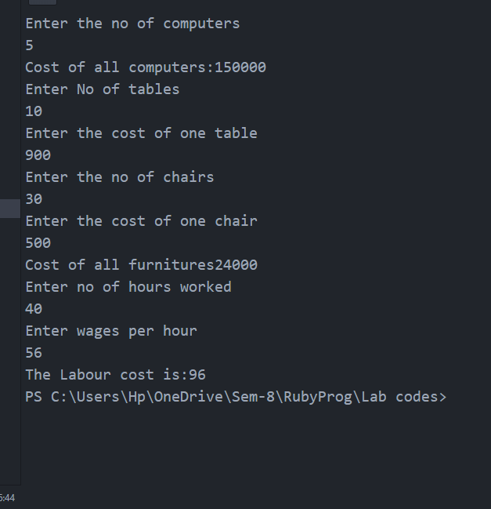

**6. Write a program that takes three numbers — the width and height of a rectangle, and the radius of a circle and returns true if the rectangle can fit inside the circle, false if it can't.**

**8, 6, 5 -> true**

**5, 9, 5 ➞ false**

**4, 7, 4➞ false**

**Code:**

puts("Enter width and height of the rectangle")

width=gets.to_i

height=gets.to_i

puts("Enter the radius of the circle")

radius=gets.to_i

s=width*width+height*height

diagnol=Math.sqrt(s)

diameter=2*radius

if diameter>=diagnol

puts("True")

else

puts("False")

end

**Output:**

