**Ruby Programmming Lab-2**

**Name:** Adithya S.T.

**Reg No:**18MIS1025

1. **Write a program to print the following pattern for N rows**

**1**

**121**

**12321**

**1234321**

**…….**

**…….**

**Code:**

puts "Enter a number:"

num = gets.chomp.to_i

for i in 1..num

z=i

for j in 1..(2*i-1)

if (j <= i)

print j

else

z = z-1

print z

end

end

puts

end

**Output:**

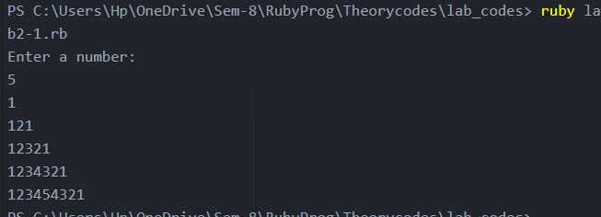

**2. Print the all factors of a number N**

**Code:**

puts "Enter the number n:"

n=gets.to_i;

puts "The factorials are:"

for i in 1..n do

if(n%i==0)

puts(i)

end

end

**Output:**

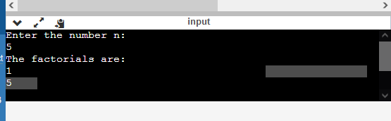

**3.Accept the two numbers find the biggest and smallest common divisors of the numbers.**

**Code:**

puts "Enter a number"

n1 = gets.chomp.to_i

puts "Enter a number"

n2= gets.chomp.to_i

a=n1

b=n2

if(n1 > n2)

a=n2

b=n1

end

while b%a != 0

temp = a

a = b%a

b = temp

end

print "Biggest Common Factor of #{n1} and #{n2} is #{b}"

print "Smallest Common Factor of #{n1} and #{n2} is #{a}"

**Output:**

