**Ruby Programming Lab-2**

**Name:** Adithya S.T.

**Reg No:** 18MIS1025

1. **Given a range of first 10 numbers, Iterate from start number to the end number and print the sum of the current number and previous number (don’t use arrays)**

**Code:**

puts "Enter 10 numbers"

sum=0

no2=0

for i in 1..10 do

no1=gets.to_i

sum=no1+no2

no2=no1

puts "The sum is "+sum.to_s

end

**Output:**

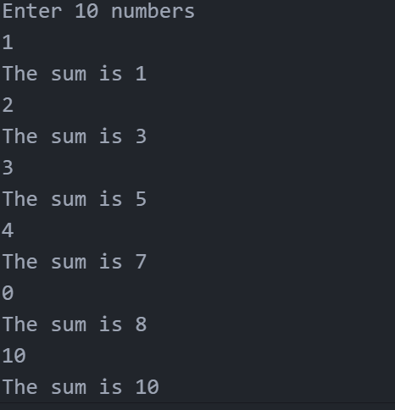

1. **Write a code to extract each digit from an integer, in the reverse order (Number of any size)**

**Expected Output:**

**For example, if the given int is 2486, the output shall be “6 8 4 2“**

**Code:**

puts "Enter a number"

no=gets.to_i

length=no.size()

puts "The digits in reverse order are:"

for i in 1..length

digit=no%10

no=no/10

puts digit

end

**Output:**

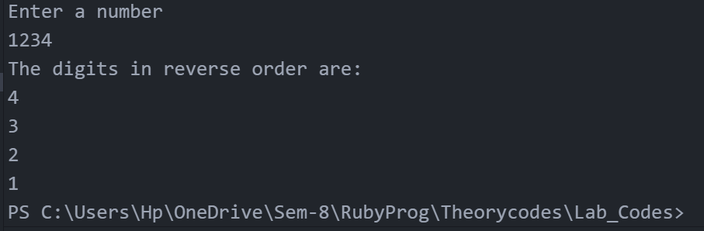

**3. Find the sum of the series n +nn + nnn + nnnn+ .. m terms**

**Given:**

**Number “ n” =7**

**Number of terms “m”=5**

**So series will become 7 + 77 + 777 + 777 + 7777**

**HINT :**

**First term= n**

**Second term = n*10 +n**

**Third term = second term*10+n**

**Fourth term = third term *10+n**

**Code:**

puts "Enter the number n"

n=gets.to_i

puts "Enter the number m"

m=gets.to_i

j=n

for i in 1..m

term=j*10+n

sum=sum+term

j=term

end

puts sum

**Output:**

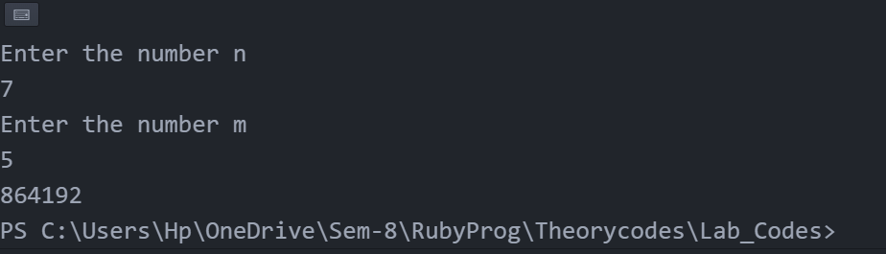

**4.** **Accept two numbers M and N .print M rows and N columns in the following format**

**For eg M=4 and N=4**

**# * * #**

**& # # &**

**\* # # \***

**# & & #**

**a. Odd rows contains ‘*’ and even rows contains &**

**b. Diagonal elements contains “#”**

**Code:**

puts "Enter the number m"

m=gets.to_i

puts "Enter the number n"

n=gets.to_i

for i in 1..m

for j in 1..n

if (i==j) || (i+j==n+1)

print("# ")

elsif (i%2==0)

print("& ")

elsif (i%2==1)

print("* ")

end

end

puts()

end

**Output:**

