**Ruby Programming Lab-3**

**Name:** Adithya S.T.

**Reg No:** 18MIS1025

1. A list contains N players details like number(Four Digit ), matches played(50 over matches), matches played(20 over matches), and batting average, highest score taken.

* List out player number who got the highest batting score
* List out player number played more number of matches together 50 over and 20 over matches.
* List out the numberss of the players whose batting average is less than the average all players batting average.
* List out the player number who played less matches and have batting average is above 80.

**Code:**

print("Enter the number of players(N)")

N=gets.to_i

numbers=Array.new(N)

numbers.compact!

matches50=Array.new(N)

matches50.compact!

matches20=Array.new(N)

matches20.compact!

average=Array.new(N)

average.compact!

score=Array.new(N)

score.compact!

matches=Array.new(N)

matches.compact!

for i in 0..N-1

print("Player: ",i+1," details\n")

print("Enter Jersey Number: ")

a=gets.to_i

numbers.insert(i,a)

print("Enter no of 50 over matches:")

b=gets.to_i

matches50.insert(i,b)

print("Enter no of 20 over matches:")

c=gets.to_i

matches20.insert(i,c)

print("Enter average:")

d=gets.to_i

average.insert(i,d)

print("Highest score:")

e=gets.to_i

score.insert(i,e)

a=matches50[i]

b=matches20[i]

c=a+b

matches.insert(i,c)

end

print("\n Player with Highest Batting score is ",numbers[score.index(score.max)])

print("\n Player with more number of 50 over and 20 over matches together is: ",numbers[matches.index(matches.max)])

print("\n Players with batting average less than others are:")

a=average.sum/average.size.to_f

for i in 0..N-1

if average[i]<a

print(numbers[i])

end

end

print("\n Player number who played less matches and have batting average>80")

a=matches.sum/matches.size.to_f

for i in 0..N-1

if matches[i]<a and average[i]>80

print(numbers[i])

end

end

**Output:**

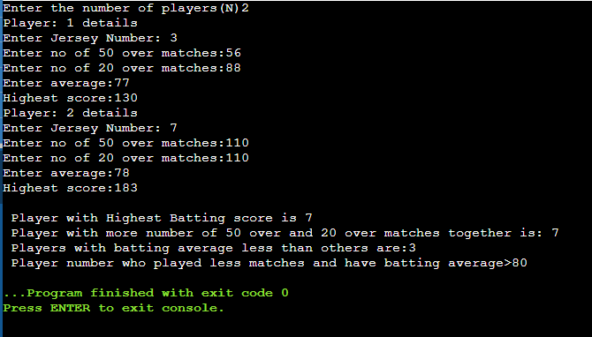

1. A list contains M players Id (three digit number), wickets taken details for N matches. Validate for every match total number of wickets taken by all players should not be greater than 10.

* List out the average wickets taken by each payer for all the matches
* List out the total number of wickets taken by all bowlers in every match
* List out the bowler Id who took the highest wicket in every match.
* For each player , count and display where he did not take any wicket.

**Code:**

print("\nNo. of Players : ")

m = gets.to_i

print("\nNo. of Matchs : ")

n = gets.to_i

arr = Array.new()

(0..m-1).each do |i|

print("\n\nPlayer #{i+1}\n\n")

temp1 = Array.new()

temp2 = Array.new()

print("\tPlayer No. : ")

temp1.push(gets.to_i)

(0..n-1).each do |j|

print("\tWickets in Match #{j+1} : ")

temp3 = gets.to_i

while(temp3>10)

print("\n\t\tWicket should not be greater than 10\n")

print("\tWickets in Match #{j+1} : ")

temp3 = gets.to_i

end

temp2.push(temp3)

end

avg = temp2.sum/temp2.size.to_f

temp1.push(temp2)

temp1.push(avg)

arr.push(temp1)

end

print("\n\nAverage Wicket taken by\n")

(0..m-1).each do |i|

print("\tPlayer #{i+1} : #{arr[i][2]}\n")

end

print("\n\nTotal no. of Wicket taken in\n")

(0..n-1).each do |i|

total = 0

(0..m-1).each do |j|

total = total + arr[j][1][i]

end

print("\tMatch #{i+1} : #{total}\n")

end

print("\n\nMax no. of Wicket taken in\n")

(0..n-1).each do |i|

max = -1

player = 0

(0..m-1).each do |j|

if(max<arr[j][1][i])

max = arr[j][1][i]

player = j

end

end

print("\tMatch #{i+1} : Player no. #{arr[player][0]}\n")

end

print("\n\nTotal Wicket taken by\n")

(0..m-1).each do |i|

print("\tPlayer #{i+1} (#{arr[i][0]}): #{arr[i][1].sum}\n")

end

**Output:**

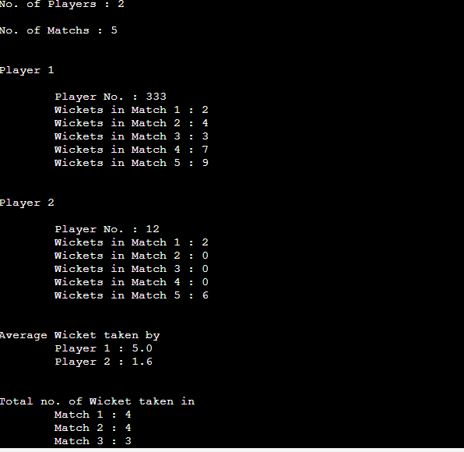

1. **Create two integer matrix of same size MX N ( M rows and M columns). Write a program to find how many common elements are there between them and print the elements also.**

**Code:**

print("Enter no of columns")

c=gets.to_i

print("Enter no of Rows")

r=gets.to_i

array1=Array.new()

array2=Array.new()

#Getting Array 1

for i in 0..c-1

for j in 0..r-1

print("Enter element:[#{i}][#{j}]:")

a1=gets.to_i

array1.push(a1)

end

end

#Getting Array 2

print("Enter Array 2:")

for i in 0..c-1

for j in 0..r-1

print("Enter element:[#{i}][#{j}]")

a2=gets.to_i

array2.push(a2)

end

end

commonElements=Array.new()

for i in 0..(r*c)-1

if array1.include?array2[i]

commonElements.push(array2)

end

end

print("\nNo. of Common Elements between Matrix 1 and Matrix 2 is #{commonElements.size.to_i} and they are : \n\t#{commonElements}")

**Output:**

print("Enter no of columns")

c=gets.to_i

print("Enter no of Rows")

r=gets.to_i

array1=Array.new()

array2=Array.new()

#Getting Array 1

for i in 0..c-1

for j in 0..r-1

print("Enter element:[#{i}][#{j}]:")

a1=gets.to_i

array1.push(a1)

end

end

#Getting Array 2

print("Enter Array 2:")

for i in 0..c-1

for j in 0..r-1

print("Enter element:[#{i}][#{j}]")

a2=gets.to_i

array2.push(a2)

end

end

commonElements=Array.new()

for i in 0..(r*c)-1

if array1.include?array2[i]

commonElements.push(array2[i])

end

end

print("\nNo. of Common Elements between Matrix 1 and Matrix 2 is #{commonElements.size.to_i} and they are : \n\t#{commonElements}")

**Output:**

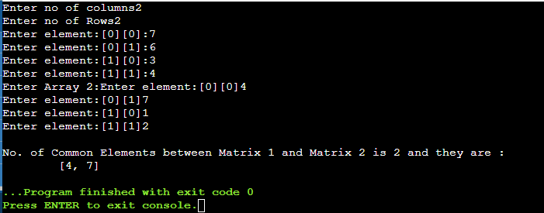

1. **Write a program to replace the duplicate elements in an matrix into zero.**

**Eg:**

**3 4 6**

**2 6 8**

**4 3 7**

**Output :**

**3 4 6**

**2 0 8**

**0 0 7**

**Code:**

array=Array.new()

print("Enter the number of rows")

r=gets.to_i

print("Enter the number of columns")

c=gets.to_i

print("Enter the matrix:")

print("\n")

for i in 0..r-1

for j in 0..c-1

print("Enter the Element [#{i}][#{j}] : ")

a=gets.to_i

if array.include?(a)

array.push(0)

else

array.push(a)

end

end

end

puts "\nThe Matrix with no duplicates:"

puts "\n"

count=0

for i in 0..r-1

for j in 0..c-1

print(array[count]," ")

count=count+1

end

puts(" ")

end

**Output:**

