**Lab-8**

**Ruby Programming**

**Name:** Adithya S.T.

**Reg No:** 18MIS1025

1. **Create Hash which stores phone number and name of the person ( phone number is the key). Assume that if the phone number starts with 9 it is airtel number, if it starts with ‘8’ means BSNL and If it starts with 7 and 6 mean jio number. Create separate list who got airtel, BSNL, Jio (3 list) and display the list who got the highest customer. Display all three list.**

**Code:**

print("No of Mobile Users:")

n=gets.chomp.to_i

hash=Hash.new

for i in 0..n-1

print("Mobile User #{i+1}:")

print("\tMobile No:")

mobile_no=gets.chomp.to_i

print("\tUser Name:")

hash[mobile_no]=gets.chomp

end

mobile_no=hash.keys

airtel=Array.new

bsnl=Array.new

jio=Array.new

for i in mobile_no do

if(i[0]=="9")

airtel.push(i)

end

if(i[0]=="8")

bsnl.push(i)

end

if(i[0]=="7" or i[0]=="6")

jio.push(i)

end

end

print("\nAirtel")

for i in airtel

print("\tMobile no: #{i}")

print("\tUser: #{hash[i]}\n")

end

print("\nBSNL")

for i in bsnl

print("\tMobile no: #{i}")

print("\tUser: #{hash[i]}\n")

end

print("\nJio")

for i in jio

print("\tMobile no:")

print("\tUser:")

end

temp=""

if(airtel.count>bsnl.count)

if airtel.count>jio.count

temp="airtel"

else

temp="jio"

end

else

if(bsnl.count>jio.count)

temp="BSNL"

else

temp="Jio"

end

end

print("\n\n#{temp} has the most no of users")

**Output:**

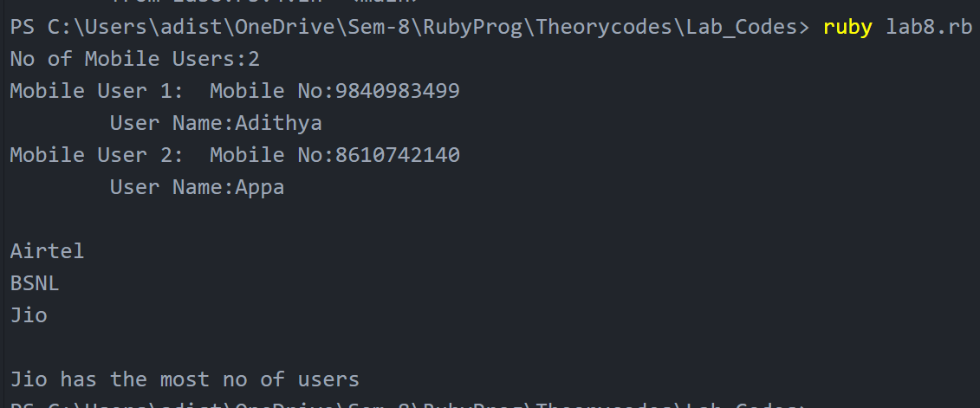

**2. Create a hash for a student with regno , name, marks for five subjects. Compute the grades for all five subject and add it to dictionary.**

**>90 grade A**

**>80 grade B**

**>70 grade C**

**>60 grade D**

**>50 grade E**

**<50 grade ‘F’**

**Display in how many subjects a student got failed**

**Display each student record .**

**Repeat this process for N students.**

**Code:**

def calculate(marks)

if(marks>90)

return "A"

end

if(marks>80)

return "B"

end

if(marks>70)

return "C"

end

if(marks>60)

return "D"

end

if(marks>50)

return "E"

end

if(marks<50)

return "F"

end

end

print("Enter No of students:")

n=gets.chomp.to_i

hash=Hash.new

for i in 0..n-1

print("Student #{i+1}")

print("\tReg No:")

reg_no=gets.chomp

print("\tName:")

name=gets.chomp

mark=Array.new

grade=Array.new

puts "\tMarks"

for j in 0..4

print("\t\tMark #{j+1}:")

mark.push(gets.chomp.to_i)

grade.push(calculate(mark[j]))

end

hash[[reg_no,name]]=mark,grade

end

keys=hash.keys

values=hash.values

for i in 0..n-1

print("Student: #{i+1}")

print("\tReg No: #{keys[i][0]}")

print("\tName: #{keys[i][1]}")

for j in 0..4

print("\t\tSubject #{j+1} Mark is #{values[i][0][j]}")

end

print("\tNo of Subjects failed: #{values[i][1].count("F")}")

end

**Output:**

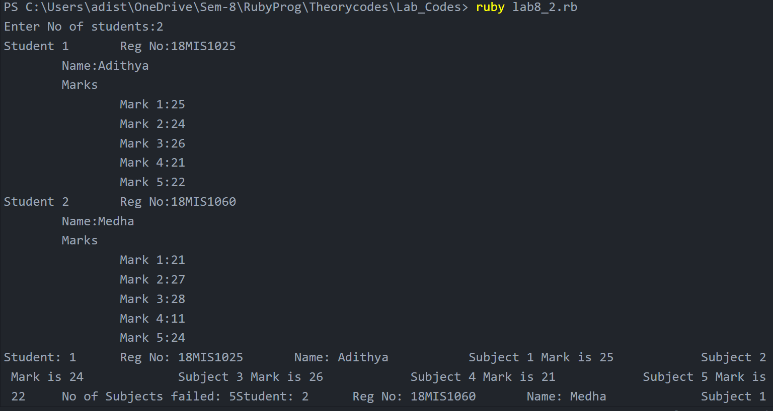

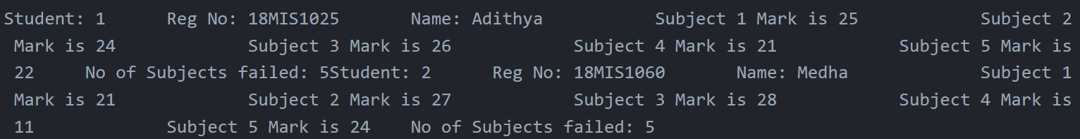

**3. Create a hash with Reg number as key and Name and date of birth( use date format) as values.**

**1. Create N records**

**2. Display name in the ascending of their date of birth.**

**3. Display reg numbers of the student who born on “January”**

**4. Count and display the number of birthdays in each month.**

**Code:**

require 'time'

print "No. of Students : "

n = gets.chomp.to_i

hash = Hash.new

for i in (0..n-1) do

puts "Studnet #{i+1}"

print "\tName : "

name = gets.chomp

print("\tReg. No. : ")

reg_no = gets.chomp

puts "\Date of Birth"

print("\t\tDay : ")

day = gets.chomp.to_i

print("\t\tMonth : ")

month = gets.chomp.to_i

print("\t\tYear : ")

year = gets.chomp.to_i

dob = Date.parse("#{year}-#{month}-#{day}")

hash[reg_no] = name, dob

end

key = hash.keys

value = hash.values

for i in (0..n-1) do

for j in (i+1..n-1) do

if(value[i][1]>value[j][1])

temp1 = value[i]

temp2 = key[i]

value[i] = value[j]

key[i] = key[j]

value[j] = temp1

key[j] = temp2

end

end

end

puts "\n\nNames of Student based on their DoB in assending order : "

for i in value do

puts "\t#{i[0]}"

end

puts "\nReg. No. of Student who born on Janauary : "

for i in (0..n-1) do

if value[i][1].month == 1

puts "\t#{key[i]}"

end

end

puts "\nDoB of Students in each month"

for i in (1..12) do

temp = []

count = 0

for j in (0..n-1) do

if(i==value[j][1].month)

temp.push(value[j][1])

count += 1

end

end

puts "\n\tMonth : #{i}"

puts "\t\tCount : #{count}"

for j in temp

puts "\t\t#{j}"

end

end

**Output:**



