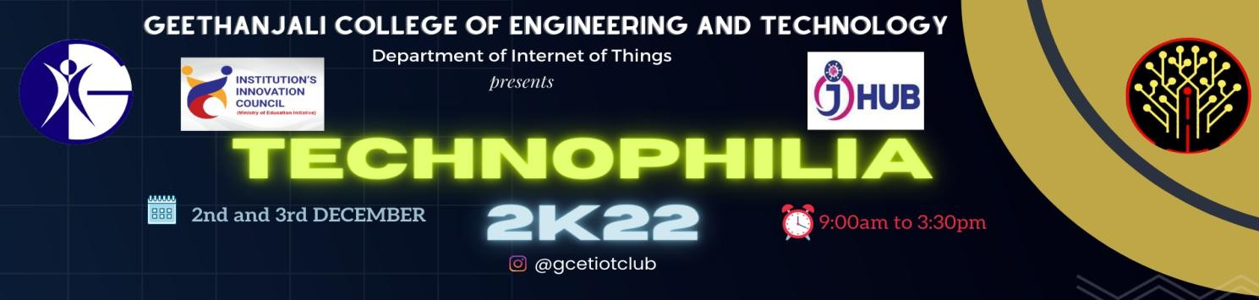

REPORT

EVENT DETAILS:
- Date : 2nd December,2022 ,3rd December,2022
- Venue : Day 1: Block 4 , Seminar hall , Geethanjali College of Engineering and Technology Day 2: Block 5 Ground Floor, Geethanjali College of Engineering and Technology
- Total Number of registrations: 325
- Number of Participants
Day 1: 208
Day 2: 103

FACULTY COORDINATOR:
- Mrs.G.Y. Vybhavi

STUDENT CO ORDINATORS:
- P. Sathvik
- M. Kalyani
- A. Akash
- A. Vallabh
- P. Sai Aditya
- B. Nikitha
- K. Charan
- P. Abhilash
- P. Nidhish
- Joel Ishika
- G. Charishma
- K. Rachana
- T. Tanishq

EVENT DESCRIPTION:
“Technophilia 2k22” is a workshop and a hackathon to 2nd and 3rd year students of Geethanjali College of Engineering and Technology conducted by IoT Club GCET. This two-day workshop featured educational guest lecturers, peer learning sessions, and enjoyable learning activities. The Main Aim of this workshop and hackathon is to introduce the basics of IoT and product development to the students.
DAY 1:
Day 1 of the event began with an inauguration ceremony presided over by B.Nikitha and A.Vallabh, who provided an overview of what the Internet of Things is all about. How IoT has changed the world since previous generations.They also discussed the IoT's real-world usage. Additional information on Mr. Manoj Kumar, our guest lecturer The founder of Bada Ghar Wala Pvt Ltd. With several examples from everyday life, Sir spoke on the importance of ideation and issue solving using the ideas of IoT and product development, as well as terms like problem identification, problem statement, problem research, solution, and customer reviews.
The Afternoon session started with team division by the help of *Thesaurus cards which had a unique emoji for each team followed by Pere learning session by committee members of IoT club hosted by P. Nidhish, Joel Ishika. The first game in the session, called "Word Search," required the students to look up relevant IoT components. This was followed by a presentation on IoT components by M. Kalyani and K. Rachana. The second game, "Test Your Memory," was then hosted by K. Charan and P. Sai Aditya. In this game, players had to memorise the goal and how to use the sensors after further explanations. The participants were given jumbled words during the final session of the day's game, "Word Puzzle," and they had to figure out the proper construction of the words within a cretin time limit. The text contained details on the fundamental Micro controllers utilised in project building.
DAY 2:
The second day of the event started with a continuation of the educational session given by committee members K. Charan and P. Abhilash, who gave a full explanation of the programming language used in IoT. Both the Arduino IDE application and the online virtual simulation tool Tinkercad were shown. In a following project selection procedure, each team received a unique project framework with which to develop a prototype. The prototypes were reviewed and approved by Dr. P Anil Kumar, Mr. P Chandra Prakash Reddy, and Dr. K Neeraja. Subsequently The introduction of the guest, Mr. Seshu Kumar, General Manager and Global Head of Wipro Virtual Desk, which was hosted by P. Sai Aditya, M. Kalyani, marked the beginning of the second part. Mr. Seshu Kumar garu gave a guest lecture on "My Story Motivational session by successful innovators," which was followed by the event's closing ceremony and awarding of prizes. The Event was concluded with vote of thanks followed by National Anthem.

*Thesaurus : Thesaurus cards with printed information about the event and the club ,they were distributed to all participants in order to divide them into teams. These cards were utilised for working during the first day's session.

SCHEDULE:
DAY-1: (2nd December,2022)

S.No | Time | Session | Delivered By
1 | 9:30am to 10:00am | Inauguration Ceremony | B.Nikitha, A. Vallabh
2 | 10:00am to 10:10am | Guest Lecture Profile | B. Nikitha
3 | 10:10am to 12:20pm | Guest Lecture | Mr. Manoj Kumar
LUNCH
4 | 1:00pm to 1:25pm | Team Selection | P. Nidhish, Joel Ishika
5 | 1:25pm to 1:35pm | Introduction about Games | P. Nidhish, Joel Ishika
6 | 1:35pm to 1:50pm | Word Search | M. Kalyani,K. Rachana
7 | 1:50pm to 2:10pm | Introduction about Sensors | M. Kalyani,K. Rachana
8 | 2:10pm to 2:20pm | Test Your Memory | K.Charan, P.Sai Aditya
9 | 2:20pm to 2:40pm | Components of IoT | K.Charan, P.Sai Aditya
10 | 2:40pm to 3:10pm | Word Puzzle | A. Akash,G.Charishma
11 | 3:10pm to 3:25pm | About Micro controllers | A.Akash,G. Charishma

DAY-2: (3rd December,2022)

S.no | Time | Session | Delivered By
1 | 9:30am to 9:40am | Team Selection | P. Sai Aditya,M. Kalyani
2 | 9:40am to 10:30am | Introduction to Arduino Programming | K.Charan, P. Abhilash
3 | 10:30am to 10:35am | Project Selection | P. Sai Aditya,M. Kalyani
4 | 10:35am to 1:30pm | Working on projects
LUNCH
5 | 1:30pm to 2:00pm | Validation of Projects
6 | 2:00pm to 2:15pm | Guest Lecture Profile | P. Sai Aditya,M. Kalyani
7 | 2:15pm to 3:15pm | Guest Lecture | Mr. Seshu Kumar
8 | 3:15pm to 3:25pm | Prize Distribution | P. Sai Aditya,M. Kalyani
9 | 3:25pm to 3:30pm | Vote of thanks | M. Kalyani

PRIZE WINNERS:

S.no | Team Name | Student Name | Roll Number | Prize | Cash | Phone Number
 |  | Shaik Suhas | 21R11A6951
 |  | Srujana Y | 21R11A6953
 |  | Hasika s | 21R11A6947
1 | Team 10 | T.Sreelekha | 21R11A6955 | I | 1500 | 9000523666
 |  | M.Gayatri | 21R11A6937
 |  | P.Sri kanth | 20R11A0232
 |  | Koushik.J | 21R11A1233
 |  | Mohan | 21R15A6905
 |  | Anand | 20R11A6929
 |  | Govind | 20R11A6920
2 | Team-12 | Rohith | 20R11A6938 | II | 1000 | 7207658891
 |  | Nishanth | 20R11A6908
 |  | Sahith | 20R11A6935
 |  | Nithin | 20R11A6912
 |  | S. Varsha | 20R11A6948
 |  | S. Manisha | 20R11A6950
 |  | P. Tulasi | 20R11A6945
3 | Team 4 | Aakansha | 21R11A637 | III | 500 | 7013387883
 |  | Harshini | 21R11A22
 |  | Nithya | 21R11A35
 |  | Adithya | 21R21A6903

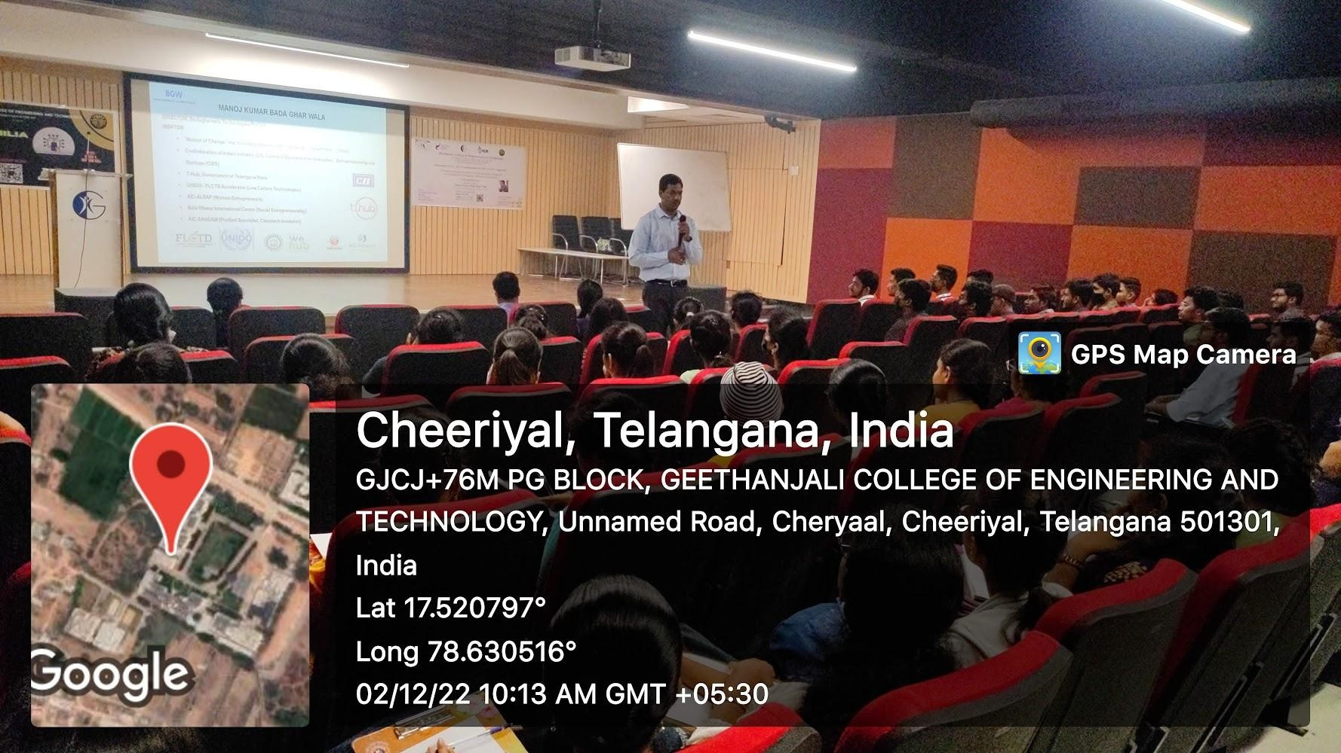
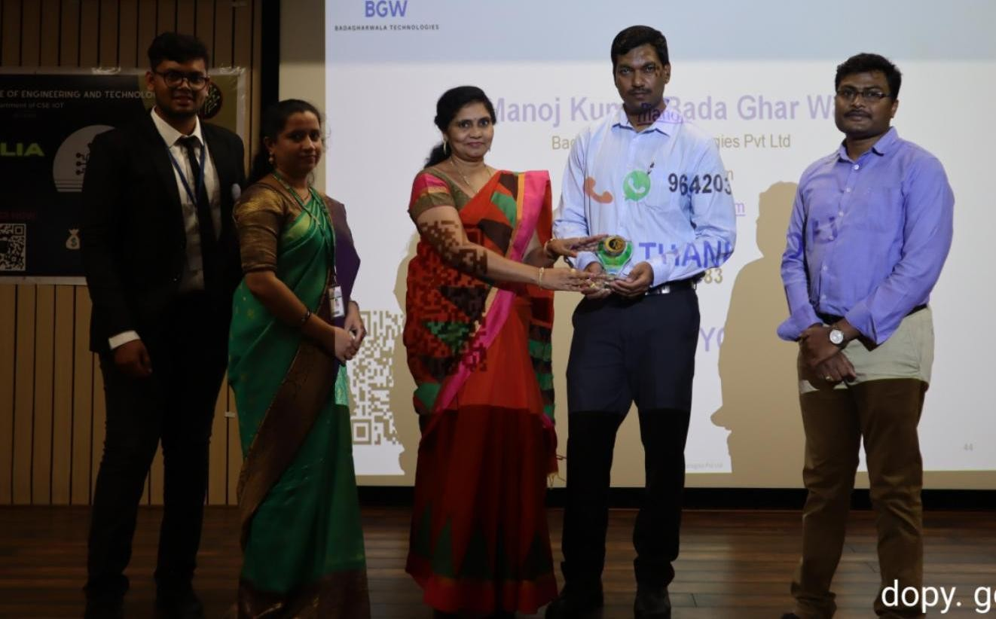
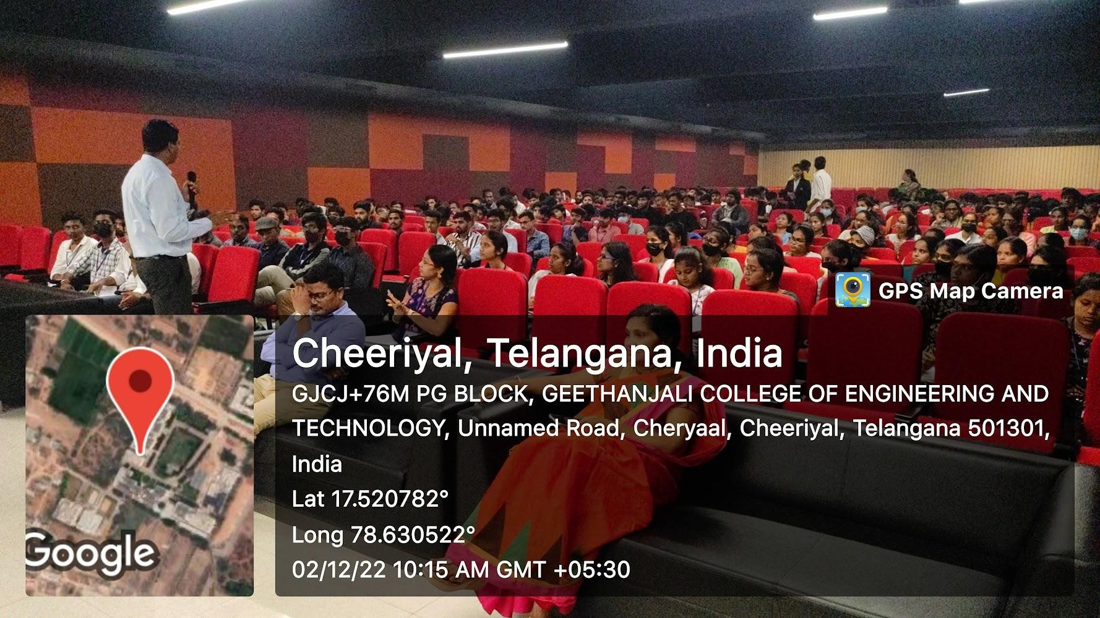
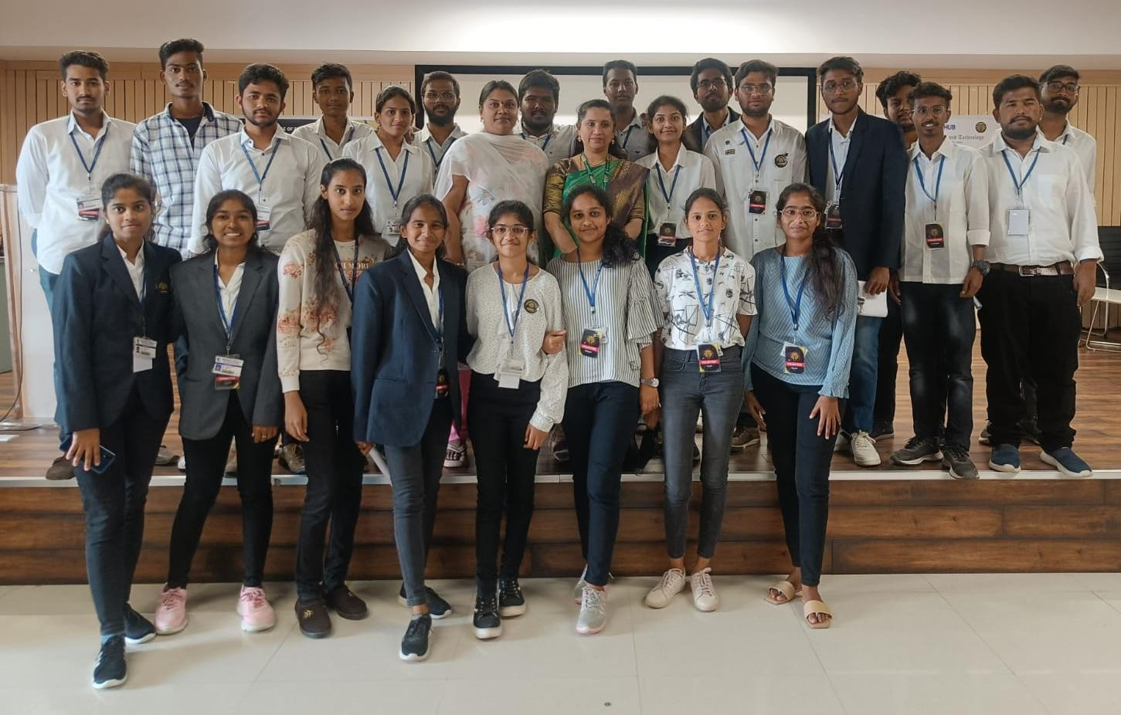
SNAPSHOTS OF THE EVENT: DAY-1

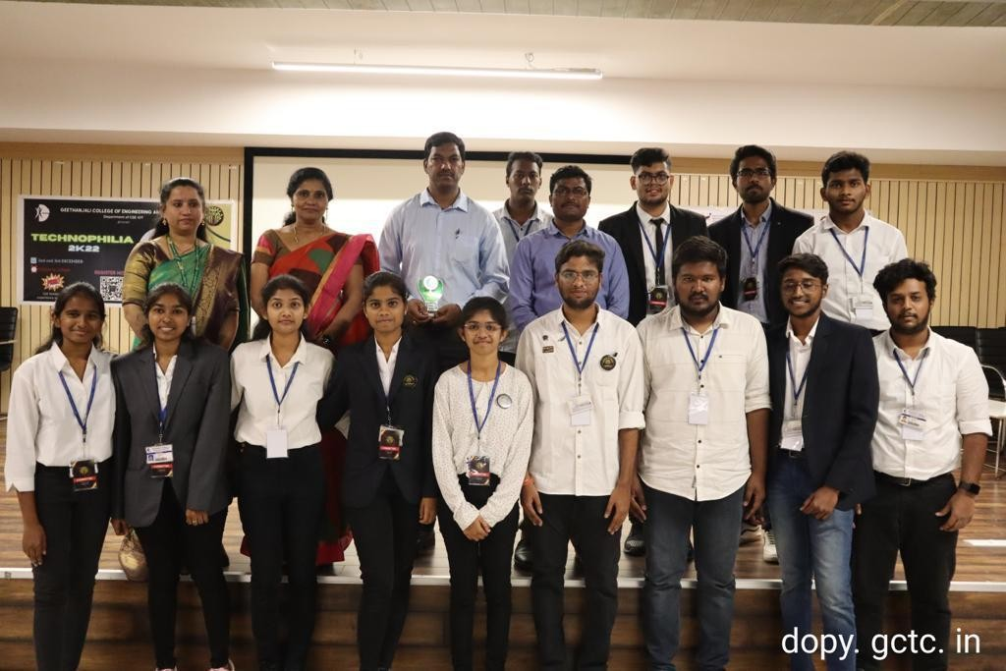

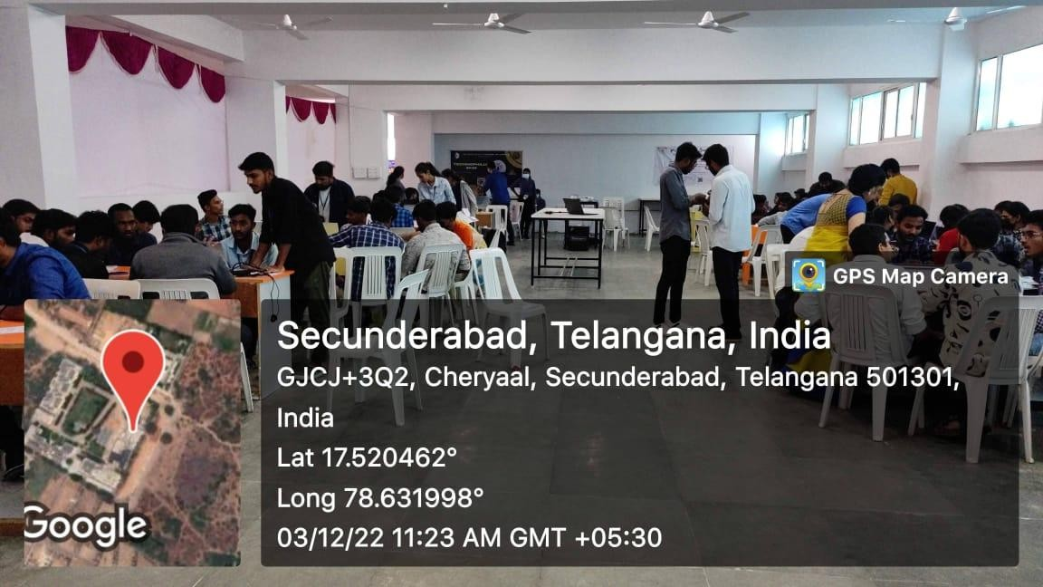
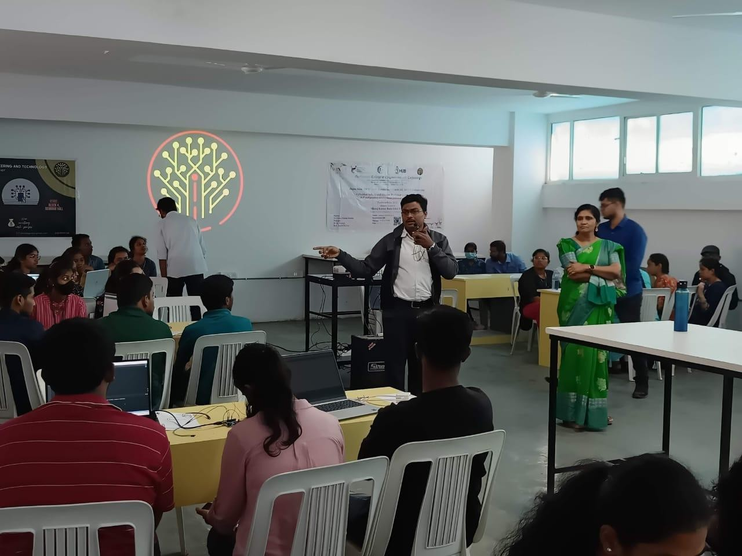
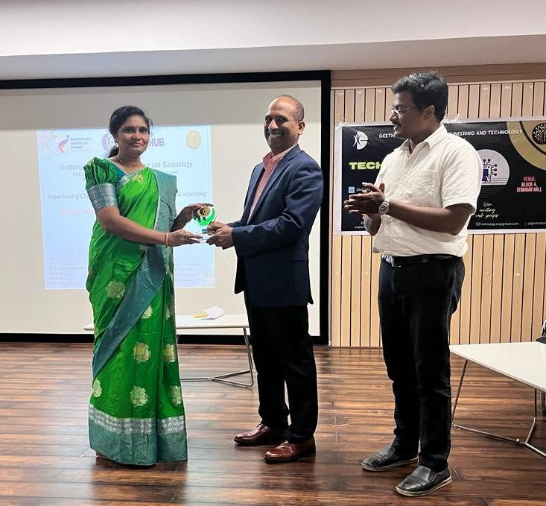
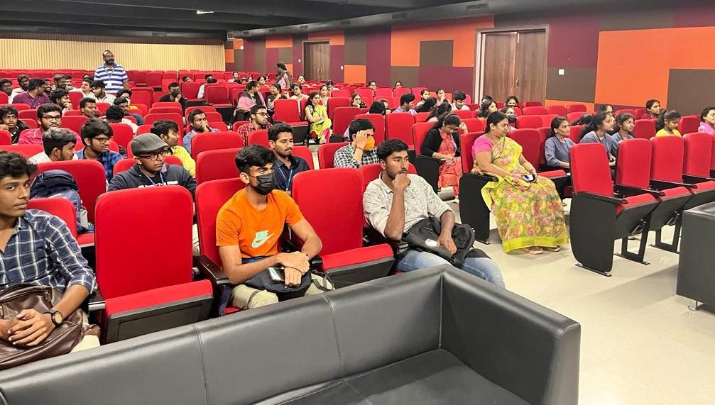
DAY2:

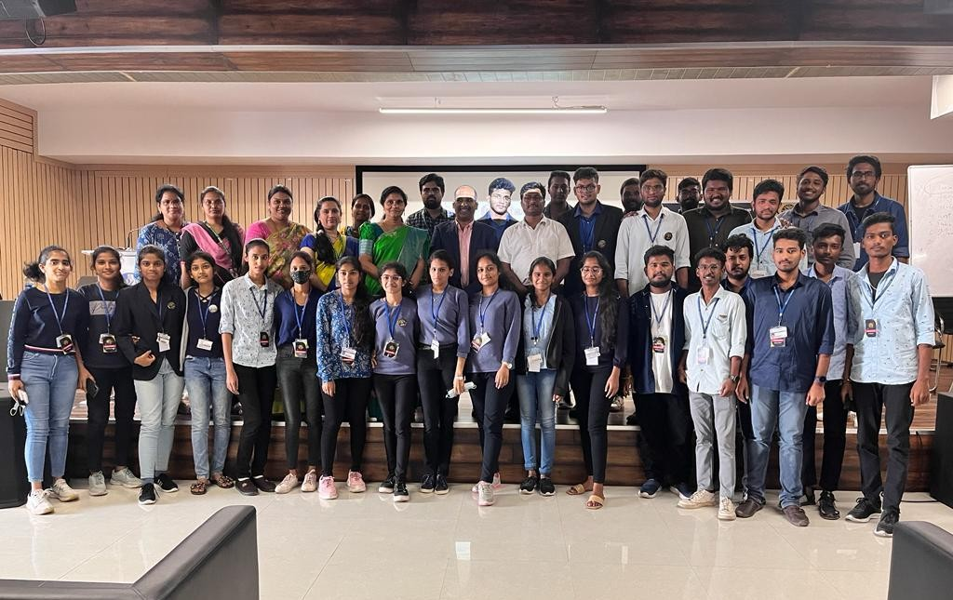

FEEDBACK STATISTICS:

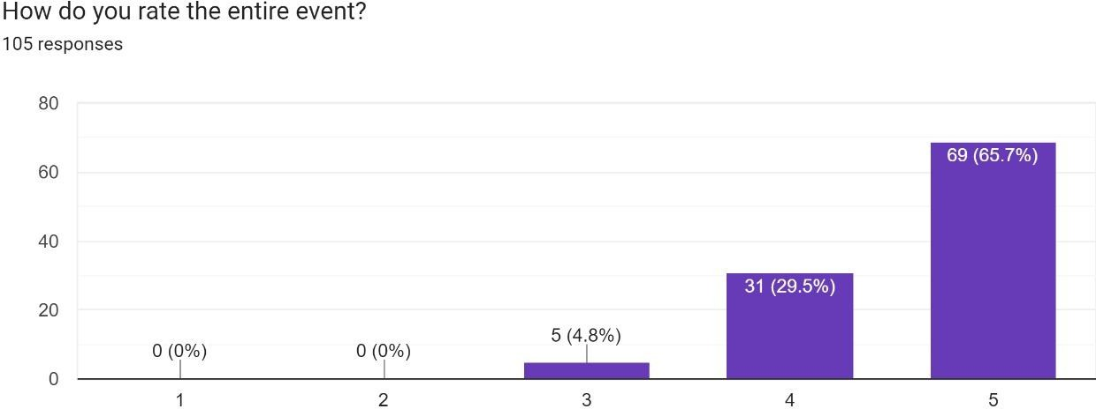

An interactive event, Technophilia 2k22 featured guest lectures, IOT hands-on activities, and project development. Students learned the fundamentals of IOT through game rounds, and they had the opportunity to create an independent project on IOT during practical sessions. Technophilia assisted students get interested in IOT and helped them see the professional opportunities that IOT may provide.

