1. Sales Analysis Dashboard: Create a dashboard that shows sales trends over time, by region, and by product category. Use different visualizations to highlight key metrics, such as sales growth rates, top-selling products, and regional sales comparisons.

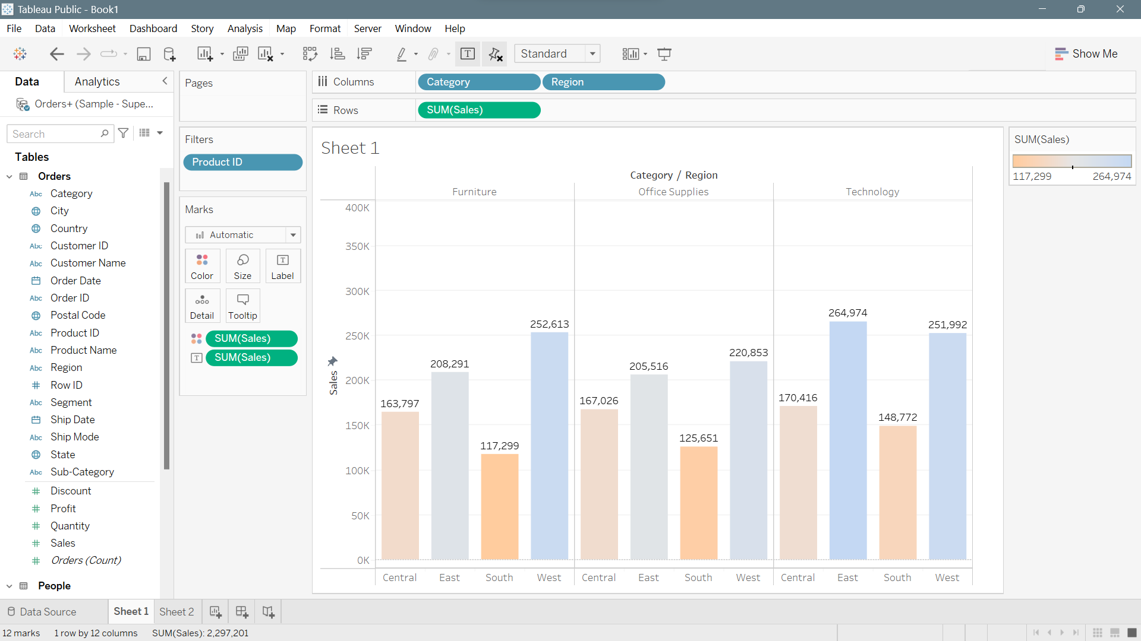

2. Customer Segmentation Analysis: Analyze  
customer data to identify key segments and create visualizations that show  
their characteristics, behaviors, and purchasing patterns. Use clustering  
techniques to group customers into segments, and then create visualizations  
that show how they differ in terms of demographics, purchasing frequency, and  
other factors.

