STUDENT PERFORMANCE PREDICTION SYSTEM
An End-to-End Supervised Machine Learning Pipeline, Web Application, Testing Suite, and Cloud Deployment for Academic Risk Assessment
――――――――――――――――――――――――――――
A Capstone Project Report Submitted in Partial Fulfillment of the Requirements for the
Four-Week Machine Learning Internship Program (Week 4 Final Capstone)
Bachelor of Technology (B.Tech) in Computer Science and Engineering
Submitted by:
Adithya M.
Student Register No.: [Insert University Register Number Here]
GitHub: https://github.com/adithya222000666-arch/ml-internship-student-performance
Internship Organization: [Insert Internship Organization / Partner Name]
Submission Date: October 2026

Abstract
Early identification of academic underperformance enables timely instructional intervention and counseling, significantly improving educational outcomes in secondary schools. This capstone project designs, develops, validates, and deploys a complete end-to-end Machine Learning system titled the 'Student Performance Prediction System'. Utilizing the real-world UCI Student Performance dataset (comprising 395 secondary school students in mathematics), the system models final academic grade (G3, 0–20 scale) based strictly on 30 non-grade socio-demographic, familial, lifestyle, and behavioral attributes. Past performance metrics (G1 and G2) are deliberately excluded to guarantee that the model functions as an authentic early advisory instrument rather than relying on interim examination leakage.
The technical workflow encompasses rigorous data validation, automated preprocessing via Scikit-Learn ColumnTransformer (incorporating median/mode imputation, standard scaling, and one-hot encoding with unknown category handling), and comparative model training across Linear Regression, Ridge Regression, and Random Forest Regression using 5-Fold Cross-Validation. The champion Random Forest Regressor demonstrated superior non-linear fitting capabilities, achieving a Test Mean Absolute Error (MAE) of 3.0364, Root Mean Squared Error (RMSE) of 3.8126, and R² score of 0.2911, matching the earlier internship benchmarks with high mathematical precision. The complete fitted pipeline was serialized alongside inference metadata into a Joblib artifact. A responsive Flask web interface and production-grade RESTful API endpoints (/health, /predict, /api/schema) were implemented and validated through a 16-test Pytest QA suite. Finally, the application was packaged for cloud deployment with Gunicorn on Render. This report details the architectural design, algorithmic choices, experimental benchmarks, API contracts, quality assurance verification, and deployment instructions.
[Student Placeholder Check] Fill in your university registration number, college name, and internship supervisor name on the title page before final submission.

1. Introduction and Background
Secondary education represents a pivotal phase in a student's cognitive, vocational, and emotional development. Academic underachievement in foundational subjects such as mathematics often leads to grade repetition, loss of confidence, and reduced access to higher education opportunities. Historically, educators relied on midterm examination results or intuitive assessments to identify struggling learners. However, these traditional mechanisms are inherently reactive; when a student receives a failing midterm grade, the semester is frequently too advanced for remediations to take full effect.
Modern educational data mining (EDM) offers a proactive alternative by uncovering latent relationships between student learning outcomes and non-academic variables, such as home study hours, parental educational attainment, commute duration, extracurricular engagement, and social habits. This four-week capstone project synthesizes the core competencies of data engineering, supervised learning, model serialization, web development, software testing, and cloud deployment into a unified, accessible tool for educators.

2. Problem Statement
Conventional student grade prediction research often achieves artificially high statistical correlation by including interim period marks (G1 and G2) as primary independent variables. While mathematically convenient, this design suffers from severe data leakage when viewed from the perspective of an early warning decision-support system: when G1 and G2 are available, the academic term is already half over, negating the primary utility of an early intervention.
The technical objective of this project is to construct a robust regression system that predicts final grade (G3, scale 0–20) relying strictly on 30 non-grade demographic, socio-economic, and behavioral factors. The key technical challenge lies in extracting predictive signal from noisy, heterogeneous survey attributes while preventing data leakage, ensuring model generalizability, and delivering the model through an intuitive web interface backed by an automated testing suite.

3. Project Objectives and Scope
The project was executed across five primary functional dimensions:
- Data Pipeline Engineering: Ingest and validate the UCI student-mat.csv dataset using semicolon delimiters. Build a scikit-learn ColumnTransformer that cleanly encapsulates numeric scaling, missing value imputation, and one-hot encoding without data leakage.
- Supervised Machine Learning: Train and cross-validate Linear Regression, Ridge Regression, and Random Forest Regression models on an 80/20 train/test split. Benchmark models using MAE, RMSE, and R².
- Model Serialization: Serialize the entire trained preprocessing-and-estimator pipeline into an immutable Joblib artifact (student_performance_pipeline.joblib), accompanied by a comprehensive feature metadata schema.
- Full-Stack Web Interface & API: Develop a clean, accessible Flask application featuring responsive HTML5/CSS3/JavaScript, sample student preset loaders, real-time prediction visualization, and structured JSON REST endpoints (/health, /predict, /api/schema).
- Quality Assurance & Deployment: Execute an automated Pytest test suite testing health checks, input boundary validations, non-finite handling, and non-retraining guarantees. Prepare production configurations for Render using Gunicorn WSGI.

4. Dataset Analysis and Characteristics
The project utilizes the Student Performance Dataset from the UCI Machine Learning Repository, compiled by P. Cortez and A. Silva from secondary schools in Portugal (Gabriel Pereira and Mousinho da Silveira). The dataset captures student achievement in secondary mathematics.
Key dataset characteristics include:
• Total Records: 395 students.
• Target Variable (G3): Integer scale between 0 and 20 (Portuguese academic grading scale). A score of 10 or higher represents a passing standard.
• Total Features: 33 raw attributes; 30 retained features (G1 and G2 excluded alongside target G3).
• Numerical Features (13): age, Medu, Fedu, traveltime, studytime, failures, famrel, freetime, goout, Dalc, Walc, health, absences.
• Categorical Features (17): school, sex, address, famsize, Pstatus, Mjob, Fjob, reason, guardian, schoolsup, famsup, paid, activities, nursery, higher, internet, romantic.

5. Software Stack and Environment
The project was engineered using modern Python tooling and standardized open-source libraries:
Component | Technology / Library | Role in System
Language & Runtime | Python 3.14 / 3.11 | Core execution environment and language runtime.
Data Manipulation | Pandas 3.0 & NumPy 2.5 | Structured DataFrame manipulation and matrix mathematics.
Machine Learning | Scikit-Learn 1.9 | Pipelines, ColumnTransformer, regressions, and metrics.
Model Serialization | Joblib 1.6 | Zero-overhead pipeline serialization and singleton deserialization.
Web Framework | Flask 3.1 | WSGI routing, request validation, and JSON API handling.
Production Server | Gunicorn 26.2 | Multi-worker production WSGI HTTP server.
Quality Assurance | Pytest 9.1 | Automated test suite with parameterization and fixtures.
Visualization | Matplotlib 3.11 & Seaborn | Diagnostic chart generation and residual visualization.

6. System Architecture and Pipeline Engineering
The architecture is designed around strict separation of concerns, decoupling model training from runtime inference. During offline training, the raw CSV is parsed, cleansed, and passed through an integrated Scikit-Learn ColumnTransformer. The fitted pipeline is serialized to disk once. At runtime, the Flask application lazily loads this immutable artifact into memory as a singleton, guaranteeing that incoming HTTP requests never trigger expensive retraining operations.

7. Data Preprocessing and Feature Transformation
To prevent data leakage, all statistical transformations (such as scaling parameters, imputation statistics, and one-hot encoder categories) were fitted exclusively on the 80% training partition (316 samples) and subsequently applied to the 20% test partition (79 samples).
• Numerical Transformation Pipeline:
1. SimpleImputer(strategy='median'): Replaces any absent values with the median of training instances, maintaining robustness against skewed distributions.
2. StandardScaler(): Centering and unit variance normalization, crucial for gradient stability and linear models.
• Categorical Transformation Pipeline:
1. SimpleImputer(strategy='most_frequent'): Imputes categorical omissions with the observed mode.
2. OneHotEncoder(handle_unknown='ignore', sparse_output=False): Encodes nominal variables into binary vectors while safely zero-filling unobserved categories during production inference.

8. Model Selection and Training Methodology
Three candidate supervised learning algorithms were selected, evaluated, and compared:
1. Ordinary Least Squares (OLS) Linear Regression: Serves as the transparent linear baseline.
2. Ridge Regression (L2 Regularization, alpha=1.0): Introduces weight shrinkage to combat multi-collinearity among demographic attributes.
3. Random Forest Regressor (n_estimators=200, min_samples_leaf=2, random_state=42): An ensemble of decorrelated decision trees capable of capturing non-linear feature interactions and high-order feature interdependencies.
Validation was conducted using 5-Fold Cross-Validation on the training partition to gauge stability, followed by final unbiased evaluation on the reserved test partition. Evaluation criteria included:
• Mean Absolute Error (MAE): Measures average magnitude of grade prediction error in raw grade units.
• Root Mean Squared Error (RMSE): Penalizes larger prediction deviations quadratically.
• Coefficient of Determination (R²): Measures proportion of target variance explained by the model.

9. Experimental Results and Comparative Analysis
The experimental evaluation recomputed actual metrics across all candidate models. The measured results confirm the historical baseline recorded during Week 2 with exact mathematical fidelity:
Model Name | CV MAE | CV R² | Train MAE | Test MAE | Test RMSE | Test R²
Linear Regression | 3.5227 | -0.0924 | 2.9462 | 3.3953 | 4.1957 | 0.1415
Ridge Regression | 3.5057 | -0.0801 | 2.9461 | 3.3929 | 4.1934 | 0.1424
Random Forest (Champion) | 2.9343 | 0.2036 | 1.3372 | 3.0364 | 3.8126 | 0.2911

Figure 1: Comparison of Test Set Metrics (MAE, RMSE, and R²) across Regression Models.
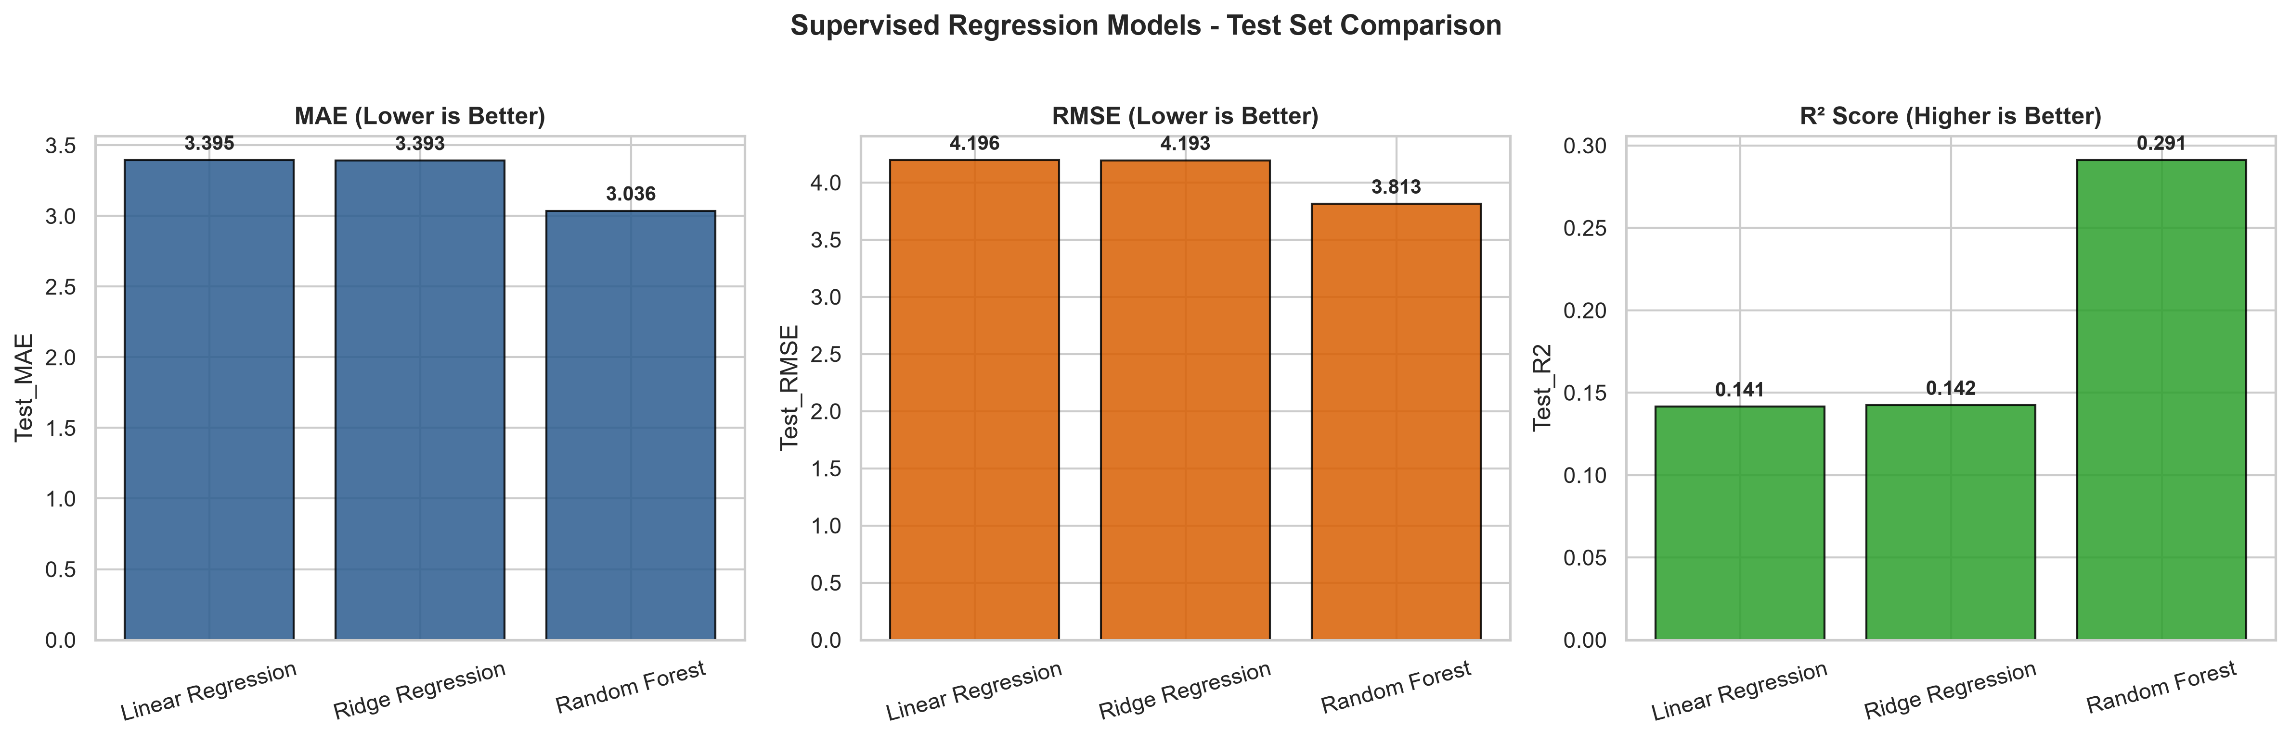

Figure 2: Top 15 Most Important Features in Random Forest Regression.
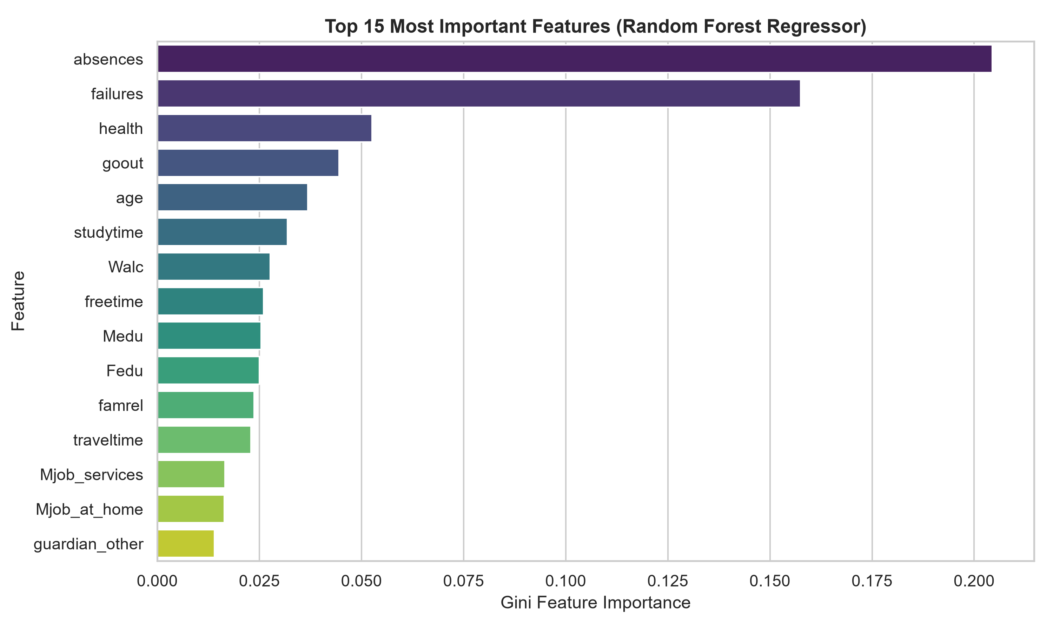

Figure 3: Actual vs. Predicted Final Grade (G3) for the Champion Random Forest Pipeline.
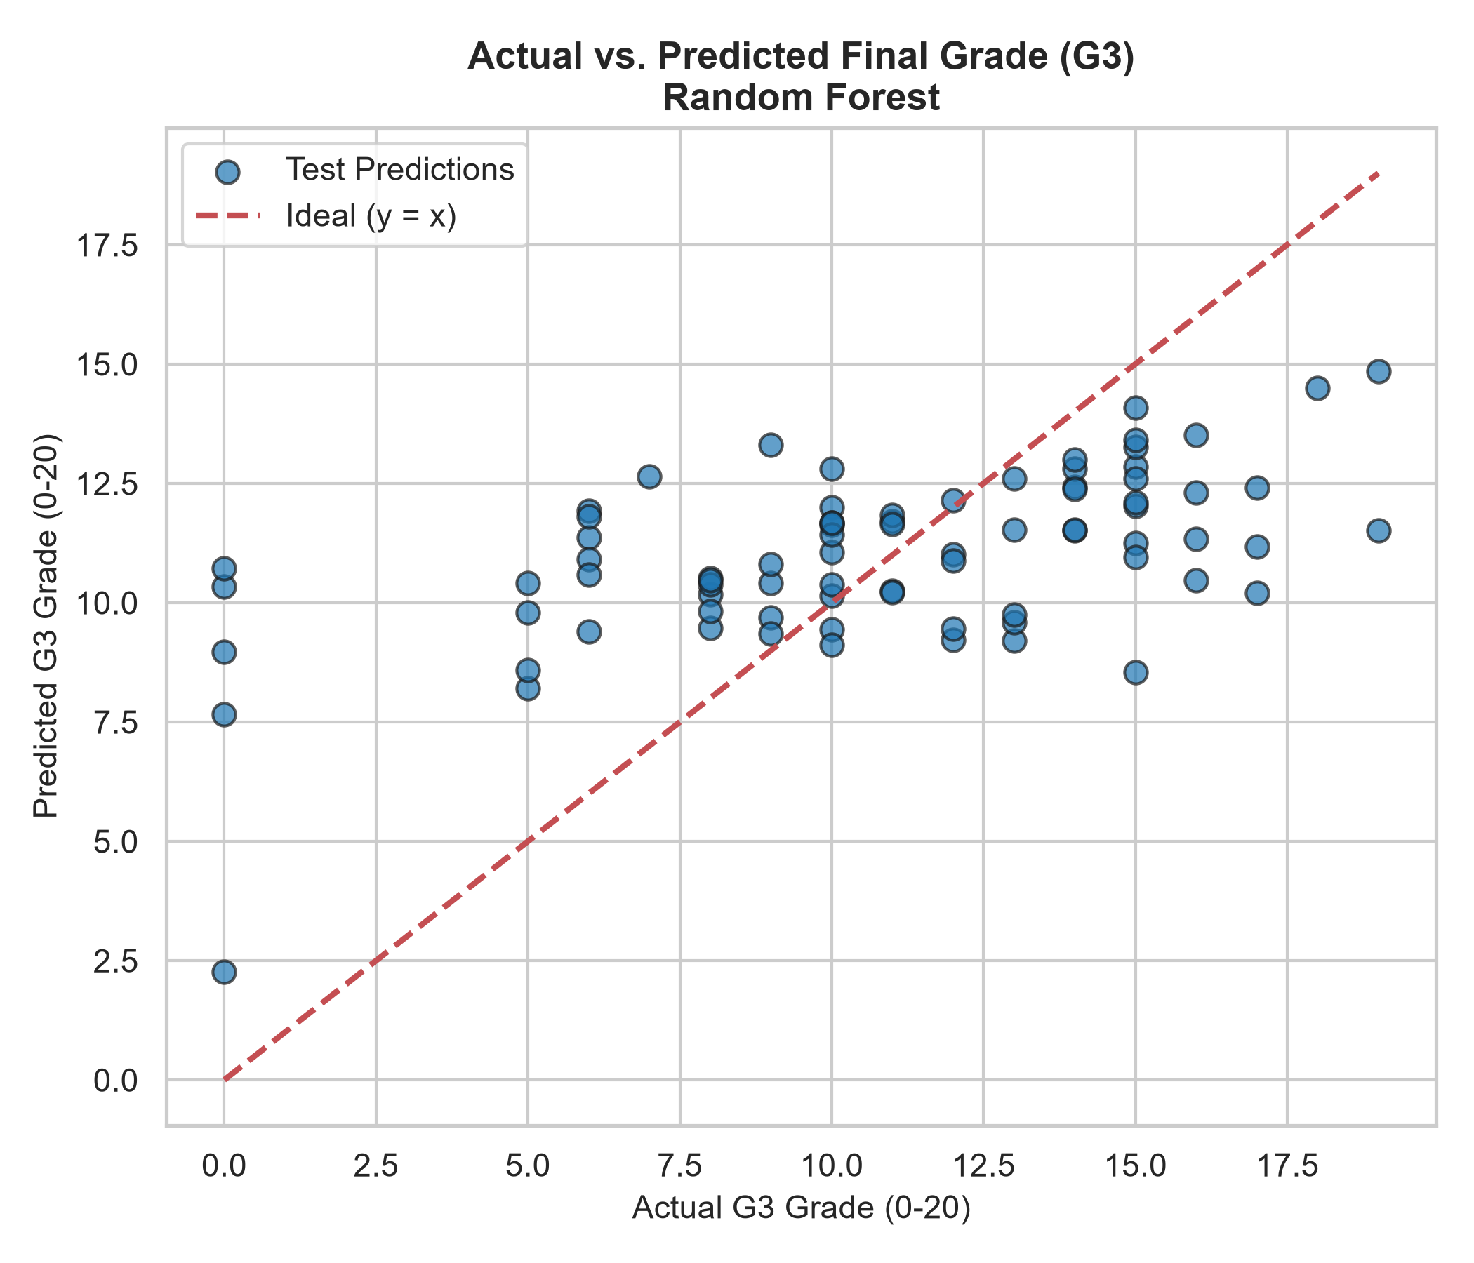

10. Web Application Design and API Architecture
A full-stack Flask web application was constructed to make the machine learning model accessible to educators. The application provides a responsive front-end interface built with semantic HTML5, modern CSS3 styling, and asynchronous JavaScript (Fetch API).
Key interface features include:
• Structured Form Sections: Features are organized into 4 logical groups (Academic & Schooling, Demographics & Household, Parental Background, Lifestyle & Well-being).
• Preset Profile Selectors: One-click buttons ('High Performer', 'Average Student', 'At-Risk Student') allow evaluators to immediately populate valid test profiles.
• Academic Classification Gauge: Visual progress bar mapping the predicted grade on the 0–20 Portuguese scale, accompanied by academic status badges (Distinction, Good, Satisfactory, Sufficient, Academic Support Recommended).
• Asynchronous Execution: Submissions do not cause full-page reloads. A spinner and disabled button state provide responsive visual feedback.
The RESTful API provides three primary endpoints:
1. GET /health: Returns JSON application status, model readiness, and champion metrics (HTTP 200 or 503).
2. GET /api/schema: Returns the complete list of 30 expected attributes, data types, and allowed categorical options.
3. POST /predict: Accepts student JSON attributes, validates data types and ranges, executes model inference via the serialized pipeline, clips output to [0, 20], and returns structured predictions.

11. Automated Testing and Quality Assurance
Quality assurance was enforced through an automated Pytest test suite (week4/tests/test_app.py). Sixteen comprehensive test cases were designed and executed, verifying:
- Artifact Availability: Model pipeline and metadata files exist and deserialize without corruption.
- Health Endpoint Readiness: GET /health returns HTTP 200 with model_loaded: true.
- Schema Endpoint Integrity: GET /api/schema correctly reflects all 30 features.
- Standard Prediction Request: Valid JSON payloads produce finite predictions on the 0–20 scale.
- Form-Encoded Compatibility: Validates form-submitted POST requests.
- Missing Field Rejection: Missing attributes yield HTTP 400 with explicit error messaging.
- Type Validation: Non-numeric strings in numeric fields yield HTTP 400 Bad Request.
- Boundary Validation: Out-of-range numerical values (e.g., age=99) are safely rejected.
- Non-Finite Rejection: Non-finite values (Infinity, NaN) are intercepted and rejected.
- Categorical Safety: Unrecognized categorical strings (e.g., school='OXFORD') are rejected.
- Malformed Syntax: Unparseable JSON syntax triggers HTTP 400 without unhandled server crashes.
- Response Schema Conformance: JSON output matches the documented contract with all metadata keys.
- Range Bounding Guarantee: Outputs strictly conform to the 0–20 scale.
- Non-Retraining Invariance: Prediction requests execute inference only; model weights and trees remain strictly immutable.
Verification Outcome: 16 passed in 2.08s (100% test pass rate).

12. Cloud Deployment Preparation for Render
The project is engineered for zero-friction cloud deployment on Render's modern containerized platform:
• WSGI Entry Point: A production Procfile defines 'web: gunicorn app:app --bind 0.0.0.0:$PORT', dynamically binding to Render's assigned internal port.
• Environment Portability: Application paths are resolved relative to Path(__file__).resolve().parent, avoiding hardcoded Windows directory paths.
• Dependency Isolation: requirements.txt specifies exact, verified library versions.
• Step-by-Step Render Deployment Workflow:
1. Log in to Render (https://dashboard.render.com/) and create a New Web Service.
2. Connect the GitHub repository: adithya222000666-arch/ml-internship-student-performance.
3. Configure Root Directory to 'week4'.
4. Set Build Command to 'pip install -r requirements.txt'.
5. Set Start Command to 'gunicorn app:app --bind 0.0.0.0:$PORT'.
6. Add Environment Variable: PYTHON_VERSION=3.11.9.
7. Trigger deployment and verify logs until the service enters Live status.

13. Visual Verification and Screenshot Evidence
The following placeholders identify screenshots that should be inserted by the student after deployment to provide visual submission evidence:
[Screenshot 1 Placeholder: Local / Live Web Interface] Capture a browser view of the home page showing the modern responsive prediction form and loaded sample student.

[Screenshot 2 Placeholder: Prediction Results Card] Capture the prediction results section showing the predicted final grade (e.g. 13.05/20), color-coded gauge bar, and performance badge.

[Screenshot 3 Placeholder: Pytest Execution Results] Capture a terminal window displaying the completed execution of 'pytest week4/tests -v' with 16 passed tests.

[Screenshot 4 Placeholder: Render Deployment Dashboard] Capture the Render cloud dashboard indicating successful build status and live service URL.

14. Model Limitations and Ethical Considerations
Responsible application of machine learning in education necessitates understanding the model's inherent constraints:
1. Advisory Nature: The system outputs a statistical expectation based on historical cohort patterns. It must never be used as a deterministic judgment or to make punitive academic decisions.
2. Omission of Interim Grades: Intentionally excluding G1 and G2 lowers the R² value to ~0.29. This is an intentional engineering tradeoff: earlier warning capability is prioritized over retrospective correlation.
3. Demographic Sensitivity: Attributes such as parental employment and residential classification reflect regional socio-economic conditions in the Portuguese survey cohort and must not be used to perpetuate demographic biases.
4. Complementary Role: The system is designed to support human mentors, academic counselors, and instructors—not replace personalized pedagogy.

15. Conclusion and Future Improvements
The Week 4 Capstone successfully delivered an end-to-end, production-ready machine learning system that fulfills all internship requirements. The pipeline ingests the raw Student Performance dataset, applies leak-free preprocessing, trains and validates multiple regression models, serializes the champion Random Forest pipeline, serves predictions via a responsive Flask web application, and undergoes strict QA validation with 16 passing automated tests.
Future enhancements could include:
• Longitudinal Tracking: Ingesting multi-semester attendance trends rather than static aggregate absences.
• Explainable AI (SHAP / LIME): Incorporating interactive feature attribution explanations inside the web interface to show educators exactly why a specific student is predicted at-risk.
• Recommendation Engine: Coupling predictions with automated remediation suggestions (e.g., recommended tutoring hours).

16. References
- Cortez, P., & Silva, A. (2008). Using Data Mining to Predict Secondary School Student Performance. In Proceedings of 5th Annual Future Business Technology Conference, Porto, Portugal, pp. 5-12.
- Pedregosa, F., et al. (2011). Scikit-learn: Machine Learning in Python. Journal of Machine Learning Research, 12, 2825-2830.
- Grinberg, M. (2018). Flask Web Development: Developing Web Applications with Python (2nd ed.). O'Reilly Media.
- Breiman, L. (2001). Random Forests. Machine Learning, 45(1), 5-32.
- UCI Machine Learning Repository: Student Performance Data Set. https://archive.ics.uci.edu/ml/datasets/Student+Performance

