Unlocking Societal Trends in Aadhaar Enrolment and Updates
UIDAI – NIC – MeitY Online Hackathon Submission
Participant Name: K. Vishal Adithya
Institution: Vignana Bharathi Institute of Technology
Category: Solo Participant
Submission Date: January 2026

Abstract

This project analyzes anonymized Aadhaar enrolment, demographic update, and biometric update datasets released by UIDAI to identify operational trends, service demand patterns, and lifecycle-driven workload behavior. Using statistical analysis, anomaly detection, and interactive visualization, the study highlights high-pressure service regions and youth biometric workload concentration. The developed Power BI dashboard enables administrators to monitor Aadhaar service performance and plan infrastructure deployment. The proposed analytical framework supports data-driven governance and scalable identity system optimization.

1. Problem Statement and Objectives

Problem Statement
- Aadhaar datasets are large and aggregated but lack direct actionable interpretation.
- Operational stress regions are difficult to detect manually.
- Lifecycle update behavior is not directly measurable.
- Resource planning requires predictive indicators.

Objectives
- Identify enrolment and update trends.
- Detect biometric workload anomalies.
- Develop lifecycle-based service indicators.
- Build an interactive decision-support dashboard.

2. Datasets Used
Three anonymized datasets provided by UIDAI were used for this analysis:
1. Aadhaar Enrolment Dataset
Columns: date, state, district, age_0_5, age_5_17, age_18_greater
2. Aadhaar Demographic Update Dataset
Columns: date, state, district, demo_age_5_17, demo_age_17_
3. Aadhaar Biometric Update Dataset
Columns: date, state, district, bio_age_5_17, bio_age_17_
All datasets were anonymized and aggregated at state and district levels.

3. Methodology

3.1 Data Processing Environment
All data preprocessing and analysis were performed using Google Colab. Python libraries including Pandas, NumPy and Matplotlib were used for data manipulation and visualization. Power BI Desktop was used for interactive dashboard development.

3.2 Data Cleaning and Normalization
- State name standardization
- Removal of misaligned district entries
- Unicode normalization
- Duplicate resolution
- Outlier clipping using percentile thresholds
After preprocessing, all datasets were standardized to 36 valid Indian States and Union Territories.

3.3 Feature Engineering
Derived metrics were created as follows:
total_enrolment = age_0_5 + age_5_17 + age_18_greater
total_demo_updates = demo_age_5_17 + demo_age_17_
total_bio_updates = bio_age_5_17 + bio_age_17_

4. Data Analysis and Results

4.1 National Age-wise Enrolment Distribution
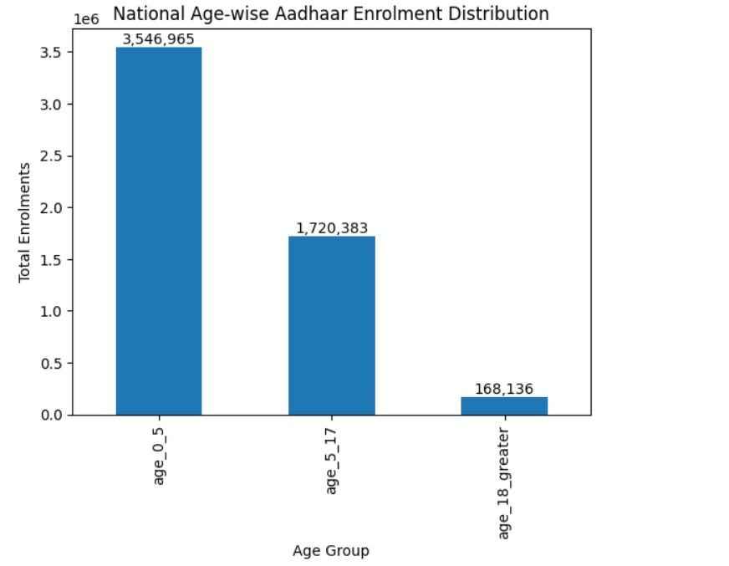
The analysis shows that Aadhaar enrolment is dominated by the 0–5 age group, indicating that most new registrations come from newborn and child enrolments. Adult enrolments remain comparatively low, demonstrating Aadhaar saturation among adults.

4.2 Monthly Aadhaar Enrolment Trends
Monthly trend analysis revealed seasonal variations in enrolment activity. Peak enrolment months suggest the influence of enrollment drives and policy campaigns.
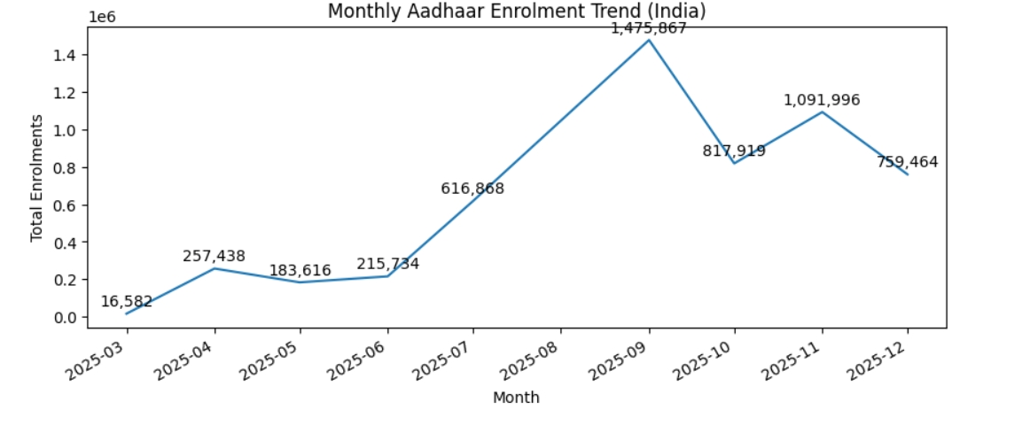

4.3 Bivariate Analysis
State-wise analysis showed strong positive correlations between Aadhaar enrolment volume and biometric update demand (correlation coefficient ≈ 0.87). Similarly, demographic updates showed a strong relationship with biometric updates (correlation coefficient ≈ 0.93).
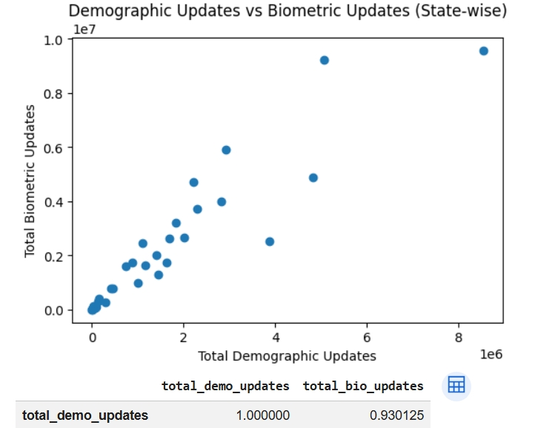

4.4 Trivariate Analysis
State-time-enrolment analysis revealed that a small number of high-population states consistently contribute the majority of national enrolments across months. This supports targeted regional infrastructure planning.
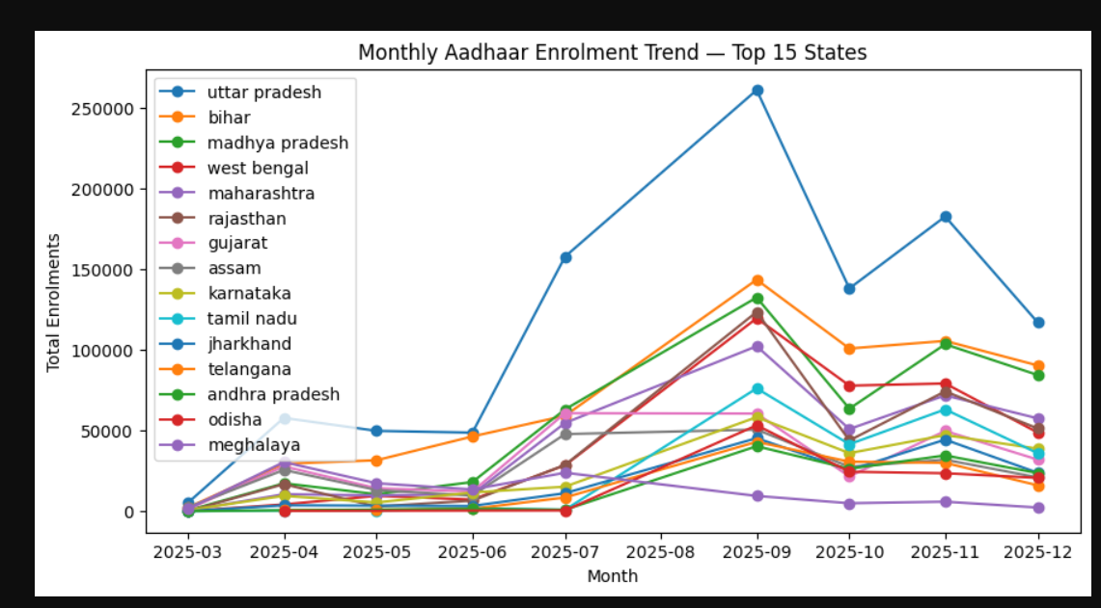

4.5 Anomaly Detection
District-level Z-score analysis identified biometric service hotspots such as Pune, Nashik, Thane, Jalgaon and Aurangabad. These districts exhibited biometric workloads far above national averages.
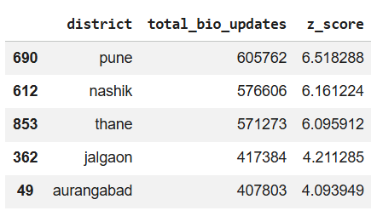

4.6 Youth Biometric Pressure Indicator
Youth Biometric Pressure was computed as the percentage share of youth biometric updates relative to total biometric updates. Several states recorded youth pressure above 60%, indicating strong lifecycle-driven service demand.
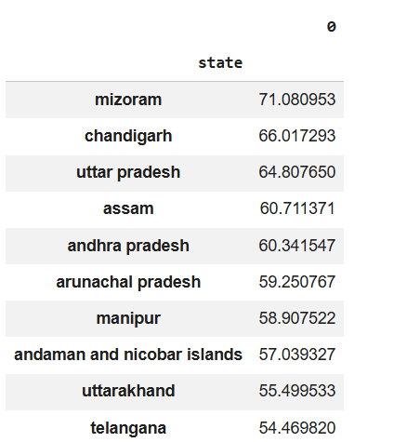
5. Interactive Dashboard Implementation
A Power BI dashboard was developed to integrate all analytical outputs. The dashboard includes KPI cards, scatter plots, ranking charts, district anomaly tables and interactive state-level filters. This enables administrators to perform real-time exploratory analysis and decision support.
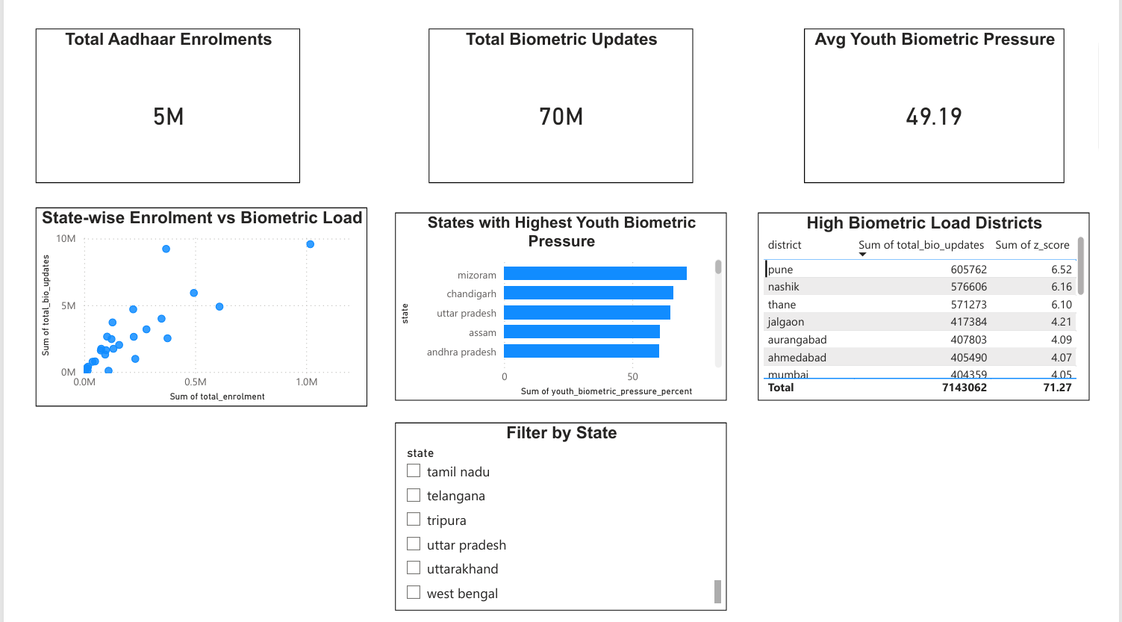

6. Solution Framework
- Deploy youth-focused biometric service centers in high youth pressure states.
- Expand infrastructure and manpower in biometric hotspot districts.
- Organize seasonal Aadhaar enrollment camps during peak months.
- Deploy mobile Aadhaar service units in migration-prone regions.
- Use predictive analytics for capacity planning.

7. Impact and Applicability

Administrative Impact
- Improved infrastructure planning
- Optimized workforce deployment
- Reduced service congestion
- Data-driven operational decisions

Social Impact
- Faster Aadhaar service delivery
- Reduced waiting times
- Improved accessibility for youth and migrants

Scalability
- Real-time operational dashboards
- Predictive workload forecasting
- Nationwide Aadhaar service monitoring systems

8. Conclusion
This project demonstrates the transformation of UIDAI datasets into actionable intelligence using statistical analysis, anomaly detection and interactive visualization. The developed analytical framework and dashboard provide a scalable foundation for improving Aadhaar service efficiency and supporting data-driven governance.

