MODEL ENGINEERING COLLEGE, THRIKKAKARA

DEPARTMENT OF COMPUTER ENGINEERING



RECORD OF PRACTICAL WORKS

OOP CST205

CLASS: CS 3 B (2019 Ad.)

Name of Student: ADITHYA A

Roll No: 03

EXP No.: 01

String Sorting

AIM

Write a java program to read a set of strings from the keyboard and display the sorted strings in ascending order. (String input can be stopped by entering "end" as the last string). Perform sorting independent of case of letters.

PROGRAM

import java.io.\*;

class Main

{

public static void main(String args[])throws IOException

{

String string1;

String s[]=new String[100];

int i,j=0,k;

i=0;

string1="finish";

System.out.println("enter a string finishing with finish");

BufferedReader br=new BufferedReader(new InputStreamReader(System.in));

for(i=0;i<100;i++)

{

s[i]=br.readLine();

j++;

if(s[i].equals(string1))

break;

}

for(i=0;i<j-1;i++)

for(k=i+1;k<j-1;k++)

{

if(s[k].compareTo(s[i])<0)

{

String t=s[i];

s[i]=s[k];

s[k]=t;

}

}

System.out.println("the sorted String is");

for(i=0;i<j-1;i++)

{

System.out.print(s[i]+" ");

}

}

}

OUTPUT

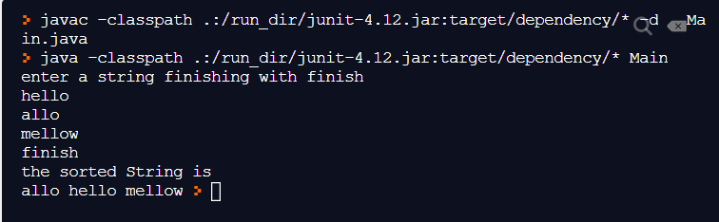

EXP No.: 02

String Search

AIM

Write a java program to read a line of text and a word from the keyboard and search that word in the line of text. Index positions of all occurrences of the word should be printed as output. If no matching was found, that should be reported.

PROGRAM

import java.io.\*;

class Main

{

public static void main(String args[])throws IOException

{

String s1;

String s;

int t,i;

int flg=1;

BufferedReader br=new BufferedReader (new InputStreamReader(System.in));

System.out.println("enter the string");

s=br.readLine();

System.out.println("enter the substring to be searched");

s1=br.readLine();

t=0;

i=0;

s=s+' ';

s1=s1+' ';

do

{

if(s.indexOf(s1,t)!=-1)

{

t=s.indexOf(s1,t);

System.out.println(t);

flg=0;

t=t+s1.length();

i=t;

}

else

i++;

}

while(i<s.length());

if(flg==1)

System.out.println("the substring is not found");

}

}

OUTPUT

