

**ASSIGNMENT 1**

**Submitted by**

***Adithya Golwalkar S R***

***220972012***

**2nd SEM - M.TECH**

**DEPARTMENT OF MECHATRONICS**

**DEPT. OF INDUSTRIAL AUTOMATION AND ROBOTICS MANIPAL INSTITUTE OF TECHNOLOGY, MANIPAL-576104**

***Exercise 1:*** Write a launch file pub_sub.launch.py to run the publisher and subscriber node.

CODE SNIPPET

Publisher

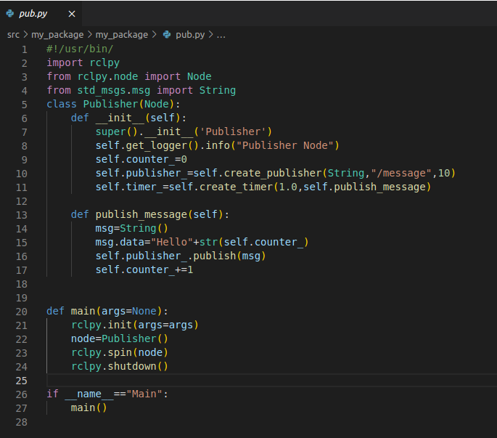

Subscriber

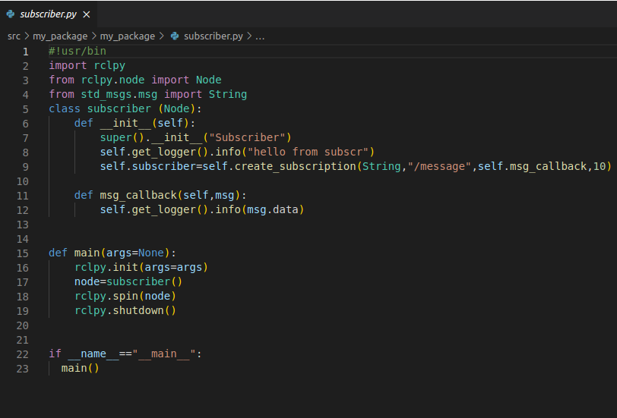

RESULT

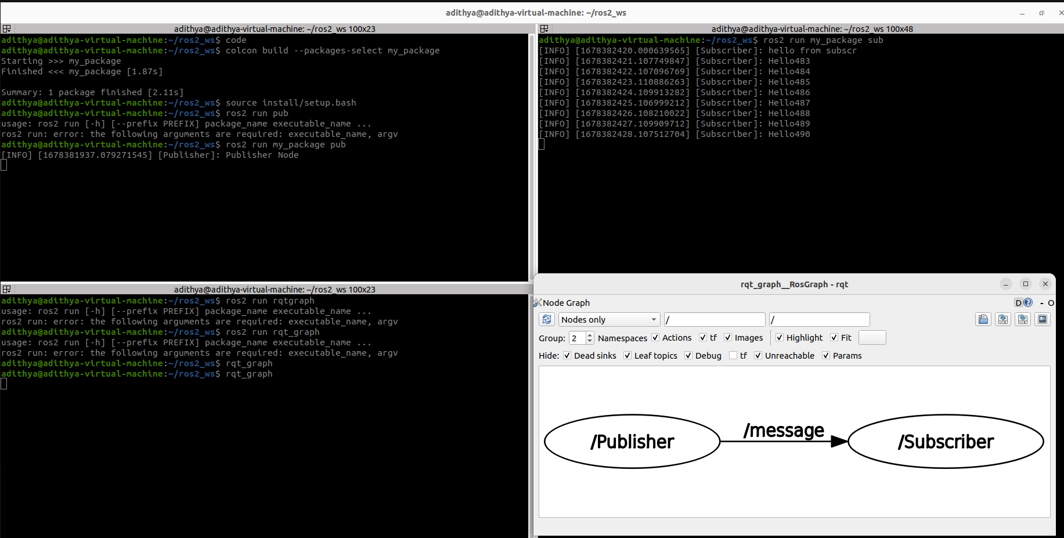

***Exercise 2:*** Create 2 nodes from scratch. First node has 1 publisher, the second has 1 publisher & 1 subscriber.

CODE SNIPPET

Publisher

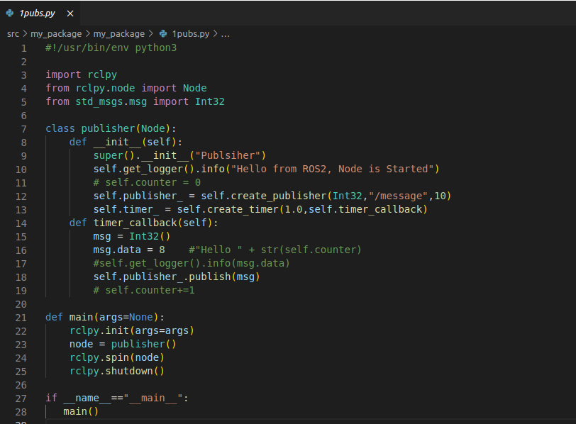

Subscriber Publisher

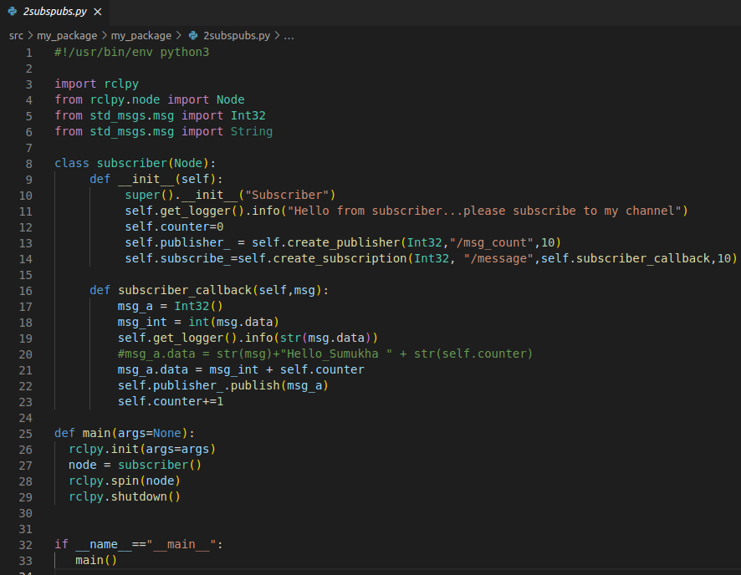

Subscriber

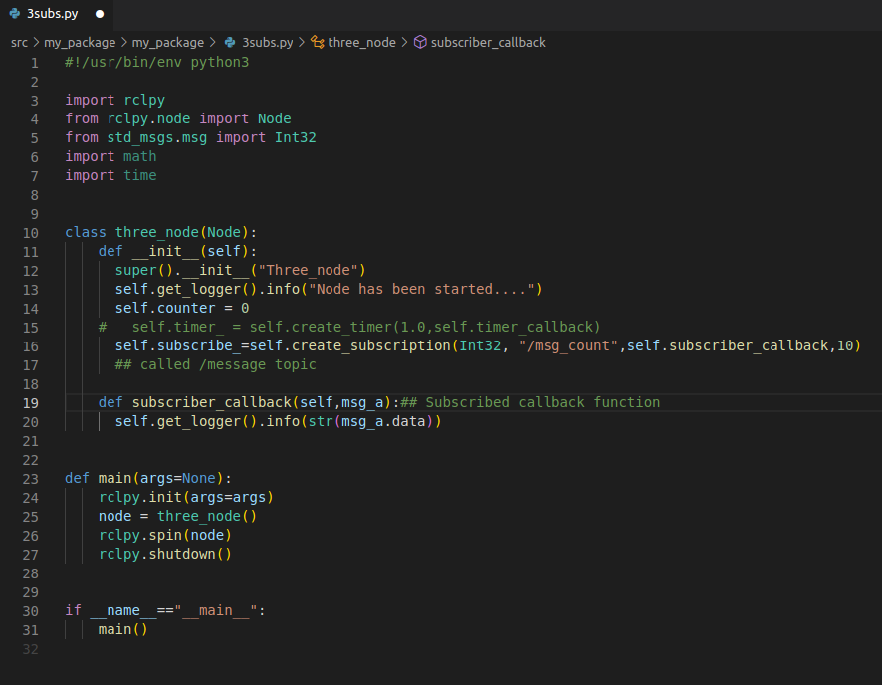

RESULT

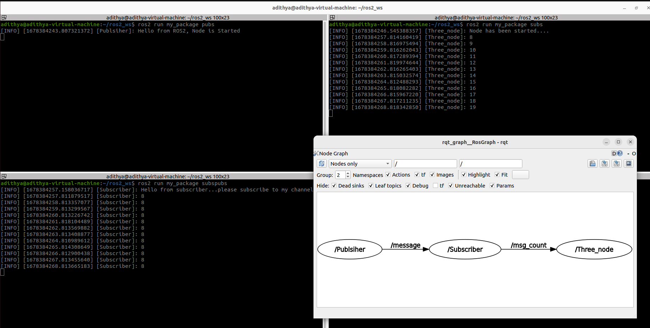

***Exercise 3:*** Write a ROS2 program to move the turtle in different shapes. (i) Square (ii) Circle (iii) Triangle (iv)Spiral

***Square***

CODE SNIPPET

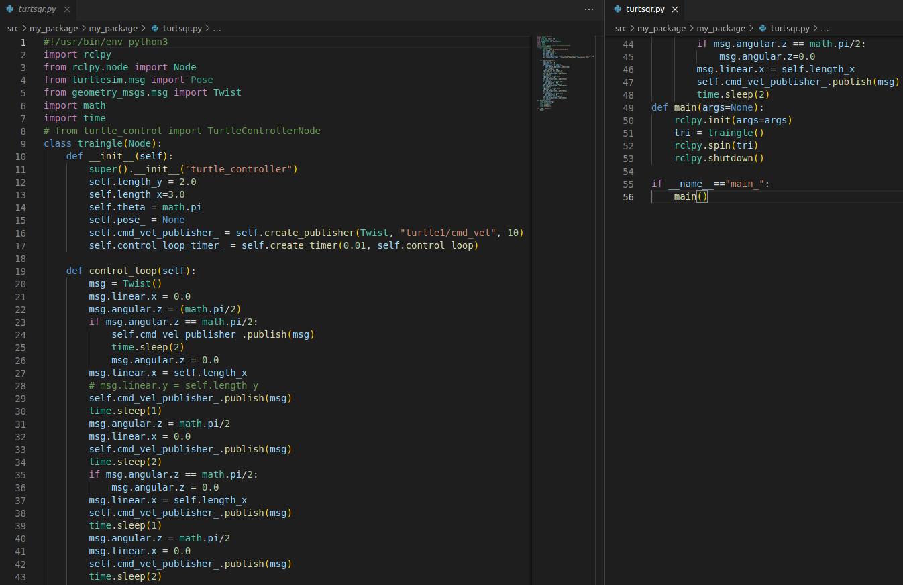

RESULT

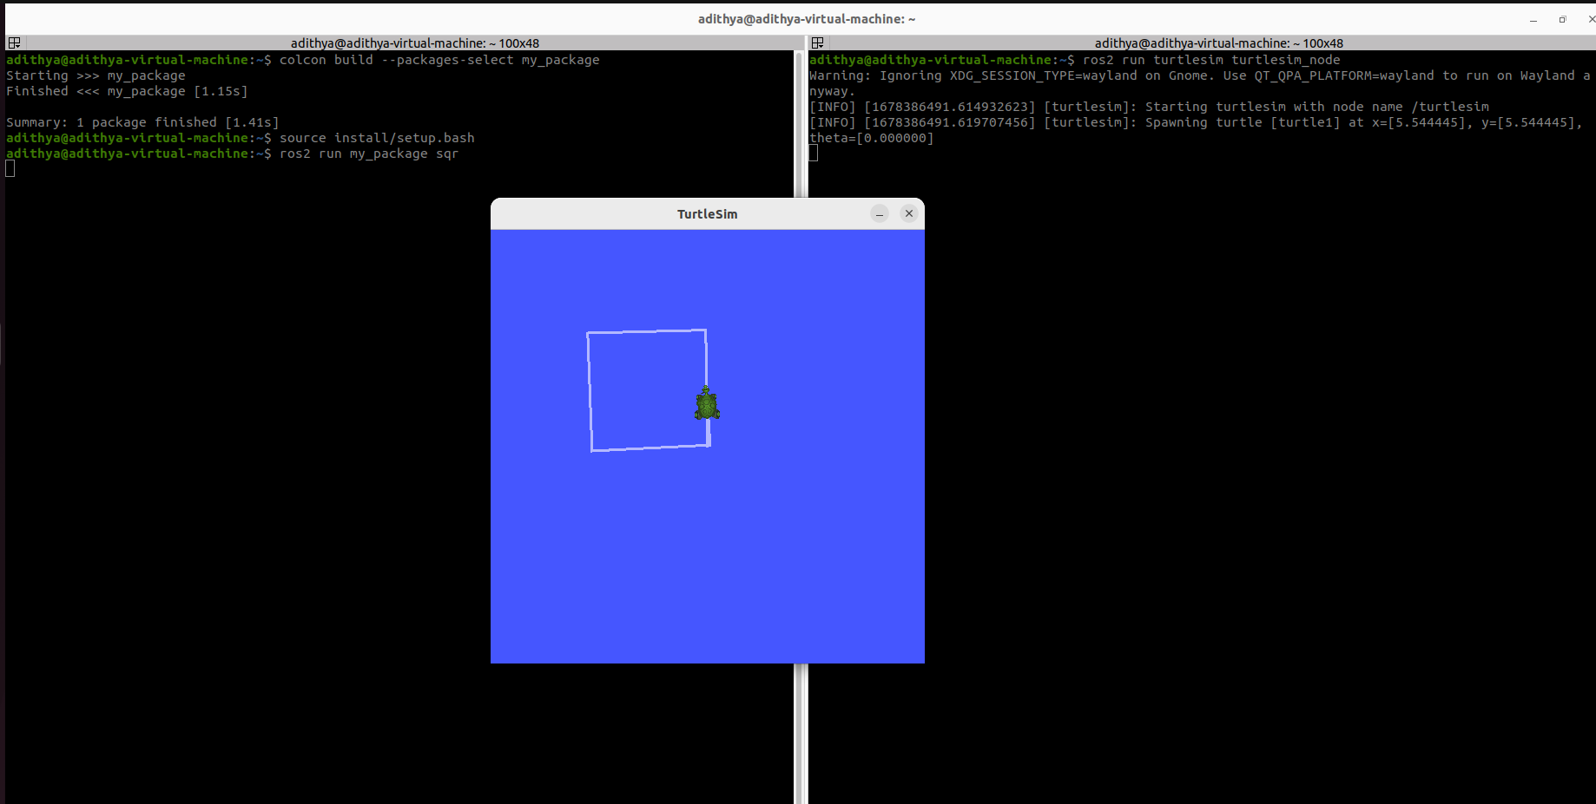

***Circle***

CODE SNIPPET

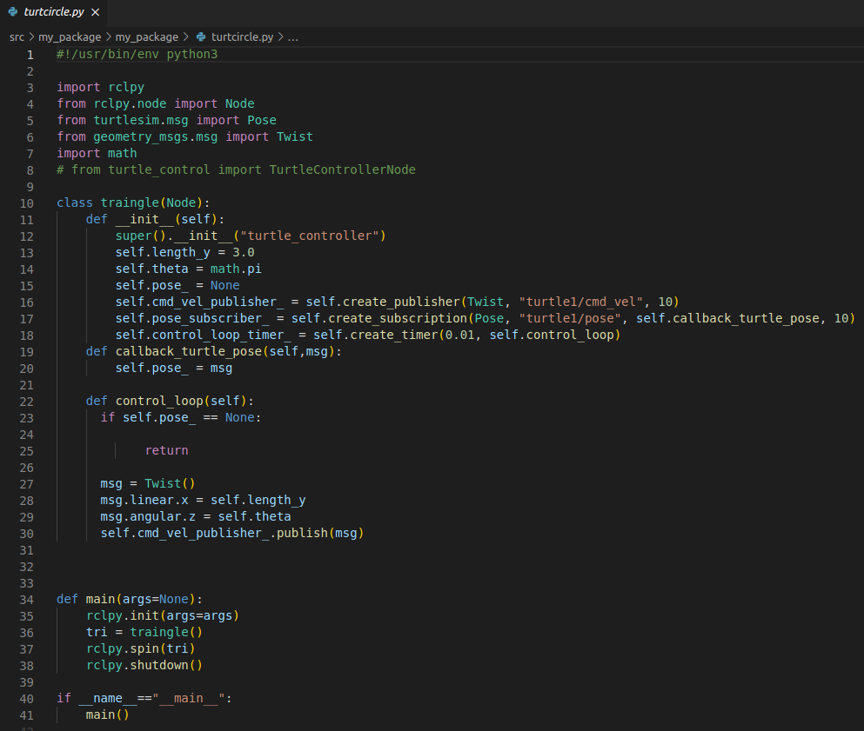

RESULT

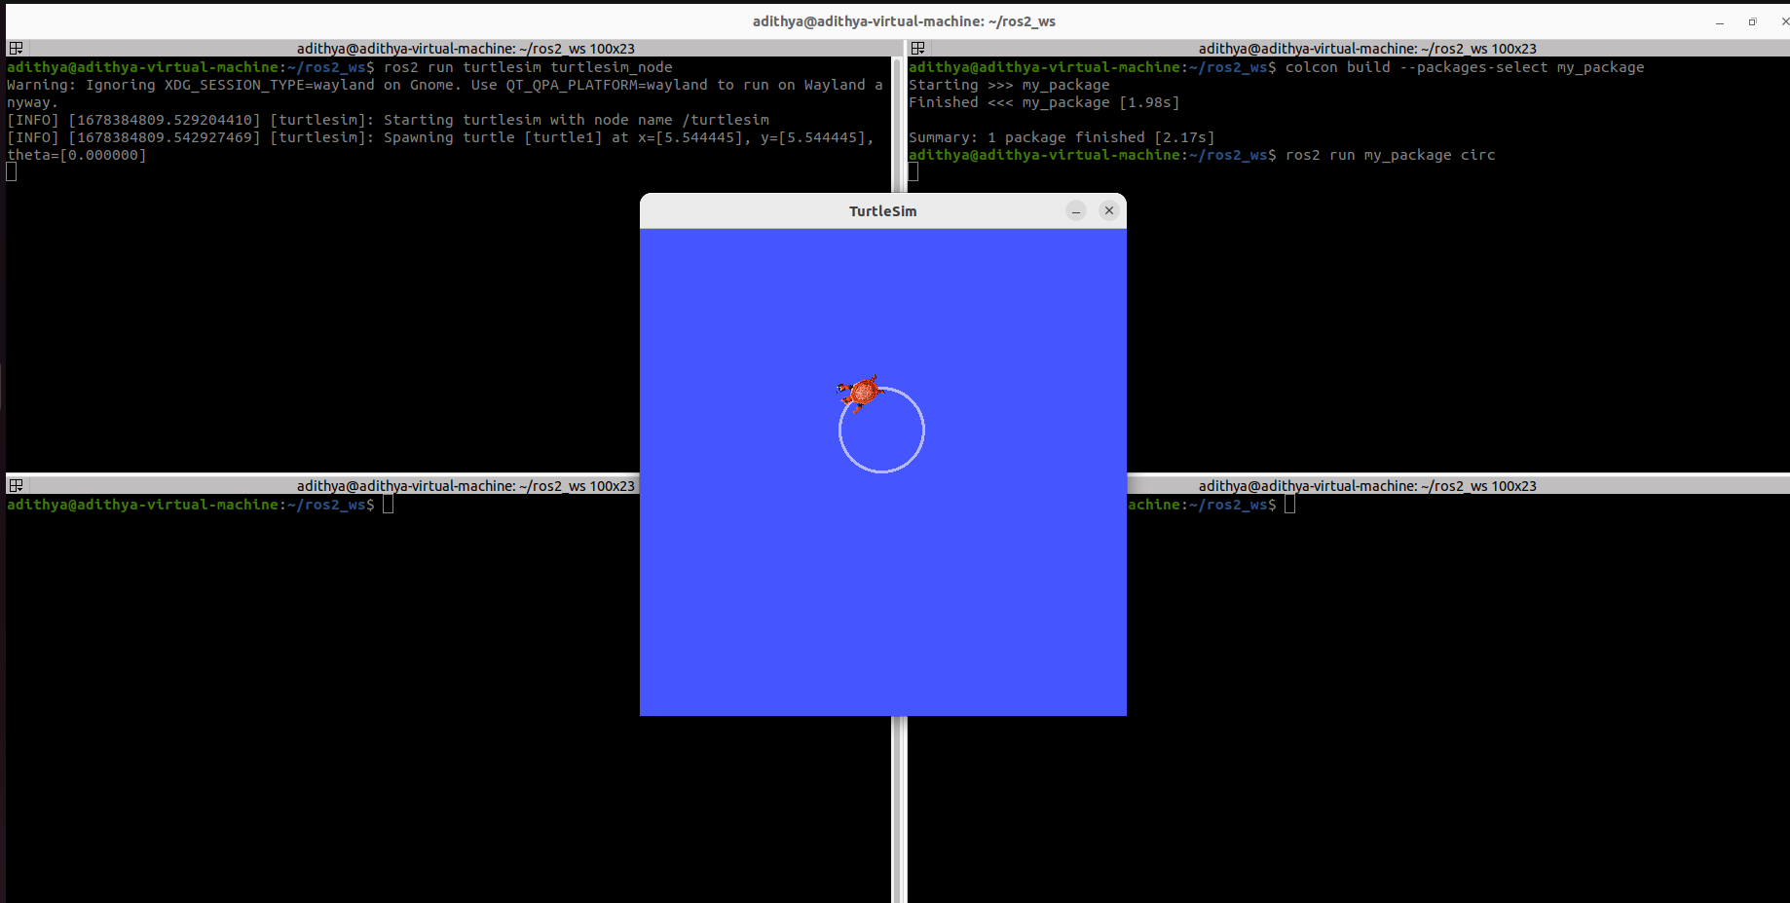

***Triangle***

CODE SNIPPET

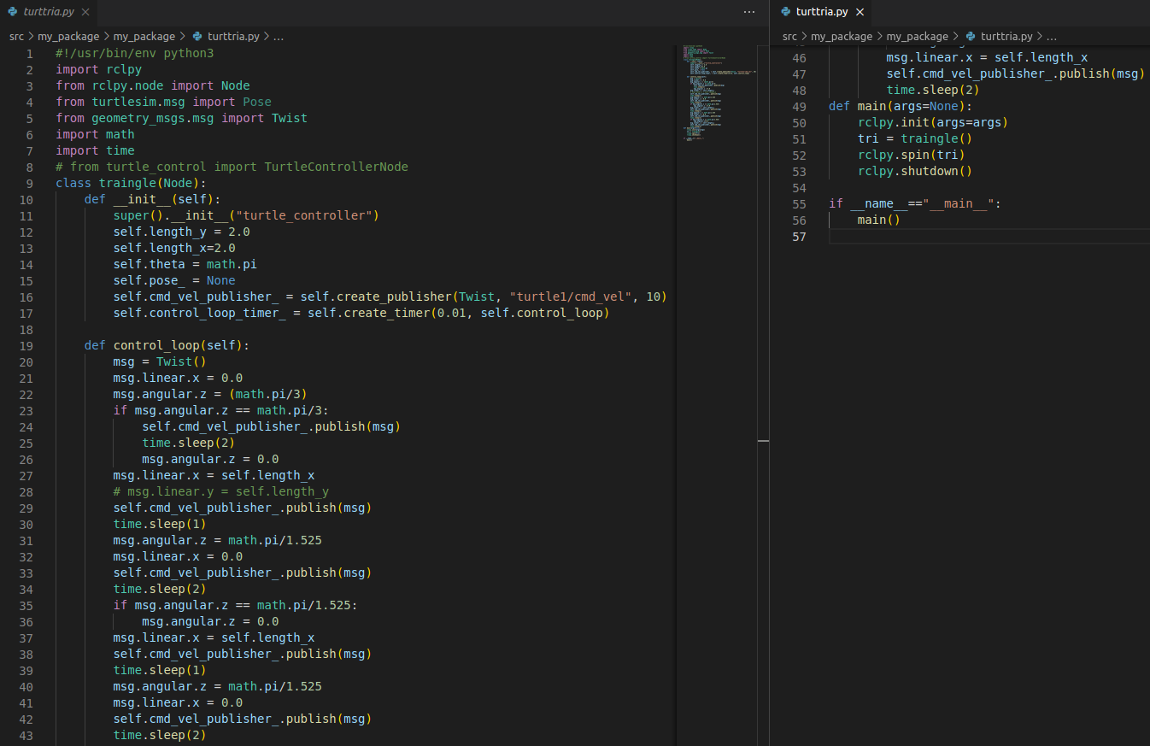

RESULT

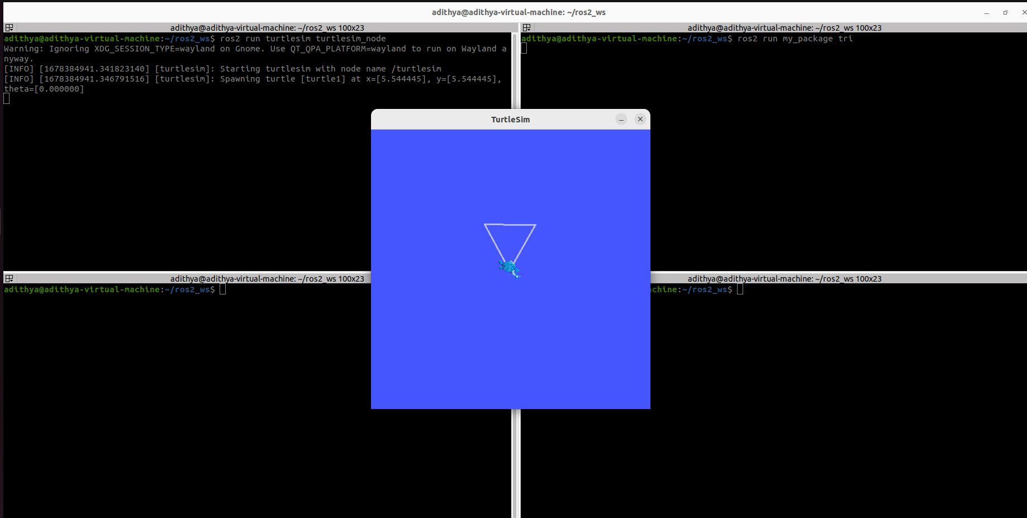

***Spiral***

CODE SNIPPET

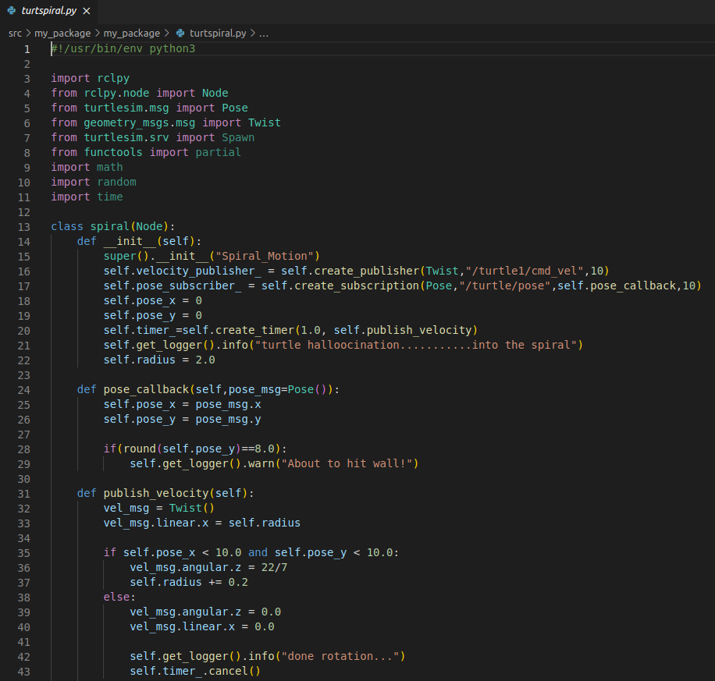

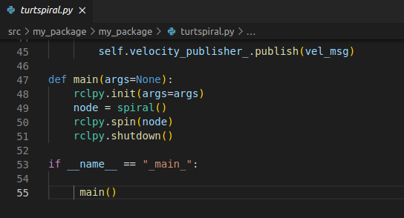

RESULT

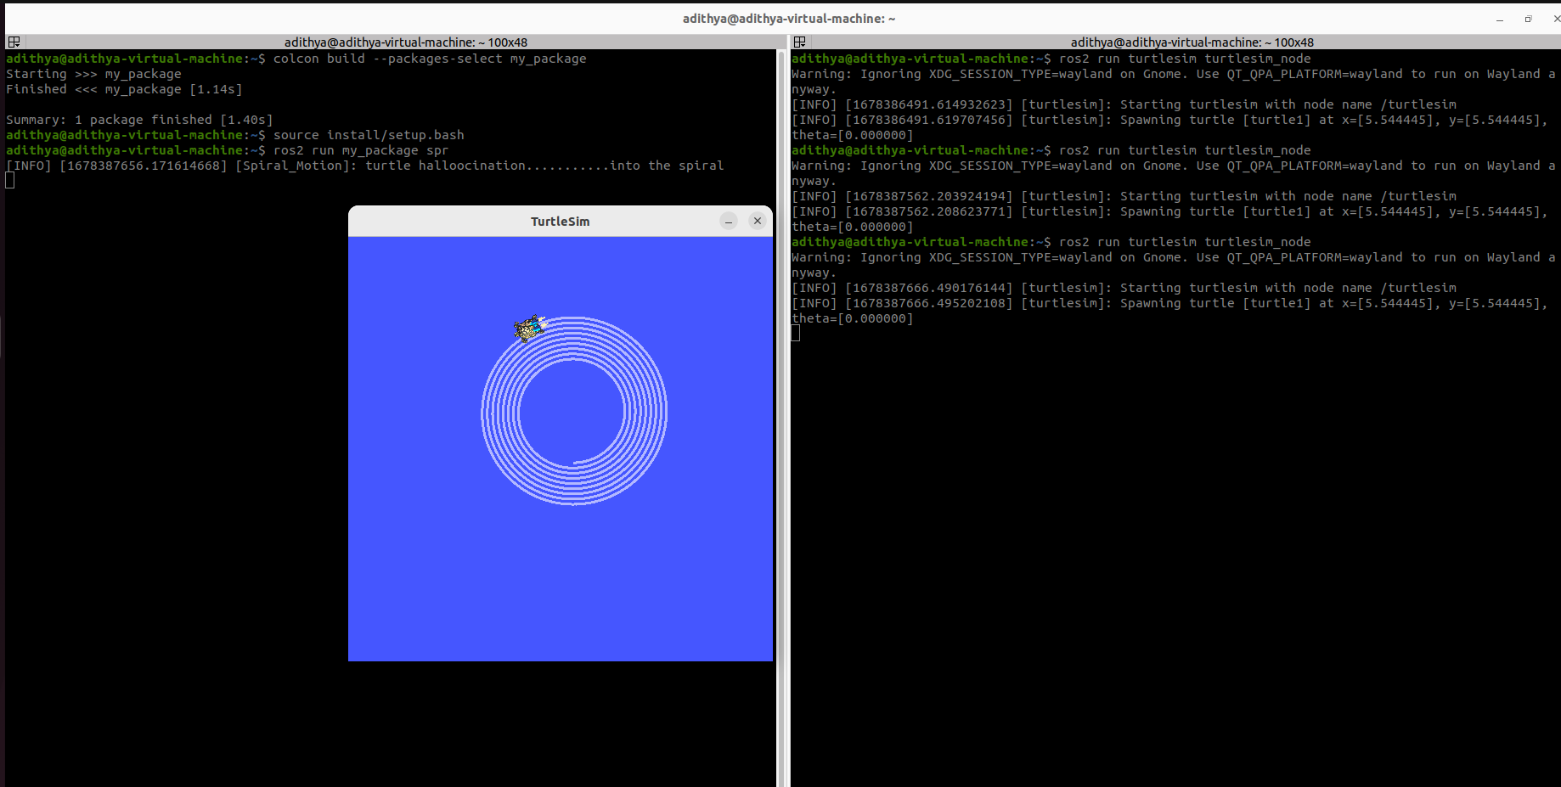

***Exercise 4:*** Write a ROS2 code to spawn a new turtle (default: turtle2) in a random location. Modify the code to move the turtle1 to turtle2 location and kill it. Use PID algorithm to navigate the turtle.

CODE SNIPPET

Spawning

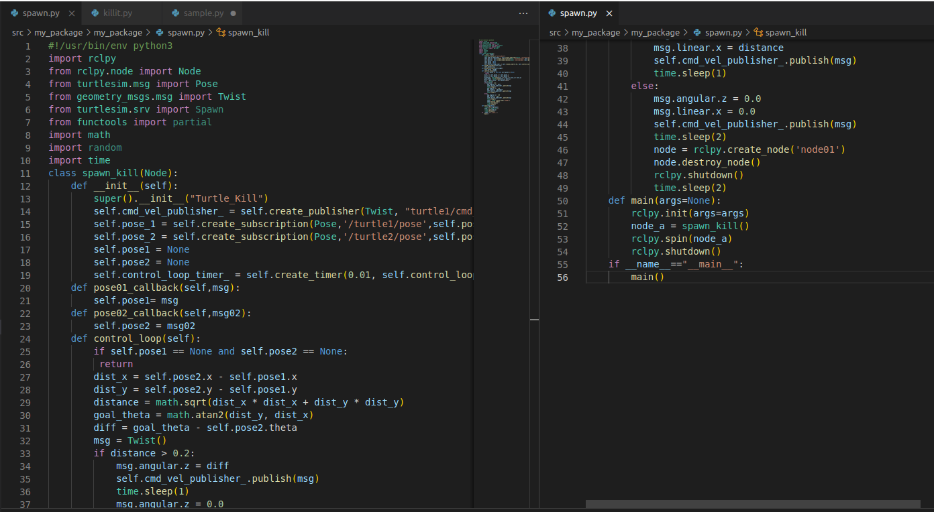

Killing

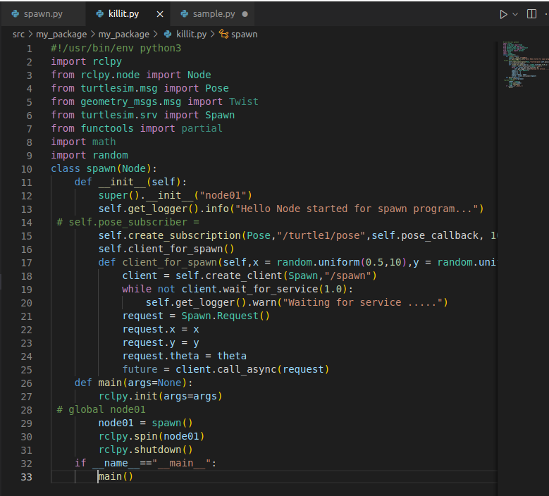

RESULT