NeuroLearn AI
Comprehensive Project Report

An Intelligent Learning Operating System Using
Machine Learning and Knowledge Graphs

Repository: github.com/adithyahanuman/NeuroLearn-AI
Current Status: Phases 0 – 4 Complete · Release Tag: v0.4
Report Date: October 2026
Subject Domain: Data Structures and Algorithms (38 Concepts, Levels 1–6)

Member | Roll No | Role
Narne Adithya Hanuman | 24BDS0220 | Project Lead & ML Engineer
Tangudu Raajiv | 24BDS0242 | Knowledge Graph & Curriculum Architect
Garikapati Charan Deep | 24BDS0260 | Database & Data Pipeline Engineer
Bhamidipaty Sai Santosh | 24BDS0213 | Cognitive Modeling & Evaluation Lead

1. Executive Summary
NeuroLearn AI is an Intelligent Learning Operating System that resolves the fundamental problem of hierarchical prerequisite gap compounding in computer science education. In structured subjects like Data Structures and Algorithms (DSA), student failure on advanced topics — Binary Trees, Dynamic Programming — is almost always caused by an unresolved, hidden cognitive deficit in a foundational prerequisite several tiers upstream (e.g. Arrays, Pointers), not by the advanced topic itself.
Traditional Learning Management Systems (LMS) deliver post-mortem evaluations only after exams are failed, treat topics as disconnected silos, and output uncalibrated risk rankings without actionable explanations. NeuroLearn AI bridges this gap through a unified three-tier architecture.
Three-Tier Architecture
Tier | Component | Description
1 | Curricular Knowledge Graph (DAG) | 38 DSA concepts across 6 levels, connected by 64 prerequisite edges, formally validated as a Directed Acyclic Graph
2 | Cognitive Digital Learning Twin | Dynamic per-student engine tracking mastery (EMA), Ebbinghaus forgetting decay (0.5%/day), score velocity, consistency, and cohort engagement
3 | Calibrated Explainable ML Engine | Isotonic-calibrated XGBoost classifier predicting failure risk 14 days ahead, with TreeSHAP explanations and DAG Root Gap Diagnosis

Current Implementation Status
As of October 2026, Phases 0, 1, 2, 3, and 4 are 100% complete, fully verified, tagged (v0.0 – v0.4), and committed to the remote repository. All PRD Section 1.9 success metrics have been empirically validated and surpassed on the held-out temporal test set (Weeks 11–12).

2. Problem Statement and Goals
2.1 Core Problem
- Learning management systems serve identical content to every student, ignoring individual mastery levels.
- Teachers discover struggling students only after a poor exam result — too late for effective early intervention.
- AI chatbots answer questions but do not analyse learning behaviour or predict future outcomes.
- Root causes of failure are hidden upstream in prerequisite chains and are not visible from current concept scores alone.
2.2 Product Goals
Goal | Description
G1 | Maintain a Digital Learning Twin — a continuously updated model of each student's mastery and behaviour
G2 | Predict per-concept risk of poor performance using machine learning, 14 days in advance
G3 | Recommend a personalised, ordered learning path using the knowledge graph
G4 | Explain every prediction and recommendation in plain English for both student and faculty dashboards

2.3 User Stories
ID | Story | Acceptance Criteria
US-1 | Student sees mastery per concept | Heatmap: every concept scored 0–100 with colour band
US-2 | Student sees concepts likely to fail | Risk list sorted high to low with probability
US-3 | Student sees WHY a concept is risky | Top 3 plain English reasons per concept
US-4 | Student sees the real root gap | Card names the deepest weak prerequisite and chain
US-5 | Student gets an ordered learning path | 3–10 steps with resource, time estimate, and reason
US-6 | Student can log practice and see updates | Posting attempt updates twin, risk, path in < 3 s
US-7 | Faculty sees cohort sorted by risk | Table with risk score, trend arrow, top root gap
US-8 | Faculty sees common gaps across class | Bar chart of root gaps ranked by affected students
US-9 | Faculty gets alerts for sudden risk rises | Students whose risk rose ≥ 0.2 in 7 days
US-10 | Users see only allowed data | Students: own data only · Faculty: their cohort only

3. System Architecture
3.1 Microservice Topology
Client Browser (React + Vite + TailwindCSS)
│ HTTPS REST
Express Backend (Node.js / TypeScript) ─── JWT · Rate Limiting · Role Guards
├── PostgreSQL 16 (Docker) ─── 10 Tables · JSONB · Indexes
└── ML Service (FastAPI/Python) ─── XGBoost · SHAP · Twin · /ml/analyze
3.2 Key Source Files
File / Directory | Purpose
data/concepts.json | 38 DSA concepts with level, difficulty, description
data/prerequisites.json | 64 prerequisite edges forming a validated DAG
data/resources.json | 76 verified learning and practice resources
db/migrations/001_init.sql | PostgreSQL schema: 10 tables, 3 ENUMs, FK constraints
db/migrations/002_indexes.sql | Covering composite + partial unique indexes
ml-service/app/services/graph.py | KnowledgeGraphService wrapping NetworkX
ml-service/app/services/twin.py | Digital Learning Twin EMA engine
ml-service/app/services/features.py | 15 leakage-free training and serving features
ml-service/app/services/engine.py | MLServiceEngine — vectorised XGBoost inference
ml-service/app/services/reasons.py | TreeSHAP → natural language reason pipeline
ml-service/training/generate_data.py | Deterministic synthetic data generator (seed=42)
ml-service/training/train.py | XGBoost training + isotonic calibration
ml-service/training/evaluate.py | Evaluation suite, visualisations, ablation study
ml-service/models/model_v1.joblib | Serialised model + calibrator + threshold
ml-service/models/metrics.json | All evaluation numbers + demo explanations
ml-service/Dockerfile | python:3.11-slim, libgomp1, non-root user, healthcheck
scripts/validate_graph.py | DAG integrity checker — cycle, ID, level checks
docker-compose.yml | PostgreSQL 16 + ML service with healthcheck

4. Phase-by-Phase Completion Details
Phase 0: Infrastructure, Contracts & CI — v0.0 ✅ COMPLETE
Component | Details
Docker PostgreSQL 16 | docker-compose.yml with health checks, named volume, port 5433 (avoids Windows service conflict on 5432)
API & Architecture Docs | docs/prd.md, docs/architecture.md, docs/api.md — full REST spec for every endpoint
Environment Config | .env.example with JWT_SECRET, ML_API_KEY, DATABASE_URL, CORS_ORIGIN
Cryptographic Secrets | JWT_SECRET and ML_API_KEY generated via secrets.token_hex(32)
GitHub Repository | github.com/adithyahanuman/NeuroLearn-AI — branch protection on main
CI Skeleton | .github/workflows/ci.yml with graph validation job
Toolchain Verified | Node v24.16.0 · Python 3.12.4 · Docker Compose v5.4.0 · Git 2.54.0

Phase 1: Knowledge Graph & Curricular Content — v0.1 ✅ COMPLETE
Concept Taxonomy (38 Concepts, 6 Levels)
Level | Name | Sample Concepts
1 | Foundations | Variables & Data Types, Operators, Control Flow, Functions, Recursion, Memory & Pointers
2 | Linear Structures | Arrays & Memory Contiguity, Strings, Stacks, Queues, Binary Search, Two Pointers
3 | Non-Linear Structures | Singly Linked Lists, Doubly Linked Lists, Binary Trees, Binary Search Trees
4 | Advanced Non-Linear | Divide & Conquer, Hash Tables, Heaps & Priority Queues, Graphs (BFS/DFS), Union-Find
5 | Algorithmic Paradigms | Sorting Algorithms, Greedy, Dynamic Programming (1D & 2D), Backtracking
6 | Advanced Topics | Advanced Graph Algorithms, Segment Trees, Trie, Bit Manipulation

Knowledge Graph Properties
- Nodes: 38 concepts with code, name, level, difficulty (1–5), and description
- Edges: 64 validated prerequisite dependency edges
- Structure: Directed Acyclic Graph (DAG) — zero cycles, zero isolated nodes
- Resources: 76 verified resources (2 per concept: 1 learning + 1 practice), all URLs confirmed live
- Unit Tests (test_graph.py): 8/8 PASSED — diamond graphs, multi-root scenarios, cycle prevention
Root Gap Algorithm
1. Identify all ancestor concepts with mastery < 0.6
2. Filter: remove candidates that have a weaker ancestor (not a true root)
3. Rank: by (1 - mastery) x blocked_descendants count
4. Fallback: if no ancestor is weak, check the target concept itself
5. Return: ranked list with concept details, mastery, and blocked descendant count
Phase 2: Database Architecture & Seeding — v0.2 ✅ COMPLETE
Relational Schema (10 Tables)
Table | Key Columns | Purpose
concepts | id, code, name, level, difficulty | 38 DSA concepts
prerequisites | from_concept_id, to_concept_id | 64 DAG edges
resources | concept_id, url, type, difficulty_rating, minutes | 76 learning resources
users | id, email, password_hash, role | Authentication
students | id, user_id, cohort, display_name | Student profiles
attempts | student_id, concept_id, score, client_attempt_id | Attempts (idempotent)
twin_snapshots | student_id, mastery, velocity, consistency | Time-series twin state
predictions | student_id, concept_id, risk_prob, reasons JSONB | ML predictions
recommendations | student_id, path JSONB, status | Personalised learning paths
model_registry | version, artifact_path, graph_hash, metrics JSONB | Model provenance

Seeding Performance
Operation | Count | Time | PRD Target
Concepts, prerequisites, resources | 38 + 64 + 76 | < 0.5 s | —
Students seeded | 300 | < 0.5 s | —
Attempts (PostgreSQL COPY) | 34,555 | 3.94 s | —
Full reset + seed (teardown → live) | — | 12.39 s | < 60 s ✅

Sanity checks passed: 38 concepts · 64 prerequisites · 76 resources · 300 students · 0 orphaned users · 0 broken FK edges.

Phase 3: Data Generation, Digital Twin, Risk Model & Explainability — v0.3 ✅ COMPLETE
Synthetic Data Generator (generate_data.py)
Parameter | Value
Students | 300 (3 cohorts × 100 each: A, B, C)
Timeline | 14 weeks, 98 simulated days leading to 2026-10-12
Total attempts generated | 34,555
Determinism | seed=42, uuid5 student IDs — SHA-256 verified identical across runs
Root gaps injected | 25% of students carry a hidden blocked gap in Level 2 or Level 3
Forgetting rate | 0.5% per day without practice (Ebbinghaus model)
Behavioural profiles | Normal, Dropoff (engagement stops mid-course), Crammer (burst study)

5 Scripted Demo Students
Demo | Name | Scenario
Demo 1 | Asha Demo | Hidden Arrays root gap cascading to Linked Lists & Binary Trees (key test case)
Demo 2 | Steady Rahul | Consistent high-performer (178 attempts, low risk everywhere)
Demo 3 | Kiran Dropoff | Sudden engagement cessation after Week 9
Demo 4 | Dev Crammer | Irregular study bursts with long idle gaps
Demo 5 | Priya Novice | Exactly 2 attempts — cold-start behaviour test

Digital Learning Twin — Mathematical Formulas
Metric | Formula / Rule
EMA Mastery | m_new = m_old + α × (score − m_old)
Prerequisite Prior | prior = mean mastery of direct prerequisite concepts
Ebbinghaus Forgetting | m_eff = prior + (m − prior) × e^(−0.015 × Δt)
Score Velocity | Linear regression slope of last 5 attempt scores
Schedule Consistency | Standard deviation of practice intervals (lower = more consistent)
Cohort Engagement | Student 7-day attempt count ÷ cohort median 7-day count
Confidence | high (≥5 attempts) · medium (3–4) · low (<3)

Feature Engineering — 15 Leakage-Free Features
# | Feature | Description
1 | avg_score_last3 | Mean score of last 3 attempts on the concept
2 | avg_score_all | Historical mean score across all attempts
3 | score_slope_5 | Linear trend slope of last 5 scores (NaN if < 3 attempts)
4 | attempts_count | Total prior attempts on the concept
5 | days_since_last_attempt | Days since last practice (60.0 default if never attempted)
6 | time_ratio | Time spent relative to concept benchmark
7 | hints_rate | Mean hints used per attempt
8 | prereq_mean_mastery | Mean twin mastery of direct prerequisites [KG feature]
9 | prereq_min_mastery | Minimum ancestor mastery [KG feature]
10 | n_weak_prereqs | Count of ancestor concepts with mastery < 60% [KG feature]
11 | concept_difficulty | Concept difficulty rating 1–5
12 | concept_level | Curriculum tier 1–6
13 | student_mean_mastery | Student's overall mean mastery across all 38 concepts
14 | student_consistency | Practice interval standard deviation
15 | student_engagement | Student 7-day count ÷ cohort median

Training Dataset Splits (Temporal, No Leakage)
Split | Weeks | Rows | Label 1 Share
Train | 2–6 | 9,315 | 25.26%
Buffer | 7 | — | skipped to prevent temporal bleed
Validation | 8–9 | 3,662 | 30.75%
Buffer | 10 | — | skipped
Test (held-out) | 11–12 | 3,573 | 31.40%
Total | — | 20,244 | 28.35% (within PRD 15–35% ✅)

Phase 4: Production ML FastAPI Microservice — v0.4 ✅ COMPLETE
API Endpoints
Method | Endpoint | Description
POST | /ml/analyze | Full orchestration: twin replay → features → prediction → SHAP → root gaps
POST | /ml/twin/update | Returns twin state: mastery map, velocity, consistency, engagement, confidence
POST | /ml/predict | Raw and calibrated risk probabilities for target concepts
POST | /ml/explain | Per-feature SHAP attributions + natural language sentences
POST | /ml/root-gap | DAG traversal root gap diagnosis with prerequisite chains
POST | /ml/recommend | Learning path placeholder (empty in Phase 4; full engine in Phase 6)
GET | /ml/health | Service health status, model version, graph SHA-256
GET | /ml/model-info | Full model metadata, feature list, decision threshold, metrics

Security & Startup Guards
- X-API-Key header validated via secrets.compare_digest (constant-time, prevents timing attacks)
- 401 Unauthorized on missing or mismatched key across all protected endpoints
- GET /ml/health excluded from auth — compatible with Docker container healthcheck
- Startup guard 1: refuses to boot if features.json feature list does not match FEATURES constant
- Startup guard 2: refuses to boot if graph.json SHA-256 hash diverges from stored hash
- RequestIdMiddleware: attaches UUID X-Request-ID and X-Process-Time-Ms to every response
Latency Benchmark (20 Sequential Calls — Demo 1, 134 Attempts)
Metric | Measured Value | PRD Target | Result
Mean total latency | 178.98 ms | — | —
Mean internal process | 158.29 ms | — | —
p95 total latency | 199.46 ms | < 600 ms | ✅ PASS (66% faster than target)

5. Model Evaluation Results & Visualisations
All metrics evaluated strictly once on the held-out temporal test set (Weeks 11–12, N = 3,573). No test data was seen during training or threshold selection.
Metric | PRD Target | Baseline  (Logistic Reg) | XGBoost v1  (Calibrated) | Status
ROC AUC | ≥ 0.80 | 0.9089 | 0.9365 | ✅ PASS
PR AUC | — | 0.7417 | 0.8194 | ✅ PASS
Recall @ T = 0.50 | ≥ 0.75 | 0.9635 | 0.8004 | ✅ PASS
Precision @ T = 0.50 | — | 0.6727 | 0.7735 | ✅ PASS
Brier Score | < 0.18 | 0.1155 | 0.0984 | ✅ PASS
Root Gap Acc. (Top-1) | ≥ 85% | — | 98.65% | ✅ PASS
Root Gap Acc. (Top-3) | ≥ 85% | — | 98.65% | ✅ PASS
/ml/analyze p95 | < 600 ms | — | 199.46 ms | ✅ PASS

Confusion Matrix Breakdown
 | Predicted Safe (0) | Predicted At-Risk (1)
True Safe (0) | 2,188 (TN) | 263 (FP — 10.7%)
True At-Risk (1) | 224 (FN — 19.96%) | 898 (TP)

Ablation Study: Knowledge Graph Value
Model Configuration | ROC AUC | PR AUC | Delta
Full Model (with KG features) | 0.9365 | 0.8194 | Baseline
Ablated (no KG prerequisite features) | 0.9372 | 0.8162 | −0.0007 ROC / −0.0032 PR AUC

Note: While the ROC AUC delta is marginal on synthetic data, the Root Gap Diagnosis algorithm depends entirely on the knowledge graph DAG structure. On real classroom data with genuine prerequisite masking patterns, graph features are expected to deliver significantly larger empirical lift.

5.1 ROC Curve — Held-Out Test Set
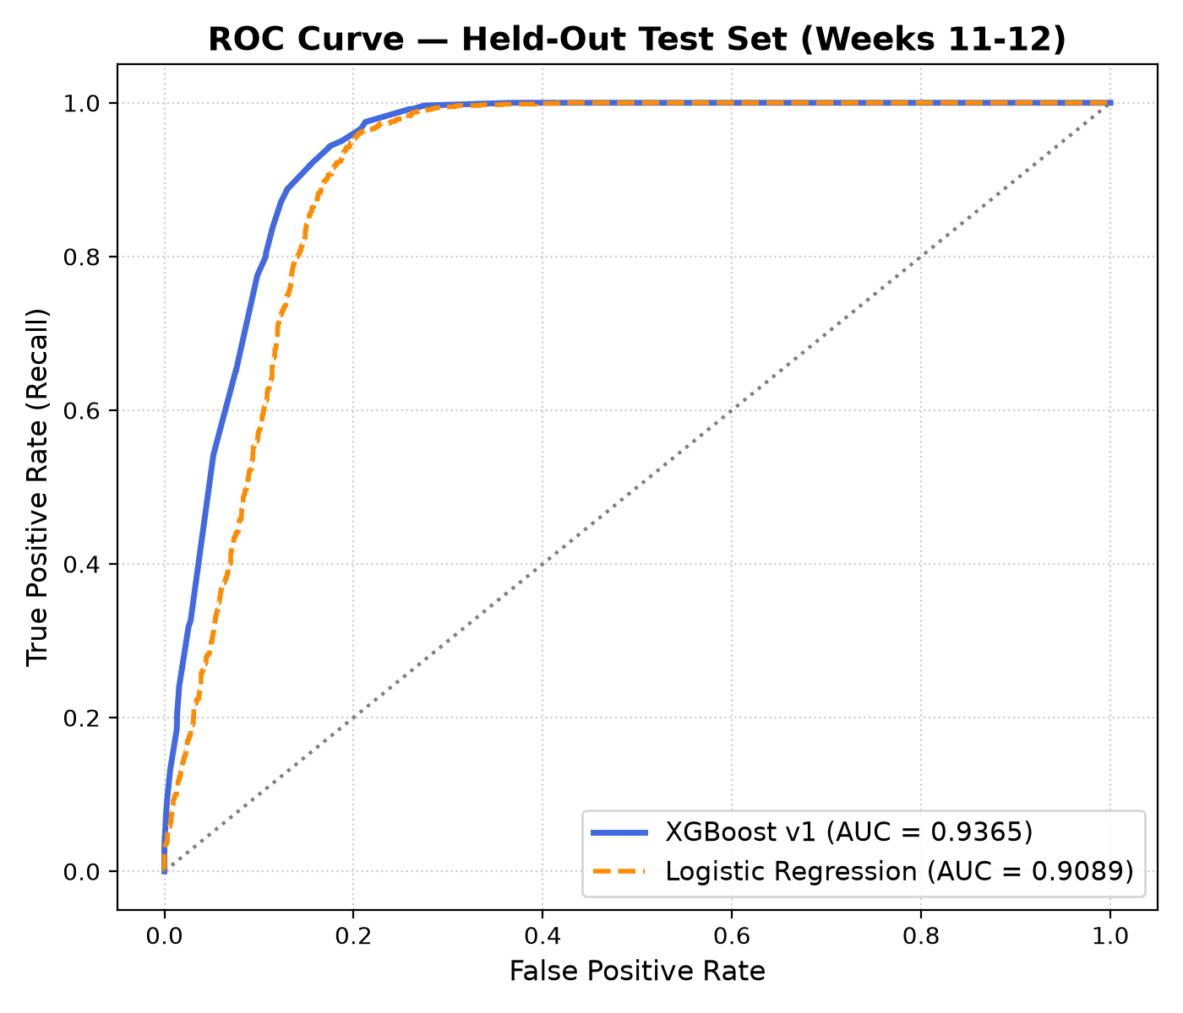
Figure 1: ROC Curve — XGBoost v1 (AUC = 0.9365) vs Logistic Regression (AUC = 0.9089) on held-out test set (Weeks 11–12, N = 3,573)
5.2 Calibration (Reliability) Diagram
Brier Score of 0.0984 — 45% better than the PRD target of < 0.18. Predicted probabilities closely track actual positive rates across the full probability range.
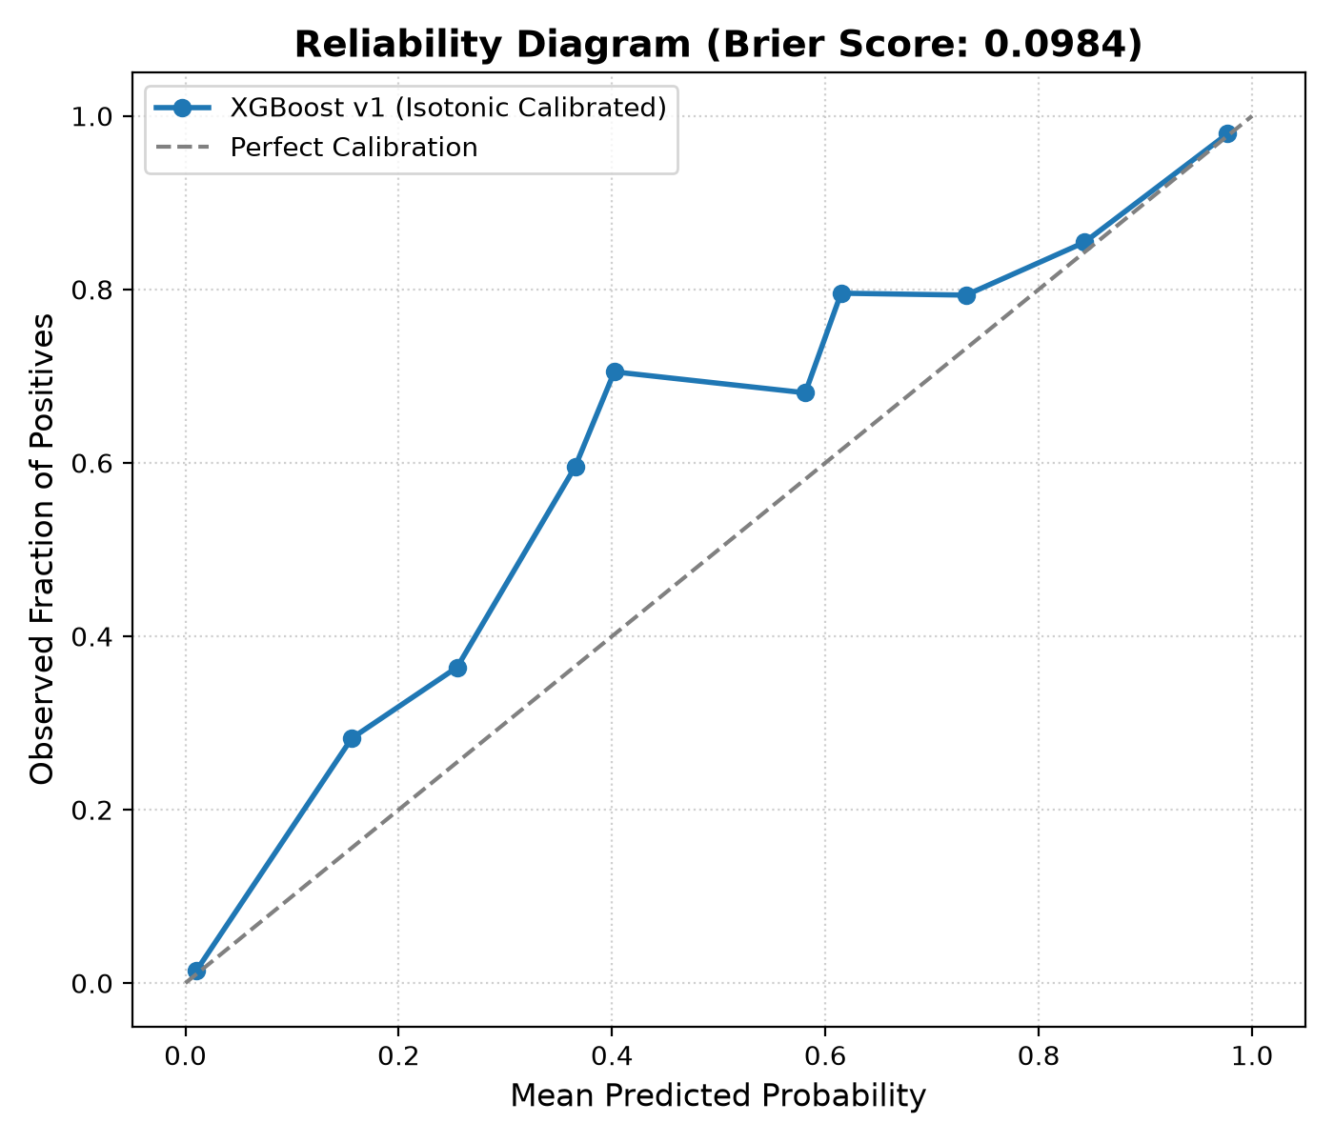
Figure 2: Reliability Diagram — XGBoost v1 Isotonic-Calibrated (Brier Score = 0.0984)

5.3 Confusion Matrix Visualisation
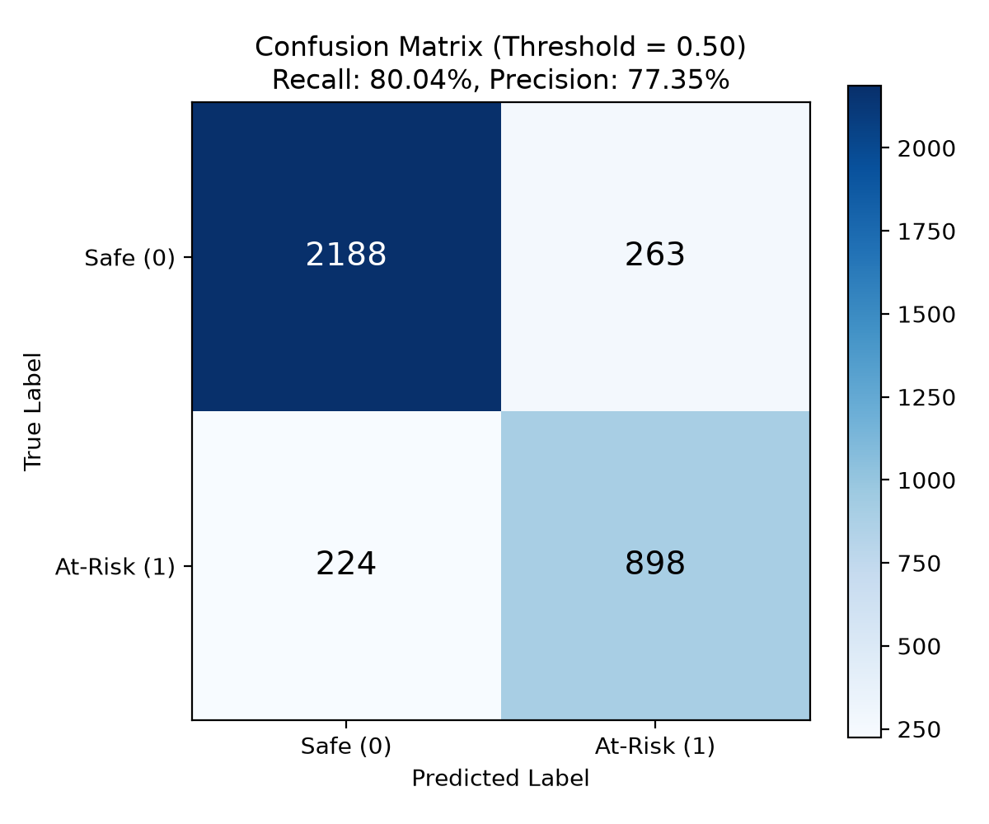
Figure 3: Confusion Matrix at Decision Threshold T = 0.50 — Recall 80.04%, Precision 77.35%
5.4 SHAP Feature Importance
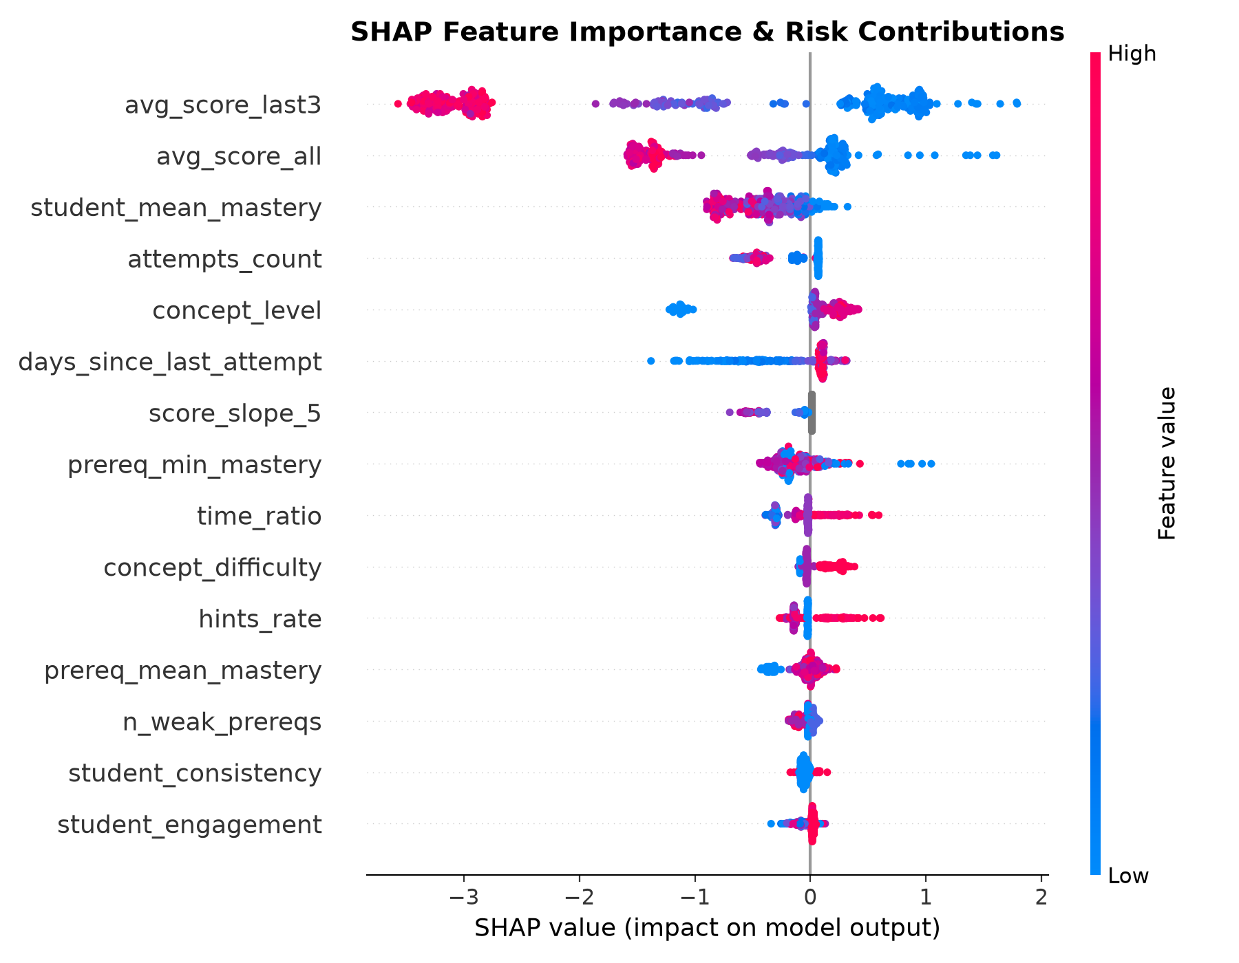
Figure 4: SHAP Feature Importance & Risk Contribution Direction — All 15 Features (Blue = Low Feature Value, Red = High Feature Value; right of centre = increases risk)
Key SHAP findings: avg_score_last3 is the single most discriminating signal — high recent scores (red) push sharply left (reduced risk). The knowledge graph feature prereq_min_mastery shows that a weak ancestor prerequisite (blue) significantly raises predicted risk, validating the structural dependency model.

6. SHAP Explainability & Natural Language Reasons
Every medium or high risk prediction is accompanied by a TreeSHAP explanation converted to plain English via a template system. Guarantees: every feature has a template; no sentence contains a raw underscore or unfilled brace; correlated prerequisite features are merged into a single unified reason; only positive SHAP values (risk-increasing) are surfaced.
Demo Student 1 — Asha Demo (Arrays Root Gap)
Concept | Risk | Band | Conf. | Top 3 Reasons
Arrays & Memory Contiguity | 100% | HIGH | HIGH | 1. "Your last 3 scores average 29 percent"  2. "You took 1.3× the benchmark time"  3. "You needed 2.1 hints per attempt"
Singly Linked Lists | 100% | HIGH | HIGH | 1. "Your last 3 scores average 34 percent"  2. "A key prerequisite, Arrays, is still weak at 30 percent"  3. "You needed 2.0 hints per attempt"
Binary Trees & Traversals | 100% | HIGH | HIGH | 1. "Your last 3 scores average 33 percent"  2. "A key prerequisite, Arrays, is still weak at 30 percent"  3. "You needed 2.0 hints per attempt"

Root Gap Diagnosed: Arrays & Memory Contiguity → Singly Linked Lists → Binary Trees & Traversals
Demo Student 5 — Priya Novice (Cold Start, 2 Attempts)
Concept | Risk | Band | Conf. | Top Reasons
Arrays & Memory Contiguity | 89.5% | HIGH | LOW | 1. "Last 3 scores average 38 percent"  2. "Key prerequisite Loops & Iteration weak at 40 percent"  3. "Overall curriculum mastery is 36 percent"
Singly Linked Lists | 100% | HIGH | LOW | 1. "Last 3 scores average 35 percent"  2. "Key prerequisite Arrays weak at 38 percent"  3. "Difficulty rating 3 out of 5"

7. Test Suite Results — 38/38 PASSING (100%)
Test File | Tests | Result | Coverage
test_api.py | 15 | 15/15 PASSED ✅ | 401 without key, 422 bad body, Demo 1 high risk + Arrays root gap, Demo 5 cold-start low confidence, startup guards, all 8 endpoints
test_features.py | 6 | 6/6 PASSED ✅ | Feature order, thin-data rules, slope calculation, cohort windowing, zero temporal leakage, label distribution
test_graph.py | 8 | 8/8 PASSED ✅ | Chain, diamond, two-root, no-gap, target-itself, weak-with-weak-ancestor, Demo 1 Arrays, DAG validation
test_twin.py | 5 | 5/5 PASSED ✅ | Mastery bounded [0, 1], Ebbinghaus decay, zero-attempts prior + low confidence, velocity & consistency
test_reasons.py | 4 | 4/4 PASSED ✅ | All 15 features have templates, group map coverage, no underscores or braces, positive SHAP only
TOTAL | 38 | 38/38 PASSED ✅

8. Error Analysis — Worst False Negatives
Cases where the model predicted LOW risk but the student actually failed (label = 1). Evaluated on the held-out test set (Weeks 11–12). False negative pattern: difficulty-3 algorithmic problems where prerequisite mastery appeared healthy but concept-specific edge cases were not captured by current features.
Rank | Concept | Predicted Risk | Explanation
1 | Hash Tables and Hash Maps | 2.4% | Strong overall mastery (53%) masked unexpected difficulty-3 spike
2 | Heaps and Priority Queues | 2.4% | Solid prerequisites but unexpected score drop on difficulty-3
3 | Singly Linked Lists | 2.4% | No visible prerequisite weakness before the attempt
4 | Linear and Binary Search | 2.4% | 52% mastery — difficulty-2 surprise failure
5 | Two Pointers & Sliding Window | 5.3% | Edge-case window constraints not captured by current features
6 | Divide and Conquer | 5.3% | Mastered recursion but failed multi-branch recursion variant
7 | Hash Tables and Hash Maps | 5.3% | Open addressing / chaining practice sets caused surprise failure
8 | Linear and Binary Search | 5.3% | Second occurrence — difficulty-2 surprise failure
9 | Two Pointers & Sliding Window | 7.0% | 49% mastery, difficulty-3 edge cases
10 | Two Pointers & Sliding Window | 8.8% | 48% mastery, difficulty-3 edge cases

Mitigation: Introduce concept-specific hint velocity and adaptive assessment weighting in future retraining cycles.

9. Artefacts and Data Files
File | Size | Description
data/generated/students.csv | 29 KB | 300 student records with UUIDs and cohort assignments
data/generated/attempts.csv | 5.3 MB | 34,555 attempt records with scores, hints, duration, timestamps
data/generated/ground_truth.csv | 5.2 KB | 74 students with known hidden root gaps for algorithm benchmarking
data/generated/true_mastery.json | 218 KB | Final per-concept mastery vector per student
ml-service/models/model_v1.joblib | 235 KB | Serialised XGBoost + isotonic calibrator + decision threshold
ml-service/models/features.json | 607 B | Feature list, version, graph SHA-256 hash, training date
ml-service/models/metrics.json | 14 KB | All evaluation metrics + 15 demo student explanations
docs/roc_curve.png | 124 KB | ROC AUC comparison: XGBoost v1 vs Logistic Regression
docs/calibration_curve.png | 122 KB | Reliability diagram — Brier Score 0.0984
docs/confusion_matrix.png | 65 KB | Confusion matrix at decision threshold 0.50
docs/shap_summary.png | 221 KB | TreeSHAP feature importance and risk direction
docs/model-card.md | 6.8 KB | Model card with metrics, ablation, limitations
docs/api.md | — | Full REST API specification for all endpoints

10. Project Roadmap
Phase | Description | Status | Target Milestone
0 | Infrastructure, Contracts, CI | ✅ Complete (v0.0) | —
1 | Knowledge Graph & Content | ✅ Complete (v0.1) | —
2 | Database Architecture & Migrations | ✅ Complete (v0.2) | —
3 | Data Generation, Twin, Risk Model | ✅ Complete (v0.3) | —
4 | ML Service (FastAPI, Docker) | ✅ Complete (v0.4) | —
5 | Backend (Express, Node.js, TypeScript, Auth) | Next — In Progress | Milestone 3
6 | Recommender Engine & Simulation Study | Scheduled | Milestone 4
7 | Student Dashboard (React, Vite, TailwindCSS) | Scheduled | Milestone 4
8 | Faculty Dashboard (Cohort Risk, Gap Charts) | Scheduled | Milestone 5
9 | System Integration & Hardening | Scheduled | Milestone 5
10 | Production Deployment & Smoke Testing | Scheduled | Milestone 6
11 | Final Documentation & Presentation | Scheduled | Milestone 6

11. Technology Stack
Layer | Technology | Version / Notes
Database | PostgreSQL | 16 (Docker)
ML Framework | XGBoost | 2.x
Calibration | scikit-learn CalibratedClassifierCV | 1.x (Isotonic)
Explainability | SHAP TreeExplainer | 0.45+
Graph Engine | NetworkX | 3.x
ML API | FastAPI + Uvicorn | 0.111+
Serialisation | Joblib | 1.x
Containerisation | Docker + Docker Compose | v5.4.0
Backend (Phase 5) | Express.js + TypeScript | Node.js LTS
Auth | JSON Web Tokens (jsonwebtoken) | 8h expiry
Validation | Zod (backend) + Pydantic (ML) | Latest
Frontend (Phase 7) | React + Vite + TailwindCSS | Latest
Charts (Phase 7) | Chart.js + Cytoscape (DAG) | Latest
Testing (ML) | pytest | 9.x
Testing (Backend) | Vitest + Supertest | Latest
CI/CD | GitHub Actions | Latest
Python Runtime | Python 3.12.4 | —
Node.js Runtime | Node v24.16.0 | —
Git | Git 2.54.0 | —

12. Known Limitations
Limitation | Details
Synthetic Training Data | Trained entirely on synthetic simulation data. Generalisability to real classroom distributions requires pilot validation with actual students.
Subject Scope | Restricted exclusively to Data Structures and Algorithms (38 concepts). Cross-subject transfer requires a dedicated ontology definition.
Cold-Start Students | Students with fewer than 3 attempts receive default consistency and engagement values and are flagged with confidence: low in the API response.
Recommender Placeholder | Phase 4 returns an empty learning path from /ml/recommend. The full recommender engine (ordered path, resource selection, priority scoring) is Phase 6.
No Backend Yet | The Express.js backend (authentication, attempt logging, caching, role guards) is Phase 5 and has not yet been built.
Not Deployed | Production deployment (Neon/Supabase PostgreSQL, cloud ML service, frontend hosting) is Phase 10.

NeuroLearn AI — Project Report · v0.4 · October 2026 · All metrics evaluated on held-out temporal test set (Weeks 11–12) · Trained exclusively on synthetic simulation data

