DSD Assignment

Full-Adder

Description :-
- A full adder is a one-bit adder that adds three one-bit numbers, often written as A, B, and Cin
- A and B are the operands, and Cin is a bit carried in from the previous less-significant stage.
- Output carry and sum typically represented by the signals Cout and S.

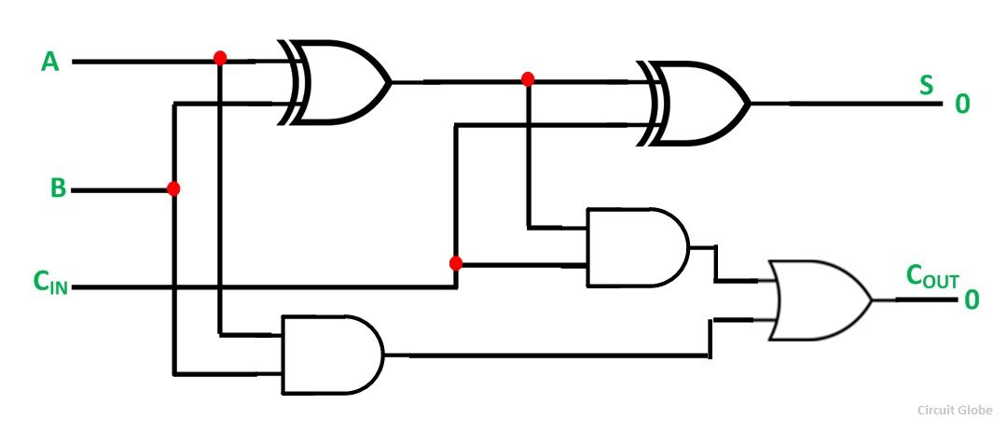
Full adder Circuit Diagram

Truth Table :-

a | b | cin(c) | sum | cout(c1)
0 | 0 | 0 | 0 | 0
0 | 0 | 1 | 1 | 0
0 | 1 | 0 | 1 | 0
0 | 1 | 1 | 0 | 1
1 | 0 | 0 | 1 | 0
1 | 0 | 1 | 0 | 1
1 | 1 | 0 | 0 | 1
1 | 1 | 1 | 1 | 1

Waveform:-

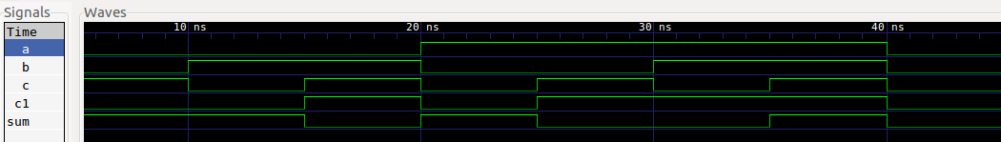
Code:-
Gate-Level

module fulladder (sum, c_out, in0, in1, c_in);

output sum, c_out;
input in0, in1, c_in;
wire xor_1,xor_2,and_1,and_2,or_1;
//outputs of each gate

xor x1(xor_1,in0,in1);
and a1(and_1,xor_1,c_in);

xor x2(sum,xor_1,c_in);
and a2(and_2,in0,in1);

or o1(c_out,and_2,and_1);
endmodule

Dataflow Level

module fulladder (sum,c1,a,b,c);

output sum,c1;
input a,b,c;
assign sum=()
assign c1=(b&&c);

endmodule

Behavioural Level
module fulladder (sum, c_out, in0, in1, c_in);

output sum, c_out;
input in0, in1, c_in;

assign { c_out, sum } = in0 + in1 + c_in;

endmodule

Testbench

`timescale 1ns/100ps
`include "fulladder.v"

module Top;

wire sum,c1;
reg a,b,c;

fulladder fu1(sum,c1,a,b,c);
initial
begin
$dumpfile("fulladder.vcd");
$dumpvars;

$monitor($time,"a=%b, b=%b , c=%b ,sum=%b, carry=%b\n",a,b,c,sum,c1);
a=0;b=0;c=0;
#5 a=0;b=0;c=1;
#5 a=0;b=1;c=0;
#5 a=0;b=1;c=1;
#5 a=1;b=0;c=0;
#5 a=1;b=0;c=1;
#5 a=1;b=1;c=0;
#5 a=1;b=1;c=1;
#5 a=0;b=0;c=0;
#5;
end
endmodule

4-to-1 Multiplexer

Description :-

- A multiplexer, abbreviated mux, is a device that has multiple inputs and one output.
- A multiplexer of 4 inputs has 2 select lines, which are used to select which input line to send to the output

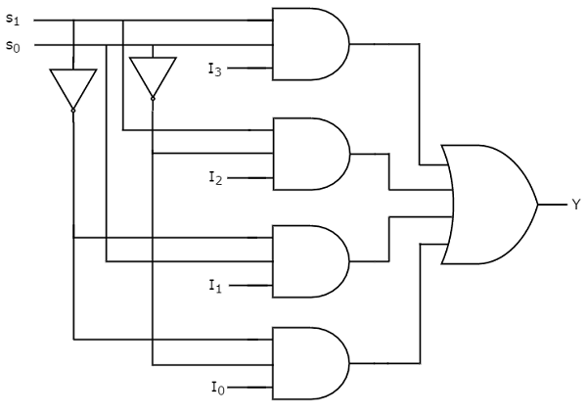

Circuit Diagram of 4-to-1 multiplexer

Truth Table:

Select[1] | Select[0] | Q(output)
0 | 0 | 0
0 | 1 | 1
1 | 0 | 2
1 | 1 | 3

Waveform:

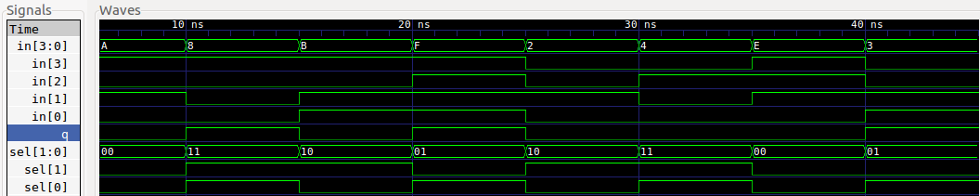

Code:

Gate Level
module fulladder (sum, c_out, in0, in1, c_in);

output sum, c_out;
input in0, in1, c_in;
wire xor_1,xor_2,and_1,and_2,or_1;
//outputs of each gate

xor x1(xor_1,in0,in1);
and a1(and_1,xor_1,c_in);

xor x2(sum,xor_1,c_in);
and a2(and_2,in0,in1);

or o1(c_out,and_2,and_1);

endmodule

Dataflow

module mux( select, d, q );

input[1:0] select;
input[3:0] d;
output q;

assign q=(d[0]&&!select[0]&&!select[1])
||(d[1]&&select[0]&&!select[1])
||(d[2]&&!select[0]&&select[1])
||(d[3]&&select[0]&&select[1]);

endmodule

Behavioural

module mux( select, d, q );

input[1:0] select;
input[3:0] d;
output q;

wire q;
wire[1:0] select;
wire[3:0] d;

assign q = d[select];

endmodule

Testbench

`timescale 1ns/100ps
`include "mux.v"

module Top;

reg[3:0] in;
reg[1:0] sel;
wire q;

mux mux1(sel,in,q);
initial
begin
$dumpfile("mux.vcd");
$dumpvars;
$monitor($time,"sel=%b, d=%b, q=%b\n",sel,in,q);
sel=2'b01;in=4'b1000;
#5 sel=2'b00;in=4'b1010;
#5 sel=2'b11;in=4'b1000;
#5 sel=2'b10;in=4'b1011;
#5 sel=2'b01;in=4'b1111;
#5 sel=2'b10;in=4'b0010;
#5 sel=2'b11;in=4'b0100;
#5 sel=2'b00;in=4'b1110;
#5 sel=2'b01;in=4'b0011;
#5;
end
endmodule

Xor Gate

Description :-

- A multiplexer, abbreviated mux, is a device that has multiple inputs and one output.
- A multiplexer of 4 inputs has 2 select lines, which are used to select which input line to send to the output

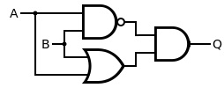
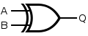
Diagram of Xor Gate

Truth Table:

a | b | out
0 | 0 | 0
0 | 1 | 1
1 | 0 | 1
1 | 1 | 0

Waveform:
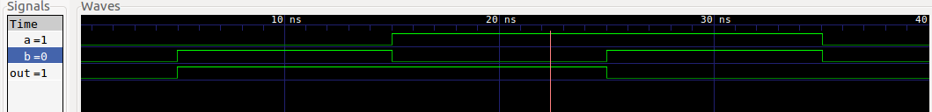

Code
Gate Level
module Xor(out,a,b);

output out;
input a,b;
wire and_1,and_2,or_1;

and a1(and_1,!a,b);
and a2(and_2,a,!b);

or o1(or_1,and_1,and_2);

assign out =or_1 ;

endmodule

Dataflow
module Xor(out,a,b);

output out;
input a,b;

assign out =(!a&b)||(a&!b);

endmodule

Behavioural
module Xor(out,a,b);
output out;
input a,b;
reg out;
always @(a or b)
begin
if(a==b)
out = 0;
else
out =1;
end
endmodule

Testbench
`timescale 1ns/100ps
`include "xor.v"

module Top;
reg a,b;
Xor xo(out,a,b);

initial

begin
$dumpfile("xor.vcd");
$dumpvars;

$monitor($time,"a=%b, b=%b , out=%b\n",a,b,out);

a=0;b=0;
#5 a=0;b=1;
#5 a=0;b=1;
#5 a=1;b=0;
#5 a=1;b=0;
#5 a=1;b=1;
#5 a=1;b=1;
#5 a=0;b=0;
#5;
end

endmodule

