Deep Learning of Facial Depth Maps for Obstructive Sleep Apnea Prediction

Now-a-days due to over competition at education and work level increasing the stress and this stress causes lots of diseases and one such disease is called ‘Obstructive Sleep Apnea’. OSH occurs when obstruction happens repeatedly in the airway during sleep due to relaxation of the tongue and airway-muscles. Usual indicators of OSA are snoring, poor night sleep due to choking or gasping for air and waking up unrefreshed. OSA diagnosis is costly both in the monetary and timely manner. That is why many patients remain undiagnosed and unaware of their condition. Previous research has shown the link between facial morphology and OSA. In this paper, author investigate the application of deep learning techniques to diagnose the disease through depth map of human facial scans. Depth map will provide more information about facial morphology as compared to the plain 2-D colour image.

In propose paper author using 3D facial scan images to train deep learning algorithm called VGG-19. Trained model of VGG-19 can be used to predict OSH from new test images.

Propose VGG-19 algorithm extract deep facial map features and then train itself and this module trained on IMAGENET dataset so we have applied transfer learning to train the algorithm on OSH facial images

Below screen showing images from OSH dataset

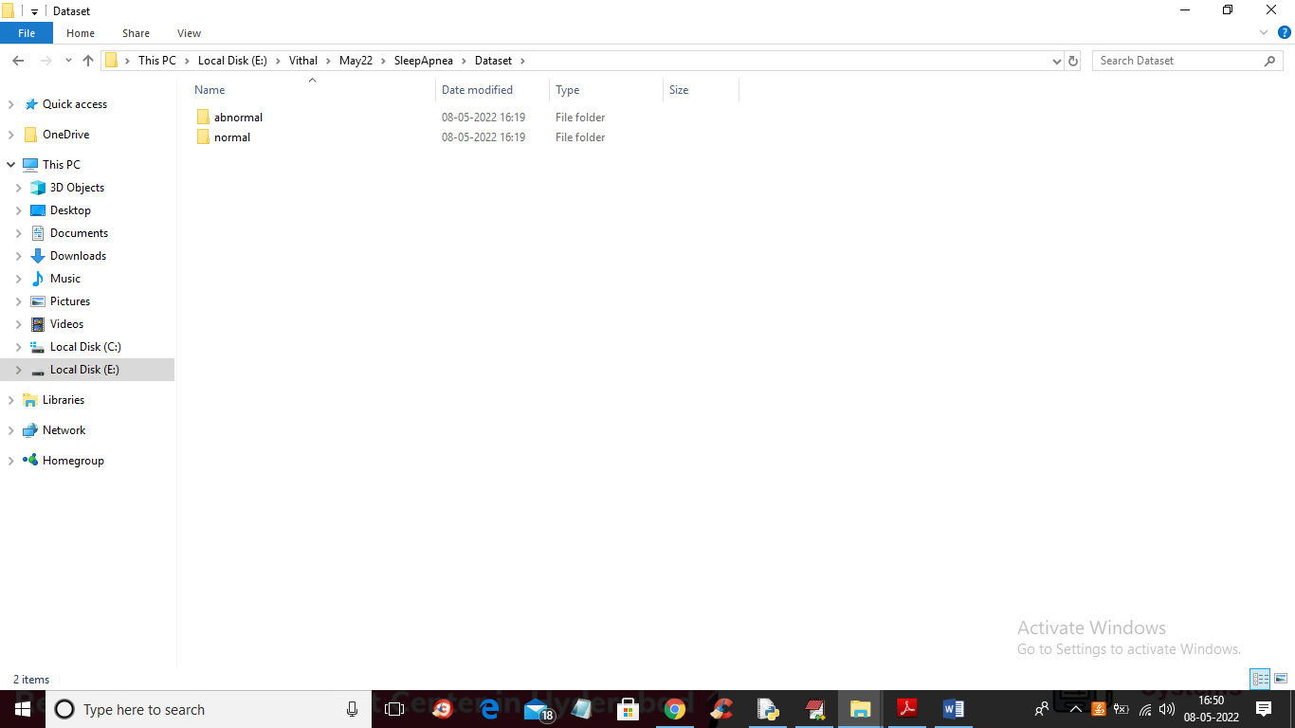

In above screen dataset folder contains 2 folders with normal and abnormal OSH images and just go inside nay folder to view images like below screen

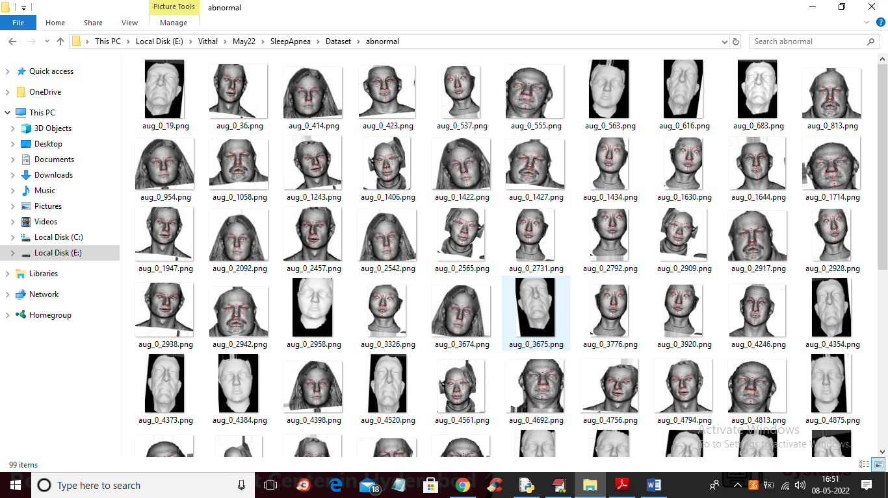

So VGG-19 will get trained on above dataset images and to implement this project we have designed following modules

1. Upload OSH Faces Dataset: using this module we will upload dataset to application
2. Preprocess Dataset: using this module we will read all images and then resize all images to equal size and then normalize all pixel values
3. Build VGG-19 Model: processed images will be input to VGG-19 algorithm to trained a model
4. Upload Test Data & Predict OSH: using this module we will upload new test image and then applied VGG19 trained model to predict test image is normal or contains OSH disease
5. Accuracy Comparison Graph: using this module we will plot VGG19 training accuracy and loss graph

SCREEN SHOTS

To run project double click on ‘run.bat’ file to get below screen

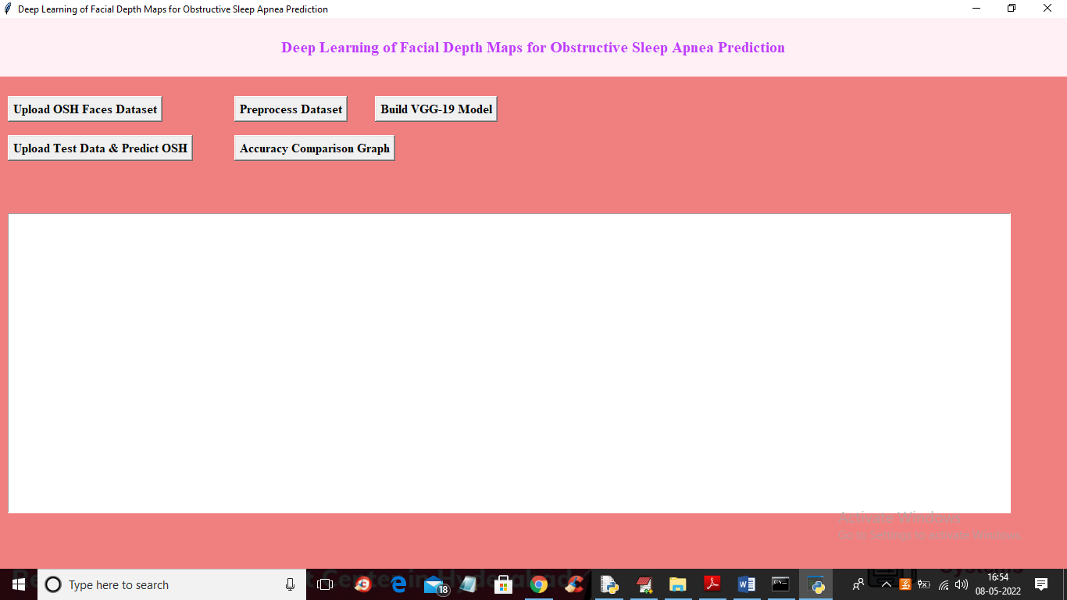

In above screen click on ‘Upload OSH Faces Dataset’ button to upload dataset and get below output

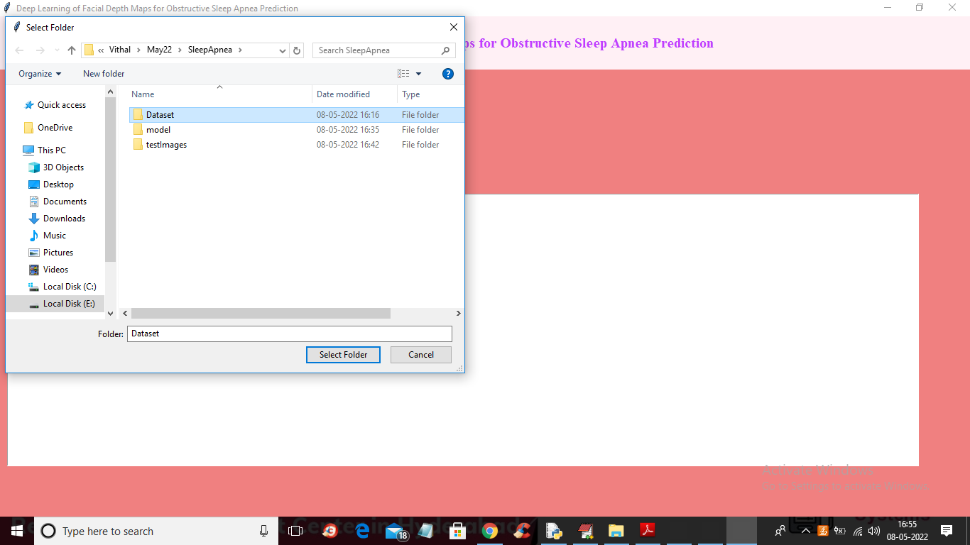

In above screen selecting and uploading ‘Dataset’ folder and then click on ‘Select Folder’ button to load dataset and to get below output

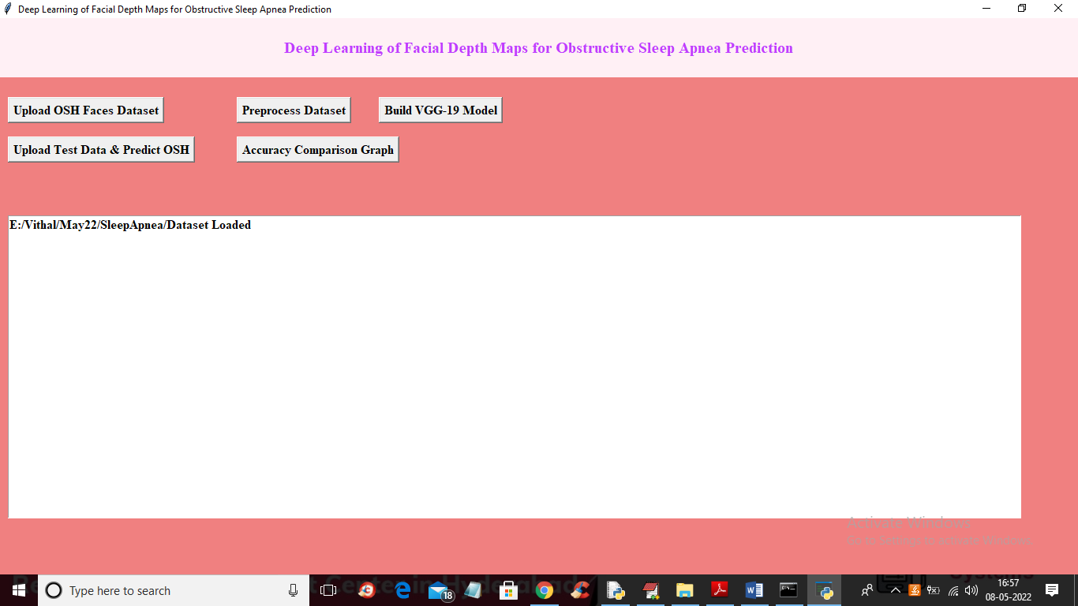

In above screen dataset loaded and now click on ‘Preprocess Dataset’ button to read all images and then normalize pixel values

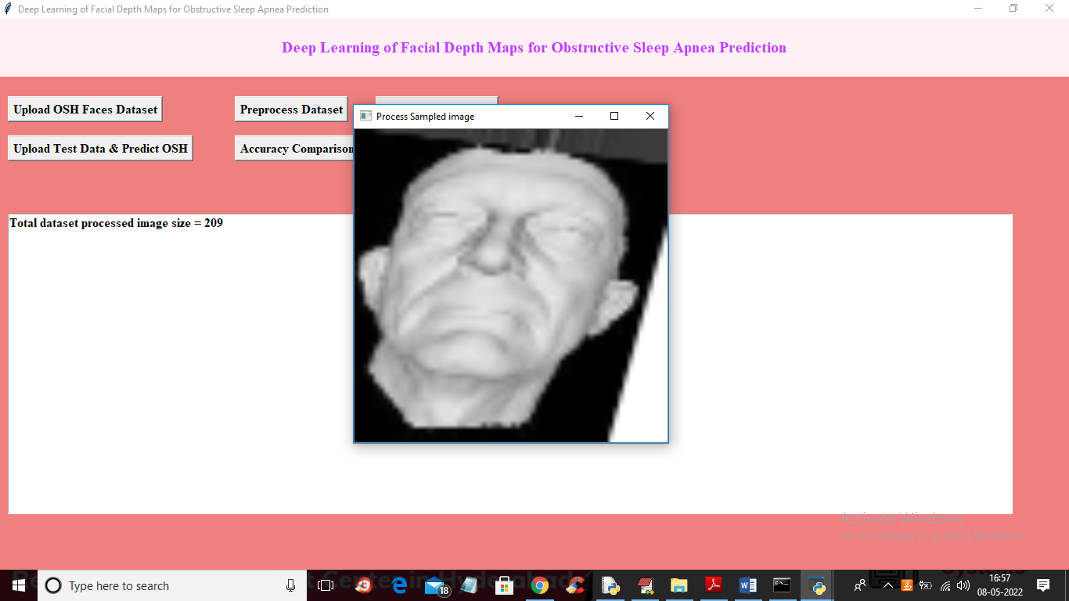

In above screen we can see dataset contains 209 images and all images are normalize properly and to check I am displaying one sample processed image and now close above image and then click on ‘Build VGG-19 Model’ button to train VGG19 on processed image and get prediction accuracy of VGG19

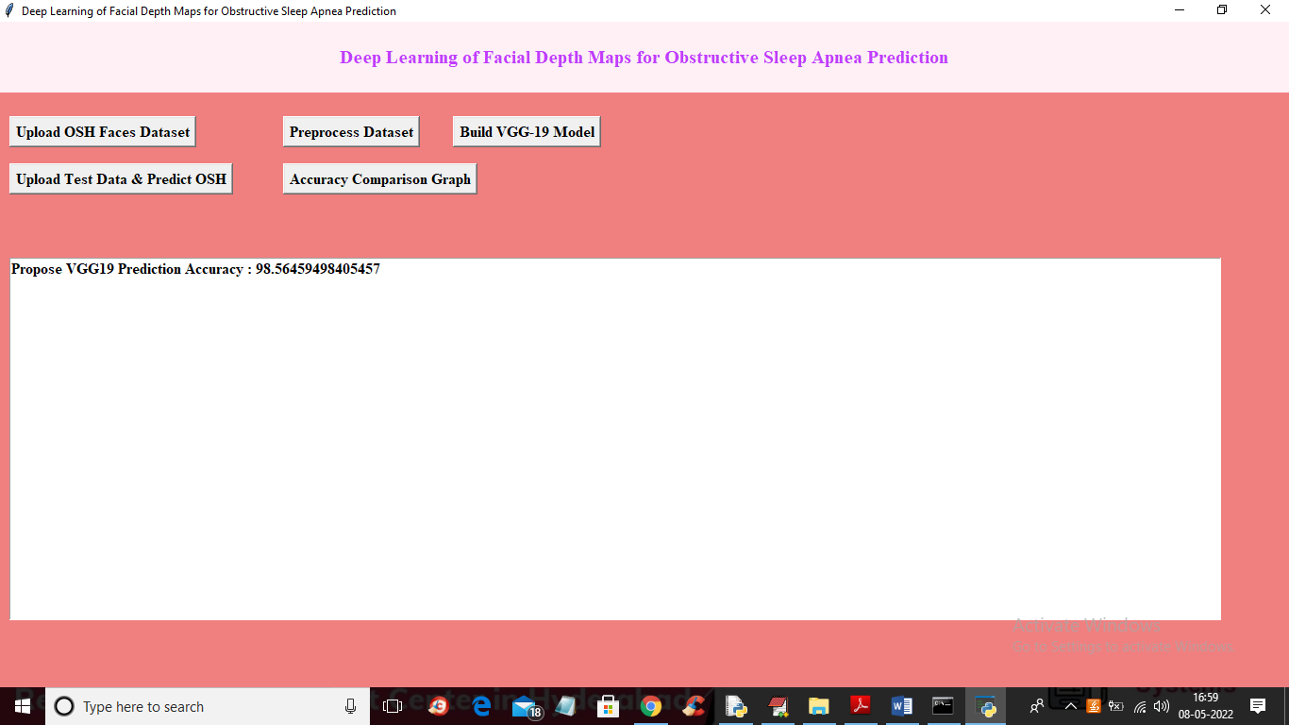

In above screen VGG19 model is build and we got its prediction accuracy as 98% and now click on ‘Upload Test Data & Predict OSH’ button to upload test image like below screen

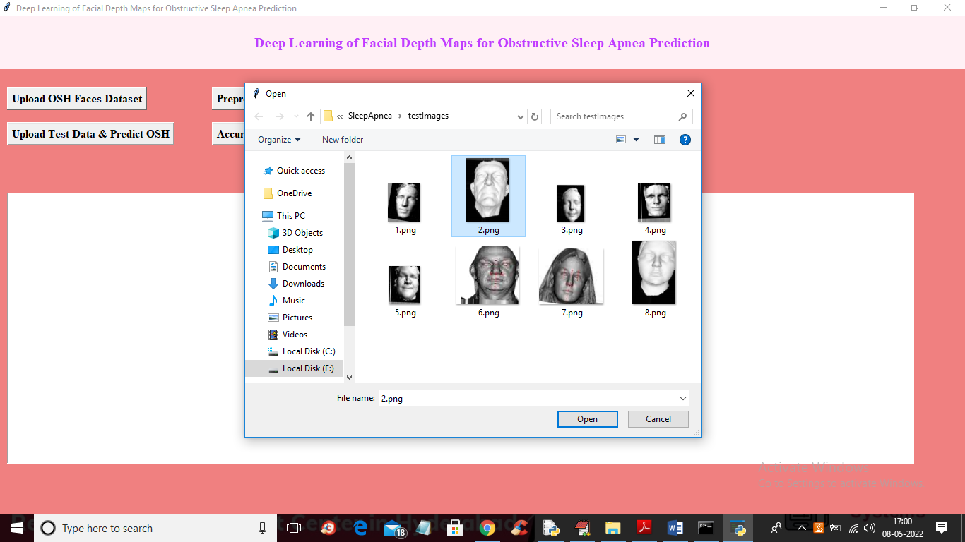

In above screen selecting and uploading ‘2.png’ file and then click on ‘Open’ button to get below output

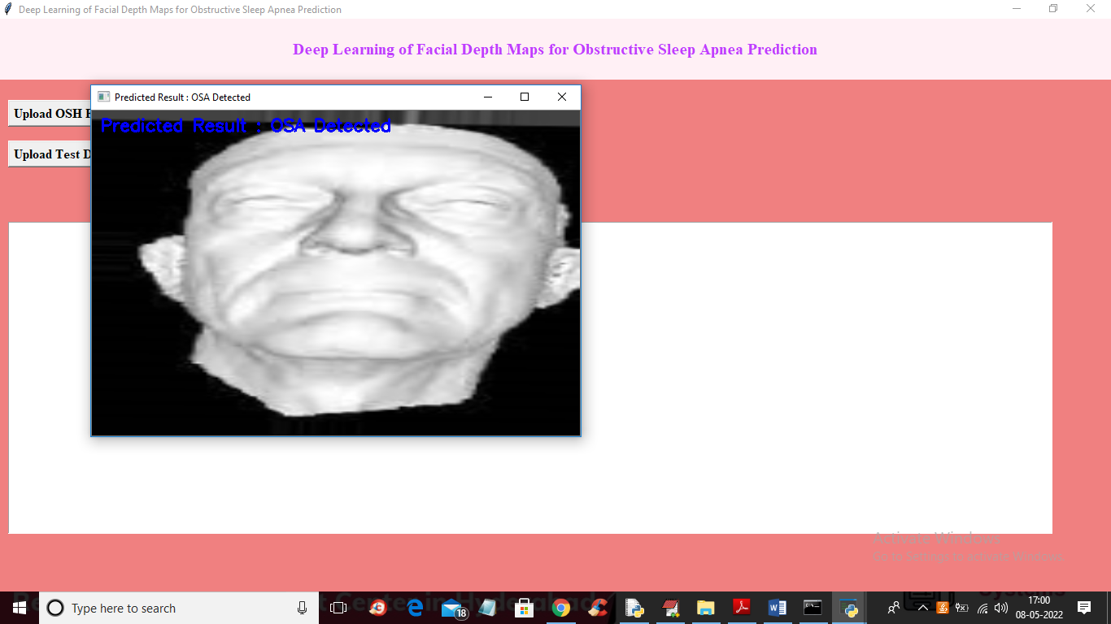

In above screen given face predicted as ‘OSA Detected’ and similarly you can upload other images and test and below is another prediction

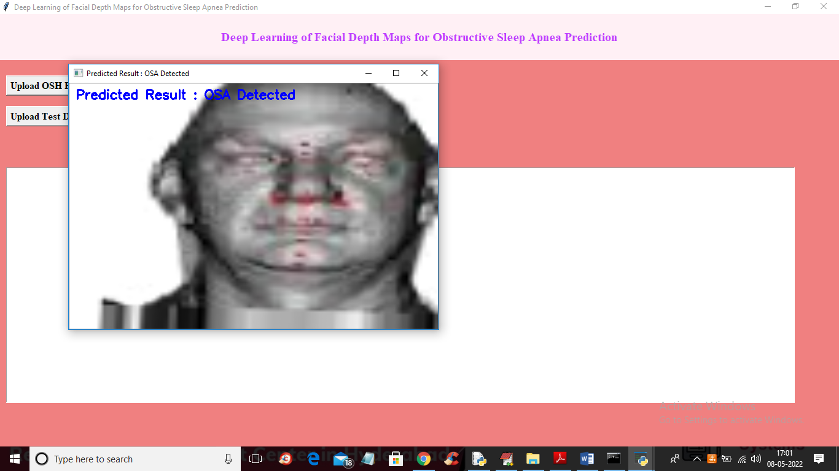

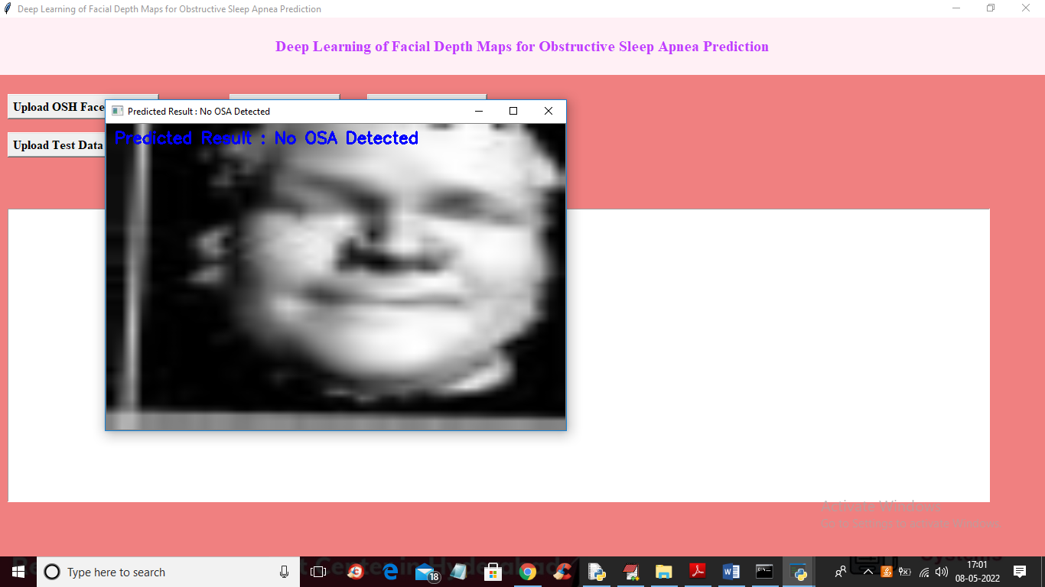

In above screen NO OSA detected so sleep Apnea disease not present and now click on ‘Accuracy Comparison Graph’ button to get below graph

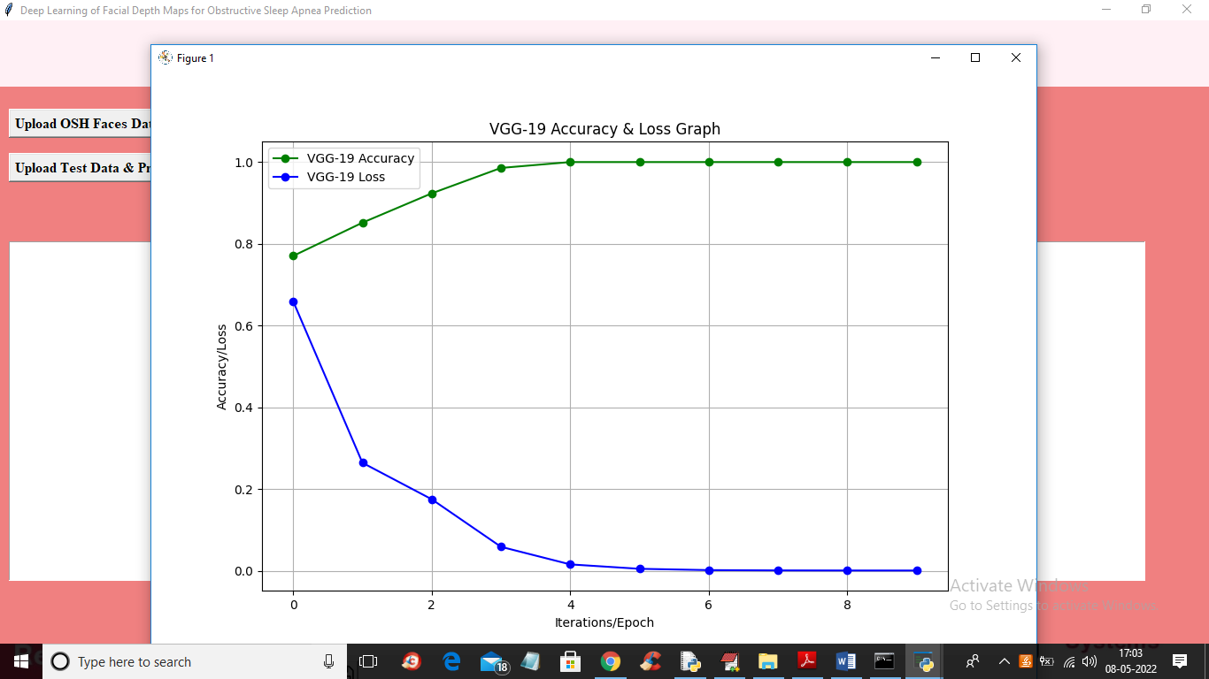

In above VGG19 training graph x-axis represents training EPOCH and y-axis represents accuracy and loss values and in above graph green line represents accuracy and blue line represents loss and we can see with each increasing epoch accuracy got increase and loss got decrease

In below screen I am showing VGG19 training code

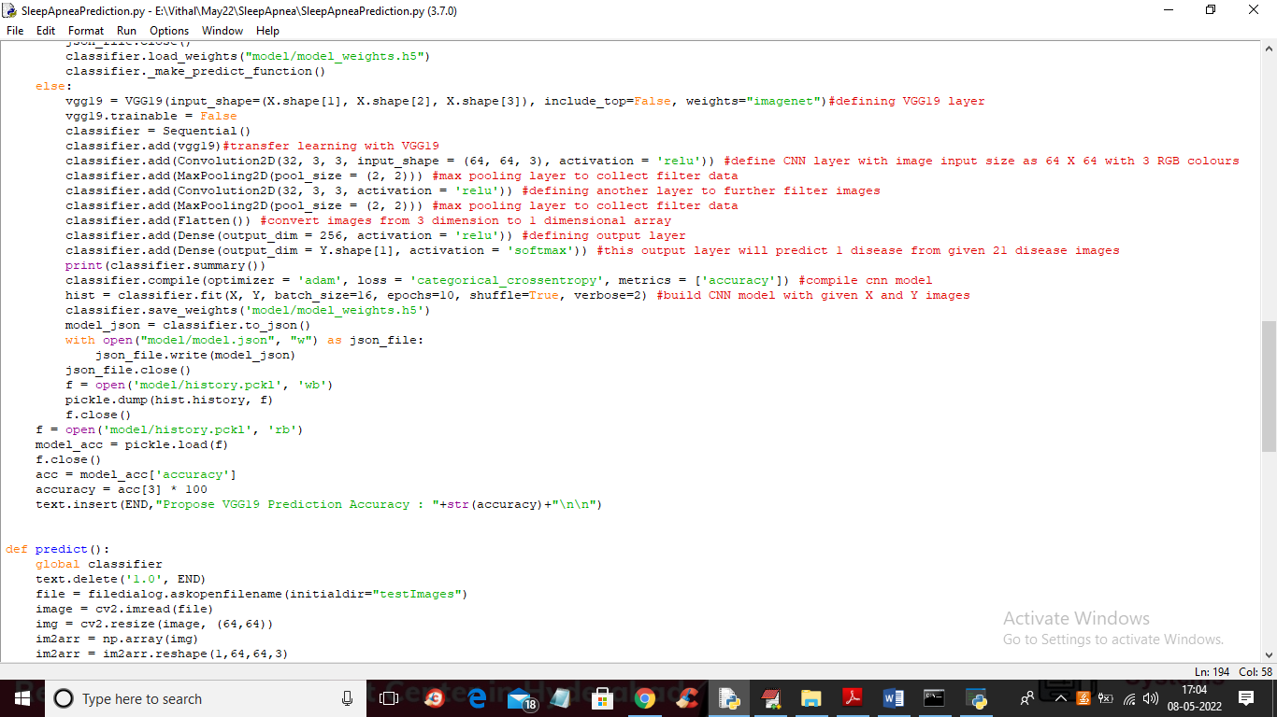

In above screen read red colour comments to know about VGG19 transfer learning