SECURITY, GOVERNANCE
& PRODUCTION OPERATIONS
Participant 9 Evidence & Validation Report
Investment Portfolio Risk & Analytics Platform

Prepared from the screenshot evidence supplied for review

Report scope | Evidence basis
Participant 9 review | Snowflake, REST API, AWS, Power BI and React/frontend screenshots
Assessment approach | Evidence-based review; no unsupported controls marked as complete
Evidence limitation | Only the supplied screenshots were used for findings in this report

Contents
- 1. Executive Summary
- 2. Evidence Inventory
- 3. Assessment Method & Status Definitions
- 4. Snowflake Security & Governance Review
- 5. REST API Security & Functional Evidence
- 6. AWS Infrastructure & Container Evidence
- 7. Power BI Security & Operations Review
- 8. React / Frontend Security Review
- 9. Cross-Control Findings & Evidence Gaps
- 10. Consolidated Control Matrix
- 11. Risk Register
- 12. Production Readiness Assessment
- Appendix A — Evidence Index

1. Executive Summary
This report consolidates the Participant 9 security, governance and production-operations evidence supplied as screenshots. The evidence covers Snowflake data access and governance, REST API behavior, AWS infrastructure/containerization, Power BI workspace and refresh controls, and React/frontend security checks.
The evidence demonstrates several positive controls, including Snowflake schema separation and read-only analytical views, AWS VPC/ALB/ECS/ECR resources, Power BI workspace/RLS/refresh configuration, and frontend evidence showing no visible credentials in the supplied example configuration or browser storage.
The review also identifies evidence gaps. In particular, the supplied material does not demonstrate IAM review, Security Group rules, Secrets Manager/Parameter Store, CloudTrail, CloudWatch dashboards/alarms, ECR vulnerability-scan results, production frontend configuration, or API authentication/authorization. These items are therefore recorded as NOT EVIDENCED or PARTIAL rather than being assumed to pass.
Area | Evidence observed | Assessment
Snowflake | Schema/architecture, access grants, read-only views, audit/query evidence | PASS / PARTIAL
REST API | Successful GET endpoint evidence; requests shown with No Auth | PARTIAL
AWS | VPC, subnets, ALB, ECS, ECR, Docker, Terraform structure | PASS / NOT EVIDENCED
Power BI | Workspace, dataset/report permissions, RLS configuration, export and refresh | PASS / PARTIAL
React / Frontend | Environment config, no visible credentials, browser storage, 404 handling | PASS / PARTIAL
IAM / Monitoring / Audit | No supplied evidence for IAM, CloudTrail, CloudWatch alarms/dashboard | NOT EVIDENCED

2. Evidence Inventory
Evidence ID | Source file | Evidence area
SNOW-01 to SNOW-15 | 3 and 4 docs.docx | Snowflake architecture, schemas, roles, grants, audit and exposed views
API-01 to API-05 | 3 and 4 docs.docx | Portfolio, holdings, allocation, risk and client endpoints
AWS-01 to AWS-07 | 6-aws.docx | VPC, subnets, ALB, ECS, ECR, Docker and Terraform
PBI-01 to PBI-07 | participant 7 ss.docx | Workspace, dataset/report permissions, RLS, export and refresh
FE-01 to FE-04 | frontend screenshots.docx | Environment/API config, credential exposure, browser storage and error handling

3. Assessment Method & Status Definitions
Assessment is limited to what can be supported by the supplied screenshots.
Status | Meaning
PASS | The supplied evidence directly demonstrates the control or behavior being reviewed.
PARTIAL | Some supporting evidence exists, but the screenshot does not fully prove the control end-to-end.
NOT EVIDENCED | The supplied files do not contain evidence sufficient to assess the control.
OBSERVATION | A notable configuration or context item requiring confirmation; not automatically a failure.

4. Snowflake Security & Governance Review
The supplied Snowflake evidence demonstrates the database structure, roles and grants, read-only access to analytical views, query/audit history and the fields/views exposed downstream.
Control | Evidence | Assessment | Observation
Database/schema separation | SNOW-01, SNOW-02 | PASS | IPRA_DB contains RAW, STAGING, CORE and ANALYTICS schemas.
Role/access evidence | SNOW-03, SNOW-04 | PASS | Role and grant information is visible.
Read-only analytical access | SNOW-05, SNOW-06 | PASS | SELECT access to governed analytical views is shown.
Audit/query access | SNOW-08 to SNOW-10 | PASS | Query/audit activity is visible.
Downstream field/view exposure | SNOW-11 to SNOW-15 | PASS | Analytical views and fields are visibly enumerated.
Least-privilege runtime identity | SNOW-04 | PARTIAL | Evidence shows administrative context; runtime application role is not conclusively established.

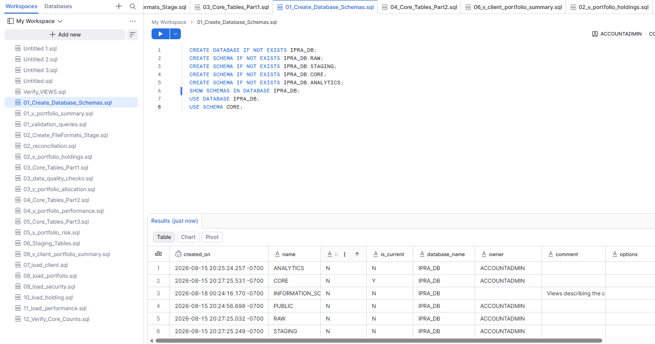
SNOW-01 — Snowflake architecture and schema context.
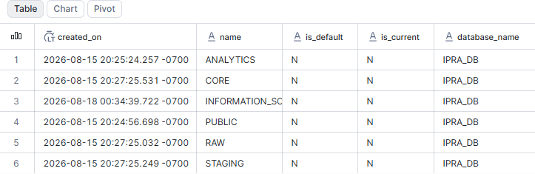
SNOW-02 — IPRA_DB schema listing.
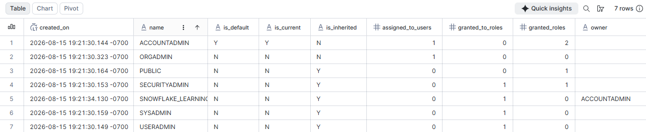
SNOW-04 — Application/human access and grants evidence.
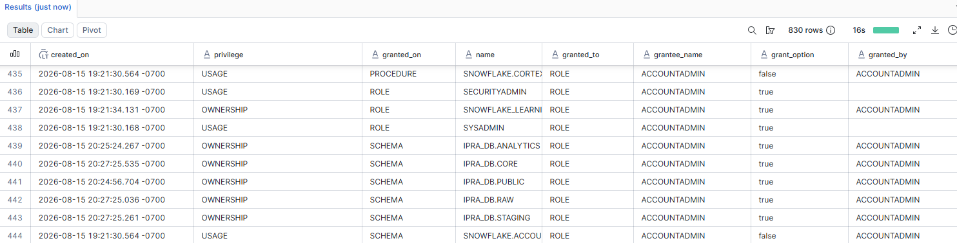
SNOW-06 — Read-only SELECT access on analytical views.
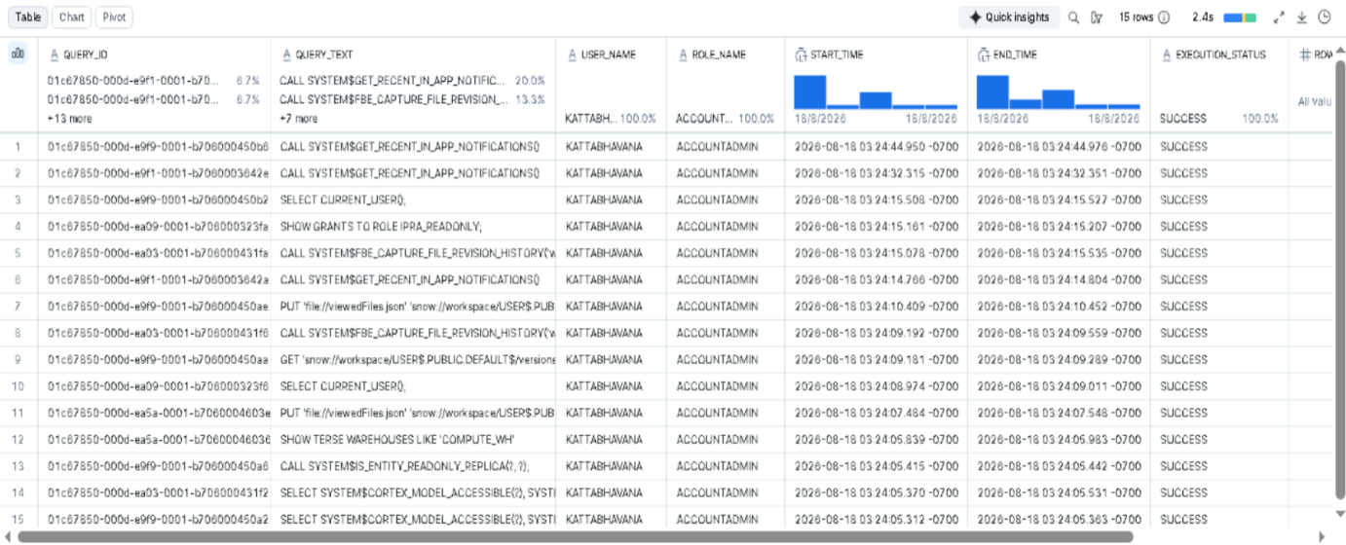
SNOW-10 — Query/audit activity evidence.
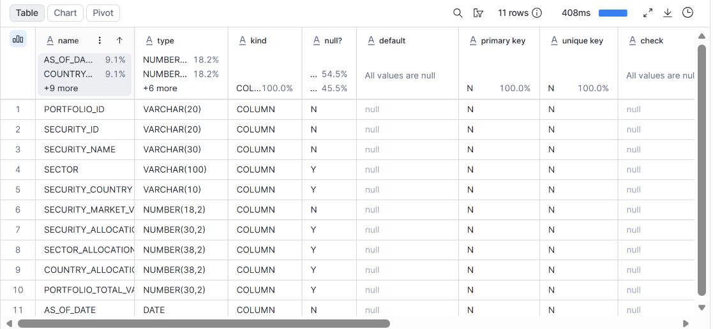
SNOW-11 — Downstream field exposure evidence.
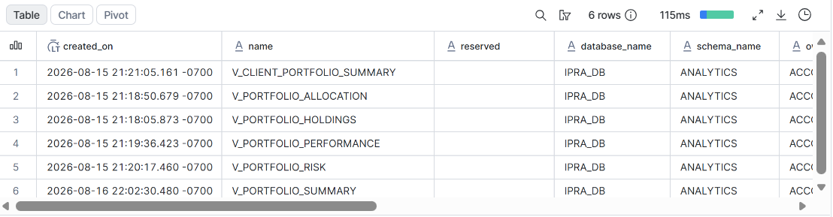
SNOW-15 — Analytical view inventory.

5. REST API Security & Functional Evidence
The supplied Postman evidence demonstrates successful retrieval from the portfolio, holdings, allocation, risk and client portfolio endpoints. These screenshots establish functional responses in the shown local environment.
Control / Test | Evidence | Assessment | Observation
Portfolio GET endpoint | API-01 | PASS | 200 OK response shown for a portfolio request.
Portfolio holdings endpoint | API-02 | PASS | 200 OK response with holdings data shown.
Portfolio allocation endpoint | API-03 | PASS | 200 OK response with allocation data shown.
Portfolio risk endpoint | API-04 | PASS | Risk response shown.
Client portfolio endpoint | API-05 | PASS | Client portfolio response shown.
Authentication | API-01 to API-05 | NOT EVIDENCED | Requests visibly show Authorization: No Auth.
Authorization / 403 behavior | API-01 to API-05 | NOT EVIDENCED | No unauthorized-operation test is supplied.
Negative validation / 400 or 422 | API-01 to API-05 | NOT EVIDENCED | No invalid-input test is supplied.

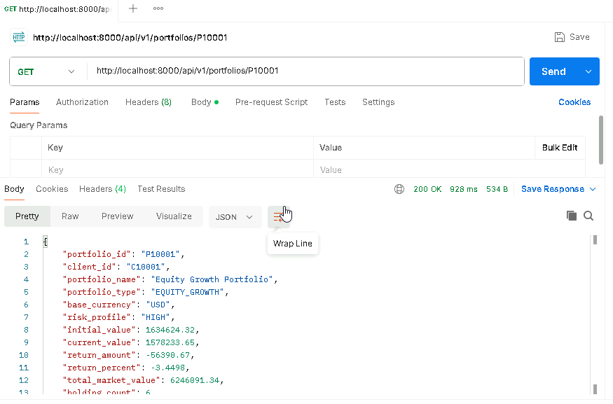
API-01 — GET portfolio by portfolio ID.
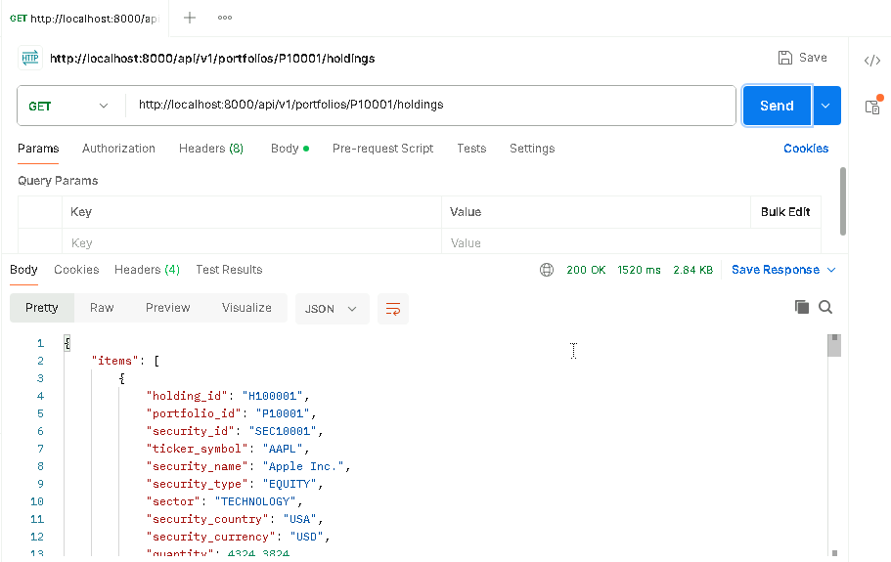
API-02 — GET individual portfolio holdings.
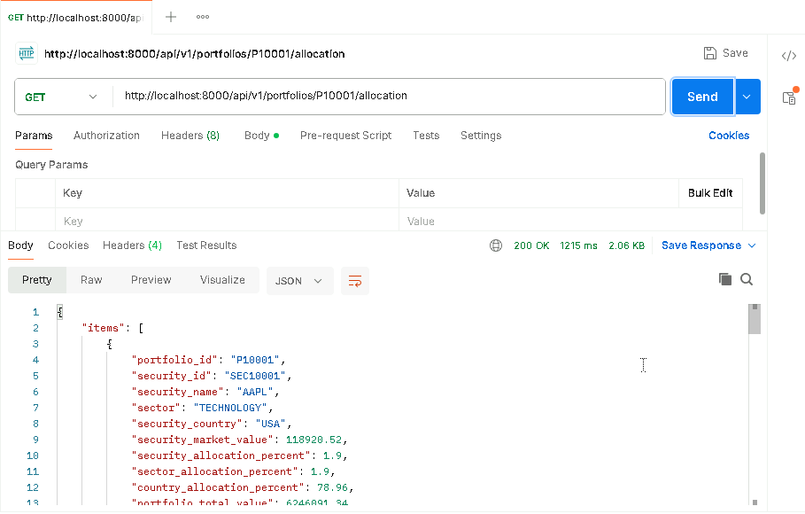
API-03 — GET portfolio allocation.
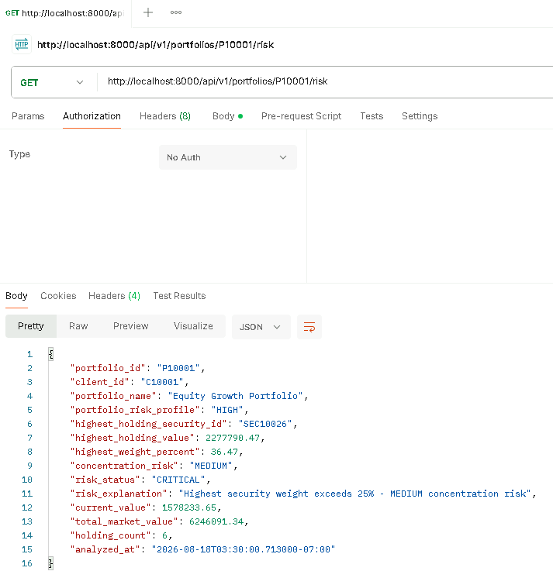
API-04 — GET portfolio risk.
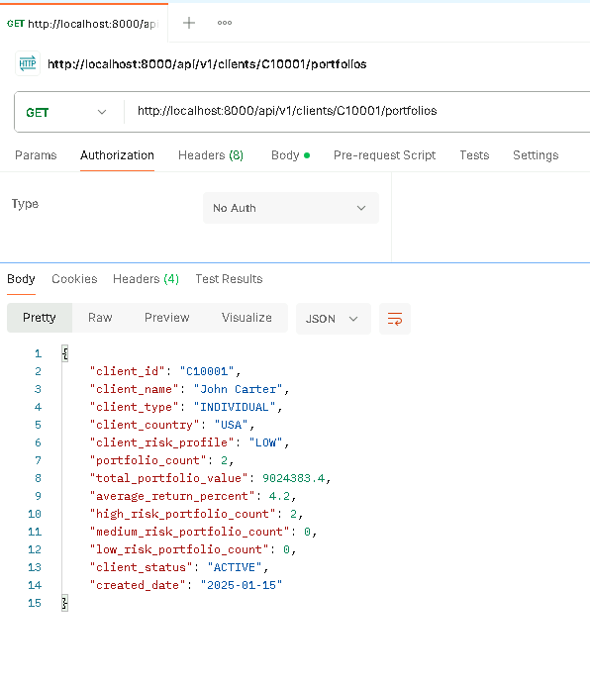
API-05 — GET client portfolios.

6. AWS Infrastructure & Container Evidence
The AWS evidence establishes the presence of the development VPC, subnet topology, internet-facing ALB, ECS cluster, private ECR repositories, local Docker containers and modular Terraform structure.
Control / Asset | Evidence | Assessment | Observation
VPC | AWS-01 | PASS | ipra-dev-vpc is shown in available state with 10.20.0.0/16 CIDR.
Subnets / routing map | AWS-02 | PASS | Four subnets and associated route tables are visible.
Application Load Balancer | AWS-03 | PASS | ipra-dev-alb is active and internet-facing.
ECS cluster/services | AWS-04 | PASS | ipra-dev-cluster is active with services/tasks visible.
Private ECR repositories | AWS-05 | PASS | Backend and frontend private repositories are visible; AES-256 encryption shown.
Docker runtime | AWS-06 | PASS | Backend/frontend containers are shown running locally.
Terraform structure | AWS-07 | PASS | Modular VPC/security-group structure is visible.
Security Group rules | — | NOT EVIDENCED | No detailed inbound/outbound rule screenshot supplied.
Secrets Manager / Parameter Store | — | NOT EVIDENCED | No screenshot supplied.
CloudTrail | — | NOT EVIDENCED | No CloudTrail evidence supplied.
CloudWatch dashboard / alarms / logs | — | NOT EVIDENCED | No dashboard, alarm or log evidence supplied.
ECR vulnerability scan | — | NOT EVIDENCED | Repository existence is shown, but scan findings are not.
IAM | — | NOT EVIDENCED | No IAM evidence supplied.

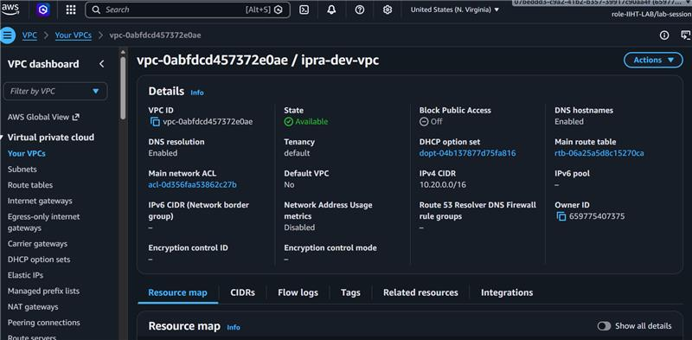
AWS-01 — VPC details.
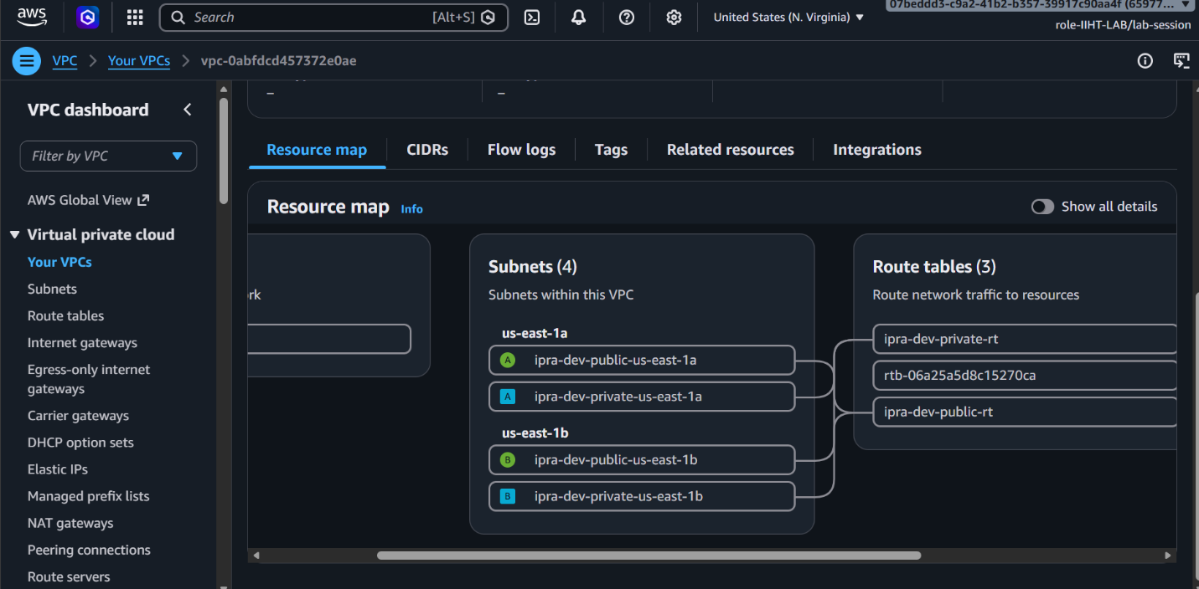
AWS-02 — VPC resource map showing subnets and route tables.
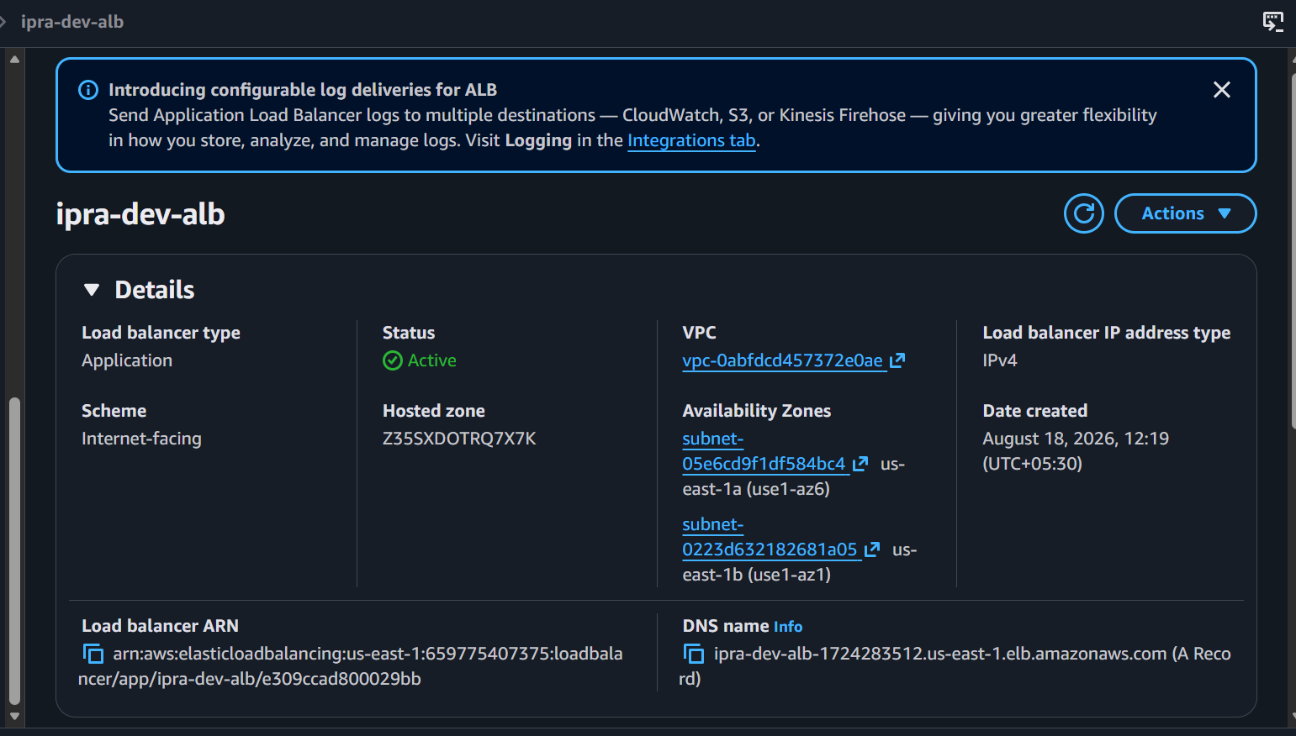
AWS-03 — Application Load Balancer.
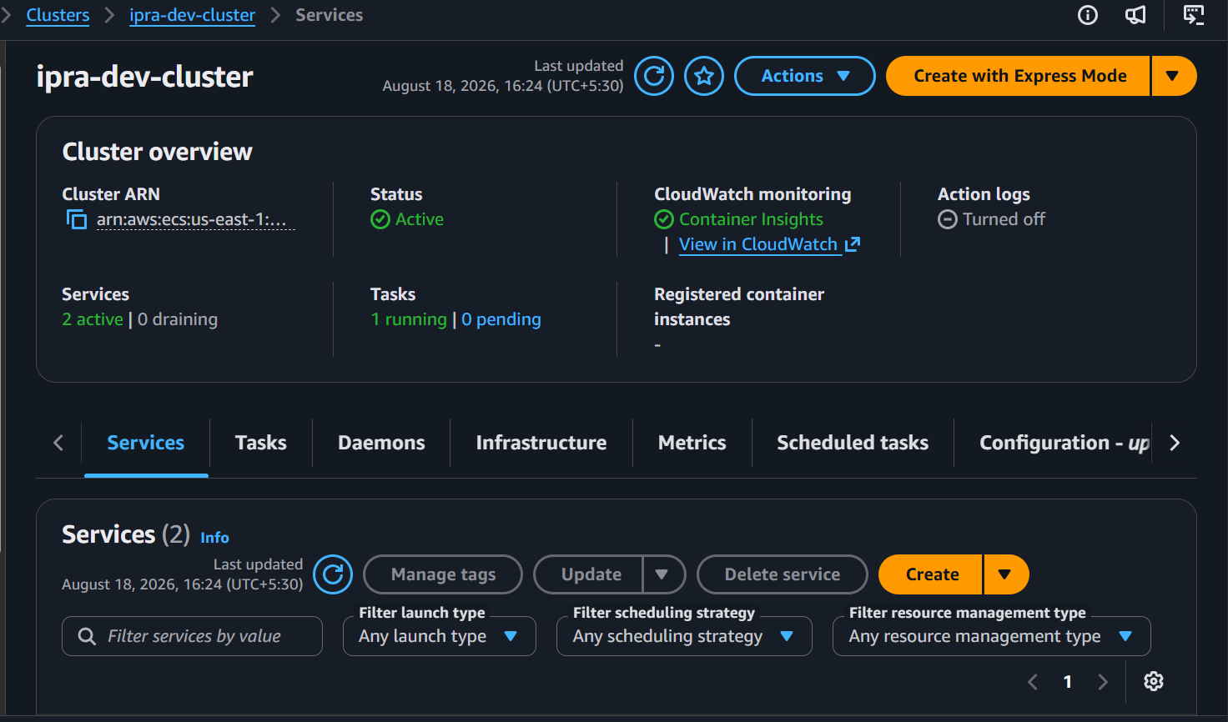
AWS-04 — ECS cluster and services.
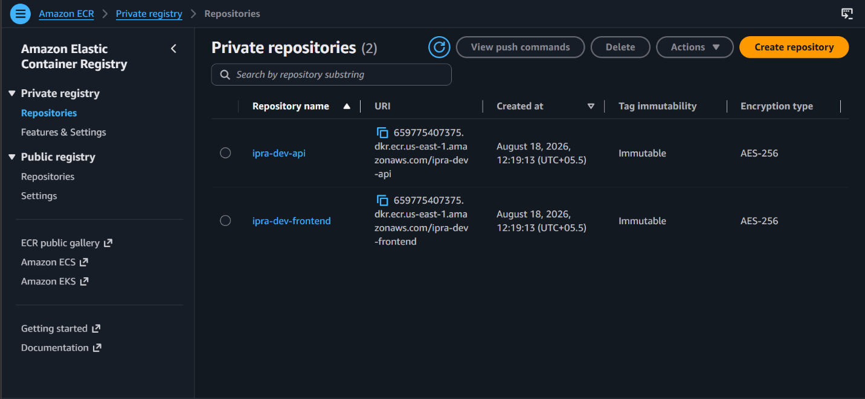
AWS-05 — Private ECR repositories.
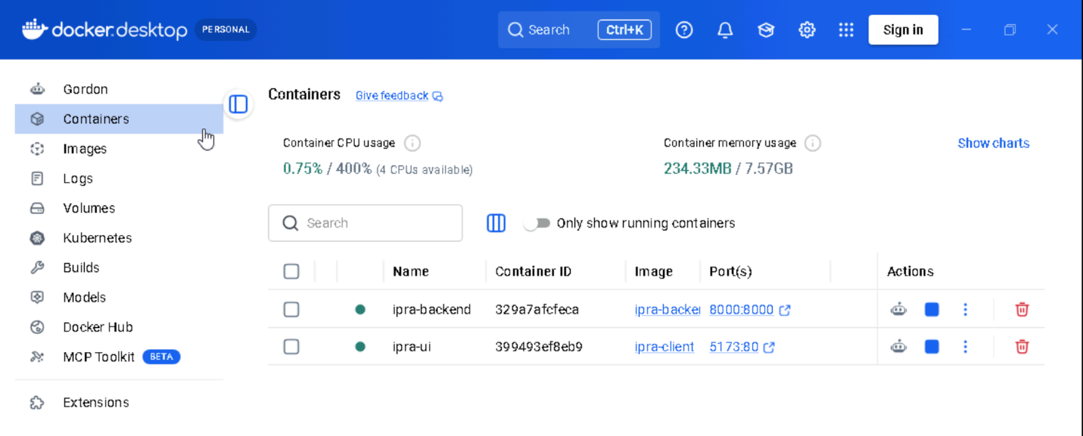
AWS-06 — Docker Desktop containers.
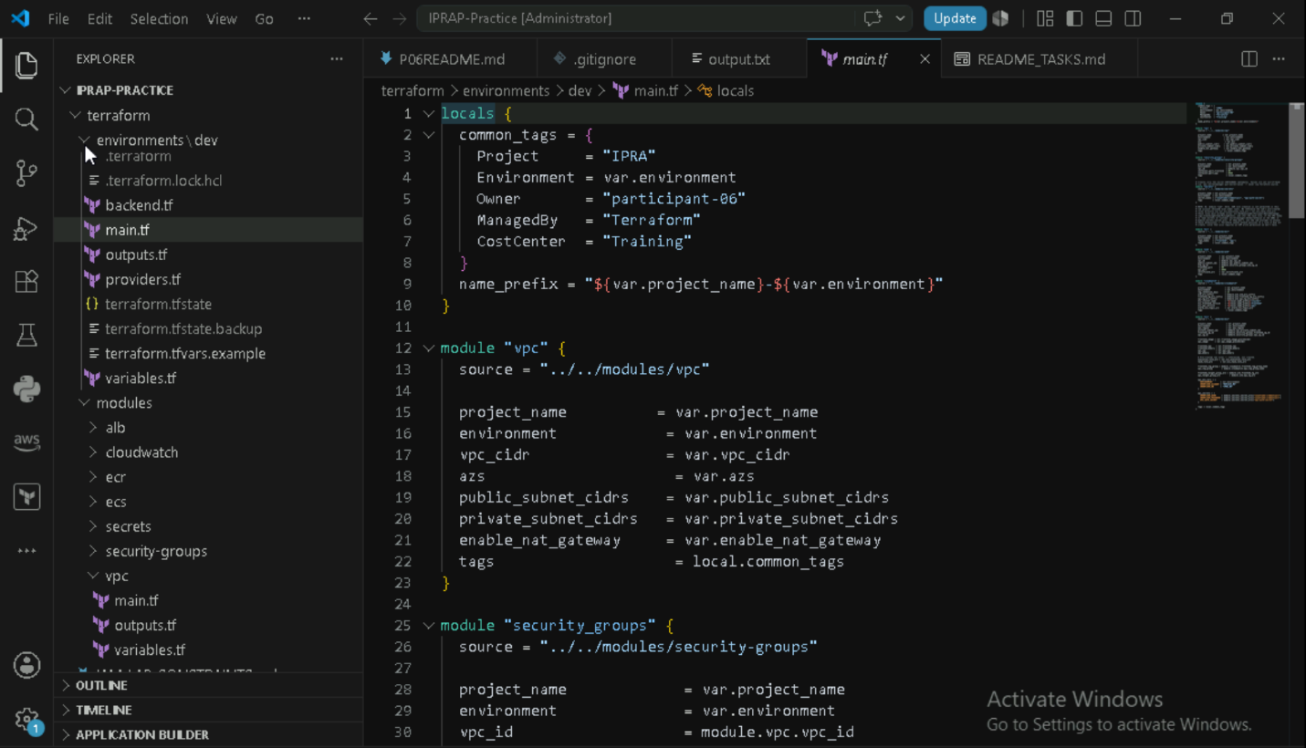
AWS-07 — Terraform module structure.

7. Power BI Security & Operations Review
The supplied Power BI evidence covers workspace structure, dataset/report permissions, row-level security configuration, export options and scheduled refresh settings.
Control | Evidence | Assessment | Observation
Workspace structure | PBI-01 | PASS | IPRA_Portfolio_Analytics workspace/report/semantic model shown.
Dataset / semantic model | PBI-02 | PASS | Snowflake → semantic model → report flow is visible.
Report permissions | PBI-03 | PASS | Direct access and permissions are shown.
RLS configuration | PBI-04 | PARTIAL | Security-role configuration is shown, but effectiveness for multiple users is not demonstrated.
Export/download settings | PBI-05 | PARTIAL | Export options are visible; policy/permission restriction is not conclusively established.
Refresh configuration | PBI-06, PBI-07 | PASS | Daily refresh and owner notification configuration are shown.

PBI-01 — Workspace structure.
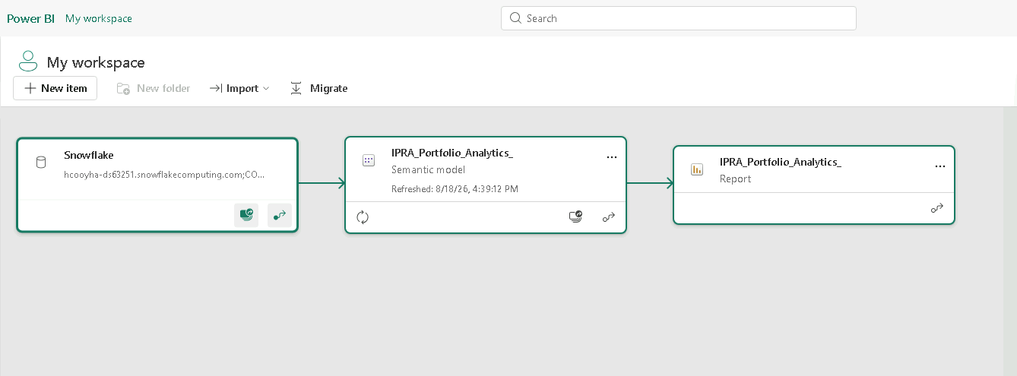
PBI-02 — Dataset/semantic-model lineage.
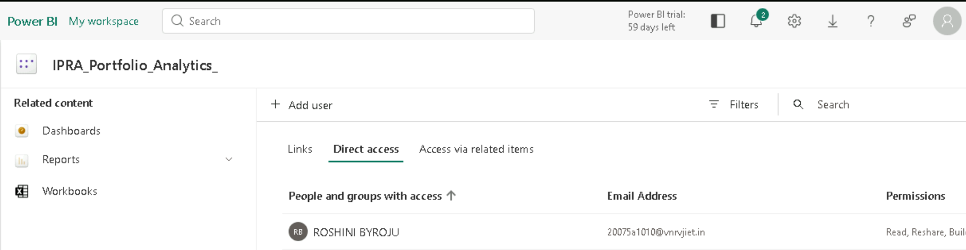
PBI-03 — Report permissions.
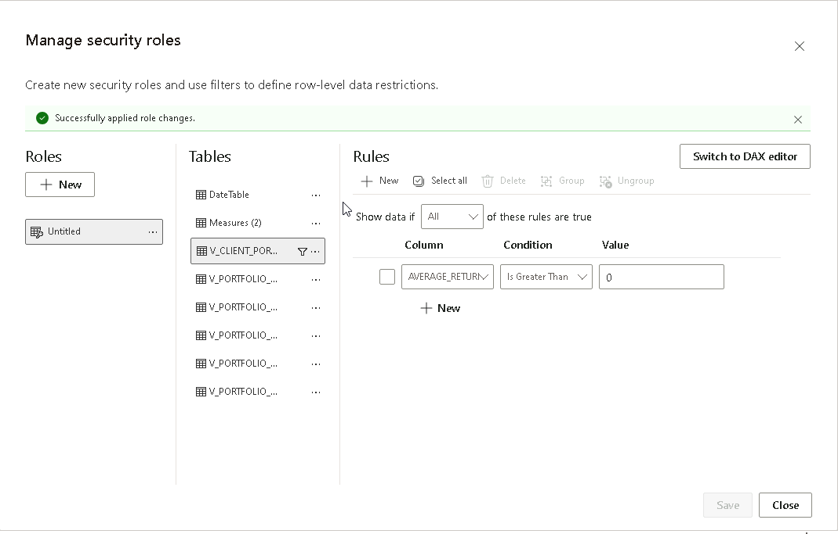
PBI-04 — Row-level security configuration.
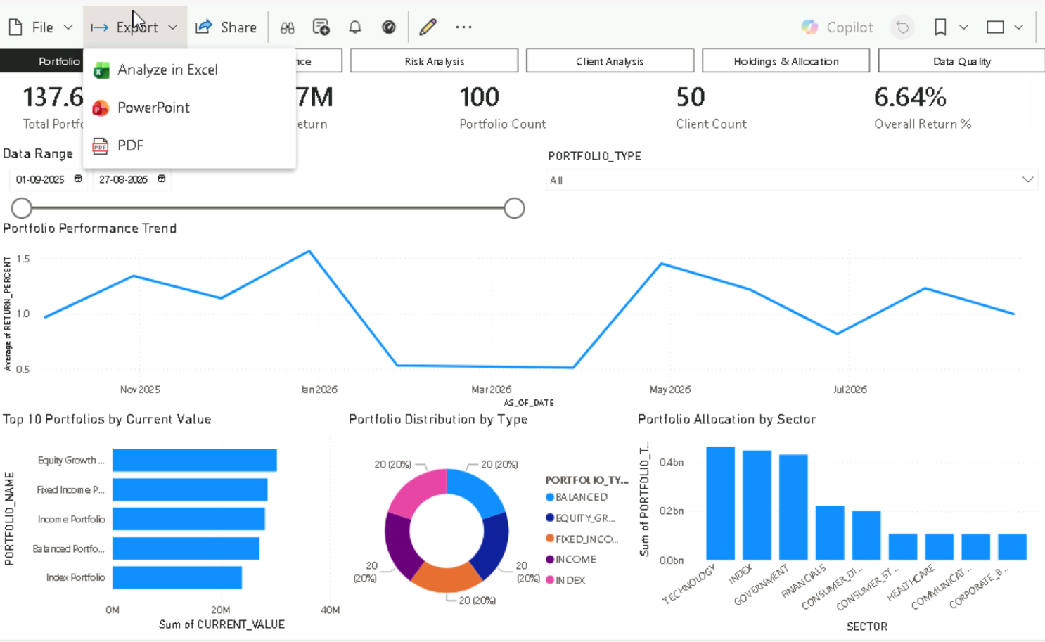
PBI-05 — Export/download options.
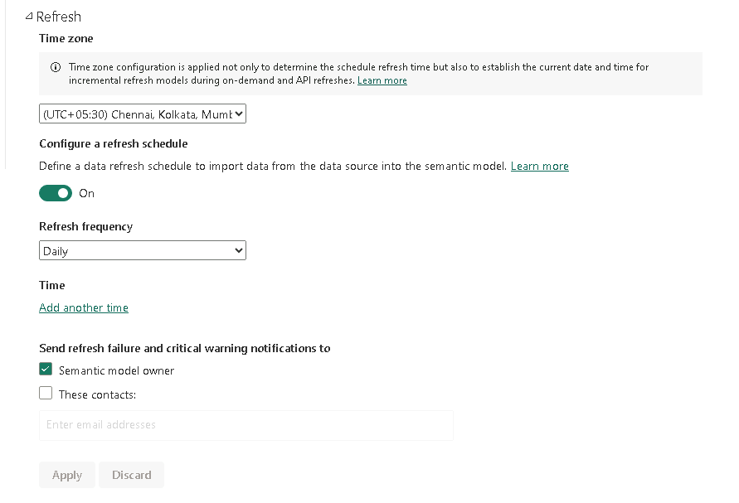
PBI-06 — Refresh schedule and notification configuration.
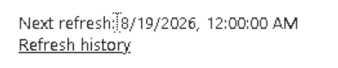
PBI-07 — Next refresh / refresh history reference.

8. React / Frontend Security Review
The frontend evidence covers the supplied environment/API configuration, absence of visible credentials in the example configuration, browser storage state and controlled 404 error handling.
Control | Evidence | Assessment | Observation
API/environment configuration | FE-01 | PARTIAL | VITE_API_BASE_URL is configured, but only localhost/development configuration is shown.
No visible credentials in example config | FE-02 | PASS | Only API base URL and mock-API flag are visible; no credentials shown.
Browser storage | FE-03 | PASS | No stored values are visible in the supplied browser-storage screenshot.
Authentication token handling | — | NOT EVIDENCED | No authentication/token flow evidence supplied.
Error handling | FE-04 | PASS | 404 is presented as a user-facing 'Portfolio Not Found' message.
Production build secret/debug review | — | NOT EVIDENCED | No production-build evidence supplied.

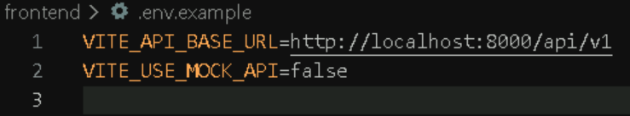
FE-01 — React environment/API configuration.
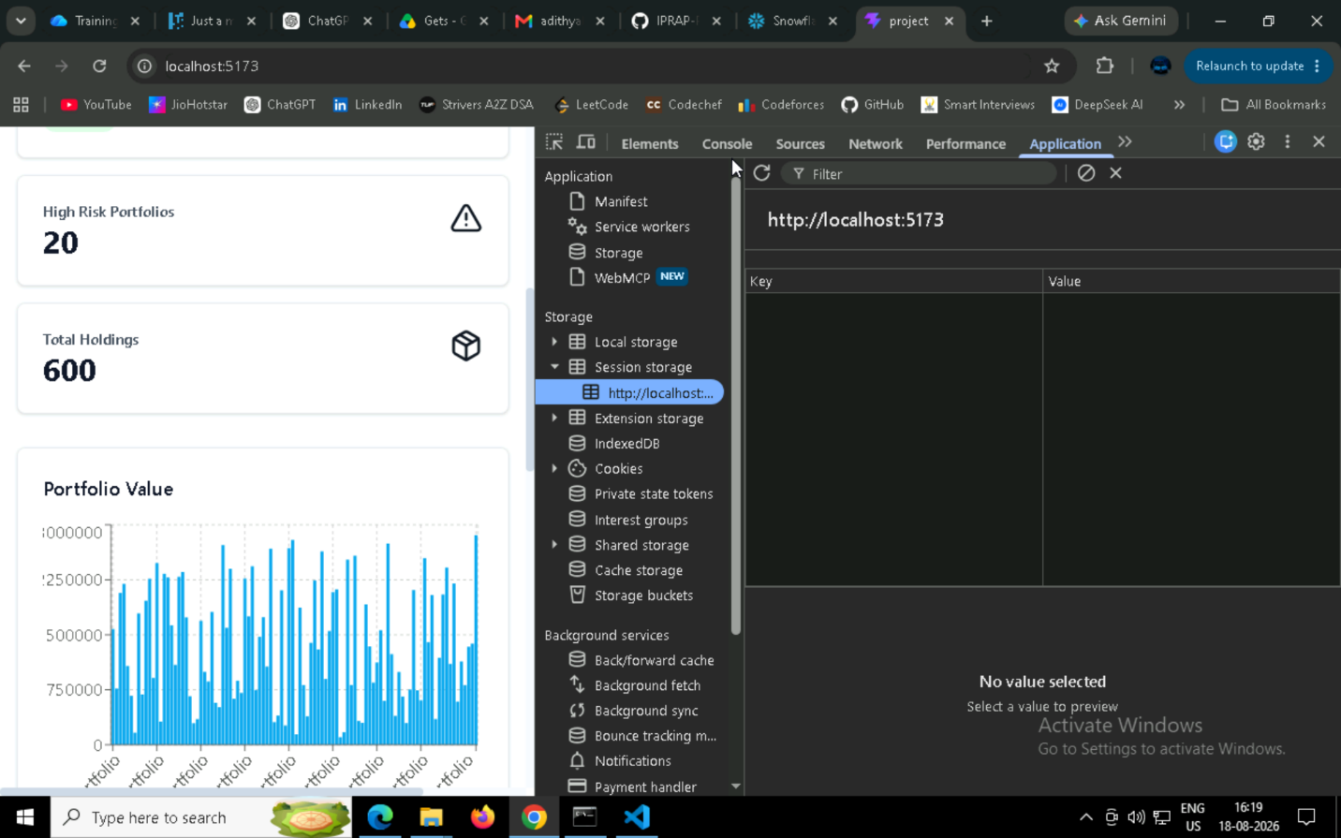
FE-02 — Example configuration showing no visible credentials.
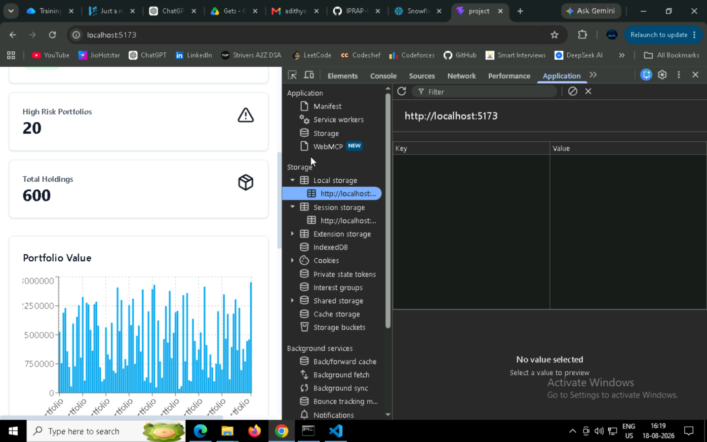
FE-03 — Browser storage inspection.
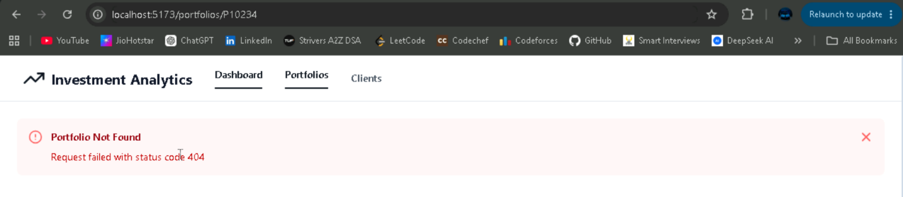
FE-04 — User-facing 404 error handling.

9. Cross-Control Findings & Evidence Gaps
ID | Finding | Severity | Evidence basis | Recommended action
F-01 | API authentication/authorization is not demonstrated | HIGH | API requests shown in Postman use No Auth; protected-endpoint behavior is not evidenced. | Obtain authentication and 401/403 evidence or document the agreed public-endpoint design.
F-02 | AWS audit/monitoring evidence missing | HIGH | No CloudTrail, CloudWatch dashboard, alarm or log screenshots were supplied. | Collect the corresponding AWS operational evidence.
F-03 | AWS secret-management evidence missing | HIGH | No Secrets Manager/Parameter Store evidence is supplied. | Provide secret-store configuration without exposing secret values.
F-04 | Security Group rule evidence missing | MEDIUM | VPC/ALB/ECS resources are shown, but actual inbound/outbound rules are not. | Collect Security Group rule screenshots.
F-05 | IAM review not evidenced | HIGH | No IAM screenshots or policy review evidence are present in the supplied files. | Mark as pending unless infrastructure owner supplies evidence.
F-06 | Power BI RLS effectiveness not tested | MEDIUM | RLS configuration is shown, but user-level filtering results are not demonstrated. | Provide a test for at least two access contexts or an equivalent validation record.
F-07 | Frontend production configuration not evidenced | MEDIUM | Only localhost/development API configuration is shown. | Provide release/production configuration evidence.
F-08 | ECR vulnerability scan not evidenced | MEDIUM | Private repositories are visible, but no vulnerability scan result is shown. | Provide scan result for release images.
F-09 | Snowflake runtime identity needs confirmation | MEDIUM | Administrative context appears in the supplied evidence; runtime application role is not conclusively established. | Confirm the actual application runtime role and permissions.

10. Consolidated Control Matrix
ID | Control | Status
SNOW-01 | Snowflake schema separation | PASS
SNOW-02 | Application/human access evidence | PASS
SNOW-03 | Read-only analytical views | PASS
SNOW-04 | Audit/query evidence | PASS
SNOW-05 | Downstream field/view exposure | PASS
API-01 | Successful portfolio endpoint | PASS
API-02 | Successful holdings endpoint | PASS
API-03 | Successful allocation endpoint | PASS
API-04 | Successful risk endpoint | PASS
API-05 | Successful client endpoint | PASS
API-SEC-01 | Authentication | NOT EVIDENCED
API-SEC-02 | Authorization | NOT EVIDENCED
AWS-01 | VPC | PASS
AWS-02 | Subnets/routing map | PASS
AWS-03 | ALB | PASS
AWS-04 | ECS | PASS
AWS-05 | ECR | PASS
AWS-06 | Docker runtime | PASS
AWS-07 | Terraform structure | PASS
AWS-SEC-01 | Security Groups | NOT EVIDENCED
AWS-SEC-02 | Secrets store | NOT EVIDENCED
AWS-SEC-03 | CloudTrail | NOT EVIDENCED
AWS-SEC-04 | CloudWatch | NOT EVIDENCED
AWS-SEC-05 | IAM | NOT EVIDENCED
PBI-01 | Workspace/dataset/report | PASS
PBI-02 | Report permissions | PASS
PBI-03 | RLS configuration | PARTIAL
PBI-04 | Export controls | PARTIAL
PBI-05 | Refresh configuration | PASS
FE-01 | Environment/API configuration | PARTIAL
FE-02 | No visible credentials | PASS
FE-03 | Browser storage | PASS
FE-04 | Error handling | PASS
FE-05 | Token handling | NOT EVIDENCED
FE-06 | Production build secrets/debug | NOT EVIDENCED

11. Risk Register
ID | Risk | Severity | Basis | Mitigation
R-01 | API access control not demonstrated | High | API screenshots show No Auth | Obtain/validate auth and authorization evidence.
R-02 | Missing AWS audit and monitoring evidence | High | No CloudTrail/CloudWatch evidence supplied | Collect audit logs, dashboards, alarms and logs.
R-03 | Secret-store controls not evidenced | High | No secret-store screenshot supplied | Provide Secrets Manager/Parameter Store evidence without values.
R-04 | IAM least privilege not evidenced | High | IAM not present in supplied evidence | Request owner evidence or record as pending.
R-05 | Security Group rules not evidenced | Medium | Only VPC topology is shown | Collect inbound/outbound rules.
R-06 | Power BI RLS effectiveness not demonstrated | Medium | Configuration shown without user-level test | Perform and capture RLS validation.
R-07 | Frontend production configuration not evidenced | Medium | Only localhost config shown | Capture release configuration/build evidence.
R-08 | ECR vulnerability scanning not evidenced | Medium | Repository shown without scan results | Capture scan result for release images.

12. Production Readiness Assessment
Based strictly on the supplied screenshots, the platform has meaningful evidence of implementation across Snowflake, API functionality, AWS infrastructure, Power BI and frontend behavior. However, the evidence pack is not sufficient to declare full production-readiness for security and operations.
Readiness area | Assessment
Data platform governance | READY WITH OBSERVATIONS
API functional evidence | READY WITH SECURITY GAPS
AWS infrastructure evidence | READY WITH OPERATIONAL EVIDENCE GAPS
BI security/operations | READY WITH PARTIAL RLS/EXPORT EVIDENCE
Frontend security evidence | READY WITH PRODUCTION-CONFIGURATION GAP
Auditability | NOT READY — CloudTrail evidence missing
Operational monitoring | NOT READY — CloudWatch dashboard/alarm/log evidence missing
Identity & least privilege | NOT READY — IAM evidence missing
Overall Participant 9 readiness | CONDITIONAL / EVIDENCE GAPS REMAIN

Conclusion: the supplied evidence supports substantial progress, but Participant 9 should not sign off the platform as fully production-ready until the identified high-priority evidence gaps are resolved or formally accepted.

Appendix A — Evidence Index
Evidence ID | Description | Source
SNOW-01 | Snowflake evidence image 1 | 3 and 4 docs.docx
SNOW-02 | Snowflake evidence image 2 | 3 and 4 docs.docx
SNOW-03 | Snowflake evidence image 3 | 3 and 4 docs.docx
SNOW-04 | Snowflake evidence image 4 | 3 and 4 docs.docx
SNOW-05 | Snowflake evidence image 5 | 3 and 4 docs.docx
SNOW-06 | Snowflake evidence image 6 | 3 and 4 docs.docx
SNOW-07 | Snowflake evidence image 7 | 3 and 4 docs.docx
SNOW-08 | Snowflake evidence image 8 | 3 and 4 docs.docx
SNOW-09 | Snowflake evidence image 9 | 3 and 4 docs.docx
SNOW-10 | Snowflake evidence image 10 | 3 and 4 docs.docx
SNOW-11 | Snowflake evidence image 11 | 3 and 4 docs.docx
SNOW-12 | Snowflake evidence image 12 | 3 and 4 docs.docx
SNOW-13 | Snowflake evidence image 13 | 3 and 4 docs.docx
SNOW-14 | Snowflake evidence image 14 | 3 and 4 docs.docx
SNOW-15 | Snowflake evidence image 15 | 3 and 4 docs.docx
API-01 | REST API evidence image 1 | 3 and 4 docs.docx
API-02 | REST API evidence image 2 | 3 and 4 docs.docx
API-03 | REST API evidence image 3 | 3 and 4 docs.docx
API-04 | REST API evidence image 4 | 3 and 4 docs.docx
API-05 | REST API evidence image 5 | 3 and 4 docs.docx
AWS-01 | AWS evidence image 1 | 6-aws.docx
AWS-02 | AWS evidence image 2 | 6-aws.docx
AWS-03 | AWS evidence image 3 | 6-aws.docx
AWS-04 | AWS evidence image 4 | 6-aws.docx
AWS-05 | AWS evidence image 5 | 6-aws.docx
AWS-06 | AWS evidence image 6 | 6-aws.docx
AWS-07 | AWS evidence image 7 | 6-aws.docx
PBI-01 | Power BI evidence image 1 | participant 7 ss.docx
PBI-02 | Power BI evidence image 2 | participant 7 ss.docx
PBI-03 | Power BI evidence image 3 | participant 7 ss.docx
PBI-04 | Power BI evidence image 4 | participant 7 ss.docx
PBI-05 | Power BI evidence image 5 | participant 7 ss.docx
PBI-06 | Power BI evidence image 6 | participant 7 ss.docx
PBI-07 | Power BI evidence image 7 | participant 7 ss.docx
FE-01 | Frontend evidence image 1 | frontend screenshots.docx
FE-02 | Frontend evidence image 2 | frontend screenshots.docx
FE-03 | Frontend evidence image 3 | frontend screenshots.docx
FE-04 | Frontend evidence image 4 | frontend screenshots.docx

