Details Required for Annual Report preparation
(Details between 01.06.2025 to 31.03.2026)
1. CENTER FOR LEARNING AND TEACHING
1.1 Innovative Teaching Methodologies Followed (Best one per Department)
Department : Aerospace
Course Code & Name : 19AST101 Introduction to Aerospace Engineering
Topic : Aircraft Wing Design
Teaching Method : Miniproject
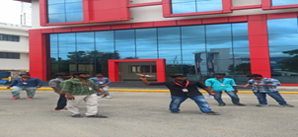

Department : Aerospace
Course Code & Name : 19AST101 Introduction to Aerospace Engineering
Topic : Aircraft Wing Design
Teaching Method : Miniproject


Department : Aerospace
Course Code & Name : 19AST101 Introduction to Aerospace Engineering
Topic : Aircraft Wing Design
Teaching Method : Miniproject
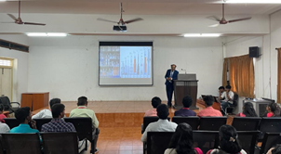

1.2 E-Contents Developed (Faculty & Students)
S.No | Branch | YouTube Lecture Videos | Other E Contents
1 | Aerospace | 2 | 1
2 | Aerospace | 7 | 1

1.3 Workshops, Seminars, Guest Lectures, FDPs & Course Facilitator Sessions Organized
Guest Lectures Organized
Total Number of Guest Lectures Organized: 1
Department : Aerospace
Guest Lecture Title : One-day workshop on “Drone Photogrammetry”
Date : 11/03/2026
Guest : Mr. T.Abhishek , (Founder & CEO, Flyers Drone Tech, Coimbatore)
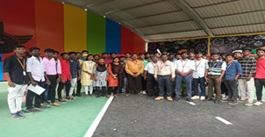

FDPs Organized
Total Number of FDP's Organized: 2
Department : Aerospace
FDP Title : sadfad
Date : 04/03/2026
Sponsored Agency : dfdsafs
Sponsored Amount : dsfdsf
Number of Beneficiary : 3
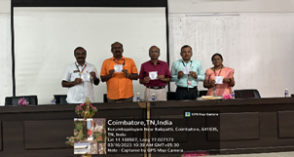

Department : Cse
FDP Title : sadfad
Date : 18/03/2026
Sponsored Agency : sdfdsf
Sponsored Amount : 20000
Number of Beneficiary : 3


Course Facilitator Sessions Organized
Total Number of Course Facilitator Session's Organized: 1
Department : Aerospace
Course Name : Introduction to Aerospace Engineering
Date : 05/03/2026
Course Facilitator Details : dsfasfs, dsfsadfsdf, dsfsdfs
Number of Students: 3
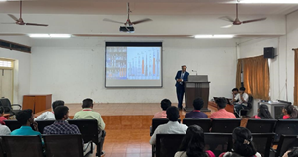

1.4 Workshop, Seminar, Guest Lecture, FDP & other technical sessions attended by Faculty Members
S.No | Event Type | Attended
1 | Workshop | 1
2 | Seminar | 0
3 | Guest Lecture | 0
4 | FDP | 0
5 | Others | 0
Workshops Attended
S.No | Name of the faculty members | Departments | Title of the event (Online / Offline) | Details of the organizer with Place | Date
1 | aSDAD S | Aerospace | SADFDSAF (Online) | ASFADSF, SDAFSADF | 11/03/2026

1.5 Workshop, Seminar, Guest Lecture & Course Facilitator Sessions Attended by Students
S.No | Event Type | Attended
1 | Workshop | 1
2 | Seminar | 0
3 | Guest Lecture | 0
4 | Course Facilitator Session | 0
Workshops Attended
S.No | Name of the students | Departments | Title of the event (Online / Offline) | Details of the organizer with Place | Date
1 | SDSAFD | Aerospace | SADFDSAF (Online) | SDFSAF, SAFDAS | 06/03/2026

1.6 NPTEL & MOOC Courses (Faculty & Students)
NPTEL/MOOC Courses (Faculty Members)
S.No | Department | Number of courses completed
1 | DSAFASF | 1

Details of number of courses completed
S.No | Departments | Name of the faculty members | Platform | Course Name | Duration | Score/Completed on
1 | DSAFASF | SDFASDF | SADFDASF | DASF | SAFD | SADFASD

NPTEL/MOOC Courses (Students)
S.No | Department | Number of courses completed
1 | DSAFASF | 1

Details of number of courses completed
S.No | Class | Name of the Student members | Platform | Course Name | Duration | Score/Completed on
1 | DSAFASF | SDFASDF | SADFDASF | Introduction to Aerospace Engineering | 2 | 23

1.7 Academic Achievements
Our students achieved very good results in the End Semester Examinations. The graduation rate details are provided below:
S.No | Branch | Appeared | Graduated | % of Graduation
1 | Aerospace | 2 | 2027 | 101350.00
Slow learning students in various subjects have been identified and special coaching classes are being conducted to improve their academic performance.

