Details Required for Annual Report preparation
(Details between 01.06.2025 to 31.03.2026)
1. CENTER FOR LEARNING AND TEACHING
1.1 Innovative Teaching Methodologies Followed (Best one per Department)
Department : Aerospace
Course Code & Name : 19AST101 Introduction to Aerospace Engineering
Topic : Aircraft Wing Design
Teaching Method : Miniproject
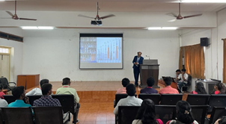

Department : Aerospace
Course Code & Name : 19AST101 Introduction to Aerospace Engineering
Topic : Aircraft Wing Design
Teaching Method : Miniproject


1.2 E-Contents Developed (Faculty & Students)
S.No | Branch | YouTube Lecture Videos | Other E Contents
1 | Aerospace | 2 | 1
2 | Aerospace | 7 | 1

1.3 Workshops, Seminars, Guest Lectures, FDPs & Course Facilitator Sessions Organized
Guest Lectures Organized
Total Number of Guest Lectures Organized: 1
Department : Aerospace
Guest Lecture Title : One-day workshop on “Drone Photogrammetry”
Date : 11/03/2026
Guest : Mr. T.Abhishek , (Founder & CEO, Flyers Drone Tech, Coimbatore)
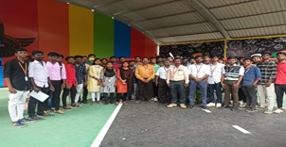

FDPs Organized
Total Number of FDP's Organized: 2
Department : Aerospace
FDP Title : sadfad
Date : 04/03/2026
Sponsored Agency : dfdsafs
Sponsored Amount : dsfdsf
Number of Beneficiary : 3
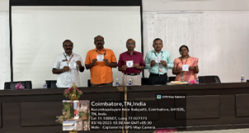

Department : Cse
FDP Title : sadfad
Date : 18/03/2026
Sponsored Agency : sdfdsf
Sponsored Amount : 20000
Number of Beneficiary : 3


Course Facilitator Sessions Organized
Total Number of Course Facilitator Session's Organized: 1
Department : Aerospace
Course Name : Introduction to Aerospace Engineering
Date : 05/03/2026
Course Facilitator Details : dsfasfs, dsfsadfsdf, dsfsdfs
Number of Students: 3
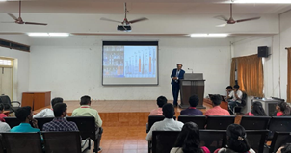

1.4 Workshop, Seminar, Guest Lecture, FDP & other technical sessions attended by Faculty Members
S.No | Event Type | Attended
1 | Workshop | 1
2 | Seminar | 0
3 | Guest Lecture | 0
4 | FDP | 0
5 | Others | 0
Workshops Attended
S.No | Name of the faculty members | Departments | Title of the event (Online / Offline) | Details of the organizer with Place | Date
1 | aSDAD S | Aerospace | SADFDSAF (Online) | ASFADSF, SDAFSADF | 11/03/2026

1.5 Workshop, Seminar, Guest Lecture & Course Facilitator Sessions Attended by Students
S.No | Event Type | Attended
1 | Workshop | 1
2 | Seminar | 0
3 | Guest Lecture | 0
4 | Course Facilitator Session | 0
Workshops Attended
S.No | Name of the students | Departments | Title of the event (Online / Offline) | Details of the organizer with Place | Date
1 | SDSAFD | Aerospace | SADFDSAF (Online) | SDFSAF, SAFDAS | 06/03/2026

1.6 NPTEL & MOOC Courses (Faculty & Students)
NPTEL/MOOC Courses (Faculty Members)
S.No | Department | Number of courses completed
1 | DSAFASF | 1

Details of number of courses completed
S.No | Departments | Name of the faculty members | Platform | Course Name | Duration | Score/Completed on
1 | DSAFASF | SDFASDF | SADFDASF | DASF | SAFD | SADFASD

NPTEL/MOOC Courses (Students)
S.No | Department | Number of courses completed
1 | CSE | 1
2 | DSAFASF | 1

Details of number of courses completed
S.No | Class | Name of the Student members | Platform | Course Name | Duration | Score/Completed on
1 | CSE | Rajkumar | SADFDASF | Introduction to Aerospace Engineering | 2 | 23
2 | DSAFASF | SDFASDF | SADFDASF | Introduction to Aerospace Engineering | 2 | 23

1.7 Academic Achievements
Our students achieved very good results in the End Semester Examinations. The graduation rate details are provided below:
S.No | Branch | Appeared | Graduated | % of Graduation
1 | Aerospace | 2 | 2027 | 101350.00
Slow learning students in various subjects have been identified and special coaching classes are being conducted to improve their academic performance.
2. CENTER FOR CREATIVITY (CFC)

2.1 Centre with Potential for Excellence
Total Number of Records: 2
Department : Aerospace
Initiative Title : Drone Technology
Resource Person : Dr.B.Vinodh Kumar
Date : 27/03/2026
Summary : ● Aerospace Department initiated process to set up a Centre of Excellence in Drone Technology on 27.04.2023. The Resource Person Dr.B.Vinodh Kumar, GM-CDIIC, Codissia Defence Innovation & ATAL Incubation Centre, Coimbatore inaugurated the Centre of Excellence.
Month : March Academic Year : 1st year


Department : Cse
Initiative Title : Drone Technology 02
Resource Person : Dr.B.Vinodh Kumar
Date : 27/03/2026
Summary : THis is sample testt
Month : March Academic Year : 1st year


2.9 Hackathon/Ideathon Organized
Total Number of Hackathons Organized: 0
Total Number of Ideathons Organized: 0
Department : Aerospace
Event Type : asfdaf
Event Title Or Theme : asfafds
Date : 10/03/2026
Month : March Academic Year : 1st year

Department : Cse
Event Type : dsfsf
Event Title Or Theme : sdfdsaf
Date : 05/03/2026
Month : March Academic Year : 1st year

