**INDEX**

|  |  |  |
| --- | --- | --- |
| **Sl.No:** | **Program** | **Page number** |
| 1 | Design a Login Form with username and password using LinearLayout and toast valid credentials. | 1 |
| 2 | Write a program that demonstrates Activity Lifecycle. | 4 |
| 3 | Implementing basic arithmetic operations of a simple calculator. | 6 |
| 4 | Implement validations on various UI controls. | 10 |
| 5 | Design a registration activity and store registration details in local memory of phone using Intents and SharedPreferences. | 15 |
| 6 | Design a simple Calculator using GridLayout and Cascaded LinearLayout. | 19 |
| 7 | Create a Facebook page using RelativeLayout; set properties using .xml file | 23 |
| 8 | Develop an application that toggles image using FrameLayout | 27 |
| 9 | Develop application that works with implicit intents | 29 |
| 10 | Implement Options Menu to navigate to activities | 31 |
| 11 | Develop an application that uses ArrayAdapter with ListView. | 34 |
| 12 | Implement and perform exception handling. | 39 |
| 13 | Develop an application that use GridView with images and display Toast on selection. | 41 |
| 14 | Develop an application that implements Spinner component and perform event handling | 43 |
| 15 | Implement Navigation drawer. | 45 |
| 16 | Create database using SQLite and perform INSERT, SELECT, UPDATE and DELETE on SQLite database. | 48 |

**PROGRAM NO: 1 DATE :10-08-22**

**AIM:** Design a login form with username and password using linear layout and toast valid credentials

**PROGRAM CODE**

Activitymain xml

<?xml version="1.0" encoding="utf-8"?>  
<LinearLayout  
 xmlns:android="http://schemas.android.com/apk/res/android"  
 xmlns:app="http://schemas.android.com/apk/res-auto"  
 xmlns:tools="http://schemas.android.com/tools"  
 android:layout_width="match_parent"  
 android:layout_height="match_parent"  
 android:orientation="vertical"  
 tools:context=".MainActivity">  
  
 <TextView  
 android:layout_width="wrap_content"  
 android:layout_height="wrap_content"  
 android:text="LOGIN"  
 android:textSize="30dp"  
 />  
 <EditText  
 android:layout_width="match_parent"  
 android:layout_height="wrap_content"  
 android:hint="Enter the Username"  
 android:id="@+id/et1"  
 />  
 <EditText  
 android:layout_width="match_parent"  
 android:layout_height="wrap_content"  
 android:hint="Enter Password"  
 android:id="@+id/et2"  
 android:inputType="textPassword"  
 />  
 <Button  
 android:layout_width="wrap_content"  
 android:layout_height="wrap_content"  
 android:text="LOGIN"  
 android:id="@+id/btn"  
 android:layout_marginLeft="150dp"  
 />  
  
</LinearLayout>

Main activity java

package com.example.myapplication2;  
  
import androidx.appcompat.app.AppCompatActivity;  
  
import android.os.Bundle;  
import android.view.View;  
import android.widget.Button;  
import android.widget.EditText;  
import android.widget.Toast;  
  
public class MainActivity extends AppCompatActivity {  
  
 @Override  
 protected void onCreate(Bundle savedInstanceState) {  
 super.onCreate(savedInstanceState);  
 setContentView(R.layout.activity_main);  
 EditText etn1=findViewById(R.id.et1);  
 EditText etn2=findViewById(R.id.et2);  
 Button button=findViewById(R.id.btn);  
 button.setOnClickListener(new View.OnClickListener() {  
 @Override  
 public void onClick(View view) {  
 validate(etn1.getText().toString(),etn2.getText().toString());  
  
 }  
 private void validate(String us,String p)  
 {  
 if (us.equals("Admin")&&p.equals("1234"))  
 {  
 Toast.makeText(getApplicationContext(), "Login successfull", Toast.LENGTH_SHORT).show();  
 }  
 else  
 {  
 Toast.makeText(getApplicationContext(), "Login unsuccessfull", Toast.LENGTH_SHORT).show();  
 }  
 }  
 });  
  
 }  
}

**RESULT:** Program compiled successfully and output verified

**OUTPUT:**

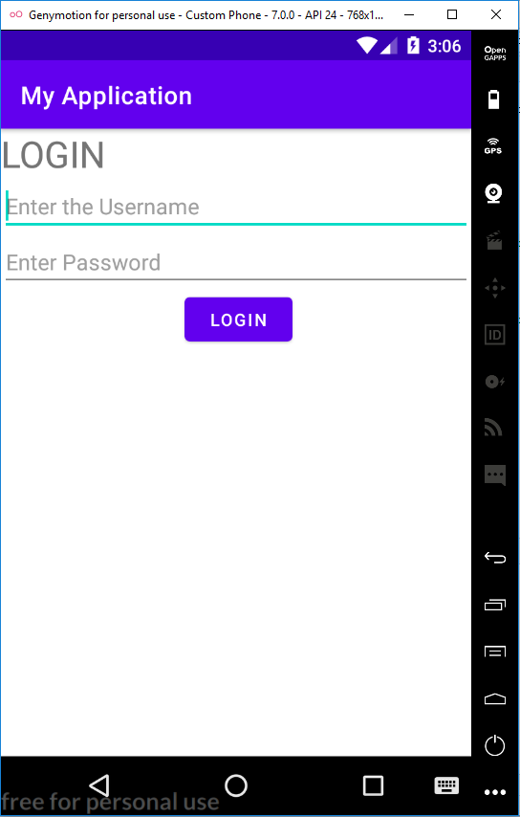 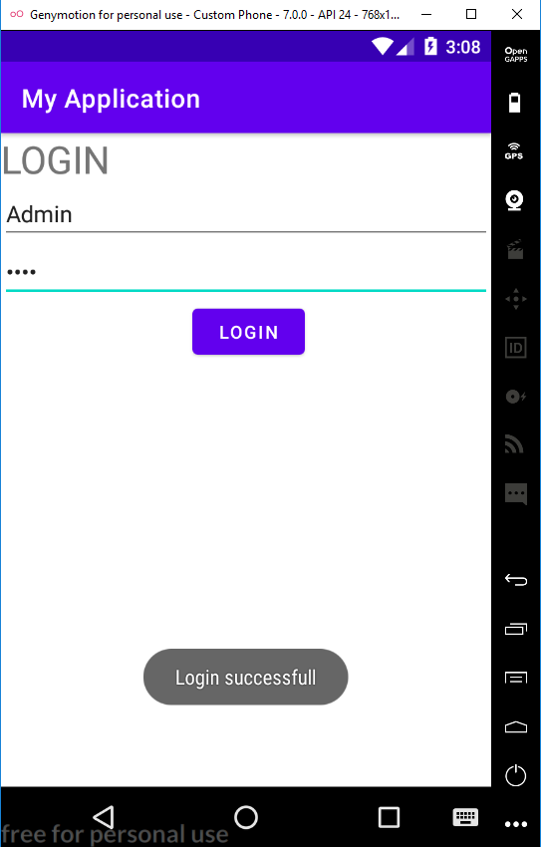

**PROGRAM NO:2 DATE :16-08-22**

**AIM:** Write a program that demonstrate activity lifecycle

**PROGRAM CODE**

Activitymain xml

<?xml version="1.0" encoding="utf-8"?>  
<androidx.constraintlayout.widget.ConstraintLayout xmlns:android="http://schemas.android.com/apk/res/android"  
 xmlns:app="http://schemas.android.com/apk/res-auto"  
 xmlns:tools="http://schemas.android.com/tools"  
 android:layout_width="match_parent"  
 android:layout_height="match_parent"  
 tools:context=".MainActivity">  
  
 <TextView  
 android:layout_width="wrap_content"  
 android:layout_height="wrap_content"  
 android:text="Hello World!"  
 app:layout_constraintBottom_toBottomOf="parent"  
 app:layout_constraintLeft_toLeftOf="parent"  
 app:layout_constraintRight_toRightOf="parent"  
 app:layout_constraintTop_toTopOf="parent" />  
  
</androidx.constraintlayout.widget.ConstraintLayout>

Main activity java

package com.example.myapplication3;  
  
import androidx.appcompat.app.AppCompatActivity;  
  
import android.os.Bundle;  
import android.util.Log;  
  
public class MainActivity extends AppCompatActivity {  
  
 @Override  
 protected void onCreate(Bundle savedInstanceState) {  
 super.onCreate(savedInstanceState);  
 setContentView(R.layout.activity_main);  
 Log.d("lifecycle","onCreate invoked");  
  
 }  
 @Override  
 protected void onStart() {  
 super.onStart();  
 Log.d("lifecycle","onStart invoked");  
 }  
 @Override  
 protected void onResume() {  
 super.onResume();  
 Log.d("lifecycle", "onResume invoked");  
 }  
 @Override  
 protected void onPause() {  
 super.onPause();  
 Log.d("lifecycle", "onPause invoked");  
 }  
 @Override  
 protected void onStop() {  
 super.onStop();  
 Log.d("lifecycle", "onStop invoked");  
 }  
 @Override  
 protected void onRestart() {  
 super.onRestart();  
 Log.d("lifecycle", "onRestart invoked");  
 }  
 @Override  
 protected void onDestroy() {  
 super.onDestroy();  
 Log.d("lifecycle", "onDestroy invoked");  
 }  
}

**RESULT:** Program compiled successfully and output verified

**OUTPUT:**

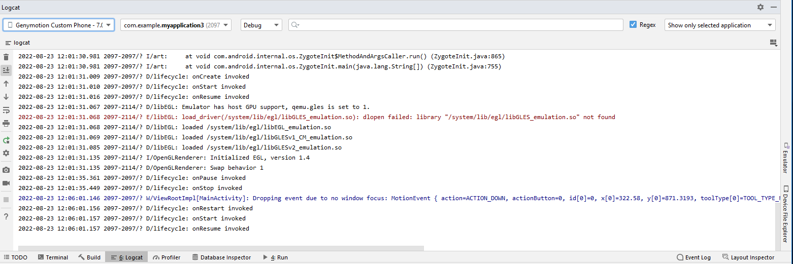

**PROGRAM NO:3 DATE :19-08-22**

**AIM:** Implementing basic arithmetic operation of a simple calculator

**PROGRAM CODE**

Activitymain xml

<?xml version="1.0" encoding="utf-8"?>  
<LinearLayout xmlns:android="http://schemas.android.com/apk/res/android"  
 xmlns:app="http://schemas.android.com/apk/res-auto"  
 xmlns:tools="http://schemas.android.com/tools"  
 android:orientation="vertical"  
 android:layout_width="match_parent"  
 android:layout_height="match_parent"  
 tools:context=".MainActivity">  
  
 <TextView  
 android:layout_width="wrap_content"  
 android:layout_height="wrap_content"  
 android:text="Enter first number"/>  
 <EditText  
 android:layout_width="wrap_content"  
 android:layout_height="wrap_content"  
 android:id="@+id/et1"/>  
 <TextView  
 android:layout_width="wrap_content"  
 android:layout_height="wrap_content"  
 android:text="Enter second number"/>  
 <EditText  
 android:layout_width="wrap_content"  
 android:layout_height="wrap_content"  
 android:id="@+id/et2"/>  
 <LinearLayout  
 android:layout_width="wrap_content"  
 android:layout_height="wrap_content">  
 <Button  
 android:layout_width="wrap_content"  
 android:layout_height="wrap_content"  
 android:id="@+id/b1"  
 android:text="ADD"/>  
 <Button  
 android:layout_width="wrap_content"  
 android:layout_height="wrap_content"  
 android:id="@+id/b2"  
 android:text="SUB"/>  
 <Button  
 android:layout_width="wrap_content"  
 android:layout_height="wrap_content"  
 android:id="@+id/b3"  
 android:text="MUL"/>  
 <Button  
 android:layout_width="wrap_content"  
 android:layout_height="wrap_content"  
 android:id="@+id/b4"  
 android:text="DIV"/>

</LinearLayout>

<TextView  
 android:layout_width="wrap_content"  
 android:layout_height="wrap_content"  
 android:id="@+id/tv1"/>  
 </LinearLayout>

Main activity java

package com.example.myapplication4;  
  
import androidx.appcompat.app.AppCompatActivity;  
  
import android.os.Bundle;  
import android.view.View;  
import android.widget.Button;  
import android.widget.EditText;  
import android.widget.TextView;  
  
public class MainActivity extends AppCompatActivity {  
  
 @Override  
 protected void onCreate(Bundle savedInstanceState) {  
 super.onCreate(savedInstanceState);  
 setContentView(R.layout.activity_main);  
 EditText t1=findViewById(R.id.et1);  
 EditText t2=findViewById(R.id.et2);  
 Button add=findViewById(R.id.b1);  
 Button sub=findViewById(R.id.b2);  
 Button mul=findViewById(R.id.b3);  
 Button div=findViewById(R.id.b4);  
 TextView tv1=findViewById(R.id.tv1);  
 add.setOnClickListener(new View.OnClickListener() {  
 @Override  
 public void onClick(View v) {  
 Double a1 = Double.parseDouble(t1.getText().toString());  
 Double a2 = Double.parseDouble(t2.getText().toString());  
 Double r = a1 + a2;  
 tv1.setText("Result is: " + String.valueOf(r));  
 }  
 });  
 sub.setOnClickListener(new View.OnClickListener() {  
 @Override  
 public void onClick(View view) {  
 Double s1=Double.parseDouble(t1.getText().toString());  
 Double s2=Double.parseDouble(t2.getText().toString());  
 Double r=s1-s2;  
 tv1.setText("Result is: "+String.valueOf(r));  
 }  
 });  
 mul.setOnClickListener(new View.OnClickListener() {  
 @Override  
 public void onClick(View view) {  
 Double m1 = Double.parseDouble(t1.getText().toString());  
 Double m2 = Double.parseDouble(t2.getText().toString());  
 Double r = m1 * m2;  
 tv1.setText("Result is" + String.valueOf(r));  
  
 }  
 });  
 div.setOnClickListener(new View.OnClickListener() {  
 @Override  
 public void onClick(View view) {  
 Double d1=Double.parseDouble(t1.getText().toString());  
 Double d2=Double.parseDouble(t2.getText().toString());  
 Double r=d1/d2;  
 tv1.setText("Result is" +String.valueOf(r));  
 }  
 });  
  
  
 }  
  
}

**RESULT:** Program compiled successfully and output verified

**OUTPUT:**

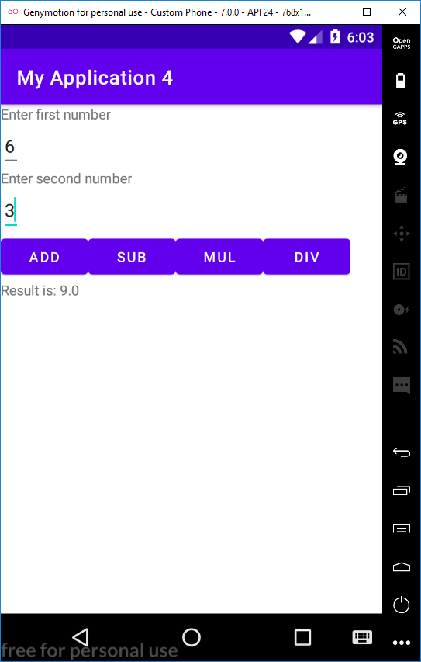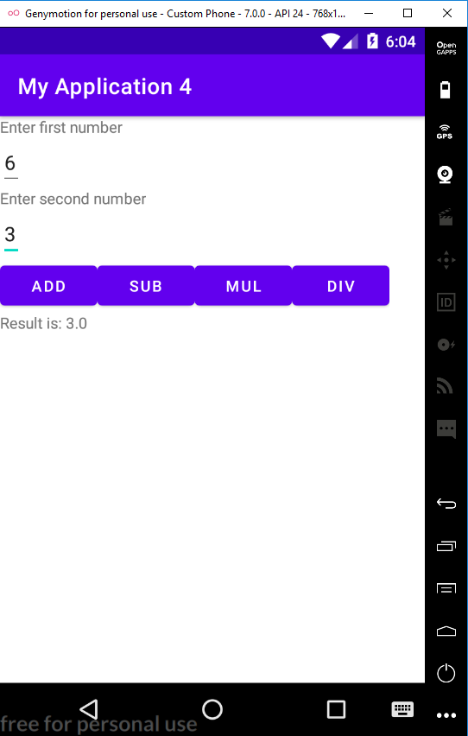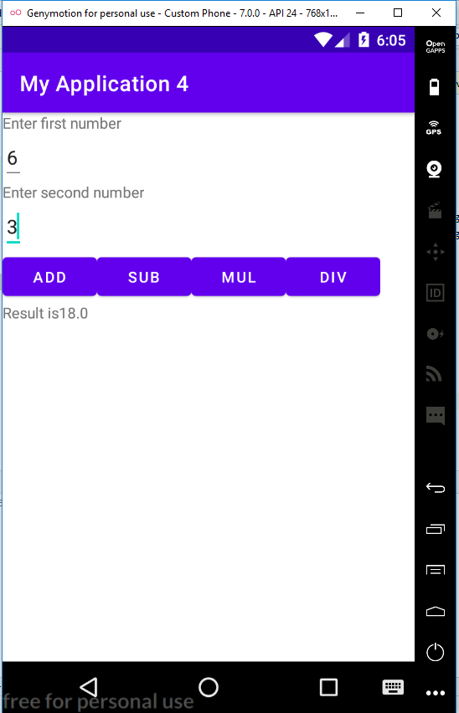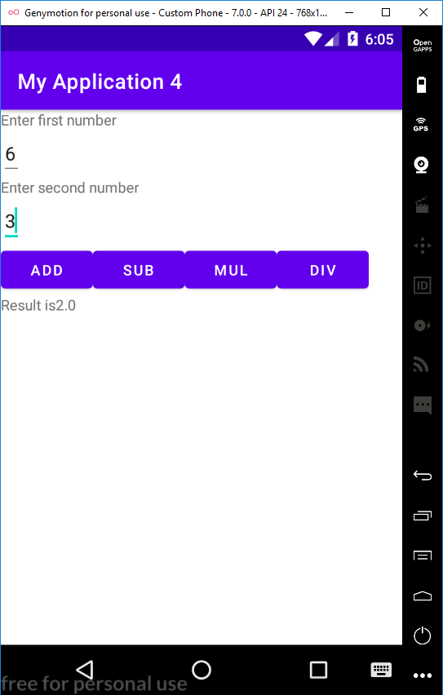

**PROGRAM NO:4 DATE :23-08-22**

**AIM:** Implement validation in various UI control

**PROGRAM CODE**

Activitymain xml

<?xml version="1.0" encoding="utf-8"?>  
<LinearLayout xmlns:android="http://schemas.android.com/apk/res/android"  
 xmlns:app="http://schemas.android.com/apk/res-auto"  
 xmlns:tools="http://schemas.android.com/tools"  
 android:layout_width="match_parent"  
 android:layout_height="match_parent"  
 android:orientation="vertical"  
 tools:context=".MainActivity">  
  
 <TextView  
 android:layout_width="match_parent"  
 android:layout_height="wrap_content"  
 android:text="REGISTRATION"  
 android:textColor="@color/cardview_light_background"  
 android:textSize="30dp"  
 />  
 <EditText  
 android:layout_width="match_parent"  
 android:layout_height="wrap_content"  
 android:hint="Name"  
 android:id="@+id/name"  
 />  
 <EditText  
 android:layout_width="match_parent"  
 android:layout_height="wrap_content"  
 android:hint="Mobile No"  
 android:id="@+id/mobile"  
 />  
 <EditText  
 android:layout_width="match_parent"  
 android:layout_height="wrap_content"  
 android:hint="Age"  
 android:id="@+id/age"  
 />  
 <TextView  
 android:layout_width="wrap_content"  
 android:layout_height="wrap_content"  
 android:hint="Gender"  
 android:id="@+id/gender"  
 />  
 <RadioGroup  
 android:layout_width="wrap_content"  
 android:layout_height="wrap_content"  
 android:id="@+id/RG"  
 >  
 <RadioButton  
 android:layout_width="wrap_content"  
 android:layout_height="wrap_content"  
 android:id="@+id/radiobutton1"  
 android:text="Male"  
 />  
 <RadioButton  
 android:layout_width="wrap_content"  
 android:layout_height="wrap_content"  
 android:id="@+id/radiobutton2"  
 android:text="Female"  
 />  
 </RadioGroup>  
 <Button  
 android:layout_width="wrap_content"  
 android:layout_height="wrap_content"  
 android:text="Submit"  
 android:id="@+id/button"  
 />  
 <CheckBox  
 android:layout_width="wrap_content"  
 android:layout_height="wrap_content"  
 android:text="I agree all terms and conditions"  
 android:id="@+id/checkbox"  
 />  
</LinearLayout>

Main activity java

package com.example.myaplication;  
  
import androidx.appcompat.app.AppCompatActivity;  
  
import android.content.Intent;  
import android.os.Bundle;  
import android.view.View;  
import android.widget.Button;  
import android.widget.CheckBox;  
import android.widget.EditText;  
import android.widget.RadioButton;  
import android.widget.RadioGroup;  
import android.widget.TextView;  
import android.widget.Toast;  
  
public class MainActivity extends AppCompatActivity {  
 EditText name;  
 EditText mobile;  
 EditText age;  
 TextView gender;  
 RadioGroup RG;  
 RadioButton radiobutton1;  
 RadioButton radiobutton2;  
 CheckBox checkbox;  
 Button button;  
  
  
 @Override  
 protected void onCreate(Bundle savedInstanceState) {  
 super.onCreate(savedInstanceState);  
 setContentView(R.layout.activity_main);  
 name = findViewById(R.id.name);  
 mobile = findViewById(R.id.mobile);  
 age = findViewById(R.id.age);  
 gender = findViewById(R.id.gender);  
 RG = findViewById(R.id.RG);  
 radiobutton1 = findViewById(R.id.radiobutton1);  
 radiobutton2 = findViewById(R.id.radiobutton2);  
 checkbox = findViewById(R.id.checkbox);  
 button = findViewById(R.id.button);  
 button.setOnClickListener(new View.OnClickListener() {  
 @Override  
 public void onClick(View view) {  
 if (error()) {  
 Intent i = new Intent(MainActivity.this, login.class);  
 startActivity(i);  
 }  
 }  
  
 });  
 }  
 private boolean error() {  
 if (name.getText().toString().length() == 0) {  
 Toast.makeText(getApplicationContext(), "please enter your name", Toast.LENGTH_LONG).show();  
 return false;  
 } else if (mobile.getText().toString().length() == 0) {  
 Toast.makeText(getApplicationContext(), "please enter your mobile number", Toast.LENGTH_LONG).show();  
 return false;  
 } else if (mobile.getText().toString().length() != 10) {  
 Toast.makeText(getApplicationContext(), "please enter 10 numbers", Toast.LENGTH_LONG).show();  
 return false;  
 } else if (!radiobutton1.isChecked() && !radiobutton2.isChecked()) {  
 Toast.makeText(getApplicationContext(), "please choose radiobutton", Toast.LENGTH_LONG).show();  
 return false;  
 } else if (!checkbox.isChecked()) {  
 Toast.makeText(getApplicationContext(), "please click on checkbox", Toast.LENGTH_LONG).show();  
 return false;  
 } else {  
 return true;  
  
 }  
 }  
 }

Activity-login xml

<?xml version="1.0" encoding="utf-8"?>  
<LinearLayout xmlns:android="http://schemas.android.com/apk/res/android"  
 xmlns:app="http://schemas.android.com/apk/res-auto"  
 xmlns:tools="http://schemas.android.com/tools"  
 android:layout_width="match_parent"  
 android:layout_height="match_parent"  
 tools:context=".login">  
  
 <TextView  
 android:id="@+id/textView"  
 android:layout_width="117dp"  
 android:layout_height="123dp"  
 android:text="Welcome"  
 tools:layout_editor_absoluteX="92dp"  
 tools:layout_editor_absoluteY="173dp" />  
</LinearLayout>

Login.java

package com.example.registration;  
  
import androidx.appcompat.app.AppCompatActivity;  
  
import android.os.Bundle;  
  
public class login extends AppCompatActivity {  
  
 @Override  
 protected void onCreate(Bundle savedInstanceState) {  
 super.onCreate(savedInstanceState);  
 setContentView(R.layout.activity_login);  
 }  
}

**RESULT:** Program compiled successfully and output verified

**OUTPUT:**

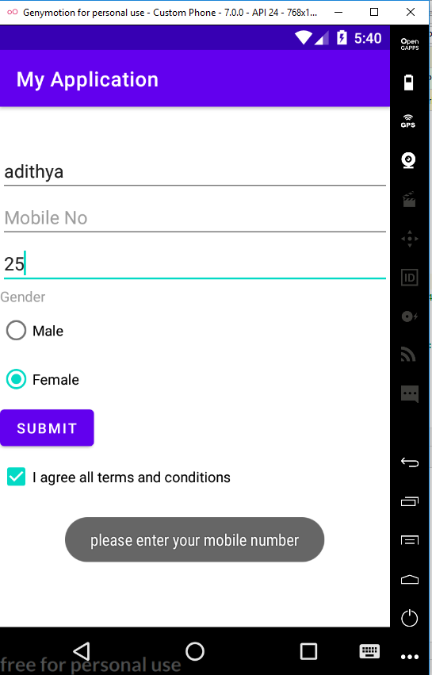

**PROGRAM NO: 5 DATE :26-08-22**

**AIM:** Design a registration activity and store registration details in local memory of phone using intends and shared preferences

**PROGRAM CODE**

Activitymain xml

<?xml version="1.0" encoding="utf-8"?>  
<RelativeLayout xmlns:android="http://schemas.android.com/apk/res/android"  
 xmlns:app="http://schemas.android.com/apk/res-auto"  
 xmlns:tools="http://schemas.android.com/tools"  
 android:layout_width="match_parent"  
 android:layout_height="match_parent"  
 tools:context=".MainActivity">  
  
 <TextView  
 android:id="@+id/textview"  
 android:layout_width="wrap_content"  
 android:layout_height="wrap_content"  
 android:layout_centerHorizontal="true"  
 android:layout_marginTop="32dp"  
 android:text="REGISTRATION FORM"  
 android:textColor="@color/black"  
 android:textSize="24sp" />  
 <EditText  
 android:layout_width="match_parent"  
 android:layout_height="wrap_content"  
 android:id="@+id/edit1"  
 android:layout_below="@+id/textview"  
 android:layout_marginStart="16dp"  
 android:layout_marginTop="8dp"  
 android:layout_marginEnd="16dp"  
 android:hint="Enter your name"  
 android:padding="10dp"  
 />  
 <EditText  
 android:layout_width="match_parent"  
 android:layout_height="wrap_content"  
 android:id="@+id/edit2"  
 android:layout_below="@+id/edit1"  
 android:layout_marginStart="16dp"  
 android:layout_marginTop="8dp"  
 android:layout_marginEnd="16dp"  
 android:hint="Enter your age"  
 android:padding="10dp"  
 android:inputType="number"  
 />  
 <EditText  
 android:layout_width="match_parent"  
 android:layout_height="wrap_content"  
 android:id="@+id/edit3"  
 android:layout_below="@+id/edit2"  
 android:layout_marginStart="16dp"  
 android:layout_marginTop="8dp"  
 android:layout_marginEnd="16dp"  
 android:hint="Enter your email"  
 android:padding="10dp"  
 />  
 <EditText  
 android:layout_width="match_parent"  
 android:layout_height="wrap_content"  
 android:id="@+id/edit4"  
 android:layout_below="@+id/edit3"  
 android:layout_marginStart="16dp"  
 android:layout_marginTop="8dp"  
 android:layout_marginEnd="16dp"  
 android:hint="Enter your address"  
 android:padding="10dp"  
 />  
 <EditText  
 android:layout_width="match_parent"  
 android:layout_height="wrap_content"  
 android:id="@+id/edit5"  
 android:layout_below="@+id/edit4"  
 android:layout_marginStart="16dp"  
 android:layout_marginTop="8dp"  
 android:layout_marginEnd="16dp"  
 android:hint="Enter your gender"  
 android:padding="10dp"  
 />  
 <EditText  
 android:layout_width="match_parent"  
 android:layout_height="wrap_content"  
 android:id="@+id/edit6"  
 android:layout_below="@+id/edit5"  
 android:layout_marginStart="16dp"  
 android:layout_marginTop="8dp"  
 android:layout_marginEnd="16dp"  
 android:hint="Enter your qualification"  
 android:padding="10dp"  
 />  
 <Button  
 android:layout_width="wrap_content"  
 android:layout_height="wrap_content"  
 android:id="@+id/b1"  
 android:layout_below="@+id/edit6"  
 android:text="submit"  
 />  
</RelativeLayout>

Main activity java

package com.example.myapplication7;  
  
import androidx.appcompat.app.AppCompatActivity;  
  
import android.content.Intent;  
import android.content.SharedPreferences;  
import android.os.Bundle;  
import android.view.View;  
import android.widget.Button;  
import android.widget.EditText;  
  
public class MainActivity extends AppCompatActivity {  
 private EditText name, age, email, address, gender, qualification;  
 Button b1;  
  
 @Override  
 protected void onCreate(Bundle savedInstanceState) {  
 super.onCreate(savedInstanceState);  
 setContentView(R.layout.activity_main);  
 name = findViewById(R.id.edit1);  
 age = findViewById(R.id.edit2);  
 email = findViewById(R.id.edit3);  
 address = findViewById(R.id.edit4);  
 gender = findViewById(R.id.edit5);  
 qualification = findViewById(R.id.edit6);  
 b1 = findViewById(R.id.b1);  
 b1.setOnClickListener(new View.OnClickListener() {  
 @Override  
 public void onClick(View view) {  
 Intent i = new Intent(MainActivity.this, MainActivity8.class);  
 startActivity(i);  
  
 }  
 });  
 }  
  
 @Override  
 protected void onResume() {  
 super.onResume();  
 SharedPreferences sh = getSharedPreferences("MySharePref", MODE_PRIVATE);  
 String s1 = sh.getString("name", "");  
 int a = sh.getInt("age", 0);  
 String s2 = sh.getString("email", " ");  
 String s3 = sh.getString("address", "");  
 String s4 = sh.getString("gender", "");  
 String s5 = sh.getString("qualification", "");  
  
 name.setText(s1);  
 age.setText(String.valueOf(a));  
 email.setText(s2);  
 address.setText(s3);  
 gender.setText(s4);  
 qualification.setText(s5);  
 }  
  
 @Override  
 protected void onPause() {  
 super.onPause();  
 SharedPreferences sharedpreferences = getSharedPreferences("MySharePref", MODE_PRIVATE);  
 SharedPreferences.Editor myEdit = sharedpreferences.edit();  
 myEdit.putString("name",name.getText().toString());  
 myEdit.putInt("age", Integer.parseInt(age.getText().toString()));  
 myEdit.putString("email", email.getText().toString());  
 myEdit.putString("address", address.getText().toString());  
 myEdit.putString("gender", gender.getText().toString());  
 myEdit.putString("qualification", qualification.getText().toString());  
 myEdit.commit();  
 }  
  
  
  
}

Activitymain xml

<?xml version="1.0" encoding="utf-8"?>  
<RelativeLayout xmlns:android="http://schemas.android.com/apk/res/android"  
 xmlns:app="http://schemas.android.com/apk/res-auto"  
 xmlns:tools="http://schemas.android.com/tools"  
 android:layout_width="match_parent"  
 android:layout_height="match_parent"  
 tools:context=".MainActivity">  
  
 <TextView  
 android:id="@+id/textview"  
 android:layout_width="wrap_content"  
 android:layout_height="wrap_content"  
 android:layout_centerHorizontal="true"  
 android:layout_marginTop="32dp"  
 android:text="Hello"  
 android:textColor="@color/black"  
 android:textSize="24sp" />  
</RelativeLayout>

Main activity java

package com.example.myapplication7;  
  
import androidx.appcompat.app.AppCompatActivity;  
  
import android.os.Bundle;  
  
public class MainActivity8 extends AppCompatActivity {  
  
 @Override  
 protected void onCreate(Bundle savedInstanceState) {  
 super.onCreate(savedInstanceState);  
 setContentView(R.layout.activity_main8);  
 }  
}

**RESULT:** Program compiled successfully and output verified

**OUTPUT:**

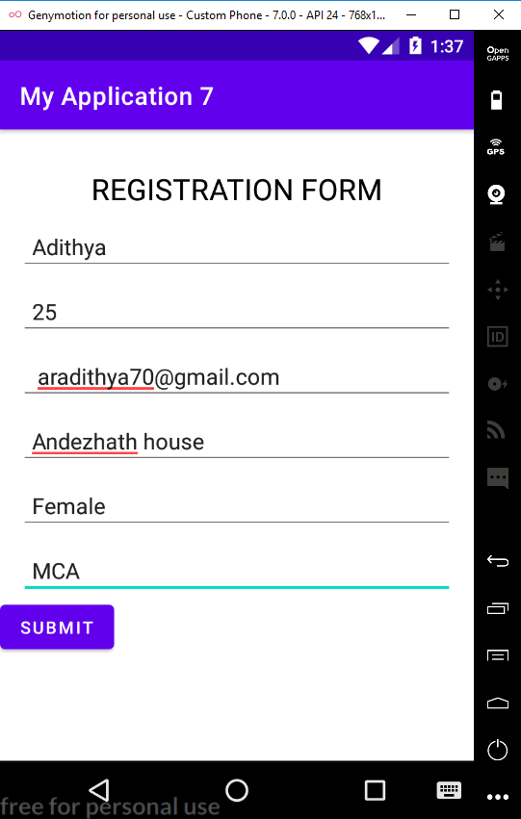 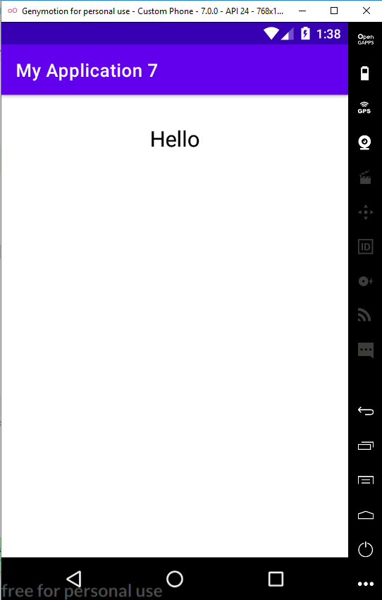

**PROGRAM NO: 6 DATE :30-08-22**

**AIM:** Implement basic arithmetic operations of a simple calculator using grid layout

**PROGRAM CODE**

Activitymain xml

<?xml version="1.0" encoding="utf-8"?>  
<GridLayout xmlns:android="http://schemas.android.com/apk/res/android"  
 xmlns:app="http://schemas.android.com/apk/res-auto"  
 xmlns:tools="http://schemas.android.com/tools"  
 android:orientation="vertical"  
 android:layout_width="match_parent"  
 android:layout_height="match_parent"  
 tools:context=".MainActivity">  
  
 <TextView  
 android:layout_width="wrap_content"  
 android:layout_height="wrap_content"  
 android:text="Enter first number"/>  
 <EditText  
 android:layout_width="wrap_content"  
 android:layout_height="wrap_content"  
 android:id="@+id/et1"/>  
 <TextView  
 android:layout_width="wrap_content"  
 android:layout_height="wrap_content"  
 android:text="Enter second number"/>  
 <EditText  
 android:layout_width="wrap_content"  
 android:layout_height="wrap_content"  
 android:id="@+id/et2"/>  
 <Button  
 android:layout_width="wrap_content"  
 android:layout_height="wrap_content"  
 android:id="@+id/b1"  
 android:text="ADD"/>  
 <Button  
 android:layout_width="wrap_content"  
 android:layout_height="wrap_content"  
 android:id="@+id/b2"  
 android:text="SUB"/>  
 <Button  
 android:layout_width="wrap_content"  
 android:layout_height="wrap_content"  
 android:id="@+id/b3"  
 android:text="MUL"/>  
 <Button  
 android:layout_width="wrap_content"  
 android:layout_height="wrap_content"  
 android:id="@+id/b4"  
 android:text="DIV"/>  
  
 <TextView  
 android:layout_width="wrap_content"  
 android:layout_height="wrap_content"  
 android:id="@+id/tv1"/>  
</GridLayout>

Main activity java

package com.example.myapplication;  
  
import androidx.appcompat.app.AppCompatActivity;  
  
import android.os.Bundle;  
import android.view.View;  
import android.widget.Button;  
import android.widget.EditText;  
import android.widget.TextView;  
  
public class MainActivity extends AppCompatActivity {  
  
 @Override  
 protected void onCreate(Bundle savedInstanceState) {  
 super.onCreate(savedInstanceState);  
 setContentView(R.layout.activity_main);  
 EditText t1=findViewById(R.id.et1);  
 EditText t2=findViewById(R.id.et2);  
 Button add=findViewById(R.id.b1);  
 Button sub=findViewById(R.id.b2);  
 Button mul=findViewById(R.id.b3);  
 Button div=findViewById(R.id.b4);  
 TextView tv1=findViewById(R.id.tv1);  
 add.setOnClickListener(new View.OnClickListener() {  
 @Override  
 public void onClick(View v) {  
 Double a1 = Double.parseDouble(t1.getText().toString());  
 Double a2 = Double.parseDouble(t2.getText().toString());  
 Double r = a1 + a2;  
 tv1.setText("Result is: " + String.valueOf(r));  
 }  
 });  
 sub.setOnClickListener(new View.OnClickListener() {  
 @Override  
 public void onClick(View view) {  
 Double s1=Double.parseDouble(t1.getText().toString());  
 Double s2=Double.parseDouble(t2.getText().toString());  
 Double r=s1-s2;  
 tv1.setText("Result is: "+String.valueOf(r));  
 }  
 });  
 mul.setOnClickListener(new View.OnClickListener() {  
 @Override  
 public void onClick(View view) {  
 Double m1 = Double.parseDouble(t1.getText().toString());  
 Double m2 = Double.parseDouble(t2.getText().toString());  
 Double r = m1 * m2;  
 tv1.setText("Result is" + String.valueOf(r));  
  
 }  
 });  
 div.setOnClickListener(new View.OnClickListener() {  
 @Override  
 public void onClick(View view) {  
 Double d1=Double.parseDouble(t1.getText().toString());  
 Double d2=Double.parseDouble(t2.getText().toString());  
 Double r=d1/d2;  
 tv1.setText("Result is" +String.valueOf(r));  
 }  
 });  
  
  
 }  
  
}

**RESULT:** Program compiled successfully and output verified

**OUTPUT:**

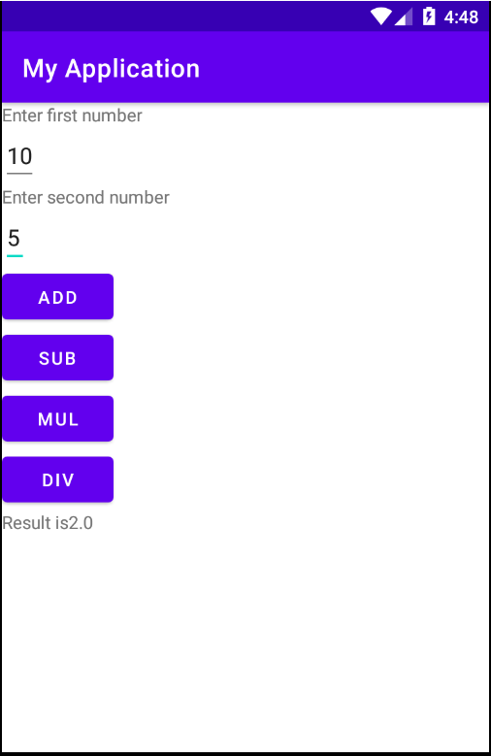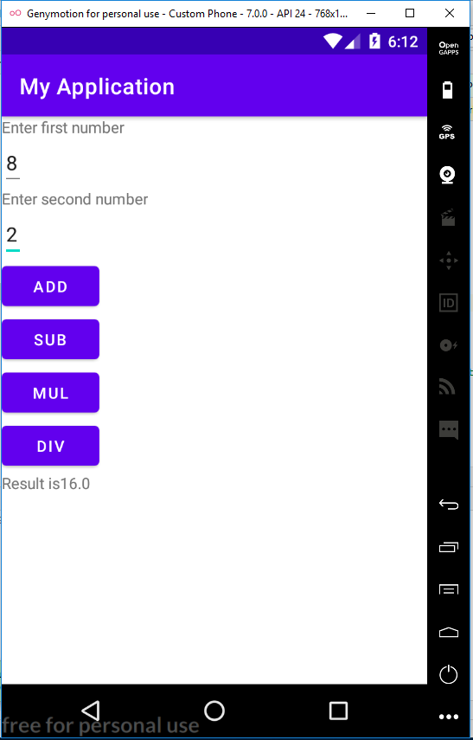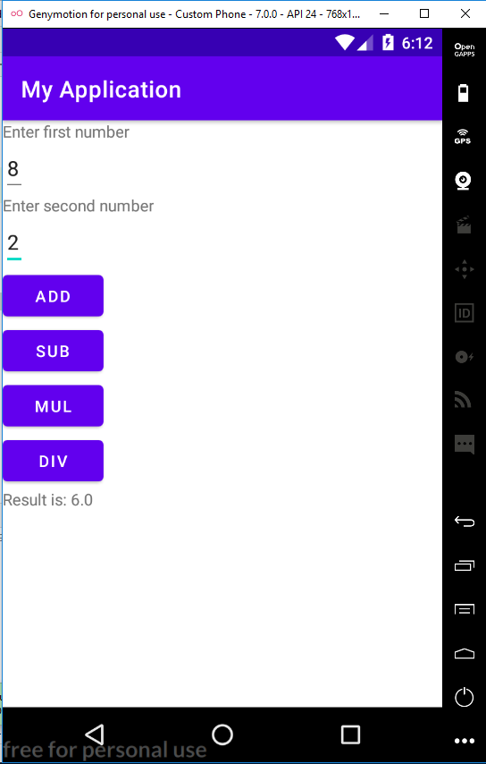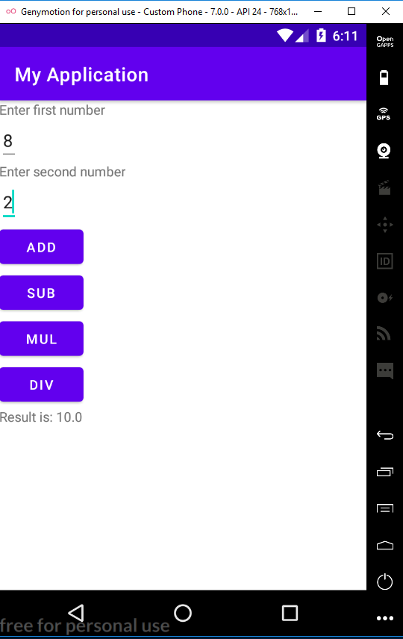

**PROGRAM NO: 7 DATE :02-09-22**

**AIM:** create a Facebook page using RelativeLayout;set properties using.xml file

**PROGRAM CODE**

Activitymain xml

*<?*xml version="1.0" encoding="utf-8"*?>*<RelativeLayout xmlns:android="http://schemas.android.com/apk/res/android"  
 xmlns:app="http://schemas.android.com/apk/res-auto"  
 xmlns:tools="http://schemas.android.com/tools"  
 android:layout_width="match_parent"  
 android:layout_height="match_parent"  
 tools:context=".MainActivity">  
  
  
  
  
<RelativeLayout  
 android:id="@+id/relativeLayout"  
 android:layout_width="match_parent"  
 android:layout_height="wrap_content">  
  
 <ImageView  
 android:layout_width="match_parent"  
 android:layout_height="250dp"  
 android:id="@+id/banner"  
 android:src="@drawable/flower"  
 android:scaleType="centerCrop"/>  
  
  
 <ImageView  
 android:layout_marginLeft="15dp"  
 android:layout_width="100dp"  
 android:layout_height="150dp"  
 android:id="@+id/profilePic"  
 android:src="@drawable/lotus"  
 android:layout_alignBottom="@+id/linearLayout"/>  
  
  
 <LinearLayout  
 android:layout_toRightOf="@+id/profilePic"  
 android:layout_width="match_parent"  
 android:layout_height="wrap_content"  
 android:layout_below="@+id/banner"  
 android:orientation="horizontal"  
  
 android:weightSum="100"  
 android:id="@+id/linearLayout">  
  
 <Button  
  
 android:layout_width="wrap_content"  
 android:layout_height="wrap_content"  
 android:text="Timeline"  
 android:textSize="5dp"  
 android:layout_weight="10"/>  
 <Button  
 android:layout_weight="10"  
 android:textSize="5dp"  
 android:layout_width="wrap_content"  
 android:layout_height="wrap_content"  
 android:text="About"  
 />  
 <Button  
 android:layout_weight="10"  
 android:textSize="5dp"  
 android:layout_width="wrap_content"  
 android:layout_height="wrap_content"  
 android:text="Friends"  
 />  
 <Button  
 android:layout_weight="10"  
 android:textSize="5dp"  
 android:layout_width="wrap_content"  
 android:layout_height="wrap_content"  
 android:text="Photos"  
  
 />  
 <Button  
 android:layout_weight="10"  
 android:textSize="5dp"  
 android:layout_width="wrap_content"  
 android:layout_height="wrap_content"  
 android:text="More"  
 />  
  
  
 </LinearLayout>  
  
 <EditText  
 android:textColor="@color/white"  
 android:textStyle="bold"  
 android:layout_width="wrap_content"  
 android:layout_height="wrap_content"  
 android:inputType="textPersonName"  
 android:text="Adithya"  
 android:ems="10"  
 android:layout_alignParentEnd="true"  
 android:layout_marginEnd="55dp"  
 android:id="@+id/textName"  
 android:layout_alignBottom="@+id/banner"/>  
  
 </RelativeLayout>  
  
  
 <RelativeLayout  
  
 android:paddingRight="15dp"  
 android:paddingLeft="15dp"  
 android:paddingTop="15dp"  
 android:paddingBottom="15dp"  
 android:layout_below="@+id/relativeLayout"  
 android:layout_width="match_parent"  
 android:layout_height="wrap_content">  
  
 <LinearLayout  
  
 android:layout_width="match_parent"  
 android:layout_height="wrap_content"  
 android:orientation="horizontal"  
 android:id="@+id/linearLayout2">  
  
 <ImageView  
 android:layout_marginLeft="5dp"  
 android:layout_marginTop="15dp"  
 android:layout_width="25dp"  
 android:layout_height="25dp"  
 android:src="@drawable/lotus"/>  
  
 <EditText  
 android:id="@+id/etPost"  
 android:layout_marginLeft="10dp"  
 android:textSize="15sp"  
 android:layout_width="match_parent"  
 android:layout_height="60dp"  
 android:hint="What's on your mind?"/>  
  
 </LinearLayout>  
  
 <Button  
 android:textSize="10sp"  
 android:text="Post"  
 android:layout_width="70dp"  
 android:layout_height="30dp"  
 android:layout_alignParentRight="true"  
 android:layout_below="@+id/linearLayout2"/>  
  
  
  
 </RelativeLayout>  
  
  
</RelativeLayout>

Main activity java

package com.example.myapplication;  
  
import androidx.appcompat.app.AppCompatActivity;  
  
import android.os.Bundle;  
  
public class MainActivity extends AppCompatActivity {  
  
 @Override  
 protected void onCreate(Bundle savedInstanceState) {  
 super.onCreate(savedInstanceState);  
 setContentView(R.layout.*activity_main*);  
 }  
}

**RESULT:** Program compiled successfully and output verified

**OUTPUT:**

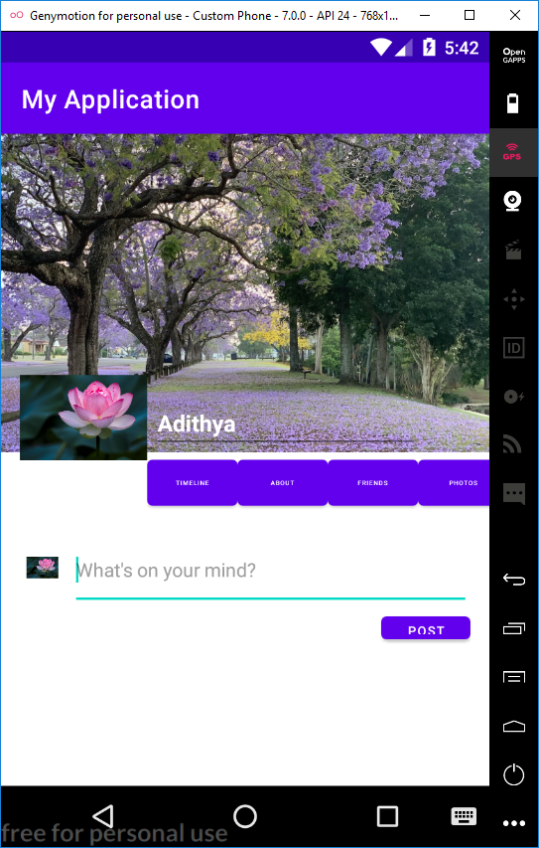

**PROGRAM NO:8 DATE :14-09-22**

**AIM:** Develop an application that toggles image using FrameLayout

**PROGRAM CODE**

Activitymain xml

*<?*xml version="1.0" encoding="utf-8"*?>*<FrameLayout xmlns:android="http://schemas.android.com/apk/res/android"  
 xmlns:app="http://schemas.android.com/apk/res-auto"  
 xmlns:tools="http://schemas.android.com/tools"  
 android:layout_width="fill_parent"  
 android:layout_height="fill_parent"  
 tools:context=".MainActivity">  
  
 <ImageView  
 android:layout_width="match_parent"  
 android:layout_height="239dp"  
 android:scaleType="fitCenter"  
 android:src="@drawable/lotus"  
 android:id="@+id/image1"/>  
  
 <ImageView  
 android:layout_width="match_parent"  
 android:layout_height="239dp"  
 android:scaleType="fitXY"  
 android:src="@drawable/sunset"  
 android:id="@+id/image2"/>  
</FrameLayout>

Main activity java

package com.example.myapplication;  
  
import androidx.appcompat.app.AppCompatActivity;  
import android.os.Bundle;  
import android.view.View;  
import android.widget.ImageView;  
public class MainActivity extends AppCompatActivity {  
 ImageView i1,i2;  
 @Override  
 protected void onCreate(Bundle savedInstanceState) {  
 super.onCreate(savedInstanceState);  
 setContentView(R.layout.*activity_main*);  
 i1=findViewById(R.id.*image1*);  
 i2=findViewById(R.id.*image2*);  
 i2.setOnClickListener(new View.OnClickListener() {  
 @Override  
 public void onClick(View view) {  
 i2.setVisibility(View.*GONE*);  
 i1.setVisibility(View.*VISIBLE*);  
  
 }  
 });  
 i1.setOnClickListener(new View.OnClickListener() {  
 @Override  
 public void onClick(View view) {  
 i1.setVisibility(View.*GONE*);  
 i2.setVisibility(View.*VISIBLE*);  
  
 }  
 });  
 }  
  
  
}

**RESULT:** Program compiled successfully and output verified

**OUTPUT:**

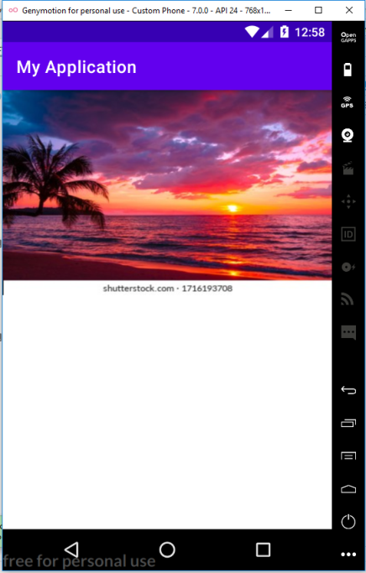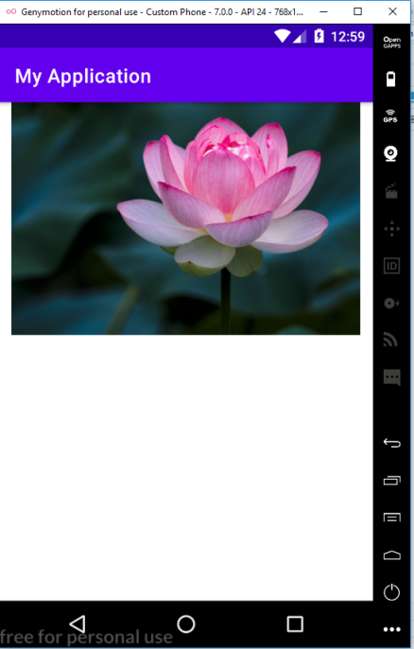

**PROGRAM NO: 9 DATE :16-09-22**

**AIM:**Write an application to implement implicit intend

**PROGRAM CODE**

Activitymain xml

*<?*xml version="1.0" encoding="utf-8"*?>*<LinearLayout xmlns:android="http://schemas.android.com/apk/res/android"  
 xmlns:app="http://schemas.android.com/apk/res-auto"  
 xmlns:tools="http://schemas.android.com/tools"

android:orientation="vertical"

android:layout_width="match_parent"  
 android:layout_height="match_parent"  
 tools:context=".MainActivity">  
  
 <EditText  
 android:layout_width="wrap_content"  
 android:layout_height="wrap_content"  
 android:text="https://github.com/adithyamca/mobile-application"  
 android:id="@+id/e1"  
 />  
 <Button  
 android:layout_width="wrap_content"  
 android:layout_height="wrap_content"  
 android:id="@+id/b1"  
 android:text="submit"  
 />  
  
</LinearLayout>

Main activity java

package com.example.myapplication8;  
  
import androidx.appcompat.app.AppCompatActivity;  
  
import android.content.Intent;  
import android.net.Uri;  
import android.os.Bundle;  
import android.view.View;  
import android.widget.Button;  
import android.widget.EditText;  
  
public class MainActivity extends AppCompatActivity {  
 EditText e1;  
 Button b1;  
 @Override  
 protected void onCreate(Bundle savedInstanceState) {  
 super.onCreate(savedInstanceState);  
 setContentView(R.layout.*activity_main*);  
 e1=findViewById(R.id.*e1*);  
 b1=findViewById(R.id.*b1*);  
 b1.setOnClickListener(new View.OnClickListener() {  
 @Override  
 public void onClick(View view) {  
 String url=e1.getText().toString();  
 Intent i=new Intent(Intent.*ACTION_VIEW*, Uri.*parse*(url));  
 startActivity(i);  
 }  
 });  
 }  
}

**RESULT:** Program compiled successfully and output verified

**OUTPUT:**

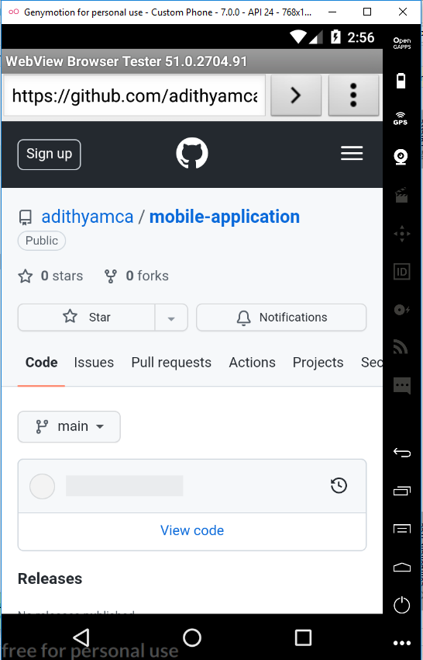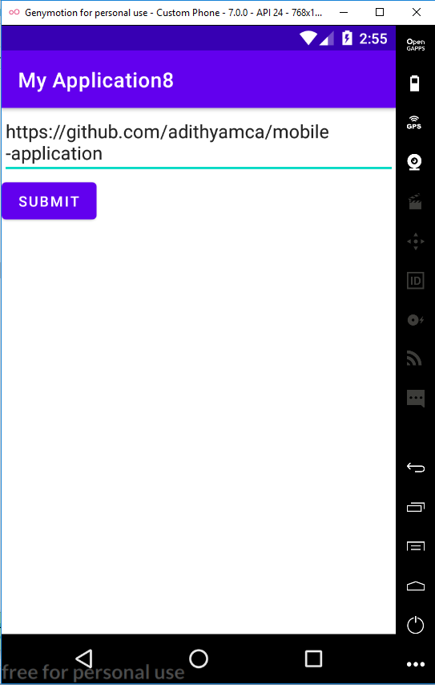

**PROGRAM NO:10 DATE :20-09-22**

**AIM:** Implement option menu to navigate activity

**PROGRAM CODE**

Activitymain xml

<?xml version="1.0" encoding="utf-8"?>  
<menu xmlns:android="http://schemas.android.com/apk/res/android">  
<item android:id="@+id/item1"  
 android:title="File"/>  
 <item android:id="@+id/item2"  
 android:title="Edit">  
 <menu>  
 <item android:id="@+id/sitem1"  
 android:title="Cut"/>  
 <item android:id="@+id/sitem2"  
 android:title="Copy"/>  
 <item android:id="@+id/sitem3"  
 android:title="paste"/>  
 </menu>  
 </item>  
 <item android:id="@+id/item3"  
 android:title="View"/>  
  
</menu>

Main activity java

package com.example.myapplication;  
  
import androidx.annotation.NonNull;  
import androidx.appcompat.app.AppCompatActivity;  
  
import android.os.Bundle;  
import android.view.Menu;  
import android.view.MenuItem;  
import android.widget.Toast;  
  
import com.example.myapplication.R;  
  
public class MainActivity extends AppCompatActivity {  
  
 @Override  
 protected void onCreate(Bundle savedInstanceState) {  
 super.onCreate(savedInstanceState);  
 setContentView(R.layout.activity_main);  
 }  
  
 @Override  
 public boolean onCreateOptionsMenu(Menu menu) {  
 getMenuInflater().inflate(R.menu.menu,menu);  
 return true;  
 }  
  
 @Override  
 public boolean onOptionsItemSelected(@NonNull MenuItem item) {  
 switch(item.getItemId()){  
 case R.id.item1:  
 Toast.makeText(getApplicationContext(),"File Selected", Toast.LENGTH_SHORT).show();  
 break;  
 case R.id.item2:  
 Toast.makeText(getApplicationContext(),"Edit Selected", Toast.LENGTH_SHORT).show();  
 break;  
  
 case R.id.sitem1:  
 Toast.makeText(getApplicationContext(),"Cut Selected", Toast.LENGTH_SHORT).show();  
 break;  
 case R.id.sitem2:  
 Toast.makeText(getApplicationContext(),"Copy Selected", Toast.LENGTH_SHORT).show();  
 break;  
 case R.id.sitem3:  
 Toast.makeText(getApplicationContext(),"Paste Selected", Toast.LENGTH_SHORT).show();  
 break;  
 case R.id.item3:  
 Toast.makeText(getApplicationContext(),"View Selected", Toast.LENGTH_SHORT).show();  
 break;  
  
 }  
 return super.onOptionsItemSelected(item);  
 }  
}

**RESULT:** Program compiled successfully and output verified

**OUTPUT:**

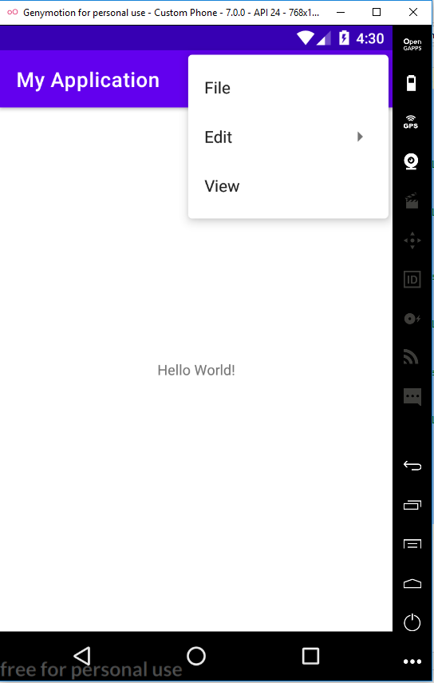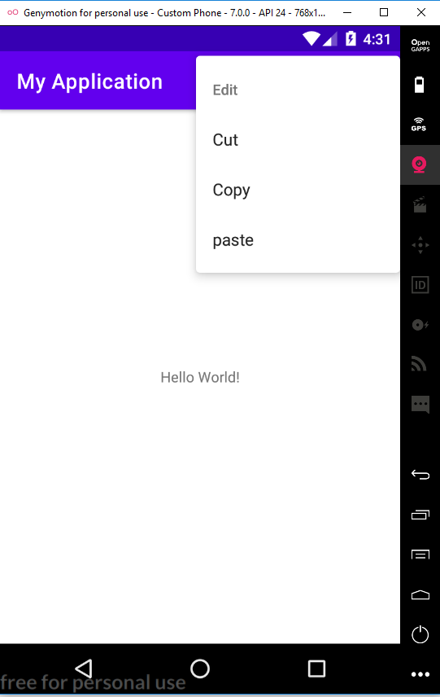

**PROGRAM NO:11 DATE :27-09-22**

**AIM:** Develop an application that uses Array Adapter with ListView

**PROGRAM CODE**

Activitymain xml

<?xml version="1.0" encoding="utf-8"?>  
<RelativeLayout xmlns:android="http://schemas.android.com/apk/res/android"  
 xmlns:app="http://schemas.android.com/apk/res-auto"  
 xmlns:tools="http://schemas.android.com/tools"  
 android:layout_width="match_parent"  
 android:layout_height="match_parent"  
 tools:context=".MainActivity">  
  
 <ListView  
 android:id="@+id/lv1"  
 android:layout_width="match_parent"  
 android:layout_height="match_parent"  
 />  
  
</RelativeLayout>

Main activity java

package com.example.myapplication;  
  
import androidx.appcompat.app.AppCompatActivity;  
  
import android.content.Intent;  
import android.os.Bundle;  
import android.view.View;  
import android.widget.AdapterView;  
import android.widget.ArrayAdapter;  
import android.widget.ListView;  
import android.widget.Toast;  
  
public class MainActivity extends AppCompatActivity {  
 ListView l;  
 String [] p={"Rajendra Prasd(1884-1963)","S Radhakrishnan(1888- 1993)"};  
 @Override  
 protected void onCreate(Bundle savedInstanceState) {  
 super.onCreate(savedInstanceState);  
 setContentView(R.layout.activity_main);  
 l=(ListView)findViewById(R.id.lv1);  
 ArrayAdapter <String> adapter= new ArrayAdapter<String>(this,android.R.layout.simple_list_item_1,p);  
 l.setAdapter(adapter);  
 l.setOnItemClickListener(new AdapterView.OnItemClickListener() {  
 @Override  
 public void onItemClick(AdapterView<?> adapterView, View view, int i, long l) {  
 //Toast.makeText(getBaseContext(),p[i],Toast.LENGTH_LONG).show();  
 if(i==0){  
 startActivity((new Intent(MainActivity.this,MainActivity2.class)  
 ));  
 }  
 else if(i==1){  
 startActivity(new Intent(MainActivity.this,MainActivity3.class));  
 }  
 }  
 });  
 }  
}

Activitymain xml

<?xml version="1.0" encoding="utf-8"?>  
<RelativeLayout xmlns:android="http://schemas.android.com/apk/res/android"  
 xmlns:app="http://schemas.android.com/apk/res-auto"  
 xmlns:tools="http://schemas.android.com/tools"  
 android:layout_width="match_parent"  
 android:layout_height="match_parent"  
 tools:context=".MainActivity">  
  
 <TextView  
 android:layout_width="wrap_content"  
 android:layout_height="match_parent"  
 android:id="@+id/tv1"  
 android:text="Two and a half years after independence, on January 26, 1950, the Constitution of independent India was ratified and he was elected the nation's first President. Dr. Prasad transformed the imperial splendor of Rashtrapati Bhavan into an elegant “Indian” home."  
 />  
</RelativeLayout>

Main activity java

package com.example.myapplication;  
  
import androidx.appcompat.app.AppCompatActivity;  
  
import android.os.Bundle;  
  
public class MainActivity2 extends AppCompatActivity {  
  
 @Override  
 protected void onCreate(Bundle savedInstanceState) {  
 super.onCreate(savedInstanceState);  
 setContentView(R.layout.activity_main2);  
 }  
}

Activitymain xml

<?xml version="1.0" encoding="utf-8"?>  
<RelativeLayout xmlns:android="http://schemas.android.com/apk/res/android"  
 xmlns:app="http://schemas.android.com/apk/res-auto"  
 xmlns:tools="http://schemas.android.com/tools"  
 android:layout_width="match_parent"  
 android:layout_height="match_parent"  
 tools:context=".MainActivity">  
  
 <TextView  
 android:layout_width="wrap_content"  
 android:layout_height="match_parent"  
 android:id="@+id/tv1"  
 android:text="Dr. Sarvepalli Radhakrishnan (5 September 1888 — 17 April 1975) was an Indian philosopher. He was famous for his work on comparative religion, comparative Eastern and Western philosophy, and was also a teacher in India and at Oxford University in the United Kingdom."  
 />  
</RelativeLayout>

Main activity java

package com.example.myapplication;  
  
import androidx.appcompat.app.AppCompatActivity;  
  
import android.os.Bundle;  
  
public class MainActivity3 extends AppCompatActivity {  
  
 @Override  
 protected void onCreate(Bundle savedInstanceState) {  
 super.onCreate(savedInstanceState);  
 setContentView(R.layout.activity_main3);  
 }  
}

**RESULT:** Program compiled successfully and output verified

**OUTPUT:**

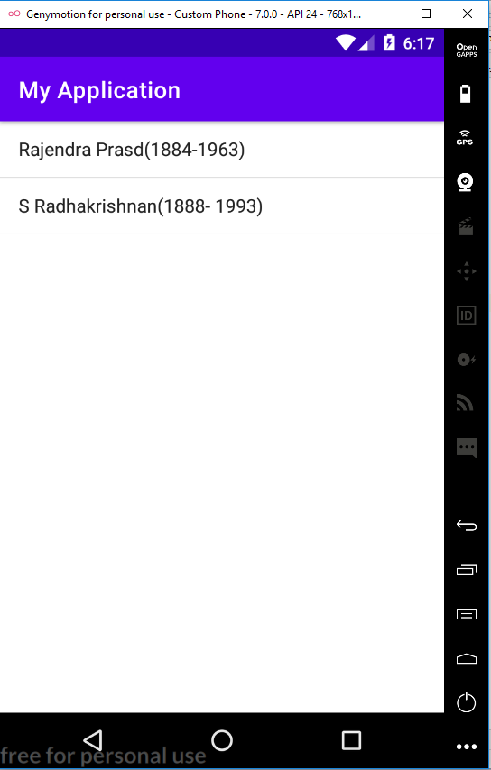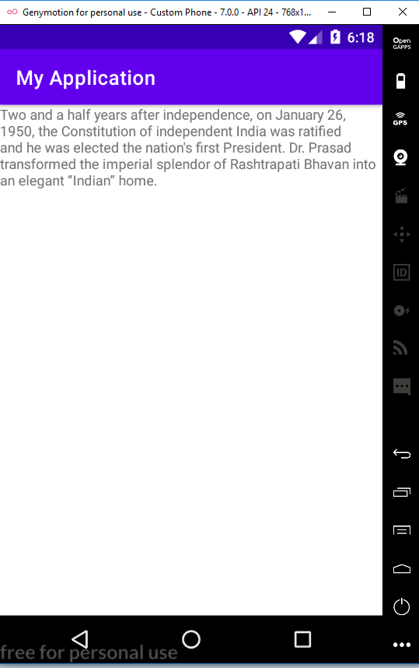

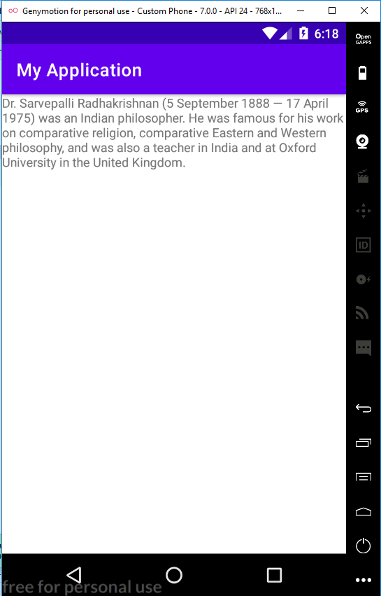

**PROGRAM NO:12 DATE :12-10-22**

**AIM:** Implement and perform exception handling.

**PROGRAM CODE**

Activitymain xml

<?xml version="1.0" encoding="utf-8"?>  
<LinearLayout xmlns:android="http://schemas.android.com/apk/res/android"  
 xmlns:app="http://schemas.android.com/apk/res-auto"  
 xmlns:tools="http://schemas.android.com/tools"  
 android:layout_width="match_parent"  
 android:layout_height="match_parent"  
 tools:context=".MainActivity">  
  
 <TextView  
 android:layout_width="match_parent"  
 android:layout_height="wrap_content"  
 android:id="@+id/tv1"/>  
  
</LinearLayout>

Main activity java

package com.example.myapplication;  
  
import androidx.appcompat.app.AppCompatActivity;  
  
import android.os.Bundle;  
import android.widget.TextView;  
import android.widget.Toast;  
  
public class MainActivity extends AppCompatActivity {  
 TextView tv1;  
 @Override  
 protected void onCreate(Bundle savedInstanceState) {  
 super.onCreate(savedInstanceState);  
 setContentView(R.layout.activity_main);  
 try {  
 tv1.setText ("Welcome");  
 }  
 catch (Exception e) {  
 Toast.makeText(this, e.getMessage(), Toast.LENGTH_LONG).show();  
 }  
 }  
 }

**RESULT:** Program compiled successfully and output verified

**OUTPUT:**

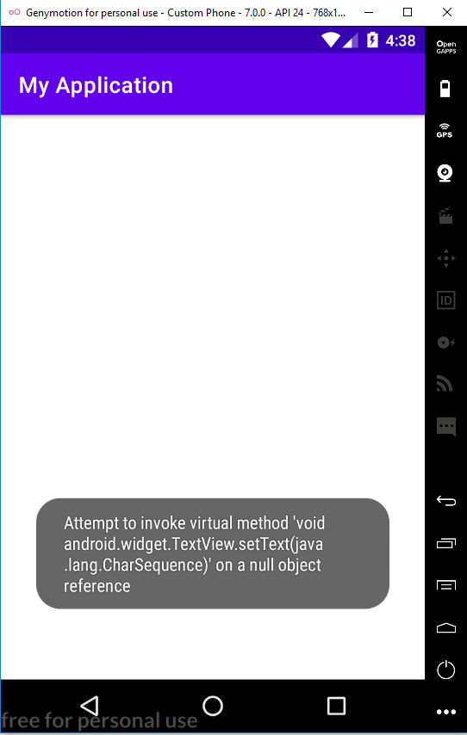

**PROGRAM NO:13 DATE :25-10-22**

**AIM:** Develop an application that use GridView with images and display Toast on selection.

**PROGRAM CODE**

Activitymain xml

<?xml version="1.0" encoding="utf-8"?>  
<GridLayout xmlns:android="http://schemas.android.com/apk/res/android"  
 xmlns:app="http://schemas.android.com/apk/res-auto"  
 xmlns:tools="http://schemas.android.com/tools"  
 android:layout_width="match_parent"  
 android:layout_height="match_parent"  
 tools:context=".MainActivity">  
  
 <ImageView  
 android:layout_width="match_parent"  
 android:layout_height="300dp"  
 android:id="@+id/img1"  
 android:src="@drawable/flower"  
 android:scaleType="centerCrop"  
 android:layout_row="0"  
 android:layout_column="0" />  
 <ImageView  
 android:layout_width="match_parent"  
 android:layout_height="300dp"  
 android:layout_column="0"  
 android:scaleType="centerCrop"  
 android:src="@drawable/lotus"  
 android:id="@+id/img2"  
 android:layout_row="1"/>  
  
</GridLayout>

Main activity java

package com.example.myapplication;  
import androidx.appcompat.app.AppCompatActivity;  
import android.os.Bundle;  
import android.view.View;  
import android.widget.Toast;  
import android.widget.ImageView;  
  
public class MainActivity extends AppCompatActivity {  
 ImageView image1,image2;  
  
 @Override  
 protected void onCreate(Bundle savedInstanceState) {  
 super.onCreate(savedInstanceState);  
 setContentView(R.layout.activity_main);  
 image1=findViewById(R.id.img1);  
 image2=findViewById(R.id.img2);  
 image1.setOnClickListener(new View.OnClickListener() {  
 @Override  
 public void onClick(View view) {  
 Toast.makeText(getApplicationContext(),"flower park",Toast.LENGTH_LONG).show();  
 }  
 });  
 image2.setOnClickListener(new View.OnClickListener() {  
 @Override  
 public void onClick(View view) {  
 Toast.makeText(getApplicationContext(),"Lotus",Toast.LENGTH_LONG).show();  
 }  
 });  
 }  
}

**RESULT:** Program compiled successfully and output verified

**OUTPUT:**

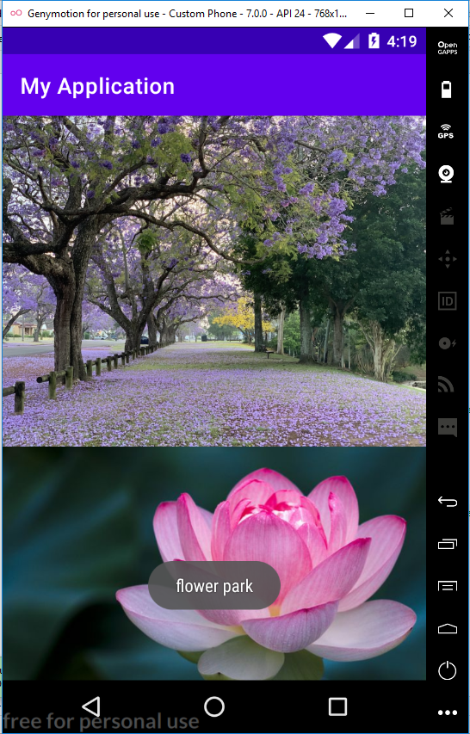

**PROGRAM NO:14 DATE :28-10-22**

**AIM:** Develop an application that implements Spinner component and perform event handling

**PROGRAM CODE**

Activitymain xml

<?xml version="1.0" encoding="utf-8"?>  
<androidx.constraintlayout.widget.ConstraintLayout xmlns:android="http://schemas.android.com/apk/res/android"  
 xmlns:app="http://schemas.android.com/apk/res-auto"  
 xmlns:tools="http://schemas.android.com/tools"  
 android:layout_width="match_parent"  
 android:layout_height="match_parent"  
 tools:context=".MainActivity">  
 <TextView  
 android:layout_width="wrap_content"  
 android:layout_height="wrap_content"  
 android:text="Select your nation:"  
 android:textSize="20dp" />  
 <Spinner  
 android:id="@+id/spinner"  
 android:layout_width="149dp"  
 android:layout_height="40dp"  
 android:layout_marginBottom="8dp"  
 android:layout_marginEnd="8dp"  
 android:layout_marginStart="8dp"  
 android:layout_marginTop="8dp"  
 app:layout_constraintBottom_toBottomOf="parent"  
 app:layout_constraintEnd_toEndOf="parent"  
 app:layout_constraintHorizontal_bias="0.502"  
 app:layout_constraintStart_toStartOf="parent"  
 app:layout_constraintTop_toTopOf="parent"  
 app:layout_constraintVertical_bias="0.498"  
 />  
  
</androidx.constraintlayout.widget.ConstraintLayout>

Main activity java

package com.example.myapplication;  
  
import androidx.appcompat.app.AppCompatActivity;  
  
import android.content.Intent;  
import android.os.Bundle;  
import android.view.View;  
import android.widget.AdapterView;  
import android.widget.ArrayAdapter;  
import android.widget.Spinner;  
import android.widget.Toast;  
  
import com.example.myapplication.R;  
  
public class MainActivity extends AppCompatActivity implements AdapterView.OnItemSelectedListener {  
 String[] country = { "India", "USA", "China", "Japan", "Other"};  
  
 @Override  
 protected void onCreate(Bundle savedInstanceState) {  
 super.onCreate(savedInstanceState);  
 setContentView(R.layout.activity_main);  
  
 Spinner spin = (Spinner) findViewById(R.id.spinner);  
 spin.setOnItemSelectedListener(this);  
  
  
 ArrayAdapter aa = new ArrayAdapter(this,android.R.layout.simple_spinner_item,country);  
 aa.setDropDownViewResource(android.R.layout.simple_spinner_dropdown_item);  
  
 spin.setAdapter(aa);  
  
 }  
  
  
 @Override  
 public void onItemSelected(AdapterView<?> arg0, View arg1, int position, long id) {  
 Toast.makeText(getApplicationContext(),country[position] , Toast.LENGTH_LONG).show();  
  
  
 }  
  
 @Override  
 public void onNothingSelected(AdapterView<?> adapterView) {  
  
 }  
  
}

**RESULT:** Program compiled successfully and output verified

**OUTPUT:**

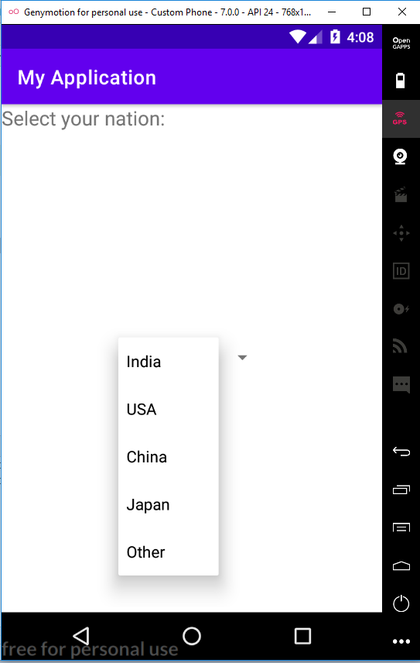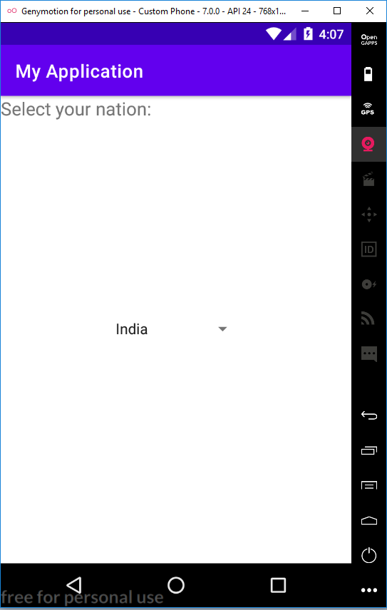

**PROGRAM NO:15 DATE :04-11-22**

**AIM:** Implement Navigation drawer.

**PROGRAM CODE**

Activitymain xml

<androidx.drawerlayout.widget.DrawerLayout  
 xmlns:android="http://schemas.android.com/apk/res/android"  
 xmlns:app="http://schemas.android.com/apk/res-auto"  
 xmlns:tools="http://schemas.android.com/tools"  
 android:id="@+id/my_drawer_layout"  
 android:layout_width="match_parent"  
 android:layout_height="match_parent"  
 tools:context=".MainActivity"  
 tools:ignore="HardcodedText">  
  
 <LinearLayout  
 android:layout_width="match_parent"  
 android:layout_height="match_parent">  
  
 <TextView  
 android:layout_width="match_parent"  
 android:layout_height="wrap_content"  
 android:layout_marginTop="128dp"  
 android:gravity="center"  
 android:text="Welcome to Galaxy"  
 android:textSize="18sp" />  
 </LinearLayout>  
  
 <com.google.android.material.navigation.NavigationView  
 android:layout_width="wrap_content"  
 android:layout_height="match_parent"  
 android:layout_gravity="start"  
 app:menu="@menu/menu" />  
  
</androidx.drawerlayout.widget.DrawerLayout>

Menu.xml

<?xml version="1.0" encoding="utf-8"?>  
<menu xmlns:android="http://schemas.android.com/apk/res/android">  
 <item  
 android:id="@+id/item1"  
 android:title="My Account"/>  
 <item  
 android:id="@+id/item2"  
 android:title="Settings"/>  
 <item  
 android:id="@+id/item3"  
 android:title="Logout"/>  
  
</menu>

String.xml

<resources>  
 <string name="app_name">Navigation Drawer</string>  
 <string name="nav_open">Open</string>  
 <string name="nav_close">Close</string>  
</resources>

Main activity java

package com.example.myapplication;  
  
import androidx.annotation.NonNull;  
import androidx.appcompat.app.ActionBarDrawerToggle;  
import androidx.appcompat.app.AppCompatActivity;  
import androidx.drawerlayout.widget.DrawerLayout;  
  
import android.os.Bundle;  
import android.view.MenuItem;  
  
public class MainActivity extends AppCompatActivity {  
 public DrawerLayout drawerLayout;  
 public ActionBarDrawerToggle actionBarDrawerToggle;  
  
 @Override  
 protected void onCreate(Bundle savedInstanceState) {  
 super.onCreate(savedInstanceState);  
 setContentView(R.layout.activity_main);  
 drawerLayout = findViewById(R.id.my_drawer_layout);  
 actionBarDrawerToggle = new ActionBarDrawerToggle(this, drawerLayout, R.string.nav_open, R.string.nav_close);  
 getSupportActionBar().setDisplayHomeAsUpEnabled(true);  
 }  
 @Override  
 public boolean onOptionsItemSelected(@NonNull MenuItem item){  
 if (actionBarDrawerToggle.onOptionsItemSelected(item)){  
 return true;  
 }  
 return super.onOptionsItemSelected(item);  
  
 }  
}

**RESULT:** Program compiled successfully and output verified

**OUTPUT:**

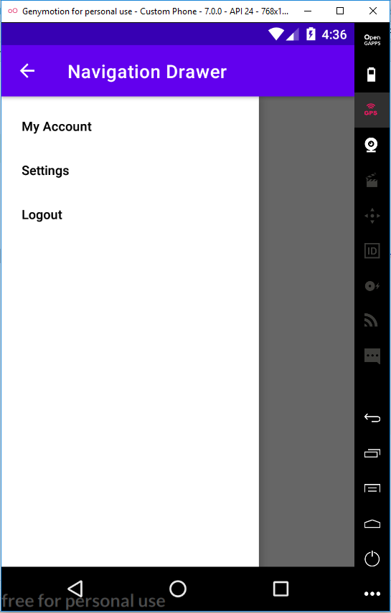

**PROGRAM NO:16 DATE :11-11-22**

**AIM:** Create database using SQLite and perform INSERT, SELECT, UPDATE and DELETE on SQLite database.

**PROGRAM CODE**

Activitymain xml

<?xml version="1.0" encoding="utf-8"?>  
<LinearLayout xmlns:android="http://schemas.android.com/apk/res/android"  
 xmlns:app="http://schemas.android.com/apk/res-auto"  
 xmlns:tools="http://schemas.android.com/tools"  
 android:layout_width="match_parent"  
 android:layout_height="match_parent"  
 android:orientation="vertical"  
 tools:context=".MainActivity">  
  
 <TextView  
 android:layout_width="match_parent"  
 android:layout_height="wrap_content"  
 android:text="Please enter the details below!"  
 android:textSize="30dp" />  
 <EditText  
 android:layout_width="match_parent"  
 android:layout_height="wrap_content"  
 android:hint="Name"  
 android:id="@+id/et1"/>  
 <EditText  
 android:layout_width="match_parent"  
 android:layout_height="wrap_content"  
 android:hint="Contact"  
 android:id="@+id/et2"  
 />  
 <EditText  
 android:layout_width="match_parent"  
 android:layout_height="wrap_content"  
 android:hint="Dob"  
 android:id="@+id/et3"/>  
 <Button  
 android:layout_width="match_parent"  
 android:layout_height="wrap_content"  
 android:text="Insert"  
 android:id="@+id/bt1"/>  
 <Button  
 android:layout_width="match_parent"  
 android:layout_height="wrap_content"  
 android:text="Update"  
 android:id="@+id/bt2"/>  
 <Button  
 android:layout_width="match_parent"  
 android:layout_height="wrap_content"  
 android:text="Delete"  
 android:id="@+id/bt3"  
 />  
 <Button  
 android:layout_width="match_parent"  
 android:layout_height="wrap_content"  
 android:text="View"  
 android:id="@+id/bt4"/>  
  
  
</LinearLayout>

Main activity java

package com.example.myapplication;  
  
import androidx.appcompat.app.AlertDialog;  
import androidx.appcompat.app.AppCompatActivity;  
  
import android.database.Cursor;  
import android.os.Bundle;  
import android.view.View;  
import android.widget.Button;  
import android.widget.EditText;  
import android.widget.Toast;  
  
public class MainActivity extends AppCompatActivity {  
 EditText et1,et2,et3;  
 Button Insert,Update,Delete,View;  
 DBHelper db;  
  
 @Override  
 protected void onCreate(Bundle savedInstanceState) {  
 super.onCreate(savedInstanceState);  
 setContentView(R.layout.activity_main);  
 et1=findViewById(R.id.et1);  
 et2=findViewById(R.id.et2);  
 et3=findViewById(R.id.et3);  
  
 Insert =findViewById(R.id.bt1);  
 Update = findViewById(R.id.bt2);  
 Delete = findViewById(R.id.bt3);  
 View =findViewById(R.id.bt4);  
 db= new DBHelper(this);  
  
  
 Insert.setOnClickListener(new View.OnClickListener() {  
 @Override  
 public void onClick(android.view.View view) {  
 String name= et1.getText().toString();  
 String contact=et2.getText().toString();  
 String dob= et3.getText().toString();  
  
 boolean checkInsertData= db.insertData(name,contact,dob);  
 if(checkInsertData==true)  
 Toast.makeText(MainActivity.this,"New entry inserted",Toast.LENGTH_LONG).show();  
 else  
 Toast.makeText(MainActivity.this,"New entry Not inserted",Toast.LENGTH_LONG).show();  
  
 }  
 });  
  
 Update.setOnClickListener(new View.OnClickListener() {  
 @Override  
 public void onClick(android.view.View view) {  
 String name= et1.getText().toString();  
 String contact=et2.getText().toString();  
 String dob= et3.getText().toString();  
  
 boolean checkUpdateData= db.updateData(name,contact,dob);  
 if(checkUpdateData==true)  
 Toast.makeText(MainActivity.this,"Entry updated",Toast.LENGTH_LONG).show();  
 else  
 Toast.makeText(MainActivity.this,"Entry Not Updated",Toast.LENGTH_LONG).show();  
  
 }  
 });  
 Delete.setOnClickListener(new View.OnClickListener() {  
 @Override  
 public void onClick(android.view.View view) {  
 String name= et1.getText().toString();  
  
  
 boolean checkDeleteData= db.deleteData(name);  
 if(checkDeleteData==true)  
 Toast.makeText(MainActivity.this,"Entry deleted",Toast.LENGTH_LONG).show();  
 else  
 Toast.makeText(MainActivity.this,"Entry Not deleted",Toast.LENGTH_LONG).show();  
  
 }  
 });  
 View.setOnClickListener(new View.OnClickListener() {  
 @Override  
 public void onClick(android.view.View view) {  
 Cursor res = db.getData();  
 if (res.getCount() == 0) {  
 Toast.makeText(MainActivity.this, "No entry exists", Toast.LENGTH_LONG).show();  
 return;  
 }  
 StringBuffer buffer = new StringBuffer();  
 while (res.moveToNext()) {  
 buffer.append("name:" + res.getString(0) + "\n");  
 buffer.append("contact:" + res.getString(1) + "\n");  
 buffer.append("data of birth:" + res.getString(2) + "\n\n\n\n\n");  
 }  
 AlertDialog.Builder builder=new AlertDialog.Builder(MainActivity.this);  
 builder.setCancelable(true);  
 builder.setTitle("User Enteries");  
 builder.setMessage(buffer.toString());  
 builder.show();  
 }  
  
 });  
 }  
  
}

DBHELPER.java

package com.example.myapplication;  
  
import android.content.ContentValues;  
import android.content.Context;  
import android.database.Cursor;  
import android.database.sqlite.SQLiteDatabase;  
import android.database.sqlite.SQLiteOpenHelper;  
  
import androidx.annotation.Nullable;  
  
public class DBHelper extends SQLiteOpenHelper {  
 public DBHelper(@Nullable Context context) {  
 super(context, "userdata.db", null, 1);  
 }  
  
 @Override  
 public void onCreate(SQLiteDatabase DB) {  
 DB.execSQL("create Table userdetails(name TEXT primary key, contact TEXT , dob TEXT)");  
 }  
  
 @Override  
 public void onUpgrade(SQLiteDatabase DB, int i, int i1) {  
 DB.execSQL("drop Table if exists userdetails");  
 }  
  
 public Boolean insertData(String name, String contact, String dob) {  
 SQLiteDatabase DB = this.getWritableDatabase();  
 ContentValues contentValues = new ContentValues();  
 contentValues.put("name", name);  
 contentValues.put("contact", contact);  
 contentValues.put("dob", dob);  
 long result = DB.insert("userdetails", null, contentValues);  
 if (result == -1)  
 return false;  
 else  
 return true;  
 }  
  
  
 public Boolean updateData(String name, String contact, String dob)  
 {  
 SQLiteDatabase DB= this.getWritableDatabase();  
 ContentValues contentValues=new ContentValues();  
 contentValues.put("contact",contact);  
 contentValues.put("dob",dob);  
 Cursor cursor=DB.rawQuery("select * from userdetails where name=?", new String[] {name});  
 if(cursor.getCount()>0) {  
  
 long result = DB.update("userdetails", contentValues, "name=?", new String[]{name});  
 if (result == -1)  
 return false;  
 else  
 return true;  
 }  
 else  
 {  
 return false;  
 }  
 }  
  
  
  
 public Boolean deleteData(String name)  
 {  
 SQLiteDatabase DB= this.getWritableDatabase();  
  
 Cursor cursor=DB.rawQuery("select * from userdetails where name=?", new String[] {name});  
 if(cursor.getCount()>0) {  
  
 long result = DB.delete("userdetails", "name=?", new String[]{name});  
 if (result == -1)  
 return false;  
 else  
 return true;  
 }  
 else  
 {  
 return false;  
 }  
 }  
  
  
 public Cursor getData()  
 {  
 SQLiteDatabase DB= this.getWritableDatabase();  
  
 Cursor cursor=DB.rawQuery("select * from userdetails",null);  
 return cursor;  
 }  
  
  
}

**RESULT:** Program compiled successfully and output verified

**OUTPUT:**

