Hallucination detection for large language models at response, sentence, span and claim level: a structured review of signals, evaluation practice and evidence gaps (2022-2026)
Adithyan C S S (24BCE2820), School of Computer Science and Engineering, Vellore Institute of Technology. Course BCSE306L, Topic 16. Supervisor: Dr. K. Ragavan.

Abstract
Large language models (LLMs) state false facts fluently, and a growing body of work tries to flag those errors automatically. We review 54 primary studies published between 2022 and 2026 that propose, evaluate or benchmark hallucination detectors for text-only LLM output. Studies were identified through a documented search of OpenAlex (4 queries) and the arXiv API (2 queries) on 24 October 2026, plus a prior collection and citation chasing, and were coded in a 31-field extraction matrix and an 8-item quality checklist. We organise the 46 detectors by signal source, supervision, granularity and cost. Attention (13) and sampled consistency (12) are the largest signal families, followed by hidden states (10). The largest group of detectors scores whole responses (22 of 46); only 9 score individual claims, and none of these is a training-free, single-pass attention method. Evaluation practice is the weakest part of the evidence: 13 of 54 (24.1%) report variance or significance tests, 10 of 54 (18.5%) measure compute cost, 15 of 54 (27.8%) test transfer to new data, models or languages, and 6 of 54 (11.1%) evaluate beyond English. Only 7 studies use a protocol that allows direct comparison with others, so we do not rank methods. We derive nine evidence-based gaps, each with counts, and recommend shared claim-level benchmarks, cost reporting relative to generation time, interval estimates and multilingual test sets.
Keywords: hallucination detection; large language models; uncertainty quantification; claim-level verification; attention; evaluation methodology; structured review

1. Introduction
LLMs are now used to answer questions, summarise documents and write long reports. They also produce statements that are fluent but false or unsupported by their sources, usually called hallucinations. A reader cannot tell a correct sentence from a hallucinated one by its style, so automatic detection is needed before LLM output can be trusted in search, medicine, law or education.
Detection research has grown fast. In our included set the number of studies rises from 1 in 2022 and 5 in 2023 to 17 in 2024 and 20 in 2025 (Figure 2). The methods differ in almost every design choice. Some sample the model many times and measure agreement [6, 7, 54]. Some read the model's attention maps or hidden states in a single forward pass [3, 15, 16]. Others call an external verifier or a stronger LLM [22, 30, 41]. They also score different units: a whole answer, a sentence, a token span or an atomic claim. Because each paper picks its own datasets, labels and metrics, the reported numbers are hard to compare.
Existing surveys (Section 2) describe hallucination in general, uncertainty quantification in general, or abstention. None of the five we examined codes each study for granularity, compute cost, transfer testing and reproducibility, or counts how often these are reported. This review does that. It is a structured review with a documented database search; we do not call it a full systematic review because one reviewer screened the records and not every eligible full text was retrieved (Section 4).
The review answers five research questions:
- RQ1. Which signal families are used to detect hallucinations, and how do they divide by supervision, granularity and cost?
- RQ2. Which datasets, labelling procedures and metrics are used, and how comparable are the reported results?
- RQ3. How often do studies measure the compute cost of detection, and what cost classes exist?
- RQ4. How often is generalisation tested across datasets, models and languages?
- RQ5. How reproducible is the evidence, judged by code release, data release and statistical reporting?
The contributions are: (i) a documented search and screening ledger with all counts traceable to a workbook; (ii) a four-axis taxonomy of 46 detectors; (iii) a comparison table of all 54 studies without cross-setting ranking; (iv) counts of evaluation and reproducibility practice; and (v) nine evidence-based gaps with recommended studies. Section 2 compares existing reviews, Section 3 gives background, Section 4 the method, Section 5 the taxonomy, Section 6 the comparative analysis, Section 7 datasets, metrics and evaluation, Section 8 challenges, Section 9 gaps, Section 10 the limitations of this review and Section 11 the answers to the research questions.

2. Related reviews
We compared five recent reviews [55-59] on scope, period, taxonomy, evaluation analysis and missing areas (Table 1). Huang et al. [57] give the broadest account of hallucination, covering causes, detection, benchmarks and mitigation; detection is one section among many. Shorinwa et al. [58] and Geng et al. [59] organise uncertainty and confidence methods into white-box and black-box classes; Geng et al. predate most attention-based and claim-level detectors, which appear from 2024 onward in our set. Wen et al. [55] cover abstention, where detection is one input to a refusal decision. Kang et al. [56] are closest to our topic and run their own experiments on two models, but treat attention methods inside a general internal-state group and leave claim-level detection to future work.
None of the five reports its search strategy or period. None counts how often primary studies report variance, compute cost, transfer or non-English evaluation. This review adds those counts, a granularity axis and a cost axis, and a study-level comparability code.
Table 1. Comparison of existing reviews with this review.
Review | Year | Scope and period | Taxonomy | Evaluation analysis | Missing / what this review adds
R1 Wen et al., Know Your Limits (abstention survey), TACL 2025 (arXiv 2407.18418) | 2025 (TACL; venue from OpenAlex record R0325) | Abstention from 3 views (query, model confidence, human values); lifecycle stages; general-purpose chatbots. Period/search method: NOT STATED | Yes (lifecycle x 3 perspectives) | Surveys benchmarks and metrics; no experiments of its own | Safety refusal dominates; detectors only as probing/uncertainty estimation; no claim/span granularity, no attention family, no comparability or reproducibility audit
R2 Kang et al., UQ for hallucination detection, arXiv 2510.12040 | 2025 (arXiv v1, 14 Oct 2025); preprint | UQ for hallucination detection on open-ended QA (short and long form); excludes agents and mitigation. Period/search method: NOT STATED; method table has 35 methods, newest 2025 | Yes (4 axes: concept, sampling, accessibility, training reliance) | Yes: own experiments, TriviaQA/GSM8K (1,000 each) and FactScore-Bio; LLaMA-3-8B, GPT-4o-mini; AUROC, PRR. Long-form drops; verbalised confidence best | Covers attention methods but inside internal-state group; claim-level only as future work; 2 models; no reproducibility/variance/comparability audit
R3 Huang et al., A Survey on Hallucination in LLMs, ACM TOIS 43(2), DOI 10.1145/3703155 | 2025 (arXiv 2311.05232, 2023) | Hallucination in general LLMs: definitions, causes (data, training, inference), detection, benchmarks, mitigation, RAG limits. Period/search method: NOT STATED | Yes (factuality vs faithfulness; causes x stages) | Benchmark tables (size, language, label, metric); no experiments | Detection is one section; uncertainty/internal-state methods grouped coarsely; no granularity axis, no cost, no reproducibility or comparability audit
R4 Shorinwa et al., Survey on UQ of LLMs, ACM CSUR, DOI 10.1145/3744238 | 2025 (arXiv 2412.05563, 2024) | UQ methods for LLMs incl. token-level, self-verbalised, semantic-similarity, mechanistic; applications incl. robotics. Period/search method: NOT STATED | Yes (4 method classes) | Discusses benchmarks and metrics; no experiments | Claim-level detection and RAG faithfulness covered briefly; no counts of variance/code/data; no cross-paper comparability
R5 Geng et al., Survey of Confidence Estimation and Calibration in LLMs, NAACL 2024, DOI 10.18653/v1/2024.naacl-long.366 | 2024 (arXiv 2311.08298, 2023) | Confidence estimation and calibration for generation and classification; white-box vs black-box. Period/search method: NOT STATED | Yes (white-box logit/internal vs black-box consistency/verbal) | No experiments (authors list this as a limitation) | Pre-dates most attention-based and claim-level work (2024-2026); no hallucination-span granularity; no reproducibility audit

3. Background
We use hallucination for generated content that is false with respect to world knowledge (factuality) or unsupported by a given source such as a retrieved passage (faithfulness) [57]. A detector assigns a score to a unit of output, and the score is compared against labels from humans, an LLM judge, or string matching against a reference answer.
Detectors read one or more signals. Output probabilities are the token probabilities the model assigns while generating; claim-conditioned variants such as CCP [2] adjust them for alternatives with the same meaning. Sampled consistency draws several answers and measures their agreement, often in meaning space, as in semantic entropy [6, 54]. Hidden-state probes train a classifier on intermediate activations [13, 16]. Attention-based methods use the attention weights, for example the share of attention on the source context [15] or on sink tokens [5]. External verifiers decompose an answer into claims and check each claim against a reference with another model [22, 41].
The unit being scored matters. Response-level detectors give one score per answer, which suits short QA. Long answers mix true and false claims, so sentence, span and claim-level detectors try to locate the error [1, 22, 24]. Common metrics are AUROC and PR-AUC for detection, and the prediction-rejection ratio (PRR) for selective generation [28].

4. Review methodology

4.1 Design
The review follows the reporting items of PRISMA 2020 [60] where they apply to a single-reviewer course review. All decisions and counts are recorded in a workbook (Search_Log, Screening_Sheet, PRISMA_Counts, Extraction_Matrix, Quality_Check, Gap_Table), which is submitted with this manuscript.

4.2 Sources and search
We searched OpenAlex [61], an open index of scholarly works that covers ACL Anthology, IEEE, ACM, Springer and arXiv records, and the arXiv API, on 24 October 2026. Scopus and Web of Science were not available to the author through an automatable interface, which we list as a limitation. OpenAlex queries searched title and abstract, from 1 January 2020 to the search date. Table 2 gives the exact strings and record counts. For each OpenAlex query we exported the 200 most relevant records; 739 lower-ranked records were not exported. We added 33 records from other sources: 29 studies collected before the search, one study found by citation chasing (Farquhar et al. [54]), two surveys and one off-topic paper in the prior collection.
Table 2. Search strings as executed and records returned (24 October 2026).
ID | Source | Query | Records
OA1 | OpenAlex | ("hallucination detection" OR "uncertainty quantification" OR "confidence estimation") AND ("large language model" OR LLM) AND (claim OR "fine-grained" OR "long-form" OR "token-level" OR "atomic fact") | 389
OA2 | OpenAlex | (attention OR "attention head" OR "hidden state" OR probe) AND hallucination AND ("large language model" OR LLM) AND detection | 336
OA3 | OpenAlex | (abstention OR "selective generation" OR "selective prediction" OR conformal) AND ("large language model" OR LLM) AND (hallucination OR factuality) | 401
OA4 | OpenAlex | (benchmark OR dataset) AND hallucination AND (claim OR span OR "retrieval-augmented") AND detection AND ("large language model" OR LLM) | 413
AX1 | arXiv | abs:"hallucination detection" AND (abs:claim OR abs:"fine-grained" OR abs:"long-form" OR abs:"token-level") | 132
AX2 | arXiv | abs:hallucination AND (abs:"attention heads" OR abs:"attention maps" OR abs:"hidden states") AND abs:detection | 84
OS1 | Other sources | No query: 29 primary studies already collected, Farquhar et al. 2024 (Nature) from citation chasing, 2 surveys and 1 off-topic paper in papers/ | 33

4.3 Eligibility criteria
Inclusion: a primary study that (a) proposes, evaluates or benchmarks a method that detects, scores or abstains on hallucinated or incorrect content in text generated by an LLM; (b) reports a quantitative evaluation; (c) is published from 2020 onward in English; and (d) is a peer-reviewed paper or an arXiv preprint. Exclusion codes at title and abstract: E1 multimodal, speech or diffusion-model output; E2 secondary study (review, survey, editorial); E3 non-archival grey literature (Zenodo, SSRN, Preprints.org, Research Square and similar); E4 not about detection or uncertainty (mitigation, application or theory only).

4.4 Screening and selection
After merging and removing 303 duplicates by normalised title, 746 records were screened on title and abstract (Figure 1). 319 were excluded (E1 73, E2 32, E3 94, E4 120). Of 427 records eligible for full text, 56 were retrieved and assessed. The other 371 were not retrieved because one reviewer could not read them all; the retrieved set was chosen by relevance rank, peer-review status and coverage of method families that were thin in the prior collection. Two full texts were excluded (one off-topic, one secondary study used in Section 2), leaving 54 included primary studies. Title and abstract decisions were made with keyword rules for E1-E4 and checked by hand; the rules and every decision are in the Screening_Sheet.
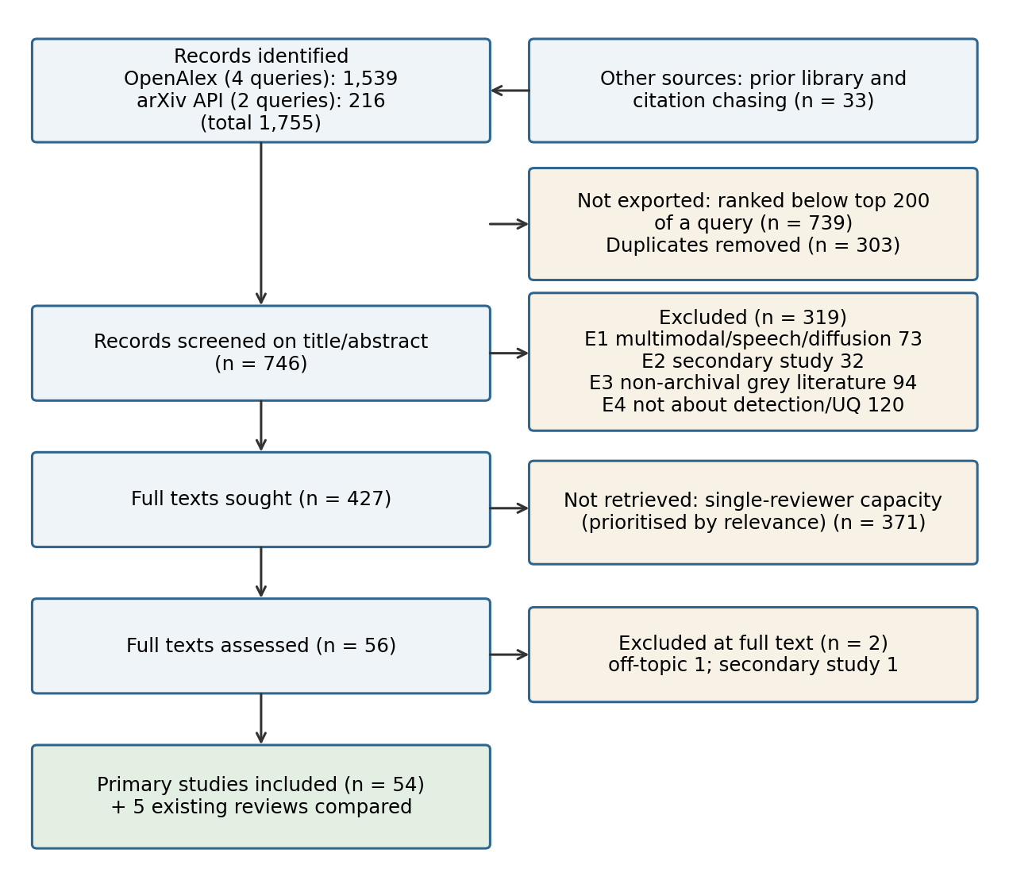
Figure 1. Flow of records through identification, screening and inclusion. All counts come from the PRISMA_Counts sheet of the review workbook.

4.5 Data extraction and quality appraisal
For each study we extracted 31 fields: bibliographic data, task, method family, method details, datasets, baselines, metrics, main result, evaluation setting, robustness testing, code and data availability, variance reporting, author-stated and reviewer-identified limitations, comparability, evidence strength and RQ mapping. Fields not reported were coded N/R. The 29 earlier studies were read in full; the 25 added studies were read from their full-text HTML (abstract, experimental setup, result tables and limitations; appendices were not read). Every DOI was resolved at doi.org on 24 October 2026; studies with no publisher DOI are cited with their arXiv DOI.
Quality was judged with eight questions (Q1 objective, Q2 method, Q3 dataset, Q4 fair baselines, Q5 valid evaluation without leakage, Q6 variance or statistics, Q7 code or data, Q8 limitations). The answers summarise reporting quality; we do not combine them into a score or rank studies by them.
Table 3. Quality appraisal of the 54 included studies (number of studies per answer).
Question | Yes | Partial | No | Not reported
Q1 Objective clear | 54 | 0 | 0 | 0
Q2 Method described | 53 | 1 | 0 | 0
Q3 Dataset described | 48 | 6 | 0 | 0
Q4 Baselines fair | 41 | 12 | 1 | 0
Q5 Evaluation valid | 45 | 8 | 0 | 1
Q6 Variance / statistics | 13 | 2 | 22 | 17
Q7 Code or data available | 42 | 2 | 6 | 4
Q8 Limitations stated | 35 | 7 | 8 | 4

Reporting of objectives, methods and data is good: Q1-Q3 are met by at least 48 of 54 studies. The weak item is Q6: only 13 studies report variance, intervals or significance tests in the main text. Eight studies were rated Partial on Q5, mostly because labels came from the same LLM family that generated the text or because chunk labels were derived from token labels.

5. Taxonomy of hallucination detectors
Of the 54 studies, 46 propose or evaluate a detector. Six are benchmarks or evaluation resources [1, 22, 24, 28, 39, 42] and two are analysis or methodology papers [17, 52]. We classified the detectors on four axes derived from the extraction matrix: signal source, supervision, granularity and cost class (Table 4, Figure 3).
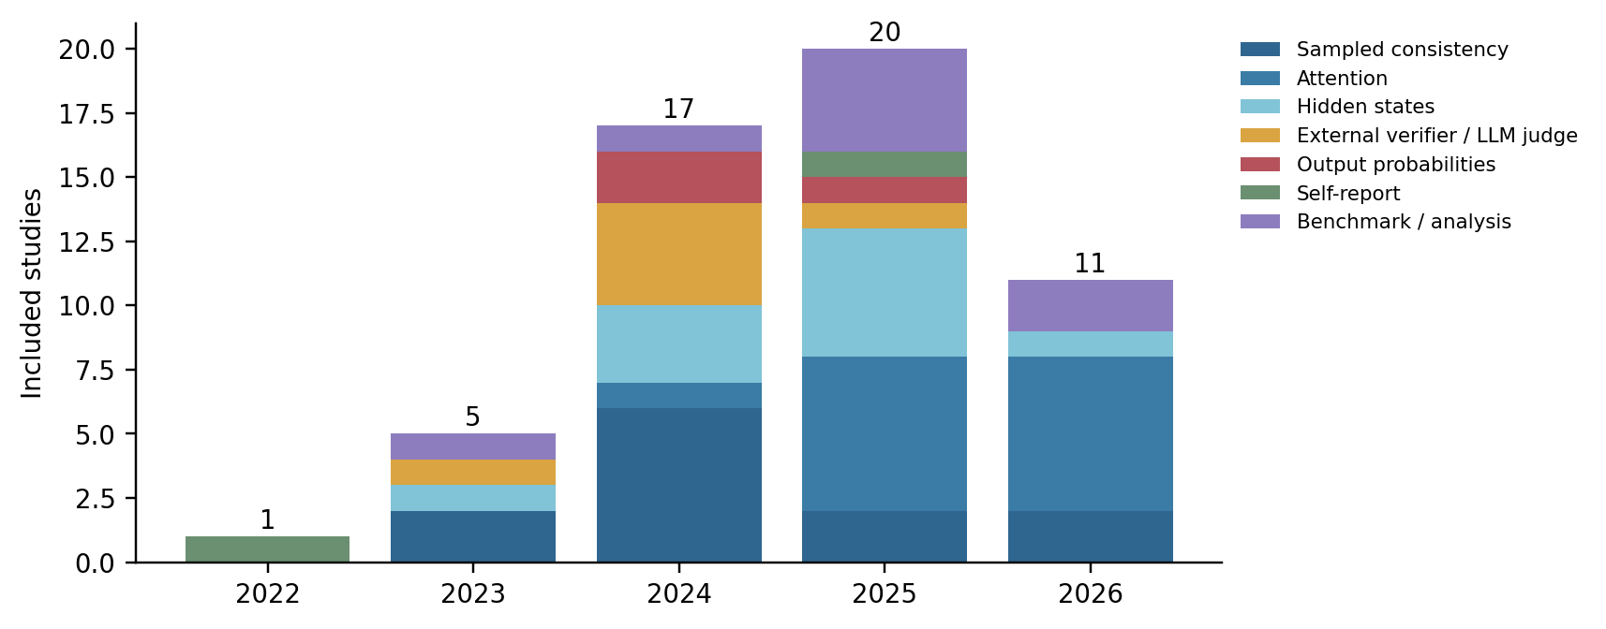
Figure 2. Included studies by publication year and signal source (n = 54).
Table 4. Taxonomy axes and number of detectors per category (n = 46).
Axis | Categories (detectors)
Signal source | Attention 13; Sampled consistency 12; Hidden states 10; External verifier / LLM judge 6; Output probabilities 3; Self-report 2
Supervision | Training-free 21; Supervised 25
Granularity | Response 22; Claim 9; Span / token / entity 8; Sentence 7
Cost class | Single pass 22; Multi-pass 18; External model 5; Single pass + auxiliary model 1

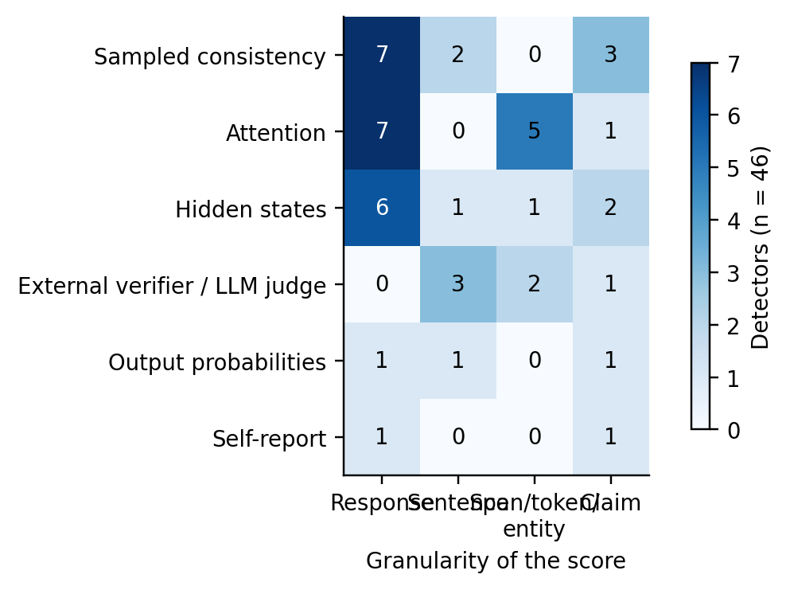
Figure 3. Detectors by signal source and granularity of the score (n = 46).

5.1 Signal source
Attention (13 detectors [3-5, 15, 18, 19, 21, 32-35, 48, 49]) is the largest family in our set and grew fastest: 12 of the 13 appeared in 2025 or 2026. Most attention methods train a probe on attention features such as lookback ratios [15], Laplacian eigenvalues [32], topological divergence [33], sink scores [5] or high-frequency energy [48]. Sampled consistency (12 [6, 7, 10-12, 23, 25, 26, 29, 46, 51, 54]) is the oldest family and is mostly training-free. Hidden-state methods (10 [13, 14, 16, 20, 27, 36, 37, 43, 45, 53]) train probes on activations, with recent work moving from single layer-token pairs to full activation tensors [37] or residual-stream dynamics [36]. External verifiers (6 [30, 38, 40, 41, 44, 47]) are used mainly for RAG and fine-grained checking. Output-probability methods (3) and self-report methods (2) are small groups.

5.2 Supervision
Supervised detectors (25) slightly outnumber training-free ones (21). Among attention methods, 11 of 13 need labelled data, at least to choose heads [33]. Training-free methods are mostly sampling-based. Three studies reduce the label need without removing it: pseudo-labels from uncertainty [53], a small probe set of about 100 examples [33] and multi-LLM training with adapters for new models [37].

5.3 Granularity
Response-level scoring dominates (22 of 46). Nine detectors score claims [2, 4, 25-27, 31, 41, 43, 51], eight score spans, tokens or entities and seven score sentences. Claim-level detectors are either sampling-based [25, 26, 51], supervised on hidden states or attention [4, 27, 43], an external checker [41], calibrated self-report [31], or probability-based with an auxiliary NLI model [2].

5.4 Cost class
Single-pass detectors (22, plus one with an auxiliary model) reuse the forward pass that produced the text. Multi-pass detectors (18) need several extra generations or passes; semantic entropy, for example, uses about ten samples [54]. Five detectors call an external model or LLM verifier. Cost class is not the same as measured cost, which Section 7.3 discusses.

6. Comparative analysis
Table A1 (appendix) lists all 54 studies with author, year, problem, method, dataset, baseline, metrics, main result and limitations. Results are copied as reported by the authors. We coded each study's comparability: 7 use a shared protocol that allows direct comparison with other studies (for example the RAGTruth split [24, 40] or the claim-level protocol of CCP [2, 43]), 42 are comparable only under conditions (same dataset but different models, labels or splits) and 5 are not comparable. For this reason we compare families by design trade-offs and report within-paper comparisons, and we do not build a cross-paper leaderboard.

6.1 Single-pass internal signals versus sampling
Within-paper comparisons repeatedly show that cheap internal-signal probes can match or beat sampling methods on the data they were trained on. Semantic entropy probes recover much of semantic entropy's performance from one forward pass [16]; TOHA reports results competitive with SelfCheckGPT and semantic entropy at much lower cost [33]; LettuceDetect, a 150-400M parameter encoder, reports 79.22% example-level F1 on RAGTruth and processes 30 to 60 examples per second on one GPU [40]. The price is supervision: these detectors need labels for each model, and several authors state that heads or probes do not transfer across architectures [32, 33].

6.2 Attention-based detectors
Attention methods share one idea, that a model that is not reading its context or its earlier answer is more likely to hallucinate [15, 17, 18]. They differ in which statistic they read. Reported gains between them are small. Binkowski et al. [5] report sink-score probes best in 23 of 28 model-dataset pairs, but most gains over Lookback Lens and spectral features are within one standard deviation. Only one attention detector is training-free and single pass [3], and it scores responses. Only one attention detector scores claims [4], and it is supervised.

6.3 Claim-level and fine-grained detection
Fine-grained evaluation changes conclusions. RefChecker reports that checking claim triplets beats response-level checking by about 10 macro-F1 points on the same responses [41]. Zhang et al. find that models that look well calibrated per response are poorly calibrated per atomic claim [31]. HalluEntity shows that token-probability scores over-predict hallucinations at entity level (AUROC about 0.54-0.62) while context-aware scores reach about 0.77-0.78 across 17 LLMs [42]. MUCH [1] and LM-Polygraph [28] are the only harnesses in our set that evaluate claim-level detectors in more than one language under one protocol.

6.4 External verifiers
Verifier pipelines (FActScore [22], FAVA [30], RefChecker [41], ANAH-v2 [38]) can explain which claim is wrong and why, and they work on closed models. They depend on a reference source and on a strong LLM. ANAH-v2 reports that a 7B annotator surpasses GPT-4 on its own test set (F1 89.30 vs 87.11), but the gold labels began as GPT-4 pre-annotations, which the authors note can bias similarity metrics [38].

7. Datasets, metrics and evaluation practice

7.1 Datasets
Short-answer QA sets dominate. TriviaQA is used by 16 studies, followed by biography sets built on FActScore or WikiBio (10), SQuAD (8), Natural Questions (8), maths reasoning (8) and RAGTruth (7) (Figure 4). Long-form factuality sets such as LongFact appear in only 2 studies. Biographies are the main long-form testbed, so long-form evidence is concentrated on one genre.
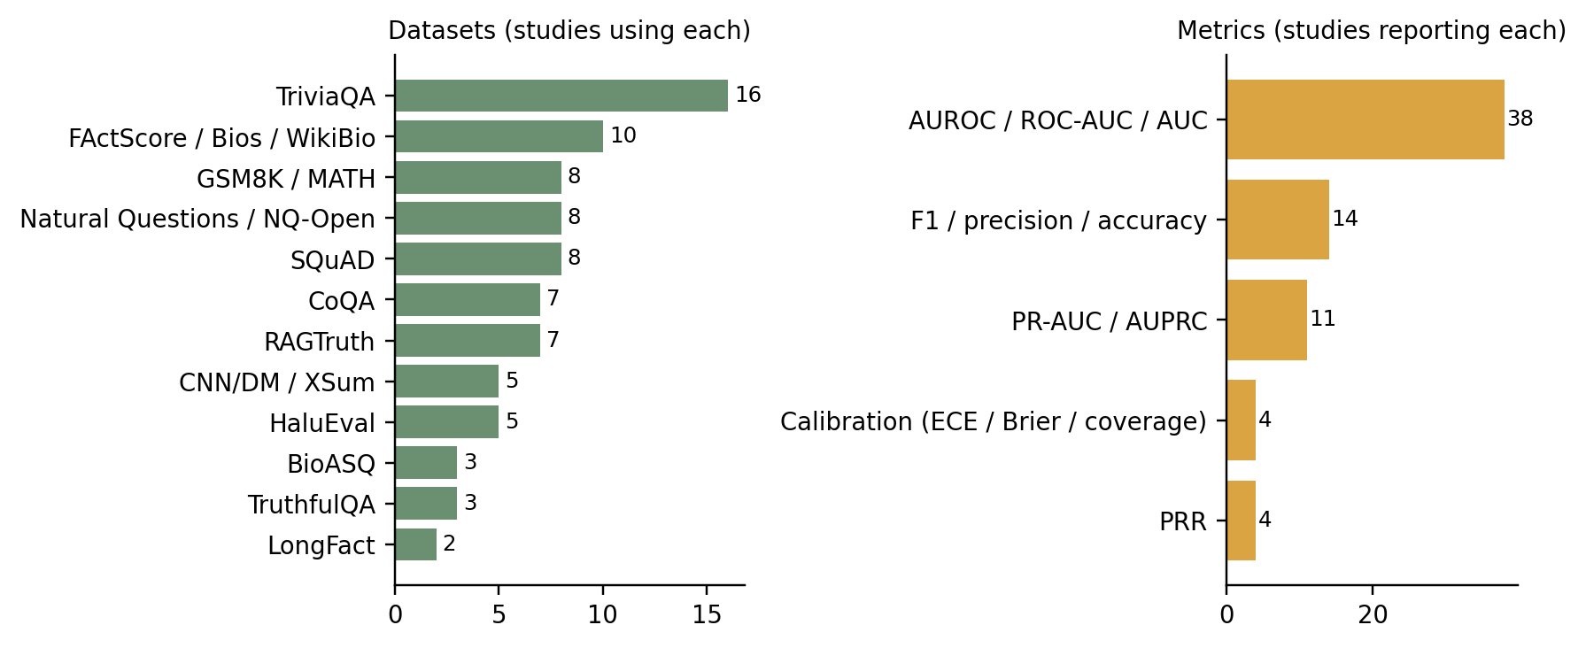
Figure 4. Datasets and metrics used by the included studies (a study can use several).

7.2 Labels and metrics
AUROC is the default metric (38 of 54 studies). PR-AUC is reported by 11, F1, precision or accuracy by 14, PRR by 4 and calibration measures by 4. Labels come from very different sources: substring match with a reference answer [45], ROUGE thresholds [6], human annotation [22, 24, 30] and, in at least 12 studies, GPT-4-class judges or automatic pipelines [1, 2, 4, 5, 15, 20, 28, 31, 32, 34, 38, 39]. At least three studies check judge labels against humans or a second judge [1, 15, 32]. Sanity tests by Zollicoffer et al. show that reasoning-trace detectors can score well by reading answer-level artefacts [52], so label and test design affect the measured skill of a detector.

7.3 Evaluation practice
Figure 5 summarises how the 54 studies report evidence. Code is linked by 41 of 54 (75.9%), but own data is released by only 17 of 54 (31.5%). Variance, intervals or significance tests appear in the main text of 13 of 54 (24.1%). Transfer across datasets, models or languages is tested by 15 of 54 (27.8%). Compute cost (runtime, throughput, FLOPs or overhead against generation) is measured by 10 of 54 (18.5%), although 18 of the 46 detectors need extra generations. Only 6 of 54 (11.1%) evaluate beyond English.
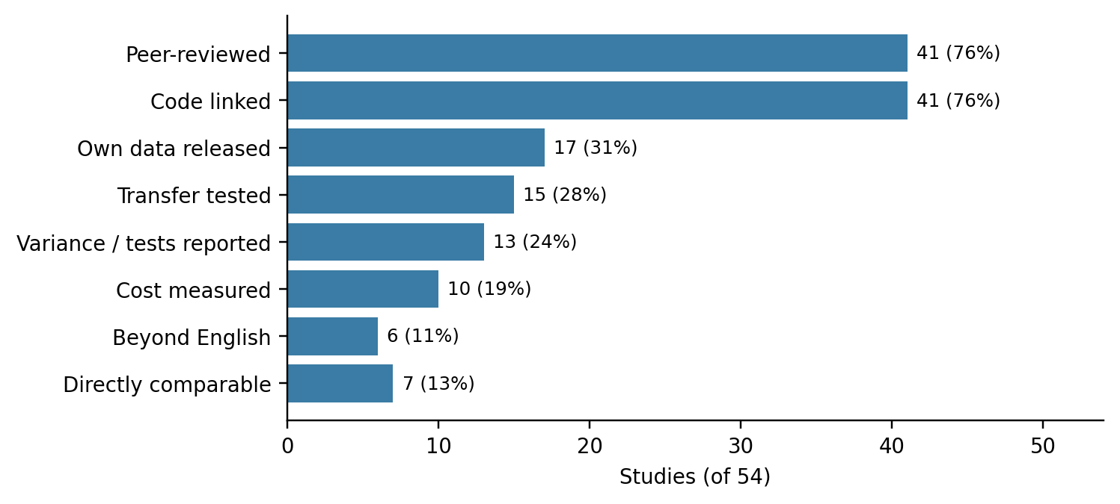
Figure 5. Evaluation and reproducibility indicators across the 54 included studies.

8. Challenges
Access. Single-pass internal-signal detectors need open weights and, for attention methods, eager attention, which is slower than fused kernels [5]. Closed models allow only sampling or external verifiers.
Labels. Supervised probes need labelled hallucinations for each model and task. When labels come from an LLM judge, detectors may learn the judge's errors [32, 39].
Cost. Sampling methods multiply generation cost, and external verifiers add calls to large models [46]. Few studies measure the overhead on stated hardware, so deployment cost cannot be compared.
Granularity mismatch. A detector trained on response labels is often applied to long answers that mix true and false claims. Claim decomposition and alignment between claims and tokens add error of their own [1, 41].
Comparability. Different datasets, models, label sources, splits and metrics mean that a 0.02 AUROC difference reported in one paper says little about the same pair of methods in another setting.

9. Research gaps and future directions
Table 5 lists the gaps. Each is supported by counts from the extraction matrix and comes with a recommended study. Strong means the pattern holds across many studies; Moderate means it depends partly on our coding.
Table 5. Evidence-based research gaps (counts from the review workbook).
ID | Gap | Evidence (n of N, study IDs) | Why it matters | Recommended study | Strength
G1 | Claim-level detection is rare among detectors | 9 of 46 (19.6%) method papers score at claim/atomic-fact level (S02, S04, S25, S26, S27, S31, S41, S43, S51); 22 score whole responses, 7 sentences, 8 spans/tokens/entities | One false claim in a long answer is rejected or accepted as a whole; users cannot see what to check | Re-evaluate response-level methods on a claim-level benchmark (MUCH, S01; LM-Polygraph claim tasks, S28) under one protocol | Strong
G2 | No training-free, single-pass, attention-based detector works at claim level | Attention-based detectors: 13 of 46 (S03, S04, S05, S15, S18, S19, S21, S32, S33, S34, S35, S48, S49); training-free among them: S03, S35 (S35 needs 3 passes); claim-level: S04 (supervised). Training-free single-pass detectors overall: 4 (S02, S03, S50, S53) | Sampling costs several extra generations; supervised heads/probes need labels per model | Test a label-free attention score at claim level against CCP (S02) and UHeads (S04) on MUCH | Moderate
G3 | Compute cost is rarely measured | 10 of 54 (18.5%) report runtime, throughput, FLOPs or overhead (S01, S03, S09, S16, S27, S32, S33, S35, S40, S46); 18 of 46 detectors need several generations or passes, 5 need an external model or LLM verifier | Deployment needs overhead relative to generation; MUCH (S01) shows large differences on one GPU | Report overhead as % of generation time per token on stated hardware for every method | Moderate
G4 | Transfer across domains, models or languages is seldom tested | 15 of 54 (27.8%) test cross-dataset, cross-model, cross-language or cross-generator transfer (S04, S08, S15, S16, S20, S27, S32, S33, S34, S36, S37, S38, S39, S43, S54) | Supervised probes are strongest in-domain but need labels for every new setting | Train on one benchmark, test on another with the same protocol; report in-domain vs zero-shot side by side | Strong
G5 | Statistical uncertainty of results is seldom reported | 13 of 54 (24.1%) report SD, intervals or significance tests in the main text (S02, S05, S10, S11, S13, S20, S21, S27, S28, S32, S33, S49, S54) | Many reported gains are 0.01-0.03 AUROC; without intervals they cannot be interpreted (e.g., S05 gains within one SD) | Bootstrap intervals by generation and paired deltas against each baseline | Strong
G6 | Data release lags code release | Code linked: 41 of 54 (75.9%); own data released: 17 of 54 (31.5%) (S01, S04, S06, S07, S13, S20, S24, S25, S26, S30, S38, S39, S40, S41, S42, S48, S54) | Supervised methods cannot be reproduced without their training labels | Release claim-level labels and extracted features with code | Moderate
G7 | No shared protocol, so results cannot be ranked across papers | Comparability: Direct 7, Conditional 42, Non-comparable 5 of 54. Metrics: AUROC / ROC-AUC / AUC 38; PR-AUC / AUPRC 11; PRR 4; F1 / precision / accuracy 14; Calibration (ECE / Brier / coverage) 4 | Leaderboards built from mixed tables mislead readers | Adopt shared harnesses (MUCH S01, LM-Polygraph S28, RAGTruth S24) and re-run published methods | Strong
G8 | Evaluation is almost entirely English | 6 of 54 (11.1%) evaluate beyond English (S01, S02, S04, S28, S39, S50) | Deployed LLMs are multilingual; error rates differ by language (S02, S28) | Evaluate on multilingual claim/span sets (MUCH, PsiloQA S39) including non-European languages | Strong
G9 | Labels are mostly produced by LLM judges | Studies whose labels come from GPT-4-class judges or automatic pipelines (S01 train, S02, S04, S05, S15, S20, S28, S31, S32, S34, S38, S39): 12 of 54 | Detector scores may track the judge's errors, not truth; S52 shows detectors can exploit artefacts | Report judge-human agreement and evaluate on human-labelled test splits | Moderate

Three directions follow from the gaps. First, claim-level evaluation of cheap detectors: G1 and G2 show that the detectors with the lowest cost score whole responses, while claim-level detectors are supervised or need sampling. A training-free, single-pass claim-level detector, evaluated on MUCH [1] against CCP [2] and UHeads [4], would test whether this trade-off is necessary. Second, shared reporting: overhead as a percentage of generation time, bootstrap intervals with paired differences, and judge-human agreement (G3, G5, G9). Third, transfer and language coverage: train on one benchmark and test zero-shot on another, and include non-English sets such as MUCH and PsiloQA [39] (G4, G8).

10. Limitations of this review
One reviewer screened and extracted all records; decisions marked AI-assisted in the workbook were made with tool support and need confirmation by a second reader. Scopus and Web of Science were not searched. Only the top 200 records per OpenAlex query were exported, and 371 eligible records were not retrieved in full text, so the included set is a prioritised sample of the eligible literature and the counts describe that sample. The 25 studies added from the search were read from their main text without appendices, so some variance or cost reporting in appendices may be missed; the counts in Section 7.3 are therefore lower bounds for those items. Taxonomy codes (signal source, granularity, cost class) are our own judgments from method descriptions. 13 of 54 studies are preprints. Finally, the author develops a claim-level attention detector as a separate course project; that work is not among the included studies, and gap G2 was derived from the counts, not from that project.

11. Conclusion
RQ1. Six signal families appear across 46 detectors. Attention (13) and sampled consistency (12) are the largest, followed by hidden states (10). Supervised (25) and training-free (21) detectors are close in number, and 22 of 46 score whole responses.
RQ2. Short-answer QA (TriviaQA in 16 studies) and biographies dominate, AUROC is reported by 38 of 54, and labels often come from LLM judges. Only 7 of 54 studies are directly comparable with others, so results should not be ranked across papers.
RQ3. 18 detectors need several passes and 5 need an external model, but only 10 of 54 (18.5%) measure cost.
RQ4. Transfer is tested by 15 of 54 (27.8%) and non-English evaluation by 6 of 54 (11.1%). Where transfer is tested, supervised probes lose accuracy outside their training data [43], while multi-LLM training helps [37].
RQ5. Code is often released (41 of 54 (75.9%)), data less often (17 of 54 (31.5%)), and statistical uncertainty is rarely reported (13 of 54 (24.1%)).
The field has many detectors but weak common evidence. Shared claim-level benchmarks, cost reported against generation time, interval estimates and multilingual test sets would make the next round of results comparable.

References
[1] Dentan, J., Canesse, A., Buscaldi, D., et al. (2026). MUCH: A multilingual claim hallucination benchmark. In Proc. LREC 2026. arXiv:2511.17081. https://doi.org/10.48550/arXiv.2511.17081
[2] Fadeeva, E., et al. (2024). Fact-checking the output of large language models via token-level uncertainty quantification. In Findings of ACL 2024. https://doi.org/10.18653/v1/2024.findings-acl.558
[3] Vazhentsev, A., Rvanova, L., Kuzmin, G., et al. (2026). Efficient hallucination detection for LLMs using uncertainty-aware attention heads. In Proc. ICML 2026 (PMLR 306). https://doi.org/10.48550/arXiv.2505.20045
[4] Shelmanov, A., et al. (2025). A head to predict and a head to question: Pre-trained uncertainty quantification heads for hallucination detection in LLM outputs. In Proc. EMNLP 2025. https://doi.org/10.18653/v1/2025.emnlp-main.1809
[5] Binkowski, J., Adamczewski, K., & Kajdanowicz, T. (2026). Attention sinks as internal signals for hallucination detection in large language models. In Proc. ICML 2026 (PMLR 306). https://doi.org/10.48550/arXiv.2604.10697
[6] Kuhn, L., Gal, Y., & Farquhar, S. (2023). Semantic uncertainty: Linguistic invariances for uncertainty estimation in natural language generation. In Proc. ICLR 2023. https://doi.org/10.48550/arXiv.2302.09664
[7] Manakul, P., Liusie, A., & Gales, M. J. F. (2023). SelfCheckGPT: Zero-resource black-box hallucination detection for generative large language models. In Proc. EMNLP 2023. https://doi.org/10.18653/v1/2023.emnlp-main.557
[8] Kadavath, S., Conerly, T., Askell, A., et al. (2022). Language models (mostly) know what they know. arXiv preprint. https://doi.org/10.48550/arXiv.2207.05221
[9] Duan, J., Cheng, H., Wang, S., et al. (2024). Shifting attention to relevance: Towards the predictive uncertainty quantification of free-form large language models. In Proc. ACL 2024. https://doi.org/10.18653/v1/2024.acl-long.276
[10] Nikitin, A., Kossen, J., Gal, Y., & Marttinen, P. (2024). Kernel language entropy: Fine-grained uncertainty quantification for LLMs from semantic similarities. In Advances in NeurIPS 37. https://doi.org/10.52202/079017-0283
[11] Qiu, X., & Miikkulainen, R. (2024). Semantic density: Uncertainty quantification for large language models through confidence measurement in semantic space. In Advances in NeurIPS 37. https://doi.org/10.52202/079017-4274
[12] Vashurin, R., Goloburda, M., Ilina, A., et al. (2025). Uncertainty quantification for LLMs through minimum Bayes risk: Bridging confidence and consistency. In Proc. NeurIPS 2025. https://doi.org/10.48550/arXiv.2502.04964
[13] Azaria, A., & Mitchell, T. (2023). The internal state of an LLM knows when it's lying. In Findings of EMNLP 2023. https://doi.org/10.18653/v1/2023.findings-emnlp.68
[14] Chen, C., Liu, K., Chen, Z., et al. (2024). INSIDE: LLMs' internal states retain the power of hallucination detection. In Proc. ICLR 2024. https://doi.org/10.48550/arXiv.2402.03744
[15] Chuang, Y.-S., Qiu, L., Hsieh, C.-Y., et al. (2024). Lookback Lens: Detecting and mitigating contextual hallucinations in large language models using only attention maps. In Proc. EMNLP 2024. https://doi.org/10.18653/v1/2024.emnlp-main.84
[16] Kossen, J., Han, J., Razzak, M., et al. (2024). Semantic entropy probes: Robust and cheap hallucination detection in LLMs. arXiv preprint. https://doi.org/10.48550/arXiv.2406.15927
[17] Wu, W., Wang, Y., Xiao, G., Peng, H., & Fu, Y. (2025). Retrieval head mechanistically explains long-context factuality. In Proc. ICLR 2025. https://doi.org/10.48550/arXiv.2404.15574
[18] Sun, Z., Zang, X., Zheng, K., et al. (2025). ReDeEP: Detecting hallucination in retrieval-augmented generation via mechanistic interpretability. In Proc. ICLR 2025. https://doi.org/10.48550/arXiv.2410.11414
[19] Ogasa, Y., & Arase, Y. (2025). Hallucinated span detection with multi-view attention features. arXiv preprint. https://doi.org/10.48550/arXiv.2504.04335
[20] Obeso, O., Arditi, A., Ferrando, J., et al. (2026). Real-time detection of hallucinated entities in long-form generation. arXiv preprint. https://doi.org/10.48550/arXiv.2509.03531
[21] van Dijk, G. (2026). Detecting hallucinations in large language models via internal attention divergence signals. arXiv preprint. https://doi.org/10.48550/arXiv.2605.05025
[22] Min, S., Krishna, K., Lyu, X., et al. (2023). FActScore: Fine-grained atomic evaluation of factual precision in long form text generation. In Proc. EMNLP 2023. https://doi.org/10.18653/v1/2023.emnlp-main.741
[23] Zhang, C., et al. (2024). LUQ: Long-text uncertainty quantification for LLMs. In Proc. EMNLP 2024. https://doi.org/10.18653/v1/2024.emnlp-main.299
[24] Niu, C., Wu, Y., Zhu, J., et al. (2024). RAGTruth: A hallucination corpus for developing trustworthy retrieval-augmented language models. In Proc. ACL 2024. https://doi.org/10.18653/v1/2024.acl-long.585
[25] Bouchard, D., Chauhan, M. S., Bajaj, V., et al. (2026). Fine-grained uncertainty quantification for long-form language model outputs: A comparative study. Transactions on Machine Learning Research. https://doi.org/10.48550/arXiv.2602.17431
[26] Sawczyn, A., et al. (2026). FactSelfCheck: Fact-level black-box hallucination detection for LLMs. In Findings of EACL 2026. https://doi.org/10.18653/v1/2026.findings-eacl.296
[27] Han, J., et al. (2025). Simple factuality probes detect hallucinations in long-form natural language generation. In Findings of EMNLP 2025. https://doi.org/10.18653/v1/2025.findings-emnlp.880
[28] Vashurin, R., et al. (2025). Benchmarking uncertainty quantification methods for large language models with LM-Polygraph. Transactions of the ACL, 13. https://doi.org/10.1162/tacl_a_00737
[29] Abbasi-Yadkori, Y., Kuzborskij, I., Stutz, D., et al. (2024). Mitigating LLM hallucinations via conformal abstention. arXiv preprint. https://doi.org/10.48550/arXiv.2405.01563
[30] Mishra, A., Asai, A., et al. (2024). Fine-grained hallucination detection and editing for language models. In Proc. COLM 2024. https://doi.org/10.48550/arXiv.2401.06855
[31] Zhang, C., Yang, R., Zhang, Z., et al. (2025). Atomic calibration of LLMs in long-form generations. In Findings of IJCNLP-AACL 2025. https://doi.org/10.18653/v1/2025.findings-ijcnlp.9
[32] Binkowski, J., Janiak, D., Sawczyn, A., Gabrys, B., & Kajdanowicz, T. (2025). Hallucination detection in LLMs using spectral features of attention maps. In Proc. EMNLP 2025. https://doi.org/10.18653/v1/2025.emnlp-main.1239
[33] Bazarova, A., Volodichev, A., et al. (2026). Hallucination detection in LLMs with topological divergence on attention graphs. In Proc. ACL 2026. https://doi.org/10.18653/v1/2026.acl-long.704
[34] Matys, P., Eliasz, J., et al. (2025). AggTruth: Contextual hallucination detection using aggregated attention scores in LLMs. In Computational Science, ICCS 2025 (LNCS). Springer. https://doi.org/10.1007/978-3-031-97570-7_18
[35] Liu, Q., Chen, X., et al. (2025). Attention-guided self-reflection for zero-shot hallucination detection in large language models. In Proc. EMNLP 2025. https://doi.org/10.18653/v1/2025.emnlp-main.1063
[36] Zhang, Z., Hu, X., et al. (2025). ICR Probe: Tracking hidden state dynamics for reliable hallucination detection in LLMs. In Proc. ACL 2025. https://doi.org/10.18653/v1/2025.acl-long.880
[37] Bar-Shalom, G., Frasca, F., et al. (2025). Beyond token probes: Hallucination detection via activation tensors with ACT-ViT. In Advances in NeurIPS 38. https://doi.org/10.52202/085713-2865
[38] Gu, Y., Ji, Z., et al. (2024). ANAH-v2: Scaling analytical hallucination annotation of large language models. In Advances in NeurIPS 37. https://doi.org/10.52202/079017-1916
[39] Rykov, E., Petrushina, K., et al. (2025). When models lie, we learn: Multilingual span-level hallucination detection with PsiloQA. In Findings of EMNLP 2025. https://doi.org/10.18653/v1/2025.findings-emnlp.626
[40] Kovacs, A., & Recski, G. (2025). LettuceDetect: A hallucination detection framework for RAG applications. arXiv preprint. https://doi.org/10.48550/arXiv.2502.17125
[41] Hu, X., Ru, D., et al. (2024). RefChecker: Reference-based fine-grained hallucination checker and benchmark for large language models. arXiv preprint. https://doi.org/10.48550/arXiv.2405.14486
[42] Yeh, M.-H., Kamachee, M., et al. (2025). HalluEntity: Benchmarking and understanding entity-level hallucination detection. Transactions on Machine Learning Research. arXiv:2502.11948
[43] Vazhentsev, A., Rvanova, L., et al. (2025). Token-level density-based uncertainty quantification methods for eliciting truthfulness of large language models. In Proc. NAACL 2025. https://doi.org/10.18653/v1/2025.naacl-long.113
[44] Choi, S., Fang, T., et al. (2023). KCTS: Knowledge-constrained tree search decoding with token-level hallucination detection. In Proc. EMNLP 2023. https://doi.org/10.18653/v1/2023.emnlp-main.867
[45] Snyder, B., Moisescu, M., et al. (2024). On early detection of hallucinations in factual question answering. In Proc. KDD 2024. https://doi.org/10.1145/3637528.3671796
[46] Goel, A., Schwartz, D., et al. (2025). Zero-knowledge LLM hallucination detection and mitigation through fine-grained cross-model consistency. In Proc. EMNLP 2025 (Industry Track). https://doi.org/10.18653/v1/2025.emnlp-industry.139
[47] Zimmerman, I., Tredup, J., et al. (2024). Two-tiered encoder-based hallucination detection for retrieval-augmented generation in the wild. In Proc. EMNLP 2024 (Industry Track). https://doi.org/10.18653/v1/2024.emnlp-industry.2
[48] Qi, S., et al. (2026). Detecting contextual hallucinations in LLMs with frequency-aware attention. arXiv preprint. https://doi.org/10.48550/arXiv.2602.18145
[49] More, S., & Pawar, T. S. (2026). Attention dispersion as a diagnostic signal for hallucination in large language models. arXiv preprint arXiv:2609.18320
[50] Chen, K., Chen, Q., et al. (2025). Enhancing uncertainty modeling with semantic graph for hallucination detection. In Proc. AAAI 2025. https://doi.org/10.1609/aaai.v39i22.34528
[51] Liu, T., & Wu, Z. S. (2024). Multi-group uncertainty quantification for long-form text generation. arXiv preprint. https://doi.org/10.48550/arXiv.2407.21057
[52] Zollicoffer, G., Vu, M. N., et al. (2026). Sanity checks for long-form hallucination detection. arXiv preprint. https://doi.org/10.48550/arXiv.2605.08346
[53] Srey, P., Wu, X., et al. (2025). Unsupervised hallucination detection by inspecting reasoning processes. In Proc. EMNLP 2025. https://doi.org/10.18653/v1/2025.emnlp-main.1124
[54] Farquhar, S., Kossen, J., Kuhn, L., & Gal, Y. (2024). Detecting hallucinations in large language models using semantic entropy. Nature, 630, 625-630. https://doi.org/10.1038/s41586-024-07421-0
[55] Wen, B., Yao, J., Feng, S., et al. (2025). Know your limits: A survey of abstention in large language models. Transactions of the ACL. arXiv:2407.18418
[56] Kang, S., Bakman, Y. F., Yaldiz, D. N., et al. (2025). Uncertainty quantification for hallucination detection in large language models: Foundations, methodology, and future directions. arXiv preprint arXiv:2510.12040
[57] Huang, L., Yu, W., et al. (2025). A survey on hallucination in large language models: Principles, taxonomy, challenges, and open questions. ACM Transactions on Information Systems, 43(2). https://doi.org/10.1145/3703155
[58] Shorinwa, O., Mei, Z., et al. (2025). A survey on uncertainty quantification of large language models: Taxonomy, open research challenges, and future directions. ACM Computing Surveys. https://doi.org/10.1145/3744238
[59] Geng, J., Cai, F., et al. (2024). A survey of confidence estimation and calibration in large language models. In Proc. NAACL 2024. https://doi.org/10.18653/v1/2024.naacl-long.366
[60] Page, M. J., McKenzie, J. E., Bossuyt, P. M., et al. (2021). The PRISMA 2020 statement: An updated guideline for reporting systematic reviews. BMJ, 372, n71. https://doi.org/10.1136/bmj.n71
[61] Priem, J., Piwowar, H., & Orr, R. (2022). OpenAlex: A fully-open index of scholarly works, authors, venues, institutions, and concepts. arXiv preprint. https://doi.org/10.48550/arXiv.2205.01833

Appendix A. Comparison table of the included studies
Results are as reported by the authors under each study's own setting; they are not comparable across rows unless the Comparability column of the workbook says Direct.
Table A1. Comparison of the 54 included studies.
Author | Year | Problem | Method | Dataset | Baseline | Metrics | Results (as reported) | Limitations (author-stated)
Dentan, J. et al. [1] | 2026 | Claim-level UQ benchmark for long-form QA, 4 languages (en/fr/es/de) | Benchmark / evaluation resource: Releases 24 logits per token plus a deterministic claim segmenter (much_segmenter, ~0.2% of generation time) (see workbook) | MUCH: 4,873 samples, 4 LLMs (Llama-3.2-3B, Llama-3.1-8B, Ministral-8B, Gemma-3-4B); train split auto-annotated (see workbook) | CCP, SAR, Max Likelihood and other token-probability baselines | ROC-AUC, PR-AUC, runtime overhead vs generation time | CCP 0.772 ROC / 0.639 PR at 124% overhead; SAR 0.746 / 0.603 at 22.4% overhead | Only four European languages (author-stated)
Fadeeva, E. et al. [2] | 2024 | Claim-level fact-checking via token-level UQ; biography generation | Token-probability / logit-based UQ: Claim-Conditioned Probability (CCP): uses an NLI model (DeBERTa-large-MNLI) over top-k alternatives at each token to remove (see workbook) | Biography generation, 7 LLMs, 4 languages; automatic claim annotation | Max probability, token entropy, P(True) and other UQ baselines | ROC-AUC, PR-AUC | CCP best for every LLM except PR-AUC on GPT-3.5-turbo (P(True) higher); largest gain Jais-13b: +0.07 ROC, +0.09 PR over closest competitor | Has a Limitations section (read to quote)
Vazhentsev, A. et al. [3] | 2026 | Sequence-level hallucination detection, white-box LLMs (QA, summarisation, translation) | Attention-based (unsupervised): RAUQ: detects 'uncertainty-aware' attention heads that reduce focus on preceding tokens when output is wrong (see workbook) | 12 datasets across QA, summarisation, translation; 9 LLMs | State-of-the-art UQ baselines | PRR | Consistently outperforms UQ baselines; <1% overhead (author claim) | No dedicated limitation section seen; future work: extend to black-box LLMs, improve calibration, other error types
Shelmanov, A. et al. [4] | 2025 | Claim-level hallucination detection in long-form output | Attention-based (supervised): Pre-trained UQ heads: small Transformer modules fed with features from LLM attention maps, trained once per base LLM (see workbook) | Multi-domain training set: 800 texts, 18,852 claims, Mistral-7B-Instruct-v0.2 (as stated in text) | Unsupervised UQ methods (e.g. token probability, CCP-style) | PR-AUC, unsupported claims positive | Mistral-7B-Instruct-v0.2, biographies (in-domain): UHead 0.66 vs CCP 0.50, Factoscope 0.61, Lookback lens 0.56, SAPLMA 0.54 (see workbook) | Cannot help if the LLM was trained to give misinformation; works best in-domain; LLM biases can transfer (see workbook)
Binkowski, J. et al. [5] | 2026 | Hallucination detection via attention maps (QA, summarisation, decision support) | Attention-based (supervised): SinkProbe: classifier on attention-sink scores (see workbook) | 7 benchmarks: GSM8K, UMWP, TruthfulQA, TriviaQA, NQ-Open, SQuADv2, HaluEvalQA; 4 LLMs (Llama3.2-3B, Phi3.5-4B, Llama3.1-8B (see workbook) | Prior attention-based detectors (e.g. Lookback Lens, topological divergence) | ROC-AUC, mean ± SD over 5-fold cross-validation | Best in 23 of 28 model-dataset pairs (authors). Example Llama3.2-3B: GSM8K 0.845±0.017 vs LookbackLens 0.835±0.017; TruthfulQA 0.785±0.059 (see workbook) | Needs attention weights (open-weight models only); efficient deployment needs a specialised kernel (see workbook)
Kuhn, L. et al. [6] | 2023 | UQ for free-form natural language generation (QA) | Sampling / consistency-based UQ: Semantic entropy: cluster sampled answers by bidirectional entailment and compute entropy over meanings rather than token seque (see workbook) | CoQA (dev split, about 8,000 questions) and TriviaQA (8,000-question subset of train); OPT 2.7B-30B (headline 30B) (see workbook) | Length-normalised entropy, lexical-similarity and other baselines | AUROC | Semantic entropy AUROC 0.77 (CoQA) and 0.83 (TriviaQA) at 30B vs 0.66 / 0.79 for number of distinct answers; beats predictive entropy (see workbook) | Does not protect against deception; focused on QA (summarisation needs better paraphrase detection)
Manakul, P. et al. [7] | 2023 | Sentence-level hallucination detection, black-box | Sampling / consistency-based UQ: SelfCheckGPT: compare a sentence with sampled responses (BERTScore, QA, n-gram, NLI, prompt variants); zero-resource, black-box | 238 GPT-3 passages about WikiBio individuals, sentence-level factuality labels | Grey-box token-probability methods and other black-box baselines | AUC-PR, correlation scores at passage level | Hallucination-class AUC-PR 72.96 (random) up to 83.21; factual-class 27.04 (random) up to 53.97 | Passages are mostly Wikipedia-style biographies (author-stated)
Kadavath, S. et al. [8] | 2022 | Self-evaluation of correctness: P(True) and P(IK) | Self-evaluation / verbalised confidence: Models propose answers then estimate P(True); separately trained P(IK) predicts whether the model knows the answer (see workbook) | Multiple-choice, true/false, TriviaQA, GSM8K and Python function-synthesis tasks (8,000 functions, 6,000/2,000 split) | N/A (calibration study) | AUROC, Brier score, calibration | e.g. P(IK) AUROC 0.864 / Brier 0.151 on TriviaQA when trained on TriviaQA | Pretrained models only (RLHF policies may be less calibrated); does not separate truth from what humans say (see workbook)
Duan, J. et al. [9] | 2024 | UQ for free-form QA | Token-probability / logit-based UQ: SAR: reweights token and sentence uncertainty by semantic relevance (measured by effect of removing a token on meaning) | Free-form QA: reading comprehension, science and medical QA (SciQ, TriviaQA etc.), up to 33B models | Predictive entropy, length-normalised entropy, semantic entropy | AUROC | SAR beats semantic entropy by 7.1% AUROC on average (Rouge-L 0.5); 2-generation SAR AUROC 0.708/0.685 (SciQ/TriviaQA) beats 5-generation baselines | Extra sentence-similarity computation (author-stated)
Nikitin, A. et al. [10] | 2024 | UQ for white- and black-box LLMs (QA) | Sampling / consistency-based UQ: Kernel Language Entropy: semantic-similarity kernels over samples, von Neumann entropy; generalises semantic entropy | BioASQ, NQ, SQuAD, SVAMP, TriviaQA | Semantic entropy, discrete SE, P(True), naive entropy, embedding regression | AUROC, AUARC | Outperforms semantic entropy across models and datasets (tables report mean ± SD) | Needs multiple samples, raising cost (author-stated)
Qiu, X. & Miikkulainen, R. [11] | 2024 | Response-wise UQ for free-form QA | Sampling / consistency-based UQ: Semantic density: confidence from a probability density over sampled responses in semantic space (NLI-based distances) | Four free-form QA benchmarks (incl. CoQA), 7 LLMs incl. Llama 3, Mixtral-8x22B | Semantic entropy, P(True), degree, NL, NE, PE | AUROC, AUPR | e.g. CoQA Llama-2-13B AUROC 0.783 vs semantic entropy 0.633 and P(True) 0.594 | Needs token output probabilities (unavailable for some proprietary LLMs); most test responses are sentence-level (see workbook)
Vashurin, R. et al. [12] | 2025 | UQ for QA, summarisation, machine translation | Sampling / consistency-based UQ: CoCoA: Minimum Bayes Risk framework combining model confidence with output consistency; CoCoA-Light variant reduces sampling | QA: TriviaQA, CoQA, MMLU, GSM8k; NMT: WMT14 Fr-En, WMT19 De-En; summarisation: XSUM; subsets and prompts follow S28 (see workbook) | SP, PPL, MTE, MCSE, MCNSE, DegMat, EigValLaplacian, Semantic Entropy, SAR, P(True) | PRR up to 50% rejection; AUROC for QA in appendix. Quality measures: accuracy (see workbook) | Best on every task and model under greedy decoding (mean PRR). Llama8b QA: CoCoA-PPL 0.454 vs SAR 0.414, SP 0.409; NMT: CoCoA-SP 0.519 vs SAR 0.455 (see workbook) | Effect varies by model/task/domain; few samples used for consistency; quality metrics may miss nuances of correctness
Azaria, A. & Mitchell, T. [13] | 2023 | Statement truthfulness from LLM hidden states | Hidden-state probes (supervised): SAPLMA: feed-forward classifier on hidden-layer activations, tested at several layers | True-false dataset, 6,084 sentences in 6 topics (cities, inventions, elements, animals, companies, scientific facts) | Sentence probability, few-shot prompting | Accuracy, AUC | 71% to 83% accuracy depending on base model; OPT-6.7b AUC about 0.76 for last layer | Evaluates statements rather than long-form generation (author-stated)
Chen, C. et al. [14] | 2024 | Hallucination detection from internal states (QA) | Hidden-state probes (unsupervised): INSIDE / EigenScore: eigenvalues of the covariance of sampled responses' embeddings as a consistency measure (see workbook) | CoQA, SQuAD, NQ, TriviaQA | Perplexity, LN-entropy, energy, lexical similarity, semantic entropy, SentSAR (see workbook) | AUROC (AUCs, AUCr), PCC | EigenScore reaches 71.9-79.8 AUCr across OPT-6.7B/LLaMA-7B/13B vs lower values for semantic entropy and SelfCheckGPT in the digest table | Needs internal states, so not for black-box models; does not mitigate (author-stated)
Chuang, Y.-S. et al. [15] | 2024 | Contextual hallucination detection and mitigation (summarisation, document QA) | Attention-based (supervised): Lookback Lens: per-head ratio of attention on context vs newly generated tokens, linear classifier; classifier-guided decoding | Self-generated: LLaMA-2-7B-Chat greedy answers on 1,000 CNN/DM summaries and 2,655 NQ questions (see workbook) | Hidden-state classifier, NLI models | AUROC (predefined spans and sliding window of 8); hallucination rate for guided (see workbook) | Predefined spans: Lookback Lens test 91.2 (QA->Sum) / 88.8 (Sum->QA), transfer 85.3 / 82.0; 28th-layer hidden-state classifier test 91.4 / 83.3 (see workbook) | Gains from guided decoding bounded by what the LLM samples among 8 candidates; extra inference for multiple candidates (see workbook)
Kossen, J. et al. [16] | 2024 | Cheap approximation of semantic entropy | Hidden-state probes (supervised): Semantic Entropy Probes: probes on hidden states of one generation trained to predict semantic entropy (see workbook) | TriviaQA, NQ Open, SQuAD, BioASQ (+ others) | Accuracy probes, semantic entropy | AUROC | Retains high hallucination-detection performance and generalises better OOD than accuracy probes | Notes that SE needs 5-10 generations
Wu, W. et al. [17] | 2025 | Mechanistic study of long-context retrieval and its link to hallucination | Mechanistic analysis: Identifies 'retrieval heads' (<5% of heads) via needle-in-a-haystack tests; masking them causes hallucination | Needle-in-a-Haystack, CoT reasoning tasks | Random-head masking | Retrieval score, task accuracy | Pruning retrieval heads breaks retrieval and induces hallucination; pruning random heads does not | No Limitations section; defers in-depth studies (e.g. KV-cache compression) to future work
Sun, Z. et al. [18] | 2025 | Hallucination detection in RAG | Attention-based (hybrid: attention heads + FFN): ReDeEP: decouples use of external context (copying heads) from parametric knowledge (knowledge FFNs) (see workbook) | RAGTruth, Dolly (AC) | 16 baselines. Mixed (MPE): SelfCheckGPT, Perplexity, LN-Entropy, Energy, Focus (see workbook) | AUC, PCC, Accuracy, Recall, F1 | RAGTruth AUC: LLaMA2-7B ReDeEP(token) 0.7325, (chunk) 0.7458 vs best baseline RAGAS 0.7290; LLaMA2-13B chunk 0.8244 vs SEP 0.8089; LLaMA3-8B token 0 (see workbook) | No Limitations section in the main text (appendix not read)
Ogasa, Y. & Arase, Y. [19] | 2025 | Hallucinated span detection (contextual generation) | Attention-based (supervised): Multi-view attention features (token influence, attention bias (see workbook) | RAGTruth subsets: QA, data-to-text, summarisation | Fine-tuned LLM on the same backbone; Lookback Lens (token-level) | Token-level micro precision, recall, F1 | Llama-3-8B-Instruct F1 (QA / Data2Text / Summ.): ours-raw 56.3 / 55.3 / 42.7; ours-norm 55.6 / 55.2 / 44.5; fine-tuning 59.7 / 50.4 / 41.6 (see workbook) | Only two models; English only; needs span-annotated training data
Obeso, O. et al. [20] | 2026 | Real-time entity-level hallucination detection in long-form text | Hidden-state probes (supervised): Linear and LoRA probes on token activations trained with web-search-grounded entity labels; scaled to 70B | Own long-form annotations; evaluated on LongFact, HealthBench, TriviaQA, MATH | Token perplexity, token entropy, semantic entropy (adapted to long form) | AUC | Llama-3.3-70B: linear probe 0.87, LoRA probe 0.90, semantic entropy 0.71 AUC | Entity-level only; annotation pipeline expensive (author-stated)
van Dijk, G. [21] | 2026 | Single-pass hallucination detection from attention (QA) | Attention-based (supervised): KL divergence of each head's attention from uniform, aggregated with a lasso logistic probe | TruthfulQA, TriviaQA, HotpotQA | Existing uncertainty estimation methods | AUROC | TruthfulQA AUROC 0.891-0.906; TriviaQA 0.835-0.846; HotpotQA 0.78-0.80 across Llama-3.2-3B, Qwen3-4B, Mistral-7B | Has Limitations section
Min, S. et al. [22] | 2023 | Evaluating factual precision of long-form text (biographies) | Benchmark / evaluation resource: FActScore: split text into atomic facts, report share supported by a knowledge source (see workbook) | People biographies; 6,500 generations from 13 LMs scored automatically | Human evaluation | Error rate of estimator vs humans, FActScore | ChatGPT scores 58%; automatic estimator error <2%; human evaluation would have cost about $26K | Has a Limitations section
Zhang, C. et al. [23] | 2024 | UQ for long-text generation | Sampling / consistency-based UQ: LUQ (Atomic / Pair): sentence-level consistency across samples; LUQ-Ensemble picks lowest-uncertainty response among models | FActScore-Bio (500 Wikidata biographies) and FActScore-Dis (new, disease entities); 6 LLMs: GPT-4, GPT-3.5, Gemini 1.0 Pro (see workbook) | Existing short-form UQ methods | Pearson and Spearman correlation between FActScore factuality and uncertainty sc (see workbook) | LUQ Pearson on FActScore-Bio: GPT-4 -0.604, GPT-3.5 -0.713, Gemini 1.0 Pro -0.851, Yi-34B -0.738, Tulu-2-70B -0.776, Vicuna-33B -0.718 (see workbook) | Factuality is the only quality aspect evaluated; ambiguous/unanswerable questions not studied (see workbook)
Niu, C. et al. [24] | 2024 | Word-level hallucination corpus for RAG | Benchmark / evaluation resource: RAGTruth: manually annotated responses from several LLMs on QA, data-to-text, summarisation (see workbook) | RAGTruth: nearly 18,000 responses | Prompt-based detection with GPT-4 and other detectors | Precision, recall, F1 at response level and character-level span level | Response-level overall F1: prompt GPT-4-turbo 63.4; SelfCheckGPT (GPT-3.5) 58.8; LMvLM 49.4; fine-tuned Llama-2-13B 78.7 (see workbook) | Generic: benchmark may not cover every practical RAG situation
Bouchard, D. et al. [25] | 2026 | Comparative study of fine-grained black-box UQ for long-form output | Sampling / consistency-based UQ: Taxonomy of decomposition, unit-level scoring and aggregation; claim-response entailment, graph-based scorers (see workbook) | FactScore-STEM-Geo (400 questions, new), FactScore-Bio, others; 10 LLM-dataset combinations | Sentence-level SelfCheckGPT-style scorers, LUQ | AUROC, AUPRC | Claim-level AUROC 0.67-0.80; claim-response entailment best in 3 of 10 and within 0.01 elsewhere, top AUPRC in all 10 | Has Limitations section
Sawczyn, A. et al. [26] | 2026 | Fact-level black-box hallucination detection | Sampling / consistency-based UQ: FactSelfCheck: facts as knowledge-graph triples; consistency across samples; fact-level correction | WikiBio (GPT-3), FavaMultiSamples (new) | SelfCheckGPT variants | AUC-PR | WikiBio 92.45 AUC-PR (text, max); FavaMultiSamples 48.52 vs SelfCheckGPT-Prompt 46.91; correction raises factual content by 35.5% vs 10.6% | Notes weaknesses of prior work that tuned on evaluation set
Han, J. et al. [27] | 2025 | Hallucination detection in long-form generation | Hidden-state probes (supervised): Factuality probes on hidden states for paragraphs and atomic claims, single forward pass | Long-form generations from open models up to 405B | Multi-sample approaches (semantic entropy, SelfCheckGPT-style) | AUROC, FLOPs | In-domain AUROC 0.726 (3B) to 0.758 (405B); OOD (GPT-4o-mini outputs) 0.625 (3B) and up; up to 100x fewer FLOPs than sampling | Has a Limitations appendix
Vashurin, R. et al. [28] | 2025 | Benchmark of UQ for LLMs across 11 tasks | Benchmark / evaluation resource: LM-Polygraph benchmark: unified implementation of white- and black-box UQ and confidence normalisation methods | Selective QA: CoQA, TriviaQA, MMLU, GSM8k; selective generation: WMT14 Fr-En, WMT19 De-En, XSum (2,000 instances each (see workbook) | Information-based, density-based, sample-diversity and reflexive methods | PRR (selective tasks); ROC-AUC and PR-AUC with unsupported claims positive (clai (see workbook) | Claim-level: CCP best in every setting except Chinese (ties P(True)); English Mistral-7B CCP 0.74 ROC / 0.46 PR vs MSP 0.65 / 0.33; Arabic 0.73 / 0 (see workbook) | No Limitations section found; authors discuss limits of ROUGE-L as a quality measure
Abbasi-Yadkori, Y. et al. [29] | 2024 | Abstention for generative QA with guarantees | Abstention / calibration with guarantees: Self-consistency similarity scored by the LLM, conformal prediction to bound hallucination rate (see workbook) | TriviaQA (short answers) and Temporal Sequences from BIG-bench (long responses) | Log-probability-score baselines | Hallucination (error) rate, abstention rate | Reliably bounds hallucination rate; less conservative than log-probability baselines on long responses | Needs O(k^2) extra inferences for the score; calibration set must be labelled manually
Mishra, A. et al. [30] | 2024 | Fine-grained hallucination detection and editing, information-seeking outputs | Retrieval-augmented verifier (supervised): FAVA: retrieval-augmented LM fine-tuned on synthetic error-inserted data (see workbook) | FavaBench: about 1,000 human-annotated passages (902 used as test) from ChatGPT, Llama2-Chat 7B/70B | ChatGPT and GPT-4 prompted, retrieval+ChatGPT, FActScore (binary) | Sentence-level per-type F1; binary F1; FActScore after editing | Authors report FAVA beats retrieval-augmented ChatGPT and GPT-4 on fine-grained detection (exact F1 in tables) | N/R in main text
Zhang, C. et al. [31] | 2025 | Calibration of long-form factual generation at atomic-claim level | Calibration / confidence fusion (training-free): Atomic calibration: decompose responses into atomic facts (GPT-4o) (see workbook) | Bios (500 people), LongFact (1,140 questions), WildHallu (7,917 entities); 7 LLMs (Llama3 8B/70B, Mistral 7B/8x7B (see workbook) | P(true), self-rating, semantic entropy, EigV (response level) | ECE, Brier, AUROC (atomic); Spearman (macro) | LLMs are worse calibrated at atomic level than at response level; fusion improves calibration | Factuality only; open-source models only
Binkowski, J. et al. [32] | 2025 | Hallucination detection in QA from attention maps | Attention-based (supervised): LapEigvals: top-k eigenvalues of the Laplacian of attention maps (as graphs) fed to a probe | 7 QA datasets (NQ-Open, TriviaQA, CoQA, SQuADv2, HaluEvalQA, TruthfulQA, GSM8K); labels by gpt-4o-mini judge (see workbook) | AttentionScore, attention-feature probes, hidden-state probes, EigenScore (see workbook) | AUROC (mean ± SD) | State of the art among attention-based methods per authors; ablations on layers, temperature, prompts | Needs labels; incompatible across architectures; minimum length (about 100 tokens); open LLMs only; English only
Bazarova, A. et al. [33] | 2026 | Contextual (RAG) hallucination detection in QA and summarisation | Attention-based (few-shot head selection): TOHA: topological divergence between prompt and response subgraphs of attention graphs on hallucination-aware heads | RAGTruth (MS MARCO, CNN/DM), CoQA, SQuAD, XSum; 5 LLMs (LLaMA-2-7B/13B, LLaMA-3.1-8B, Mistral-7B, Qwen2.5-7B) | Perplexity, max entropy, ReDeEP, HaloScope, LLM-Check, semantic entropy, EigenScore (see workbook) | ROC-AUC averaged over 5 splits (± reported); significance tests in appendix | State-of-the-art or competitive with minimal annotated data (probe set of about 100) | Head choice may vary across architectures; text only
Matys, P. et al. [34] | 2025 | Online contextual hallucination detection in RAG | Attention-based (supervised): AggTruth: four aggregations of attention mass on passage tokens, per head, over 8-token sliding windows (see workbook) | Own token-labelled RAG responses (labels by GPT-4o) on QA and summarisation; several open LLMs | Lookback Lens (best prior) | AUROC (same-task and cross-task) | Stable same-task and cross-task performance, beats Lookback Lens in several settings | Sliding-window attention models limit context length
Liu, Q. et al. [35] | 2025 | Zero-shot hallucination detection in factual QA | Attention-guided consistency (training-free): AGSER: split the query into attentive and non-attentive parts by attention contribution, regenerate (see workbook) | Books, Movies, Global Country Information (from InterrogateLLM); Llama2-7B/13B, Llama3-8B, Qwen2.5-14B | SBERT, SelfCheckGPT, INSIDE, InterrogateLLM | AUC | Outperforms the zero-shot baselines on 4 LLMs and 3 datasets with 3 forward passes | Open-source models only; still 3 inference passes
Zhang, Z. et al. [36] | 2025 | Hallucination detection from hidden-state dynamics | Hidden-state probes (supervised): ICR Score: contribution of attention/FFN modules to the residual-stream update per layer; ICR Probe is an MLP on pooled scores | HaluEval, SQuAD, TriviaQA, HotpotQA; Llama-3-8B-Instruct, Qwen2.5-7B, Gemma-2-9B | PPL, LN-Entropy, LLM-Check, SAPLMA, SEP | AUROC | Better than baselines with fewer parameters; cross-dataset tests | Open models only; detection only; needs more complex tasks
Bar-Shalom, G. et al. [37] | 2025 | Hallucination detection from full activation tensors | Hidden-state probes (supervised, multi-LLM): ACT-ViT: Vision-Transformer-style model over layer x token activation tensors (see workbook) | Datasets and LLMs from Orgad et al. (Mistral-7B, Llama-3-8B and others; QA and other generation tasks) | Probing classifiers (single layer-token), other probes | AUROC | Beats probes; benefits from multi-LLM training; zero-shot to unseen datasets; transfers to new LLMs by adapter fine-tuning | Discussed in Sec. 6 (not extracted)
Gu, Y. et al. [38] | 2024 | Scalable hallucination annotation for long-form QA | LLM-based annotator (supervised): ANAH-v2: EM-style iterative self-training that scales an annotation set and retrains a 7B annotator each round | ANAH test subset; zero-shot on HaluEval and HalluQA | GPT-4, ANAH-7B/20B | F1, accuracy, ROUGE-L, BERTScore | Stage-3 annotator: F1 89.30, accuracy 89.55 vs GPT-4 87.11 / 86.97 (authors) | N/R in main text
Rykov, E. et al. [39] | 2025 | Multilingual span-level hallucination detection | Benchmark / evaluation resource: PsiloQA: automatic pipeline (GPT-4o QA from Wikipedia, answers from 24 LLMs without context, GPT-4o span annotation) (see workbook) | PsiloQA: 14 languages; 63,792 train / 3,355 val / 2,897 test | UQ methods, LLM-based tagging, fine-tuned encoders | Span-level IoU / AP (as in Mu-SHROOM) | Fine-tuned encoders best across languages; cross-lingual transfer works | Single annotator model (GPT-4o) bias; QA task only
Kovacs, A. & Recski, G. [40] | 2025 | Token-level hallucination detection for RAG | Encoder token classifier (supervised): LettuceDetect: ModernBERT (8k context) token classifier over context-question-answer triples | RAGTruth | Luna and other encoders, prompt-based LLM detectors | Example-level and span-level F1 | Example-level F1 79.22%, +14.8% over Luna; 30-60 examples/s on one GPU (authors) | N/R
Hu, X. et al. [41] | 2024 | Reference-based fine-grained hallucination checking | LLM extractor + checker (claim-triplets): RefChecker: extract claim-triplets, check each against a reference under zero, noisy and accurate context settings | 2.1k responses from 7 LLMs, 11k annotated claim-triplets | RoBERTa-NLI, AlignScore, GPT-4, Claude 2, SelfCheckGPT, FActScore | Macro-F1 over 3 classes; correlation with humans | Triplet granularity beats response level by about 10 macro-F1 points; 6.8-26.1 points over prior methods | Triplets bias toward local context; plain-text general domain only
Yeh, M.-H. et al. [42] | 2025 | Entity-level hallucination detection in biographies | Benchmark / evaluation resource: HalluEntity: entity-level labels on ChatGPT biographies; evaluates token-probability UQ across 17 LLMs | HalluEntity: 157 biographies (span-level test set) | Likelihood, entropy, CCP, SAR, Focus | AUROC, AUPRC | Context-aware methods better; token-probability methods over-predict; Focus about 0.77-0.78 AUROC vs likelihood about 0.54-0.62 | N/R in main text
Vazhentsev, A. et al. [43] | 2025 | Supervised UQ for selective generation and claim-level fact-checking | Hidden-state density (supervised): Token-level Mahalanobis distance from several layers; linear regression on MD features | 11 datasets via LM-Polygraph; claim-level fact-checking as in Fadeeva et al. | Information-based and consistency-based UQ | PRR (selective generation); ROC-AUC, PR-AUC (claims) | Substantial gains over existing UQ; generalises out of domain (authors) | Supervised; only 7-9B models tested (compute)
Choi, S. et al. [44] | 2023 | Knowledge-grounded generation (dialogue, summarisation) | Token-level detector inside decoding: KCTS: knowledge classifier with RIPA token-level hallucination signal guides MCTS decoding of a frozen LM | Wizard of Wikipedia (unseen topics), CNN/DM | FUDGE, NADO, MCTS, SFT and zero-shot LMs, ChatGPT | Token and knowledge overlap, ROUGE-L, BLEU, UniEval, human eval | KCTS improves knowledge grounding over decoding baselines | Extra compute per token (multiple LM and discriminator passes)
Snyder, B. et al. [45] | 2024 | Early hallucination detection in open QA | Multi-artifact probes (supervised): Classifiers on softmax probabilities, Integrated Gradients attributions, self-attention and FC activations (see workbook) | TriviaQA and other open-domain QA sets; OPT, Falcon, OpenLLaMA | Single-artifact classifiers | AUROC | Classifiers reach high AUROC; tokens before a hallucination already predict it (authors) | N/R in main text
Goel, A. et al. [46] | 2025 | Black-box fine-grained detection and mitigation | Cross-model sampling consistency (training-free): Finch-Zk: compare segments of responses from diverse models to semantically equivalent prompts (see workbook) | FELM (847 questions), GPQA-diamond (198) for mitigation | GPT-4 judge (vanilla, CoT, RAG), SelfCheckGPT | Precision, recall, F1, balanced accuracy (sentence and response) (see workbook) | Sentence-level F1 49.2 vs 46.8 SelfCheckGPT and 35.4 GPT-4 judge (authors' table) | Consistent hallucinations fool consistency; multi-model sampling cost
Zimmerman, I. et al. [47] | 2024 | Enterprise RAG hallucination detection (customer service) | Encoder NLI models (supervised): Two-tiered small encoder models trained on a new production dataset, with handling of non-verifiable statements | Customer-service conversations from four large brands (private) plus public datasets | Prompted LLMs, public NLI models | F1 and latency (abstract) | Proposed encoders outperform existing solutions on production data (abstract) | N/R (only abstract page read)
Qi, S. et al. [48] | 2026 | Contextual hallucination detection in RAG at token level | Attention-based (supervised): High-frequency energy of attention signals over generation steps as features for a lightweight detector | RAGTruth, HalluRAG; LLaMA-2-7B/13B-Chat, Mistral-7B-Instruct | SelfCheckGPT, RefChecker, EigenScore, ReDeEP, Lookback Lens, attention variance and entrop (see workbook) | AUROC / F1 (token and response) | Gains over verification, internal-representation and attention baselines (authors) | N/R in main text
More, S. & Pawar, T. S. [49] | 2026 | Hallucination in mathematical reasoning | Attention-based (unsupervised metric + LR): Temporal dispersion of attention entropy across layers as features for a logistic-regression detector | GSM8K, MATH-500; Qwen2.5 1.5B and 3B | Output entropy and probability features | AUC with significance tests | AUC gains up to +0.076 over output-based baselines (authors) | Maths only; Qwen2.5 only
Chen, K. et al. [50] | 2025 | Sentence- and passage-level hallucination detection | Token-probability with semantic graph (training-free): Semantic graph over entities and sentences (see workbook) | WikiBio (238 passages, 1,908 sentences); NoteSum (new Chinese, 200 passages, 1,004 sentences) | SelfCheckGPT variants, token-probability methods | AUC-PR (sentence), Pearson/Spearman (passage) | Clear gains over baselines on both datasets (authors) | N/R in main text
Liu, T. & Wu, Z. S. [51] | 2024 | Group-conditional UQ for long-form text | Calibration / conformal (training-free scores): Claim-level calibration and output-level conformal prediction (see workbook) | Bio-NQ: 8,541 entities from Natural Questions; FActScore-style claim labels | Self-consistency, P(True), verbalised confidence | Calibration error, coverage | Marginal guarantees break inside subgroups; group-conditional methods fix them (authors) | N/R in main text
Zollicoffer, G. et al. [52] | 2026 | Sanity checks for reasoning-trace hallucination detectors | Evaluation methodology: Force and Remove oracle tests; TRACT lexical trajectory scorer | BBH-Tracking, GPQA Diamond, MATH-500, CausalT5K; 5 LLMs | 7 black-box UQ scorers (EMR, NCP, BSC, NCS, NSN, RACE, SEU) | AUROC | Many detectors rely on answer-level artefacts; TRACT is robust under the tests | Tests are necessary, not sufficient; canonical-answer tasks only
Srey, P. et al. [53] | 2025 | Unsupervised hallucination detection | Hidden-state probes (unsupervised, pseudo-labels): IRIS: prompt LLM to verify a statement, take contextual embedding (see workbook) | True-False dataset (7 topics), HaluEval2 (5 domains), others; Mistral-7B and other models 0.5B-32B | Zero/few-shot prompting, CoT, EigenScore, SAR, CCS, MIND, SAPLMA (supervised), GPT-4o | Accuracy / AUROC | Average 90.38 on True-False vs 52-63 for EigenScore, SAR, CCS, MIND (authors' table) | Single statements, not passages; interpretability
Farquhar, S. et al. [54] | 2024 | Detecting confabulations in QA and paragraph generation | Sampling / consistency-based UQ: Semantic entropy over meaning clusters (bidirectional entailment); discrete variant for black-box (see workbook) | TriviaQA, SQuAD, BioASQ, NQ-Open, SVAMP; biography paragraphs; LLaMA-2, Falcon, Mistral, GPT-4 | Naive entropy, P(True), embedding regression | AUROC, AURAC (with error bars) | Semantic entropy beats baselines across datasets and models (authors) | Only confabulations, not systematic errors; needs about 10 samples

