Experiment-6
Create table Items: - itemid (primary key), Itemname(type =varchar(50)), category, Price, Instock (type=int, greater than or equal to zero)
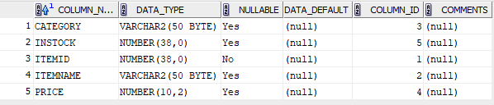
Create table Customers:- custid (primary key), Custname, Address, state
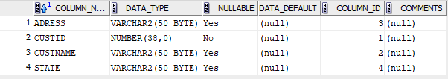
Create Orders:- orderid (primary key), Itemid( refers to itemid of Items table), Custid (refers to custid in customers table), Quantity (type=int), Orderdate (type=date)
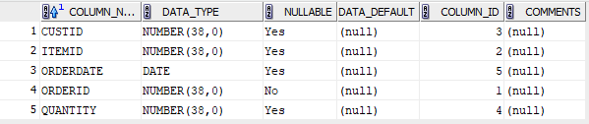
Delivery:- deliveryid (primary key), Custid (refers to custid in customers table), Orderid (refers to ordered in orders table)
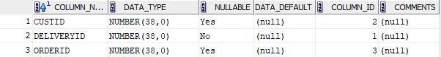
- List the details of all customers who have placed an order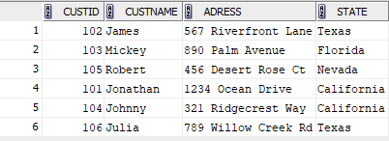

- Find the order date for all customers whose name starts in the letter‘J’

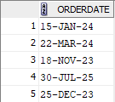
- Display the name and price of all items bought by the customer‘Mickey’
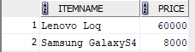
4. List the details of all customers who have placed an order after January 2013 and not received delivery of items

