# DXC AZURE ANALYTICS

Assignment- 17-06-2022

Name : Nandi Vomkara Aditya Mohan Date of submission: 17-06-2022

ID : DXCAB12003 No.of questions : 8

1. Write a python program to predict car sales of a company by using below data,

year: 2010 2011 2012 2013 2014 2015 2016 2017 2018 2019 2020

Sales in millions: 169 199 262 301 345 398 501 595 610 700 720 display outcome using linear regression method

Ans) follow the below steps to perform the prediction

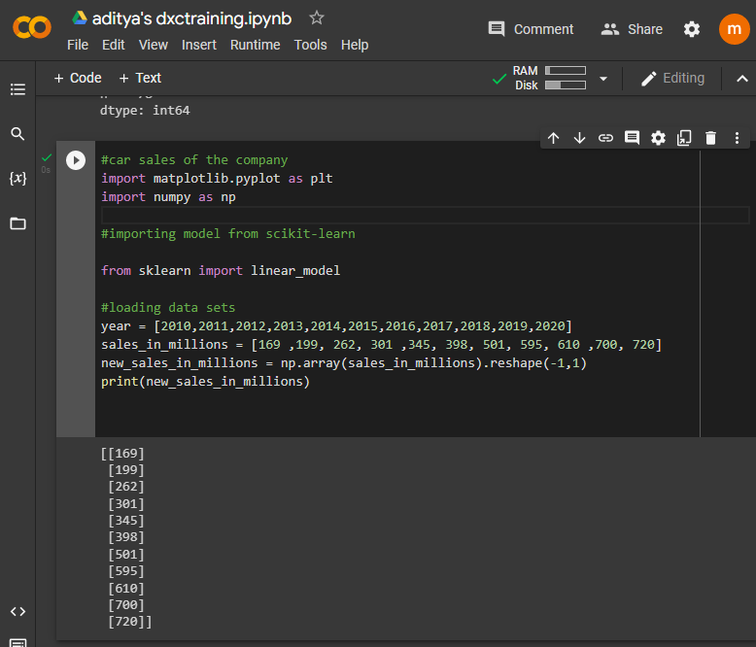

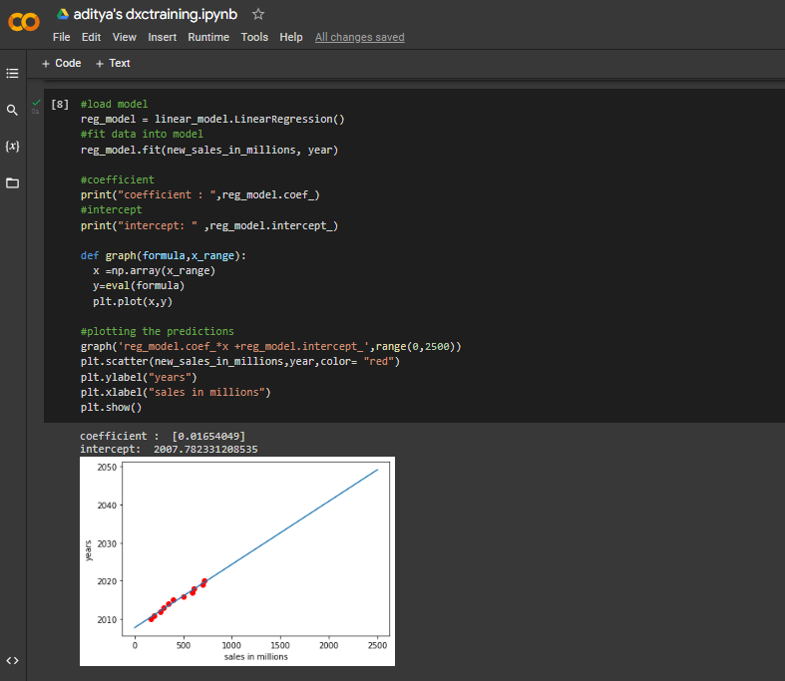

2. Write python program to generate possible tuples from any two sample Lists

Ans)

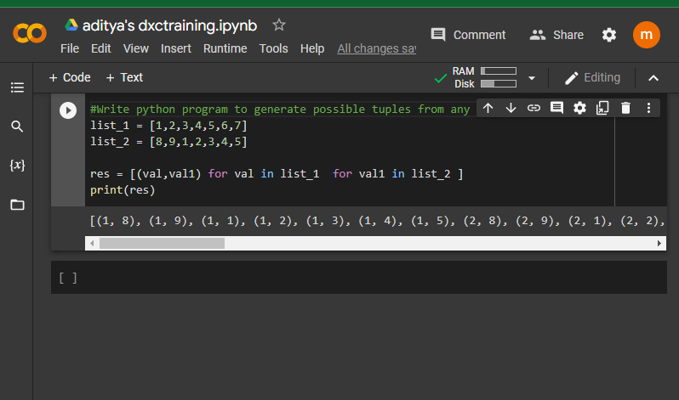

3. Create Azure Databricks & try to connect databricks & powerBI, explain the steps with screenshots.

Ans) to create data bricks we have to follow the following steps

Step-1: login into the azure portal and search for the DATA Bricks

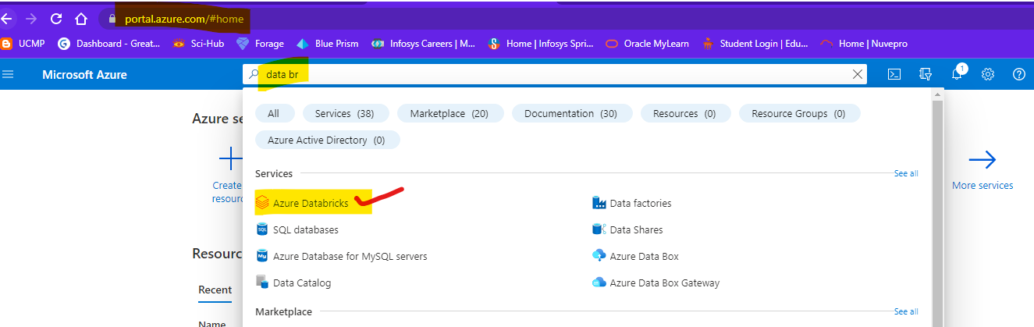

Step-2: click on azure data bricks and it will navigate you to the page. And click on create-to-create data bricks

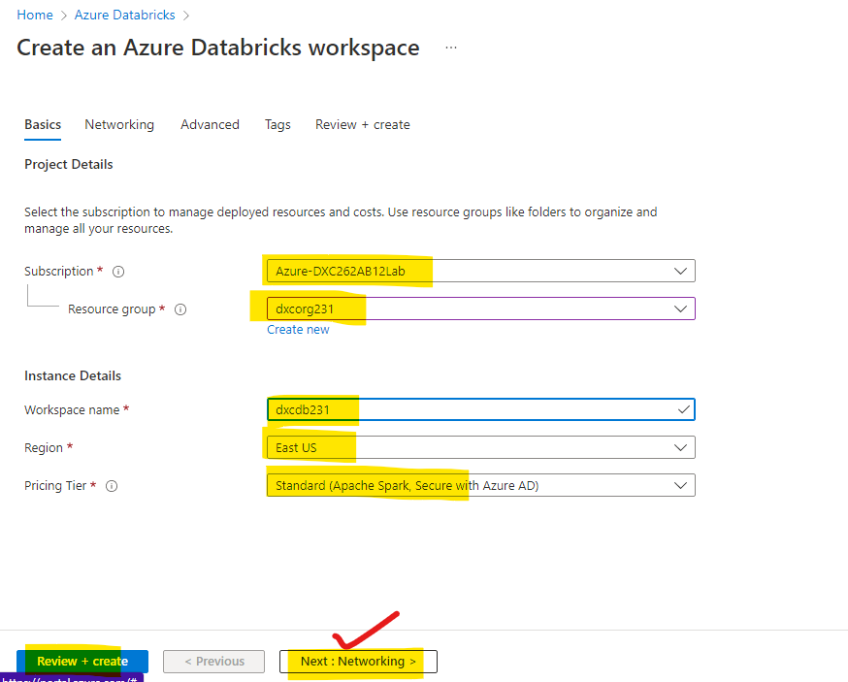

Step-3: after checking all these review and create and wait for deployment after deployment we will get like this

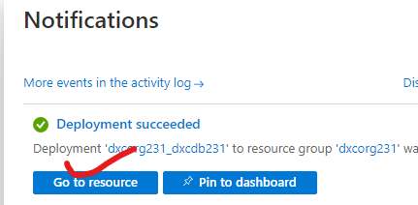

Step-4: after clicking of go to resource button you are navigated to the data bricks

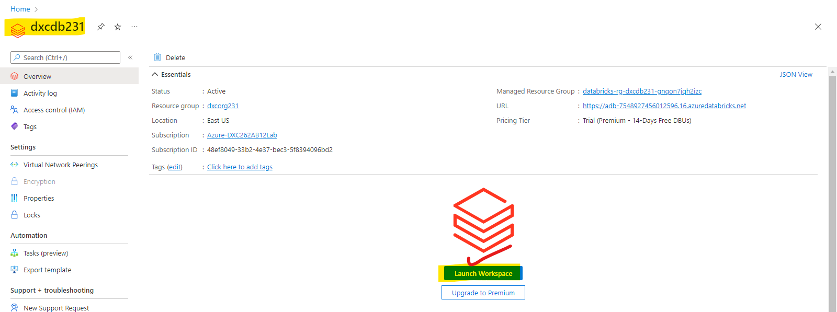

Step-5: after click on launch workspace, you are in data bricks

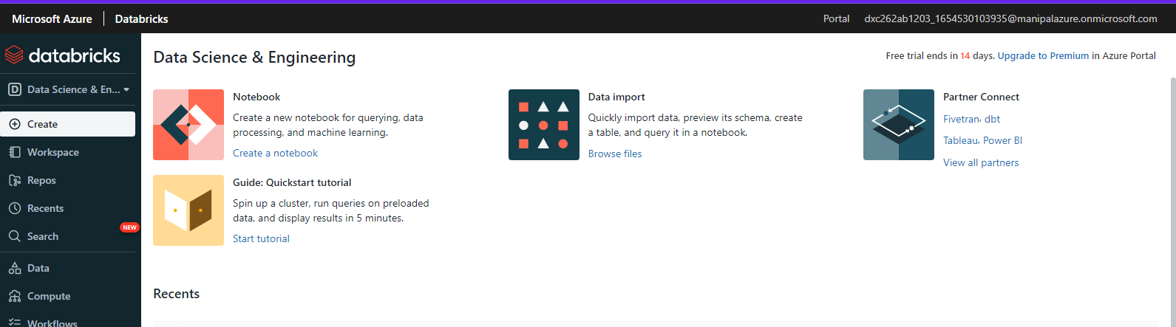

Step-6: after that open user settings and generate a token . after that go to tables and click on partner connect and select the power BI and attach the cluster and download the file as shown below.

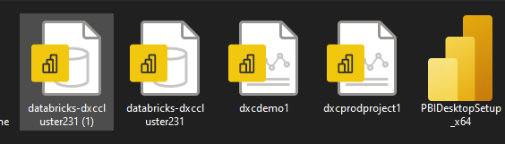

4.Create Azure Synapse & connect with Azure Blob, explain the steps with screenshots

Ans)

Step-1: create a azure synapse account

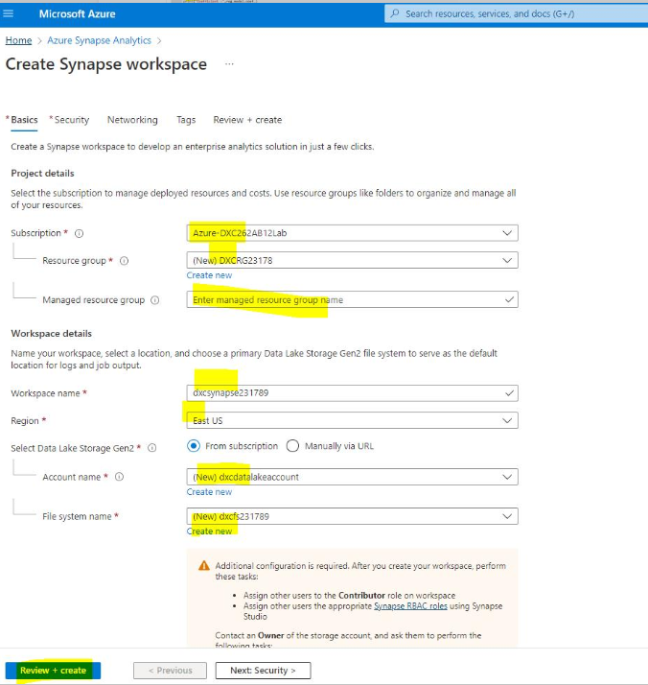

Step-2: Wait for the deployment

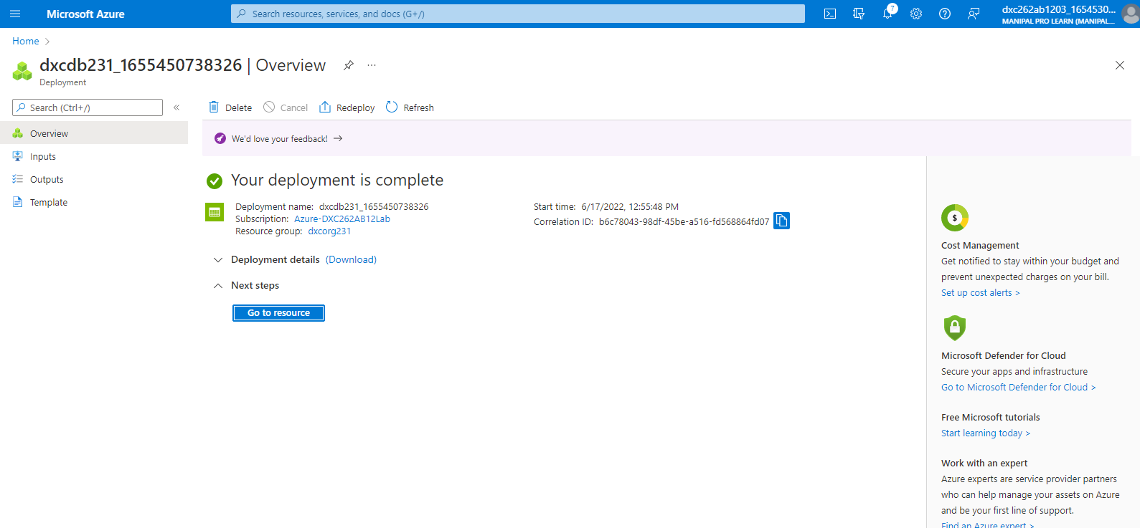

Step-3:click on goto resource and navigate to the synapse studio and click on open

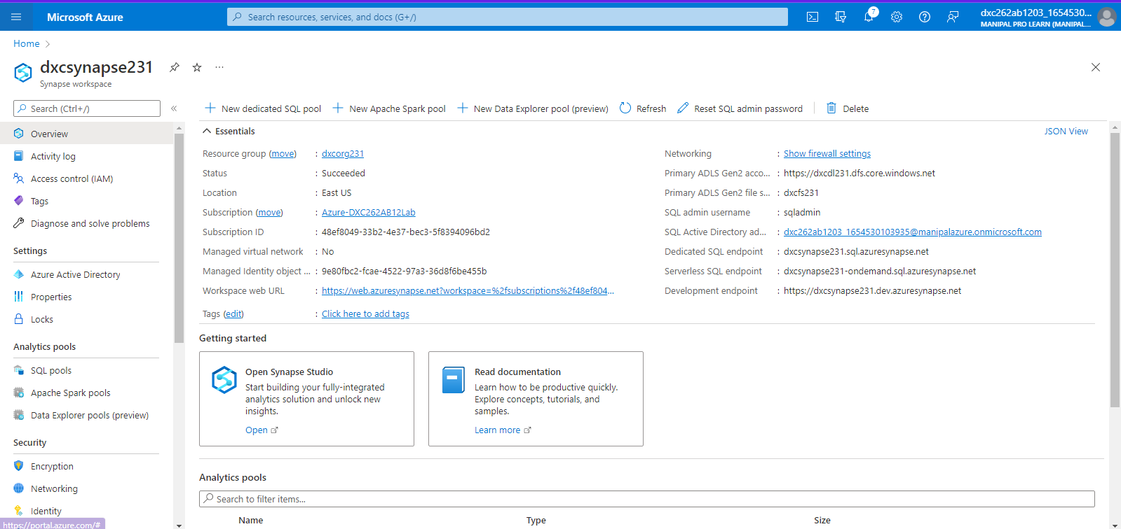

Step-4: This page will appear

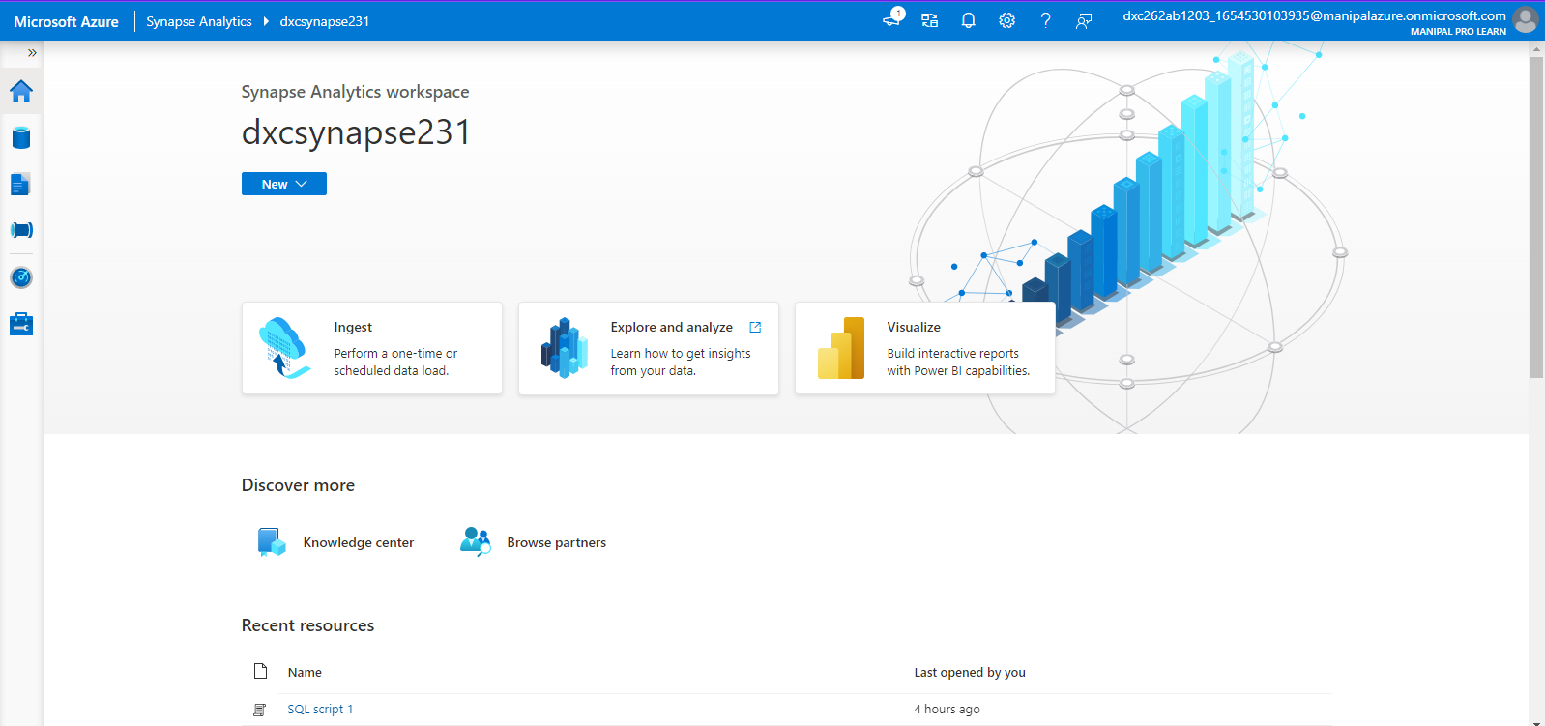

Step-5: click on data after that click on connect external data as shown in the screen

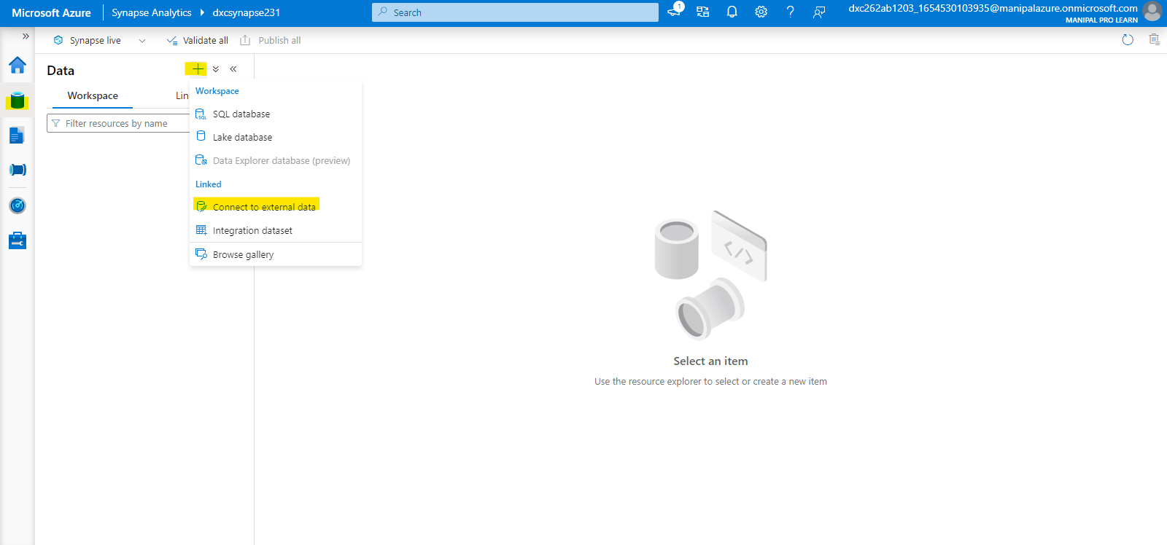

Step-6: click on azure blob storage and click on create

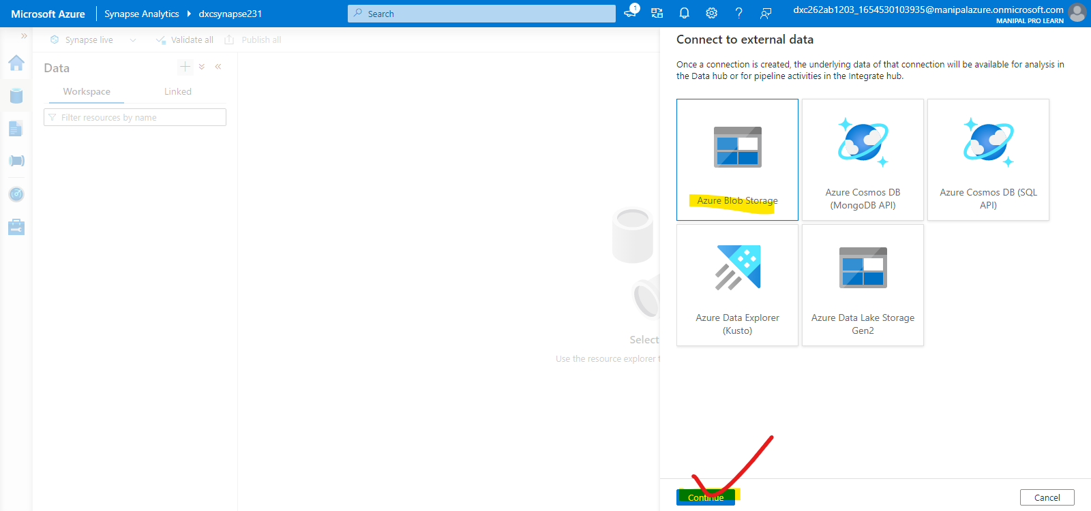

Step-7: new linked services page will open give the info required and check connection and later click on create.

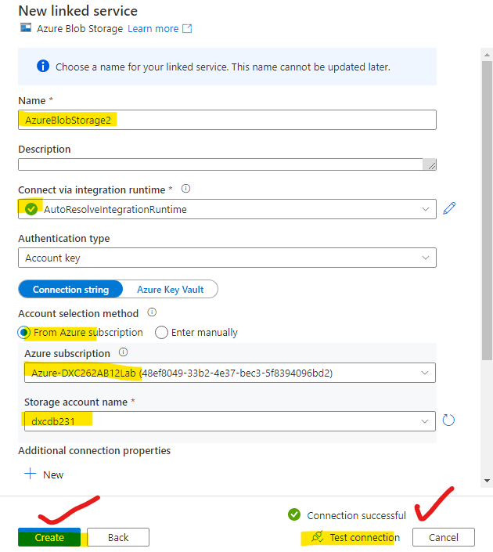

Step-8: after that the blob storage is connected successfully

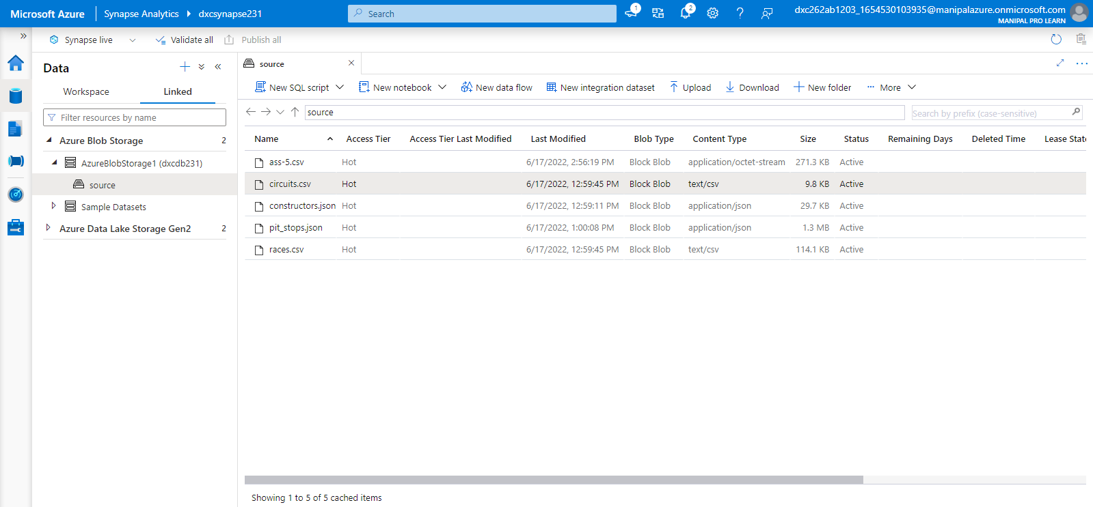

5.Create Azure Synapse spark pool & query sample JSON file, explain the steps with screenshots

Ans)

To create a spark pool we have to follow the steps mentioned below

Step-1: click on manage pools

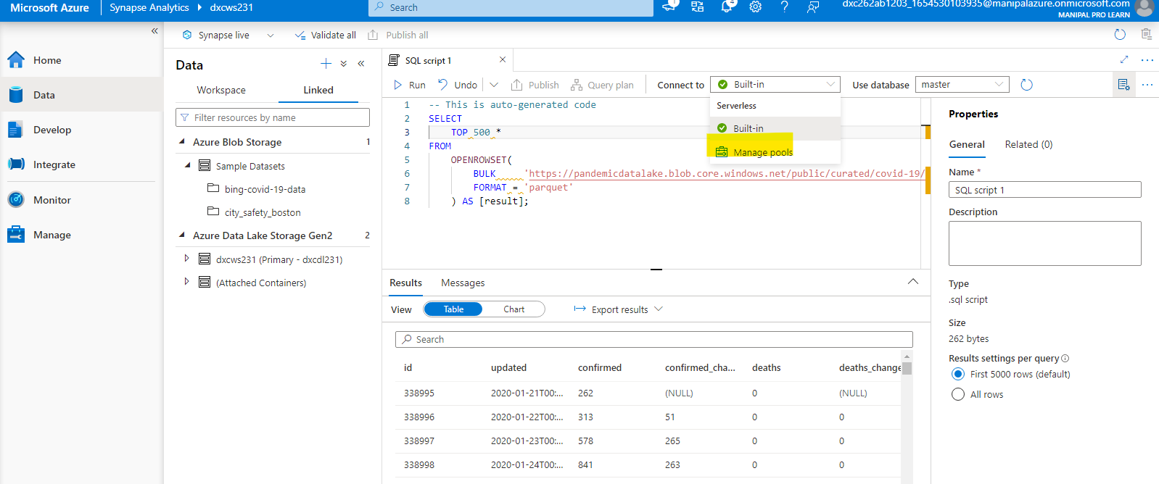

Step-2: after that it navigates to the mange page and select spark pool there refer screenshot

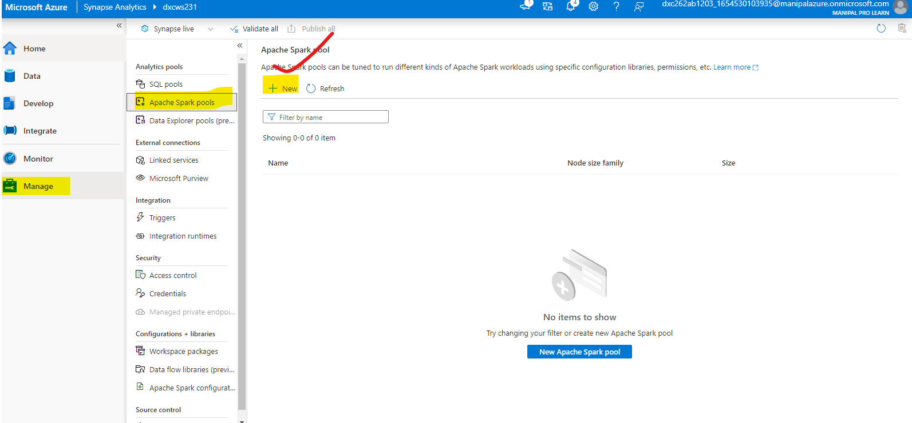

Step-3: fill all the requirements and click on review and create

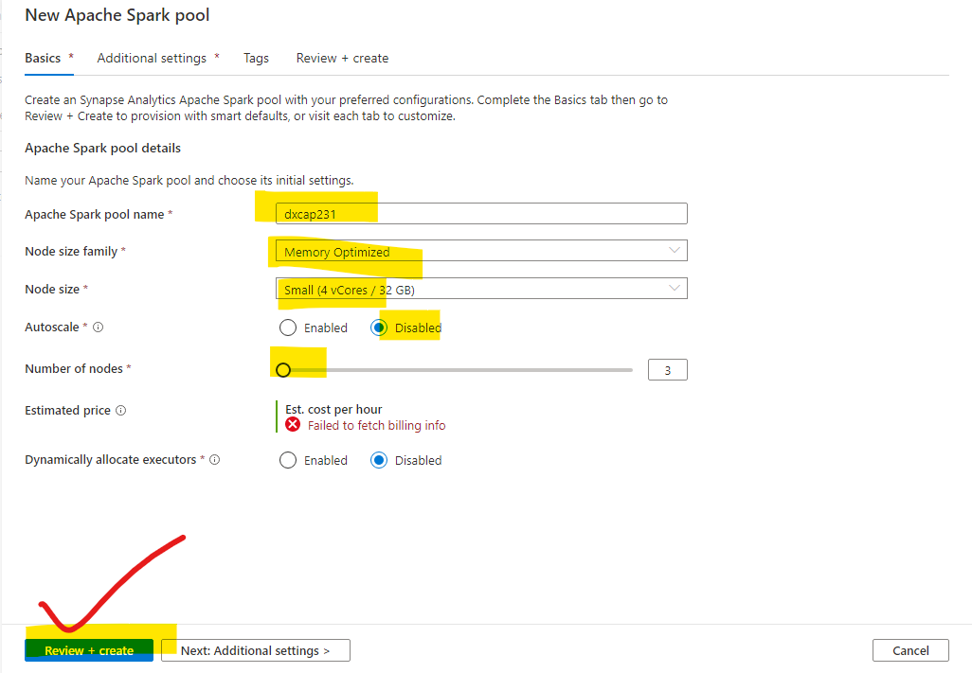

Step-4 : it takes few minutes to deploy

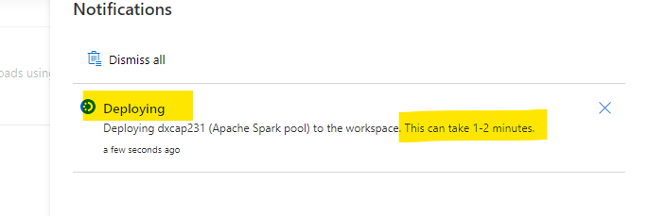

Step-5: and done

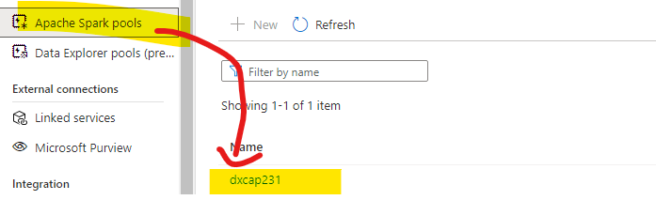

Step-6: now querying a sample json file. Attach to the pool and click on run all. Its takes dome time

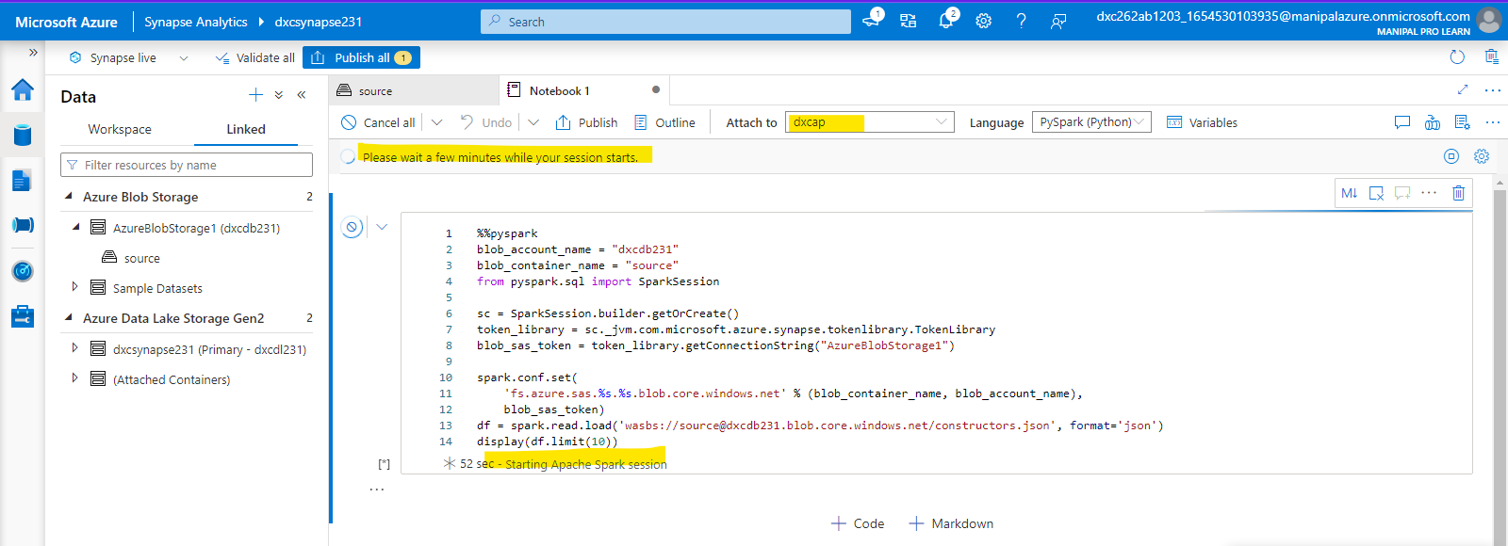

Step-7: The data will be queried successfully as shown in the screen

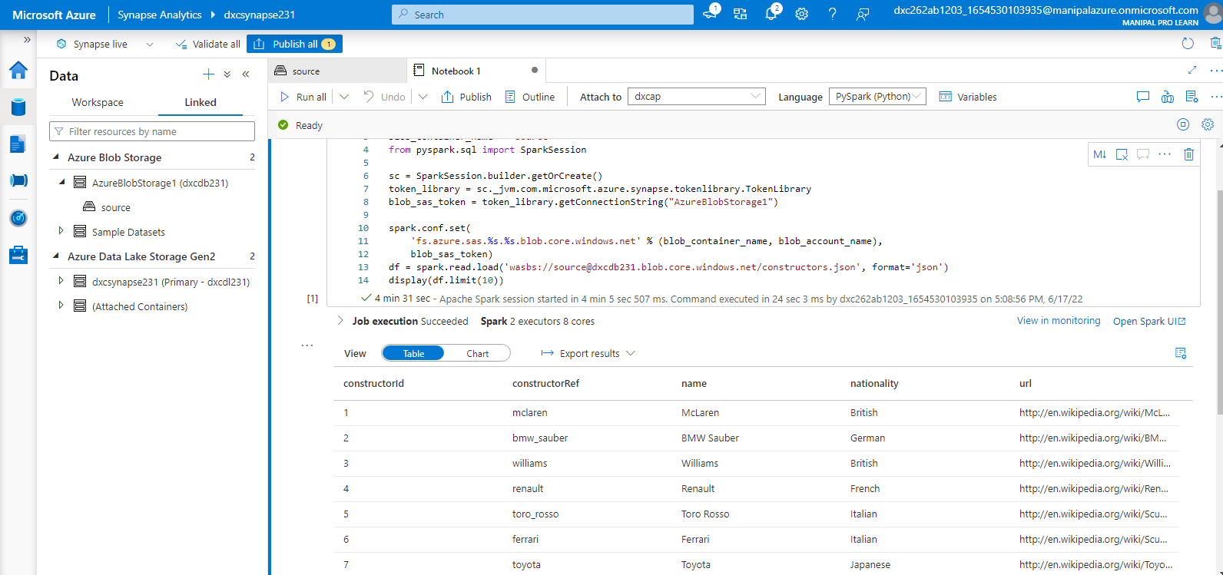

6.Create Azure Cosmos DB & import sample JSON file, explain the steps with screenshots

Ans) To create Azure cosmos DB we need to follow the below mentioned steps

Step-1: go to azure portal and search for azure cosmos DB

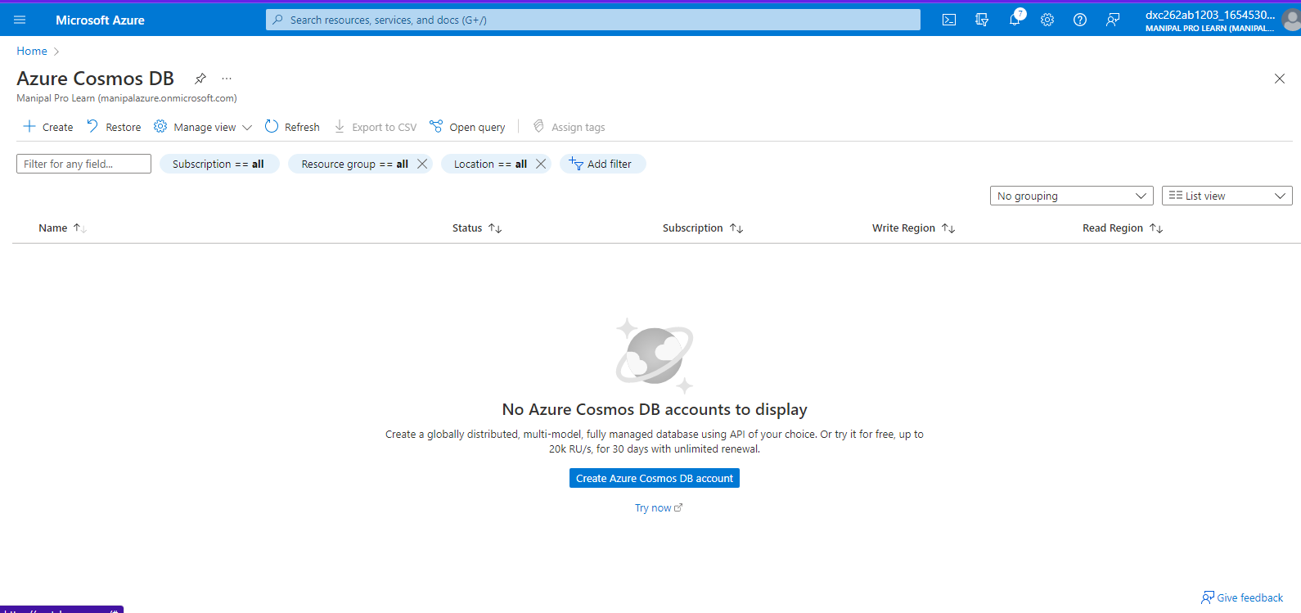

step-2: we have to select the API option and we are recommended with core sql

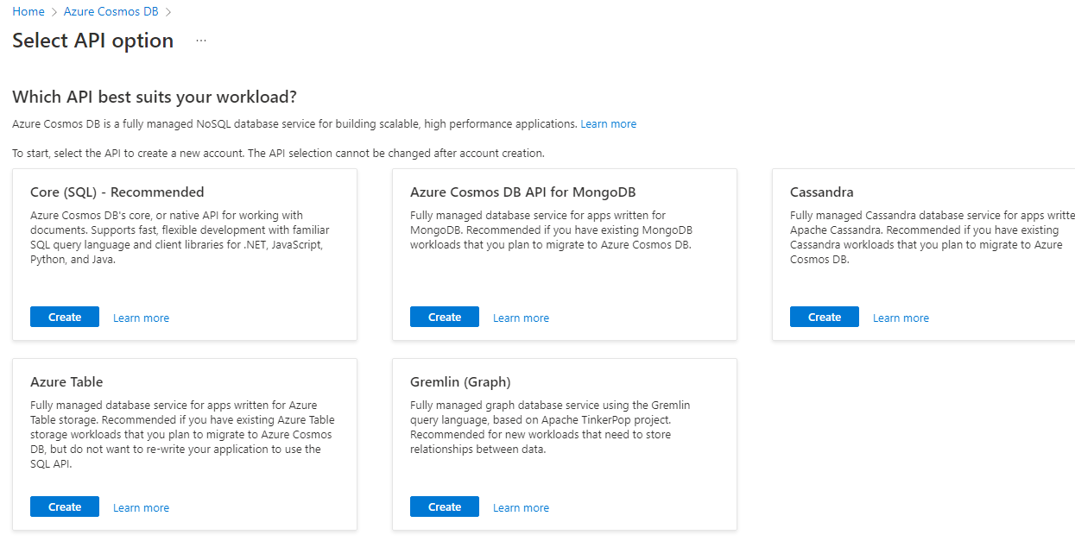

Step-3: we have to fill the following details

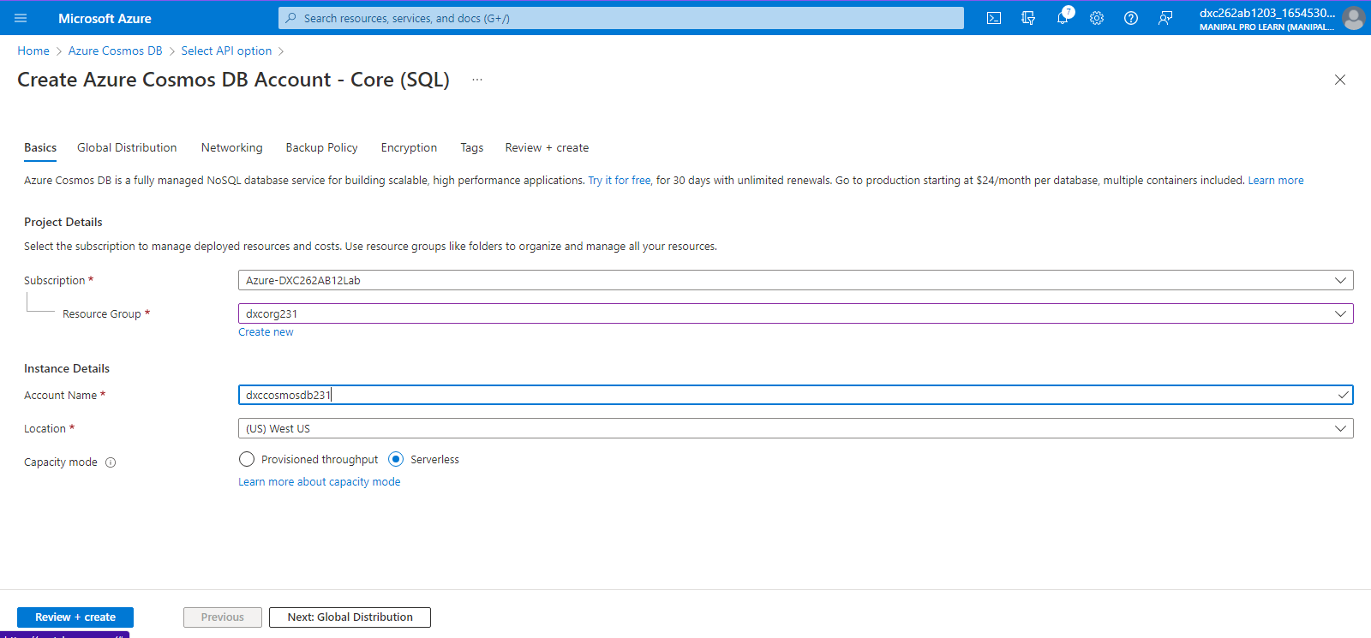

Step-4: after successful validation click on create

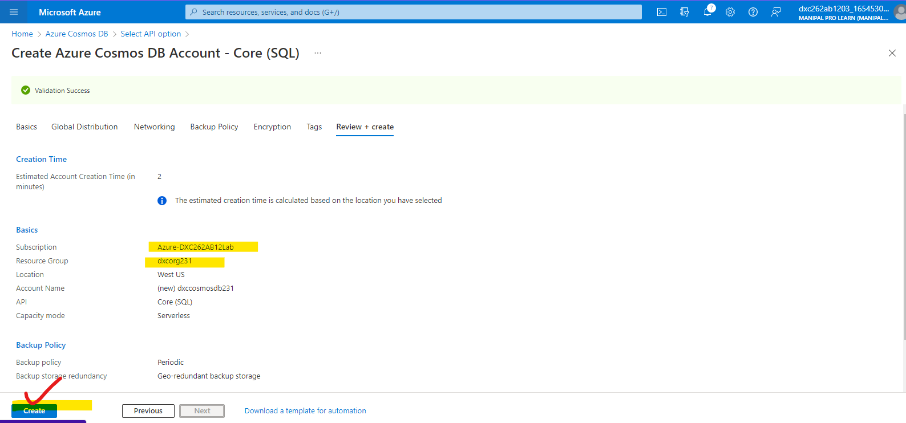

Step-5: wait for the deployment to complete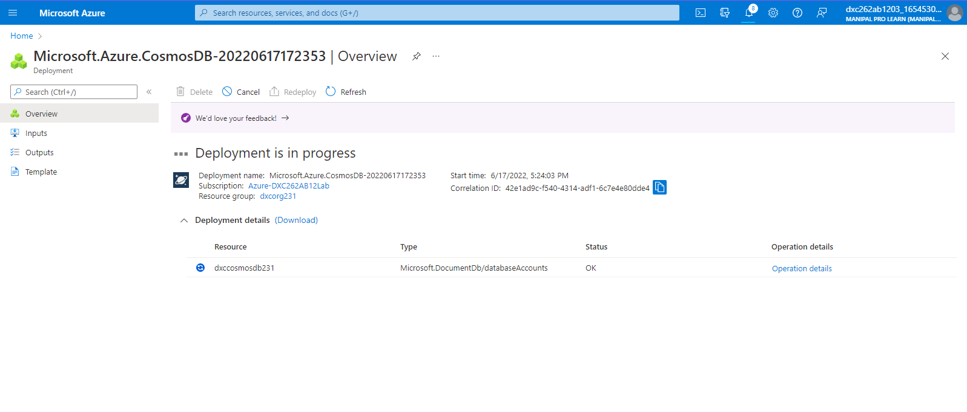

Step-6: after completion of deployment click on go to resource

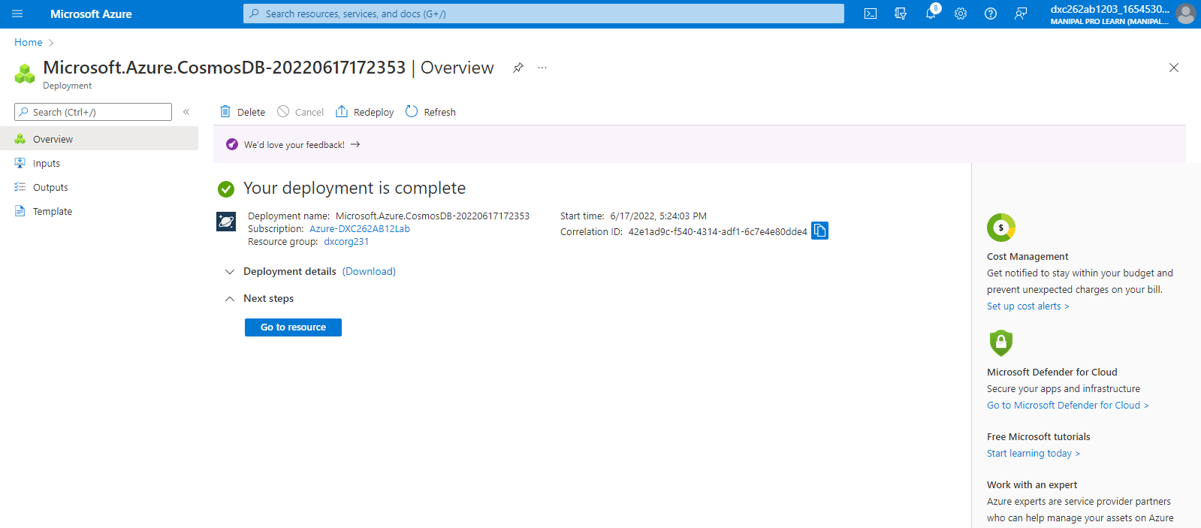

Step-7:after going to the cosmos DB and follow the below mentioned steps

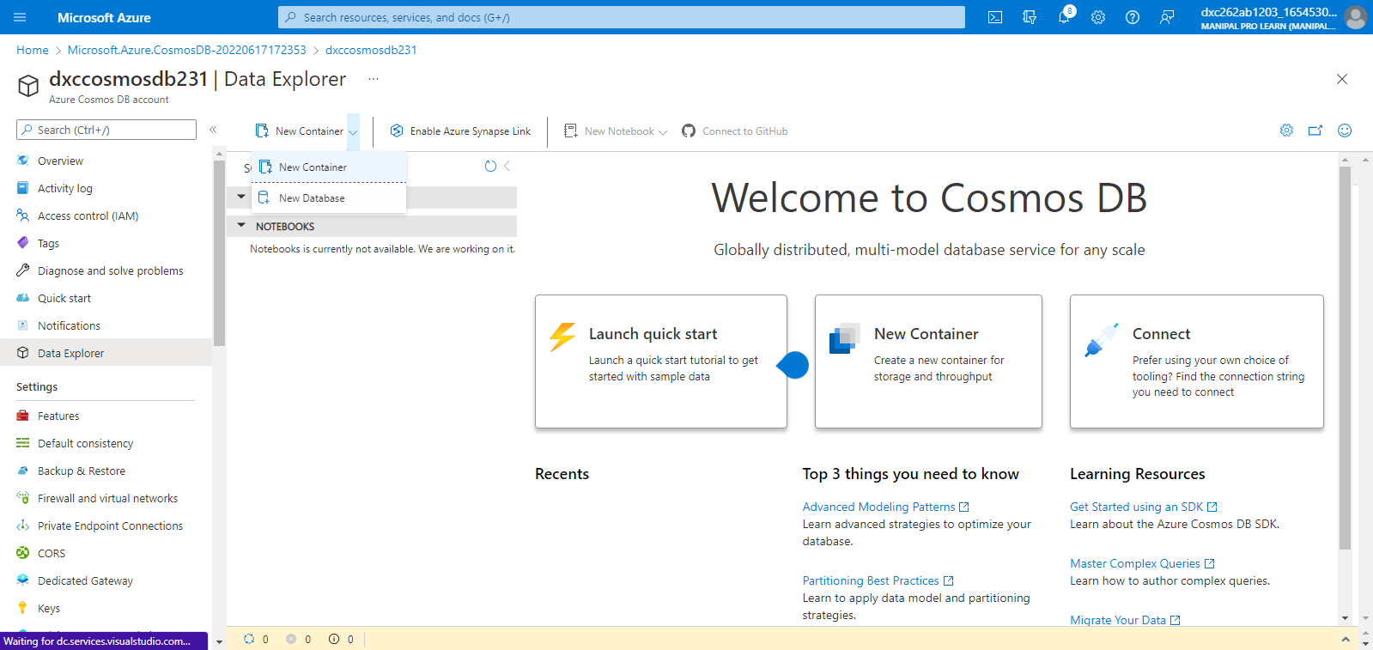

Step-7: create the container

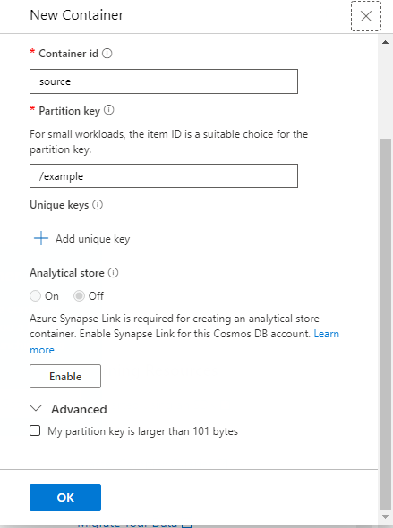

Step-8: upload the data as shown below screen and after clicking on execute query then the data will be queried

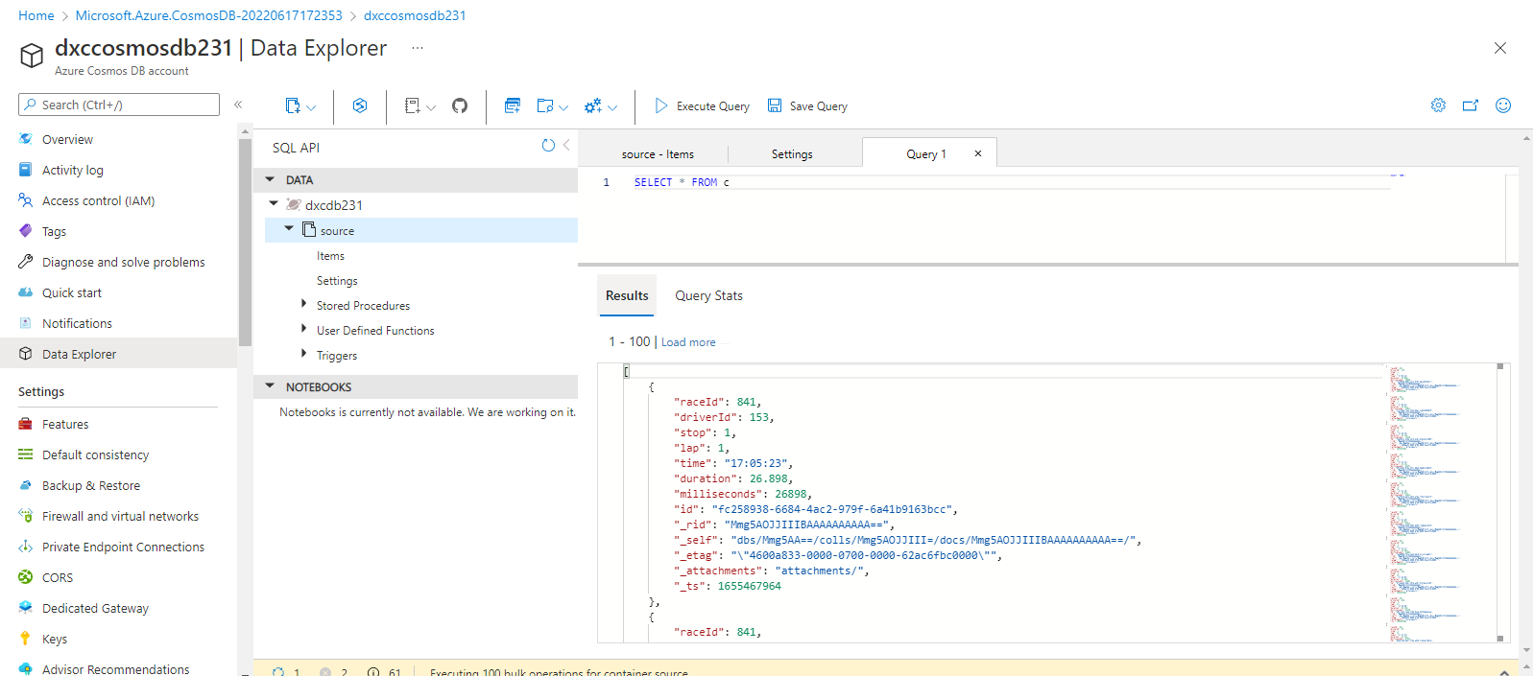

7.Connect COSMOS DB & Azure Synapse analytics & explain the steps with screenshots

Ans) to connect the Cosmos DB and Azure synapse we have to follow the below mentioned steps

Step-1: open azure synapse and click on data and click on + icon and select connect external data

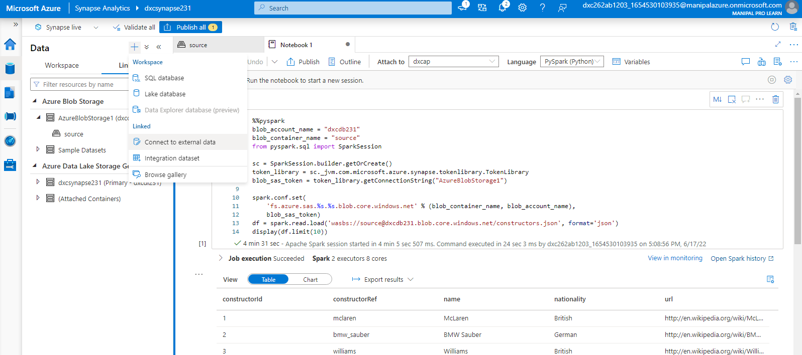

Step-2:then select the cosmos db sql api

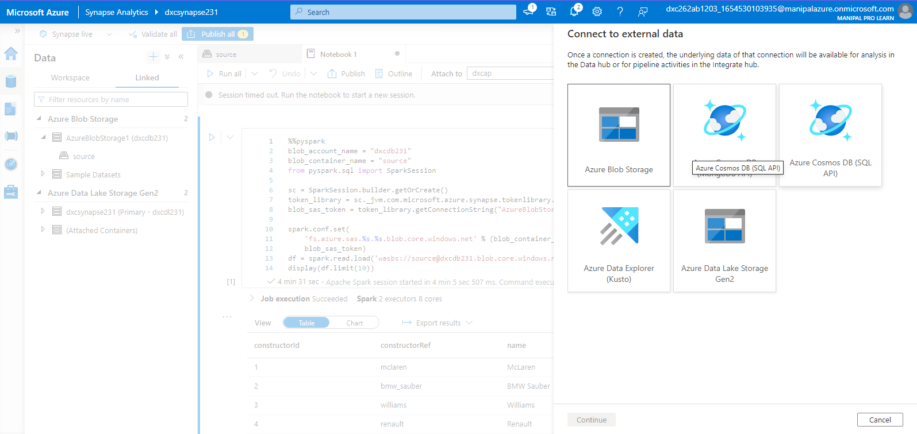

Step-3: we have to fill the below mentioned fields

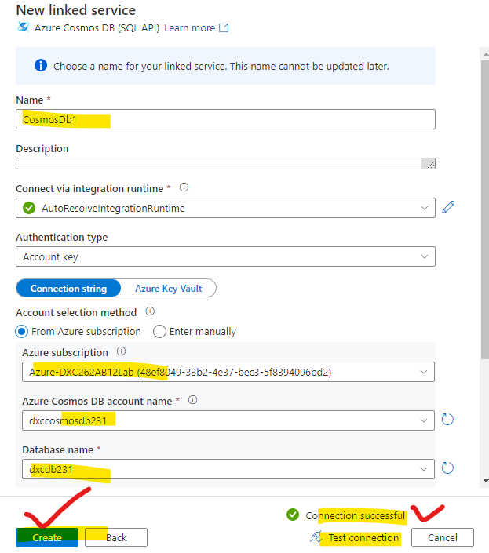

Step-4:after that cosmos DB is successfully connected with synapse

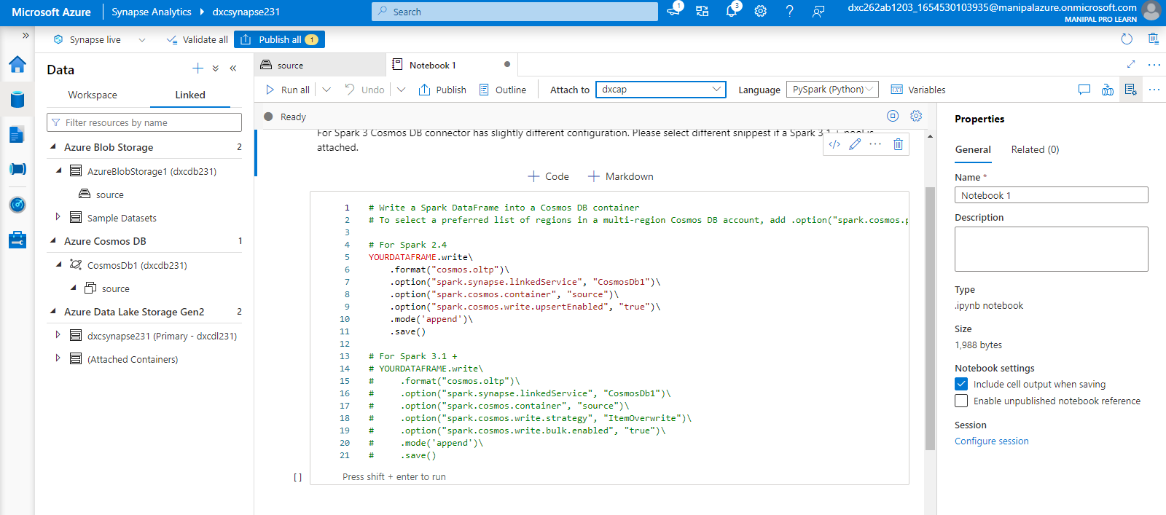

8.Create azure Data factory & azure Blob, connect Blob & ADF, import blob files into Data factory & explain the steps with screenshots

Ans) Azure data factory can be created by using the following steps

**Step-1**: login to the azure portal and search for azure data factory as shown in fig 1.1

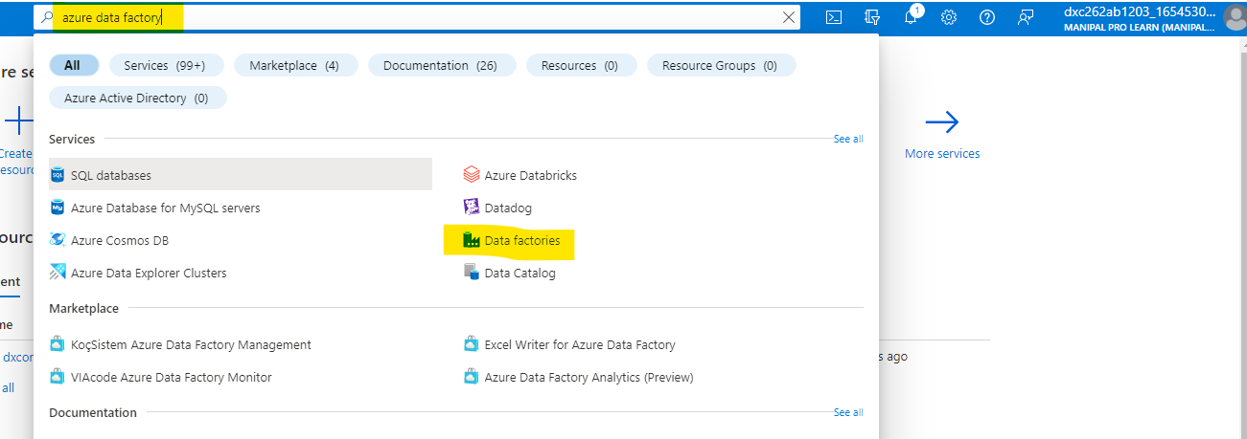

Fig 1.1 shows search for data factory in azure portal

**Step-2:** after navigating to the azure data factory page click on create and select the resource group, name, region, version after that click on next follow the fig 1.2

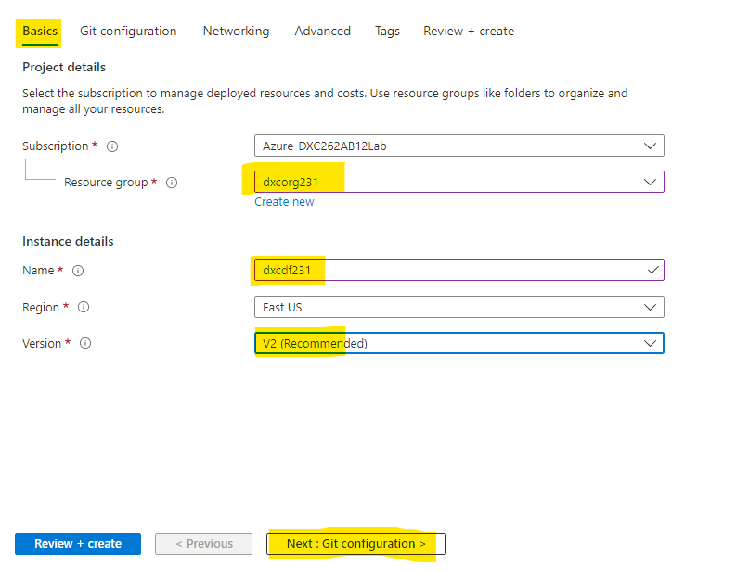

Fig-1.2 shows the creation procedure of data factory

**Step-3:** click on git configurations and checkbox it as configure git later as shown in fig 1.3

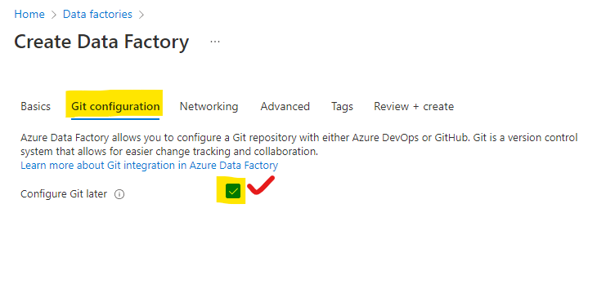

Fig-1.3 shows the git configuration during data factory creation

Step-4: Go through the next steps followed by succesfull completion of validation clikc on create as shown in fig-1.4

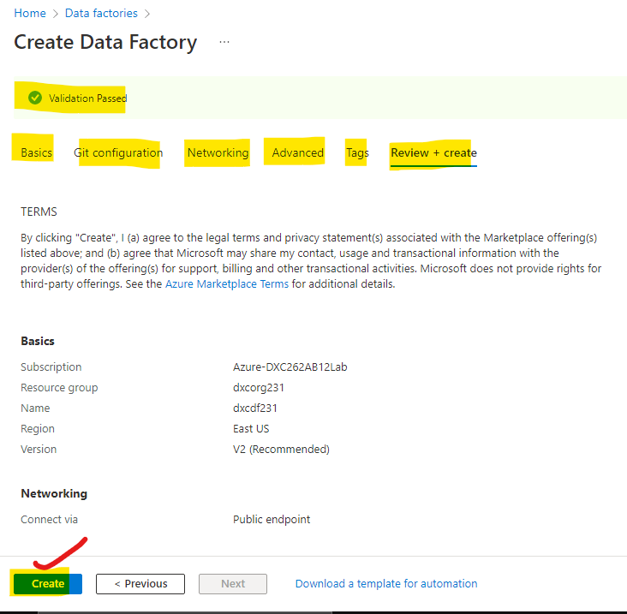

Fig-1.4 shows the steps in creation of data factory

**Step-5:** after clicking on create it takes some time for deployment after deployment you can see the following as shown in fig-1.5

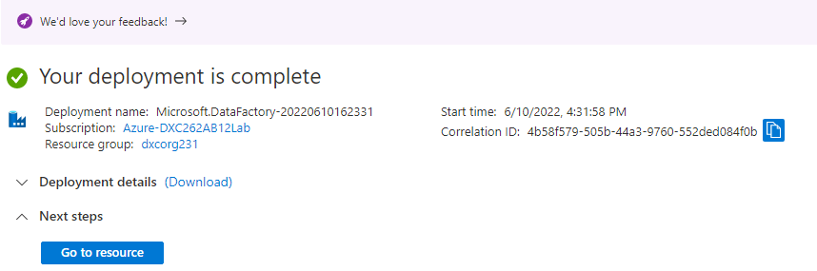

Fig1.5 shows the successful deployment of azure data factory

**Step-6**: click on go to resources after that click on open as shown in the figure 1.6

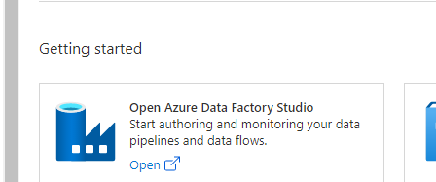

Fig-1.6 helps to navigate to the DF studio

Step-7: After clicking over that it will open azure data factory in new window as mentioned in fig 1.7 and we can use this creation of pipelines

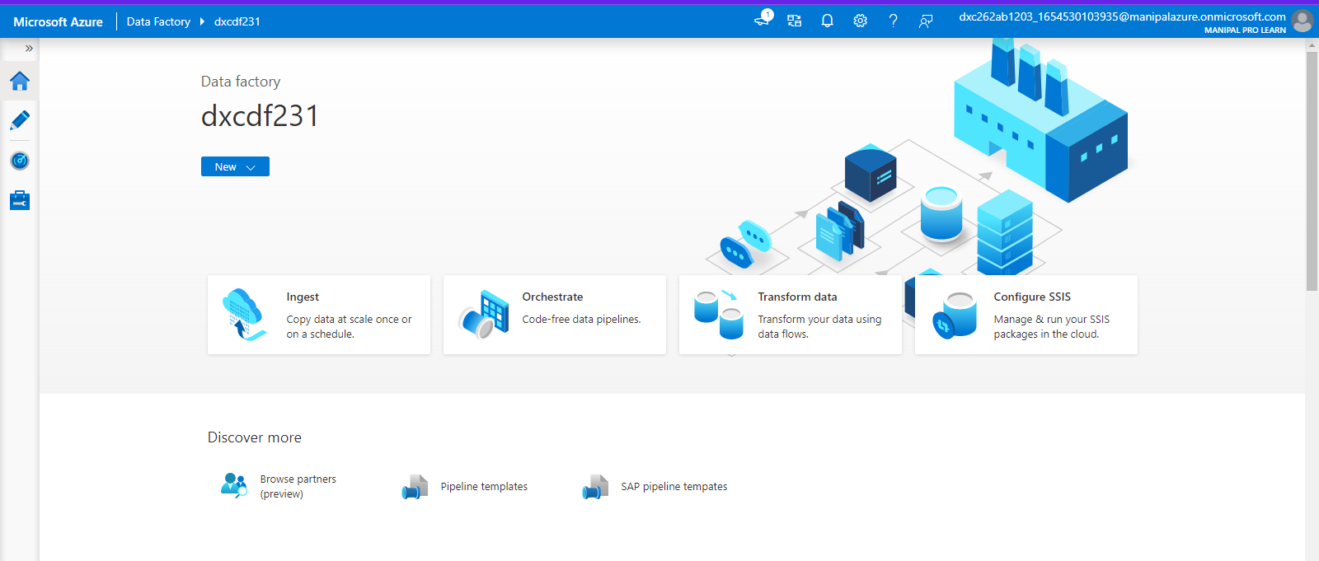

Fig-1.7 shows the main page of DATA FACTORY

Step-2 : we are moving the data from the source to the destination using the copy data tool and creating a pipeline

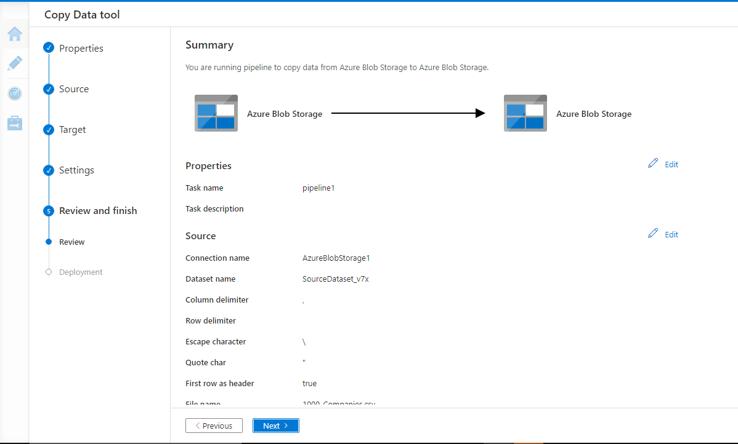

Step-3: The validation and deployment is done and pipeline is created successfully.

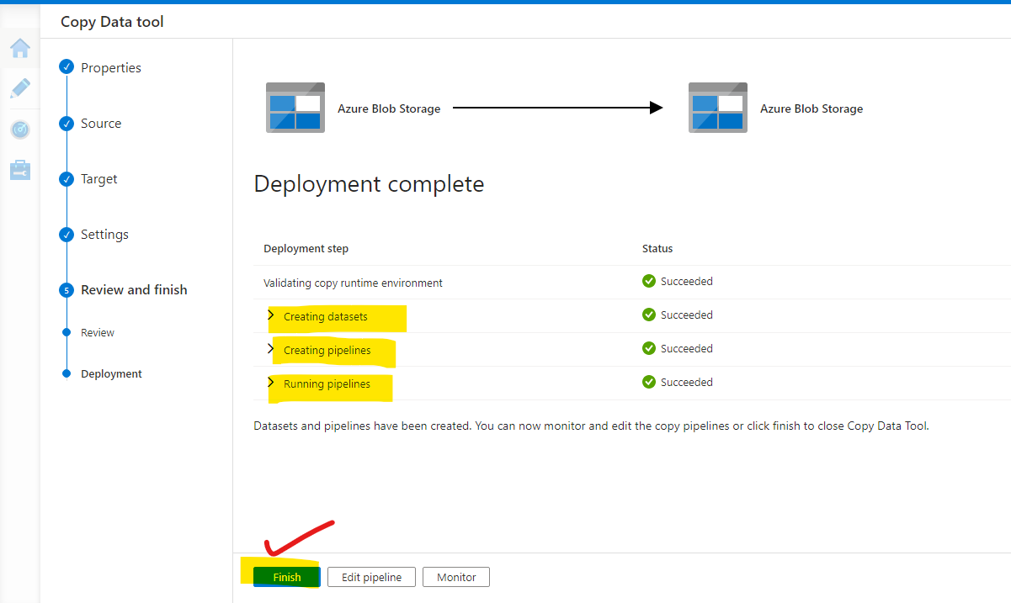

Step-4: The data is successfully copied from source to destination.

