**AI_Summarizer [PYQT5 , Whispher , GPT-4]**

This Program can be used in any Online/Offline/ Browser/Application Based Meeting to capture the Meeting communication and convert it into a summarised form of the important details from the meeting and Send it to the participants at the end of the meeting via mail. And also it allows you to resend the mail to new people previously not mentioned.

[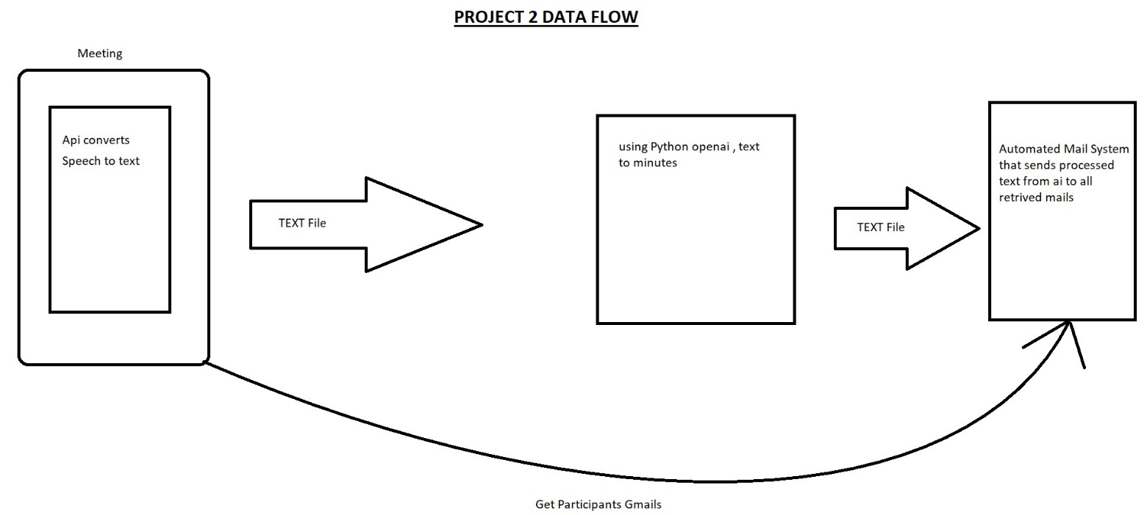](https://private-user-images.githubusercontent.com/39313793/274655385-065c3eff-e80f-4eea-979a-429dd2cf943d.jpg?jwt=eyJhbGciOiJIUzI1NiIsInR5cCI6IkpXVCJ9..l-tvSkhIa8iNtEnHcR79eZRST2O9GGwxaWbwYmAkd_A)

* Table of Contents

Installation

Usage

Contributon

* Installation

*If Facing error after installation use Advanced Installation method .*

**Basic Installation:**

Navigate to ./Setup Folder

* Install python-3.9.0-amd64.exe
* execute setup.py [auto install dependencies]

**Advanced Installation:**

Navigate to ./Setup Folder

* execute remove_python.py
* Install python-3.9.0-amd64.exe
* execute setup.py [auto install dependencies]

You can install the project using pip and the provided requirements.txt file.

* Open Terminal /CMD and navigate to Project folder with requirements.txt file
* pip install -r requirements.txt
* Usage

Setup:

* Navigate to main folder edit files mail3.py and remail.py with notepad or idle editor
* Replace

sender_email = "abc@gmail.com" # Enter your email

sender_password = "wwwn aqlf gcxn uuuu" # Enter your app password

with the mail id details used by the ai to sent mails.

* To Get / activate app password

**Set up an application password through Google**

In order to send emails using Gmail, you'll need to set up an app password.

* Head over to [myaccount.google.com/security](https://myaccount.google.com/security), and then click into the 'app passwords section (as shown in image below).

[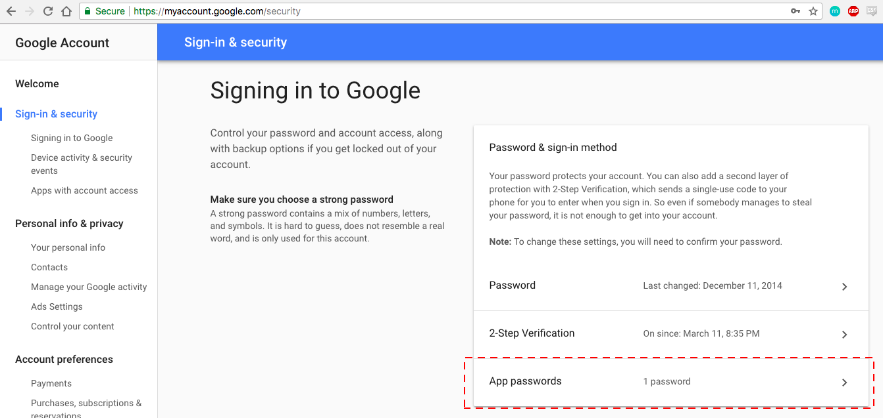](https://www.interviewqs.com/images/blog/py_email_img_1.png)

* Select the app ('mail' in this case) and device (I used 'mac').
* Click 'generate', save the password (we will feed it into the python script below).

Usage:

* Execute the Application Main Exe “AI Summarizer.exe”

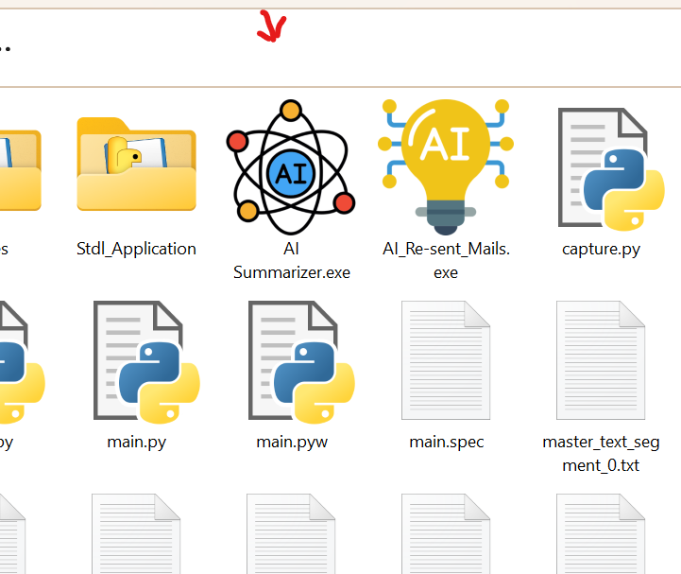

* Pop Up “Process monitor “ Window click “Start Application” to launch the application. On the next page the company logo is the interactive button to proceed to the next stage.
* After Loading , in “Capture / Syncing Audio Files” stage a pop up

Start/Stop the meeting recording via GUI appears shown Below

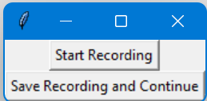

* Click on “Start Recording” to Capture the meeting speaker & mic conversations input/outputs
* Click on “Start Recording” to end Recording.
* Click on Save Recording and Continue to Proceed with Detection /Convertion of the audio file.
* Now the Audio Detected language and Generation of Summary and minutes updates are shown in the Process Monitor window.

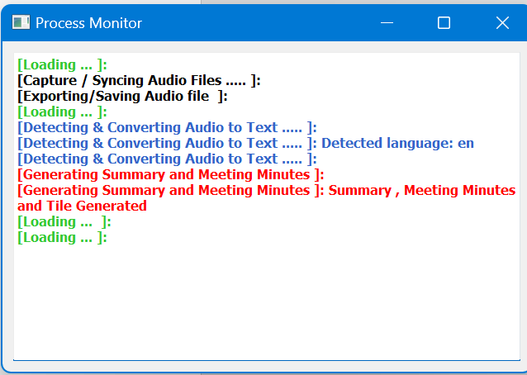

* On the new pop up window

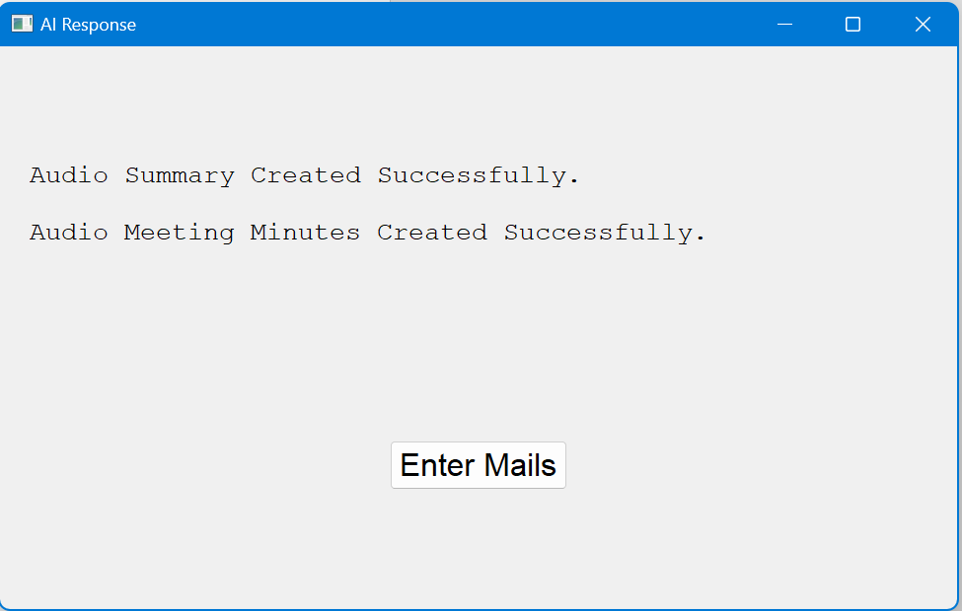  
  
click on enter mails to proceed…

* new window pops up , here the title is *auto detected and typed* in by the ai , which is editable by the user. 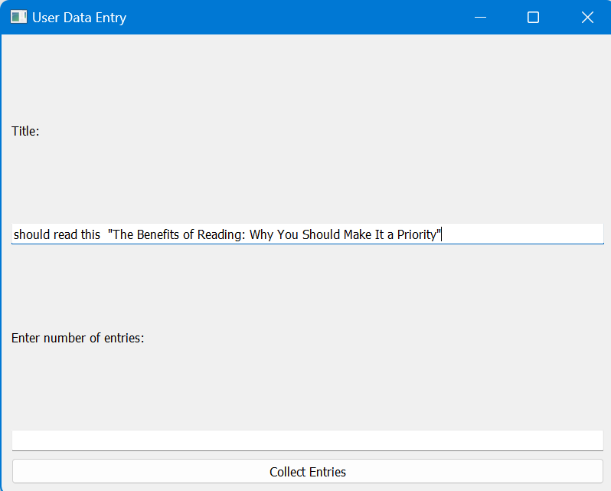
* Enter the number of entries followed by the entries details in the new pop up.

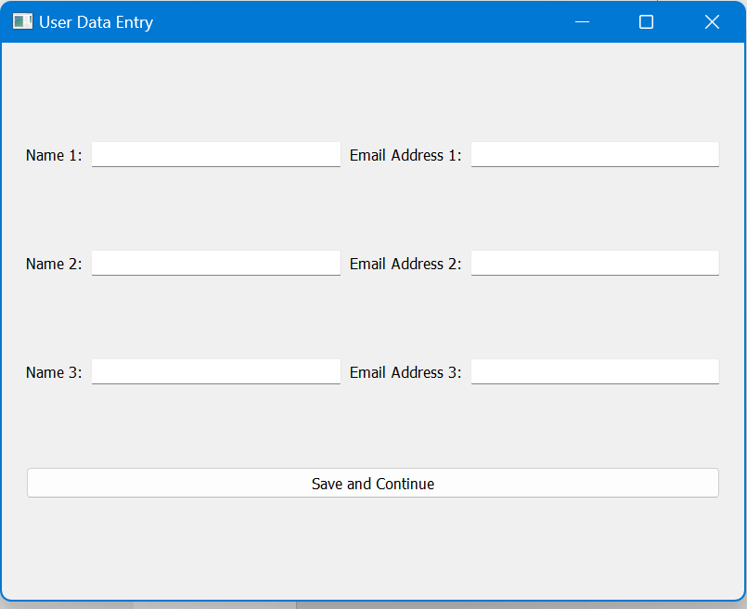

* Click “save and continue”

, verification window opens with the entered data , here you can click edit to go back and edit or continue to proceed

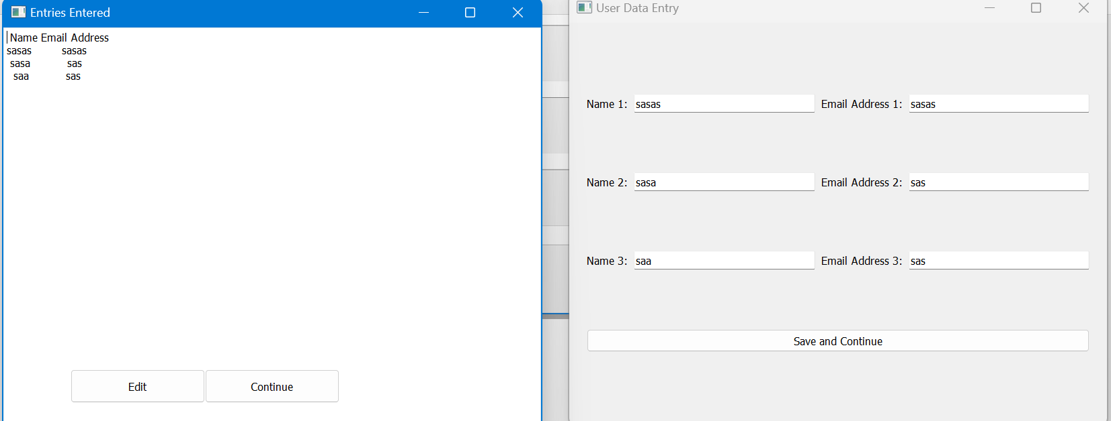

* Now required mails are sent to specific address , update shown in process monitor.

**All History of generated data is saved in ‘./Data’ folder with date-time stamp.**

* **To resent / sent specific mails again to other mails ids :**
* Execute ‘AI_Re-sent_Mails.exe’
* Pop Up “Process monitor “ Window click “Start Application” to launch the application.
* new window pops up ,
* Enter the number of entries followed by the entries details in the new pop up.

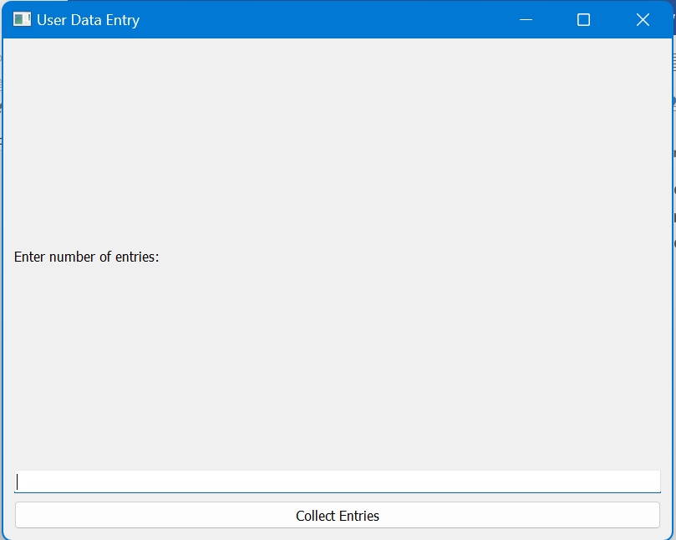



* Click “save and continue”

, verification window opens with the entered data , here you can click edit to go back and edit or continue to proceed



* Now required mails are sent to specific address, update shown in process monitor.

Contribution

**Adithya N Raj**

**Giridhar Prakash**

**Madhav A Nair**

**Madhav Sunil**