CYPHER Evidence and Detection Confirmation
This document contains the requested verification screenshots and explains how the eight-frame confirmation rule operates in the engine and browser paths.

Detection confirmation paths

Engine stream mode
The Python engine processes consecutive frames from a video or webcam stream. It keeps a separate streak for each camera and object class. The count increases when the label is detected and resets to zero when it is absent. A reportable object creates an incident after eight consecutive frames, followed by the cooldown rule, and the result is submitted through /api/incidents/ingest.

Browser demonstration mode
- Live detection captures webcam frames approximately every 450 ms, maintains an eight-frame streak in the browser, and submits an incident after confirmation.
- The guided webcam flow first captures five snapshots as a stability pre-check. The selected label must appear in at least two snapshots. After the user explicitly confirms the result, the browser performs the full eight-frame check.
For an uploaded still image, repeating the image eight times is only a confirmation gate. It is not independent temporal evidence. The engine stream and live-webcam paths provide the actual frame-to-frame confirmation.

Figure 1 Grafana dashboard
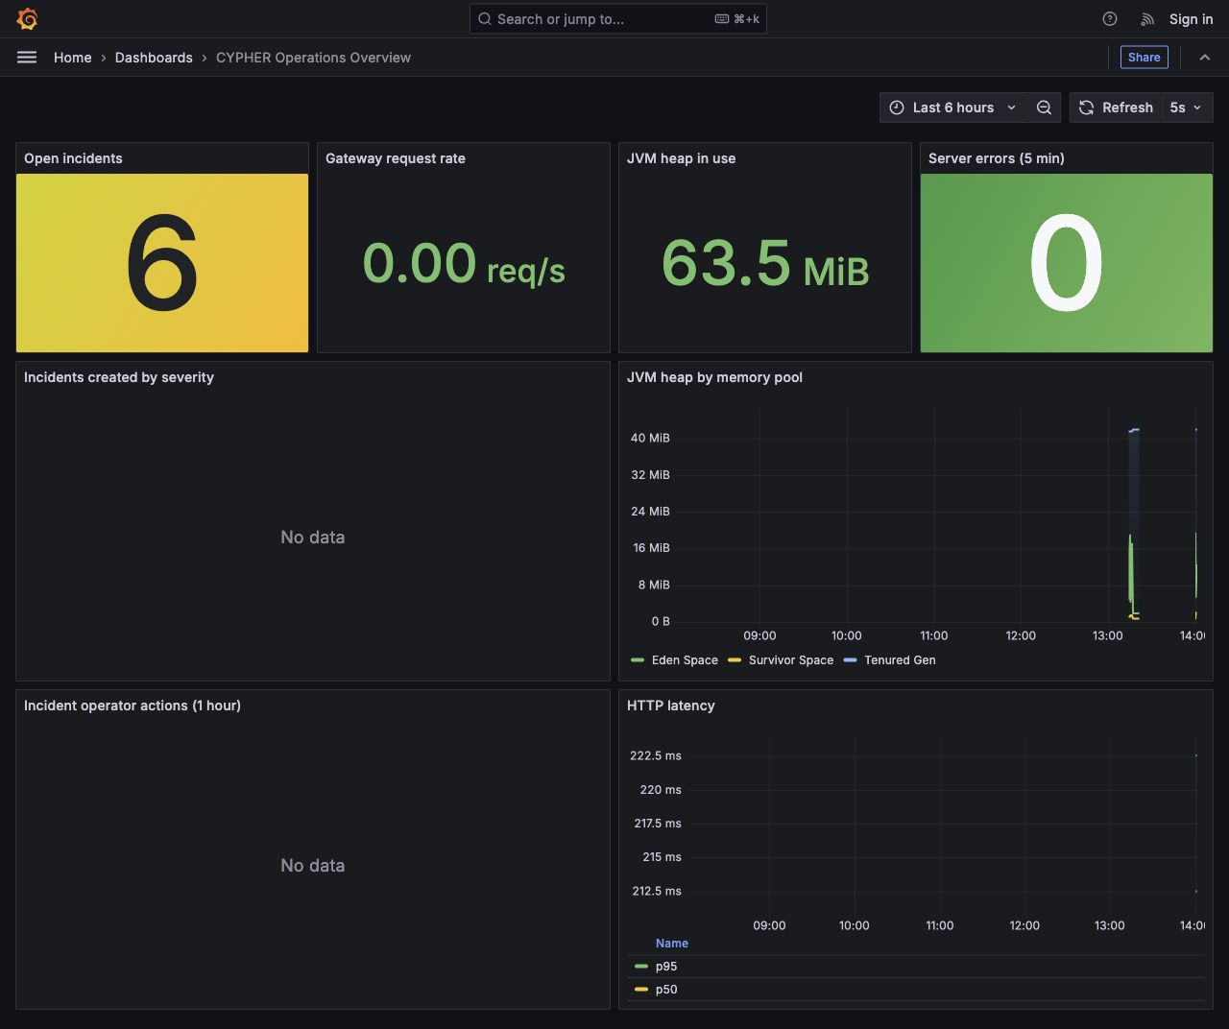
Live CYPHER operations dashboard on AWS.

Figure 2 Jenkins build
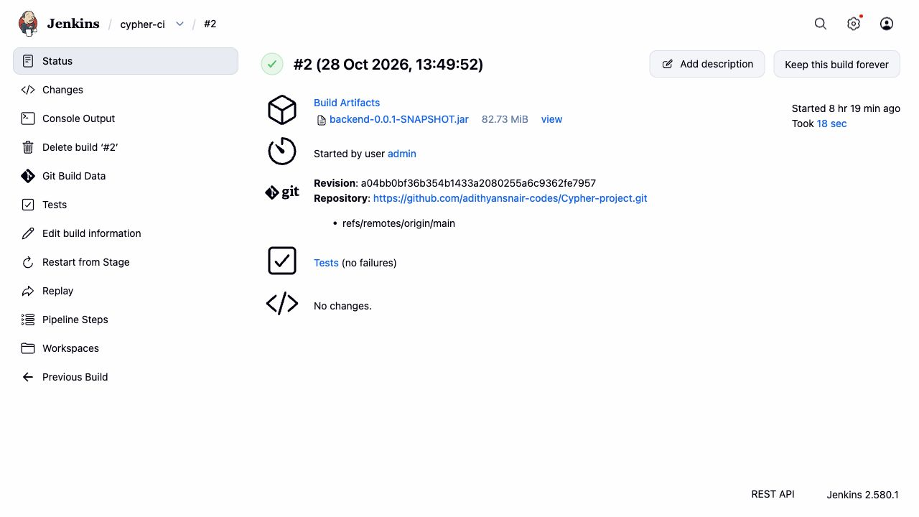
Jenkins build 2 completed successfully with no test failures.

Figure 3 GitHub Actions
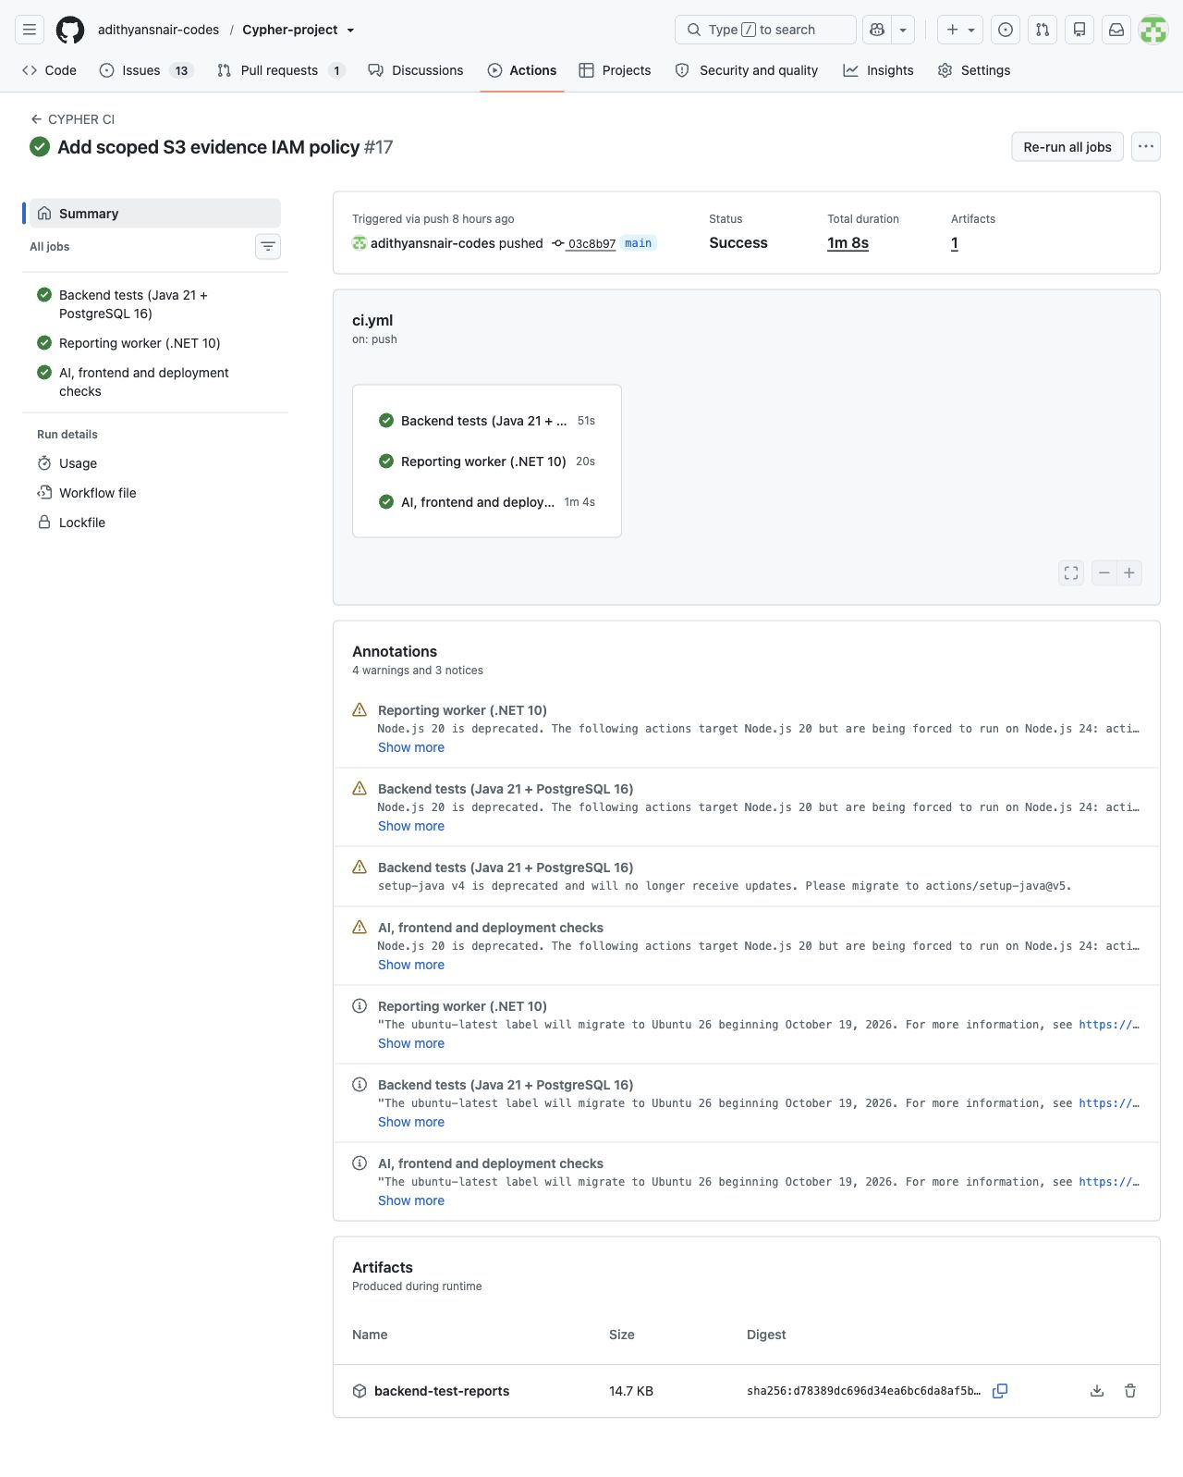
GitHub Actions run 40657882715 completed successfully.

Figure 4 Prometheus targets
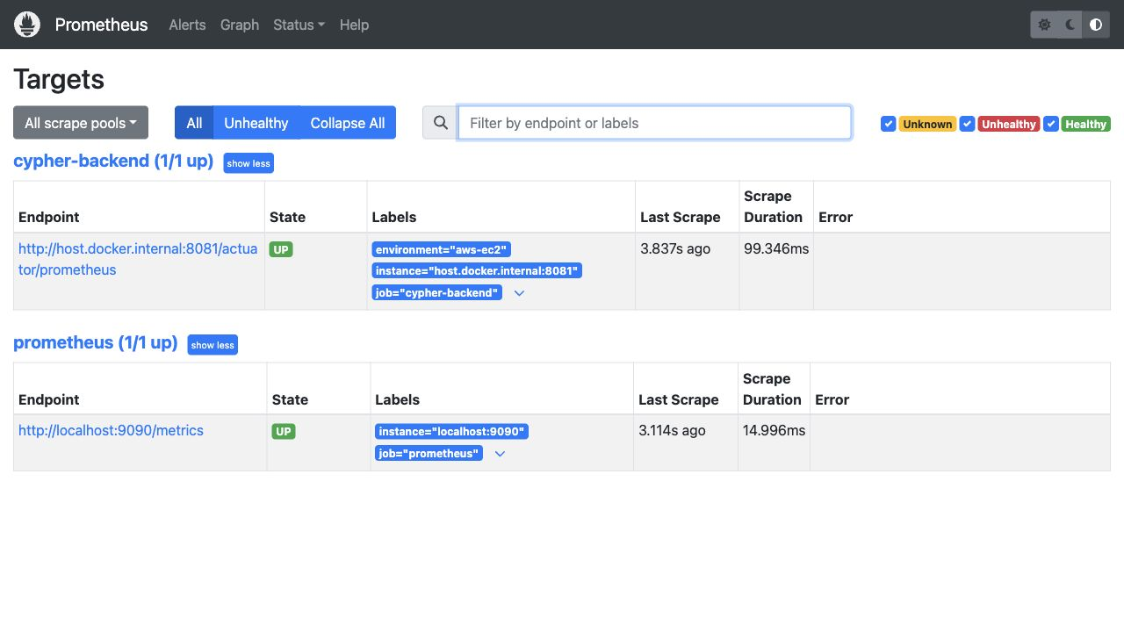
The CYPHER backend and Prometheus targets are both UP.

