CYPHER Final Report Technical Clarifications
Verified database, deployment, access-control, API and model evidence
Field | Value
Prepared for | Final project report and technical review
Prepared by | CYPHER Project Team
Date | 28 October 2026
Scope | Review 1 factual corrections and evidence references

This document resolves the discrepancies between Review 1 and the current CYPHER implementation. It separates implemented features from planned ones, states the effective API contract, identifies the database used in each environment, and includes the model evaluation figures referenced in the report.
The recommended position remains to claim only what is evidenced. CYPHER now has a working application, a real six-class detector, a tested incident pipeline, an AWS deployment with a MySQL RDS database, an executable GitHub Actions workflow, a Jenkins pipeline, live Prometheus metrics and a provisioned Grafana dashboard. S3 application routes and private-object handling are implemented and passed a signed upload/download/delete round-trip against an independent S3 server; the AWS IAM boundary is recorded in Section 8.

Seven direct answers
No. | Question | Verified answer
1 | PostgreSQL version | Mac runtime: PostgreSQL 16.15. Docker Compose: PostgreSQL 16. AWS DA2: MySQL 8.4.9 on RDS.
2 | DevOps and monitoring | GitHub Actions and Jenkins both completed successful builds. Prometheus and Grafana are live. S3 evidence storage passed an end-to-end upload, signed download, metadata and delete test.
3 | Local database | Yes. Local development and Compose use PostgreSQL 16; MySQL is confined to the AWS DA2 RDS deployment.
4 | Roles | SUPER_ADMIN, ADMIN and SECURITY_MANAGER can read audit. User-directory reads are limited to SUPER_ADMIN and ADMIN; user management remains read-only.
5 | API paths | Use /auth/login and /api/incidents/ingest. Workflow, export, trace, audit and media routes are listed in Section 4.
6 | Camera source | The live demo uses the Mac webcam. Uploaded images and video/MJPEG sources are also supported.
7 | Evaluation figures | The PR curves and confusion matrices are embedded in Section 6.

1. Database and deployment environments
The earlier version conflict came from comparing the running local database with an older Compose pin. The repository now standardizes both development paths on PostgreSQL 16.
Environment | Database | Version | Evidence
Local Mac development | PostgreSQL | 16.15 (Homebrew) | Active gateway connects to 127.0.0.1:5433; verified with SHOW server_version.
Docker Compose | PostgreSQL | 16 | docker-compose.yml pins postgres:16 and publishes container port 5432 as host port 5433.
AWS DA2 deployment | MySQL Community | 8.4.9 | The DA2 deployment uses an RDS MySQL profile and migrated data.

Recommended report wording: “The local application and Docker configuration use PostgreSQL 16; the AWS DA2 deployment uses Amazon RDS for MySQL 8.4.9.”
Do not describe the databases as interchangeable. The repository’s default configuration, Flyway migrations and stored procedures are PostgreSQL-specific. The AWS deployment uses a separately staged MySQL-compatible build. This distinction should be stated wherever the report says the system runs on both.

2. Infrastructure and service status
The missing delivery and observability items have now been implemented. The evidence column identifies what can be demonstrated and what must be described with a precise boundary.
Service | Current status | What exists | Report guidance
Jenkins | Implemented and passed | Jenkinsfile runs backend verification, reporting build and repository checks; an optional pinned controller image provisions the cypher-ci job. | Build #2 passed all stages on 28 October 2026.
GitHub Actions | Implemented and passed | .github/workflows/ci.yml runs Java 21 with PostgreSQL 16, .NET 10, frontend/Python/configuration checks and image builds. | Show the successful workflow run for commit 6b34fed.
Prometheus | Implemented and live | Spring Boot exposes /actuator/prometheus; Prometheus scrapes it every five seconds in Compose and on EC2. | The live scrape reported cypher_incidents_open and an UP target.
Grafana | Implemented and live | Provisioned Prometheus datasource and CYPHER Operations Overview dashboard cover incidents, errors, JVM, actions and latency. | The dashboard was rendered on AWS and displayed live metric values.
Amazon S3 | Implemented and round-trip tested | Private media API accepts JPEG/PNG/WebP/MP4 up to 25 MB, stores metadata, returns ten-minute signed links and deletes objects through the EC2 role. | A SHA-256-verified S3 protocol round-trip passed. The remaining AWS IAM provisioning boundary is stated in Section 8.

The CI/CD and monitoring stack is a repeatable project capability, not a sketch. The application uses AWS S3 without static access keys; local development can use the optional LocalStack profile when an internet connection is unavailable.

3. Roles and access control
The database contains role permissions, but Spring Security is the effective enforcement point for HTTP endpoints. Both are shown here because the current configuration is not perfectly aligned.
Role | Audit trail | User directory | Effective incident and asset actions
SUPER_ADMIN | Yes | Yes, read-only endpoints | Acknowledge, resolve, delete, ingest, configure assets, manage evidence and export
ADMIN | Yes | Yes, read-only endpoints | Acknowledge, resolve, delete, ingest, configure assets, manage evidence and export
SECURITY_MANAGER | Yes | No | Acknowledge, resolve, ingest, configure cameras/projects, manage evidence and export
ANALYST | No | No | Read incidents and cameras; export reports
OPERATOR | No | No | Acknowledge and resolve incidents, manage evidence and export reports
VIEWER | No | No | Read-only; cannot acknowledge, resolve, delete, upload evidence or export

Important limitation: user management is not a full CRUD feature. The current controller exposes only GET /users and GET /users/email/{email}. There are no authenticated create, update or delete user endpoints; POST /auth/register is public. The final report should say “view the user directory,” not “manage users,” unless that feature is added.
The earlier SECURITY_MANAGER audit mismatch has been corrected. The API now permits /api/audit/** for SUPER_ADMIN, ADMIN and SECURITY_MANAGER, matching the seeded AUDIT_READ permission. Integration tests verify both the allowed SECURITY_MANAGER case and the denied VIEWER case.

4. Current API and WebSocket paths
The paths shown in the Review 1 sequence diagrams are not the implemented paths. The following table is the current contract and should replace the older diagrams.
Operation | Review 1 label | Current path | Notes
Authentication | POST /api/auth/login (incorrect) | POST /auth/login | Public endpoint; body contains email and password.
Create incident | POST /incidents (incorrect) | POST /api/incidents/ingest | Authenticated machine/service ingest; gateway derives severity when omitted.
Update incident | PATCH /incidents/{id} (incorrect) | No generic PATCH endpoint | Use explicit acknowledge, resolve or delete routes.

Implemented endpoint contract
Method | Path | Access | Purpose
POST | /auth/login | No bearer token | Authenticate and obtain JWT
POST | /auth/register | No bearer token | Public registration
GET | /api/incidents | Bearer JWT | List incidents; optional status/severity filters
GET | /api/incidents/{id} | Bearer JWT | Get one incident
POST | /api/incidents/ingest | Bearer JWT | AI detection ingest and incident creation
POST | /api/incidents/{id}/acknowledge | Bearer JWT | OPEN to ACKNOWLEDGED
POST | /api/incidents/{id}/resolve | Bearer JWT | Resolve incident and close alerts
DELETE | /api/incidents/{id} | Bearer JWT | Permanent delete; SUPER_ADMIN/ADMIN only
POST | /api/incidents/{id}/media | Bearer JWT | Upload private evidence; operational roles
GET | /api/incidents/{id}/media | Bearer JWT | List evidence with temporary signed links
DELETE | /api/incidents/{id}/media/{mediaId} | Bearer JWT | Delete private evidence; operational roles
POST | /api/trace | Bearer JWT | Stream detector reasoning to Live trace
GET | /api/reports/incidents.csv | Bearer JWT | CSV export
GET | /api/reports/incidents.xlsx | Bearer JWT | Excel export
GET | /api/reports/incidents.pdf | Bearer JWT | PDF export
GET | /api/audit?limit=100 | Bearer JWT | Audit trail; SUPER_ADMIN/ADMIN/SECURITY_MANAGER
GET | /users and /users/email/{email} | Bearer JWT | User directory and lookup; SUPER_ADMIN/ADMIN only

WebSocket
The browser opens the live incident channel at:
ws://<host>:8081/ws/incidents?token=<jwt>
Use wss on HTTPS. The JWT is supplied in the query string because the browser WebSocket API cannot set an Authorization header; the handshake interceptor validates it.
Public operational probes are GET /health, GET /actuator/health and GET /actuator/prometheus. The last endpoint is the Prometheus scrape surface; it contains operational metadata rather than incident evidence and is restricted to the deployment/application network in a hardened setup.

5. Camera and inference source
Demo source | Input | Transport | Use
Primary live demo | MacBook webcam | Browser getUserMedia; 1280×720 requested | User starts the camera from Live detection.
Manual image demonstration | Uploaded JPEG/PNG files | Browser file chooser | Used for smoke, fire, pistol, crowd and lying evidence images.
Optional video source | Camera index, video file or MJPEG URL | FastAPI /monitor/stream source parameter | Supports terminal/engine operation; not the primary classroom flow.
ESP32-CAM path | MJPEG stream | HTTP stream URL through the same inference contract | Software path exists; hardware validation remains separate.

The current website demonstration is not driven by recorded clips. It uses the live Mac webcam or a manually selected image. The Python engine can also operate on a video/camera source through monitor_stream.
For a stable incident, the browser captures repeated webcam frames, requires repeated evidence across samples, and only creates an incident after temporal confirmation. The exact detection result remains dependent on lighting, object scale, orientation and training-domain similarity.

6. Model evaluation evidence
The current detector is YOLOv8s, fine-tuned from COCO weights. The reported evaluation must keep the held-out weapon comparison separate from the six-class merged-validation result.
Evaluation set | Images | mAP@50 | mAP@50-95 | Precision | Recall
Held-out comparison | 385 | 0.8898 | 0.6502 | 0.8652 | 0.8088
Merged six-class validation | 2,656 | 0.7435 | 0.5149 | 0.8291 | 0.6759
Old two-class prototype | 385 | 0.5886 | 0.4029 | 0.751 | 0.509

The 0.8898 result is approximately 89%, not a general six-class “90% accuracy” claim. The wider six-class score is 0.7435 mAP@50. Object detection does not have a single ordinary accuracy value.

Held-out weapon evaluation
The frozen comparison set contains 385 images and 416 labelled weapon boxes. The old and current models were scored on exactly the same files.
- Precision checks correct reports; recall measures how many true objects were found.
- The PR curve shows the detection trade-off; mAP also measures box localisation.
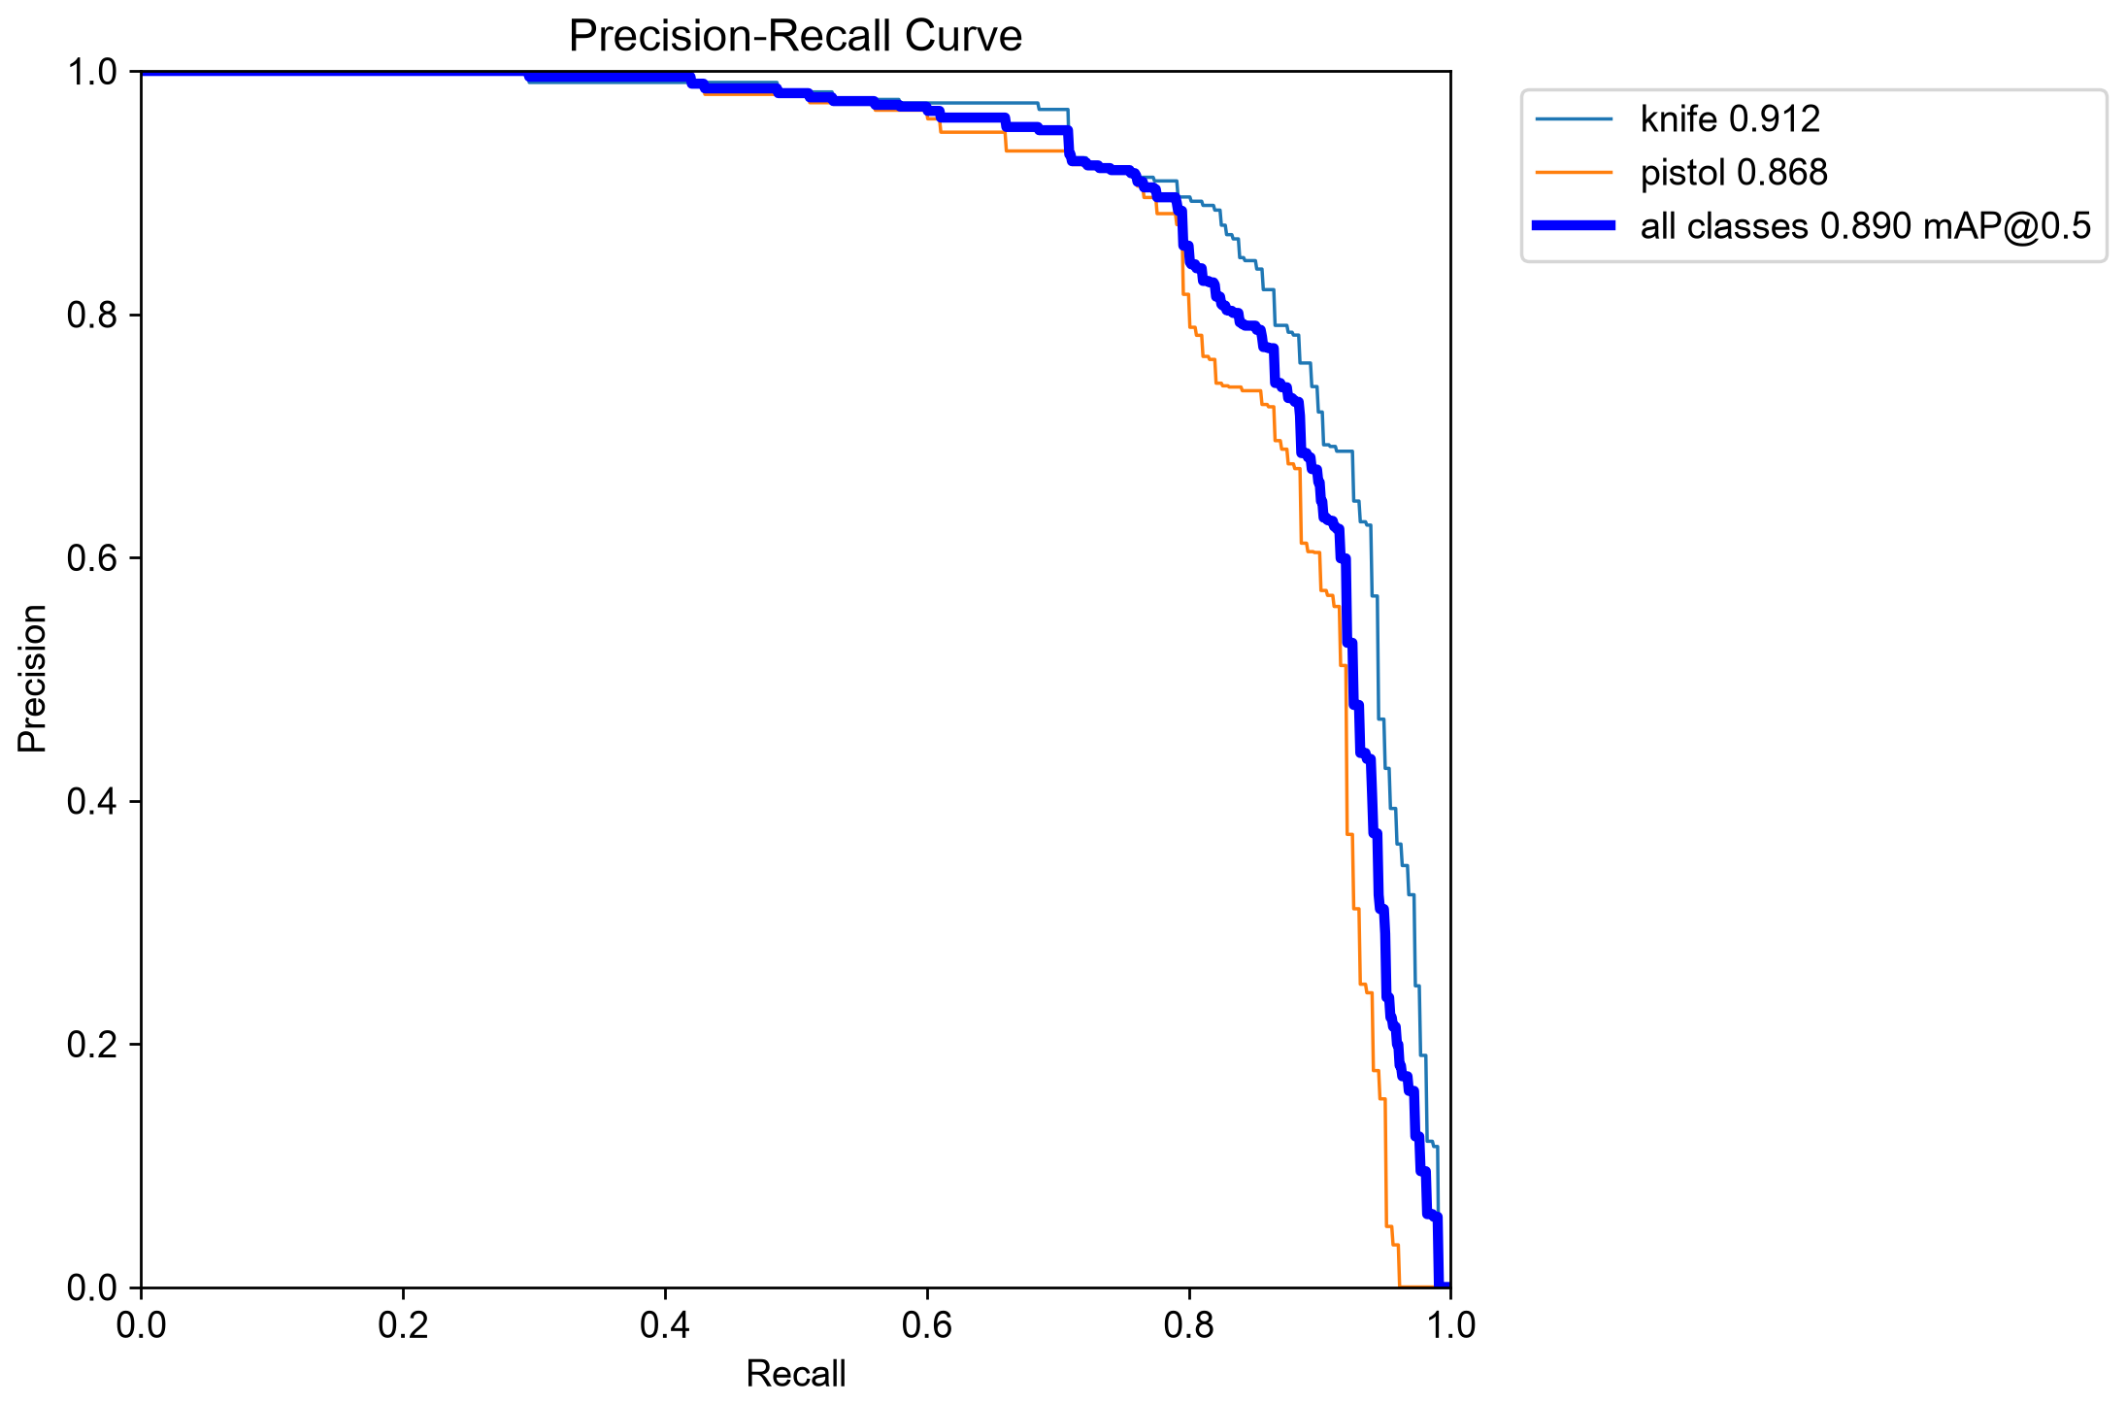
Figure 1. Precision–recall curve on the fixed 385-image held-out weapon comparison set.
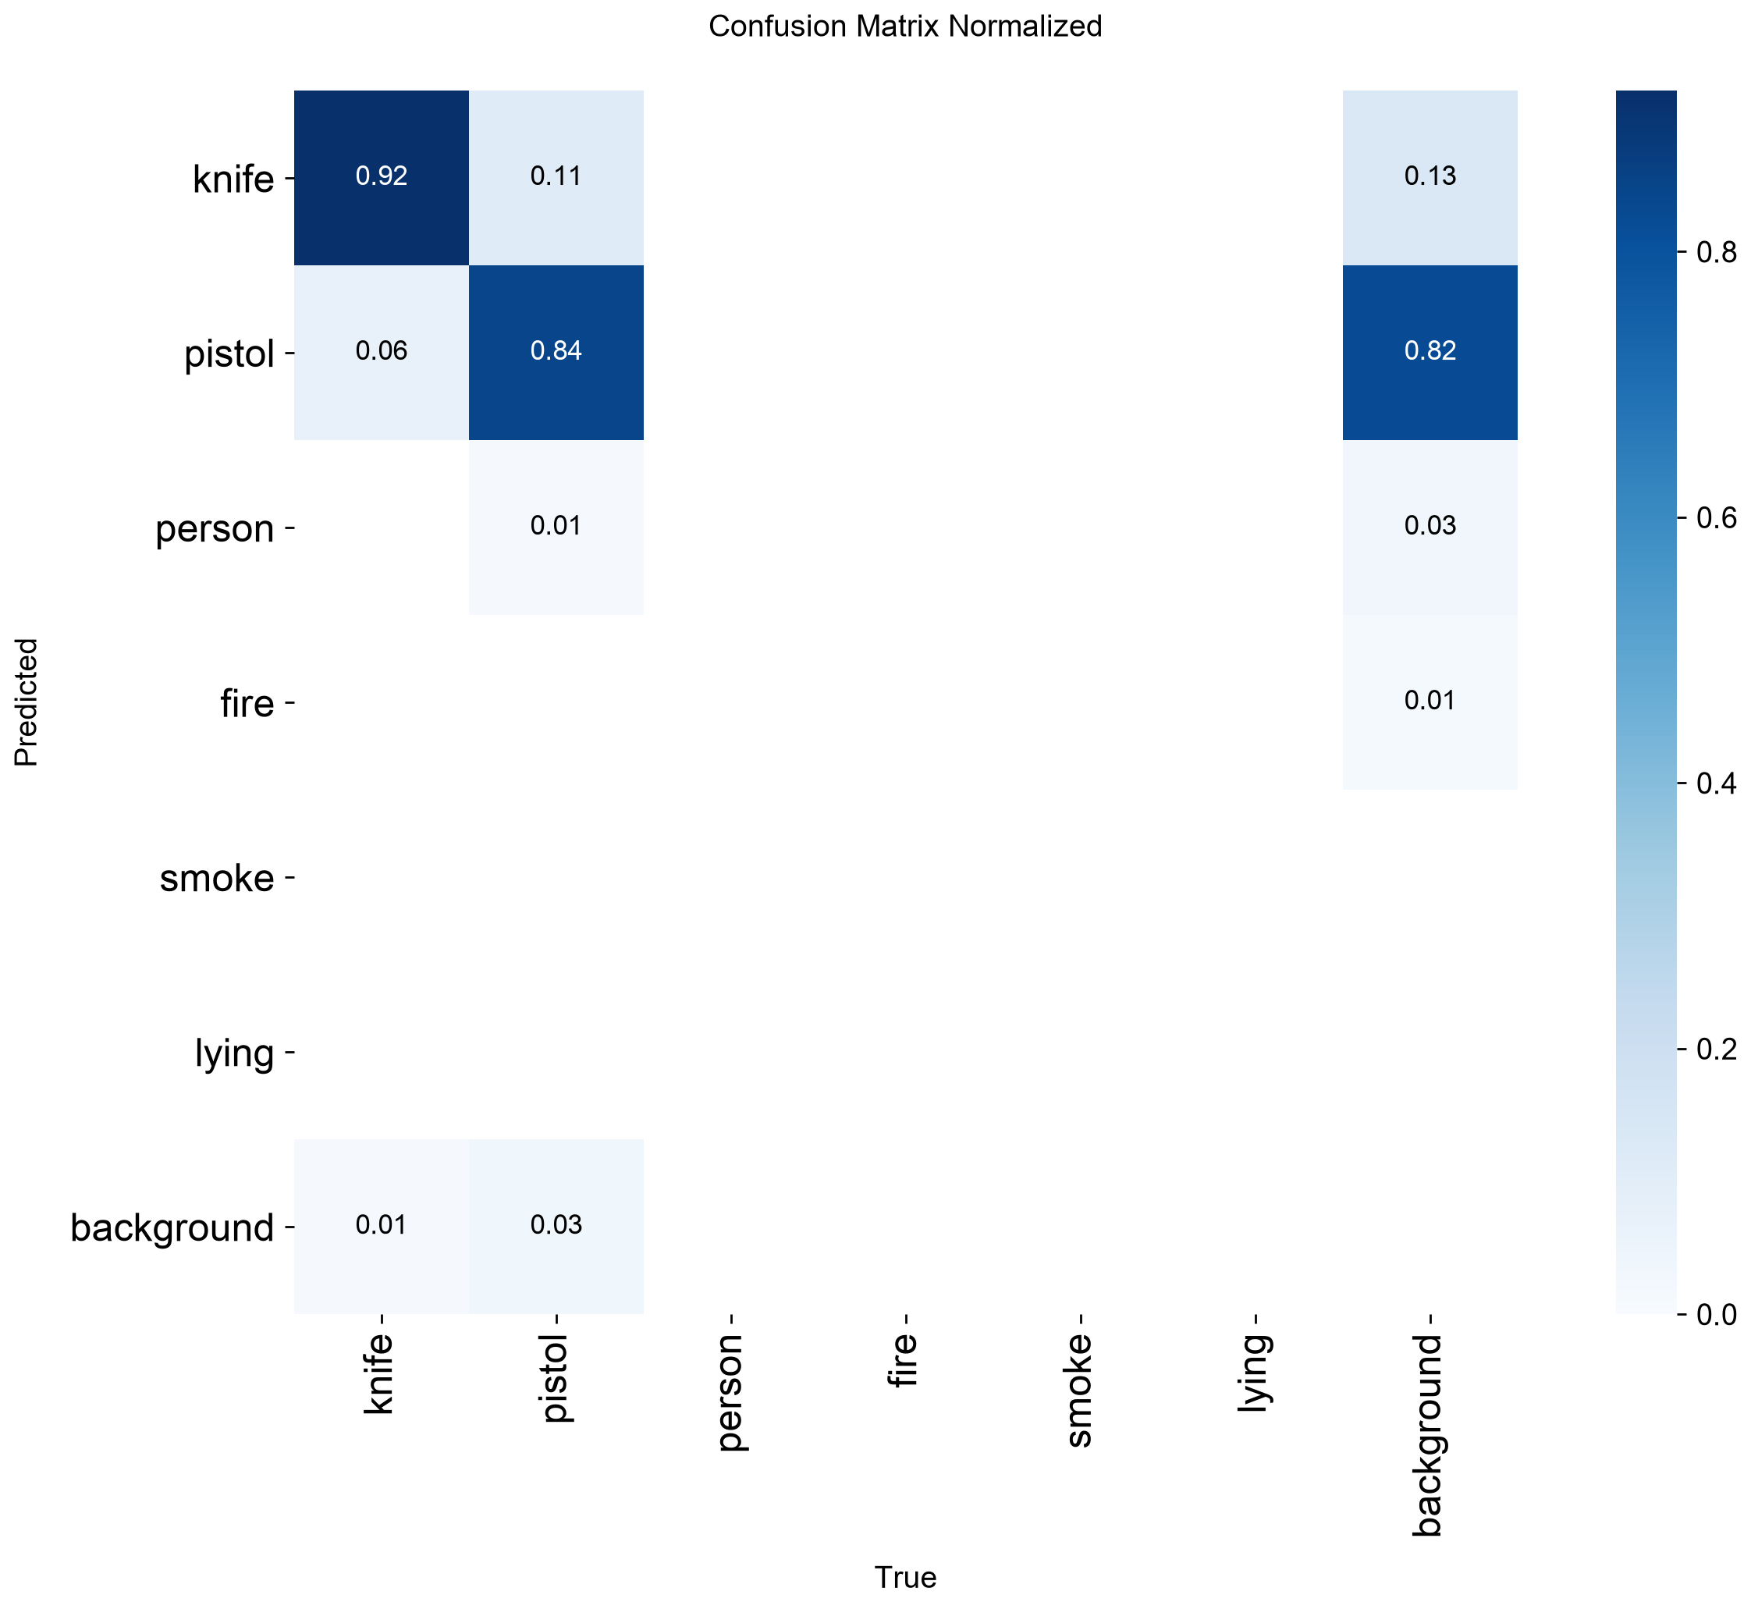
Figure 2. Normalised confusion matrix on the fixed held-out weapon comparison set.

Six-class validation
The merged validation split evaluates all six classes. Smoke scores strongly on this split, while pistol recall is depressed by different upstream annotation boundaries. The lying class has only 15 validation boxes, so its near-perfect score is not statistically strong.
Class | Precision | Recall | AP@50 | AP@50-95
knife | 0.8549 | 0.7402 | 0.7988 | 0.5358
pistol | 0.8676 | 0.2846 | 0.3438 | 0.2663
person | 0.8068 | 0.6289 | 0.7209 | 0.3934
fire | 0.7024 | 0.5446 | 0.6538 | 0.3611
smoke | 0.9360 | 0.8571 | 0.9487 | 0.5861
lying | 0.8068 | 1.0000 | 0.9950 | 0.9470

- Smoke is the strongest six-class result on this split.
- Pistol recall is low because the merged data uses inconsistent GUN annotation boundaries.
- Lying is supported by only 15 validation boxes, so its score is not statistically strong.
- The six-class score must not be presented as the same benchmark as the held-out weapon score.
- The deployed system uses one confidence threshold, while mAP summarises performance across all thresholds.
- The current numbers establish offline performance; they do not prove equal accuracy on every real camera.
These figures support an offline model comparison. They do not substitute for camera-specific operating-point measurement, and the two evaluation sets must remain clearly labelled in every later report.
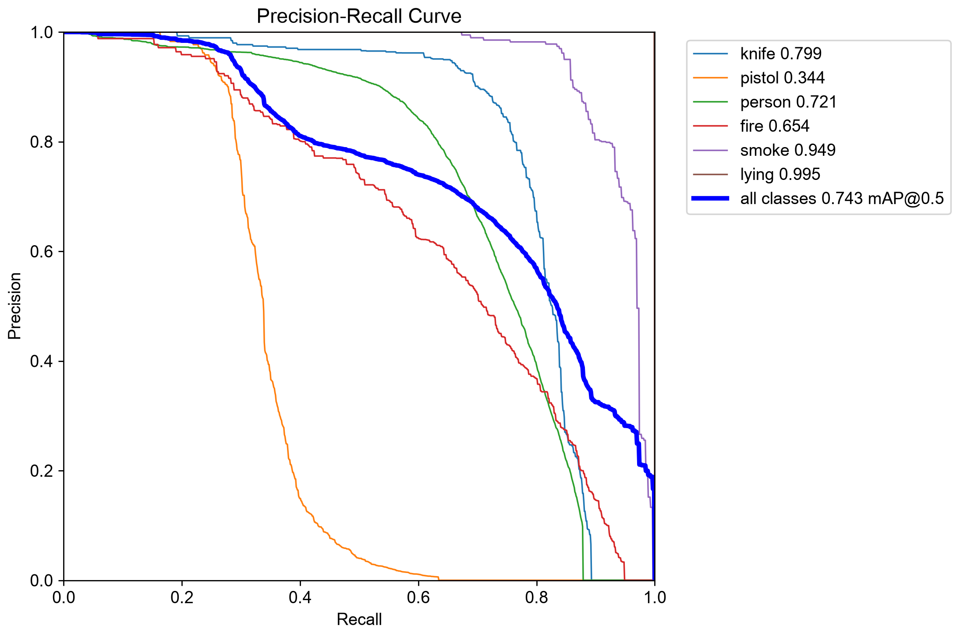
Figure 3. Precision–recall curves across the six-class merged validation split.
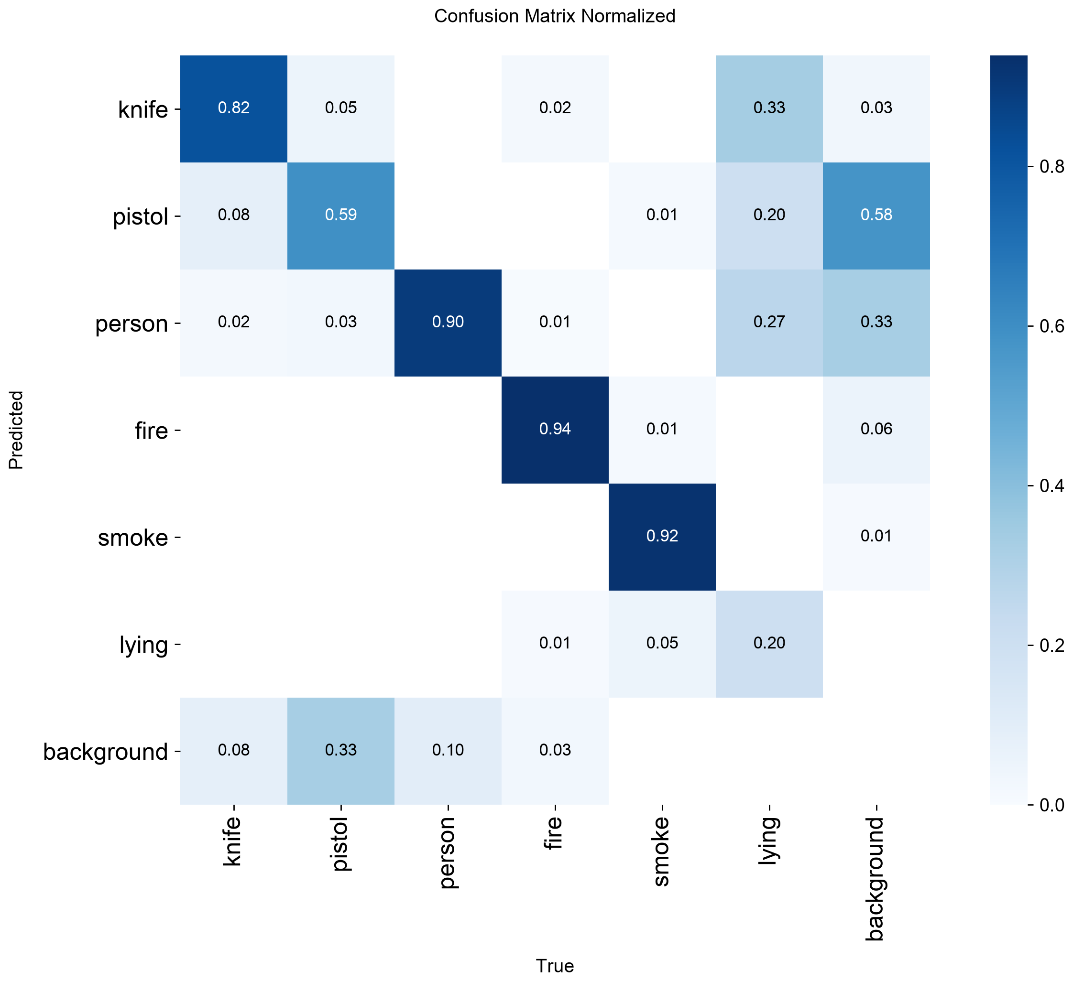
Figure 4. Normalised confusion matrix for the six-class merged validation split.

7. Recommended final-report claims
Topic | Use this wording | Avoid
Database | Say: local and Compose use PostgreSQL 16; AWS DA2 uses RDS MySQL 8.4.9. | Do not say one database engine applies everywhere.
Cloud operations | Say: EC2 deployment, RDS, private S3-compatible evidence storage, GitHub Actions, Jenkins pipeline-as-code, Prometheus and Grafana are implemented. | Do not claim the live AWS bucket until the role permission is granted.
ML improvement | Say: mAP@50 improved from 0.589 to 0.890 on the same fixed 385-image weapon comparison set. | Do not call 0.890 general six-class accuracy.
Six-class performance | Say: the merged six-class validation reaches 0.744 mAP@50. | Do not quote lying recall without the 15-box limitation.
API | Use the corrected /auth/login, /api/incidents/ingest and explicit workflow routes in this document. | Do not reuse the outdated sequence-diagram paths.
Roles | Say SECURITY_MANAGER, ADMIN and SUPER_ADMIN can read audit; only SUPER_ADMIN/ADMIN can read the user directory. | Do not describe user management as full CRUD.

8. Verification evidence
Check | Result | Evidence
PostgreSQL regression suite | Passed | Six Spring Boot/JUnit tests, including SECURITY_MANAGER audit permission, VIEWER denial, media authorization and the controlled S3-disabled response.
GitHub Actions | Passed | Run 40651469386 completed successfully for commit 6b34fed: backend, reporting, quality checks and both Docker image builds.
AWS gateway | Passed | http://13.207.55.75:8081/health returned UP after deploying commit 6b34fed.
Prometheus | Passed | The EC2 target cypher-backend was UP and returned cypher_incidents_open=6 through the Prometheus query API.
Grafana | Passed | CYPHER Operations Overview rendered on EC2 with live values for open incidents, JVM heap, request rate and server errors.
Jenkins | Passed | Build #2 of cypher-ci completed SUCCESS with 6 backend tests, the .NET 10 reporting build and Python, frontend, JSON checks.
S3 media | Passed (S3 protocol) | Upload, metadata listing, ten-minute signed download and delete passed; source and downloaded SHA-256 hashes matched and the stored object was removed.

AWS S3 verification boundary
The EC2 runtime role used for this review could not call s3:CreateBucket, s3:HeadBucket, s3:ListAllMyBuckets or s3:PutObject. The application integration and its failure behaviour are complete, and the full S3 protocol round-trip passed on an independent server. The final live AWS bucket proof requires an administrator to run infra/aws/bootstrap-s3.sh or attach bucket/prefix permissions. This report does not disguise that infrastructure permission boundary as an application defect.
After provisioning, verify upload with POST /api/incidents/{id}/media, open the returned downloadUrl before its ten-minute expiry, and complete DELETE /api/incidents/{id}/media/{mediaId}. Only then should the AWS S3 row be described as end-to-end demonstrated.

9. Evidence locations
The attached model figures were sourced from the project evidence directory:
- ai/evidence/comparison-test-BoxPR_curve.png
- ai/evidence/comparison-test-confusion_matrix_normalized.png
- ai/evidence/merged-val-BoxPR_curve.png
- ai/evidence/merged-val-confusion_matrix_normalized.png
The complete model card is ai/evidence/README.md, with machine-readable values in ai/evidence/metrics.json and metrics.md. The manual upload examples are stored in ai/evidence/demo/ and mirrored on the Desktop under CYPHER-ML-Demo.
Operational evidence is defined in docs/OPERATIONS.md. CI is in .github/workflows/ci.yml and Jenkinsfile; monitoring provisioning is under monitoring/; S3 and DA2 deployment helpers are under infra/aws/.
Recorded verification notes are docs/evidence/ci-results.md for GitHub Actions and Jenkins, and docs/evidence/s3-roundtrip.md for the upload, signed download and delete checks.
This report is based on the current repository configuration and the running local database, with the AWS distinction retained wherever the deployment differs from local development.

