Title:
EEG Epileptic Seizure Detection using Logistic Regression and Neural Networks

Author: Adithya Vinayak Patil.
Date: 29th August 2025.

ABSTRACT:
Epileptic seizure detection is a critical problem in medical diagnostics and neurophysiological research. This project evaluates and compares two machine learning approaches for classifying electroencephalogram (EEG) signals: a baseline Logistic Regression (LR) model and a more advanced Neural Network (NN).
The dataset used is the Bangalore EEG Epilepsy Dataset (BEED), which contains 16,000 balanced EEG segments recorded from 20 adult subjects using the 10-20 electrode system. The data includes four categories: healthy subjects, generalized seizures, focal seizures, and seizure events. Preprocessing steps included feature scaling and train-test splitting.
Results indicate that Logistic Regression achieved an overall accuracy of 47%, struggling to model the complex non-linear dynamics of EEG data. In contrast, the Neural Network achieved 93% accuracy, with strong performance across all four categories. These findings highlight the advantage of deep learning architectures in modeling non-linear, high-dimensional biomedical signals.

1. Introduction
Epilepsy affects millions worldwide, making seizure detection an important area of healthcare and biomedical research. Traditional methods rely heavily on manual EEG interpretation by neurologists, which is time-consuming and error-prone. Machine learning models provide a faster, scalable approach to classify EEG signals and aid in early diagnosis.
This project explores and compares two models: Logistic Regression, a simple linear classifier, and Neural Networks, capable of capturing non-linear relationships in EEG data. The goal is to evaluate their effectiveness on the BEED dataset and analyze their relative strengths and weaknesses.

2. Dataset Description

The Bangalore EEG Epilepsy Dataset (BEED) is a high-fidelity EEG collection recorded at a neurological research centre in Bangalore, India.

- Size: 16,000 segments of 20-second recordings
- Classes (4):
  - Healthy Subjects (0)
  - Generalized Seizures (1)
  - Focal Seizures (2)
  - Seizure Events (3, e.g., eye blinking, nail biting, staring)
- Subjects: 20 adults (ages 21–55), equal gender distribution
- Electrode System: Standard 10-20, 16 EEG channels (X1–X16)
- Sampling Rate: 256 Hz
- Label: Binary seizure presence indicator (y)

This dataset is balanced across categories, making it suitable for model benchmarking in seizure detection.

3. Methodology

3.1 Preprocessing
- Imported EEG data in CSV format.
- Split dataset into features (X1–X16) and labels (y).
- Applied StandardScaler normalization for feature scaling.
- Performed train-test split (80:20).
3.2 Logistic Regression
- Implemented using scikit-learn.
- Evaluated using accuracy, precision, recall, F1-score, and confusion matrix.
3.3 Neural Network
- Implemented in TensorFlow/Keras.
- Architecture included multiple dense layers with Batch Normalization, LeakyReLU / ReLU activations, Dropout layers, and L2 regularization.
- Optimizer: Adam (learning rate 0.001).
- Loss function: Sparse Categorical Crossentropy.
- Early stopping applied to prevent overfitting.
- Evaluated using same metrics as LR.

4. Results
4.1 Logistic Regression
- Accuracy: 47%
- Struggled across all four classes, indicating poor ability to capture non-linear EEG features.
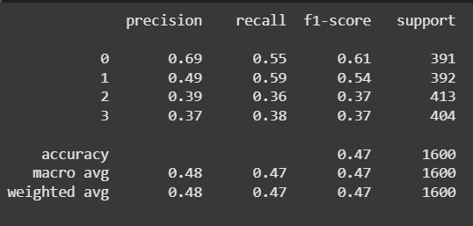

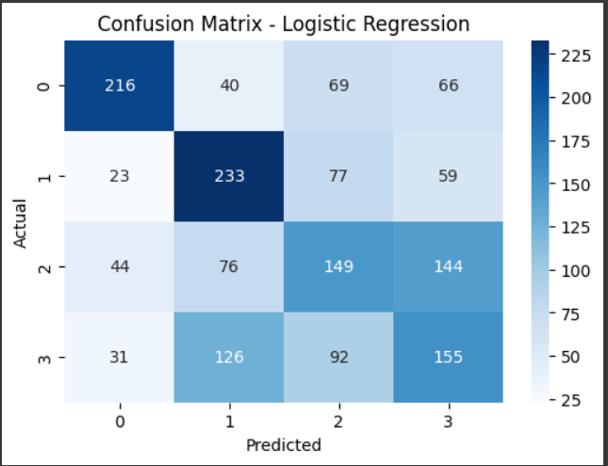

4.2 Neural Network
- Accuracy: 93%
- Excellent performance across all classes.
- Class 0 (Healthy) detected with perfect precision and recall.
- Slightly lower recall observed in seizure event class, but overall strong generalization.

CONFUSION MATRIX:
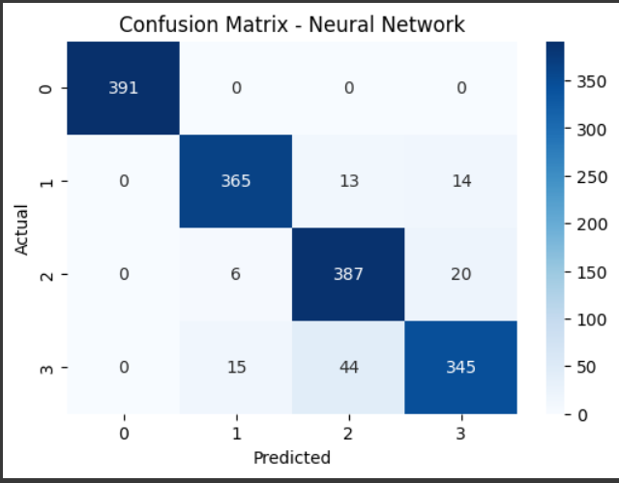

CLASSIFICATION REPORT:
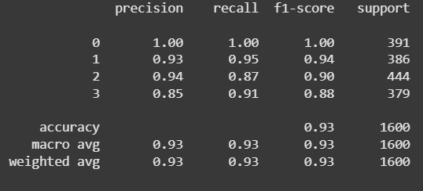
VALIDATION VS TRAINING LOSS CURVE:
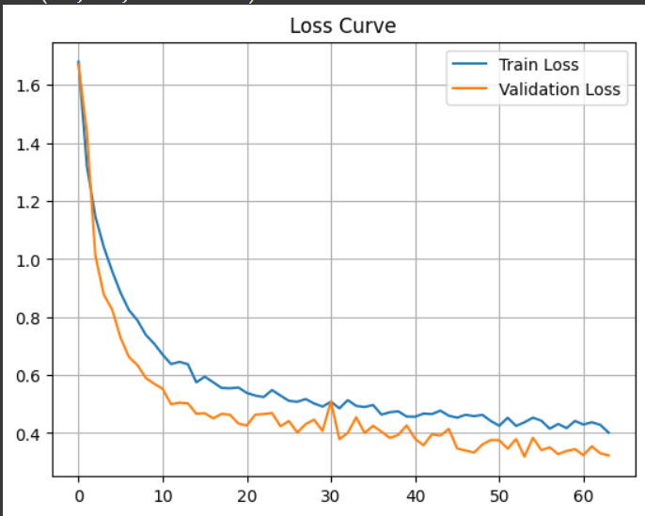

5. Discussion and Observations
The comparative results reveal clear differences in model capabilities:
- Logistic Regression, being a linear classifier, failed to capture the complex spatio-temporal patterns in EEG signals, reflected in its low overall accuracy.
- The Neural Network demonstrated superior feature representation learning, capturing hidden non-linear relationships, resulting in significant performance improvement.
- Loss curves confirm effective training without severe overfitting due to early stopping and dropout regularization.
- Neural Network’s strong classification ability suggests deep learning is more suitable for EEG analysis compared to traditional linear methods.

6. Conclusion and Future Work
This project demonstrates that Neural Networks significantly outperform Logistic Regression in epileptic seizure detection using the BEED dataset. With an accuracy of 93%, the NN model shows strong potential for practical applications in clinical decision support systems.
Future Work:
- Implementing Convolutional Neural Networks (CNNs) to better capture temporal-spatial EEG patterns.
- Exploring Recurrent Neural Networks (RNNs/LSTMs) for sequential EEG signal modeling.
- Applying hyperparameter tuning and cross-validation for further optimization.
- Investigating transfer learning approaches with larger EEG datasets.

7. References
- BEED Dataset:
https://archive.ics.uci.edu/dataset/1134/beed:+bangalore+eeg+epilepsy+dataset
- Scikit-learn Documentation.
- TensorFlow/Keras Documentation.

8. Appendix
- Google Colab Notebook Link:
https://colab.research.google.com/drive/1RER-E9sNotQl0c8kLn1IGRQGOUuErW6m?usp=sharing

