**DESIGN PRINCIPLES AND PATTERNS HANDS-ON**

**Exercise 1: Implementing the Singleton Pattern**

**Code:**

Main.java

public class Main {

public static void main(String[] args){

Logger logger1 = Logger.getInstance();

Logger logger2 = Logger.getInstance();

logger1.log("This is first log message");

logger2.log("This is second log message");

if(logger1==logger2)

{

System.out.println("Both are at the same instance");

}

else

{

System.out.println("Both are in different instance");

}

}

}

Logger.java

public class Logger {

private static Logger instance;

private Logger() {

System.out.println("Logger Created");

}

public static Logger getInstance() {

if (instance == null)

{

instance = new Logger();

}

return instance;

}

public void log(String message)

{ System.out.println("[Log]:"+ message);

}

}

**Output:**

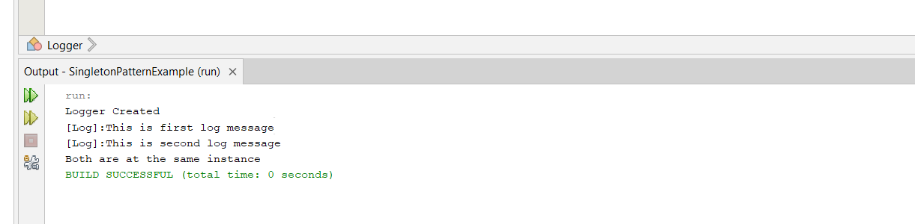

**Exercise 2: Implementing the Factory Method Pattern**

Code:

public class FactoryMethodExample {

interface Document {

void open();

}

static class WordDocument implements Document {

public void open() {

System.out.println("Opening a Word document.");

} }

static class PdfDocument implements Document {

public void open() {

System.out.println("Opening a PDF document.");

}

}

static class ExcelDocument implements Document {

public void open() {

System.out.println("Opening an Excel document."); }

}

abstract static class DocumentFactory {

public abstract Document createDocument();

}

static class WordDocumentFactory extends DocumentFactory {

public Document createDocument() {

return new WordDocument(); }

}

static class PdfDocumentFactory extends DocumentFactory {

public Document createDocument() {

return new PdfDocument(); }

}

static class ExcelDocumentFactory extends DocumentFactory {

public Document createDocument() {

return new ExcelDocument(); }

}

public static void main(String[] args) {

DocumentFactory wordFactory = new WordDocumentFactory();

Document word = wordFactory.createDocument();

word.open();

DocumentFactory pdfFactory = new PdfDocumentFactory();

Document pdf = pdfFactory.createDocument();

pdf.open();

DocumentFactory excelFactory = new ExcelDocumentFactory();

Document excel = excelFactory.createDocument();

excel.open();

}

}

**Output:**

