**Week-7 React Mandatory Hands-On**

**9. ReactJS-HOL**

App.js

import React from "react";

function ListOfPlayers() {

const players = [

{ name: "Player1", score: 85 },

{ name: "Player2", score: 65 },

{ name: "Player3", score: 90 },

{ name: "Player4", score: 55 },

{ name: "Player5", score: 72 },

{ name: "Player6", score: 45 },

{ name: "Player7", score: 88 },

{ name: "Player8", score: 60 },

{ name: "Player9", score: 95 },

{ name: "Player10", score: 40 },

{ name: "Player11", score: 78 }

];

const players70 = [];

players.map((item) => {

if (item.score <= 70) {

players70.push(item);

}

return null;

});

return (

<div>

<h2>All Players</h2>

<ul>

{players.map((item) => (

<li key={item.name}>

Mr. {item.name} <span>{item.score}</span>

</li>

))}

</ul>

<h2>Players with score ≤ 70</h2>

<ul>

{players70.map((item) => (

<li key={item.name}>

Mr. {item.name} <span>{item.score}</span>

</li>

))}

</ul>

</div>

);

}

export function OddPlayers({ first, third, fifth }) {

return (

<div>

<li>First: {first}</li>

<li>Third: {third}</li>

<li>Fifth: {fifth}</li>

</div>

);

}

export function IndianPlayersList() {

const T20Players = ["First Player", "Second Player", "Third Player"];

const RanjiTrophyPlayers = ["Fourth Player", "Fifth Player", "Sixth Player"];

const IndianPlayers = [...T20Players, ...RanjiTrophyPlayers];

return (

<div>

<h2>Indian Players</h2>

<ul>

{IndianPlayers.map((player, index) => (

<li key={index}>{player}</li>

))}

</ul>

</div>

);

}

export default function App() {

const flag = true;

return (

<div>

<h1>Cricket App</h1>

<ListOfPlayers />

{flag ? (

<IndianPlayersList />

) : (

<OddPlayers

first="First Player"

third="Third Player"

fifth="Fifth Player"

/>

)}

</div>

);

}

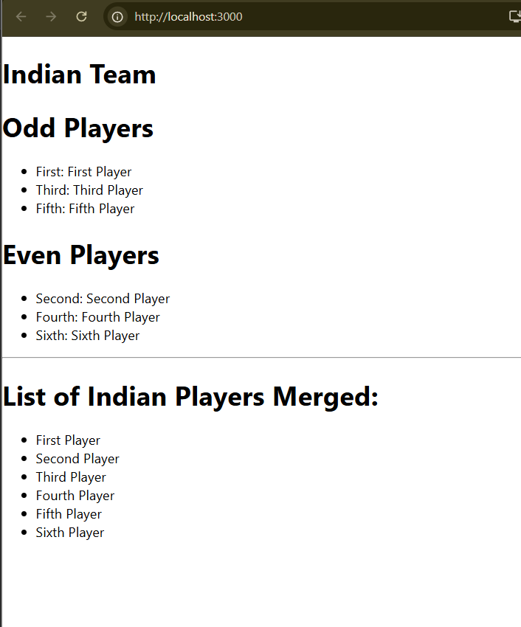Output:

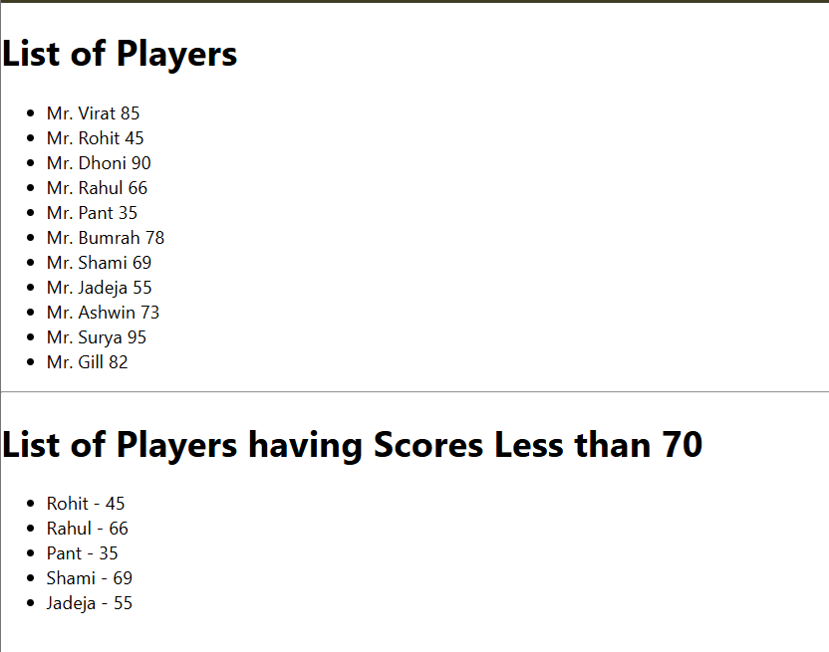

**10. ReactJS-HOL**

**App.js**

import React from "react";

export default function App() {

const element = "Office Space";

const jsxatt = (

<img

src="https://via.placeholder.com/300x200"

width="25%"

height="25%"

alt="Office Space"

/>

);

const ItemName = { Name: "DBS", Rent: 50000, Address: "Chennai" };

const officeList = [

{ Name: "DBS", Rent: 50000, Address: "Chennai" },

{ Name: "WeWork", Rent: 75000, Address: "Bangalore" },

{ Name: "Regus", Rent: 60000, Address: "Hyderabad" },

{ Name: "SmartSpace", Rent: 45000, Address: "Pune" }

];

const getRentColor = (rent) => {

return { color: rent <= 60000 ? "red" : "green" };

};

return (

<div style={{ padding: "20px" }}>

{/* Heading */}

<h1>

{element}, at Affordable Range

</h1>

{/* Single office object */}

{jsxatt}

<h1>Name: {ItemName.Name}</h1>

<h3 style={getRentColor(ItemName.Rent)}>Rent: Rs. {ItemName.Rent}</h3>

<h3>Address: {ItemName.Address}</h3>

<hr />

{/* List of offices */}

<h2>Available Office Spaces</h2>

{officeList.map((office, index) => (

<div key={index} style={{ marginBottom: "15px" }}>

<h3>Name: {office.Name}</h3>

<h4 style={getRentColor(office.Rent)}>

Rent: Rs. {office.Rent}

</h4>

<h4>Address: {office.Address}</h4>

</div>

))}

</div>

);

}

**Output:**



**11. ReactJS-HOL**

App.js

import React, { Component } from "react";

class CurrencyConvertor extends Component {

  constructor(props) {

    super(props);

    this.state = {

      amount: "",

      currency: ""

    };

  }

  handleChange = (event) => {

    this.setState({ [event.target.name]: event.target.value });

  };

  handleSubmit = (event) => {

    event.preventDefault();

    let euroRate = 80; // 1 Euro = 80 INR

    let euroAmount = this.state.amount / euroRate;

    alert(`Converting to Euro Amount is ${euroAmount}`);

  };

  render() {

    return (

      <div>

        <h2 style={{ color: "green" }}>Currency Convertor!!!</h2>

        <form onSubmit={this.handleSubmit}>

          <div>

            Amount:{" "}

            <input

              type="number"

              name="amount"

              value={this.state.amount}

              onChange={this.handleChange}

            />

          </div>

          <div>

            Currency:{" "}

            <input

              type="text"

              name="currency"

              value={this.state.currency}

              onChange={this.handleChange}

            />

          </div>

          <div>

            <button type="submit">Submit</button>

          </div>

        </form>

      </div>

    );

  }

}

class App extends Component {

  constructor(props) {

    super(props);

    this.state = {

      count: 0

    };

  }

  increment = () => {

    this.setState({ count: this.state.count + 1 });

  };

  sayHello = () => {

    alert("Hello! Member1");

  };

  decrement = () => {

    this.setState({ count: this.state.count - 1 });

  };

  sayMessage = (message) => {

    alert(message);

  };

  handleClick = (e) => {

    alert("I was clicked");

  };

  render() {

    return (

      <div>

        <h1>{this.state.count}</h1>

        <button onClick={() => { this.increment(); this.sayHello(); }}>Increment</button>

        <button onClick={this.decrement}>Decrement</button>

        <button onClick={() => this.sayMessage("welcome")}>Say welcome</button>

        <button onClick={this.handleClick}>Click on me</button>

        <CurrencyConvertor />

      </div>

    );

  }

}

export default App;

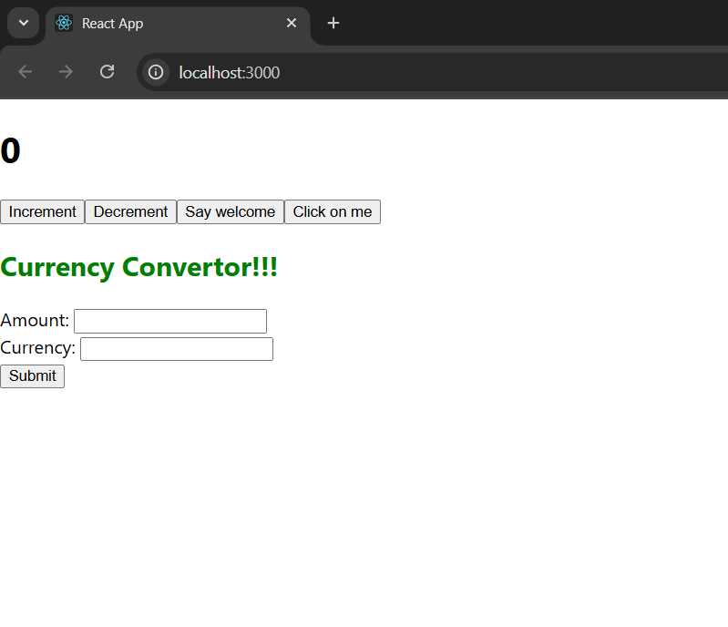**Output:**

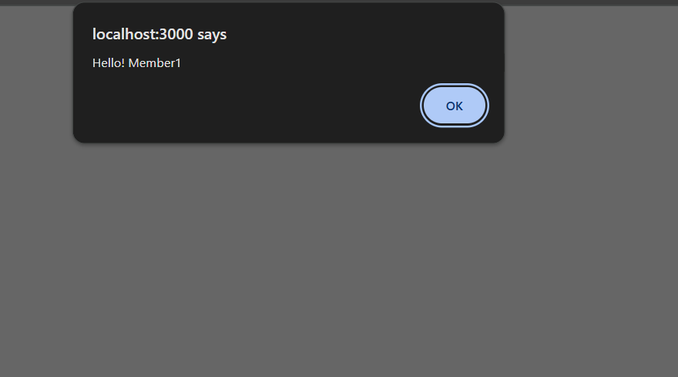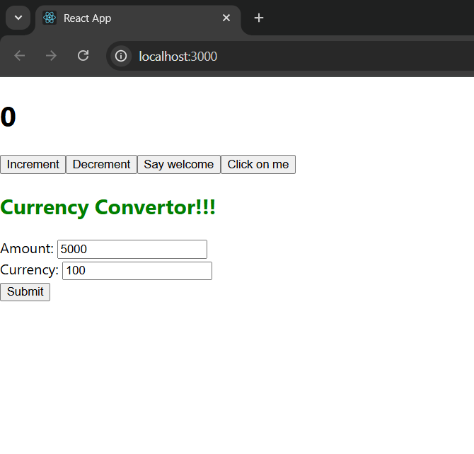

**12. ReactJS-HOL**

App.js

import React, { useState } from "react";

import "./App.css";

function GuestPage({ onLogin }) {

return (

<div className="page">

<h1>Welcome to Flight Booking</h1>

<p>Browse flights below. Login to book tickets.</p>

<FlightDetails />

<button onClick={onLogin}>Login</button>

</div>

);

}

function UserPage({ onLogout }) {

return (

<div className="page">

<h1>Welcome Back, User!</h1>

<p>You can now book tickets for your desired flights.</p>

<FlightDetails />

<BookTickets />

<button onClick={onLogout}>Logout</button>

</div>

);

}

function FlightDetails() {

const flights = [

{ id: 1, destination: "New York", price: 450 },

{ id: 2, destination: "London", price: 600 },

{ id: 3, destination: "Tokyo", price: 800 }

];

return (

<div>

<h2>Available Flights</h2>

<ul>

{flights.map((flight) => (

<li key={flight.id}>

{flight.destination} - ${flight.price}

</li>

))}

</ul>

</div>

);

}

function BookTickets() {

const [selectedFlight, setSelectedFlight] = useState("");

if (!selectedFlight) {

return (

<div>

<h3>Select a flight to book</h3>

<select onChange={(e) => setSelectedFlight(e.target.value)}>

<option value="">-- Select --</option>

<option value="New York">New York</option>

<option value="London">London</option>

<option value="Tokyo">Tokyo</option>

</select>

</div>

);

}

return (

<div>

<h3>Booking Confirmation</h3>

<p>You have booked your flight to <strong>{selectedFlight}</strong> successfully!</p>

</div>

);

}

function App() {

const [isLoggedIn, setIsLoggedIn] = useState(false);

let content;

if (isLoggedIn) {

content = <UserPage onLogout={() => setIsLoggedIn(false)} />;

} else {

content = <GuestPage onLogin={() => setIsLoggedIn(true)} />;

}

return <div className="App">{content}</div>;

}

export default App;

**Output:**

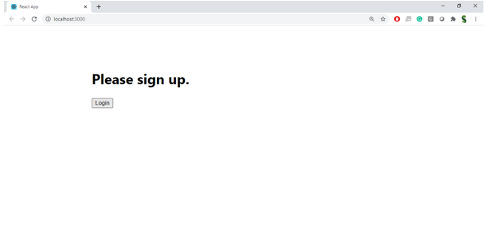

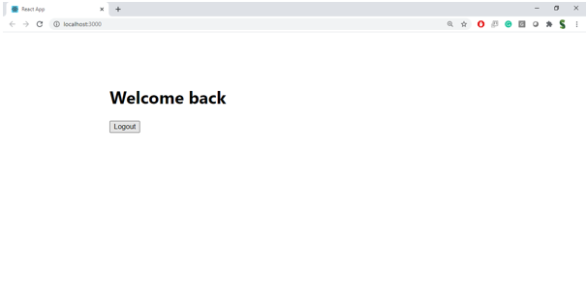

**13. ReactJS-HOL**

**App.js**

import React, { useState } from "react";

function App() {

const [view, setView] = useState("books");

const [showCourses, setShowCourses] = useState(true);

const courses = [

{ id: 1, title: "React Basics", price: "$50" },

{ id: 2, title: "Advanced JavaScript", price: "$75" },

{ id: 3, title: "Node.js Mastery", price: "$100" }

];

let content;

if (view === "books") {

content = <BookDetails />;

} else if (view === "blogs") {

content = <BlogDetails />;

} else {

content = <CourseDetails courses={courses} />;

}

return (

<div style={{ padding: "20px" }}>

<h1>Blogger App</h1>

{/* Buttons to switch view */}

<div>

<button onClick={() => setView("books")}>Show Books</button>

<button onClick={() => setView("blogs")}>Show Blogs</button>

<button onClick={() => setView("courses")}>Show Courses</button>

</div>

<hr />

{/* Conditional Rendering - Element Variable */}

<h2>Element Variable Example:</h2>

{content}

<hr />

{/* Conditional Rendering - Ternary Operator */}

<h2>Ternary Example:</h2>

{view === "books" ? <BookDetails /> : <BlogDetails />}

<hr />

{/* Conditional Rendering - Logical && */}

<h2>Logical && Example (Show courses if true):</h2>

{showCourses && <CourseDetails courses={courses} />}

<button onClick={() => setShowCourses(!showCourses)}>

Toggle Courses

</button>

<hr />

{/* Rendering multiple components */}

<h2>Multiple Components Rendered Together:</h2>

<BookDetails />

<BlogDetails />

<CourseDetails courses={courses} />

</div>

);

}

function BookDetails() {

const books = [

{ id: 1, name: "The Alchemist", author: "Paulo Coelho" },

{ id: 2, name: "Atomic Habits", author: "James Clear" }

];

const bookList = books.map(book => (

<li key={book.id}>

{book.name} - {book.author}

</li>

));

return (

<div>

<h2>Book Details</h2>

<ul>{bookList}</ul>

</div>

);

}

function BlogDetails() {

const blogs = [

{ id: 1, title: "Learning React", author: "John Doe" },

{ id: 2, title: "Advanced React Patterns", author: "Jane Smith" }

];

return (

<div>

<h2>Blog Details</h2>

<ul>

{blogs.map(blog => (

<li key={blog.id}>

{blog.title} - {blog.author}

</li>

))}

</ul>

</div>

);

}

function CourseDetails({ courses }) {

if (!courses || courses.length === 0) {

return <p>No courses available</p>; // Prevent rendering if empty

}

return (

<div>

<h2>Course Details</h2>

<ul>

{courses.map(course => (

<CourseItem key={course.id} course={course} />

))}

</ul>

</div>

);

}

function CourseItem({ course }) {

return (

<li>

{course.title} - {course.price}

</li>

);

}

export default App;

**Output:**

