|  |  |
| --- | --- |
| **Ex. No. 4** | **Design a Sign-In and Sign-Up Page with Navigation Bar using CSS Position and Forms** |
| **Date of Exercise** | 01-2-2022 |
| **Web Host Link** | [Exercise 4](https://dichogamous-decreme.000webhostapp.com/Web%20Dev%20Exercise%204/index.html) |
| **YouTube Link** |  |

**Aim**

Design a Sign-In and Sign-Up Page with Navigation Bar using CSS Position and Forms

**Description**

Navigation Bars

Having easy-to-use navigation is important for any web site.

With CSS you can transform boring HTML menus into good-looking navigation bars.’

A navigation bar is basically a list of links, so using the <ul> and <li> elements makes perfect sense

There are two ways to create a horizontal navigation bar. Using inline or floating list items.

One way to build a horizontal navigation bar is to specify the <li> elements as inline

li {

display: inline;

}

display: inline; - By default, <li> elements are block elements. Here, we remove the line breaks before and after each list item, to display them on one line

Another way of creating a horizontal navigation bar is to float the <li> elements, and specify a layout for the navigation links:

li {

float: left;

}

a {

display: block;

padding: 8px;

background-color: #dddddd;

}

float: left; - Use float to get block elements to float next to each other

display: block; - Allows us to specify padding (and height, width, margins, etc. if you want)

padding: 8px; - Specify some padding between each <a> element, to make them look good

background-color: #dddddd; - Add a gray background-color to each <a> element

Styling Input Fields

Use the width property to determine the width of the input field

input[type=text] - will only select text fields

input[type=password] - will only select password fields

input[type=number] - will only select number fields

Padded Inputs

Use the padding property to add space inside the text field.

Bordered Inputs

Use the border property to change the border size and color, and use the border-radius property to add rounded corners

Colored Inputs

Use the background-color property to add a background color to the input, and the color property to change the text color:

Focused Inputs

By default, some browsers will add a blue outline around the input when it gets focus (clicked on). You can remove this behavior by adding outline: none; to the input.

The position Property

The position property specifies the type of positioning method used for an element.

There are five different position values:

static

relative

fixed

absolute

sticky

position: static;

An element with position: static; is not positioned in any special way; it is always positioned according to the normal flow of the page:

position: relative;

An element with position: relative; is positioned relative to its normal position.

position: fixed;

An element with position: fixed; is positioned relative to the viewport, which means it always stays in the same place even if the page is scrolled. The top, right, bottom, and left properties are used to position the element.

position: absolute;

An element with position: absolute; is positioned relative to the nearest positioned ancestor (instead of positioned relative to the viewport, like fixed).

position: sticky;

An element with position: sticky; is positioned based on the user's scroll position.

**Program**

**HTML code:**

<!DOCTYPE html>

<html>

<head>

<title>Exercise 4</title>

<meta charset="UTF-8">

<meta name="viewport" content="width=device-width, initial-scale=1.0">

<link href="customstyle.css" rel="stylesheet">

</head>

<body>

<!-- Navigation Bar -->

<ul class='navbar'>

<li><a href='https://www.riotgames.com/en/work-with-us'>Work with us</a></li>

<li><a href='https://www.riotgames.com/en/who-we-are'>Who we are</a></li>

<li><a href='https://www.leagueoflegends.com/en-gb/'>League of Legends</a></li>

<li><a href='https://playvalorant.com/en-gb/'>Valorant</a></li>

<li><a href='https://teamfighttactics.leagueoflegends.com/en-gb/'>Team Fight Tactics</a></li>

</ul>

<!-- Background images with sign-in and sign-up -->

<div class='epic1'>

<div class='signin'>

<form>

<h1>Sign In</h1>

<label>Username &nbsp;</label>

<input type='text' placeholder="Enter username" ><!-- Username input -->

<label>Password &nbsp;</label>

<input type='password' placeholder="Enter password"><!-- Password input -->

<input type='submit' value='Login'>

</form>

</div>

<div class='signup'>

<form>

<h2>Sign up</h2>

<label>Name &nbsp;</label>

<input type='text' placeholder="Enter name" ><!-- Name input -->

<label>Email</label>

<input type="text" placeholder="Enter Email"><!--Email Input-->

<label>Password &nbsp;</label>

<input type='password' placeholder="Enter password"><!-- Password input -->

<input type='submit' value='Signup'>

</form>

</div>

</div>

<div class='epic2'>

</div>

</body>

</html>

**CSS Code:**

*{

margin: 0px;

padding: 0px;

box-sizing: border-box;

}

.navbar{

list-style-type: none;

width: 100%;

height: 40px;

background-color: black;

position: fixed;

z-index: 1;

box-shadow: 1px 1px 5px white;

}

.navbar li{

float: left;

width: 20%;

text-align: center;

}

.navbar a{

display: block;

color: white;

text-decoration: none;

line-height: 39px;

/*font-weight: 400;*/

}

.navbar a:hover{

background-color: grey;

color: white;

font-weight: bold;

}

/*Background image CSS code*/

.epic1{

height: 800px;

background-image: url('Disruption_VAL_DESKTOP_POSTER_1730X720.jpg');

background-repeat: no-repeat;

background-position: center;

background-size: cover;

position: relative;

top: 40px;

background-attachment: fixed;

}

.epic2{

height: 800px;

background-image: url('lolbg.jpg');

background-repeat: no-repeat;

background-position: center;

background-size: cover;

background-attachment: fixed;

}

label, input{

display: block;

margin-bottom: 10px;

width: 100%;

font-size: 20px;

}

input{

padding: 12px;

}

input[type='text'], input[type='password']{

border: none;

outline: none;

background-color: lightgray;

border-radius: 8px;

}

input[type='text']:focus, input[type='password']:focus{

background-color: white;

border: 1px solid red;

outline: 1px solid lightcoral;

box-shadow: 1px 1px 5px darkblue;

}

input[type='submit']{

margin-top: 35px;

border:none;

background-color: red;

color: white;

font-family: Copperplate;

border-radius: 8px;

}

input[type='submit']:hover{

background-color: red;

outline: 1px solid lightcoral;

box-shadow: 1px 1px 5px black;

}

/*sign-in box*/

.signin{

width: 330px;

height: 360px;

background-color: white;

position: fixed;

top: 200px;

left: 32%;

padding: 20px;

border-radius: 10px;

box-shadow: 2px 2px 8px white;

}

.signin h1{

text-align: center;

font-family: monotype corsiva;

/*font-family: 'Anton';*/

margin-bottom: 10px;

font-style: normal;

font-weight: bold;

}

/*sign-up box*/

.signup{

width: 330px;

height: 425px;

background-color: white;

position: fixed;

top: 200px;

left: 55%;

padding: 20px;

border-radius: 10px;

box-shadow: 2px 2px 8px white;

}

.signup h2{

text-align: center;

font-family: monotype corsiva;

/*font-family: 'Anton';*/

margin-bottom: 20px;

font-style: normal;

font-weight: bold;

}

.signup input[type='submit']{

margin-top: 25px;

border:none;

background-color: red;

color: white;

font-family: Copperplate;

border-radius: 8px;

}

**Output**

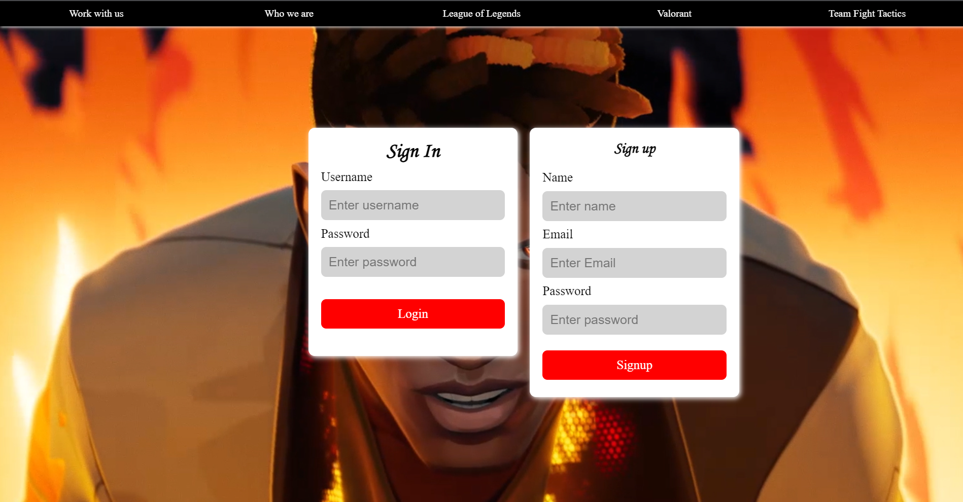

**Result:** Website is successfully created and the output is verified.