Results

**E-R Diagram Practice (3)**

Draw an ER Diagram for a simple online store where customers can order products.

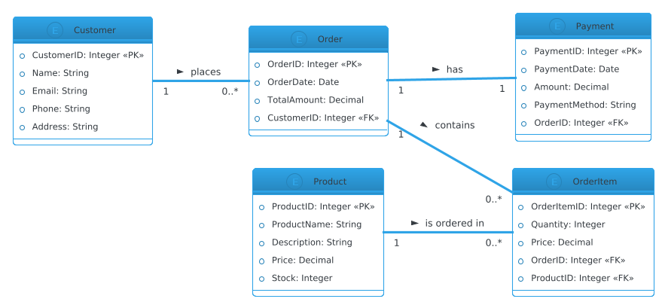

**Week 4: Web Application Development (7)**

Create a Flask application with forms and routes to manage a simple database of pets.

**Results:** Code and Running Dashboard:

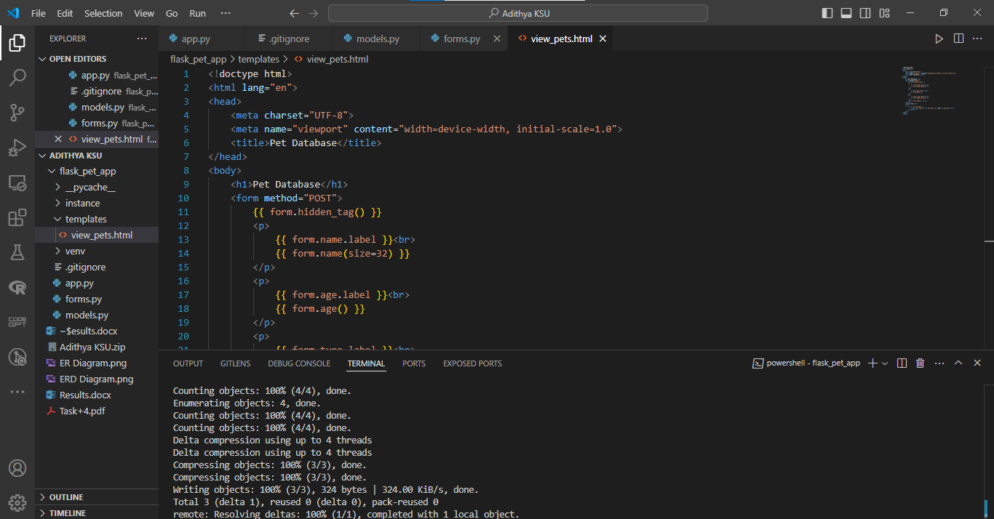

Output Dashboard:

