POSTER: Quick Basket

Adithya R Ganesh, Adeeb Tahir

1 Sri Sivasubramaniya Nadar College of Engineering, Kalavakkam, TN 603110

adithyarganesh@gmail.com

2 Sri Sivasubramaniya Nadar College of Engineering, Kalavakkam, TN 603110

[adeeb.tr@gmail.com](mailto:swami1197@gmail.com)

**Abstract:** We as valuable customers have incredibly packed schedules and hence value time, perhaps more than any other factor when it comes to tasks such as shopping. Our patience is stupendously tested at the billing counter. A long arduous queue filled with angry customers or an unnecessary time lag isn’t everybody’s cup of tea. Our project focuses on considerably reducing this ‘waiting’. With QUICK BASKET, we wish to bring an integrated solution to one of today’s prominent issues: Cloth Retail Billing Queues.

**OBJECTIVE & MOTIVATION:**

Without the shadow of doubt, no customer likes waiting for more than a couple of minutes at a billing queue. This can become especially irksome at peak shopping hours where a couple of hundreds of customers enter and exit the clothing departmental avenue every now and then. The motivation behind QUICK BASKET came about when we were at one of our favourite departmental outlets ‘Lifestyle’. After grabbing what we needed, we paced to the billing counter and to our dismay: a LONG QUEUE! As we slowly made our way to the front of the line, we were discussing why not come up with a solution to this. We thought about somehow taking this billing process and speeding it up say by a factor of 10 and by this we mean that over 95% of your billing is already done the moment you drop an item in your basket/trolley. Thus paved the way for our idea: QUICK BASKET!

**Methodology:**

The mainframe billing process is modularised, in other words, localised to a portable form which is situated at a convenient location, say one corner of a shopping basket or trolley. We will be working with a programmable Arduino uno board whose code algorithms shall tend to :

* Multiple instance detection
* RF code detection
* Display(via LED)

This can be achieved through RF readers.

**Architecture**:

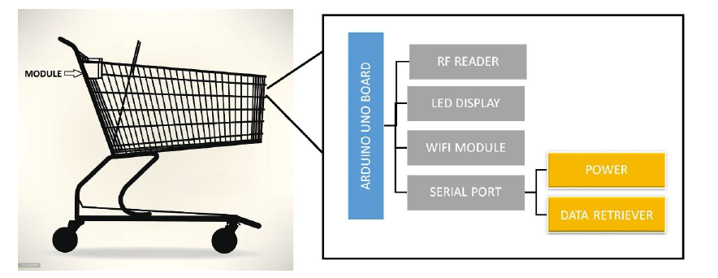

2.1 **Arduino interface with RF reader and LCD display**

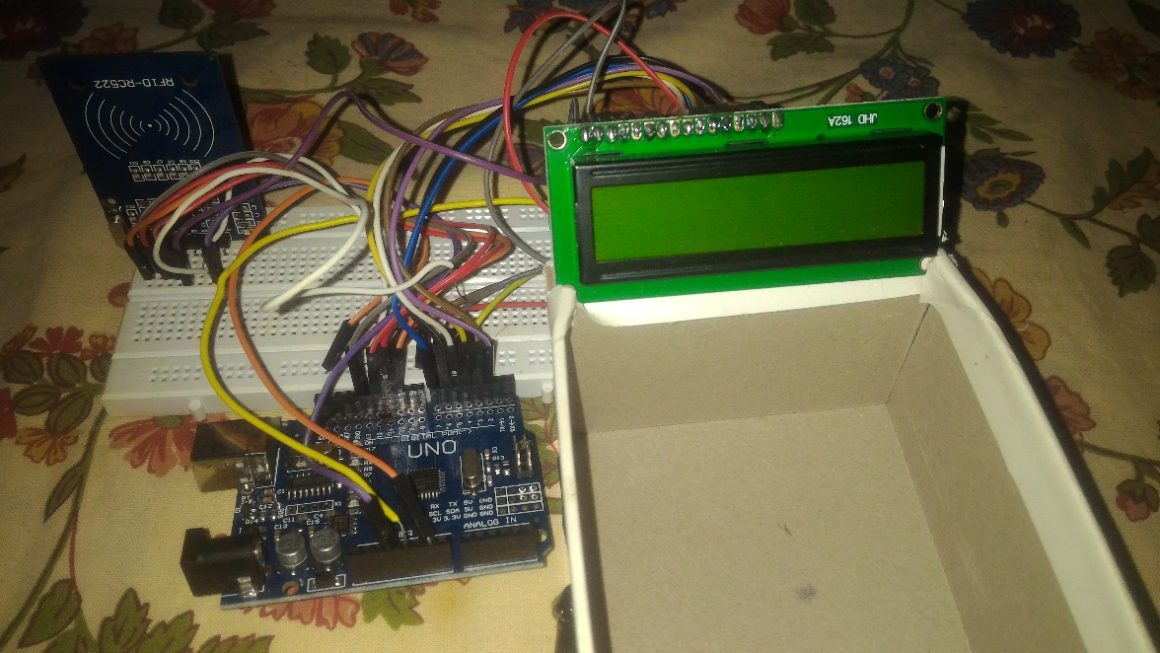

**Hardware and software requirements**

1. Arduino Uno Boards

2. Wi-Fi-Modules

3. LED Displays

4. RFID Readers

5. RF tags

6. Power Source Adapters (Batteries)

**Social Impact:**

A better approach to buy products offline has been implemented that help both the general public and shops. In our current fast paced world it has become essential to make all our surroundings work at an increased rate. Customers now can manage their time efficiently. Now, we are looking for a cash free lifestyle with every mode of payment becoming more and more electronic. This leads to increased security and also one enables one to walk in and walk out of the store with nothing but their ID.

**Beneficiaries:**

People who have a tight schedule

People who often misplace their wallets.

**Results:**

A **QuickBasket** module with price update functionality created. The module can successfully detect an item when placed in the cart and immediately flashes the updated price inclusive of the rate of the item on the LCD display. When the same item is scanned again, the price is subtracted indicating that the item has been taken out of the basket. Further, any numeric errors such as negative pricing or bills have been eliminated with code constraints ensuring the price never drops below zero.

**Screenshots:**

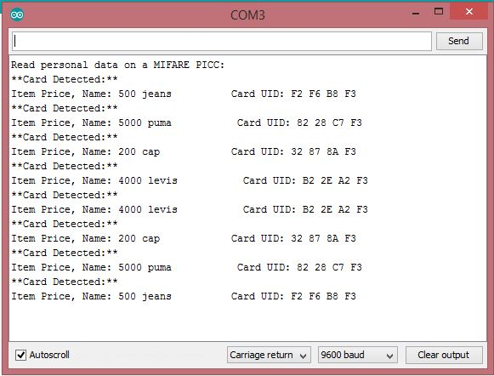

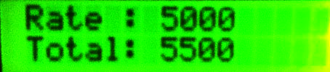 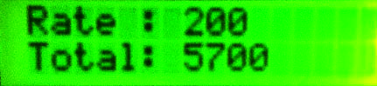

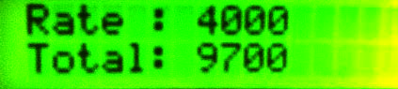 

**4. CONCLUSIONS AND FUTURE WORKS**

In this report, we have addressed the problem of waiting in lines for buying clothes. All the connections have been soldered and tested. It was found that our model for a proposed solution works more or less well. The proposed software works well in real time. However, we are continuing this study with a much larger variety of items and with various other modules In addition, we also intend to improve the computational performance of our method by adding other important constraints to our module. The speed/accuracy of our system has provided us with positive results.

With further advancement in technology and scanning proficiency, this project could be extended to a more localised type of market like a grocery store where small items can also be embedded with RF tech.

**References:**

1. The TAB Book Of Arduino – Simon Monk
2. Arduino Cookbook – Margolis
3. www.electroschematics.com
4. www.duino4projects.com