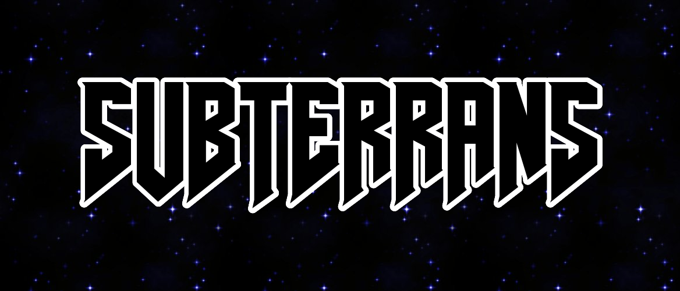

**an Alien Hunter RPG**

Adithya Ashok, Chiadika Obinwa

**Overview:**

This is a single-player survival roleplaying game, where you play as a bounty hunter hired to eliminate space pirates hiding out in an underground tunnel and defeat their leaders.

**Gameplay Features:**

5 types of enemies: riflemen, armored fighters, grenadiers, heavy gunners and kamikaze sweepers.

2 mini-bosses, 1 mega-boss.

Original soundtrack and in-game noises.

Health bar, collision detection, spawn rates, randomized mob generation.

Physics Engine written for bullets and object collisions.

Storyline prologue: sequentially typed out.

Your character can move in 4 directions, and shoot.

Hiding behind barricades will help you dodge bullets.

Mini-bosses and mega-boss have a unique design and game mechanics, with increasing levels of difficulty.

Animated cutscenes and dialogues.

**Hardware/Coding:**

10+ sprites, joystick (2x ADC), soundtrack, ST7735, buttons used to fire and start.