Q2
PART-A
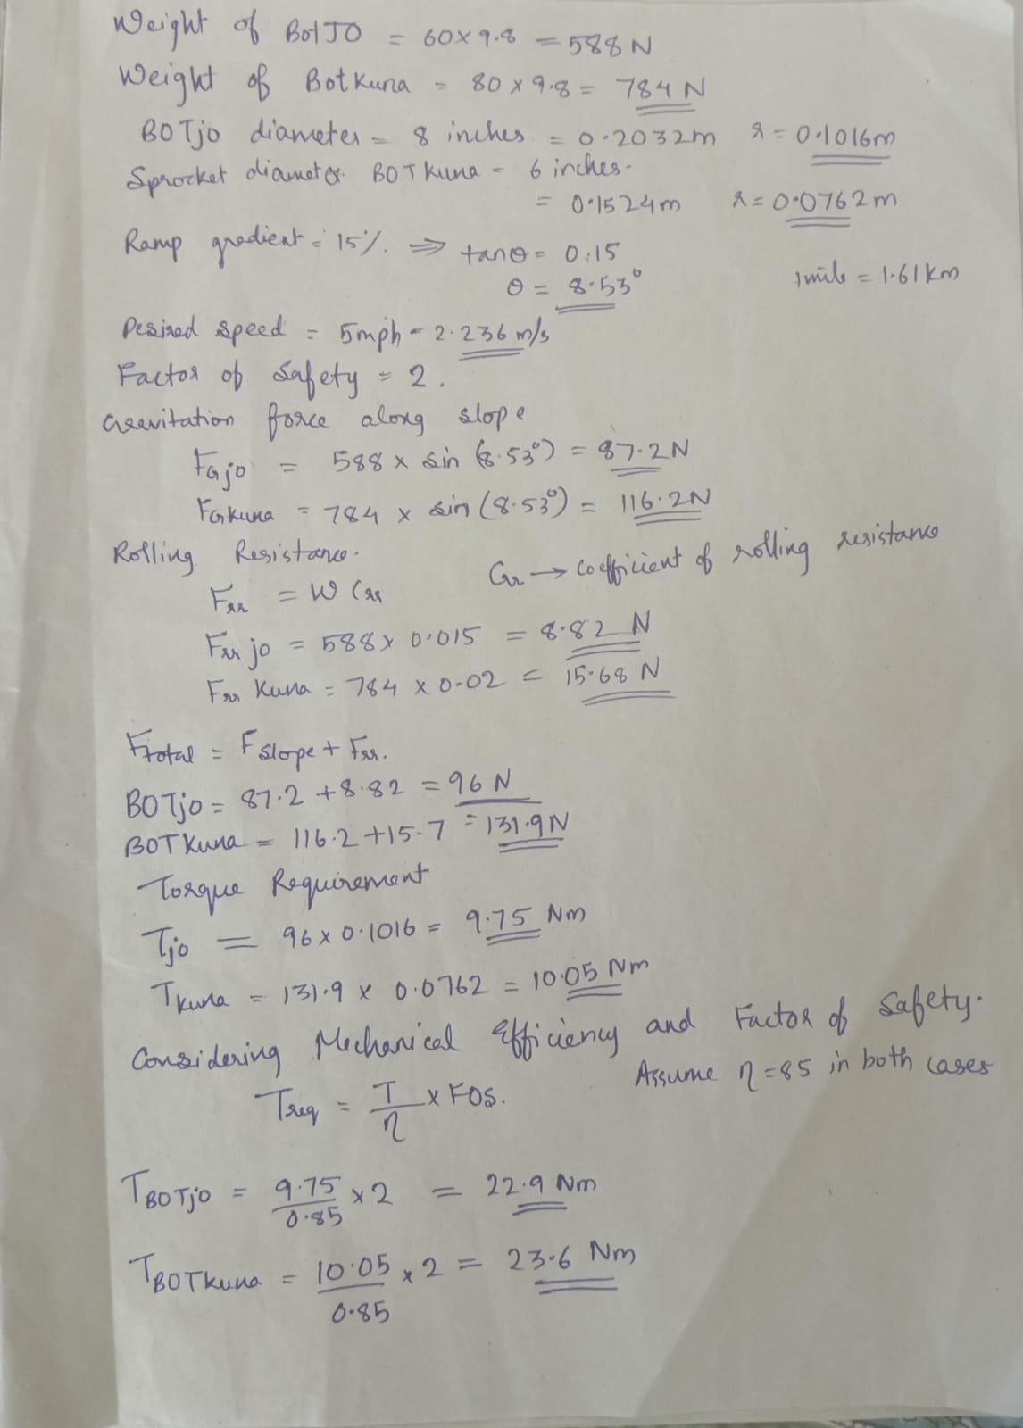
PART-B
- Comparing DC motors and BLDC (Brushless DC motors) BLDC is better. It has a better efficiency and high performance.
- Rhino BLDC 2.5 Nm 2500 RPM 48 V 500W
Compact and widely used in robots

MY1020 2.2 Nm 2500 RPM 24 V 500W
Affordable and meet torque demands

Rhino BLDC 4 Nm 3000 RPM 48 V 900W
Higher safety

- Maximum absolute force for BOTjo =T/r
=225.4 N
- Maximum absolute force for BOTkuna = 309.7 N
Reference
- https://youtu.be/O2hFpxTXzjY?si=BW2v3rJ8u1LJ1MT8
- https://youtu.be/_S2lyaMgBQ8?si=rcEZG3Q23bLwRm-V
- https://youtu.be/QJTSI_tFb3o?si=p4Ggn0THL1am95_K

