Q4
PART-A
Different types of braking systems in automobiles includes
- Foot brake and Hand brake
Mechanical brake operating by hand or foot and it is used for parking and emergency brake. These either act on the rear wheels or attached to the propeller shaft.
- Internal Expanding brake
Consists of two shoes. Each shoe is pivoted about a fulcrum at one end. The outer surface of the shoes is lined with some frictional material reduces the drum speed. The drum contains the entire mechanism to keep out dust and moisture. Friction between the shoe and the drum produces braking torque.
- External Contracting Brakes
For parking brakes , cranes , and to control the drive shaft speed. Made of comparatively thin, flexible steel, shaped to lift the drum.
- Power Brakes
Does not require any braking effects to apply the power operated brake. Only a valve is to be controlled.
- Vacuum Brakes
The effort provided by it is proportional to the applied power. The atmospheric valve remains open and the vacuum valve remains closed.
- Air Brakes
Commonly using in heavy vehicles like buses and trucks. Air brakes are applied by compressed air pressure rather than foot pressure.
- Hydraulic Brakes
The pedal force is transmitting to the brake shoe by means of a confined liquid through force transmission
- Electric brakes
Have an electromagnet within the brake drum. The brake is worked when the current from the battery is used to energize the electromagnet. These brakes are much faster than other types of brakes.

- Self energizing brakes
The force of the rotating drum is used to increase the brake pressure. When the vehicle is travelling forward the drum starts rotating in an anticlockwise direction.

PART-B
- A disc brake works when the pad squeezes the disc, while a drum brake works when the shoes press against drums.
- Disc brakes are more resistant to wet weather as its surface is smooth.
- Disc brake has a better heat dissipation capacity.
- Disc brake has a better performance in breaking.
- Drum brakes have inbuild parking brakes, making them perfect for rear brake.

These are the reasons for disc-brakes are present at front and drum brakes are present at the rear.

PART-C
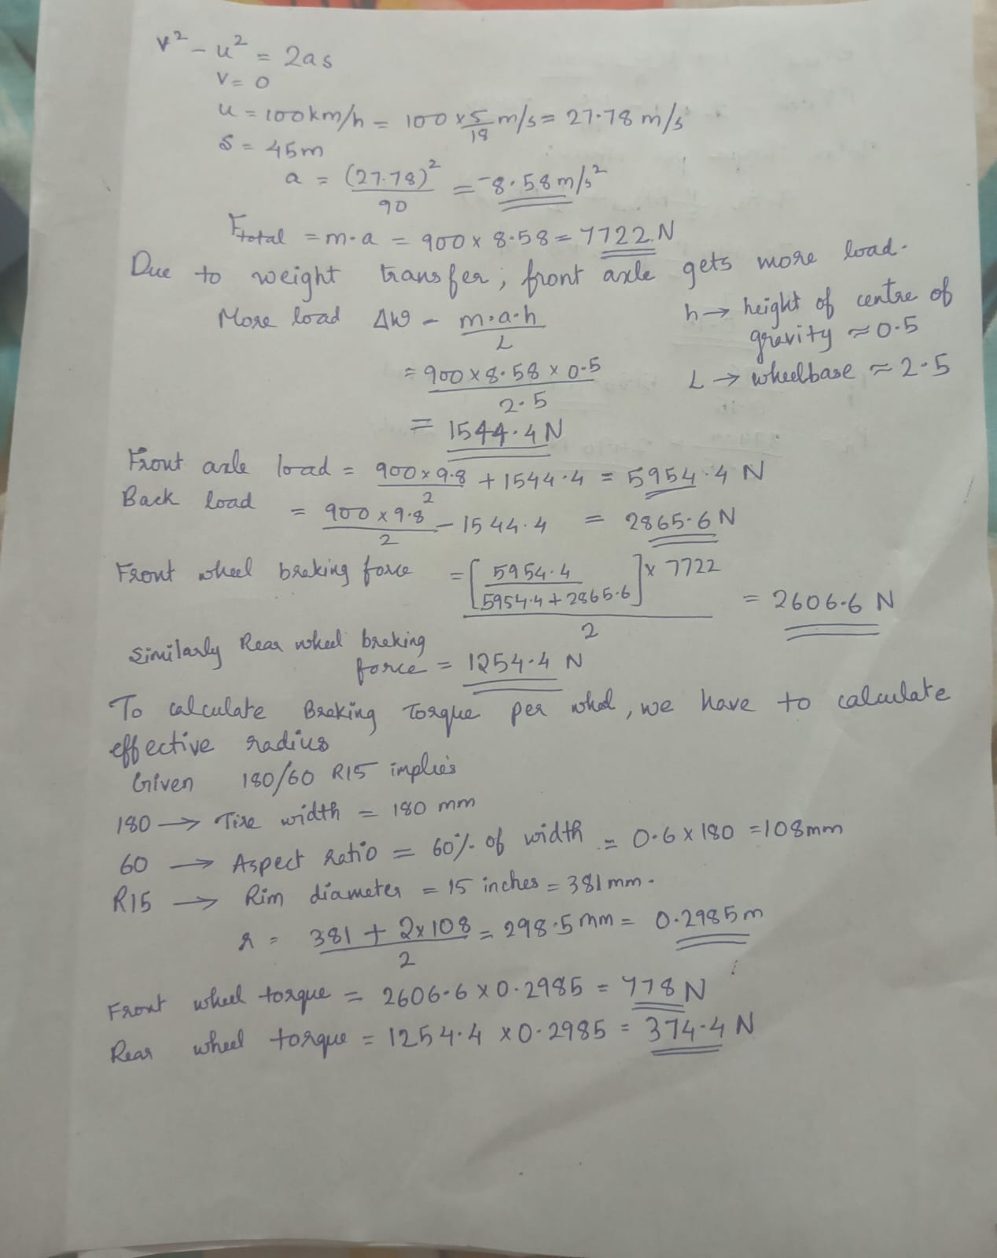

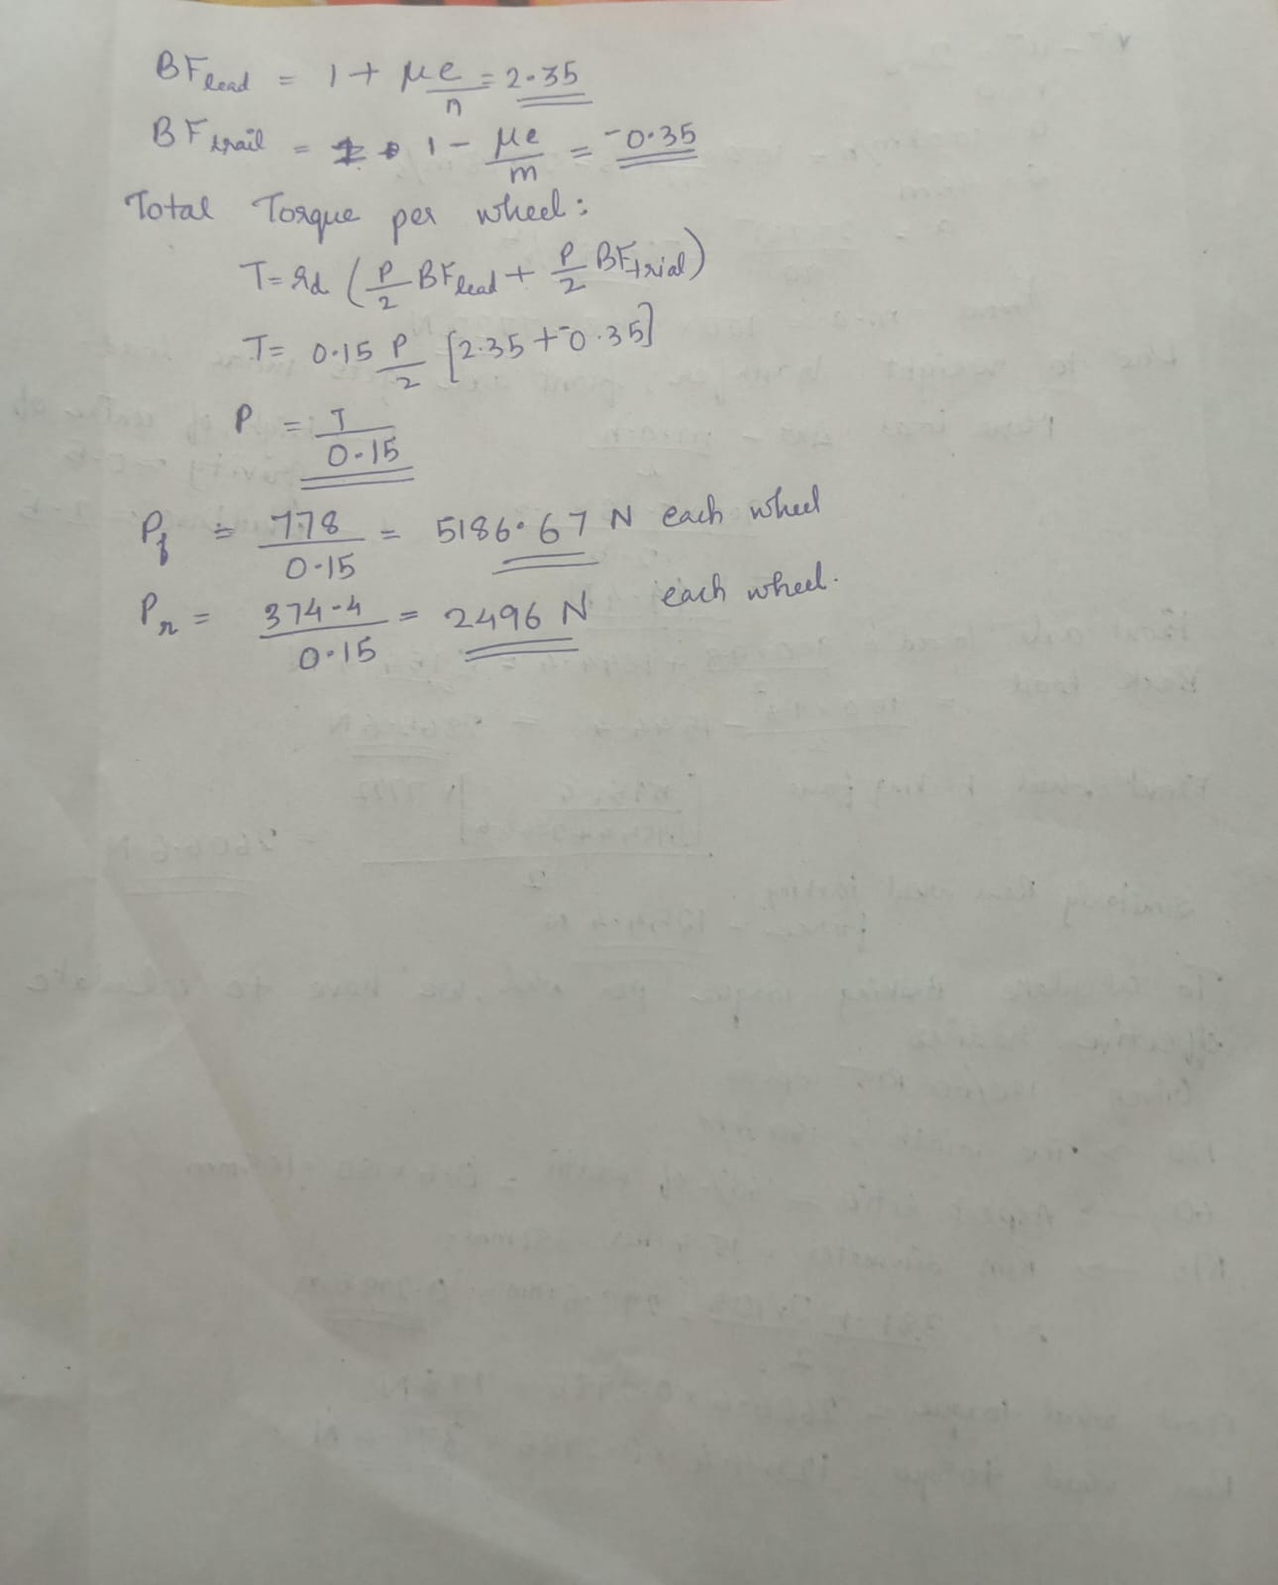

PART-D

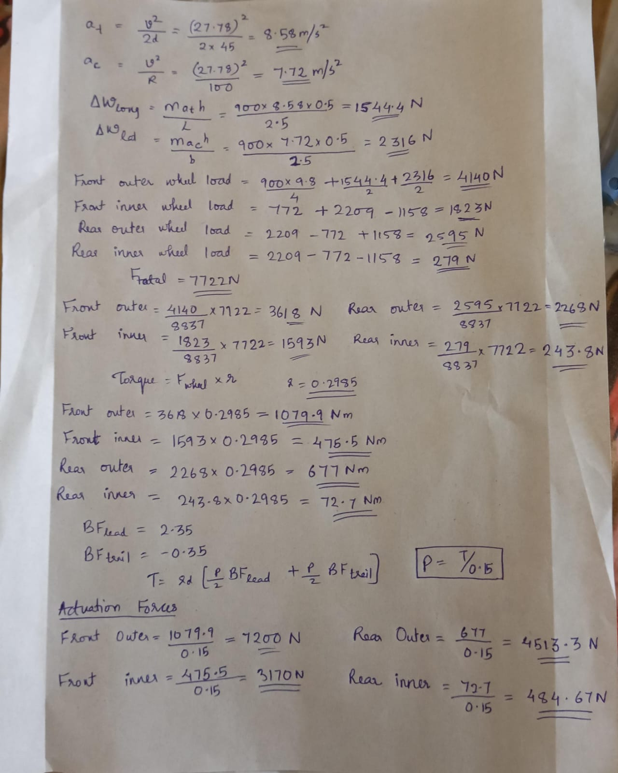

Reference used
- https://youtu.be/a5tcMhEWhsU?si=BrY_zBoQ0v12FRbE
- https://youtu.be/RAQcvP07RHE?si=vyewwjUmhqvVO8lE
- https://youtu.be/qCE54-H2zkM?si=kAqdYegiGUikom-I
- https://youtu.be/B_tO_qDqlbY?si=XoxzNfmsPRQhcojZ

