ABHIYAAN APPLICATION
Name : Adithy Asok
Roll No : ME25B009
Previous Experience : Good at joining parts
Knows welding
Current PoRs : Volunteer in Saarang FR team
Why I want to be a part of Team Abhiyaan :
to get hand’s on experience on mechanical world
to get productive
Relevant courses :
Institute : ME1480 – Passed with a A grade
ME1100 – Passed
ME1401 – Passed
Online : AIBL Java + DS
AIML bootcamp from IIT Madras

Q1
PART-A
A car’s control system can be explained in following way
Disturbances This is feed forward
reference controller
r u control system states x
controller inputs
Disturbances
reference
r u control u system x states x outputs
x controller inputs

This is a feedback controller
- Feedforward control changes how we operate a system
- Feedback changes the dynamics of a system
- Feedback control is powerful but dangerous

- In the figure control inputs implies steering wheels ,brakes, accelerator
- States implies the speed, position, or direction.

Heater heat in battery system heat out temperature sensor

Heater manager co

Open loop and Closed loop control
- Open loop control system is a type of control system which is independent of feedback
- It is simple to design as feedback mechanism is not used but its accuracy is low
- Eg: immersion water heater
Toaster
Mixer grinder
- Closed loop control works on feedback from the system
- It is expensive as it use complex mechanism ,it’s accuracy level is high
- Eg: air conditioner
Geyser
Air fryer
- Conclusion
Closed loop control is better than open loop because of its accuracy . It is more reliable.

Design of robot

I am designing a robot which receives velocity commands from a higher level planner which perform according to the instruction . Velocity commands are reference inputs it will be then received by controller, it analyses the input and creates required control input to system(or motor), then the output is created. Changes can be made in control inputs (if required) to arrive at desired output.
In this system we have to use a closed loop control as it can make changes in input if any disturbances arrives (like wind).
Disturbances(y)

system
control
x u u x y
x y y

state estimation
Disturbances can be noises , wind etc
Different types of control strategies are there
- On-Off
On-off control or bang-bang control works on only two states on and off. It doesn’t adjust gradually. It is not suitable for systems which require high precision.

- PID
PID control is another type of control which much more precise and effective than on-off control system.

- Cascaded PID
Cascaded PID is a type of control system which uses multiple PIDs. It is even more accurate and precise , but it’s working is very complicated.

For this robot PID will be the best option because it is precise , simple, easily available
Different microcontrollers available includes
- ESP32
- STM32
- Arduino Uno
Different single board computers available are
- Raspberry Pi 5
- Jetson Nano
- BeagleBone Black
For our robot the best microcontroller will be STM32 because of its high performance, low power consumption and cost effective. It is good for handling disturbances such as noise. It is widely used in drones , automotive cars and robotics.
The best single board computer for our robot is Jetson Nano. It uses AI for handling decision making. Combining STM32 and Jetson Nano will make the robot the best. It is cost effective.

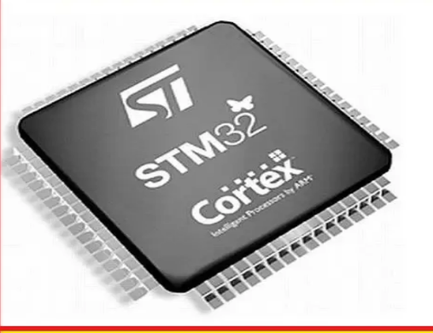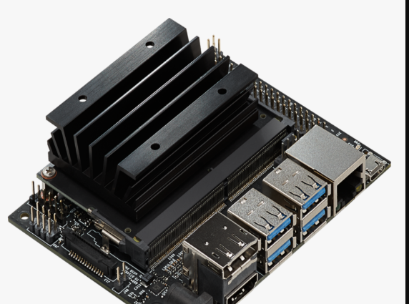
STM32 Jetson Nano
Reference
Reference videos mentioned in application

PART-B

