Sri Lanka Institute of Information
Technology

DESIGN AND IMPLEMENTATION OF A
DATA WAREHOUSE AND BUSINESS INTELLIGENCE SOLUTION
E-Commerce Sales, Customer & Delivery Intelligence Platform
Using the Brazilian Olist E-Commerce Dataset

Final Project Report

IT number | Name
IT24101668 | Nanayakkara N N D A S
IT24103767 | Edirisinghe A.U
IT24103815 | Fernando W.P.S.
IT24104068 | Chandrasiri R.M.D.S

Y3.S1. WE. DS. 0202
Group: 2026-DS-76

IT3101 – Data Warehousing and Business Intelligence

Declaration and AI Use Acknowledgement
This report documents the design and implementation of an end-to-end Data Warehouse and Business Intelligence solution for the IT3101 assignment. The SQL Server database, ETL workflow, dimensional model, data mart views, validation results, and Power BI dashboards presented in the final submission should reflect the implementation completed by the student/group.
Generative AI was used as a supporting tool for planning, explanation, debugging, SQL guidance, documentation structure, and language refinement. All implementation results, screenshots, numerical outputs, and final conclusions should be verified against the implemented SQL Server database and Power BI report. The final submission should be reviewed and adapted so that it reflects the student’s own understanding and implementation.

Executive Summary
This project develops a complete DWBI solution for an e-commerce scenario using the Brazilian Olist dataset. Nine operational CSV files are profiled and loaded into a layered SQL Server architecture consisting of RAW, STG, DW, and MART schemas. The dimensional warehouse contains six dimensions and three fact tables with explicit primary keys, foreign keys, fact grains, surrogate keys, and time hierarchies. Four reporting MART views are exposed to Power BI.
The final validated warehouse contains 99,441 order rows, 112,650 sales-item rows, and 103,886 payment rows. Validated product sales are 13,591,643.70, freight value is 2,251,909.54, gross item value is 15,843,553.24, and total payment value is 16,008,872.12. The final Power BI solution contains Executive Summary, Trend Analysis, and Interactive Analysis pages with filters, slicers, and Year → Quarter → Month drill-down/roll-up.

Table of Contents
Contents
Declaration and AI Use Acknowledgement 2
Executive Summary 2
1. Introduction 5
1.1 Project Objectives 5
1.2 Technology Stack 5
2. Task 1 – Dataset Selection and Business Scenario Identification 6
2.1 Dataset and Business Domain 6
2.2 Dataset Overview 6
2.3 Business Scenario and Problems Addressed 6
2.4 Suitability for DWBI 6
3. Task 2 – Data Source Identification and Preparation 7
3.1 Source Relationships 7
3.2 Source Profiling 7
3.3 Data Preparation Strategy 8
4. Task 3 – Data Warehouse Architecture Design 9
4.1 Layered DWBI Architecture 9
4.2 Layer Responsibilities 10
5. Task 4 – Dimensional Data Warehouse Design and Implementation 10
5.1 Dimensional Model Overview 10
5.2 Dimension Tables 11
5.3 Fact Tables and Grain 11
5.4 Measures and Business Definitions 12
5.5 Keys, Relationships, and Hierarchies 12
6. Task 5 – ETL Process Development 13
6.1 ETL Workflow 13
6.2 Extraction 14
6.3 Transformation 14
6.4 Loading Sequence 14
6.5 ETL Validation 14
6.6 SQL Script Execution Order 15
7. Task 6 – Data Mart Development 16
7.1 Purpose and Target Users 16
7.2 Implemented MART Views 16
7.3 Analytical Benefits 16
8. Task 7 – OLAP Analysis and Power BI Dashboard Development 17
8.1 Power BI Connection 17
8.2 Report Page 1 – Executive Summary 17
8.3 Report Page 2 – Trend Analysis 18
8.4 Report Page 3 – Interactive Analysis 18
8.5 OLAP Operations Demonstrated 19
9. Task 8 – Business Insights and Recommendations 20
9.1 Insight 1 – Sales Trend Over Time 20
9.2 Insight 2 – Product Category Concentration 20
9.3 Insight 3 – Delivery Performance 20
9.4 Insight 4 – Regional Concentration 20
9.5 Insight 5 – Customer Retention Opportunity 20
10. Final Validation Summary 21
11. Conclusion 22
12. References 22
Appendix A – Screenshot and Figure Placement Checklist 23
Appendix B – SQL / Technical File Inventory 23
Appendix C – Assignment Requirement Coverage 24

1. Introduction
Modern e-commerce platforms generate high volumes of operational data across customers, products, sellers, orders, payments, reviews, freight, deliveries, and geography. Operational source systems are optimized for transactions, while management requires an analytical environment that can integrate historical data, provide consistent KPIs, and support trend and drill-down analysis.
The objective of this project is to design and implement an end-to-end Data Warehouse and Business Intelligence solution that transforms the Olist operational CSV files into a validated dimensional warehouse, reporting data marts, and interactive Power BI dashboards.

1.1 Project Objectives
- Select and justify a realistic OLTP-style e-commerce dataset.
- Profile nine source files and document data-quality issues and source relationships.
- Implement a layered SQL Server architecture using RAW, STG, DW, and MART schemas.
- Design a dimensional warehouse with explicit fact grains, measures, surrogate keys, PK/FK constraints, and hierarchies.
- Implement reproducible ETL for extraction, transformation, dimension loading, fact loading, and validation.
- Develop reporting-ready data mart views for executive, sales, delivery, and payment analysis.
- Build a three-page Power BI report with KPIs, time trends, filters, slicers, and drill-down/roll-up.
- Produce at least five evidence-based business insights with practical recommendations.

1.2 Technology Stack

Technology | Use in Project
Python + pandas | Initial source profiling, key analysis, missing-value investigation, and relationship checks.
Microsoft SQL Server | RAW, STG, dimensional DW, facts, constraints, MART views, and validation.
SQL Server Management Studio (SSMS) | SQL development, execution, database diagrams, and evidence capture.
Microsoft Power BI Desktop | Executive KPIs, trend analysis, slicers, regional comparison, and OLAP drill-down/roll-up.
Markdown documentation | Source inventory, quality decisions, ETL, dimensional model, MART, validation, and insights.

2. Task 1 – Dataset Selection and Business Scenario Identification

2.1 Dataset and Business Domain
The selected dataset is the Brazilian Olist e-commerce dataset. It represents a realistic retail/e-commerce operational environment containing customers, orders, order items, products, sellers, payments, reviews, geolocation, and product-category translation data. The dataset is suitable for dimensional analysis because the source files contain multiple related business entities and several measurable business processes.

2.2 Dataset Overview
Source File | Rows | Role in Solution
olist_customers_dataset.csv | 99,441 | Customer identifiers and customer geography.
olist_geolocation_dataset.csv | 1,000,163 | ZIP-prefix latitude/longitude and geographic reference data.
olist_order_items_dataset.csv | 112,650 | Order-item grain, product, seller, price, and freight.
olist_order_payments_dataset.csv | 103,886 | Payment transaction sequence, type, installments, and value.
olist_order_reviews_dataset.csv | 99,224 | Review score and optional review comments.
olist_orders_dataset.csv | 99,441 | Order status and purchase/delivery timestamps.
olist_products_dataset.csv | 32,951 | Product category and descriptive/physical attributes.
olist_sellers_dataset.csv | 3,095 | Seller identifiers and seller geography.
product_category_name_translation.csv | 71 | Portuguese-to-English product category mapping.

2.3 Business Scenario and Problems Addressed
The analytical platform is designed to support e-commerce sales, customer, delivery, seller, and payment intelligence. The solution separates different business-process grains so that order, order-item, and payment measures are not incorrectly combined.
- How do product sales and order volumes change over time?
- Which product categories generate the highest sales?
- Which customer and seller states contribute the most sales?
- How quickly are orders delivered and what proportion are on time?
- How do review scores relate to the order-level customer experience?
- Which payment types and installment patterns are used?
- How can decision makers interactively drill from yearly to quarterly and monthly performance?

2.4 Suitability for DWBI
The dataset represents an OLTP-style multi-file environment with sufficient volume, multiple business keys, descriptive attributes, measures, date fields, and natural fact/dimension candidates. It therefore supports star/snowflake dimensional modelling, ETL, data marts, OLAP analysis, and interactive BI reporting.

3. Task 2 – Data Source Identification and Preparation

3.1 Source Relationships
The nine CSV files are integrated through operational keys such as order_id, customer_id, product_id, seller_id, ZIP-code prefix, and product_category_name. A source relationship diagram should be included here using only the nine source files used by this implementation.

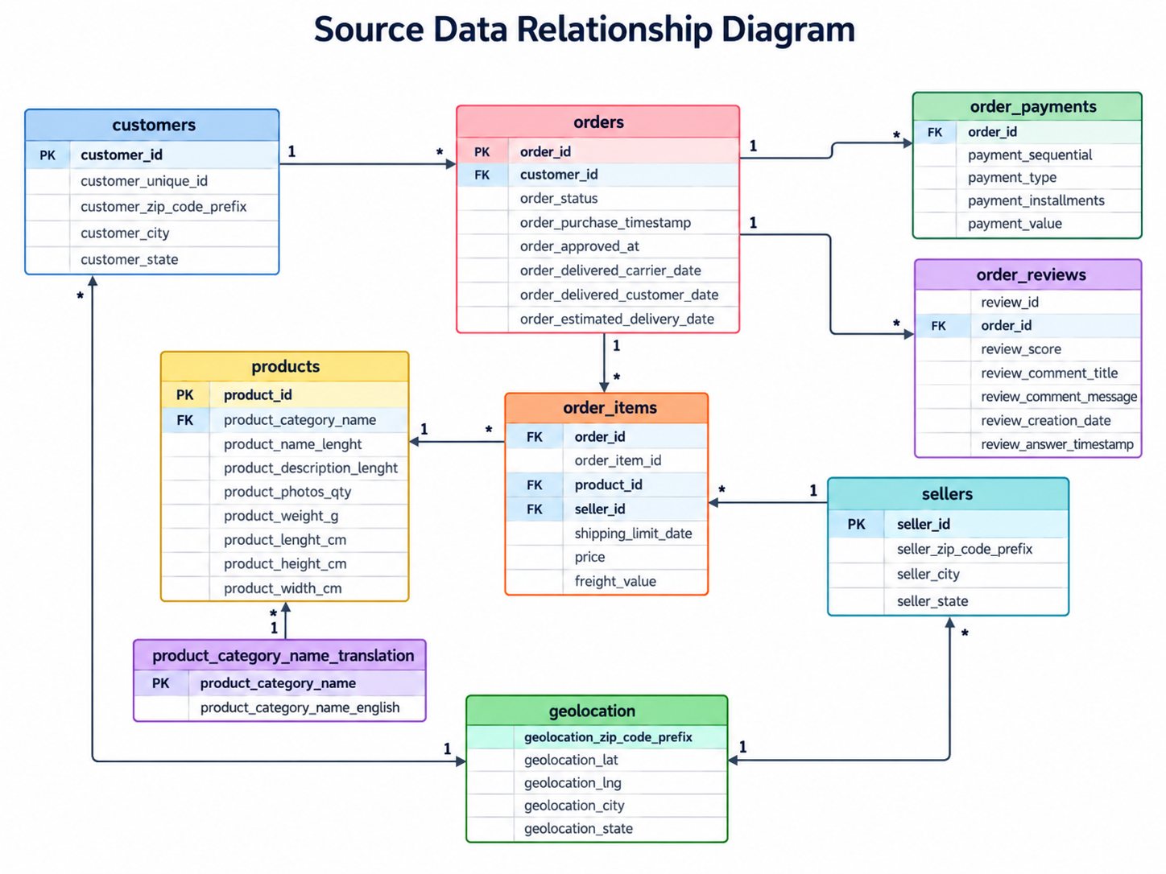

Caption: Source Data Relationship Diagram

3.2 Source Profiling
Python profiling scripts were executed before SQL implementation to identify row counts, missing values, duplicate patterns, key uniqueness, referential relationships, and special cases that affect dimensional design.
Area | Validated Finding / Decision
Customers | 99,441 customer_id rows; 96,096 distinct customer_unique_id values. Repeat customers exist.
Geolocation | 1,000,163 rows; 261,831 complete duplicate rows; 19,015 distinct ZIP prefixes. Geography must be consolidated at ZIP-prefix level.
Orders | 99,441 orders; 160 missing approval timestamps; 1,783 missing carrier-delivery timestamps; 2,965 missing customer-delivery timestamps.
Payments | 103,886 payment rows; one order has no payment; multi-payment orders exist.
Reviews | review_id is not globally unique; 547 orders have multiple reviews. Reviews are aggregated to order grain using AVG(review_score).
Products | 610 products have missing category/descriptive attributes; those products are preserved rather than removed.
Translations | Two Portuguese categories have no English translation; fallback logic is applied.
Relationships | Core source relationships showed zero orphan rows for Orders→Customers, Items→Orders/Products/Sellers, Payments→Orders, and Reviews→Orders.

3.3 Data Preparation Strategy
- Preserve the original CSV values in the RAW layer.
- Convert and standardize data types in STG rather than changing source files.
- Use LTRIM/RTRIM and NULLIF to clean whitespace and empty values.
- Use TRY_CONVERT for safe numeric and datetime conversion.
- Standardize order status and payment type to lowercase and state codes to uppercase.
- Preserve legitimate missing values where business meaning exists.
- Use fallback category and location logic rather than deleting valid business records.

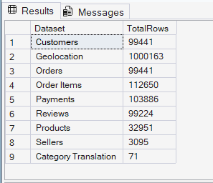
Caption: RAW Source Row Counts

4. Task 3 – Data Warehouse Architecture Design

4.1 Layered DWBI Architecture
The solution uses a layered architecture that separates source preservation, data preparation, dimensional storage, analytical views, and presentation. This improves traceability, reproducibility, maintainability, and validation.
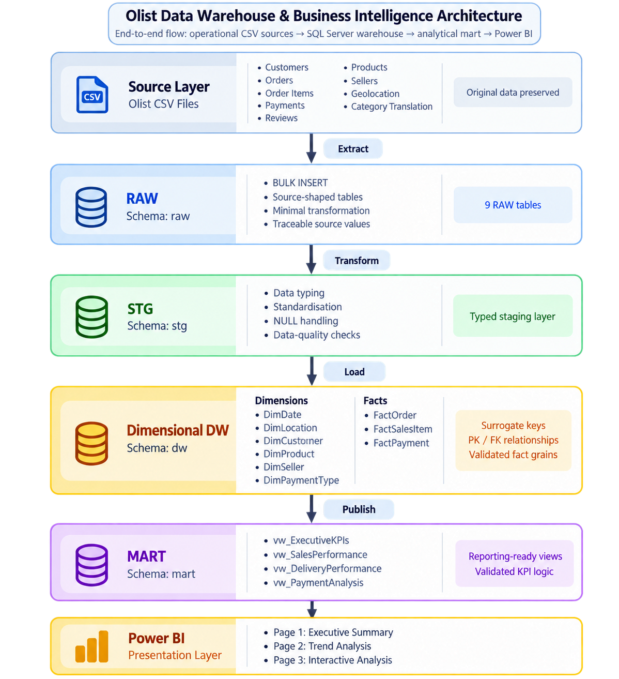

Caption: DWBI Architecture: Source → RAW → STG → DW → MART → Power BI

4.2 Layer Responsibilities
Layer | Schema / Tool | Responsibility
Source | CSV files | Original operational-style Olist data.
RAW | raw | Source-shaped landing tables with minimal transformation.
STG | stg | Typed, standardized, validated preparation layer.
Data Warehouse | dw | Dimensions, facts, surrogate keys, PK/FK relationships, and analytical measures.
Data Mart | mart | Reporting-ready views with validated business logic.
Presentation | Power BI | KPIs, trends, filters, slicers, drill-down/roll-up, and decision support.

5. Task 4 – Dimensional Data Warehouse Design and Implementation

5.1 Dimensional Model Overview
The corrected warehouse contains six dimensions and three facts. Separate fact tables are used because orders, order items, and payments have different grains. This prevents double counting and keeps business measures semantically correct.
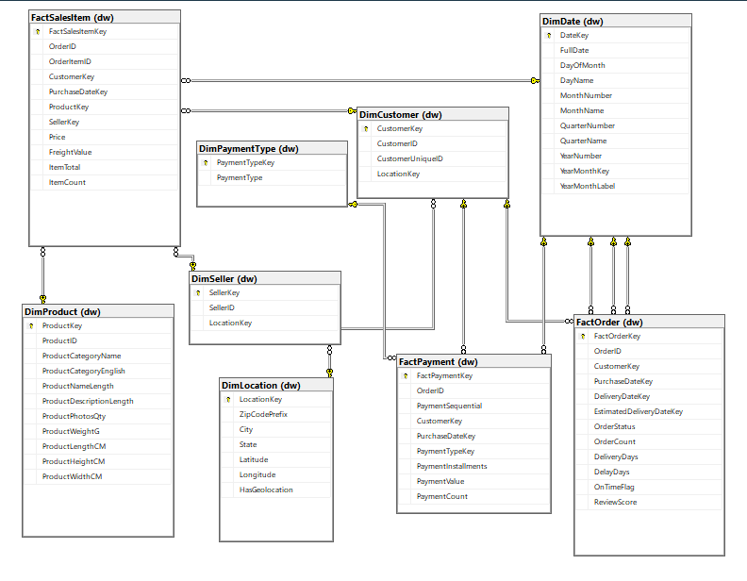
Caption: Implemented Dimensional Model / SSMS Database Diagram

5.2 Dimension Tables
Dimension | Primary Key | Purpose | Validated Rows
dw.DimDate | DateKey | Calendar attributes and Year → Quarter → Month hierarchy. | 800
dw.DimLocation | LocationKey | ZIP-prefix geography, city/state, latitude/longitude, HasGeolocation. | 19,178
dw.DimCustomer | CustomerKey | Operational customer ID, unique customer ID, and location key. | 99,442
dw.DimProduct | ProductKey | Product identity, category translation, and physical/descriptive attributes. | 32,952
dw.DimSeller | SellerKey | Seller identity and location key. | 3,096
dw.DimPaymentType | PaymentTypeKey | Payment method categories plus technical unknown. | 6

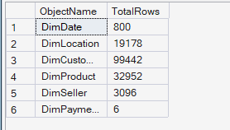
Caption: Final Dimension Row Counts

5.3 Fact Tables and Grain
Fact Table | Business Grain | Main Measures | Validated Rows
dw.FactOrder | One row per order | OrderCount, DeliveryDays, DelayDays, OnTimeFlag, ReviewScore | 99,441
dw.FactSalesItem | One row per order item | Price, FreightValue, ItemTotal, ItemCount | 112,650
dw.FactPayment | One row per payment transaction | PaymentInstallments, PaymentValue, PaymentCount | 103,886

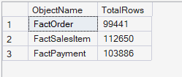
Caption: Final Fact Row Counts

5.4 Measures and Business Definitions
Measure | Definition / Interpretation
Product Sales | SUM(Price) – product sale amount excluding freight.
Freight Value | SUM(FreightValue) – shipping/freight amount.
Gross Item Value | SUM(ItemTotal), where ItemTotal = Price + FreightValue.
Payment Value | SUM(PaymentValue) – payment transaction value; kept separate from sales.
Delivery Days | DATEDIFF(day, purchase date, actual customer delivery date).
Delay Days | DATEDIFF(day, estimated delivery date, actual customer delivery date); positive means late.
On-Time Flag | 1 = delivered by estimated date; 0 = late; NULL = no actual delivery date.
Review Score | Order-level average of review_score; NULL when no review exists.

5.5 Keys, Relationships, and Hierarchies
Dimensions use integer surrogate keys, with technical unknown members reserved at key 0 where applicable. The warehouse implements explicit primary keys, unique constraints, and foreign keys. The date hierarchy supports Year → Quarter → Month and is used for Power BI drill-down and roll-up.
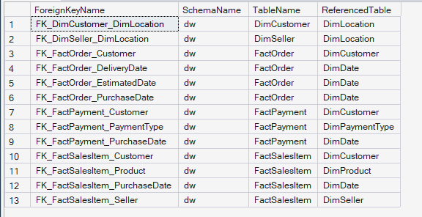
Caption: Foreign-Key Audit (11 Relationships)

6. Task 5 – ETL Process Development

6.1 ETL Workflow
The ETL process follows the sequence Source CSV → RAW → STG → dimensions → facts → MART → Power BI. SQL scripts are numbered so the full warehouse can be rebuilt in a controlled order.
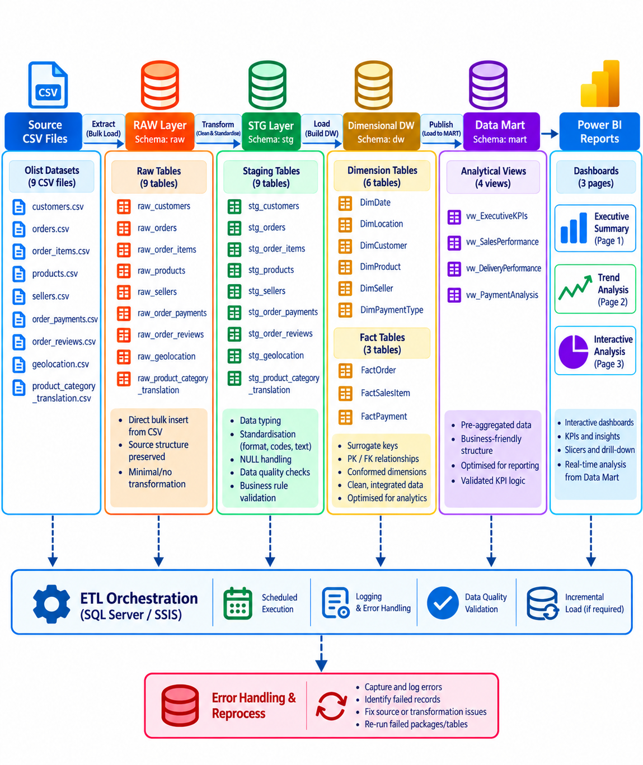
Caption: ETL Workflow Diagram

6.2 Extraction
Nine Olist CSV files are copied to C:\DWBI\OlistRaw and loaded into the RAW schema using SQL Server BULK INSERT with CSV handling, UTF-8 encoding, and header-row skipping. RAW tables intentionally preserve source-shaped values.

6.3 Transformation
- Whitespace trimming and empty-string-to-NULL conversion.
- Typed conversion of dates, numbers, prices, freight, review scores, product measurements, and coordinates.
- Standardization of status/payment text and state codes.
- Product category translation with fallback handling.
- Consolidation of geolocation by ZIP prefix using averaged coordinates and representative city/state.
- Order-level review aggregation using AVG(review_score).
- Derived delivery measures: DeliveryDays, DelayDays, and OnTimeFlag.
- Derived sales measure: ItemTotal = Price + FreightValue.
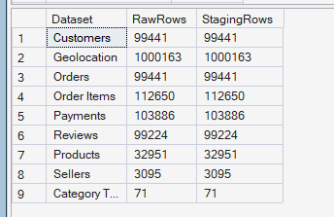
Caption: RAW vs STG Validation

6.4 Loading Sequence
- Create database and schemas.
- Create and load RAW tables.
- Create and load STG tables.
- Validate staging data.
- Audit dimension source values.
- Create and load dimensions.
- Create and load fact tables.
- Audit KPI source measures.
- Create MART views.
- Run final end-to-end verification.

6.5 ETL Validation
Validation checks confirm that fact grains are unique, monetary totals reconcile with staging, missing delivery dates remain NULL rather than being misclassified, and no loaded fact rows require technical unknown dimension keys for the current dataset.
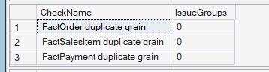
Caption: Fact Grain Validation

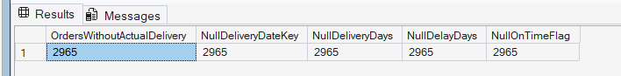

6.6 SQL Script Execution Order
01_create_database.sql
02_create_raw_tables.sql
03_load_raw_data.sql
04_create_staging_tables.sql
05_load_staging.sql
06_validate_staging.sql
07_dimension_source_audit.sql
08_create_dimensions.sql
09_load_dimensions.sql
10_create_facts.sql
11_load_facts.sql
12_kpi_source_audit.sql
13_create_mart_views.sql
14_final_verification.sql

7. Task 6 – Data Mart Development

7.1 Purpose and Target Users
The MART layer exposes simplified, reporting-ready analytical views to Power BI. It reduces repeated joins, keeps KPI logic consistent, and separates order, sales-item, delivery, and payment grains. Target users include management, sales/product analysts, operations/logistics analysts, and finance/payment analysts.

7.2 Implemented MART Views
View | Grain | Primary Analytical Use | Rows
mart.vw_ExecutiveKPIs | One summary row | Executive KPIs across orders, customers, items, delivery, reviews, and payments. | 1
mart.vw_SalesPerformance | One row per sales item | Sales, product, customer, seller, geography, freight, and time analysis. | 112,650
mart.vw_DeliveryPerformance | One row per order | Delivery status, delay, on-time analysis, and review score. | 99,441
mart.vw_PaymentAnalysis | One row per payment transaction | Payment type, installment, value, time, and customer analysis. | 103,886

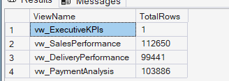
Caption: MART View Row Counts

7.3 Analytical Benefits
- Simplifies Power BI development by exposing denormalized reporting fields.
- Keeps validated KPI definitions outside the visualization layer.
- Preserves known analytical grain for each view.
- Reduces double-counting risk when comparing order, item, delivery, and payment measures.
- Provides a traceable bridge from warehouse facts/dimensions to dashboard visuals.

8. Task 7 – OLAP Analysis and Power BI Dashboard Development

8.1 Power BI Connection
Power BI Desktop is connected to SQL Server database OlistDWBI in Import mode. The four MART views are loaded as reporting sources. The final dashboard contains three pages aligned with the assignment requirements.

8.2 Report Page 1 – Executive Summary
The Executive Summary provides a high-level view of business performance. KPI cards use mart.vw_ExecutiveKPIs, while sales trend and category visuals use mart.vw_SalesPerformance.
- Total Sales (ProductSalesValue) ≈ 13.59M
- Total Orders = 99,441
- Unique Customers = 96,096
- Average Delivery Days = 12.50
- Average Review Score ≈ 4.09
- On-Time Delivery Percentage = 91.89%
- Total Sales by Month – chronological line chart using SUM(Price).
- Top 10 Product Categories by Sales – bar chart using SUM(Price).

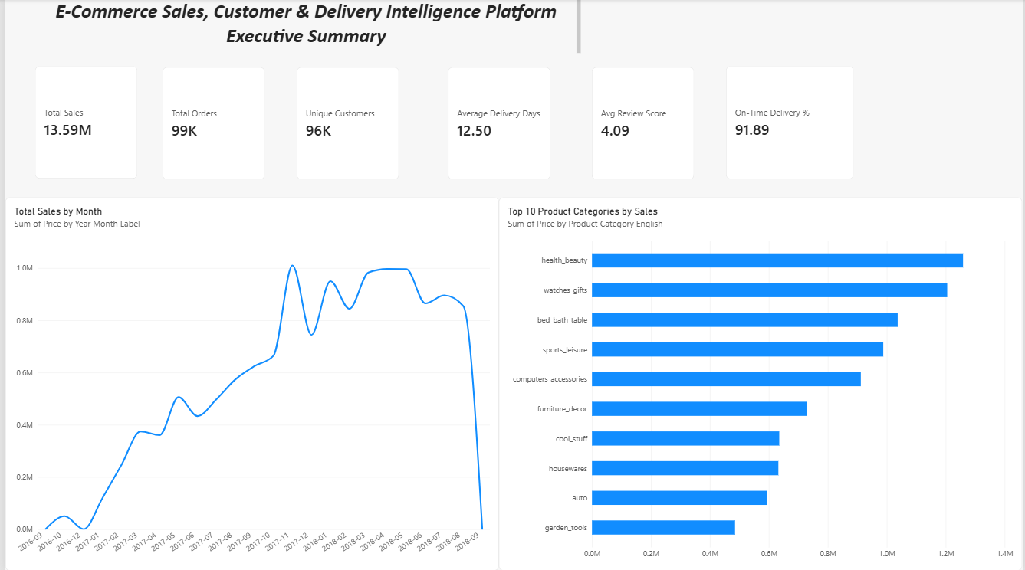
Caption: Power BI – Executive Summary

8.3 Report Page 2 – Trend Analysis
The Trend Analysis page uses Year and Product Category slicers together with three time-based visuals. Monthly order volume uses DISTINCTCOUNT(OrderID) because vw_SalesPerformance is at order-item grain.
- Monthly Sales Trend – YearMonthLabel by SUM(Price).
- Monthly Order Trend – YearMonthLabel by DISTINCTCOUNT(OrderID).
- Monthly Freight Trend – YearMonthLabel by SUM(FreightValue).
- Year slicer and Product Category dropdown slicer.

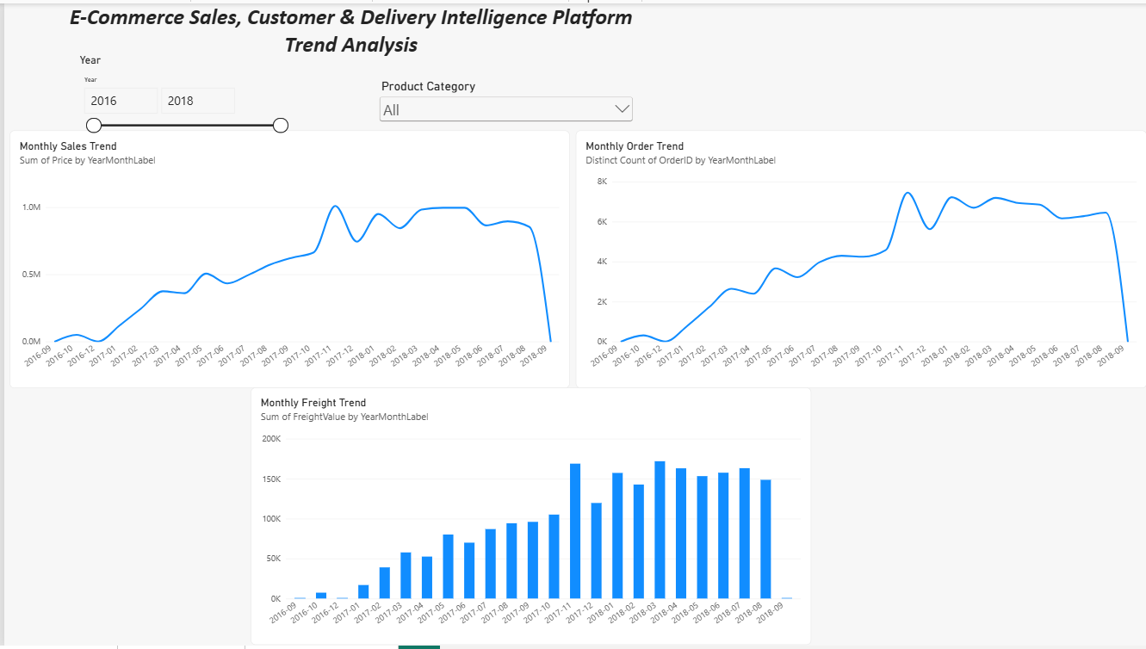
Caption: Power BI – Trend Analysis

8.4 Report Page 3 – Interactive Analysis
The Interactive Analysis page demonstrates filters, slicers, regional comparisons, detailed record inspection, and OLAP-style drill-down/roll-up.
- Year slicer.
- Product Category dropdown slicer.
- Sales drill-down hierarchy: YearNumber → QuarterName → YearMonthLabel.
- Sales by Customer State.
- Sales by Seller State.
- Detail table containing order, time, category, state, price, and freight fields.
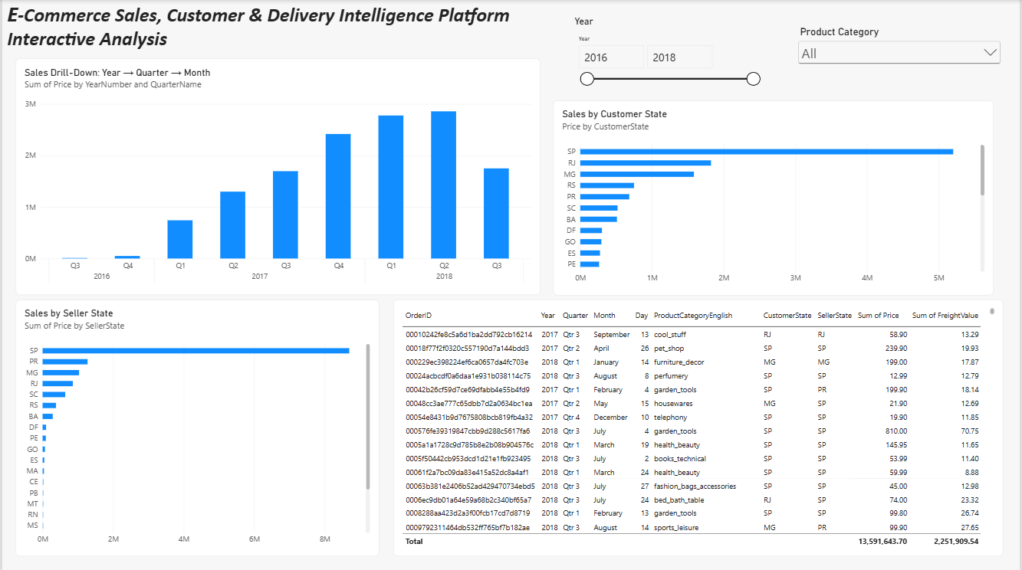
Caption: Power BI – Interactive Analysis

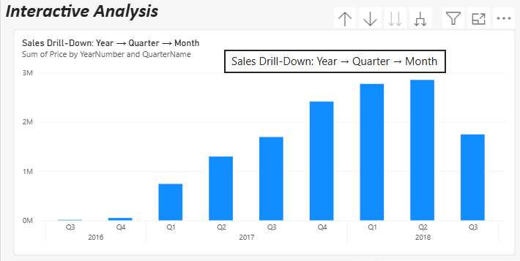
8.5 OLAP Operations Demonstrated
Operation | Implementation in This Project | Evidence
Slice | Filter one dimension value, e.g., Year or Product Category. | Year and Product Category slicers.
Dice | Combine multiple dimension selections to focus the analytical subset. | Year + Product Category together.
Drill-down | Move from Year to Quarter to Month. | Hierarchy column chart.
Roll-up | Move from Month back to Quarter and Year. | Power BI hierarchy controls.

Caption: Power BI Drill-Down Demonstration

9. Task 8 – Business Insights and Recommendations
The following five insights should be supported directly by the final Power BI dashboard and/or validated SQL results. Keep each insight in the structure: Finding → Evidence → Recommendation.

9.1 Insight 1 – Sales Trend Over Time
Finding: Monthly product sales grow substantially from the early dataset period through 2017 and remain comparatively high during much of 2018. The final period should be interpreted cautiously because dataset coverage is incomplete.
Evidence: Product sales total approximately 13.59M and the monthly sales chart shows the historical trend using SUM(Price).
Recommendation: Use complete monthly periods for performance comparisons and align inventory, promotions, and staffing with stronger historical demand periods.

9.2 Insight 2 – Product Category Concentration
Finding: A relatively small group of categories contributes a large share of product sales. The dashboard ranks health_beauty, watches_gifts, bed_bath_table, sports_leisure, and computers_accessories among the leading categories.
Evidence: Top 10 Product Categories by Sales visual based on SUM(Price).
Recommendation: Prioritize stock availability, supplier relationships, and targeted promotions for high-performing categories, while reviewing low-performing categories for pricing or assortment decisions.

9.3 Insight 3 – Delivery Performance
Finding: Most delivered orders arrive on time, but late deliveries remain operationally meaningful.
Evidence: 96,476 orders have an actual delivery date, 88,649 are on time, 7,827 are late, the on-time delivery rate is 91.89%, and average delivery duration is 12.50 days.
Recommendation: Investigate late deliveries by seller, state, product category, and time period to improve carrier selection, fulfilment, and delivery estimates.

9.4 Insight 4 – Regional Concentration
Finding: The Interactive Analysis page shows SP (São Paulo) as the dominant customer and seller state by sales, with RJ and MG also important customer markets.
Evidence: Sales by Customer State and Sales by Seller State visuals.
Recommendation: Protect logistics and seller support capacity in SP while evaluating growth opportunities in other high-potential states to reduce geographic concentration.

9.5 Insight 5 – Customer Retention Opportunity
Finding: Total orders (99,441) are only slightly higher than unique customers (96,096), and profiling identified 2,997 customer_unique_id values with more than one customer/order record. Repeat purchasing therefore exists but is limited relative to the customer base.
Recommendation: Strengthen loyalty, personalized offers, post-purchase communication, and category-based recommendations to increase repeat purchasing.
If your final screenshots reveal stronger evidence for another insight (for example payment behavior or review score patterns), you may replace one of the five above. Do not include unsupported or copied results from the reference report.

10. Final Validation Summary
The final SQL verification consolidates source counts, staging counts, dimension counts, fact grains, unknown-key usage, delivery/review handling, MART row counts, foreign keys, and executive KPIs. This section provides concise evidence that the complete rebuild is internally consistent.
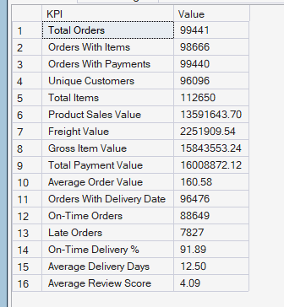
Caption: Executive KPI SQL Validation
Validation Area | Final Result
RAW load | All nine RAW counts match the original CSV files.
RAW vs STG | All nine source counts preserved through staging.
Fact grains | 0 duplicate grain violations across FactOrder, FactSalesItem, and FactPayment.
Unknown keys | 0 loaded fact rows using technical unknown dimension members.
Monetary reconciliation | Product sales, freight, and payment totals match staging totals.
Foreign keys | 11 explicit warehouse FK relationships.
MART views | 4 validated reporting views with expected grains and row counts.
Power BI | All 3 pages completed; slicers and drill-down/roll-up tested.

11. Conclusion
The project implements a reproducible end-to-end DWBI solution from nine Olist CSV sources to validated Power BI dashboards. The layered RAW → STG → DW → MART architecture preserves source traceability, supports explicit data-quality handling, and separates business-process grains across orders, sales items, and payments.
The dimensional warehouse provides reusable customer, product, seller, location, payment-type, and date dimensions together with three fact tables. Reporting-ready MART views simplify Power BI consumption and keep important business definitions consistent. The three Power BI pages support executive monitoring, time-series analysis, regional comparison, filtering, and OLAP-style drill-down/roll-up. The resulting insights support decisions related to sales planning, product priorities, delivery operations, regional strategy, and customer retention.
Possible future extensions include more advanced payment analysis, review-sentiment analysis, seller performance scoring, delivery-delay prediction, and incremental-refresh automation.

12. References
- IT3101 – Data Warehousing and Business Intelligence. Assignment Descriptor: Design and Implementation of a Data Warehouse and Business Intelligence Solution.
- Olist. Brazilian E-Commerce Public Dataset by Olist. [https://www.kaggle.com/datasets/olistbr/brazilian-ecommerce].
- Microsoft SQL Server / SQL Server Management Studio documentation.
- Microsoft Power BI documentation.
- Project-generated source inventory, ETL documentation, dimensional model documentation, MART documentation, validation summary, and business-insight files.
- GitHub Repository. Olist Data Warehouse and Business Intelligence Project. Available at: https://github.com/adithyauvini/IT3101--E-Commerce-Sales-Customer-Delivery-Intelligence-Platform

Appendix A – Screenshot and Figure Placement Checklist
No. | File Name | Where to Place | Purpose
A1 | source_relationships.png | Section 3.1 | Source data relationship diagram.
A2 | 01_raw_table_counts.png | Section 3.3 | Evidence that all nine RAW sources loaded.
A3 | dwbi_architecture_diagram_vertical.png | Section 4.1 | Layered architecture.
A4 | dimensional_model_ssms.png | Section 5.1 | Implemented dimensional schema and relationships.
A5 | 03_dimension_counts.png | Section 5.2 | Dimension row counts.
A6 | 04_fact_counts.png | Section 5.3 | Fact row counts.
A7 | 06_foreign_keys.png | Section 5.5 | Explicit FK relationships.
A8 | etl_workflow.png | Section 6.1 | ETL process flow.
A9 | 02_staging_validation.png | Section 6.3 | RAW vs STG preservation.
A10 | 05_fact_grain_validation.png | Section 6.5 | 0 duplicate fact-grain violations.
A11 | 07_mart_views.png | Section 7.2 | All four MART views and row counts.
A12 | 09_powerbi_executive_summary.png | Section 8.2 | Power BI Page 1.
A13 | 10_powerbi_trend_analysis.png | Section 8.3 | Power BI Page 2.
A14 | 11_powerbi_interactive_analysis.png | Section 8.4 | Power BI Page 3.
A15 | 12_powerbi_drilldown.png | Section 8.5 | OLAP drill-down evidence.
A16 | 08_executive_kpi_sql.png | Section 10 | Final KPI validation.

Appendix B – SQL / Technical File Inventory
Include the final technical files in the submission package. The report does not need to reproduce every SQL script in full; use this appendix to document the reproducible execution sequence.
sql/
01_create_database.sql
02_create_raw_tables.sql
03_load_raw_data.sql
04_create_staging_tables.sql
05_load_staging.sql
06_validate_staging.sql
07_dimension_source_audit.sql
08_create_dimensions.sql
09_load_dimensions.sql
10_create_facts.sql
11_load_facts.sql
12_kpi_source_audit.sql
13_create_mart_views.sql
14_final_verification.sql
scripts/
01_data_quality.py
02_key_relationship_profile.py
03_data_quality_investigation.py
powerbi/
Olist_BI_Solution.pbix

Appendix C – Assignment Requirement Coverage
Assignment Task | Report Section | Implementation Evidence
Task 1 – Dataset & business scenario | Section 2 | Dataset overview, business questions, suitability.
Task 2 – Sources & preparation | Section 3 | Nine source files, relationship diagram, profiling, quality decisions.
Task 3 – Architecture | Section 4 | Layered RAW → STG → DW → MART → Power BI architecture.
Task 4 – Dimensional DW | Section 5 | 6 dimensions, 3 facts, grain, measures, PK/FK, hierarchy, SSMS diagram.
Task 5 – ETL | Section 6 | Extraction, transformations, loading sequence, validation.
Task 6 – Data Mart | Section 7 | 4 MART views, users, grain, benefits, row validation.
Task 7 – OLAP & BI | Section 8 | 3 Power BI pages, KPIs, trends, slicers, drill-down/roll-up.
Task 8 – Insights | Section 9 | 5 evidence-based insights with recommendations.

